
[文档标题]
[文档副标题]

[日期]
[公司名称]
[公司地址]

table of contents
Executive Summary 2
1.0 Introduction 3
1.1The Background of the Starbucks 3
1.2 the purpose of the report 3
1.3 business level strategy 3
1.4 competitive advantage 3
1.5 porters’ generic Strategies 4
2.0 Main Body 5
2.1 Differentiation Strategy 5
2.2 Starbucks’ Differentiation Strategy 5
2.2.1 product and service 5
2.2.2 brand 6
2.2.3 environment 6
2.3 The advantage of the Differentiation Strategy 7
2.3.1 Strong Market Position and Global Brand Recognition 7
2.3.2 Products of the Highest Quality 7
2.3.3 Customer base loyalty 7
2.4 the limitations of a Differentiation strategy 7
2.4.1 expensive product 7
2.4.2 Self-Cannibalization through overcrowding 8
3.0 Conclusion 8
4.0 recommendations 8
references 8

Executive Summary
This report will：
Identify the strategy adopted by Starbucks.
Analyses how Starbuck achieved the strategy adopted.
Critically evaluate the strategy used by Starbucks.
Offer recommendations based on the findings at the end so Starbucks can improve performance.

The information within this report was collected from a variety of sources including textbooks, academic journals and the Starbucks’ website.

This report found the Starbucks use the differentiation strategy from porter’s Generic Strategies, to achieve this strategy Starbucks, employ the following methods:
High quality of the product and service
Establish their own special brand
Create a great environment
There are a variety of strengths of the differentiation strategy which Starbucks have gained by adopting the strategy, there are:
Strong Market Position and Global Brand Recognition
Products of the Highest Quality
Customer base loyalty
However, there are also many limitations of using the differentiation strategy which can affect Starbuck, such as:
expensive product
Self-Cannibalization through overcrowding
The recommendations which could possibly improve Starbucks performance are:
Develop some new products
Find lower price suppliers
Turn off some unprofitable stores

1.0 Introduction

1.1The Background of the Starbucks
In1971, the Starbucks was established with the Jerry Baldwin, Gordon Bowker and Zev Siegel ,in 1980,Howard Schultz become a director of retail operations and marketing in Starbucks. in 1990, the company expanded and increase resources by opening a new roasting plant. By the end of 1992，the number of Starbucks has increased to 165, it expanded from USA to Canada, it improve Starbucks visibility, the customer can find it in everywhere. In 1995, Starbucks established its brand name and have opened the 676th store in the market. It added in-house music. In 1996, Starbucks entered the international market by opening stores in Japan, Hawaii and Singapore in joint venture with Sizably In which. By the end of year 2000 Starbucks had ventured into countries from England to china to Australia with about 3300 stores and by the last quarter of 2008 the total international stores reached 5113 and 11567 stores in the United States. (starbucks.com, 2010)

1.2 the purpose of the report
this report will :
- Identify the strategy of the Starbucks , and analysis Starbucks benefits from the competition and give some examples.
2. Analyse the advantage and disadvantage of the strategy.
3. Provide some recommendation to the Starbucks.

1.3 business level strategy

An organization's core competencies should be focused on satisfying customer needs or preferences in order to achieve above average returns. This is done through Business-level strategies. Business level strategies detail actions taken to provide value to customers and gain a competitive advantage by exploiting core competencies in specific, individual product or service markets. Business-level strategy pay attention to how to satisfy customers, provide some goods and services, and increase operating profits. business-level strategy focuses on Position themself as a competitor and grasping technology changes and market trends.(Beard 1981).

1.4 competitive advantage
Competitive advantages are conditions that allow a company or country to produce a good or service at a lower price or in a more desirable fashion for customers. These conditions allow the productive entity to generate more sales or superior margins than its competition. Competitive advantages are attributed to a variety of factors, including cost structure, brand, quality of product offerings, distribution network, intellectual property and customer support. .（Porte 1985）

1.5 porters’ generic Strategies
Porter's generic strategies is show that how the company get a competitive advantage. there are four generic strategies, it's differentiation, cost leadership, focus differentiation and focus cost leadership. as shown below：
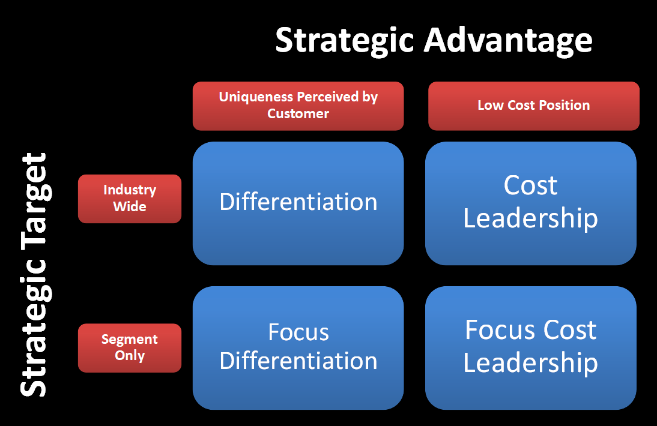
Figure 1: Porter's generic strategies
The differentiation is described that the company use their own technical advantages and management advantages to produce some new productions that has a higher quality and some characteristics, or use more flexible marketing tools and more thoughtful service. The cost leadership is indicate this strategy means that companies will use their best efforts to reduce costs of the production and management. companies also control the cost of service, marketing and advertising, it will make the company gain more profitable. The focus strategy is mean that companies focus their business activities on a specific market and provide special products and services to specific markets, this strategy include Focus Differentiation and Focus Cost Leadership. (porter,1980)

2.0 Main Body
Starbucks as the world's largest and most successful coffee chain, Starbucks retail products include over 30 world-class coffee beans, hand-made espresso coffee and a variety of coffee hot and cold drinks, fresh and delicious pastries and a wide variety of coffee machines, Coffee cup and other goods. Starbucks already has nearly 21,300 stores worldwide, which is closely related to the diversification strategy used by Starbucks. Differentiation was a competitive tool for Starbucks. By offering differentiated products and services in the coffee and food industry, Starbucks achieved much higher profit margins than regular coffee shops. （Securities and Exchange Commission，2016）。

2.1 Differentiation Strategy
Differentiation is based on the specific competitive advantage, it is used to improve the customer responsiveness by creating some new production and unique resources. Porter think the differentiation can be divided into service and product differentiation. the company should need to create some have their own unique services and products, thus forming their own characteristics. or invest more in product creation and service innovation under the premise of lower cost. the company should show some differences in the product and management with the competitors。There are many ways to achieve differentiation, such as grasp a special technology，establish a brand and special service。(Boehe. 2010)

2.2 Starbucks’ Differentiation Strategy
The Starbucks use the differentiation strategy by improving service and products, building a brand and changing the environment. I will explain how Starbucks implements these strategies in detail below.

2.2.1 product and service
Starbucks places great emphasis on product quality, they have very strict standards for every step of the way from importing raw materials to making coffee. Starbucks coffee beans are from the world's leading coffee beans origin; therefore, it is no doubt that the quality of the coffee beans is the best. They classify coffee beans by flavor such as Lively flavor, rich flavor and rough flavor, so that customers can choose their favorite coffee according to their taste. (Schultz,1984)
About the service, Starbucks only hires those who have a passion for coffee, and they regularly train employees, the training content is conclude customer service, sales tips and some coffee knowledge. these trainings have clear processes and exact standards. staffs must service customers according to this standard. In addition to the service, Starbucks will also provide customers with some detailed knowledge of coffee and how to make it. for example, the Starbucks in Shanghai has a service called "coffee classroom", Starbucks will be specially equipped a coffee master for a group of customers that about three or four people. The coffee guru will patiently and carefully explain to the customer if they have any questions, customers not only find the coffee that suits their taste, but also learn about some of the knowledge and culture of coffee.

2.2.2 brand
Kieran (2016) indicate that Brand image represents the image of a company's products and services. It is more important than the product and service, because the deepest impression for customers is the brand. First of all, they advocate the global coffee culture as a benchmark, making some high quality and taste of coffee to attract consumers, give customers a good impression. Secondly, they advocate the global coffee culture as a benchmark, making some high quality and taste of coffee to attract consumers, thirdly, building a very sound service standard, finally, adhere to the concept of customer first can help the Starbucks to build a brand image and maintain customer awareness
Branding has been one of the pivotal elements of Starbucks strategy over many years. The company has invested significantly in creating a standardised look and feel of its stores, merchandise and food and drinks. The Starbucks Siren logo is one of the most recognisable logos in the world. The global expansion strategy has a key objective of recreating the Starbucks experience in every new country the company enters. This essentially results in a similar kind of experience in its stores, whether it is located in New York, New Mexico, Moscow, Tokyo or Shanghai.
The company’s brand strategy has kept pace with time and has evolved to take advantage of new and emerging customer engagement platforms. The company operates a website called mystarbucksidea.com, where customers can leave ideas for the company to expand and improve its products and customer experience, improve engagement with the community and enhance social responsibility. This is akin to the emerging methodology of “crowd-sourcing” in the field of innovation.

2.2.3 environment
In the Starbucks store, they will create a good environment for customers, the Starbucks invited professional designers to design wallpaper and windows, and table and chairs and sofa placed is also very particular. The tables and chairs are all made of wood, some murals on the wall, it gives customer a quaint feeling. and the shop is also filled with elegant music. Starbucks tries hard to make its own coffee shop the "third place" for people, For customers, this store can be used not only to meet guests, but also to relax here alone , this environment allows consumers to obtain great spiritual needs, so that customers have a wonderful and profound impression in the experience

2.3 The advantage of the Differentiation Strategy

2.3.1 Strong Market Position and Global Brand Recognition
Strong Market Position and Global Brand Recognition: Starbucks has a significant geographical presence across the globe and maintain a 36.7% market share in the United States and has operations in over 60 countries. Starbucks is also the most recognized brand in the coffeehouse segment and is ranked 91st in the best global brands of 2013.8 Starbucks effectively leverages its rich brand equity by merchandizing products, licensing its brand logo out. Such strong market position and brand recognition allows the company to gain significant competitive advantage in further expanding into international markets and also help register higher growth in both domestic and international markets. Over the years, they have achieved significant economies of scale with superior distribution channels and supplier relationships.

2.3.2 Products of the Highest Quality
They give the highest importance to the quality of their products, whether it is the acquisition of raw materials, or the production process will be in accordance with strict processes to make sure that the quality of the coffee they make is higher than that of other coffee companies, higher quality means less breakdowns,this is a great boost to the company's brand。

2.3.3 Customer base loyalty
Starbucks has cult following status among consumers and they have also implemented loyalty-based programs to drive loyalty with the Starbucks Rewards programs and Starbucks Card. The Starbucks Card is a value card program that provides convenience, support gifting, and increase the frequency of store visits by cardholders and integrated with their mobile application.

2.4 the limitations of a Differentiation strategy

2.4.1 expensive cost
If Starbucks wants to adopt a differentiation strategy, they needs to improve their company's technology, this requires the company to increase research in this area.While Starbucks does differentiate their products with being highly quality couple with the whole ‘Starbucks Experience’, in times of economic sluggishness, consumers to have so switching costs to competitor’s products with lower prices and forgo paying a premium. These premium prices could also pose some weakness for it to succeed in developing countries.

2.4.2 Imitation of competitors
Imitation of competitors is also a big risk,because there are many competitive advantages are visible, such as service and layout for the coffee shop environment，
competitors will improve themselves by analyzing and imitating the competitive advantages of Starbucks, this will result in the loss of Starbucks competitive advantage, for example, Starbucks will put some fresh music in their cafes to relax the consumer, which will be imitated by their competitors, so that they lose this advantage. In addition, the way of service can also be known.

3.0 Conclusion
In conclusion, the starbucks want to gain some competition advantages by:
Improve the quality of products and services
Enhance brand image
Provide customers with a good consumer environment

the Starbucks did get some competition advantages by using this strategy, such as Strong Market Position and Global Brand Recognition by use the differentiation strategy. At the same tiome, the Starbucks also face some risk, for example, the cost of the products and service is high,and it is easy to imitate.

4.0 recommendations
Develop some new products,the Starbucks can create some new flavor coffee.
Find lower price suppliers, the Starbucks can reduce the cost by it
Turn off some unprofitable stores,This avoids the risks posed by the economic crisis.

