Stress Analysis and Dynamics

Designing an overhead gantry crane

Introduction
I have been tasked to design a cost effective under running girder gantry crane. The crane is to be manufactured from steel and lift a weight of 5000kg of mass. I also need to calculate the second moment of area required for the bridge girder and select a suitable section. Types of strain gauges need to be discussed and what type of strain gauge I will need to apply to the crane for it to operate in a safe and sufficient manner.
Below is a detailed report about the Second moment of area required along with calculations and also documentation in regards to research and choice of strain gauges used.
1.
Calculate the minimum second moment of area and recommend a suitable section.
To begin we will use equation
∆max = $\frac{pl^{3}}{48EI}$

E = Young’s modulus (Pa) = 210 GPa (x10⁹)

I = Moment of area/inertia (m⁴ ) = ?
$l$ = Length of beam (m) = 12m
p = Total concentrated pinot load (N) =5000kg
∆ = Deflection (m) = 10mm (x10 ⁻³ )
First of all, we must convert 5000kg into Newton’s;
Force = Mass x Acceleration
F = 5000 x 9.81
F = 49,050 N
F = 49.050 kN (x10³)
Length of bridge girder is not given and it is assumed to be 12 meters.
∆max = $\frac{49.050x{10}^{3} x ({12)}^{3}}{48 x 210x{10}^{9} x I}$
As I is unknown we must re-arrange equation in order to get second moment of area;
I = $\frac{49.050x{10}^{3}x {\left(12\right)}^{3}}{48 x 210x{10}^{9}x 10x{10}^{-3}}$
I = $8.408571429x{10}^{-4}m^{4}$
With addition of 247kg hoist the answer becomes
I = $\frac{51.473x{10}^{3}x {\left(12\right)}^{3}}{48 x 210x{10}^{9}x 10x{10}^{-3}}$
I = $8.823942857x{10}^{-4}m^{4}$
To convert m⁴ cm⁴ we must multiply the answer by 100 000 000
I = 88,239.4 cm⁴
With the second moment of area now calculated we must select a suitable section “I” beam. In order to do so I visited the website https://www.steelforlifebluebook.co.uk/ . This website is very useful as it has all the information required when selecting a section for an “I” beam.

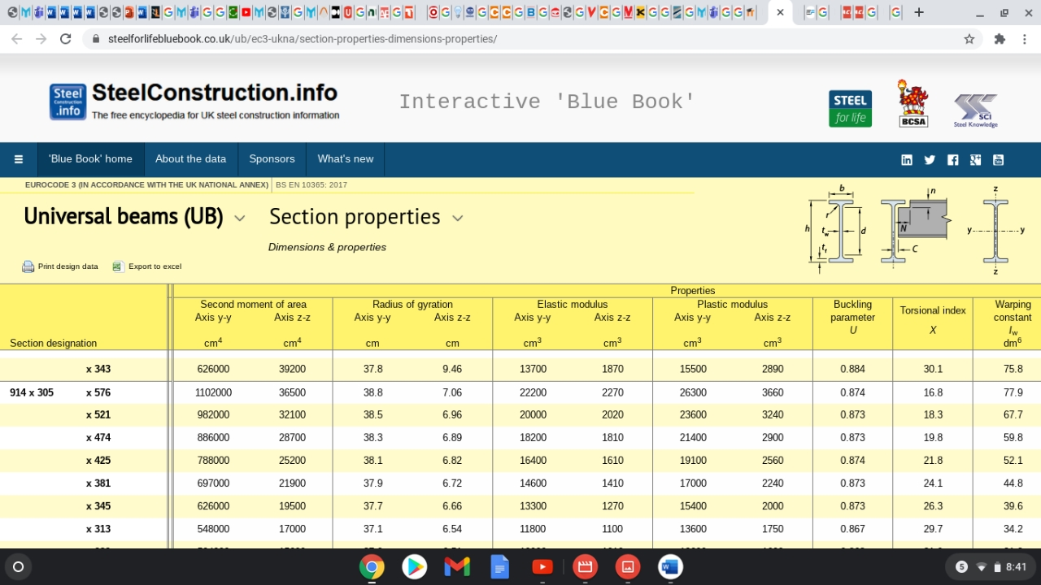
The minimum second moment of area calculated previously is 88,239.4 cm⁴ and this is the minimum recommended value. As highlighted above with the use of this table I have selected a section of 914 x 305 x 474. My choice in using this section is that the second moment of area is larger than the minimum amount required therefore justifying my choice.

2.
Assumptions
In order to calculate the second moment of area required in task 1 there are a couple of assumptions that need to be made in order to do so. Without these assumptions it would be impossible to calculate and to recommend a suitable section beam. A First assumption is that the length of the bridge girder would need to be assumed/determined as the calculation requires a length in order to fully complete it. With that being assumed I decided to do some research about what the average or standard length of underrunning girder is. I found that majority of under running girders have a length of under 65 feet which is under 19 meters. With that I also decided to take into consideration as if the under running girder would be installed in the machine shop where I work. I decided on a length of 12 meters as a sufficient and suitable length as it wouldn’t be too large to have in our machine shop and take up floor space and also, I feel it isn’t too little as it is lifting a mass of 5000kg.
A second assumption to make would be to determine what type of beam is in use for the bridge girder. There are 3 main types of beams which are cantilever beam, fixed beam and simply supported beam. It cannot be a cantilever beam as it isn’t supported at one end and free at the other end. It cannot also be a fixed beam as they are supported on both ends but are fixed in place. Therefore, the beam being used on this under runner girder is a simply supported beam. It is simply supported as the beam is supported on both ends which are free to rotate and move horizontally. In this scenario the bridge girder is simply supported over the conductor through the end trucks. Also, it has a point load at the Centre.
Included to the lifting weight mass of 5000kg I have decided to add also the weight of the hoist and hoist block. There will be a decent amount of mass to the hoist as it needs to be able to lift a capacity of 5000kg, it wont be substantial amount compared to 5000kg but I feel that it needs to be taken into consideration. With this, I had done some research on hoists being able to have a lifting capacity of 5000kg and come across a hoist with a weight base of 545lbs. Converting lbs to kg the weight base of the hoist is 247kg.
Here is my research regarding the hoist and its specifications:
https://www.aceindustries.com/p-6416-yale-y80-5-ton-wire-rope-hoist-10-fpm-three-phase-20-ft-lift.aspx

3.
Types of strain gauges
There are many types of strain gauges used and available in today’s day and age. These gauges are used daily in every aspect of engineering and are listed as follows;
- Piezoresistive strain gauge - This strain gauge is a semiconductor material. When the material is stretched or compressed the resistance changes also. Typically, these gauges are made from silicon and their gauge factor is higher than that of a bonded foil strain gauge. As a result, it leads to a big increase in mV/V sensitivity and noise in the output signal. (Piezoresistive Strain Gauges, 2021)

- Linear strain gauges – This type of strain gauge is used to record strain in the direction in which its measuring is aligned. Usually, it is installed along the direction of the main force where the direction of its force must be known. This strain gauge is preferred when the measurements are in one direction only. Linear strain gauges are used to measure bending, axial and torsion strains and are widely used in beams. (Linear strain gauges, 2021)

- Mechanical Strain gauges - These strain gauges are often called extensometers, and they can be used to measure strain under static or gradually changing load conditions. The strain gauge has two blades, which are clamped in contact with the test part. During the strain of the test part, the two blades will be slightly displaced, and the displacement will be amplified by mechanical linkage.

- Acoustic strain gauges - An Acoustic strain gauge is a gauge that consists of steel wire tensioned between two predefined brackets. The change of its distance will change the natural frequency with the change of strain. With an acoustic strain gauge, the frequency change can be expanded by reducing the length and even the strain of the wire. Acoustic strain gauges tend to have high accuracy and reliability and also can be used to measure structural strain.

- Pneumatic strain gauges - A Pneumatic strain gauge is a strain gauge that can measure the size/dimension change based on the flow rate of air escaping from a nozzle under pressure. This type of strain gauge is capable of dynamic and static measurements whilst also being reliable.
- Inductance strain gauges - These gauges are very sensitive. These gauges are primarily used to measure small changes. The member to be measured is connected to one end of the moveable iron armature. The longer part of the armature is in-between two iron cores with wires coiled in-between them. The coil will generate impedance within the bridge circuit, which will produce an output voltage relative to the input displacement and relative to the strain.

- Un-bonded strain gauge - With an un-bonded strain gauge, a piece of wire is stretched in many folds between a pair of insulated pins. These pins are fixed to a moveable or flexible part of the main body. When strained the wire will strain also. (What are strain gauges and its types Instrumentation, 2021)

- Resistance strain gauges – This strain gauge is used widely in the engineering community. These gauges are made of metal foil and are used to define small mechanical strains, scales for weighing and engineering testing of metal and rigid components. The change in the gauge resistor is determined by the use of a Wheatstone bridge resistor. With the use of a Wheatstone bridge there are three different configurations that are used which are, quarter-bridge, half-bridge and full-bridge. All three configurations are unique in their own way by the number of active elements in the Wheatstone bridge, orientation of the strain gauges and type of strain being measured.
Here I will discuss the three different configurations:
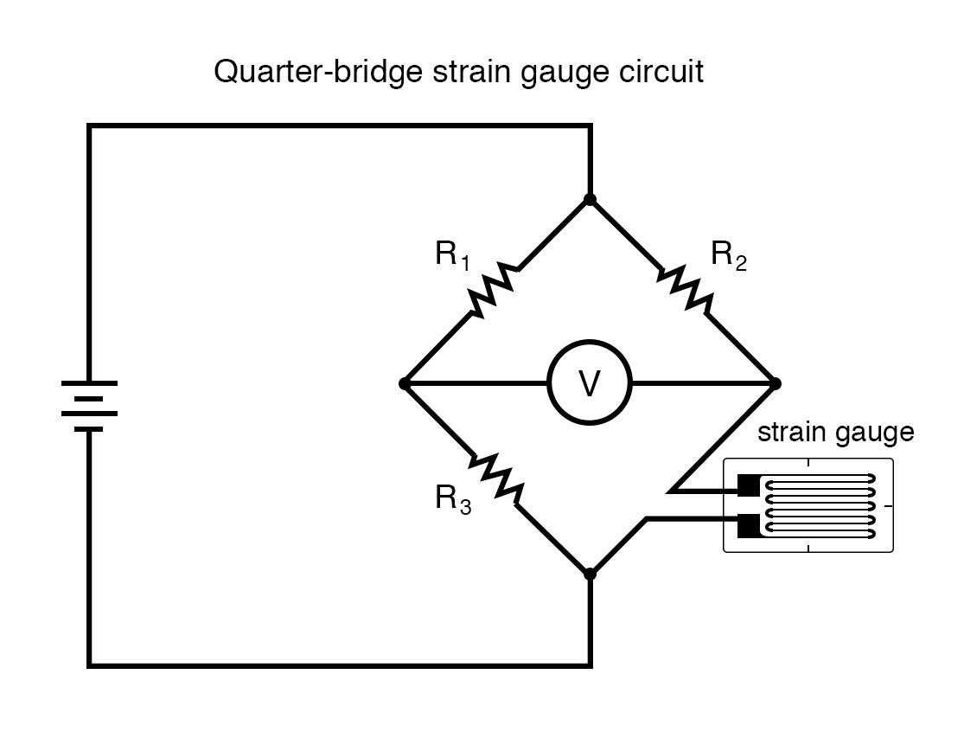
- Quarter-bridge -

This is the simplest form of strain gauge and resistor R4 is replaced with a strain gauge while keeping all other resistors and their resistances unchanged. The type of no-load resistance on the strain gauge must be selected carefully so that the bridge reaches perfect balance without applying force. The voltmeter connected to both ends of Vo will read 0. If there is any strain experienced within the strain gauge the resistance will change and also the voltage across the voltmeter will change therefore measuring the strain. Resistance is also affected by the temperature of the conductive material which will affect the strain gauge.
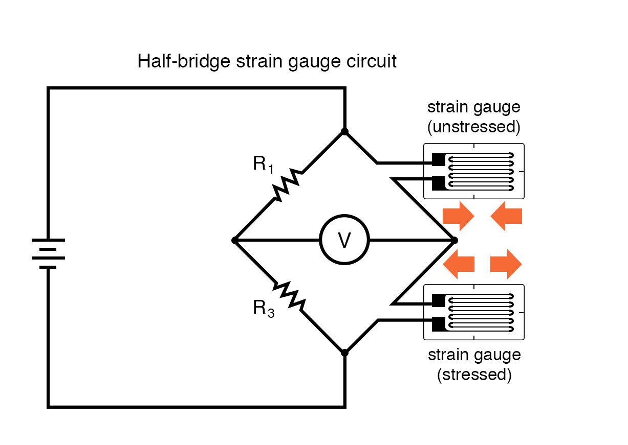
- Half bridge -
A half bridge strain gauge is very similar to a quarter bridge strain gauge. However, in this bridge type it uses two strain gauges instead of one like the quarter bridge. The second strain gauge is placed in place of resistor R2. Gauge 2 is the dummy gauge which is bonded to an ‘unstressed’ material in so that it cancels out any resistive changes in resistor R1. This gauge greatly reduces temperature errors.

- Full bridge –
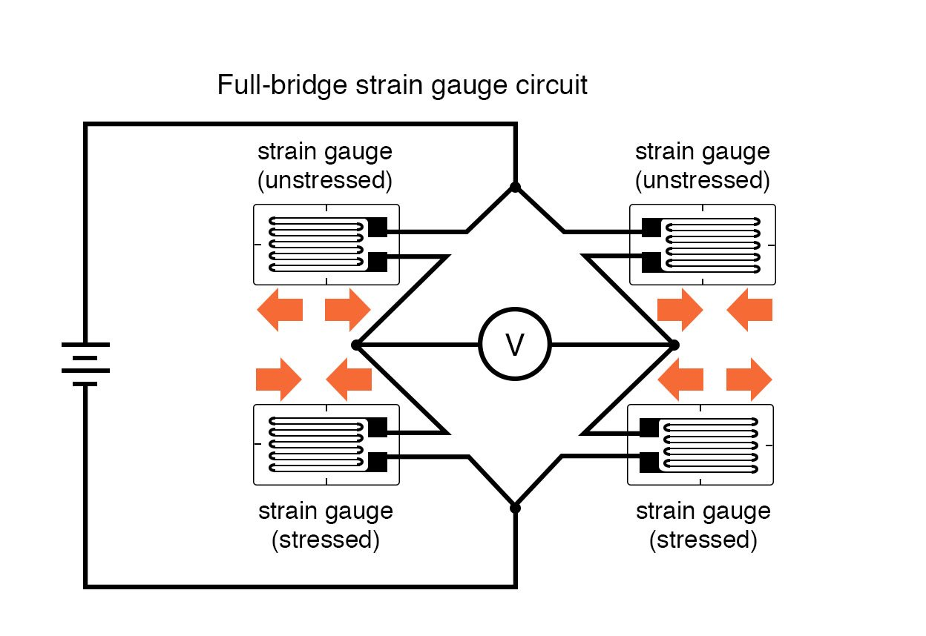
The full bridge strain gauge has a number of advantages over the other two variety of gauges. All four resistors are replaced by strain gauges in this case, with the top half gauges remaining unstressed and the lower half remaining stressed. One of the most promising properties of a full bridge strain gauge is that it is linear while the others are not. However, it is difficult to implement as it needs four gauges to be positioned in close vicinity.
(Measuring Strain with Strain Gages, 2021)
How have strain gauges been developed historically and how they may develop in the future
Historically strain gauges were developed after the discovery that the resistance of a conductor is proportional to the length of the conductor and inversely proportional to the cross-sectional area of the conductor. They are simple and reliable methods of strain measurement and work on the Wheatstone bridge balance principal. There are many different shapes, types and sizes of strain gauges and its measuring length can be as short as 0.015 inches and can measure strains as little as 0.000001 inches. However, one of their disadvantages is that they can only be used once and usually cannot be reused. They also need to be bonded to the surface of structure.
In the future another mean of measuring strain could be something like digital image correlation. It’s a 3-D optical technology that can measure strain on almost most materials and can measure bending and combined loads for static and dynamic applications. The use of 3-D digital image correlation can be applied on very small to large areas. Digital image correlation can be reused and does not require bonding to any surface.
(Strain gauge | instrument, 2021)
(Digital Image Correlation (DIC) | 3D Full-Field Measurement, 2021)

4.
To monitor the safety of the crane during use it is recommended to apply a strain gauge to during its operation. I would suggest to use a linear strain gauge to be applied to carry this out. The reasons I suggest this is because linear strain gauges are used to record strain in the direction in which its measuring is aligned. Linear strain gauges are used when the measurement is in one direction, which is the case here. The strain is occurring on a simply supported beam with a point load at the Centre hence the direction is downwards. Linear gauges are widely used in measuring bending in beams so I believe that this is a good option to use it for this particular under running girder. This strain gauge is installed along the direction of which the force is known and I will discuss where I would install it:

Bottom web
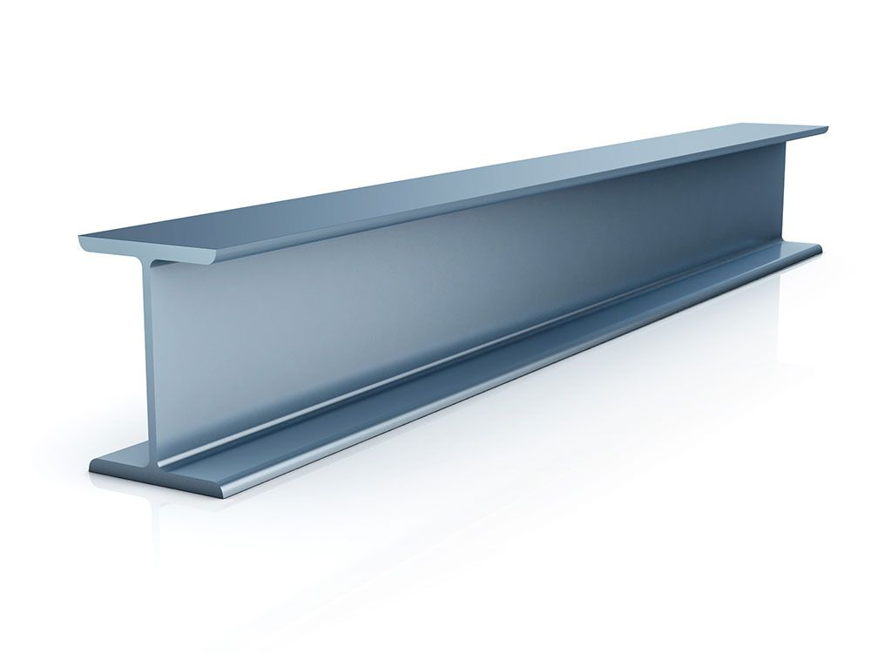
Here is an example of a “I” beam which is similar to the design of the bridge girder. As you can see, I have placed the arrow on where I believe that the strain gauge should be placed. It has been placed here at the center of the bottom web because of the bending stress. The stress in the bottom web will be more than the stress in the top web of the beam and as a result, the strain in the bottom web is expected to be more than the strain in the top web which I believe will give a more accurate reading. The reading of the strain gauge can be interpreted by the process of calibration. Strain is to be measured only after the calibration of the voltage to strain relation of the gauge.

Conclusion
This concludes my report. I believe I have achieved what was set out and have calculated the second moment of area and hence recommend a suitable section for the under running gantry crane for its use in operation. I believe that I have talked about many varieties of strain gauges that are used in today’s engineering world and also that I have justified a suitable strain gauge to use in this scenario and how they should be applied.

Bibliography
Sensorsone.com. 2021. Piezoresistive Strain Gauges. [online] Available at: <https://www.sensorsone.com/piezoresistive-strain-gauges/> [Accessed 7 April 2021].

2021. Linear strain gauges. [online] Available at: <https://www.bestech.com.au/blogs/different-types-of-strain-gauge-geometries/> [Accessed 7 April 2021].

Instrumentation, F., 2021. What is Strain gauge and its types. [online] Industrial Automation, PLC Programming, scada & Pid Control System. Available at: <https://forumautomation.com/t/what-is-strain-gauge-and-its-types/7342> [Accessed 13 April 2021].

Ni.com. 2021. Measuring Strain with Strain Gages. [online] Available at: <https://www.ni.com/en-gb/innovations/white-papers/07/measuring-strain-with-strain-gages.html> [Accessed 16 April 2021].

Encyclopedia Britannica. 2021. Strain gauge | instrument. [online] Available at: <https://www.britannica.com/technology/strain-gauge> [Accessed 18 April 2021].

Dantec Dynamics | Precision Measurement Systems & Sensors. 2021. Digital Image Correlation (DIC) | 3D Full-Field Measurement. [online] Available at: <https://www.dantecdynamics.com/solutions-applications/solutions/stress-strain-espi-dic/digital-image-correlation-dic/> [Accessed 20 April 2021].
Image’s reference
2021. [image] Available at: <https://www.allaboutcircuits.com/textbook/direct-current/chpt-9/strain-gauges/> [Accessed 23 April 2021].
2021. [image] Available at: <https://www.alcoengineering.co.uk/steel-universal-i-beams.html> [Accessed 23 April 2021].

