Comparison of Two Hospitality Organisations

Student Name Md Zahidul Alam
Student ID 2127518
Module Code: BMIH5007
Tutor: Tristan Hawkins
Module Title: Financial Management for the Hotel Industry
Contents
Introduction 3
Financial Management Strategies & Best Practices 4
Key areas of the Comparison between Mandarin Oriental Hotel Group and Premier Inn 6
Total Revenue 7
Market position 7
Growth Potential 8
Financial Commitment to CSR 9
Area of Improvement 11
Conclusion 12
Reference list 13

Introduction
The financial management of an organisation serves as the fundamental basis for its achievement. Likewise, the hotels and venues that achieve the highest level of success are those that adhere to the fundamental principles of financial management, as this allows them to effectively and lucratively conduct their commercial operations. This research aims to provide a comprehensive examination and comparison of Premier Inn and the Mandarin Oriental Hotel Group, both of which are prominent entities operating within the hospitality sector. Both of these enterprises are considered trailblazers in their respective fields.

Financial Management Strategies & Best Practices
While the hotel sector has a plethora of potential, it is not devoid of its fair share of obstacles. This category encompasses expenses, market rivalry, and dynamic regulatory frameworks. Effective financial management strategies are essential for hotels and other businesses operating within the sector (Drury, 2021). However, the implementation of comprehensive training programmes might pose challenges in terms of scheduling.
- The topic of discussion pertains to the field of financial management and the practice of forecasting
The budgets allocated to hotels and restaurants that achieve success are always characterised by meticulous planning and stringent management measures. The use of a budget can enhance the effectiveness and efficiency of activity planning and scheduling. The concept of allocating funds in a budget is a source of motivation for both managers and staff members (Information Resources Management Association, 2019) . Additionally, it may be utilised to evaluate the degree of management's success by comparing actual expenditure with anticipated amounts.
- Developing an equitable pricing plan.
To achieve success, every organisation must possess a comprehensive understanding of the optimal pricing strategy. The establishment of robust client connections is of utmost importance, and the implementation of a well-considered pricing plan is a fundamental aspect of wise financial management (Chapple, 2014). To ensure optimal functionality, it is imperative to incorporate precise attributes that substantiate the designated price point.
- Channel Administration
To augment visibility, it is necessary to allocate resources towards offline channels such as trade exhibits. Without a doubt, this type of investment holds significant value and has demonstrated remarkable performance, with the potential for an astonishing return on investment (Seal et al., 2018).
- Engaging in preparatory measures and effectively overseeing available resources
The assessment of one's capability and the quantification of visitors to be accommodated have significant importance. Having a clear understanding of what to anticipate and possessing excellent strategies for managing the process can greatly enhance ones ability to handle an overbooking situation and uphold client happiness.
To ensure optimal provision of facilities and services to visitors consistently, it is imperative to use efficient capacity management strategies (United States. Bureau Of Statistics, 2016). It is recommended to have a comprehensive monitoring system for all reservations to proactively mitigate any potential issues. The acquisition of it is of utmost importance due to the substantial benefits that arise from doing so.
- The task at hand involves the process of dividing an entity or concept into smaller, distinct parts or categories
There exist several methodologies for the process of segmentation. The variation in information may be contingent upon the country in question or the credibility of the source material. Instances of source-based categorization include people, meetings, conferences, and leisure groups.

Key areas of the Comparison between Mandarin Oriental Hotel Group and Premier Inn

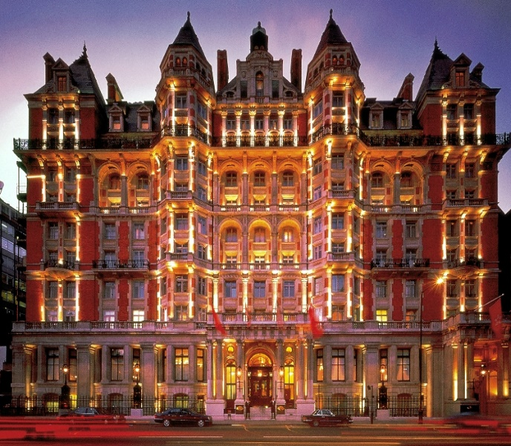
Figure: Mandarin Oriental Hotel Group
Source: (Walker, 2021)
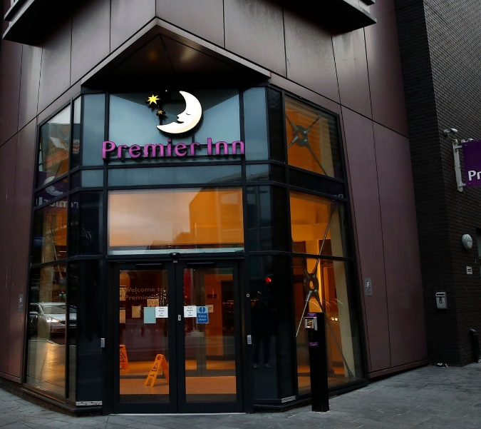
Figure: Premier Inn
Source: (Smith and Milligan, 2015)
The exclusive Mandarin Oriental Hotel Group owns and operates a number of the world's most opulent hotels, resorts, and private residences. The Group now runs 36 hotels and 7 apartments that pay respect to the Group's oriental history and local flavour in 23 different countries and territories. The Group's origins are Asian, but it has expanded well beyond the continent. As part of the Jardine Matheson Group, Mandarin Oriental is expanding with a large number of new hotel openings (Jogaratnam and Ching‐Yick Tse, 2017). By combining Eastern opulence with Western finesse, Mandarin Oriental aspires to be universally known as the finest luxury hotel chain in the world.
On the other hand, Premier Inn is here to make sure that everyone in the UK has a comfortable place to sleep as the largest hotel chain in the country. One may rest assured that he/she will have a job since the company have more available rooms in more places than any other UK hotel chain, as well as more than 800 hotels in the UK, Ireland, and Germany (Smith and Milligan, 2015). As the owners and operators of all of our hotels, one can rest certain that the experience will be consistent in terms of comfort, service, and quality. The Facility have 150 hotels, but if someone is searching for the ultimate in comfort, it is recommended upgrading to a Premier Plus room. Several more Premier Inn hotels are now under construction, although there are already over 40 operational in key German cities including Frankfurt, Hamburg, and Munich.

Total Revenue
Mandarin Oriental Hotel Group: For the twelve months before the most recently available financial statements, Mandarin Oriental recorded a total revenue of $0.45 billion. The company's revenues increased significantly in 2022, reaching $0.45 billion from the previous year's $0.31 billion. Revenue is the sum of money a company makes from the selling of its products or services to customers. On the other hand, no costs are subtracted from income (Walker, 2021).
Premier Inn: Due to increased demand from budget-conscious travellers, Premier Inn's owner said that the hotel chain's profitability had reached pre-pandemic levels, solidifying Premier Inn's position as the leading operator of budget rooms in the United Kingdom. Pre-tax profits of £375 million for the fiscal year ending March 3, 2022, were much more than expected by industry watchers. This number is up considerably from the £58 million recorded in 2022, and it's up by 34% compared to the fiscal year that ended in February of 2020. Premier Inn UK's adjusted annual profits explosion, amounting to a phenomenal 544% gain, was a major contributor to the favourable results. Investors were so pleased with these results that they drove the share price of Whitbread up by 5 per cent, making it the FTSE 100 index's largest gainer.

Market position
Mandarin Oriental Hotel Group: The vast and varied customer market should be carefully segmented into smaller groups characterised by consistent attributes so that Mandarin Oriental Hotel Group can identify the target segment or segments that exhibit congruence with the company's resources and skills (Hayes and Miller, 2016).
Assessing the marketability and expansion potential of the segments being targeted is an integral part of the targeting process. Based on the characteristics of each sector, as well as the company's resources, expertise, and growth goals, Mandarin Oriental Hotel Group may decide to focus on one or more of these areas.
- Each category's commercial appeal and growth potential may be assessed using a variety of metrics.
- The discovered pieces are of the right length and width.
- Show that there are obvious distinctions (Hooley et al., 2020).
- Extra money for advertising shouldn't come out of the budgeted amount.
- Different parts can get to without any trouble.
After segmenting the market and choosing a target audience, Mandarin Oriental Hotel Group must create a clear positioning statement that will influence consumers to view their product in a positive light.
Premier Inn: The hotels are the living proof of the "good night's sleep" slogan's veracity. All Premier Inn hotels have the same design aesthetic, with an inviting and luxurious purple colour scheme and standard furnishings that aim to make guests feel at home away from their own. The rooms are always spotless, brightly lit, and generously proportioned (Morritt and Weinstein, 2017). Blackout drapes, supplementary pillows, and luxurious mattresses all contribute to an atmosphere conducive to a restful night's sleep.
Premier Inn's success stems from the hotel chain's well-established brand positioning in a variety of markets. Potential benefits for all businesses might be realised via the application of unified branding across many channels and the unwavering commitment to the brand's core values (Kuo, Chen and Tseng, 2017). Their brand's steady growth is evidence that they're masters of market perception, which bodes well for their ability to expand their offerings and continually satisfy customers.

Growth Potential
Mandarin Oriental Hotel Group: The inventory of holiday rentals, chalets, and mansions offered by the Mandarin Oriental Hotel Group has grown significantly since its inception in the spring of 2022. Each Mandarin Oriental Exclusive Home is handpicked by StayOne, the luxury home rental network with which the Mandarin Oriental partners, for its high standard of quality and convenient location (Brotherton, 2015). These residences also include individualised service and unique activities that are consistent with the luxurious Mandarin Oriental brand. Since its first season in 2022, the Group's most recent endeavour has seen incredible success, with the portfolio expanding by more than 150% in just a year. The collection currently numbers over twenty hotels, including opulent lodgings throughout Asia, Europe, and the United Kingdom.
In 2020, the Mandarin Oriental hotel chain made a calculated investment in StayOne, a move that indicated the company's intention to enter the luxury vacation rental market. This was a change from the company's previous image as an operator of high-quality hotels. This company's hotel sector counterpart has grown substantially as a result of the COVID-19 outbreak. From 2022 to 2028, its growth is expected to be 19.84% every year on average (Mandarin Oriental International Limited, 2022). After investing, StayOne and Mandarin Oriental have hand-picked a small number of homes to join the expansive Mandarin Oriental Exclusive Homes portfolio.
Premier Inn: As part of its long-term expansion plan, Premier Inn opened 11 new hotels throughout the UK during the previous year. After opening the Hub by Premier Inn Clerkenwell in London a year ago, the budget hotel chain owned by Whitbread boasted that it had expanded its national presence by 1,500 rooms. Hotels have been opened in Milton Keynes, Cumbria, and Jersey (one of the Channel Islands) in addition to Canary Wharf and Paddington Basin in London. Alex Flach, Whitbread's UK development director, says the new hotels are representative of the company's strategy to rapidly expand Premier Inn in response to promising new markets (Fionnuala Mchugh, 2015). The present number of rooms in the UK and Ireland is 82,000, but with this growth, that number will rise to 125,000. According to the company's announcement, Whitbread plans to acquire more than 160 additional Premier Inn hotels in the United Kingdom and Ireland.

Financial Commitment to CSR
Mandarin Oriental Hotel Group: Mandarin Oriental has a strong tradition of corporate responsibility, and the Group carefully considers the long-term effects of every major choice it makes. Conducting oneself with a sense of responsibility is one of the tenets promoted by Mandarin Oriental. The Naturally Better initiative was launched to put people, places, and things first. One of our lofty objectives is to eliminate the use of plastics in all of our hotels (Guliani and Rizwan, 2016). It is also hoped to broaden the scope of our responsible sourcing initiatives to include more key categories including wild-caught seafood, fair-trade coffee and tea, organic chocolate and vanilla, and cage-free eggs. Explore the numerous programmes highlighted here or visit our sustainability-focused websites to learn more about Mandarin Oriental's dedication to improving the environment.
Premier Inn: Hotel Premier Inn is owned by Whitbread, a company with environmental goals that include phasing out unnecessary single-use plastics over the next decade through its "Force for Good" campaign (George, 2021). The CEO of Premier Inn has stated that the company is working closely with its suppliers to research and assess the scope of plastic consumption to find practical alternatives to wasteful single-use goods. An academic tone is present in the user's writing. There is no need to rewrite it. Whitbread defines "unnecessary single-use" as plastics that are used once and then thrown away, as these are not necessary for maintaining food safety. Sauce packets used in restaurants and cafes are only one example of the many ways that plastic has found its way into everyday life. The company said it will perform a comprehensive study to look into the possibilities of replacing single-use plastics with recyclable alternatives in cases where their use was judged essential, such as for milk portions served in hotels. Whitbread predicts that after an extensive review and revamp, single-use plastic will be significantly reduced by the year 2025. The goal of this movement is to get rid of millions of disposable plastic things that aren't needed.

Area of Improvement
The hospitality sector is always evolving and developing new standards. However, the regular activities that shape the experience of the visitors are permanent. Revenue management and cleaning are only two of the many tasks that fall within the purview of hotel managers (Szende, Dalton and Michelle (Myongjee) Yoo, 2021). However, accuracy is often overlooked while being crucial to the success of these endeavours. Improvements to the property that are suggested by guests are very helpful.
- Employee education and development is the focus here.
- Taking advantage of new technologies
- Cleaning service management at its finest (and, 2019)
- The check-in and check-out procedures have been simplified
- Providing customised experiences for guests.
- Revenue management that works
- The topic of discussion pertains to the idea of making the most efficient use of available energy and materials.
- Protecting the well-being of visitors
- Dissection and refinement as a means of progress (Jagmohan Negi, 2015)
- Group work that succeeds because of open lines of communication

Conclusion
The establishment of a robust framework and the implementation of necessary protocols are vital to maximise the value clients receive in exchange for their financial investment. Implementing appropriate financial management solutions is of utmost importance as it guarantees the consistent occurrence of positive experiences. It is logical and rational to engage in a comprehensive examination of the industry, formulate an optimal pricing strategy and financial plan, and thereafter implement a well-defined market segmentation approach. Conceptually similar methodologies, such as forecasting, have substantial importance since they provide the ability to get insights into future events and anticipate potential challenges.

Reference list
and, H. (2019). Technical Training for the Hotel and Catering Industry.
Brotherton, B. (2015). The International hospitality industry : structure, characteristics and issues. Oxford ; Boston: Butterworth-Heinemann.
Chapple, K. (2014). Planning Sustainable Cities and Regions. Routledge.
Drury, C. (2021). Management and Cost Accounting. 10th ed. Andover: Cengage Learning.
Fionnuala Mchugh (2015). Mandarin oriental : hotel group. Cooper-Hewitt Museum.
George, R. (2021). Marketing tourism and hospitality : concepts and cases. Cham, Switzerland: Palgrave Macmillan.
Guliani, L.K. and Rizwan, S.A. (2016). Corporate social responsibility in the hospitality and tourism industry. Hershey, Pennsylvania (701 E. Chocolate Avenue, Hershey, PA 17033, USA): IGI Global.
Hayes, D.K. and Miller, A. (2016). Revenue Management for the Hospitality Industry. Wiley Global Education.
Hooley, G.J., Nicoulaud, B., Rudd, J.M. and Lee, N. (2020). Marketing strategy & competitive positioning. 7th ed. Harlow ; New York: Pearson.
Information Resources Management Association (2019). Corporate social responsibility : concepts, methodologies, tools, and applications. Hershey, Pennsylvania: Business Science Reference, An Imprint Of Igi Global.
Jagmohan Negi (2015). Professional Hotel Management..
Jogaratnam, G. and Ching‐Yick Tse, E. (2017). Entrepreneurial orientation and the structuring of organizations. International Journal of Contemporary Hospitality Management, 18(6), pp.454–468. doi:https://doi.org/10.1108/09596110610681502.
Kuo, C.-M., Chen, L.-C. and Tseng, C.-Y. (2017). Investigating an innovative service with hospitality robots. International Journal of Contemporary Hospitality Management, 29(5), pp.1305–1321. doi:https://doi.org/10.1108/ijchm-08-2015-0414.
Mandarin Oriental International Limited (2022). Annual Report.
Morritt, R. and Weinstein, A. (2017). Segmentation Strategies for Hospitality Managers. Routledge.
Seal, W., Rohde, C., Garrison, R. and Noreen, E. (2018). EBOOK: Management Accounting, 6e. McGraw-Hill Education (UK).
Smith, S. and Milligan, A. (2015). Delivering a branded customer experience people love. London ; Philadelphia: Kogan Page.
Szende, P., Dalton, A.N. and Michelle (Myongjee) Yoo (2021). Operations Management in the Hospitality Industry. Emerald Group Publishing.
United States. Bureau Of Statistics (2016). Occupational outlook handbook. Washington, Dc: Gpo.
Walker, J.R. (2021). Introduction to hospitality management. Boston: Pearson.

