

Student Name: Robert Nzeyimana

Student Number:2329949

Lecturer Name:Tsiwani Khumalo

Module Code: BMHP5015

Module Title: Changemakers: Building your

Personal Brand for Sustainable Employment

Assignment Title: Component 2: Assignment (Report)

Submission Deadline: 2nd April 2026

TABLE OF CONTENTS
Introduction 3
Job Role: Employability Skills 4
Evaluating My Own Skills 4
Action Plan and Timeline 6
Building Personal Brand 8
Promoting The Professional Identity 9
Building a Network for Successful Employment 10
Conclusion 11
Reference List 12

Component 2: Assignment (Report)

Introduction
The role of an A Social Worker is of great significance to the health and care sector in the UK, as they have the responsibility of protecting vulnerable people in society, supporting families in need, and promoting social justice and well-being. The report aims to critically analyse the skills required for employment in this field, the level of competence, and the training plan. The reason for choosing this career stems from a high passion for advocating for the rights of disadvantaged groups and working towards improving their social welfare sustainably.
Figure 1:Job advertisement
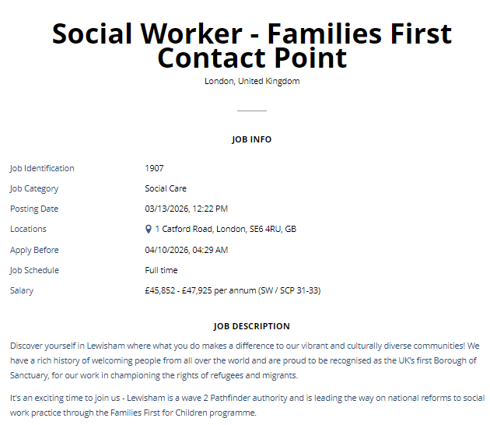
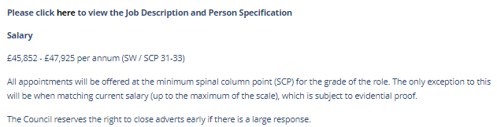
Figure 2: Job advertisement
(Source: Indeed, 2026)

Job Role: Employability Skills
Identification of Key Employability Skills in the Job Description and Person Specification for a Social Worker
UK job descriptions of the role of a Social worker mainly focus on high-level communication, awareness, safeguarding, analytical reasoning, and working with other specialists (Kleipoedszus, 2024). The social workers will be required to carry out a full needs assessment, prepare statutory case reports, and coordinate interventions among the health, housing, and legal services. As an example, the practitioner dealing with a case involving child protection can contact teachers, police officers, and healthcare workers to assess risks (Alfandari and Taylor, 2022). It also requires technical skills, such as digital case administration systems. Administrative loads and complicated case loads, though, may restrict the amount of time that one has to be able to engage directly in therapeutic work with the service users.
Importance of Employability Skills for Effective Professional Performance in Social Work Practice
In social work practise, employability skills are critical in ensuring effective performance due to the complex societal crisis usually faced by vulnerable people that the professionals deal with. Effective communication helps practitioners to clarify the safeguarding decisions to families, especially in the sensitive case of child protection investigation (Garstang et al., 2023). Critical thinking and problem-solving enable the workers to assess risk and formulate viable intervention strategies whenever families experience housing insecurity, domestic abuse, or mental illnesses. However, emotional labour and bureaucracy might have an impact on the ability to make decisions, as well as the need to be resilient and to have professional development.

Evaluating My Own Skills
Self-Assessment
My present goals and objectives involve acquiring background knowledge and a career in the field of social work through both academic and work experience. The study of Health and Social Care at the University of Wales Trinity Saint David has provided an insight into the safeguarding, caring for individuals, and good wellbeing within the community (Read et al., 2025). Being a part-time care assistant in a residential care home has been able to help me assist the elderly in their daily activities. Also, the prior working experience in a logistics environment enhanced discipline, teamwork and organisational responsibility that are important in handling sensitive information and in coordinating professional roles in complex care environments.
Strengths
A number of strengths are similar to those required in a Social Worker. My greatest strength is interpersonal communication, as this skill has been developed through communication with people in a care home setting. In this setting, interpersonal communication is required in order to maintain dignity. English and French, being multilingual languages, are also helpful in communicating with people from various cultures (Oliinyk et al., 2024). Analytical reasoning skills have also been developed through academic assignments in analysing the scenarios in the Safeguarding case. I have a good understanding of teamworking skills, which I have developed through various working assignments.
Areas for Improvement
Although one may discuss these strengths, some of the competencies need to be developed further to satisfy professional expectations of a Social Worker (Kangasniemi et al., 2022). At the moment, I lack first-hand experience of performing formal needs assessments, writing statutory safeguarding reports and implementing legal frameworks of intricate family cases. Although theoretical knowledge on multidisciplinary case management is taught in academia, the practical exposure is yet to be established. There is also a need to be more acquainted with social care legislation, professional documentation standards and crisis intervention strategies (Ghelani, 2023). To build confidence in dealing with sensitive and high-risk situations, the areas will have to be strengthened by using structured placements, supervised practise, and specialist training.
Who can help?
The competencies that will be needed to become a Social Worker can be facilitated by several professional sources. The University of Wales Trinity Saint David has academic lecturers able to give advice on safeguarding frameworks, research practises, and reflective practises (Wikström et al., 2023). Mentoring by experienced practitioners working in residential care settings can be provided by giving real case experience and professional decision-making skills. There is also training material and seminars, as well as networking opportunities, offered by professional organisations like the British Association of Social Workers (Mugumbate et al., 2023). The opportunity to work with these professionals will assist to enhance practical skills, increase professional knowledge and building confidence in accomplishing sophisticated social care duties.

Action Plan and Timeline
Action Plan
Goal Development | Skills to Develop | Specific Actions | Resources / Support | Expected Outcome | Timeline
Obtaining a professional qualification | Social work theory, safeguarding knowledge | Enrol in a Social Work degree programme and complete academic modules related to child protection and adult care | University tutors, academic resources, and professional workshops | Strong theoretical understanding required for becoming a Social Worker | Short–Medium term
Gaining practical care experience | Empathy, communication, and safeguarding awareness | Continue working as a care assistant and volunteer in community support services | Care home supervisors, community organisations | Improved ability to support vulnerable individuals and recognise safeguarding concerns | Short term
Developing assessment and case management skills | Critical thinking, documentation | Participate in supervised placements and observe case review meetings | Practice mentors, local authority professionals | Understanding of real case management and intervention planning | Medium term
Enhancing professional knowledge | Legal frameworks, ethical practice | Attend safeguarding and mental health training workshops | Professional bodies such as the British Association of Social Workers | Improved confidence in applying policy and ethical standards | Medium term
Building professional communication | Networking, professional identity | Attend professional networking events and create a professional profile on LinkedIn | Career advisors, mentors | Increased employability and industry connections | Long term

Timeline (Gantt Chart)
Development Activities | Month 1 | Month 2 | Month 3 | Month 4 | Month 5 | Month 6 | Expected Outcome
Continue Health and Social Care studies at the University |  |  |  |  |  |  | Strong academic foundation in social care principles, safeguarding, and ethical practice
Gain experience working as a care assistant in residential care |  |  |  |  |  |  | Enhanced interpersonal communication, empathy, and understanding of service user needs
Volunteer in community support organisations assisting vulnerable groups |  |  |  |  |  |  | Exposure to community-based support systems and multidisciplinary collaboration
Attend safeguarding, mental health, and professional development training |  |  |  |  |  |  | Improved knowledge of intervention strategies and policy frameworks
Build a professional network and online profile through LinkedIn and sector events |  |  |  |  |  |  | Strong professional visibility and connections within the social care sector
Apply for entry-level positions as a Social Worker |  |  |  |  |  |  | Transition into professional practice within the UK social care system

Building Personal Brand
Resources

Content
Establishing a good personal brand is vital for gaining professional credibility in the field of health and social care and for building a path towards a future career as a Social Worker. A good personal brand can highlight commitment to safeguarding, ethics, and advocacy for disadvantaged groups (Confetto et al., 2023). The process of developing a good personal brand requires demonstrating knowledge, compassion, and learning through professional communication and engagement in social care issues.
A good way to develop a good personal brand is by sharing reflective blogs about actual issues in the field of health and social care, such as how to support elderly people who are socially isolated or how to increase awareness about safeguarding in community services, based on the experiences gained while working as a care assistant (Szántó et al., 2025).
Preparing short articles that analyse different social issues, like stigmatisation of mental health issues, child protection issues, or issues that affect migrant families, can also help to prove one's knowledge of complex social care environments (Oldroyd et al., 2022). Sharing one's insights can also help to prove one's professional inquisitiveness.
Discussions of case studies can also help to build professional credibility. By analysing different case study scenarios or ethical dilemmas in social care practice, one can prove their critical thinking skills.

Promoting the Professional Identity
CV and Cover Letter
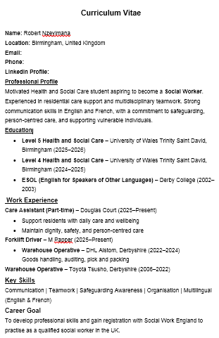
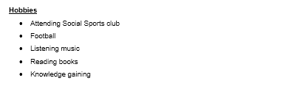
Figure 3: Curriculum Vitae (CV)
Cover Letter
Subject: Application for Social Worker Position
Dear Hiring Manager,
I hope this mail finds you well.
I am writing this letter to show my interest in your organisation for the social worker position. I am currently studying Health and Social Care at the University of Wales Trinity Saint David. I also have experience working as a care assistant for vulnerable people in residential homes. I believe that this experience has helped me to improve my communication skills and understanding of vulnerable people. I want to achieve a qualification in social work and help people who are facing social problems. I am very motivated to show my skills and dedication in your team.
Yours sincerely,
Robert Nzeyimana
Online Presence
Having a strong online presence is important in terms of conveying professional identity and employability in the health and social care industry (Koivunen, 2023). Updating a profile on LinkedIn will assist in highlighting academic achievements, experience as a care assistant, and skills such as knowledge in terms of safeguarding and communication. Updating a profile on LinkedIn with information about personal thoughts on social care issues, training courses attended, or volunteering will assist in highlighting professional growth (Alam et al., 2025). Having a personal website will assist in conveying greater credibility by including a portfolio of academic achievements, personal thoughts on learning, and aspirations in becoming a social worker.

Building a Network for Successful Employment
Explaining the importance of networking
Networking has a vital function in the process of career advancement in the health and social care industry, given that the practice of the field often involves working in conjunction with other services and specialists (Tereshchenko et al., 2024). For a Social Worker in training, networking with other professionals, educators, and service providers can offer a rich learning experience in terms of actual case handling, case safety, and interdisciplinary working. Networking can help in the sharing of information pertaining to policy changes, community resources, and job opportunities (Zamiri and Esmaeili, 2024). Networking with other professionals can help boost professional confidence, learning the realities of social care settings, and advance one’s career.

Identifying potential mentors, professional associations, and networking events
Several mentors and professional bodies can assist in the progression of a career to become a Social Worker (Mihalache, 2023). Mentors like lecturers in universities, such as the University of Wales Trinity Saint David, can offer academic mentor guidance. Professional bodies like the British Association of Social Workers can offer training workshops that provide aspiring professionals with opportunities to network with professional experts (Apgar and Zerrusen, 2024). Attending social care conferences, training sessions like safeguarding training, and participating in community outreach programs can provide aspiring professionals with opportunities to develop professional relationships and become more visible in the health and social care employment network.

Conclusion
Summarising the key points
In this report, the professional responsibilities and requirements for employability of a Social Worker in the health and social care system in the UK have been examined. In this regard, the key competencies that have been highlighted in the discussion include communication skills, awareness of safeguarding issues, teamwork, and critical decision-making skills to provide support to vulnerable groups in society. In this respect, it can be noted that professional requirements in social work practice have to do with the preparation of the individual to face the challenges that come with the profession.
Self-evaluation, action plan, and strategies for building the personal brand
The report also included a critical evaluation of the present skills, where strengths that have been built up through academic studies with the University of Wales Trinity Saint David and work experience in residential care settings have been acknowledged. An action plan was devised to improve professional skills through further courses, volunteering, and networking with other professional workers in the field. Developing strategies to build a personal brand was also considered to further enhance employability. This shows that there is a strong commitment to professional development and that the motivation to be a successful Social Worker in the long term remains strong.

Reference List
- Alam, M.M., Stubbs, F.K., Nousek-McGregor, A.E. and Sherry, L. (2025) ‘LinkedIn to Get In: embedding learning activities to support student career development through online professional networking’, pp. 10-16. Available at: https://doi.org/10.1099/acmi.0.001125.v2.
- Alfandari, R. and Taylor, B.J. (2022) ‘Processes of Multiprofessional Child Protection Decision Making in Hospital Settings: Systematic Narrative Review’, Trauma, Violence, & Abuse, 24(1), p. 152483802110294, pp. 40-56. Available at: https://doi.org/10.1177/15248380211029404.
- Apgar, D. and Zerrusen, L. (2024) ‘Imposter Syndrome in Social Work Practice: Clinical Considerations and Implications’, Clinical Social Work Journal [Preprint], pp. 125-130. Available at: https://doi.org/10.1007/s10615-024-00971-w.
- Confetto, M.G., Palazzo, M., Ferri, M.A. and Normando, M. (2023) ‘Brand Activism for Sustainable Development Goals: A Comparative Analysis in the Beauty and Personal Care Industry’, Sustainability, 15(7), pp. 60-70. Available at: https://doi.org/10.1111/hsc.13595.
- Garstang, J., Dickens, J., Menka, M. and Taylor, J. (2023) ‘Improving professional practice in the investigation and management of intrafamilial child sexual abuse: Qualitative analysis of serious child protection reviews’, Child Abuse & Neglect, 137(137), pp. 50-65. Available at: https://doi.org/10.1016/j.chiabu.2023.106053.
- Ghelani, A. (2023) ‘Knowledge and Skills for Social Workers on Mobile Crisis Intervention Teams’, Clinical Social Work Journal, 50(4), pp. 6-20. Available at: https://doi.org/10.1007/s10615-021-00823-x.
- Indeed (2026) Social Worker - Families First Contact Point, Lewisham Career Site. Available at: https://efuy.fa.em3.oraclecloud.com/hcmUI/CandidateExperience/en/sites/CX_1/job/1907?utm_source=Indeed&utm_medium=organic&utm_campaign=Indeed (Accessed: 16 March 2026).
- Kangasniemi, M., Karki, S., Voutilainen, A., Saarnio, R., Viinamäki, L. and Häggman‐Laitila, A. (2022) ‘The value that social workers’ competencies add to health care: An integrative review’, Health & Social Care in the Community, 30(2), pp. 30-60. Available at: https://doi.org/10.1111/hsc.13266.
- Kleipoedszus, S. (2024) ‘Bournemouth University Research Online [BURO] - Knowledge Strategies for making Safeguarding decisions in Social Work.’, Bournemouth.ac.uk, pp. 51-75. Available at: https://eprints.bournemouth.ac.uk/40452/1/KLEIPOEDSZUS%2C%20Stefan_Ph.D._2024.pdf.
- Koivunen, K. (2023) ‘Co-creating professional brand identity on social media in a career transition’, Oulu.fi, pp. 62-76. Available at: https://doi.org/978-952-62-3826-5.
- Mihalache, N.M. (2023) ‘THE INFLUENCE OF MENTORING AND INSTITUTIONAL PARTNERSHIPS ON GOOD PRACTICE MODELS AND PROFESSIONAL TRAINING IN SOCIAL WORK’, Analele Ştiinţifice ale Universităţii»Alexandru Ioan Cuza«din Iaşi. Sociologie şi Asistenţă Socială, 16(2), pp. 5-16. Available at: https://www.ceeol.com/search/article-detail?id=1224694 (Accessed: 17 March 2026).
- Mugumbate, J.R., Mupedziswa, R., Twikirize, J.M., Mthethwa, E., Desta, A.A. and Oyinlola, O. (2023) ‘Understanding Ubuntu and its contribution to social work education in Africa and other regions of the world’, Social Work Education, 43(4), pp. 1-17. Available at: https://doi.org/10.1080/02615479.2023.2168638.
- Oldroyd, J.C., Kabir, A., Dzakpasu, F.Q.S., Mahmud, H., Rana, J. and Islam, R.M. (2022) ‘The experiences of children and adolescents undergoing forced separation from their parents during migration: A systematic review’, Health & Social Care in the Community, 30(3), pp. 10-22. Available at: https://doi.org/10.1111/hsc.13595.
- Oliinyk, O., Bevz, N., Shuliakov, I. and Derevianko, I. (2024) ‘The Impact of Multilingual Education On Developing Communication Skills for University Students Within Foreign Language Learning’, Traduction et Langues, 23(1), pp. 125-142. Available at: https://asjp.cerist.dz/index.php/en/article/251759 (Accessed: 17 March 2026).
- Read, S., Verity, F., Llewellyn, M., Calder, G. and Richards, J. (2025) ‘Prevention and social care for older people in Wales: reflections from a research study’, Brunel.ac.uk, pp. 31-50. Available at: orcid:%20Simon%20Read%20https://orcid.org/0000-0003-2445-283X.
- Szántó, P., Papp-Váry, Á. and Radácsi, L. (2025) ‘Research Gap in Personal Branding: Understanding and Quantifying Personal Branding by Developing a Standardized Framework for Personal Brand Equity Measurement’, Administrative Sciences, 15(4), pp. 36-53. Available at: https://doi.org/10.3390/admsci15040148.
- Tereshchenko, E., Salmela, E., Melkko, E., Swee King Phang and Ari Happonen (2024) ‘Emerging best strategies and capabilities for university–industry cooperation: opportunities for MSMEs and universities to improve collaboration. A literature review 2000–2023, Journal of innovation and entrepreneurship, 13(1), pp. 39-51. Available at: https://doi.org/10.1186/s13731-024-00386-4.
- Wikström, E., Arman, R., Dellve, L. and Gillberg, N. (2023) ‘Mentoring programmes – building capacity for learning and retaining workers in the workplace’, Journal of Workplace Learning, 35(8), pp. 732-751. Available at: https://doi.org/10.1108/jwl-01-2023-0003.
- Zamiri, M. and Esmaeili, A. (2024) ‘Methods and Technologies for Supporting Knowledge Sharing within Learning communities: a Systematic Literature Review’, Administrative Sciences, 14(1), pp. 1-34. Available at: https://www.mdpi.com/2076-3387/14/1/17.

