Data Handling and Business Intelligence
LCBB5000
Nour Razvan Vasile
Lecturer: Mr Khaza Ahmed

Table of Contents
Part 1 3
Data Visualisation Dashboard 3
Slicers and Filter Connections on the Dashboard 8
Mode,Median,Mean,Range, Standard Deviation……………………………………………………………………9
Reference list 10

Part 1

A
The excel sheet is downloaded from the kegel websites with variables of invoice id, customer types, COGS gross margin percentage, and so on. The requirements of the files have been done with the focused group analysis done with the excel pivot table. Furthermore, the approach of the analysis has been made with the particular development in the scenario for the corresponding development and the aspects of the sales data and product line development (Wiblen, and McDonnell, 2020).
Gross margin per sales
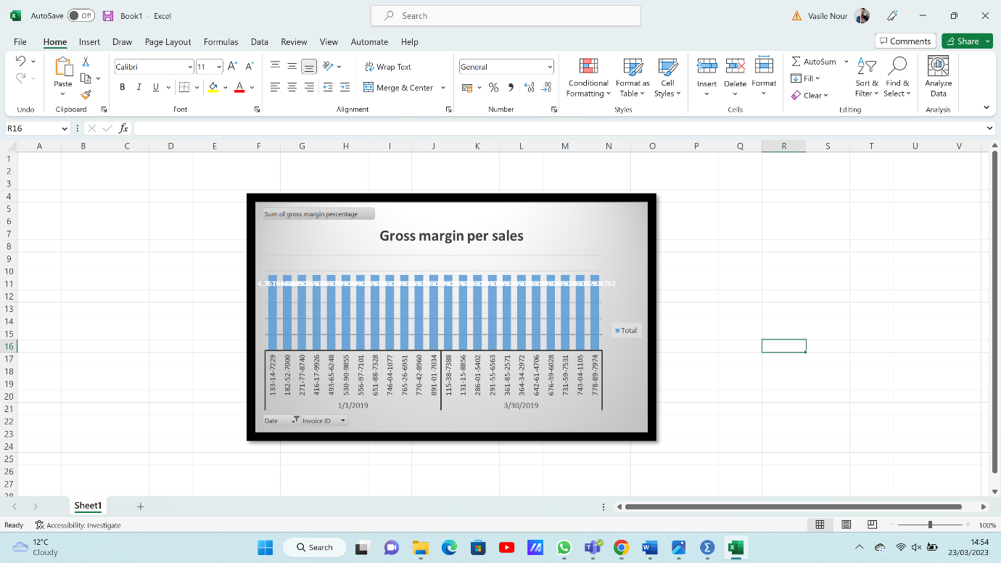
Figure 1

The above figure represents the gross margin per sale of the given products. This also visualised the further information of gross margin per day in the sales. On the other hand, the approach of the analysis has demonstrated that on maximum days or every day, the gross margin tends to be the same from 4.5 to 4.87.


The above figure represents the corresponding approach of the finding that has been analysed with further information and developed with the corresponding aspects that can be separated by the product lines. Three types of product lines illustrate gross margin in that pie chart. Health and beauty products have the lowest profit margin among all weather and fashion and accessories have the highest gross margin. Therefore, this can be said that customers are more conscious of their fashion and beauty than their health awareness. As cited by Wiblen, and McDonnell (2020), it is also important to remember that consumer preferences are very important to a product line's profitability. The fact that fashion and accessories have the largest gross margin shows that consumers are ready to spend more for these goods, demonstrating a significant demand for stylish and current things. In contrast, the lower gross margin for health and beauty products may indicate that consumers are more price conscious and are more inclined to look for less expensive alternatives.
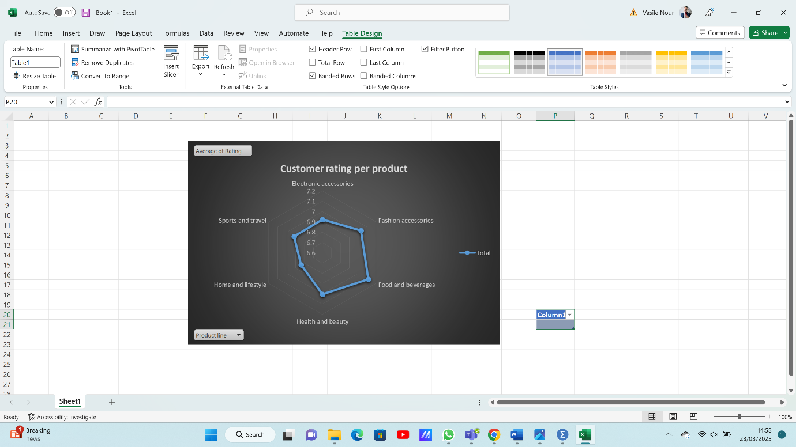
The above figure demonstrates the customer rating of allover products in the given data set. This shows that electronic accessories have the lowest customer rating while food and beverage products have the highest customer rating. This can be because the food and beverage products are based on taste and regular production materials (Horel, and Giesecke, 2020). Therefore, the aspects have been developed with further communicative development in the scenario and approach in this content.
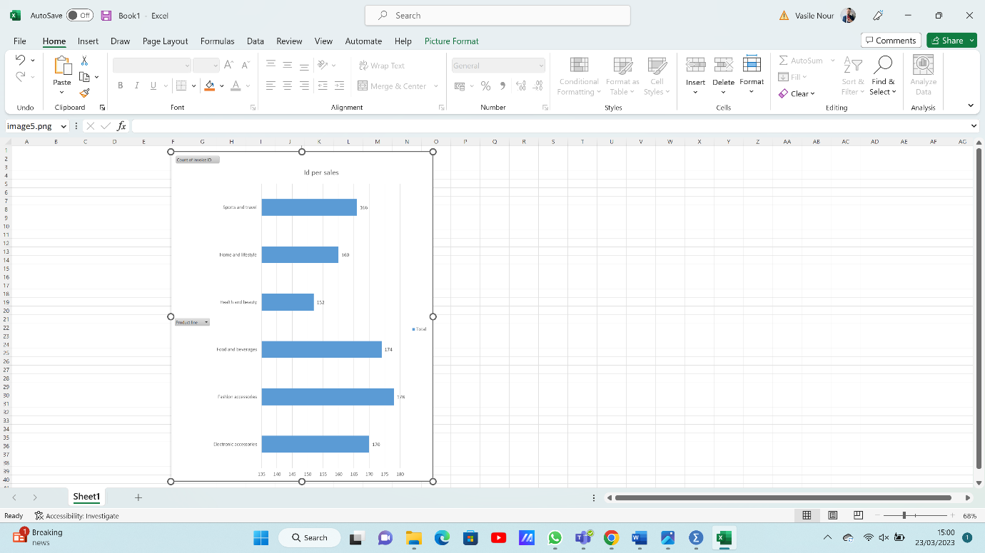
The above figure shows that the approaches of the corresponding development have been analysed for the development in the scenario and structure based on the sales lines and the invoice per sales line. Therefore, in this section, the maximum number of invoices made for the accessories is 178 invoices. Weather, in comparison the healthy and beauty products has developed structural impacts in further development with 152 invoices made. The examination of the development methodologies utilised in the example scenario has shed important light on the composition and functionality of various product lines. As cited by Saputra (2020), the accessories category has the most invoices, with 178, according to an analysis of the sales lines and invoices per sales line, showing good sales success in this area. The healthy and beauty items category, on the other hand, has shown structural effects on further development, with a total of 152 invoices generated.
This information may be used to guide future decisions and pinpoint areas where product development and marketing tactics need to be strengthened. As cited by Sousa et al. (2021), the strong sales performance of accessories points to the potential for improved revenue and profitability for the firm if investments are made in this product area.
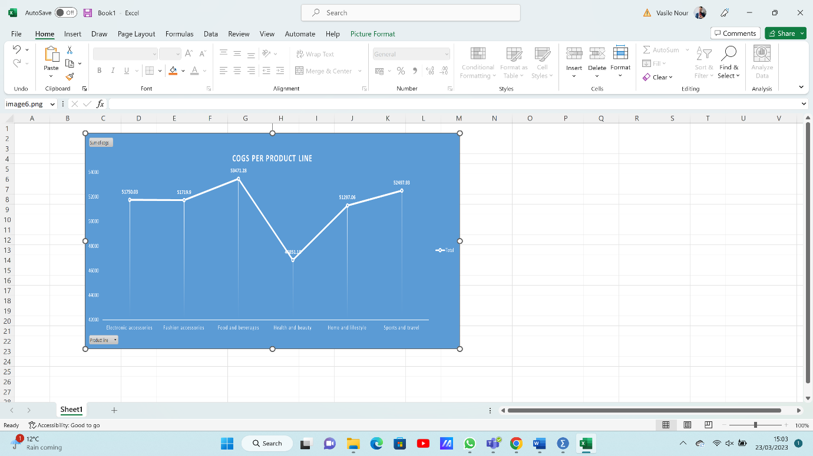
The above figure represents the data structure on the development scenario and construction analysis for the corresponding analysis of COGS (“cost of goods sold”) based on the per product line. This development of the visualisation has been done by the PIVOT chart analysis in excel. A further approach to this scenario can be developed with this particular cost analysis of the particular product in the given timetable (Kumar, 2020). As the previous chart shows the lowest rating and lowest gross margin for health and beauty products. A more thorough investigation of the causes behind the health and beauty product line's poor performance may be required to increase its profitability. As cited by Wiblen, and McDonnell (2020), this might entail looking into the precise costs of making these goods, such as labour costs, administrative costs, and raw material prices. It could be feasible to boost the gross margin and overall profitability of the product line by finding areas where expenses might be cut.
Investing in R&D to produce fresh, unique items that appeal to consumers and fetch higher prices might be another strategy for enhancing the performance of the health and beauty product line. To find unmet consumer demands, this may entail performing market research.

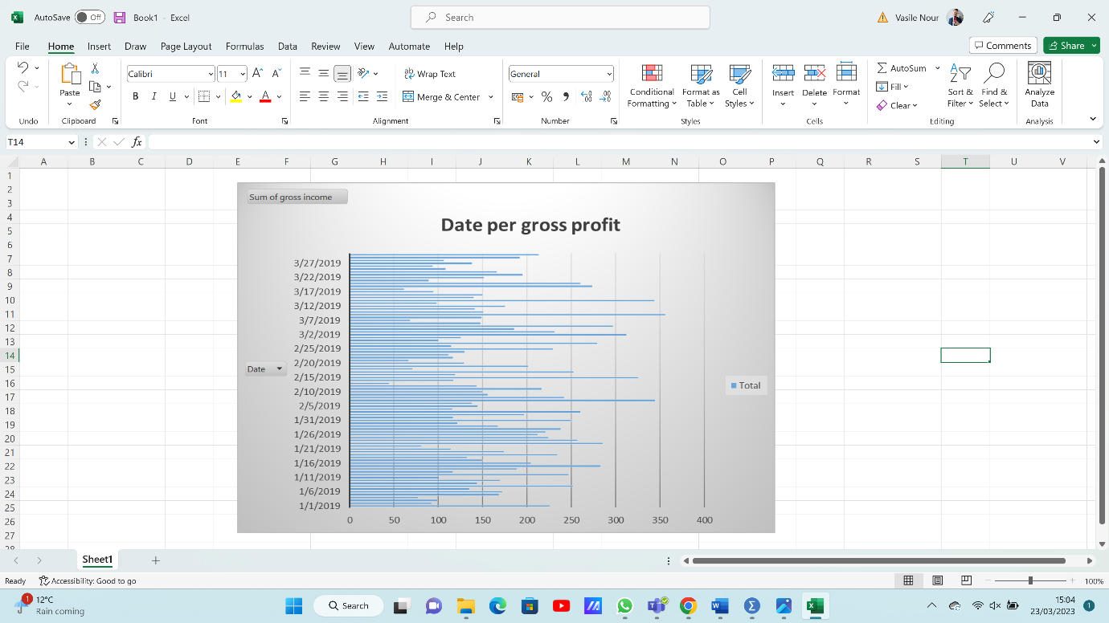
Calculating the average daily revenue, the monthly income, or the days with the highest and lowest earnings would all be useful in further exploring this data. To better visualise this data and spot any patterns or trends, one might also develop a graph or chart.

B
I. Discuss the most profitable product line.
The highest gross income is generated by the "Food and beverages" product line, which has a total gross income of 2673.564 units. The author Shahid, and Qureshi (2022) suggests that, of all the product lines included in the table, this one is the most lucrative. It is crucial to keep in mind that this table only shows the gross revenue earned by each product line and does not account for additional expenditures like manufacturing costs, marketing costs, or other overhead costs that might have an impact on total profitability.
Hence, before choosing the most lucrative product line, firms should carefully analyse their profit margins and other pertinent aspects. This will make it possible for the company to decide on product development, marketing, and price strategies that would optimise profitability and overall market success.
II. Discuss the performance of Branches A, B and C
While Branch C has the highest gross income with a total of 5265.1765 units produced, Branch A and Branch B have roughly identical gross profits with 5057.1605 and 5057.032 units, respectively. But it's important to consider other factors as well, such as fluctuating market conditions, changing client demographics, and shifting customer demand for the items, that might have an impact on these figures. As cited by Akhtar et al. (2020), it should be noted that even if Branch C appears to be doing the best right now, long-term success is not always assured by this. As was previously said, a number of external factors, such as market trends, economic situations, and customer preferences, might have an impact on how well each branch performs. Each branch must thus continue to be flexible and evaluate their tactics frequently to make sure they are serving the evolving demands of their clients.
Also, this can see that Branch A has the highest average (7.07205824), Branch B has the lowest average (6.818072289), and Branch C has the highest average (7.072865854). This indicates that Branch C has performed better than Branch B in terms of surpassing customer expectations and providing a wonderful shopping experience. As cited by Rahman, and Muktadir (2021), it's crucial to take the industry's competitors into account. Even if the data primarily focuses on how these three branches are performing, there may be other rivals in the market that are performing better or worse. To stay on top of the competition, each branch must closely monitor its rivals and pinpoint areas for improvement.
This shows that Branch A's cost of goods sold (COGS) is 101143.21 units, Branch B's is 101140.64 units, and Branch C's is 105303.53 units, all three branches having comparable COGS. This demonstrates that the production costs and running costs are similar throughout the branches (Saputra, 2020). While Branch C now seems to be the branch that is performing the best overall, a more thorough examination is required to fully understand each branch's performance and pinpoint prospective development opportunities. These branches can enhance their overall performance and maintain an advantage in a cutthroat market by monitoring both internal and external factors and routinely revising their plans.
Branch C appears to be performing the best overall based on the facts provided; it has the grossest income, the highest average rating, and just slightly higher COGS than the other branches (Rahman, and Muktadir, 2021). Further study is required to fully understand the benefits and drawbacks of each industry and to identify potential growth areas.
III. Discuss the sales performance by gender.
In all, 2869 items have been bought by female consumers, compared to 2641 by male customers. This suggests that consumers who made purchases were more likely to be women than men.
Females have purchased 530 units overall from the "Fashion accessories" product line, followed by the "Home and lifestyle" and "Food and drinks" product lines with 498 and 514 units, respectively, in terms of sales performance by gender and product line. With a total of 511 units sold, the "Health and Beauty" product line sold the most units among male consumers, followed by the "Home and lifestyle" and "Food and drinks" product lines (Sousa, 2021).
With a total of 31591.35 units, the "Food and drinks" product line had the highest cost of goods sold (COGS) for female consumers, whereas the highest COGS for male customers was in the "Health and Beauty" product line with a total of 29174.05 units. As cited by Akhtar et al. (2020), these results imply that when it comes to consumer purchasing choices, there can be unique gender preferences. Female customers may be more interested in fashion accessories and home and lifestyle products than their male counterparts, as evidenced by the fact that they bought more things overall and had better sales performance in several product categories. Male clients, on the other hand, had a larger predilection for health and beauty items.
The disparity in COGS between male and female customers also draws attention to possible disparities in spending preferences between the two groups. While the higher COGS for male customers in the health and beauty product line may suggest that they are more willing to invest in self-care and personal grooming, the higher COGS for female customers in the food and drink product line may indicate that they are more willing to spend money on high-end food and beverage items.
In general, these observations might be helpful for companies trying to better comprehend and meet the particular demands and preferences of their target customers. As cited by Rahman, and Muktadir (2021), businesses may better appeal to their target demographic by customising their marketing strategy and product offers by evaluating gender-based consumer data.

(C)
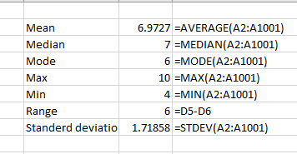

The above table shows the descriptive statistics of customer ratings of the dataset. In the excel file mean, median, and mode is done with the proper excel formula. Therefore, the mean of the customer rating is 6.9727 which is calculated by the “=Average” formula in excel. Besides that, the Median is calculated by the “=median” formula in excel, and the median of customer rating is 7. On the other hand, the by “=Mode” formula, the mode of the data has been calculated, and the mode is 6. The range is calculated with subtract the maxim from the minimum values of the dataset. Therefore, the range is 6 for the given dataset. Besides that, the standard deviation is calculated by the “=stdev” formula in excel. Moreover, the standard deviation is a measurement of the dataset's variability or distance from the mean. The standard deviation of customer ratings in this dataset is 1.6234.
It suggests that the majority of customer evaluations fall between 5.3493 and 8.5961, or one standard deviation, from the mean rating. A low standard deviation indicates a high level of consistency or resemblance among the data, whereas a large standard deviation suggests that the data points are spread out over a greater range. As cited by Rahman, and Muktadir (2021), the standard deviation aids in determining the consistency of the data. The interquartile range (IQR) is an additional indicator of the dataset's variability. The difference between the first and third quartiles is used to determine the IQR. The IQR of customer ratings for this dataset is 2, meaning that 50% of the customer evaluations fall between 6 and 8 and the other 50% fall between 4 and 6.

Reference list
Wiblen, S. and McDonnell, A., 2020. Connecting ‘talent’meanings and multi-level context: A discursive approach. The International Journal of Human Resource Management, 31(4), pp.474-510.
Horel, E. and Giesecke, K., 2020. Significance tests for neural networks. The Journal of Machine Learning Research, 21(1), pp.9291-9319.
Kumar, T.S., 2020. Data mining based marketing decision support system using hybrid machine learning algorithm. Journal of Artificial Intelligence, 2(03), pp.185-193.
Shahid, S. and Qureshi, J.A.A., 2022. Consumer empowerment in the digital media marketing age: A comparative literature review and trends across selected countries. 3c Empresa: investigación y pensamiento crítico, 11(1), pp.149-177.
Saputra, A.H., 2020. Rancang bangun sistem informasi inventory barang menggunakan metode First-In First-Out (FIFO) berbasis web pada PT. Cipta Rasa Multindo (Bachelor's thesis, Fakultas Sains dan Teknologi Universitas Islam Negeri Syarif Hidayatullah Jakarta).
Rahman, A. and Muktadir, M.G., 2021. SPSS: an imperative quantitative data analysis tool for social science research. Int. J. Res. Innov. Soc. Sci, 5, pp.300-302.
George, D. and Mallery, P., 2021. IBM SPSS statistics 27 step by step: A simple guide and reference. Routledge.
Akhtar, N., Tabassum, N., Perwej, A. and Perwej, Y., 2020. Data analytics and visualization using Tableau utilitarian for COVID-19 (Coronavirus). Global Journal of Engineering and Technology Advances.
Sousa, R., Miranda, R., Moreira, A., Alves, C., Lori, N. and Machado, J., 2021. Software tools for conducting real-time information processing and visualization in industry: An up-to-date review. Applied Sciences, 11(11), p.4800.
Denagama Vitharanage, I.M., Bandara, W., Syed, R. and Toman, D., 2020, June. An empirically supported conceptualisation of robotic process automation (RPA) benefits. In Proceedings of the 28th European Conference on Information Systems (ECIS2020). Association for Information Systems.

