

LOCATION: Swansea | LLEOLIAD: abertawe
LEVEL 6 | LEFEL 6
EXAMINATION PERIOD | CYFNOD ARHOLIADAU
May 2025 | Mai 2025
MODULE CODE: ACCA6023
Enterprise Networking, Security and Automation

Student Name: _______________________________

STUDENT ID: _________________________________

TIME: 2 HOURS
answer all questions

This is an individual practical lab-test, held under examination conditions. You will be assigned three Routers, 0ne Switch and Two PCS. configure these devices based on the following specifications.
The routerS ARE R1,r2 and ISP. the switch s1 and the PCs are PC1, PC2.

This paper contributes 75 % to overall module ASSESSMENT.

Task 1: In class Activity (15 %)
- OSPF Challenge (7.5%) 07/03/2025
- NAT Challenge (7.5%) 21/03/2025

Task 2: Network Configuration (85 %)

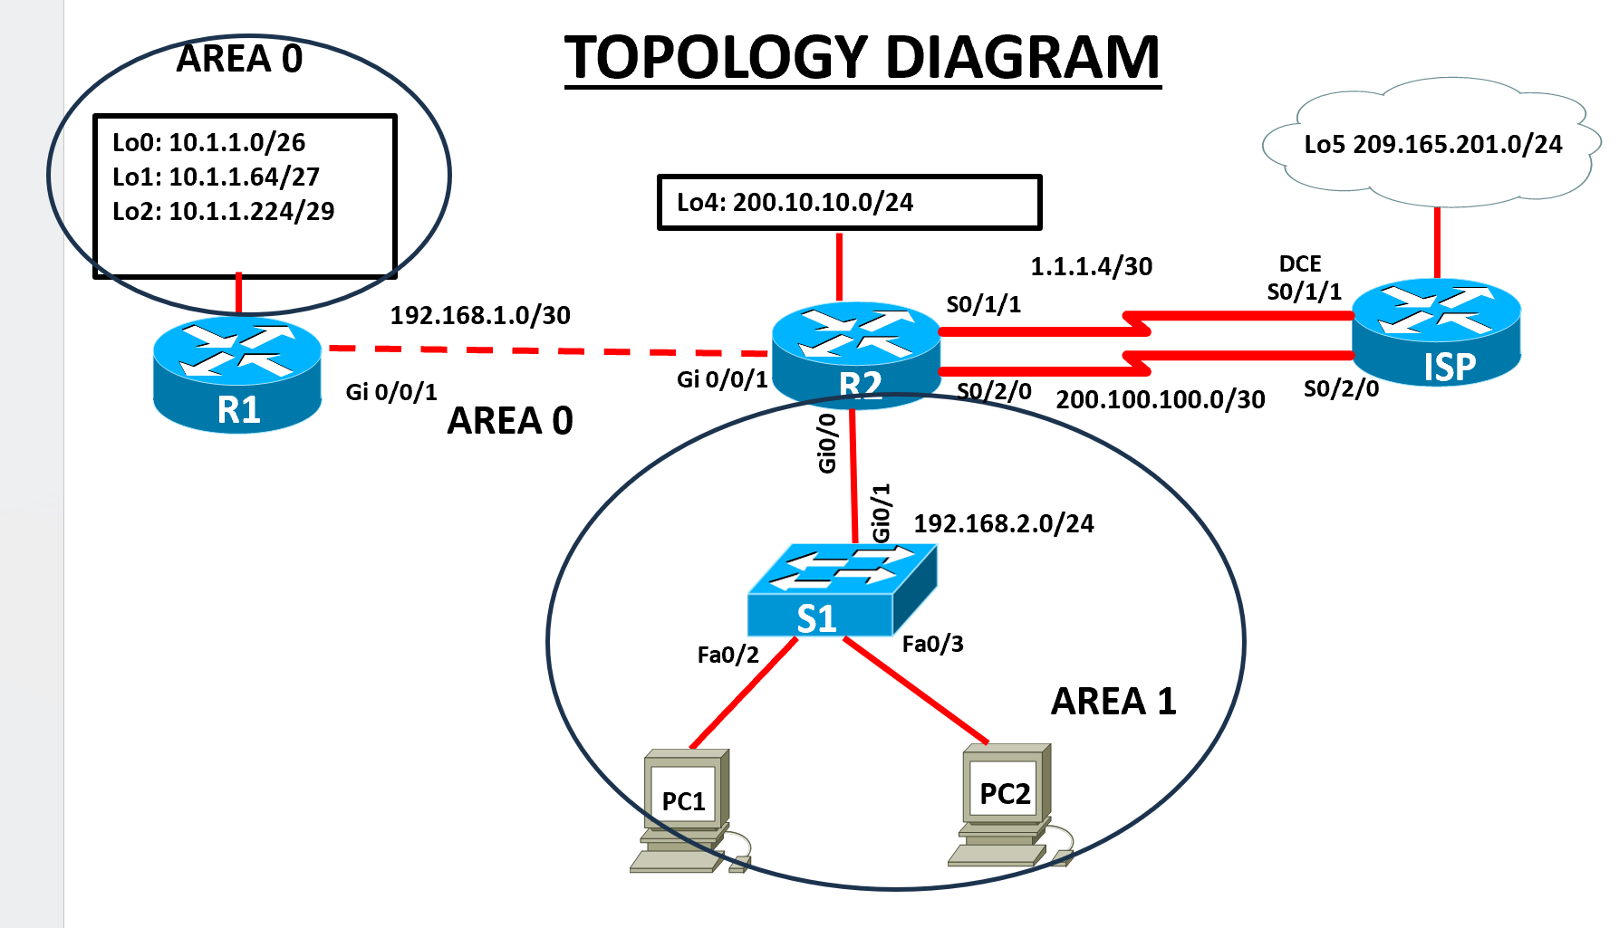

2.1

- From the topology diagram, fill in the IP Address table below. For the LAN, assign the first usable address to the router interface, the second usable address to the switch, and use the third and fourth addresses for the PCs. For the loopback interfaces, use the first usable addresses. ( 10 marks)

Addressing Table

Device | Interface | IP Address | Subnet Mask | Default Gateway
R1 | Gi/0/01 | 192.168.1.1 | 255.255.255.252 | N/A
R1 | Lo0 | 10.1.1.1 | 255.255.255.192 | N/A
 | Lo1 | 10.1.1.65 | 255.255.255.224 | N/A
R1 | Lo2 | 10.1.1.225 | 255.255.255.248 | N/A
R2  R2  R2 | Gi0/0/1 | 192.168.1.2 | 255.255.255.252 | N/A
R2  R2  R2 | Se0/1/1 | 1.1.1.5 | 255.255.255.252 | N/A
R2  R2  R2 | Se 0/2/0 | 200.100.100.1 | 255.255.255.252 | N/A
R2  R2  R2 | Gig 0/0/0 | 192.168.2.1 | 255.255.255.0 | N/A
R2  R2  R2 | Lo4 | 200.10.10.1 | 255.255.255.0 | N/A
ISP | Se0/1/1 | 1.1.1.6 | 255.255.255.252 | N/A
ISP | Se0/2/0 | 200.100.100.2 | 255.255.255.252 | N/A
ISP | Lo5 | 209.165.201.1 | 255.255.255.0 | N/A
S1 | VLAN 1 | 192.168.2.2 | 255.255.255.0 | 192.168.2.1
PC1 | NIC | 192.168.2.3 | 255.255.255.0 | 192.168.2.1
PC2 | NIC | 192.168.2.4 | 255.255.255.0 | 192.168.2.1

(ii)Physically cable the network as shown in the topology diagram. (5 marks)

Examiner Comments and Signature:
Signature:

Configure the routers R1 ,R2 and ISP (15 marks)
Configuration tasks for R1,R2 and ISP include the following:
It is essential that you complete a 'show ip interfaces brief' on the routers before you commence. Some will have Gi0/0 & Gi0/1 interfaces, while others will have Gi0/0/0 & Gi0/0/1, depending on the model used in each Cisco Academy. Interfaces for switches might also differ depending on the model.

- Disable DNS lookup, configure all routers with hostname R1,R2,and ISP as appropriate.
- Configure IP addresses according to the Addressing Table, setting appropriate Descriptions on the Interfaces and make sure the interfaces are activated
- Configure Multi-area OSPF with Process ID 1 on R1 and R2, and Areas 0 and 1 as shown on the topology. Use Router IDs 1.1.1.1 and 2.2.2.2 on R1 and R2 respectively.
NB: On R2, include only two networks for OSPF Process ID 1: 192.168.1.0/30 and the LAN 192.168.2.0/24.
- Set LAN and Loopback interfaces to Passive
- Configure Lo0 on R1 as a point-to-point network for OSPF
- On all the Routers ,configure the hello-interval timer to 30 seconds
- On all the Routers ,configure the hello-interval timer to 120 seconds
- Configure a static default route with Se 0/1/1 on R2 as the exit interface, then share the default information with R1

2.3 Configure S1. (2 marks)
Configuration tasks for the switches include the following:

- Disable DNS lookup, configure the switch with hostname S1.
- Configure the IP address according to the Addressing Table, setting appropriate Description (on the Interface , make sure the interface is activated

Configure host computers and Test for Connectivity(4 marks)
Configure the host computers PC1 and PC2 with IP addresses according to the addressing table.

After configuring each host computer, perform the following tests;
Source | Target | Protocol | Expected Result
PC1 | PC2 | Ping | Success
PC1 | R2(Gi0/0/1) IP address | ping | Success
PC1 | R1( Lo0) IP address | ping | Success
PC2 | ISP(Lo5) IP address | ping | Failure

Examiner Comments and Signature:
Signature:

Configure PAT(NAT overload) ( 12 marks)
You have been advised to implement PAT on the Se0/1/1 interface, which is on the subnet 1.1.1.4/30, so that devices on the LAN 192.168.2.0/24 can access the internet on 209.165.201.0/24.
- Define the inside and outside NAT interfaces
- Create a standard access list to define which IP addresses are allowed to be translated.
- Configure PAT to allow multiple devices to share the single IP address on Se 0/1/1
- Verify the Configuration
Source | Target | Protocol | Expected Result
R2 | ISP(Lo5) IP address | Ping | Success
PC1 | ISP(Lo5) IP address | Ping | Success
PC2 | ISP(Se0/1/1) IP address | Ping | Success
- Run the Show ip nat translations on R2 command and record the following Ip addresses;
Inside global…………………… Inside local………………… Outside global ……………….

Examiner Comments and Signature:
Note: Ask the invigilator to check and sign off the 2.4 Task . If not signed off by the invigilator, marks will not be awarded for this task.
Network Connectivity Verification:

Signature:

Configure eBGP ( 10 marks)
Configure eBGP (External Border Gateway Protocol) between R2 and the ISP router using the serial link with the network 200.100.100.0/30.

- Verify whether you have configured IP addresses on the Interfaces using the 200.100.100.0/30 network
- Set up eBGP peering between R2 (AS 65001) and ISP (AS 65002) routers
- Advertise ISP(Lo5) and R2(Lo4) loopback interfaces via eBGP
- Verify the Configuration
Source | Target | Protocol | Expected Result
ISP(Lo5)IP address | R2(Lo4) IP address | Extended Ping | Success

Configure CDP,LLDP,and NTP ( 12 marks)

- Disable CDP globally on R2 and S1
- Enable LLDP globally on R2 and s1
- On R2, configure the link to S1 to only receive LLDP messages.
- On S1 switch, configure the link to R2 router to only send, not receive, LLDP messages.
- Disable LLDP completely on access port fa 0/2 that is in use.
- Display the current time on R2
- Set the time on R2 , time entered should be in UTC
- Configure R2 to be the NTP master with a stratum level of 1
- Configure S1 as NTP client. Use the appropriate NTP commands to obtain time from R2’s G0/0 interface , as well as to periodically update the calendar or hardware clock on the switch.
- Use appropriate show command to verify that S1 is synchronized with R2

Configuration for R2 (NTP Master)
bash
CopyEdit
# Verify current time and timezone
R2# show clock detail

# Set the time zone to UTC (if not already in UTC)
R2(config)# clock timezone UTC 0 0

# Set the system clock to UTC time (example: 16 March 2025, 14:30:00 UTC)
R2# clock set 14:30:00 16 MAR 2025

# Verify the configured time
R2# show clock detail

# Configure R2 as an NTP master with a stratum level of 1
R2(config)# ntp master 1

# Verify NTP configuration
R2# show ntp status
R2# show ntp associations

Configuration for S1 (NTP Client)
bash
CopyEdit
# Configure S1 to sync time with R2 (assuming R2's G0/0/0 has IP 192.168.1.1)
S1(config)# ntp server 192.168.1.1

# Ensure the hardware clock (calendar) is updated periodically
S1(config)# ntp update-calendar

# Verify NTP synchronization
S1# show ntp status
S1# show ntp associations

Saving and Cleanup

Submission Requirement:
For each device you configured, a txt file containing the following outputs must be submitted on Moodle. The file name should be StudentID_devicename.txt
show run
show ip int brief
show ip protocols (NB:for routers only)
show ip route
show ip nat translations (R2 only)
Show ip bgp summary (R2 and ISP only)
Show ip bgp (R2 and ISP only)
Show ntp status
All documentation for your solution should be submitted electronically on Moodle within the time allocated. It is your responsibility that you copy all the files correctly. Any files submitted after the deadline will be capped at 40%

Code
R1#show run

!
hostname R1
interface Loopback0
ip address 10.1.1.1 255.255.255.192
!
interface Loopback1
ip address 10.1.1.65 255.255.255.224
!
interface Loopback2
ip address 10.1.1.225 255.255.255.248
!
interface GigabitEthernet0/0/0
no ip address
duplex auto
speed auto
shutdown
!
interface GigabitEthernet0/0/1
no ip address
duplex auto
speed auto
shutdown
!
interface Serial0/1/0
ip address 192.168.1.1 255.255.255.252
!
interface Serial0/1/1
no ip address
clock rate 2000000
shutdown
!
interface Serial0/2/0
no ip address
clock rate 2000000
shutdown
!
interface Serial0/2/1
no ip address
clock rate 2000000
shutdown
!
interface Vlan1
no ip address
shutdown
!
router ospf 1
router-id 1.1.1.1
log-adjacency-changes
passive-interface Loopback0
passive-interface Loopback1
passive-interface Loopback2
network 192.168.1.0 0.0.0.3 area 0
network 10.1.1.0 0.0.0.63 area 0
network 10.1.1.64 0.0.0.31 area 0
network 10.1.1.224 0.0.0.7 area 0
!
!
!
end

R1#

R2#show run
!
hostname R2
interface Loopback4
ip address 200.10.10.1 255.255.255.0
!
interface GigabitEthernet0/0/0
ip address 192.168.2.1 255.255.255.0
ip nat inside
duplex auto
speed auto
!
interface GigabitEthernet0/0/1
no ip address
duplex auto
speed auto
shutdown
!
interface Serial0/1/0
ip address 192.168.1.2 255.255.255.252
clock rate 2000000
!
interface Serial0/1/1
ip address 1.1.1.5 255.255.255.252
ip nat outside
!
interface Serial0/2/0
ip address 200.100.100.1 255.255.255.252
!
interface Serial0/2/1
no ip address
clock rate 2000000
shutdown
!
interface Vlan1
no ip address
shutdown
!
router ospf 1
router-id 2.2.2.2
log-adjacency-changes
passive-interface GigabitEthernet0/0/0
network 192.168.1.0 0.0.0.3 area 0
network 192.168.2.0 0.0.0.255 area 1
default-information originate
!
router bgp 65001
bgp log-neighbor-changes
no synchronization
neighbor 200.100.100.2 remote-as 65002
network 200.10.10.0
!
ip nat inside source list 1 interface Serial0/1/1 overload
ip classless
ip route 0.0.0.0 0.0.0.0 Serial0/1/1
!
ip flow-export version 9
!
!
access-list 1 permit 192.168.2.0 0.0.0.255
!
!
!
!
!
line con 0
!
line aux 0
!
line vty 0 4
login
!
!
!
end

R2#
ISP#show run
!
hostname ISP
interface Loopback5
ip address 209.165.201.1 255.255.255.0
!
interface GigabitEthernet0/0/0
no ip address
duplex auto
speed auto
shutdown
!
interface GigabitEthernet0/0/1
no ip address
duplex auto
speed auto
shutdown
!
interface Serial0/1/0
no ip address
clock rate 2000000
shutdown
!
interface Serial0/1/1
ip address 1.1.1.6 255.255.255.252
clock rate 2000000
!
interface Serial0/2/0
ip address 200.100.100.2 255.255.255.252
clock rate 2000000
!
interface Serial0/2/1
no ip address
clock rate 2000000
shutdown
!
interface Vlan1
no ip address
shutdown
!
router bgp 65002
bgp log-neighbor-changes
no synchronization
neighbor 200.100.100.1 remote-as 65001
network 209.165.201.0
!
ip classless
!
ip flow-export version 9
!
!
!
!
!
!
!
line con 0
!
line aux 0
!
line vty 0 4
login
!
!
!
end

ISP#
S1#show run
!
hostname S1
!
!
interface Vlan1
ip address 192.168.2.2 255.255.255.0
!
ip default-gateway 192.168.2.1
!
!
!
!
line con 0
!
line vty 0 4
login
line vty 5 15
login
!
!
!
!
end

S1#

