
Scripting and programming concepts
Coursework- Programming Assignment with Associated Documentation

Name: Lucas Adouko
Student ID: 2424749
Course Name: BSc Applied Computing
Module Name: Scripting and Programming Concepts
Module Code: ACCA5036
GitHub Link: https://github.com/LucasAdouko/Coursework-Assessment-Python.git

Table of Contents
Introduction 2
Main Body 2
Analysis 2
Requirements Analysis 2
Functional Requirements 2
Non-Functional Requirements 3
Software Design and Development 4
Design: 4
System Pseudocode 4
Flowchart 8
Implementation Decisions: 12
Data Structures and Variables 12
Device Representation (Dictionary) 12
Central Storage (List) 13
Global Variables 13
Source Code: 14
GitHub Link: https://github.com/LucasAdouko/Coursework-Assessment-Python.git 14
System Initialization and Boot Sequence Implementation 14
Utility Functions and Device Creation Implementation 15
Inventory Display and Device Status Modification Implementation 17
Search Functionality Implementation 18
Menu Navigation, Application Control Loop, and System Exit Implementation 20
Testing and Debugging Report 22
Testing Strategy and Verification 22
Debugging and Issues Resolved 22
Evaluation 23
Critical Evaluation of the Solution 23
Future Improvements 23
Conclusion 24
References 25

Introduction
Modern classrooms use a lot of electronic hardware like smart boards, projectors, and computers to help students learn. However, schools often struggle to keep track of these items because they use disorganized paper logs or messy spreadsheets [1]. This project introduces a software solution called Classroom Manager, built in Python. The goal of this application is to provide a clean and simple text-based menu where school staff can easily add new devices, view the entire inventory, search for specific equipment, and update their operational status in real-time. This report will explain how the software works, how it stores data in memory using Python lists and dictionaries, and how the code is structured.

Main Body

Analysis

Requirements Analysis
Before writing any lines of code, it is very important to analyse what the software must do [2]. This analysis helps us understand the needs of the school staff and how the computer program can solve their problems. The main goal of this system is to replace manual tracking methods with a fast, reliable, and automatic system. By identifying the exact needs of the users, we can build a structured application that does exactly what they expect without adding unnecessary complexity.

Functional Requirements
Functional requirements describe the specific actions and tasks that the software solution must perform. They are the core features that the user can interact with through the menu. Our application provides the following functionalities:
- Add New Devices: The system allows school staff to register new hardware into the application. When a user purchases a new item, they can enter its specific name (such as "Smart Light" or "Projector") and assign it to a precise room or location. The software automatically assigns a unique ID number to this item and sets its initial status to "Online".

- Update Device Status: Hardware conditions change frequently in a school. This feature allows staff to look up an existing device and change its state. The user can select between three clear options: "Online" (working normally), "Offline" (not connected), or "Under maintenance" (currently being repaired by a technician).
- View Device List: To give administrators a full view of the school infrastructure, the software provides a complete overview option. When selected, the program loops through the memory and prints a clean list showing every device name, its assigned room, and its current active status.
- Simple Search: If a technician wants to check on a specific machine quickly, they do not need to scroll through the entire list. They can use the search feature, type the exact name of the item, and the system will immediately display its location and status on the screen.
- User-Friendly Interface: The software is designed for school staff who might not have advanced technical skills. Instead of forcing users to type complex programming commands, the application uses a simple, intuitive numbered menu (1 to 5). Users only need to type a single digit to navigate the system.
- Scalability: The architecture of the program is highly flexible. Because the code is separated into independent functions, it is very easy to expand the system later. Developers can add new features in the future such as filtering devices by room or calculating statistics without rewriting the core program.

Non-Functional Requirements
Non-functional requirements describe the quality criteria and operational behaviour of the system. They do not represent specific menu options, but they define how well the system performs its tasks:
- Reliability: The application must handle data with high accuracy. When a user adds a device or changes a status, the information must remain consistent and correct throughout the entire user session. The system also includes validation checks to prevent users from entering blank names or invalid statuses.
- Performance: Because the application runs directly in the computer terminal and stores data locally in the RAM, response times are extremely fast. Recording a new device or retrieving information happens almost instantly, ensuring that staff members do not waste time waiting for loading screens.
- Security: While advanced security features like passwords are outside the current scope, the application ensures data safety by protecting the system from internal crashes. If a user types an incorrect option or an invalid inputs, the software handles the error gracefully instead of crashing, which prevents accidental loss of data during operation.
- Accessibility: The program focuses heavily on text accessibility. By using a lightweight command-line interface with no heavy graphics, the system can run on any computer, even older machines with very basic hardware. The layout uses clear spacing and visual lines so that the text is easy to read for any administrator.

Software Design and Development

Design:

System Pseudocode
The following pseudocode demonstrates the logical structure of the main loop and core operations.
GLOBAL devices_list = []
GLOBAL device_id_counter = 1
FUNCTION add_device():
DISPLAY "Enter device name:"
INPUT device_name
DISPLAY "Enter room/location:"
INPUT device_room
IF device_name IS EMPTY OR device_room IS EMPTY THEN
DISPLAY "Error: Name and room cannot be empty!"
RETURN
ENDIF
CREATE new_device AS DICTIONARY {
"id": device_id_counter,
"name": device_name,
"room": device_room,
"status": "Online"
}
APPEND new_device TO devices_list
device_id_counter = device_id_counter + 1
DISPLAY "Success: Device added."
END FUNCTION
FUNCTION update_status():
DISPLAY "Enter the name of the device to update:"
INPUT target_name
FOR EACH device IN devices_list DO
IF device["name"] EQUALS target_name (case-insensitive) THEN
DISPLAY "Enter new status (Online / Offline / Under maintenance):"
INPUT new_status

IF new_status IN ["Online", "Offline", "Under maintenance"] THEN
device["status"] = new_status
DISPLAY "Status updated successfully."
RETURN
ELSE
DISPLAY "Invalid status entered."
RETURN
ENDIF
ENDIF
ENDFOR

DISPLAY "Device not found."
END FUNCTION

FUNCTION view_devices():
IF devices_list IS EMPTY THEN
DISPLAY "No devices found."
RETURN
ENDIF

FOR EACH device IN devices_list DO
PRINT device["id"], device["name"], device["room"], device["status"]
ENDFOR
END FUNCTION

FUNCTION search_device():
DISPLAY "Enter device name to search:"
INPUT search_name

FOR EACH device IN devices_list DO
IF device["name"] EQUALS search_name (case-insensitive) THEN
PRINT device["id"], device["name"], device["room"], device["status"]
RETURN
ENDIF
ENDFOR

DISPLAY "Device not found."
END FUNCTION

FUNCTION main():
CALL boot_system()

WHILE True DO
CALL clear_screen()
CALL menu_navigation()
INPUT choice
IF choice == "1" THEN
CALL add_device()
ELSE IF choice == "2" THEN
CALL update_status()
ELSE IF choice == "3" THEN
CALL view_devices()
ELSE IF choice == "4" THEN
CALL search_device()
ELSE IF choice == "5" THEN
DISPLAY "Goodbye!"
BREAK LOOP
ELSE
DISPLAY "Invalid choice. Select 1 to 5."
ENDIF
ENDWHILE
END FUNCTION

Flowchart
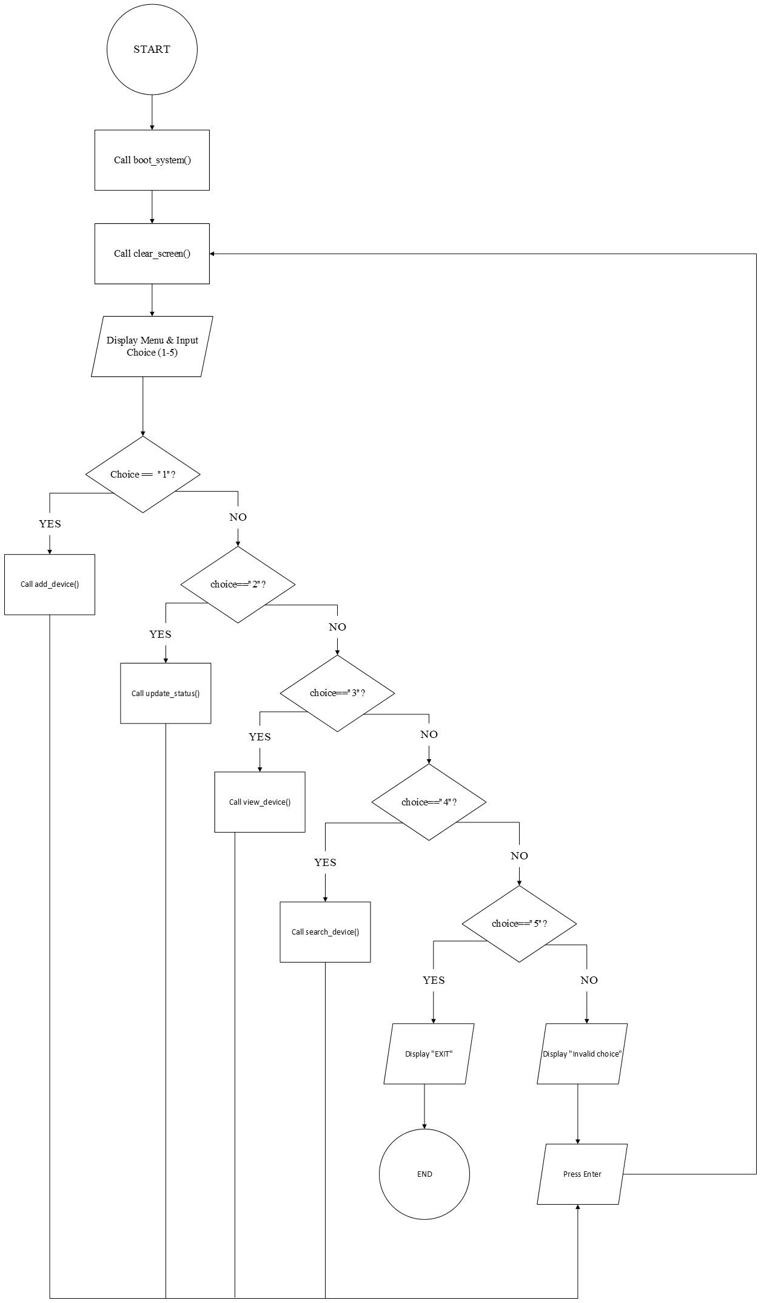

Flowchart 1 (main)
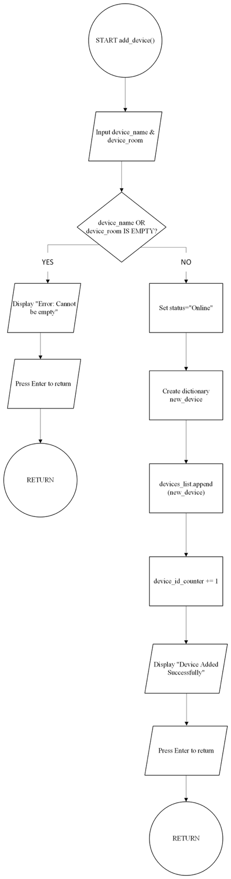

Flowchart 2 (add device)

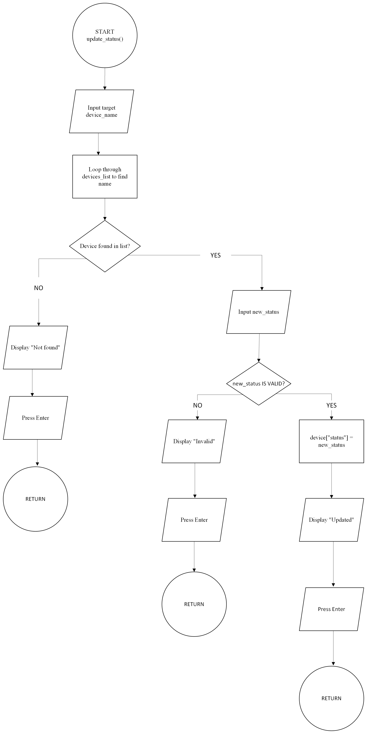

Flowchart 3 (Update)
The flowchart provides a clear visual representation of how the program controls data flow and executes commands from start to finish. The system operates on an event-driven loop, using standardized geometric shapes to represent user inputs, processing tasks, decision-making branches, and system start or stop points.
The execution begins at the top oval shape labelled START, which represents launching the main Python script. The process immediately moves to a process rectangle labelled Call boot_system(), where the software runs internal startup routines, simulates system module checks, and displays a dynamic loading animation. Once the boot sequence finishes, the execution proceeds to another process rectangle labelled Call clear_screen(). This step wipes the terminal window completely to remove any clutter before rendering the primary application interface.
After cleaning the terminal, the program enters its main interactive loop. It renders the menu options and pauses for user input, represented by a parallelogram labelled Display Menu & Input Choice (1-5). This shape indicates an input/output operation where the user types a selection between 1‬ and 5‬. Once an input is received, the program enters a structured decision tree consisting of diamond-shaped decision nodes. Each diamond asks a specific conditional question about the selected number to determine the appropriate execution path. ‬‬‬‬‬‬
Options 1 through 4 route the flow directly into specific function calls executed inside process rectangles. Selecting option 1 triggers Call add_device(), which prompts for device details and appends the new dictionary record to the global list. Option 2 calls Call update_status(), allowing the user to search for a hardware entry and modify its operational state. Option 3 executes Call view_devices(), which reads all active records from memory and prints them on the screen. Option 4 runs Call search_device(), filtering the central list by device name and displaying its location and status.
If the user selects option 5, all previous condition checks evaluate to false until reaching the choice 5 diamond. The YES branch leads to an exit sequence, displaying a visual termination message in a parallelogram before guiding the process directly to the final oval labelled END. Conversely, if the user enters an invalid selection (such as typing "6" or "abc"), all decision nodes evaluate to NO. The execution falls back to an error handling parallelogram that displays an error message and waits for the user to press Enter.
Finally, every sub-process incorporates a return loop. Once any of the four device management functions finish executing or after an invalid choice error is cleared a return line routes the execution path straight back to the vertical line on the right side of the diagram. This loop brings the user back to Call clear_screen(), resetting the terminal window and displaying a fresh menu for the next operation.

Implementation Decisions:
Data Structures and Variables
To build a fast, lightweight, and responsive software solution without the overhead of installing an external SQL database, the application relies entirely on Python’s native data structures stored directly in the system’s random-access memory (RAM) [3]. This architectural decision guarantees near-instantaneous read and write operations during runtime. The data model is designed around two fundamental Python structures: Dictionaries and Lists.
Device Representation (Dictionary)
In Python, a dictionary is a mutable, key-value data structure that allows information to be organized using logical attributes rather than numerical array indexes [4]. In the Classroom Manager application, every single piece of physical hardware is modelled as an individual dictionary containing four key-value pairs ({Key: Value}):
- id (Integer): A unique, automatically generated integer that serves as the primary key for the device. It guarantees that every hardware record can be distinctively identified, even if two physical items share identical names or are placed in the same room (e.g., 1, 2).
- name (String): A text string entered by the user representing the descriptive title or model of the hardware (e.g., "Projector B2" or "Smart Light A1"). This field allows school technicians to search for items using human-readable names.
- room (String): The physical location of the device (e.g., "Room 100").
- status (String): A controlled text string representing the current operational state of the device. To maintain data consistency across the application, this variable is strictly restricted to three valid states: "Online", "Offline", or "Under Maintenance".
Using a dictionary structure provides high readability within the code. Instead of accessing device attributes through confusing numerical indices (like device[0] or device[1]), the developer and the program can access data through clear textual keys like device["name"] or device["status"].

Central Storage (List)
To hold all individual device records together in a single workspace, the application uses a global Python list named devices_list. A list is an ordered, dynamic collection that can store multiple items in this case, multiple dictionaries in a sequential sequence.
When a user registers a new device, the system creates the individual dictionary object and immediately appends it to devices_list. This list acts as an in-memory database table where each element inside the list represents a row, and the keys inside each dictionary represent the columns. Because Python lists are dynamic, they automatically grow as new devices are added, eliminating the need to set a fixed maximum limit on how many items the school can manage.

Global Variables
- devices_list (List): Initialized as an empty array ([]), this variable holds all active device dictionaries throughout the application session. Because it is defined globally, functions like add_device(), view_devices(), update_status(), and search_device() can all read from or modify the exact same collection of records.
- device_id_counter (Integer): Initialized with a starting integer value of 1, this variable mimics an auto-incrementing database ID field. Every time the add_device() function is executed successfully, the system assigns the current value of device_id_counter to the new device's "id" key and immediately increments the counter by 1 (device_id_counter += 1). This mechanism ensures that ID numbers are sequential, unique, and never duplicated during a session.

Source Code:

GitHub Link: https://github.com/LucasAdouko/Coursework-Assessment-Python.git

System Initialization and Boot Sequence Implementation
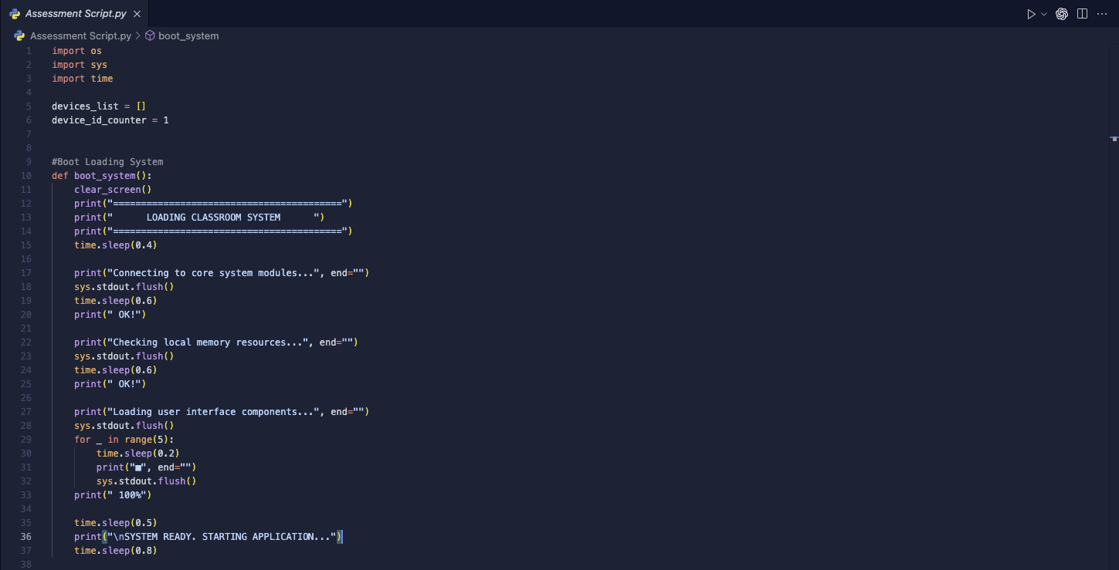
Figure 1 : System Initialization and Boot Sequence Implementation

The initial section of the source code establishes the necessary module dependencies, defines global variables for memory management, and implements the visual startup sequence for the application. At the top of the file, three core Python libraries are imported: os, sys, and time. The os library provides access to system-level commands, allowing the program to communicate with the host operating system to handle screen clearing tasks. The sys module provides direct control over standard output streams, which is required to flush text buffers immediately during dynamic terminal animations. Finally, the time module introduces controlled execution delays, giving the application a realistic, timed feedback loop instead of printing all commands instantly.
Directly below the import statements, the system initializes its primary data structures in global memory. The variable devices_list is defined as an empty list ([]) that acts as the central storage repository for all hardware records throughout the runtime session. Simultaneously, device_id_counter is instantiated as an integer initialized to 1. This global integer functions as an automatic identifier counter, ensuring that every newly added device receives a unique, incremental ID number without requiring manual assignment from the user.

The boot_system() function is designed to create an engaging visual startup experience that simulates a professional operating system boot process. Upon execution, it first invokes clear_screen() to remove any previous terminal text, followed by rendering a styled header banner. To prevent text from printing instantaneously, the program incorporates strategic pauses using time.sleep(). For instance, when displaying system status messages such as "Connecting to core system modules...", the code utilizes the parameter end="" inside the print() function to suppress the default newline character. This keeps the cursor on the same line so that the confirmation text ("OK!") prints directly next to the status message after a brief delay. To ensure that these incremental text updates appear in real time, the code calls sys.stdout.flush() after printing each message segment. By default, terminal output buffers characters and prints them in batches, explicitly calling flush() forces Python to push characters to the terminal screen immediately. This mechanism is especially prominent during the progress bar animation, where a for loop iterates five times to print solid square blocks (■) at 0.2‬-second intervals. Once the loop completes, the program appends “100%” to the line, pauses briefly, and outputs a final notification indicating that the system is fully operational and ready to launch the main application interface.‬‬
Utility Functions and Device Creation Implementation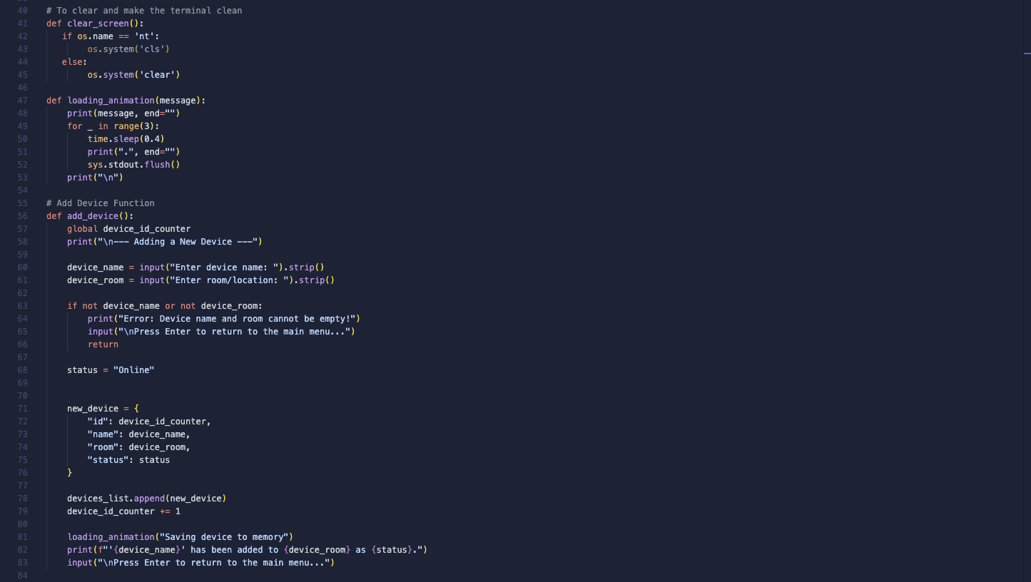
Figure 2: Utility Functions and Device Creation Implementation

This section of the code focuses on essential system utility functions and the implementation of the core device creation feature. The first function, clear_screen(), provides a cross-platform solution for maintaining a clean terminal user interface. Because different operating systems use different command-line instructions to clear the terminal window, the function inspects the internal system variable os.name. If the application detects a Windows environment ('nt'), it executes os.system('cls'). Otherwise, for Unix-based operating systems such as macOS or Linux, it runs os.system('clear'). This ensures that the application runs cleanly and reliably regardless of the operating system used by school administrators.
To maintain visual consistency during data processing, the script implements a reusable helper function named loading_animation(message). This function receives a custom text string as a parameter and displays an animated sequence of three dots across the screen. By utilizing end="" inside the initial print() call and applying a 0.4‬-second pause with time.sleep(0.4) between each printed dot, the system creates a smooth visual effect. The addition of sys.stdout.flush() forces each dot to render immediately in the terminal window. Once all three dots are printed, the function outputs a double newline character ("\n\n"), ensuring that any subsequent text printed on the screen appears cleanly below the animation.
The add_device() function contains the business logic for registering new hardware into the system memory. At the beginning of the function, the program declares global device_id_counter to allow the function to modify the global tracking integer initialized at startup. The system prompts the user to type the device name and its room location. Crucially, the code applies the .strip() method to both user inputs, which automatically removes any accidental leading or trailing space characters. The system then evaluates the inputs using an if condition (if not device_name or not device_room). If either input is blank, the application displays an error message, pauses execution with an input() prompt, and executes an early return statement to safely exit back to the main menu without saving invalid data.
When valid text inputs are provided, the software automatically assigns an initial status string of "Online". It then constructs a new dictionary object named new_device, mapping the programmatic keys "id", "name", "room", and "status" to their respective values. This newly created dictionary is appended directly to the central global array using devices_list.append(new_device). Immediately after saving the record, the function increments device_id_counter by 1‬ to prepare a unique identifier for the next device. Finally, the function invokes loading_animation("Saving device to memory"), outputs a formatted confirmation message detailing the added device, and waits for the user to press Enter before returning to the main menu loop.‬‬

Inventory Display and Device Status Modification Implementation
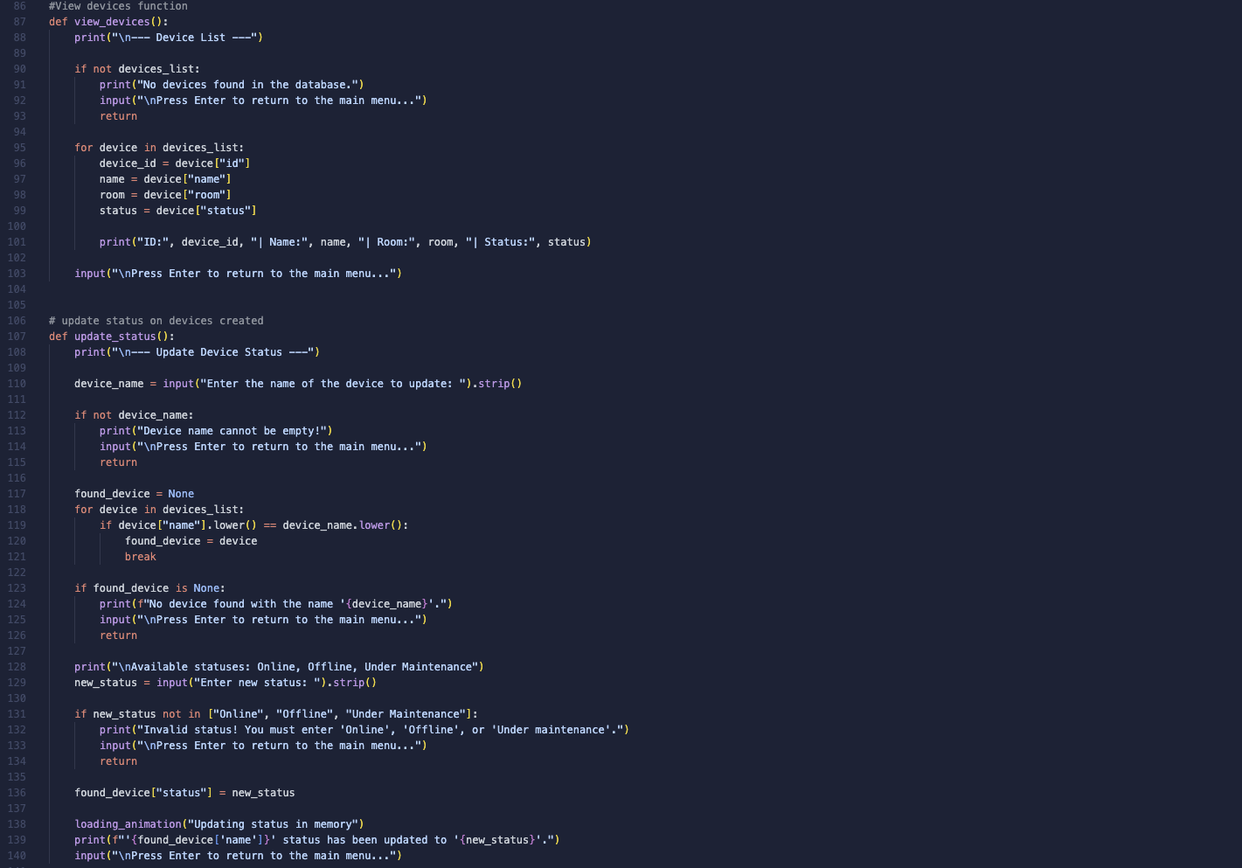
Figure 3: Inventory Display and Device Status Modification Implementation
This section of the codebase contains the implementation for viewing all stored hardware assets and modifying their operational statuses dynamically. The view_devices() function is responsible for retrieving and formatting all entries currently held in memory. Upon execution, the function first evaluates whether any records exist by checking if not devices_list. If the list is empty, the program outputs a clear notification stating, "No devices found in the database", prompts the user to press Enter, and executes an early return statement to safely return to the main menu without throwing an error.
When records are present, view_devices() utilizes a for loop to iterate sequentially through every dictionary object stored inside devices_list. During each iteration, the function unpacks the individual dictionary values into local variables: device_id, name, room, and status. It then formats these values into a single readable line formatted as ID: X | Name: Y | Room: Z | Status: W. This clean output allows school administrators to quickly inspect the complete inventory without dealing with raw data syntax. Once all records in the loop have been printed, the function pauses execution with input(), giving the user unlimited time to review the screen contents before returning to the main menu.

The update_status() function enables administrators to search for an existing device by name and update its working state. It begins by requesting a target device name and applying .strip() to remove leading and trailing whitespace. If the input is blank, the code triggers a validation check and returns early. To locate the requested record regardless of capitalization differences, the function initializes a tracking variable named found_device = None and iterates through devices_list using a for loop. Inside the loop, it applies the .lower() string method to both the stored device name (device["name"].lower()) and the search input (device_name.lower()). This case-insensitive comparison ensures that searching for "projector" successfully matches "Projector". Once a match is found, found_device stores the reference to that specific dictionary, and the loop terminates immediately using break.
If found_device remains None after searching the entire list, the system displays a clear error message stating that no matching device was found and returns to the menu. However, if a match is successfully identified, the function prompts the user to enter a new status string. To maintain data integrity across the system, the application validates this input against an explicit whitelist of allowed status values: ["Online", "Offline", "Under Maintenance"]. If the user enters an invalid state (such as typing "Broken"), the program prints an error message and aborts the update operation using an early return. When a valid status is provided, the function updates the record directly in memory (found_device["status"] = new_status), triggers loading_animation("Updating status in memory"), prints a formatted confirmation message, and waits for a user keypress before returning to the main menu.

Search Functionality Implementation
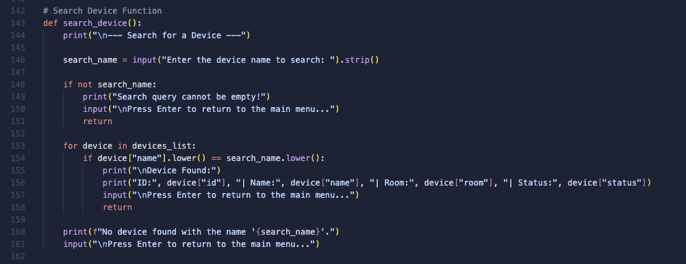
Figure 4: Search Functionality Implementation

The search_device() function provides a targeted querying mechanism that allows school technicians to find the exact room location and active status of a specific hardware item without having to scroll through the full inventory list. Upon execution, the function displays a section header and prompts the user to enter the name of the device they wish to find. Like the input handling in previous functions, the .strip() string method is chained directly to the input() call to clean the search string by stripping away any accidental leading or trailing space characters.
To prevent unnecessary processing, the function performs an immediate validation check on the query string using the condition if not search_name. If the user submits a blank input, the application intercepts the request, displays an error message stating "Search query cannot be empty!", and pauses execution with an input() prompt. Executing an early return statement at this point halts the function, safely redirecting the user back to the main menu without executing the search loop.
When a non-empty search term is provided, the function iterates sequentially through the stored records in devices_list using a for loop. To ensure a user-friendly search experience, the comparison condition utilizes the .lower() method on both the target device name stored in memory (device["name"].lower()) and the user's search query (search_name.lower()). This case-insensitive matching logic ensures that inputs such as "smart light", "Smart Light", or "SMART LIGHT" all evaluate as identical matches.
Once a matching record is identified within the loop, the system immediately displays a "Device Found:" header followed by the complete device details formatted as ID: X | Name: Y | Room: Z | Status: W. Immediately after printing the record, the function prompts the user to press Enter and executes a return statement. This early exit terminates the function as soon as the match is displayed, preventing unnecessary iterations through the remainder of the list. If the loop completes its entire traversal of devices_list without finding a matching device name, execution naturally falls through to lines 160 and 161, which print an informative error message stating "No device found with the name..." and wait for a user keypress before returning to the main menu loop.

Menu Navigation, Application Control Loop, and System Exit Implementation
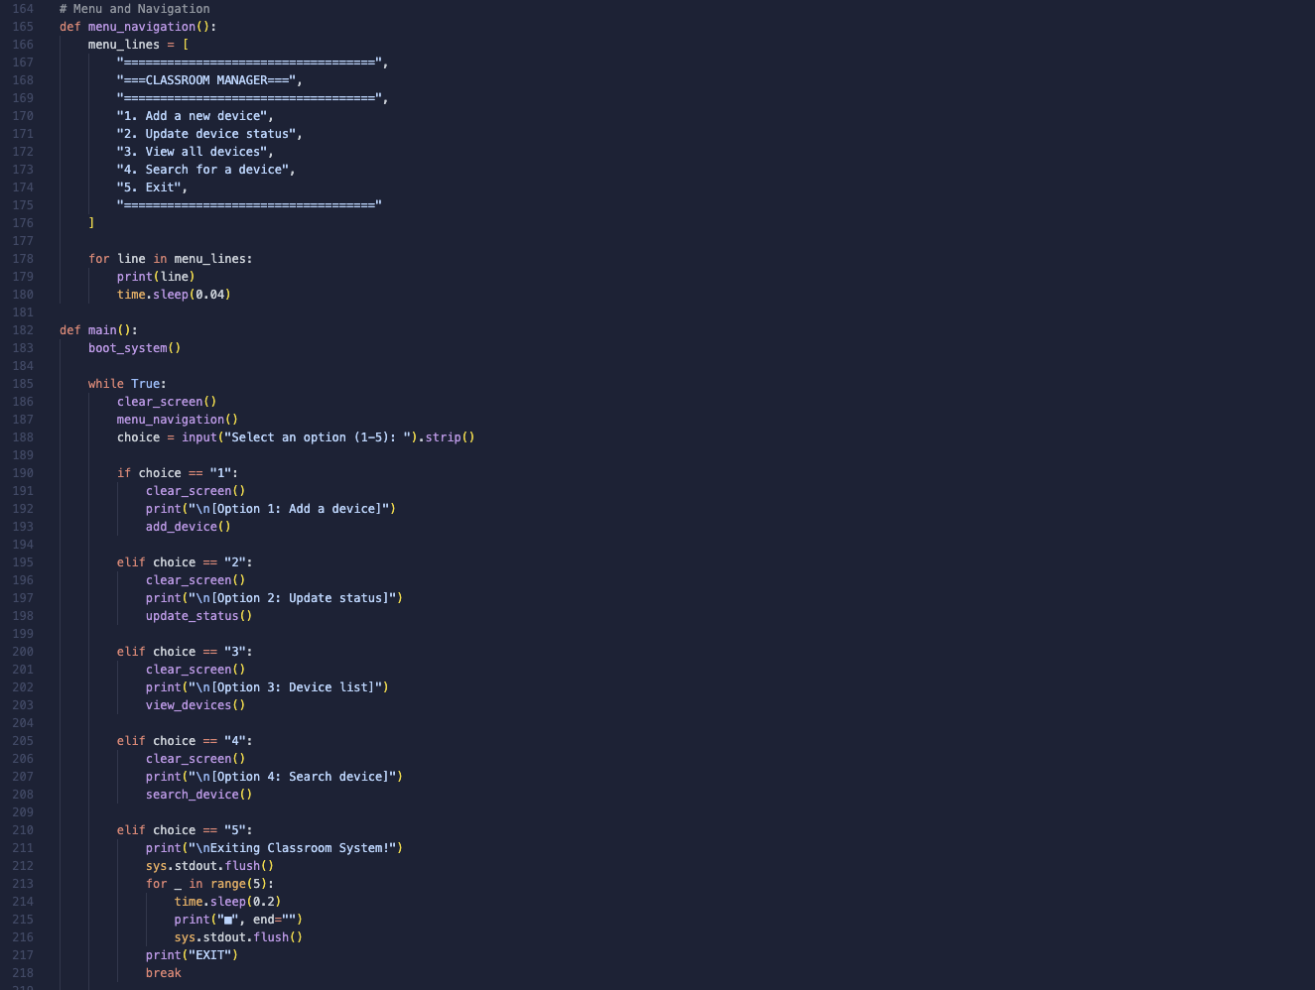
Figure 5: Menu Navigation, Application Control Loop, and System Exit Implementation

This final section of the codebase manages the user navigation interface and houses the core execution controller of the software. The menu_navigation() function is responsible for dynamically rendering the primary user interface. Instead of using a single static print block, the function stores the visual interface layout inside a Python list named menu_lines. This list contains formatted string elements representing header borders and numbered options ranging from 1 to 5. The function iterates through this list using a for loop, printing each line sequentially with a micro-delay of 0.04‬ seconds (time.sleep(0.04)). This creates a subtle visual animation where the menu smoothly draws onto the screen rather than appearing all at once. ‬‬

The main() function serves as the central control loop for the entire application. When the script is executed, main() begins by calling boot_system(), triggering the initial loading sequence. Immediately after boot completion, the system enters an infinite while True loop that keeps the application running continuously until explicitly exited by the user. Inside each iteration of this loop, the program performs three initial steps: it invokes clear_screen() to wipe any leftover text, calls menu_navigation() to draw the fresh menu and prompts the user for input using choice = input("Select an option (1-5): ").strip(). The .strip() method removes any accidental space keypresses around the entered character. The program routes user requests using a conditional decision structure consisting of if, elif, and else statements:
- Option 1 (choice == "1"): Clears the screen, prints an option header, and executes add_device().
- Option 2 (choice == "2"): Clears the screen, prints an option header, and executes update_status().
- Option 3 (choice == "3"): Clears the screen, prints an option header, and executes view_devices().
- Option 4 (choice == "4"): Clears the screen, prints an option header, and executes search_device().
When the user selects Option 5 (choice == "5"), the application initiates a graceful shutdown sequence. It prints an exit notification, flushes the output buffer, and enters a for loop that iterates five times to print an animated closing progress bar using solid square characters (■) spaced at 0.2‬-second intervals. Once the bar reaches completion, the word "EXIT" is printed, and the break statement is executed, safely terminating the infinite while loop and closing the application cleanly. Finally, if the user enters any value outside the valid range (such as "6", "abc", or a blank input), execution falls through to the default else: block. The application displays a warning message ("Please enter a number between 1 and 5."), pauses with an input() prompt waiting for the user to press Enter, and automatically restarts the main while loop to clear the screen and redisplay the menu.‬‬

Testing and Debugging Report

Testing Strategy and Verification
System testing is essential to ensure that the application works correctly and handles errors safely. The testing strategy focused on black-box testing and input validation. Every feature was tested to verify that options 1 through 5 perform their intended tasks. This included adding valid devices, updating operational states, viewing the list, and searching for items. Special attention was given to edge cases, such as entering blank inputs or typing invalid menu options, ensuring the program shows an error message instead of crashing. The testing process confirmed that all primary functional requirements met expectations. When a user registers a new device, the system accurately creates a dictionary and appends it to devices_list. Viewing all devices successfully displays formatted records and searching works properly even with lower-case text inputs. Invalid inputs such as entering blank device names or selecting an out-of-range option like "9" were successfully caught by input validation checks, allowing the system to prompt the user and safely return to the main menu.

Debugging and Issues Resolved
During development, three main bugs were identified and fixed:
- Indentation Error in Main Loop: An early version had incorrect indentation around the break statement in option 5 and the else: block. This caused the application loop to terminate prematurely. Correcting the alignment inside main() restored proper loop control.
- Terminal Animation Buffering: When printing loading bars with end="", characters were buffered internally and printed all at once instead of one by one. Adding sys.stdout.flush() after each output forced the terminal to render the animation smoothly in real time.
- Case-Sensitivity Issues: Searching for devices required exact capital letters. Chaining .lower() to both the dictionary entry and the user query made searches and status updates case-insensitive and much more user-friendly.

Evaluation

Critical Evaluation of the Solution
The Classroom Manager software successfully fulfils the primary goals established during the requirements analysis phase. The system provides a lightweight, fast, and stable solution for tracking classroom hardware without relying on complex database setups. By utilizing Python's native dictionaries and lists, data retrieval and manipulation happen instantly in system memory. The user interface is clean, organized, and accessible to non-technical staff, thanks to the step-by-step numbered menu, dynamic loading feedback, and clear output formatting.
However, the application has certain technical limitations due to its in-memory architecture. Because records are stored entirely in active RAM within the central list, all saved data is cleared as soon as the program terminates, or the computer is turned off. Additionally, the current version lacks persistent storage, meaning it does not save entries to external files such as JSON or CSV formats, requiring users to re-enter data upon launching a new session. Finally, there is no user authentication or password protection system, which means anyone who launches the terminal script has full access to view, modify, or add devices.

Future Improvements
To expand the software for enterprise-level school deployment, future iterations of the project could incorporate several key technical enhancements. Integrating Python's built-in JSON module or file handling functions would allow the application to automatically save device records to a local text file and reload them at startup [5]. Implementing a simple login system with username and password verification would restrict administrative privileges to authorized IT staff only. Lastly, adding sub-menus for advanced data filtering would enable users to view devices grouped by specific rooms, search by status categories, or export printable inventory reports.

Conclusion
In conclusion, the Classroom Manager application provides a practical, user-friendly, and reliable software solution to address the administrative challenges of managing classroom technology. By replacing messy paper logs and complex spreadsheets with a structured command-line tool, school staff can easily register new hardware, view total inventories, search for specific equipment, and modify device operational statuses in real time.
The project successfully demonstrates core computer science and programming concepts, including modular function design, structured data modelling using lists of dictionaries, input validation, and user interface customization. Despite its current limitations regarding persistent data storage, the application serves as a strong, functional prototype that completely satisfies all initial user requirements and provides a scalable foundation for future administrative software development.

References
[1] Totok Sulistyo, Karmila Achmad and Ida Bagus, "The Asset Management and Tracking System for Technical and Vocational Education and Training (TVET) Institution Based on Ubiquitous Computing," 23rd June 2021, [Online]. Available: https://d1wqtxts1xzle7.cloudfront.net/90434516/4474-libre.pdf?1661825841=&response-content-disposition=inline%3B+filename%3DThe_Asset_Management_and_Tracking_System.pdf&Expires=1786441015&Signature=fmYUegkRHVIA4m0gGB109Km2WGCUVxLVZ4VTezeayxLMIpT~46rKswwF8ULh1Fo0P21NER0zY1RnDZ-OSKF5jKEhz-UZP9fCPUfnLH5yrnZOZY~fmluNZiqL3ZpONtdkXUgw0~e4cGmztzUEN10LDXWnUtXaNrD4E-wEcILXz1yXpw-EDPJOXzAm~d4jhYo1Etl6mbJCYz5a4y0DR4zbgO77TH88TOlggI4Az1HzNkYXUPYV38AUmPB4mqCMpjZLI2ySj5~0XwOuiDh7un0fnyqoIy~zqUKR0Mcay6Bii5mTVp2uNiqZ4971W6N3nCr3Qc9FFHTSbp5NDLUyXyaoCQ__&Key-Pair-Id=APKAJLOHF5GGSLRBV4ZA
[2] Jun Ying Zhou, "Functional Requirement and Non-Functional Requirements: A survey," [Online]. Available: https://spectrum.library.concordia.ca/id/eprint/7991/1/MQ91163.pdf
[3] H. Zhang, G. Chen, B. C. Ooi, K. Tan and M. Zhang, "In-Memory Big Data Management and Processing: A Survey," vol. 27, no. 7, pp.1920–1948, July 1, 2015, doi: 10.1109/TKDE.2015.2427795.
[4] Michael T. Goodrich, Roberto Tamassia and Michael H. Goldwasser, "Data Strucures & Algorithms," [Online]. Available: http://ir.harambeeuniversity.edu.et/bitstream/handle/123456789/1548/Data%20Structures%20and%20Algorithms%20in%20Python%20%28%20PDFDrive.com%20%29.pdf?sequence=1
[5] Eduard Maltsev and Oleksandr Muliarevych, "BEYOND JSON: EVALUATING SERIALIZATION FORMATS
FOR SPACE-EFFICIENT COMMUNICATION," vol. Vol. 9, 09.04 2024, [Online]. Available: https://science.lpnu.ua/sites/default/files/journal-paper/2024/jun/35114/vse200624doi-11-17.pdf

