

Workplace Culture and its important on Organisational Efficiency
BMSW 5105

Virgin Atlantic UK

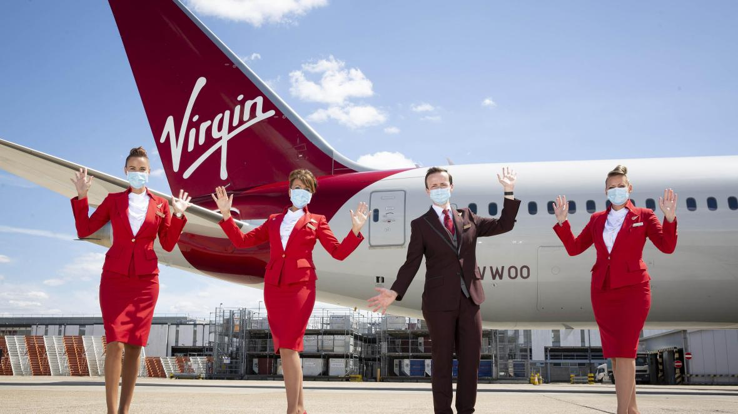

Student Name: Maura De Sousa
Student ID Number: 1815905
Lecture Name: Dr. Rexon Nting
Submission date: 7th January 2021

Table of content
1.Introduction
2.Company background
3.What is organizational culture and its importance
4. Theories and models
- Pestle Analysis
Pollical, economic, social, technological, legal, environment
-Porter’s Five Forces
Threat of substitutes, bargaining power of buyers, Bargaining of suppliers, threat of new entrants, Industry Rivalry
- Schein Model of organisational culture
- Artifacts, Espoused values, Basic underlying assumptions
5.How this theories and models apply within the Virgin Atlantic and how it impacted with the Covid19 pandemic/ Diagrams
. Pestle Analysis
. Porter’s Five Forces
. Schein Model of organisational culture
6. Critical evaluation about Virgin Atlantic
7. Conclusion
8.References

Introduction
This essay is focused on the external environmental factors along with the effects that Covid-19 has caused on the organizational culture and its performance. A full and detailed background overview of the company that is going to be implemented on this report which is the Virgin Atlantic Airline UK that it was launched by owner which is called Richard Branson’s in 1984 with its origin that is based in London will be mentioned along with the internal and the external factors with the inclusion of the company’s strategies and revenues of Virgin Atlantic UK. The definition of culture will be described so the readers can have a minimum idea and understanding of what culture is about and why is it important. Key theories/ models will be introduced throughout the essay accompanied with its definition that is mainly going to be focused on explaining what are the theories/ models, which are the Pestle Analysis theory, Porter’s Five Forces model and the Schein Model which is a cultural dimensions theory, these theories/models are going to be implemented and are going to be related to the companies aspects along with the critical evaluation on how the organisation operates and the impacts of the culture and its performance, relating it to the pandemic Covid-19 crises on how it affected within the company. Towards the end an own critical evaluation will be presented to evaluate the companies present cultural and its ethical standards along with the values and beliefs and how they are sustainable with the employees and the organisations achievements, objectives and its social responsibilities.

Company background
Virgin Atlantic was founded by three members which are Richard Branson’s, Allan Hellary and Rondolph Fieldes. The company was launched in the earlies 1970’s and its first flight took place on the 22nd June 1984. Virgin Atlantic is a private limited company, it was used to be called British Atlantic Airways, but it soon changed to its original todays name that is by Virgin Atlantic. The company has a trading name of virgin airlines such as the Virgin Airway Limited and Virgin Atlantic International Limited and is a British airline with is base head office that is in Crawley in England.
The Virgin Atlantic was first design to mainly fly between London and the Falkland Islands, its first operating bases were in London to Gatwick, London to Heathrow and London to Manchester. Virgin Atlantic have become one of the largest carriers around the UK to fly customers along with linking all flights with non-stop translantic routes internationally such as Delhi, Johannesburg, Hong-Kong, Los Angeles and New York, with the opportunity of Virgin Atlantic to venture with Delta, Air France and KLM, it had a facility of having more than 350 cities across the North America, the Europe and all the UK have now become easier to be reachable. (Virgin Atlantic,2020).

Joint venture partners- Delta, Air France and KLM.
Codeshare partners- Aero México, Air New Zealand, Singapore Airlines and Westje
Interline partners- Air Botswana and the Caribbean Airlines (Virgin Atlantic,202

Virgin Atlantic chooses their codeshare and joint venture partners cautiously to ensure an easier way for customers to book their respective flights beyond the own direct flight programme. Normally, the flights are worked together as a joint commercial business hence why the name given is joint venture. Therefore, having relations with other companies it opens doors for so many more destinations within the network. The Virgin Atlantic company partner routes has involvements with join ventures, codeshare partners and interline partners which are related to entertainments, health and wellness, money, people & planet, technologies, travel leisure and space in various continents such as in Asia, in Africa, in Europe North and South of America and Australia. (Virgin Atlantic,2020).

Virgin Atlantic is famous for having one of the best services/ customers service’s and low costs travels for passengers with a good reputation for quality and innovative products development. The company provides various products as a choice to allow customers to benefit when travelling with Virgin Atlantic, the company has its operation of five products services are the airline business class which is the upper class, a premium, a economy delight, a economy classic and the economy light.
The upper class was launched in November 23rd, the Virgin Atlantic has won an honourable awards because of it design, Virgin Atlantic decided to re-launch in April as the airline began to make deliver of its Boeing 787 Dreamliner aircraft. Every upper-class cabin holds onboard a bar.
All premium customers enjoy the social space that it’s available at the front of the cabin, it allows the travellers to stretch their legs and allows the interaction of speaking towards the crew members and other travellers, also customers have the ability to serve themselves with beverages and snacks that the company offers.
Travellers that opt for an economy tickets have the onboard service that the Virgin Atlantic is known for, which are the inclusion of complimentary drinks, snacks and foods. On demand the flight supplies Wi-fi and entertainment on every route. Different options that can picked such as the light, classic or the delight ticket, this includes the extra legroom spaces with an overheated storage space along with having the priority to be the first when boarding.
The purpose of Virgin Atlantic is to care for the human spirt and let it fly, the main goals of the company is to be able to become the customers most favourable airline. Virgin Atlantic is already achieving its full potential with the help the translantic joint venture and with the Delta airlines, to bring new/ lots of opportunities accompanied with the Virgin holidays flight. Virgin Atlantic certifies that all members of the company have the right the right skills and tools that brings an exclusive Virgin Atlantic experience. Virgin Atlantic currently has over 5000 employes (Virgin Atlantic, 2020)
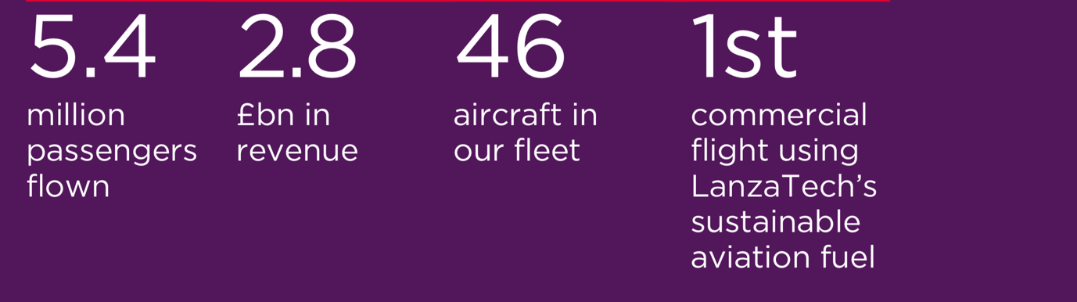Virgin Atlantic

This diagram is a reliable source that shows the exact number of passengers that has flown with the company that is 5.4 million travellers along with the 2.8 billion in revenue of the company. The aircraft in the company’s fleet which is 46 and it shows that Virgin Atlantic is the first airline to use the LanzaTech’s sustainable aviation fuel. (Virgin Atlantic, 2020)

What is organizational culture and its importance
Organizational culture is mainly how each individual’s persuade their thoughts, feelings and values within the company, this are followed by the acts, ideas and the beliefs of socially shared cultural nature. Normally the senior organizational members manage the culture of its organization by drawing special attention on what’s important and what’s not important to see how all corporates must be understood. The word culture is as remarkable and complicated to understand, especially when it comes to use it in thoughtful aspects. This differs between companies and the managers interest in culture. (Alvesson,2020).
Frost et al’s (1985:17), states that organizational culture is a form of talking about the significance of individual’s symbols, rituals, myths, stories and legends along with the interpretation of events, ideas and experiences effected by one’s groups whichever the live.
The importance of organizational culture is that it generates an environmental operational so every employee can achieve their respective goals that is set by the company. In general organizational culture is the component that contributes for a success or fail within the business company. Therefore, the reason why organizational culture is important It’s because it allows the employees to have an important role and be part of the progress within the workplace. Although organisations need to be well organised and have strong culture/cultural progress, Overall the importance of this is to be able to understand the values that exists in an organisational culture. (Burolus,2012).

Pestle Analysis
Pestle analysis is composed by six factors which are the political environment, economic environment, social environment, technological environment, legal environment and the ecological environment. Ones can use the Pestle analysis to identify and analyse the forces of the macro-environment of the business company.( Alanzi,2018).
The pestle analysis model is mainly used as an implementation to analyse the business purposes and its evaluation. Using the Pestle analysis, it allows the model to do its evaluation of the business company environment externally. Has Pestle analysis examinates the external factors that can influence the business it relates to SWOT analysis in relation that within the model of SWOT analysis some external factors are connected such as the opportunities an threats (Perera,2017). This then beneficiates and helps the organisation to understand its market positions in a more effective form. (Thomas,2007).
Political
The political environmental involves the political and the government stabilities and its instabilities along with the changes that occurs in the governments constitutions, the national policies, political and many other factors. Political environment is more considerable in foreign business as they require more political support that is needed for the accomplishments and penetrations of the market. In general, political environment defines the country operational and political risks that are specially concerned by the company. (Perera,2017).
Economic
The economic environment are factors that includes the economic growth, the interest and the exchange rates and so on. This then effects on how an organization carries out their business and how profitable they are or can be. This factors can also involve the Macro-economy which it deals with the management in the economy and Micro-economy which deals with how incomes are spend by individual’s. (SHU,2020).
SOCIAL
The social environment factors take in count all advantages and disadvantages of every event that are affected by the market and the community socially. These events involve cultural expectations, norms, global warming and many other factors. Although these are demographic, population analytics and it involves a lot more than that, these factors pursue the social environment of the market and also determinates the cultural trends. (Rastogi and Trivedi, 2016).
Technological
The technological environment refers to the positively and the negatively effects of the technology within the operations of the industry and the market, along with the development of technological awareness that a market owns. Although, these factors can take into consideration the changes that occurs within the financial decisions. (Rastogi and Trivedi,2016).
Legal
Legal environment refers to the legal responsibilities such as the employments, taxations, the imports and exports etc., these elements have internal and external sides (Rastogi and Trivedi, 2016). Overall legal environment means any law that takes part in crime, operations, terrorist and legislation that varies from country to country.
Environmental
The environmental factors are influenced by the surroundings of the environment. Business environment analysis involves the climate and global changes, the geographical and many other factors that are related with the environment.

Porter’s Five Forces
The Porter’s Five Forces model is constituted by five factors these are the bargaining power of suppliers, the threat of new entrains, the industry rivalry, the bargaining power of buyers and the threats of substitutes. Porter’s five forces model is a management tool that allows the ability to analyse the industry profitability and attractiveness by using the external perspectives. (Dalken,2014).
Threat of substitutes
Threat of substitutes is basically finding ways on how customers can switch to alternative products. Its why the existence of many similar products but different branding, these are all branded by different competitors. (business-to-you,2016).
Bargaining power of buyers

Bargaining power of buyers is mainly described as the market outputs, the reason why is customers have the ability to put companies under pressure which means that it allows the good bargaining’s of prices. (business-to-you, 2016). Saying this because when a company doesn’t have many customers, companies then tends to find ways on how they can attract more customers to avoid slow growth within the industry and to prevent customers from switching to the competitors. (business-to-you,2016).
Bargaining of suppliers
The bargaining of suppliers is described as the market inputs. This force analysis as the ability to control the quality of products and the reduction or augmentation of prices. Business obtain better choices if they have more than one supplier as this master an availability of different products services. (Business-to-you,2016).
Threat of new entrants
Threat of new entrains is mainly defined as the ability of ones to enter the marketplace. Therefore, new entrants within the industry introduces new market shares. (Business-to-you,2016).
Industry rivalry
Industry rivalry looks into at how the marketplace competition is. It determines how many competitors is in play and how they are capable of doing. Rivalry is normally high when the competitors are alike in power and size. Competitors/companies tend to do advertisements, reduction of prices, although this can affect the business bottom line. (Business-to-you,2016).

Schein Model of organisational culture
The schein organisational culture was developed in 1980 by a professor called Edgar Schein he states that “ basic assumptions shape values and Devalue shape practises and behaviour”
Schein developed three cultural models the artifacts, values and assumptions.(Management Study Hd, 2020).
Artifacts
Artifacts Is based on what individuals can easily spot within the organisation, is the visual aspects the ones can see changes. .(Management Study Hd, 2020).

Values
So that is related to one of the work and the organisation, and is also can be defined as the value of the organisation. .(Management Study Hd, 2020).

Assumptions
assumption is related to inner aspects to assume, this relates to the determination after human nature unstated what's true or false statements .(Management Study Hd, 2020).

How this theories and models apply within the Virgin Atlantic and how it impacted with the Covid19 pandemic

This diagram bellow is showing the pestle analysis of Virgin Atlantic company along with detailed analysis.
Virgin Atlantic Pestle Analysis
Political  Brexit  Laws- covid-19 national lockdown | Economical  Salary reduction  Increase of fuel cost
Social  Safety measures adapted  Losses of jobs  Fall of business travellers | Technological  New technologies  Wearable technology -  Smart watch boarding pass \  Smart glass- face wearable
Legal  Alliance with other companies | Environment  Reduction of aircraft CO2 emission  Pandemic

Political, Economic and Social.
Virgin Atlantic flies 4 domestic destinations and 28 international destinations in 17 countries.
The political environment takes major part within the Virgin Atlantic ensuring always the success within the company and not the fails, this allows the government to make best changes that can conduct a good policy within the airline. Has the Britons voted for the British Exit known as Brexit, this will bring down falls within the Virgin Atlantic airline.
Has Virgin Atlantic operates nationally, internationally and has trading partners in the EU with the Brexit in place and bad agreements it can bring drastically low share prices. Therefore, the government needs to make right choices and strategies to ensure that Virgin Atlantic does not suffer major losses and trading companies maintain the current deals with the Virgin airline.
The disruption of air services will have to come into an agreement resulting the airline to have the ability to fly to the international countries as usual. Because of Brexit the possibility of an increasing boarding controls and passengers’ managements will take in place, and Virgin Atlantic company may need a bilateral letter which it comes onto an agreement that the airline is allowed to fly to the international destinations as normal. Government will need to apply the Visa policies as Virgin Atlantic travellers most likely will need a visa to go on holidays if the Brexit deal doesn’t come into an agreement. The recent pandemic Covid-19 occurred and has the number of cases were arising the government was obligated to decree the national lockdown. This affected lots of business and the people, business had to shut down for numerous of weeks due to the pandemic Covid-19 resulting into the global economic down falls in the whole UK. Virgin airline was majorly affected as the company had to stop flights. Customers were obligated to cancel trips as they couldn’t fly due to the government policies, the return of customers refund had to be done, this had a big impacted to the airlines pocket. The Virgin Atlantic had no potion and they eventually shed more than 1000 jobs as the Covid-19 pandemic crises raised. the cut down of salaries had to be done because the airline wasn’t capable to sustain the employee’s salary as a result of the losses of money/profit. 80 million pounds were lost due to the increase of fuel. Virgin Atlantic fuel rose by one third compared than the last two years. Finally, when the government decree the regulations on how the Virgin Atlantic could reopen, the company had to do major adaptions to ensure the health and safety measurements of the employees and customers. From the moment ones arrive at the airport hand sanitising services are available throughout the entire journey. The Virgin Atlantic adapted its floors with markers so each traveller can see the number of each people that can be at one spot at the time and respect the protocol of safe distance measurements, at the check-in area. Plastic clear screens were placed at the check-in desks to avoid any contact from travellers and the employees. Before entering the airplane crewmembers most check travellers’ temperatures as the policy states that no higher than 38 degrees as this can indicate the signs of covid-19 symptoms. Therefore, temperatures need to be under, so individuals are safe to fly. The regular cleaning is adapted at all facilities such as the check-in services and at the self-services, they must be disinfected at all times to avoid growth of bacteria.
Technological, Legal and Environment
The Virgin Atlantic is the first airline to launch a wearable technology in the Upper-class wing at the Heathrow Airport. The company has developed a Google Glass and a Sony Smartwatch to deliver new passengers technological experiences. Using the Google Glass the airline staff can easily check the passenger’s information and telling the travellers about their flights, the weather and the events that will occur at the passenger’s destination. The Google Glass can also translate into different languages. The Sony Smartwatch 2 is a purchase watch that supports the passengers boarding pass. Travellers can now use this wearable technology as a boarding pass, this is beneficial as it helps with the reduction of paper instead of caring paper then throwing it away. With the Covid-19 pandemic, these wearable features have a great impact within the airline as it has the ability of hands-free meaning no contact with individual’s resulting into not passing bacteria. The Fortunate line has joint venture partners, codeshare partners and interline partners this makes it easier when passengers tried to book their flights as it allies practical journeys that can easily be booked. the share partners decided that due the Covid-19 pandemic they would provide tests for travellers to avoid this spread of the disease, passengers are able to travel with a negative test. Virgin Atlantic is finding possible ways and how to reduce the aircraft CO2 emission by 30%,the airline plans to see efficient ways to reduce the harm to the environment. tterefore Virgin Media works with clean tech company lanzatech to reduce gases waste into low carbon jet fuel, and because of the pandemic the airline thinking of cutting the carbon emissions to 0.

Porter’s Five forces Analysis
This diagram people will show the Porter’s five forces analysis within the Virgin Atlantic airline and in conjunction with detailed analysis will be given.

Threat of substitutes | Industry rivalry | Bargaining power of buyers | Bargaining of suppliers | Threat of new entrants
. Individuals are using other methods of dislocation  -walk, cycling | . The airline British Airways is a rivalry of Virgin Atlantic  . Overcomes of the airline alliances | . The raising of prices | . Boeing 787-9  . Airbus | . Ryanair  . EasyJet

Threat of substitutes
Virgin Atlantic is on a threat of losing its customers as the airline is not proving as much of flights daily due to the pandemic. This is a bad thing as customers are now opting for cheaper and safety ways that they can possibly use to avoid any contact with other individuals. Because when using the airlines ones are seat near each other and nit respecting the 2-meter rule. Therefore, nowadays people tend to cycle or walk more to their destinations and has lockdown applies travelling is not the best option.
Industry Rivalry
The airline industry is full of carries entering the industry. British Airways is the biggest competitor of the Virgin Atlantic airline. Has the Virgin Atlantic Airline has partnerships with different foreign airlines this gives the airline advantages to be more successful. In contrast with the Covid-19 British Airways and Virgin Atlantic the lack of profitability is bringing down the airline companies.

Bargaining power of buyers
Due to the Corona virus pandemic the Virgin Airline was obligated to raise their prices due to its troubles. The airline had to raise prices of tickets and reduction of employee’s salaries because the airline revenues is low. Customers are not willing to pay for the raising of prices. Although, customers have to economise as they are not receiving as much money to be spending in the airlines. Virgin Atlantic needs to be careful and find new strategies to overcome this problem otherwise its revenues can go drastically down resulting into bankrupt.
Bargaining of Suppliers
The virgin Atlantic airline uses its fleet Boeing 787-9 and airbus aircraft to operate services internationally. Has normally Virgin Atlantic does international journeys but in this time of the year the airline had to stop major flights internationally and even locally due to the pandemic. Although, the airline adopted a new use of its Boeing to distribute and do mas test/ vaccines of Covid-19.
Threat of new entrants
Countries that have their own national airlines things can be very cheap. Therefore, when travelling locally people normally prefer to use the easyJet airline or Ryanair which they are very unexpensive companies. With that Virgin Atlantic has a downside on which passengers may not opt to use the airline for short distances. But with the todays pandemic not either local airlines/ international airlines will be able to fly resulting into loss.

Schein Model of organisational culture
Artifacts
Passengers have the picture that the virgin Airline has a uniform that is coloured red and wait automatically if ones spot a member of the team wearing something else, passengers will find it very suspicious. Merging the artifacts with Covid-19 the first thing that passengers wanted to stop within the airline is the hand sanitizer, the airline provided this product throughout each area of the airline.
Espoused Values
Virgin Atlantic value sits customers. Therefore, the airline always makes sure that the members are dressed well, the airline also values the ability that the employees have on the way they speak towards the customers as this always need to in an effective way and politely. Due to coronavirus the insurance of always wearing a face mask to keep the safety of employees and customers is need it at all times,
Basic Underlying Assumption
Some customers assume that because they have pay for higher services within the Virgin airline that they don’t need to pay for their own boarding passes when check-in personally at the airport. With the impact of Covid-19 the airline had to adapt new forms of check-in customers wouldn’t have to pay for their paper boarding pass but instead they can use the wearable watch that has already the travellers boarding pass.

Critical evaluation about Virgin Atlantic
Virgin Atlantic’s purpose is to be able to accept the human essence. The airline values the community and the planet, that is why the airline uses the C02 emission and adopted on using the lanzatech to reduce gases. The Virgin Atlantic airline always ensures the customers and employees safety and how they are cared and listen to all the times. The airline invests towards the development of new skills of employees and superiors to empower and allow the creativity within the company Being diverse is one of the aims of airline, as Virgin Atlantic likes to create diversity within the workplace so it can reflect to the communities, any gender or different ethnicities backgrounds are welcome. The employees have the right to bring themselves at all times as having different values and perspectives can bring new ideas than can improve in the business. With the help of employees, the airline was able to develop the “Flourish programme”. This is a programme that allows every member within the Virgin Atlantic company to come together to brainstorm new techniques that can be inspirational and motivated by everyone at the company. By this it contributes a long-term health environment for the business.
Employees made good impacts and efforts within the airline as they had the care of ensuring all service areas were well adapted and safe for travellers to use, this made the company efficient as customers like to be treated well. The Virgin Atlantic employees invest on a programme called waste watchers to stop waste on the aircraft, products used to be offered to any customer in these days they have to be requested by travellers to reduce the aircraft waist. With this new programme the airline waste went down by 8%. The Virgin Airline has a special base training that allows the employees to be trained. In the base contains miniatures of the whole Virgin Atlantic company overview to allow employees to see what they have to do. Two kinds of training are implemented at the base such as the cabin safety training and the customer service training, this allows the employees to be well prepared to conduct their duties effectively when working at the company.

Conclusion
At the end this report readers can see the data/ research that was conducted about the Virgin Atlantic airline. Pestle Analysis, Porter’s Five Forces and Schein model of organisation was presented throughout the report along with how these models and theories implements within the Virgin Atlantic airline. Towards the end a critical evaluation of Virgin Atlantic company will be conducted to see how the airline represents its organisation and how the employees are sustainable within the company.

References
Alanzi.S (2018) Pestle analysis introduction.
Alvesson, M (2002) Understanding organisational change. London: Sage Publications.
Burdus, E. (2020). Management comparat international. Bucharest: Editura Pro Universitaria.
Business-to-you. (2016) “The place that brings real life business management and strategy to you”, Porter’s five forces.
Dälken, F., (2014). Are Porter’s five competitive forces still applicable? A critical examination concerning the relevance for today’s business (Bachelor's thesis, University of Twente).
Frost, P.J. et al. (eds) (1985) organizational Culture. Newbury Park: Sage.
Perara, Rashain. (2017). The Pestle Analysis.
Rastogi,NITANK and Trivedi, MK, (2016). Pestle technique- a tool to identify external risks in construction projects. International research journal of engineering and technology ( IRJET), 3 (1), pp. 384-388.
Sheffield Hallay Iniversity – Pestle analysis: https://blogs.shu.ac.uk/shupdreviewtoolkit/files/2019/01/PESTEL-ANALYSIS.pdf Assessed 29th December,2020).
Thomas, H., 2017. An analysis of the environment and competitive dynamics of management education. Journal of management development, 26 (1), pp. 9-21.
Virgin Atlantic Photo:
Virgin Atlantic: https://corporate.virginatlantic.com/content/dam/corporate/media-centre/Press%20Kit%20-%20Aug%2019.pdf (Assessed 29th December,2020).
Virgin Atlantic annual report: https://flywith.virginatlantic.com/content/dam/corporate/VIR007_2018%20Annual%20Report%20%26%20Accounts.pdf (Assessed 29th December,2020).

