Shannon Giles
1802458@student,uwtsd.ac.uk
A Report on the History of Education and Changes that have been made Since the 1800’s in the UK For Lindsey Roberts

Executive Summary
A Report on a key change in education practice as a result of reform for Lindsey Roberts.
The report is based on the different Acts that have been passed and the effects they have had on the British education system. It will include 3 main Acts; The Education Act of 1870, The 1944 Education Act and the !988 Education Reform Act respectively. I will also make reference to other acts but not in as much detail.
Table of Contents (Ctrl + Click to access pages)
Title 0
Executive Summary 0
Author & Author Email 0
Table of Contents 1
Introduction 2
Methodology 2
Main Body 2
History of Education in the UK 2
1944 Education Act 4
1988 Education Reform Act 4
Conclusion 5
References 6

Introduction
My report is going to be about the 1988 Education Reform Act. This was a very important act that was passed as before this, there was no standardized national curriculum, then once it was put in place there were mandatory policies in place that stated children must learn numeracy and literacy in very particular ways. My aims for this report are to explain the main reasons for this Act being put in place and why it is still relevant today and the impact that it has had on learning. I am writing this report as I am a student studying Education and wish to become a teacher in the future and understanding how education used to be and how it has changed and improved over time is something that I believe will benefit me in the field of education. I will first talk about the history of British Education, then I will discuss how there have been multiple legislations around the topic of Education. After that I will discuss how the 1988 Education Reform Act has changed the format of education and how things are now in modern day British Education.
Methodology
To conduct this report I have looked at multiple relevant primary and secondary resources and taken note of the most applicable parts for this report.
Main Body
History of Education in the UK:
I will focus this section of the main body on the history of education within the United Kingdom. I will only be discussing the history since 1800 in detail as that is what is most relevant to this report. Before 1870 traditional education as we see it today was nowhere near as prominent and was not compulsory, most working class families would have their young children working rather than going to schools as the money they brought in would be necessary for the family to survive. There were some schools in rural areas which were mainly funded by religious groups and would have a heavily religious bias. There were also ragged schools which were schools that would provide free education, food and clothing for working class children in the early 1800’s. Other types of schools before the Education Act of 1870 included Dame schools, named this due to being run by women, typically in their own houses, and there were also reformatory schools for children who had broken the law and were considered young offenders.
In 1870 the first ever legislation to confront the issue of education was created, this was the 1870 Education Act. This act continued to let the voluntary schools (the ones that were run by the Church) to continue on the way they were but it also allowed for the introduction of ‘School Boards’. These boards allowed schools to get their funding from their local areas and it also allowed them to be non denominational which is something that the voluntary schools were not. This allowed schools to become more inclusive and more available for students as they did not have to travel to find a school with their denomination anymore, they could attend a local school and still feel included and welcome. This Act, however, did not make education compulsory, the Act that did pass that law came 6 years later, this Act was called the 1876 Royal Commission on the Factory Acts. It was decided that education will be compulsory for children between the ages of five and ten due to wanting a way to be able to stop children being forced to work at such young ages. This Act paired nicely with the 1870 Education Act and enrolment in schools from 1880 onwards grew rapidly (see fig 1).
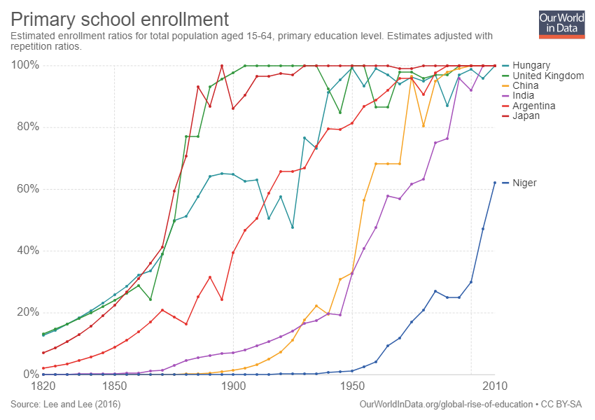
Fig 1
The age of required attendance continued to rise, it rose to 11 in 1893 and 12 in 1899 and is currently at the age of 16. It had also been decided in the Elementary Education (Blind and Deaf) Act of 1893 that education was compulsory for children with hearing and/or sight impediments too. After this act was passed, in 1899 there was another Act passed that included children with other disabilities in the law for compulsory education, this was the Elementary Education (Defective and Epileptic Children) Act.
1944 Education Act:
This education Act that was introduced in 1944 stated that it would allow free secondary education to all children up until the age of 15. At this time there were three types of schools;
- Grammar School
- Secondary Modern &
- Technical
Grammar schools were generally only attended by the middle class children as there were many costs involved with attending. After 1944 it was stated in the Education Act that there would be a testing system that would determine which of the three schools you attended. This test was known as the 11 plus. If you passed the 11 plus then you would automatically get into grammar school, no matter your income. However as I previously stated, students from poorer backgrounds were still disadvantaged, even if they passed the 11 plus. Although it was revolutionary for secondary education to be made free for everyone, there were still downsides to the way that education was done between 1944 and 1988. It was seen that grammar schools were the best which meant that students who did not get into a grammar schools would be seen as not as smart as pupils who did, meaning that so many pupils would get labelled a certain way at the age of 10. It was this criticism that led to the creation of comprehensive schools in the 1960’s and then eventually to the 1988 Education Reform Act.
1988 Education Reform Act:
In 1988 the Education Reform Act was introduced. This Act was to become a major stride in how teaching is performed in schools all over the UK. It was introduced to help provide a system of education that would be able to suit all children in the UK. It meant that schools were now funded by central government rather than the local authority. It also introduced standardized tests such as GCSE’s and SAT’s. These tests allowed schools to compare themselves with other schools in league tables. It also introduced a national curriculum meaning that no matter which comprehensive school you attended in the UK you would be learning the same things as other schools. This meant that parents would have more freedom in their choices of school and more ease in selecting them as they only had to look at league table results and they knew which school was doing better. There have been negatives with this system since it is basing what school is ‘good’ on how well the students perform in exams and not much else.
Conclusion
- The way that teaching has been done and pupils have learned has changed drastically since the 1800’s
- Education is now much more fair and equal for all religions and all classes
- It is not perfect and still has flaws but the 1988 Act has definitely reformed education for the better

References
BBC Teach, What was life like at a Victorian Reformatory School? | History – Victorian Villains https://www.youtube.com/watch?v=erYwMz5rdW0 [Accessed 10th December 2018]
Education in England. Education in England: a History, 2018. <http://www.educationengland.org.uk/history/timeline.html> [Accessed: 7th December 2018]
Education Reform Act 1988(London, Her Majesty's Stationery Office: Paul Freeman, 1988), <http://www.legislation.gov.uk/ukpga/1988/40/pdfs/ukpga_19880040_en.pdf> [Accessed: 7 December 2018].
Fig 1. <https://ourworldindata.org/primary-and-secondary-education> [Accessed: 8th December 2018]
Machin, S. Vignoles, A. Education Policy in the UK. (London, Centre for the Economics of Education, 2005) < file:///C:/Users/shann/Downloads/Key%20Reforms%20in%20UK%20-%20ceedp57.pdf> [Accessed: 7 December 2018]
Galvani, R. The Changing Experience of English Secondary Education. (Hackney Community College, 2010) <file:///C:/Users/shann/Downloads/94-328-1-PB.pdf> [Accessed: 9th December 2018]
Parliament. Education Reform Act 1988. <https://www.parliament.uk/about/living-heritage/transformingsociety/livinglearning/school/overview/educationreformact1988/> [Accessed: 8th December 2018]
Parliament. The 1870 Education Act. <https://www.parliament.uk/about/living-heritage/transformingsociety/livinglearning/school/overview/1870educationact/> [Accessed: 7th December 2018]
Parliament. The Education Act of 1944. <https://www.parliament.uk/about/living-heritage/transformingsociety/livinglearning/school/overview/educationact1944/> [Accessed: 7th December 2018]
ReviseSociology. 2017. The 1988 Education Reform Act – Class Notes. https://revisesociology.com/2017/10/24/the-1988-education-reform-act-class-notes/ [Accessed: 7th December 2018]
Weald & Download Open Air Museum. Education Before 1870. <http://wealddown.co.uk/openairclassroom/Further%20information/information-education%20before%201870.htm> [Accessed: 9th December 2018]

Education Reform Act 1988, (London, Her Majesty’s Stationery Office, Paul Freeman, 1988).
BBC Teach, What was life like at a Victorian Reformatory School? | History – Victorian Villains https://www.youtube.com/watch?v=erYwMz5rdW0
Parliament. The 1870 Education Act. <https://www.parliament.uk/about/living-heritage/transformingsociety/livinglearning/school/overview/1870educationact/>
Fig 1. <https://ourworldindata.org/primary-and-secondary-education> [Accessed: 8th December 2018]
Parliament. The Education Act of 1944. <https://www.parliament.uk/about/living-heritage/transformingsociety/livinglearning/school/overview/educationact1944/>
Parliament. Education Reform Act 1988. <https://www.parliament.uk/about/living-heritage/transformingsociety/livinglearning/school/overview/educationreformact1988/>

