Environmental Analysis of Car Industry - Assessment 1

Contents
Introduction 3
Business Environment of the Car Industry in the UK 4
Analyzing the Macro Environment of Car Industry Using PESTEL Framework 5
Political Factors 6
Economic Factors 7
Socio-cultural Factors 10
Technological Factors 11
Environmental Factors 12
Legal Factors 12
Evaluating Competitive Positioning of Car Industry Using Porter’s Five Forces Model 13
Bargaining Power of Buyers 13
Bargaining Power of Suppliers 13
The threat of New Entrants 13
Threat of Substitute 14
Competitive Rivalry 14
Assessing Opportunities and Challenges of the Car Industry in the UK 15
Conclusion 16
References 17

Introduction
The business environment of an industry is the surrounding where internal and external forces actively influence the business operation, profitability, and sustainability of the business (Tayeb, 2015). Analysis of the internal business environment increases the efficiency of the business while the external environment assessment energies the effectiveness within a particular region. The report portrays the business environment of the car industry in the United Kingdom which is one of the largest sectors contributing to the GDP as an economic pillar of the nation. The first phase of the report reveals the external environmental analysis of car industry using PESTEL framework which evidences that the UK has a mild political risk, good economic opportunities for can manufacturers due to lower interest rate, favorable socio-cultural, technological and legal base for car manufacturers, however a strict environmental practices overseas. The second phase demonstrates the competitive positioning of the industry using Porter's five forces model which indicates the industry fragmentation with aggressive competitiveness. The final portion of the report evaluates the opportunities and threats of this industry using SWOT analysis which effectively evidences the potential of the industry while it may face situational threats for pandemic as well as many other economic downturns.

Business Environment of the Car Industry in the UK
The business environment is the surroundings and systems related to the business that directly or indirectly affect the business operation, revenue generation, and profitability (Mohamed, 2015). This is the crucial part to be understood by the business persons who want to make a sustainable business within a particular industry. Moreover, industry analysis is the basic task for entrepreneurs to design strategic mission and objectives. The business environment of the car industry includes three levels of environmental factors that are compulsory to consider to flourish in the automotive sector.
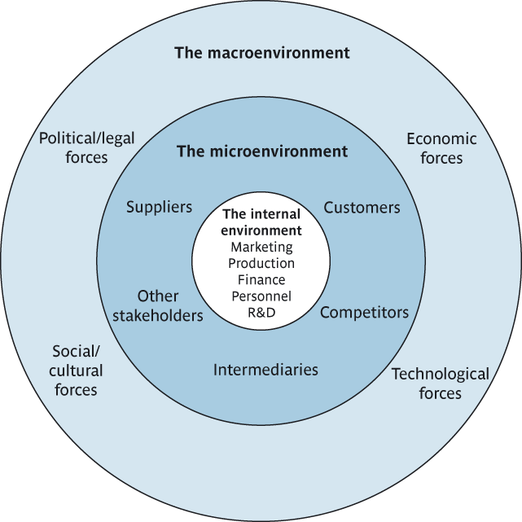
Figure 1: Three levels of the environment of the car industry in the UK (Mohamed, 2015)
The car industry belongs to the automotive sector which is one of the prime sectors of the UK for contributing to the national income since it has generated an £82 billion turnover in 2019. More than 60 specialist car manufacturers are present in this industry who are specialized in this sector (SMMT | Supporting & promoting the UK automotive industry, 2020). 2500 suppliers are continuously contributing to this sector with automotive parts and necessary equipment for cars. 168,000 employees are directly deployed in this sector who relentlessly working in different roles of the respective companies. In 2019, the United Kingdom has been able to manufacture more than 1.3 million cars while a large portion of these cars is exported to 160 countries in the world for persistent demand.

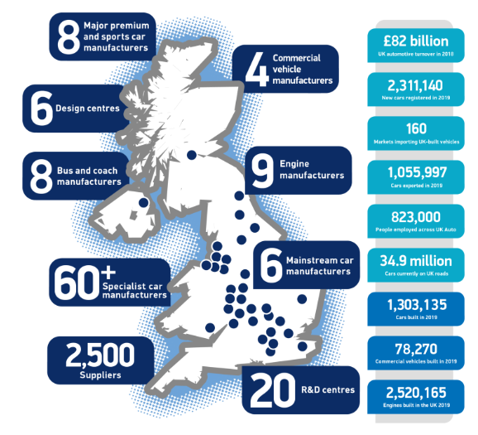
Figure 2: Summarized statistics of the automotive industry in the UK (SMMT | Supporting & promoting the UK automotive industry, 2020)

Analyzing the Macro Environment of Car Industry Using PESTEL Framework
PESTEL analysis is one of the basic techniques to understand the external environment of a business as well as its respective industry. The British car industry is affected by its external environment whose components are political, economic, socio-cultural, technological, environmental, and legal factors. In this section, the overall condition of these factors is discussed in a nutshell.

Political Factors
The political environment of the United Kingdom is has gone to a slight downturn since the Brexit issue has made the whole system vulnerable for a certain period. While the Brexit took place in the region, political instability prevailed, however gradually the change responded to the good situation. The country exercises a democratic political system under a constitutional monarchy which has made the region’s politics an equitable ground. Such a condition is a good sign for the car industry in the UK. There are several political risks associated with this environment which is essential to take into consideration for car businesses.
Political Risks in the Car Industry of the UK
The political risks are measured by undertaking several components such as corruption, trust in the institution, ethnic fragmentation, the status of minorities, inequality of income, and level of social provision. Observing these factors, the global ranking of political risk of the UK figures out 1 index point on a degree from 1 (low risk) to 7 (high risk).
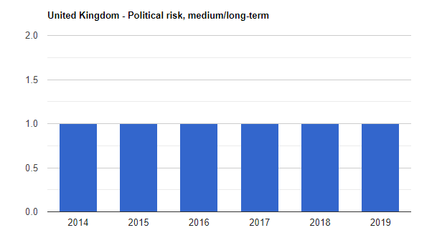
Figure 3: Political risk point of the united kingdom from 2014-2019 (United Kingdom Political risk, medium/long-term - data, chart | TheGlobalEconomy.com, 2020)
Despite a low-risk index of the political risks, due to the Brexit issue, in 2018, the UK car industry has faced a 6.8% drop in the new car registration (Why the U.K. Auto Industry Is Stalling Over Brexit Risks - Knowledge@Wharton, 2020). Export of the automotive products has also declined to 15% to Europe while investment in this industry has dropped to 80% in the last two years. But this uncertainty has brought a massive shift in this sector which has made a broader change. The market of a diesel car is shifted to the electric cars in Europe but the consumers are slowly responding to this new trend. At the same time, UK consumers are not habituated with electric cars which have made a good sign for a car manufacturer in the UK. The manufacturers are moving towards electric cars rather than importing from Europe. Thus the political condition has made a slight opportunity for the domestic manufacturer to utilize innovation to produce the eco friendly car. It is also important to mention that, China is one of the largest markets for electric cars which can be a good opportunity for the UK car industry to grab.

Economic Factors
The economic environment of a country is necessary for a smooth business operation because it the factor that ensures resource availability, usability, and distribution to the people. The interest rate of the United Kingdom historically shifted to a favorable position for borrowers rather than savers since the interest rate is only .25% in 2020 and it was almost stable at this point for the past 10 years.
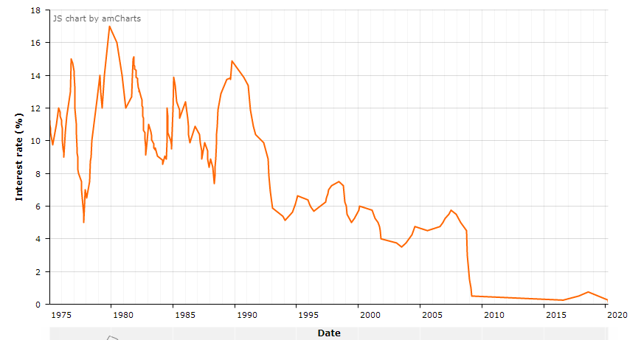
Figure 4: the trend of interest rate in the UK for the last 45 years (UK Interest Rate History / Graph, 2020)
Favorably, the car companies of the United Kingdom gets the benefit of business borrowing due to a little payment against their business loan. It has flourished the business of the car industry for the last 15 years since the companies need to introduce a huge capital expenditure in these kinds of businesses which is almost difficult to manage solely (UK Interest Rate History / Graph, 2020).
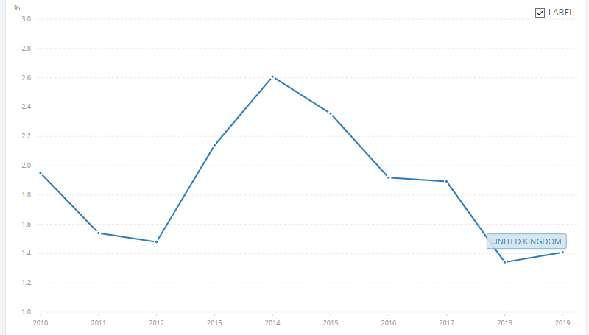
Figure 5: National income (GDP) trend in the UK (GDP growth (annual %) - United Kingdom | Data, 2020)
The national income of the UK is quite satisfactory for the car business. The income has faced a downturn in 2018 due to the Brexit circumstance, however, the economy has turned back to its income generation at 1.41%. This explains the aggregation of four factors of the economy that are consumption, investment, government spending, and net export.
The aggregate demand of the economy suggests the automotive industry to initiate new cars and manufacture more since the demand is high which comprises consumer spending, investment spending, government spending, and export-import spending. The inflationary situation is moderate indicating the purchasing power of the consumers for capital expenditure. At the same time, the unemployment rate indicates that the car manufacturing industry can facilitate more employees who are unemployed due to some economic shifts (Pettinger, 2020).
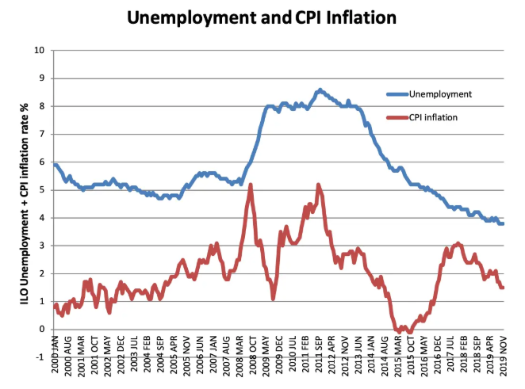
Figure 6: Unemployment and the inflationary situation in the UK (Pettinger, 2020)

Socio-cultural Factors
The social and cultural base of a country shapes the preferences and spending patterns of an individual. Several factors influence consumers in their buying nature.

Although the people of the United Kingdom lead an expensive lifestyle, due to the massive Pandemic COVID-19, the lifestyle has broadly shifted to the health and food industries while cutting the spending for transportation and luxury products. The restrictions on the movement in the Pandemic situation, the global price of crude oil were responsible for a large consumer price inflation downturn in the UK.
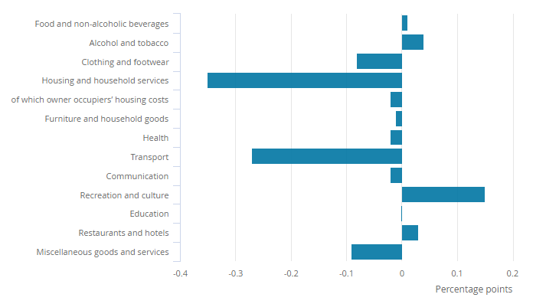
Figure 7: Contribution to the change in the consumer price index in the UK (Consumer price inflation, UK - Office for National Statistics, 2020)
This downturn in the car industry explains the alarming situation while the post-pandemic situation gives the light of hope since the situation shifted the consumers from using public transportation to private vehicles. Along with that, the multi-culture system, the majority of working-class people of the UK with a stable income, increased age-old population, and lavish lifestyle denotes the potential for the car industry in the United Kingdom.

Technological Factors
For flourishing the car industry of the UK, it is necessary to outline the product improvisation, technological infrastructure, data sources, and R & D expenses. Since the world is moving towards electric cars, it is a time-bound decision for this industry to shift with a dynamic response. The government of the UK is relentlessly supporting the technological aspects to flourish new ideas, strengthen infrastructure with talented specialists, and investing a pool of funds in this development. The car industry gets this benefit of adequate infrastructural support of technology. An integrated manufacturing system assisted by Artificial intelligence made the industry comfortable to innovate new cars. However, comparing to the global perspective, the United Kingdom is lagging in the race of research and development expenses (Research and development (R&D) support in the UK - great.gov.uk international, 2020). The US and Japan are leading the research and development expenditures while the UK stands in 9th position in the work ranking of research and development expenditures.
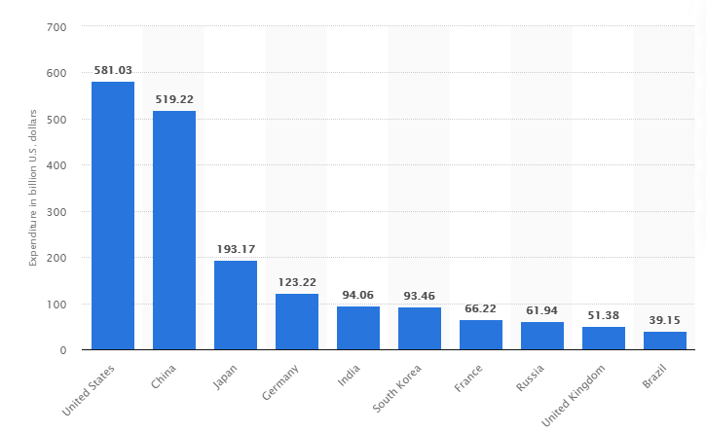
Figure 8: Research and development expenditures in several countries (Top countries by gross R&D expenditure worldwide 2019 | Statista, 2020)

Environmental Factors
Environmental protection has become a fundamental issue for all businesses. Initiating green products and services get the priority of consumer preference since the consumers are now very concerned about the ecological balance. The government of the UK is concerned about plastic pollution since only 1.5 tonnes of plastics are renewable which is one-third of the total plastic waste (Mohamed, 2015). Thus the automotive industry is suggested to use plastic parts that are renewable and less harmful for the environment. Diesel cars are more harmful to air pollution as it emits more carbon than that of petrol. For this reason, the car industry of the UK needs concentration in initiating green technology and transport so that it can settle down environmental issues.

Legal Factors
The legal environment of the United Kingdom is very strict for any sector. While it is about the transportation sector, the manufacturers are obligated to maintain health and safety measures. Moreover, the sector is suggested to practice equal pay structure of the employees, minimum wage compliance, race as well as ethnicity indiscrimination. Including Toyota, many prominent companies have faced questions due to their faulty airbags (Five reasons the car industry is struggling, 2020). It has brought the new regulation for the car companies to put the safety of passengers first.

Evaluating Competitive Positioning of Car Industry Using Porter’s Five Forces Model
Using Porter’s five forces model, the competitive positioning of the Car industry is evaluated in this section where five concepts are analyzed based on the recent situation.

Bargaining Power of Buyers
There are a lot of companies that are operating their business in the car industry. Along with domestic companies, foreign cars are grasping the market of the UK. For this reason, the buyers of this industry have a strong force to switch to another company due to the low cost of the switch. The quality of information is high in this region for which buyers can easily get access to the authentic information about the product (UK car market down 2.4% in 2019, 2020). The companies tend to remain cautious about their product due to the strong bargaining power of buyers.

Bargaining Power of Suppliers
The bargaining power of suppliers is low because the industry has immense suppliers to produce parts of the car. Moreover, the companies can import the parts from China as well as Japan for which the suppliers have become adequate for all the companies (Mohamed, 2015). Multiple supply chains, less likely forward integration of suppliers have made the force weaker.

The threat of New Entrants
Since the automotive industry requires huge capital expenditure, it is less likely to have a sudden threat of new entrants in this sector. After entering into this industry, a brand needs to develop the product for a certain period. That is why the threat of new entrants is weak in the car industry. Moreover, the economics of scale cannot be achieved at the initial level of the company that discourages new entrants to operate in can industry.

Threat of Substitute
The substitute product of cars exerts bicycles, public transports, and motorbikes. All these are easily available. However, in suburban or urban areas in the UK, public transport is merely available to transport (Bekker, 2020). Moreover, it cannot give the convenience of the car for which the threat of substitutes is moderate for the car industry.

Competitive Rivalry
There is aggressive competitiveness among the companies in the car industry. Two types of car companies are present in this sector; cost leaders and differentiators. For this high variety, the firms can differentiate their product and get the benefit of competitive positioning.
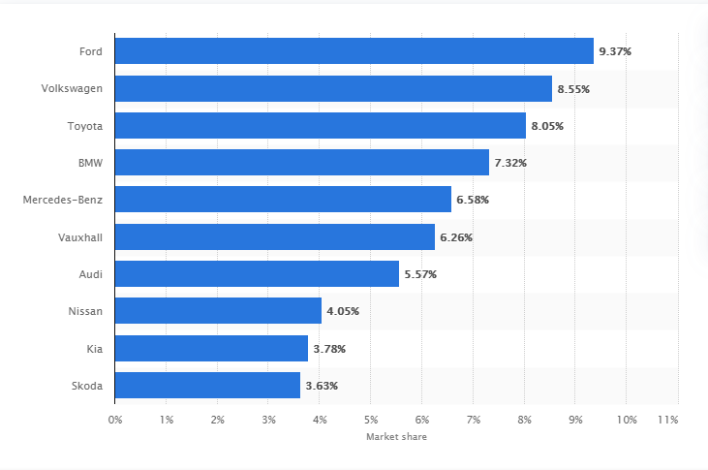
Figure 9: Market share of car companies in the UK (Car brands' UK market share by month 2020 | Statista, 2020)
The market fragmentation explains the competitive positioning of the car industry. Along with the domestic manufacturers, a lot of foreign cars are present who gets sizable market share within the industry.

Assessing Opportunities and Challenges of the Car Industry in the UK
Using SWOT analysis, the opportunities and challenges of the car industry are outlined in this section. This is the internal and external environmental analysis of an industry through which threats can be found out and opportunities can be outlined.
Strengths | 1. The car industry in the UK is persistent in innovation.  2. It has a world-class technological infrastructure to develop products.  3. The consumers of the UK prefer personal vehicles rather than the public.
Weaknesses | 1. The consumer’s high bargaining power makes difficulties for the key player of the industry (Five reasons the car industry is struggling, 2020).  2. Government restriction on transportation in any situation can create vulnerability of industry.
Opportunities | 1. By 2025, 15% of the new cars will be designed as electric cars which creates the opportunity for new companies as well as old ones to flourish brand development (Bekker, 2020).  2. Since people are pursuing freedom in their lifestyle in the UK, it exerts a good opportunity to expand the market of cars.  3. After the COVID-19 situation, the people will be habituated with private cars rather than public due to a sudden shift in their lifestyle. It indicates potential market expansion and industry upward trend.
Threats | 1. As long as the car companies in the UK cannot start manufacturing electric cars, fuel prices will make the sufferer of this industry.  2. Since the country is sluggish due to lower interest rates and national income, players in this industry will wipe out due to recession, unemployment, and competition at an aggressive level (Bekker, 2020).  3. If the pandemic situation continues for a long time, this sector is likely to face the massive downturn in demand, production, cost structure, and portability.

Conclusion
In the age of globalization and its effect, the businesses have become more customer-centric, innovative, and difficult (Mohamed, 2015). With the presence of domestic and foreign manufacturers, the business environment has become more agile for which it is necessary to observe the internal and external environment of the business cautiously. This report illustrated the business environment of the car industry in the United Kingdom. The first phase of the report revealed the external environmental analysis of car industry using PESTEL framework which evidenced that the UK had a mild political risk, good economic opportunities for can manufacturers due to lower interest rate, favorable socio-cultural, technological and legal base for car manufacturers, however a strict environmental practices overseas. The second phase demonstrated the competitive positioning of the industry using Porter's five forces model which indicated the industry fragmentation with aggressive competitiveness. The final portion of the report evaluated the opportunities and threats of this industry using SWOT analysis which effectively evidenced the potential of the industry while it might face situational threats for pandemic as well as many other economic downturns.

References
BBC News. 2020. Five Reasons The Car Industry Is Struggling. [online] Available at: <https://www.bbc.com/news/business-48545733> [Accessed 18 August 2020].
Bekker, H., 2020. 2019 (Full Year) Britain: New Car Market Overview And Analysis - Car Sales Statistics. [online] Car Sales Statistics. Available at: <https://www.best-selling-cars.com/britain-uk/2019-full-year-britain-new-car-market-overview-and-analysis/> [Accessed 18 August 2020].
Data.worldbank.org. 2020. GDP Growth (Annual %) - United Kingdom | Data. [online] Available at: <https://data.worldbank.org/indicator/NY.GDP.MKTP.KD.ZG?end=2019&locations=GB&start=2010&view=chart> [Accessed 18 August 2020].
Great.gov.uk. 2020. Research And Development (R&D) Support In The UK - Great.Gov.Uk International. [online] Available at: <https://www.great.gov.uk/international/content/invest/how-to-setup-in-the-uk/research-and-development-rd-support-in-the-uk/> [Accessed 18 August 2020].
Just-auto.com. 2020. UK Car Market Down 2.4% In 2019. [online] Available at: <https://www.just-auto.com/news/uk-car-market-down-24-in-2019_id192838.aspx> [Accessed 18 August 2020].
Knowledge@Wharton. 2020. Why The U.K. Auto Industry Is Stalling Over Brexit Risks - Knowledge@Wharton. [online] Available at: <https://knowledge.wharton.upenn.edu/article/brexit-auto-industry/> [Accessed 18 August 2020].
Mohamed, A., 2015. The international business environment: a proposed analytical framework. International Journal of Business Environment, 7(2), p.168.
Ons.gov.uk. 2020. Consumer Price Inflation, UK - Office For National Statistics. [online] Available at: <https://www.ons.gov.uk/economy/inflationandpriceindices/bulletins/consumerpriceinflation/april2020#:~:text=1.,culture%20(0.31%20percentage%20points).> [Accessed 18 August 2020].
Pettinger, T., 2020. UK Monetary Policy - Economics Help. [online] Economics Help. Available at: <https://www.economicshelp.org/macroeconomics/monetary-policy/> [Accessed 18 August 2020].
Property Investment Project. 2020. UK Interest Rate History / Graph. [online] Available at: <https://www.propertyinvestmentproject.co.uk/property-statistics/uk-interest-rate-history-graph/> [Accessed 18 August 2020].
SMMT. 2020. SMMT | Supporting & Promoting The UK Automotive Industry. [online] Available at: <https://www.smmt.co.uk> [Accessed 18 August 2020].
Statista. 2020. Car Brands' UK Market Share By Month 2020 | Statista. [online] Available at: <https://www.statista.com/statistics/300467/leading-car-companies-market-share-in-the-united-kingdom/> [Accessed 18 August 2020].
Statista. 2020. Top Countries By Gross R&D Expenditure Worldwide 2019 | Statista. [online] Available at: <https://www.statista.com/statistics/732247/worldwide-research-and-development-gross-expenditure-top-countries/> [Accessed 18 August 2020].
Tayeb, M., 2015. The Global Business Environment. London: Sage Publications.
TheGlobalEconomy.com. 2020. United Kingdom Political Risk, Medium/Long-Term - Data, Chart | Theglobaleconomy.Com. [online] Available at: <https://www.theglobaleconomy.com/United-Kingdom/political_risk_long_term/> [Accessed 18 August 2020].

