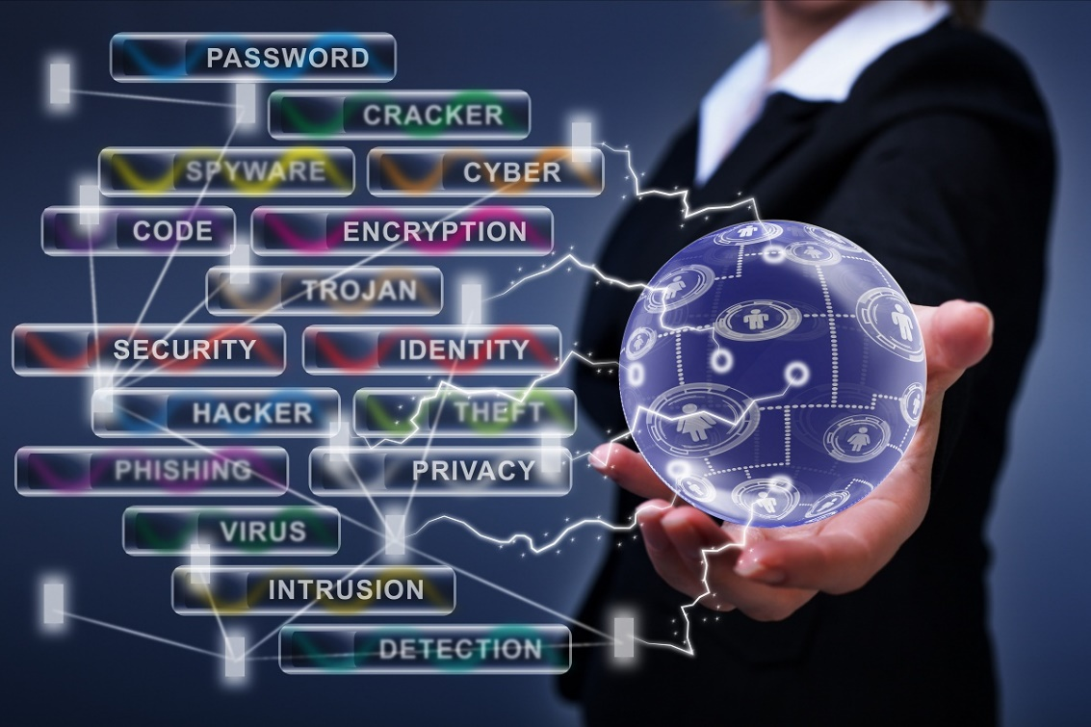
Student Name: Sadaf Yusufzai
Student ID: 251331
Module Code: ACCA4024-LON
Group: 4
Lecturer: Dr. Anum Paracha

Network And Cyber Security Essentials
Table of Contents
Introduction 2
2. Identification of Threats 3
2.1 Internal Threats 3
2.2 External Threats 3
3. Security Policies 4
3.1 Access Control and Password Policy 4
3.2 Network and IoT Security Policy 5
3.3 Data Protection and Governance Policy 5
3.4 Acceptable Use and Remote Access Policy 5
3.5 Backup and Recovery Policy 5
4. Mitigation Measures 5
4.1 Access Control and MFA 6
4.2 Network Segmentation 6
4.3 Security Updates and Malware Protection 6
4.4 Backups and Data Protection 6
5. Monitoring and Incident Response 6
5.1 Network Monitoring 7
5.2 Incident Response Process 7
6. Training and Awareness 8
6.1 Security Awareness Training 9
6.2 Phishing and Social Engineering 9
6.3 Reporting Security Concerns 9
6.4 Reviewing Staff Awareness 9
7. Conclusion 9
References 10
Appendix A 12

Introduction
In this assignment, I will examine the cybersecurity risks facing SteelForm Manufacturing Ltd (SFM) and develop suitable ways to improve the security of the company. SFM uses smart manufacturing technology, including IoT-enabled sensors, automated machinery and a cloud-based production management system. Although these technologies support the company's manufacturing activities, connecting more systems and devices can also create additional security risks.

I will begin by identifying the main internal and external threats that could affect SFM and explain why they are a concern. I will then develop suitable security policies and recommend practical measures to reduce these risks. The report will also explain how the company can monitor its network and respond to security incidents. Finally, I will propose a staff training and awareness programme to help employees understand their responsibilities and follow the new security policies. Overall, the report will provide a structured approach to protecting SFM's information, systems and manufacturing operations.

2. Identification of Threats
SFM faces both internal and external cybersecurity threats because employees, production systems, IoT devices and cloud services are connected. Identifying these threats is important because a successful attack could expose confidential information, interrupt production and cause financial or reputational damage.

2.1 Internal Threats
Human Error- Employees could accidentally open harmful email attachments, use weak passwords or send sensitive information to the wrong person. These mistakes could allow an attacker to access company information or systems. This is a concern because employees regularly use connected systems as part of their work.

Misuse of Access- An employee could access information that is not required for their role or share login details with another person. This could expose confidential customer, production or design information. The risk is particularly important for SFM because it produces custom-engineered components for the automotive and aerospace industries.
Insider Threats- A current or former employee could deliberately copy confidential information, delete important files or interfere with company systems. This could happen for financial gain or with the intention of harming the organisation. For SFM, an insider threat could lead to industrial espionage, data loss or disruption to production.

2.2 External Threats
Phishing and Social Engineering-Attackers could send fake emails containing harmful links or pretend to be a trusted supplier to obtain passwords or other sensitive information [1]. Procurement staff could also receive false payment requests. This is a direct concern because SFM has already experienced phishing emails targeting its procurement staff.

Malware and Ransomware-Malware could enter SFM through an infected attachment, unsafe download or compromised device. Ransomware could encrypt important files or prevent employees from accessing production systems. This could interrupt manufacturing, delay customer orders and create financial losses.

Unauthorised Network and IoT Access-Attackers could attempt to enter the network through stolen passwords, vulnerable IoT devices or poorly protected connections. If successful, they could access sensitive information or interfere with production systems. This is particularly relevant because SFM has already experienced unauthorised attempts to access its production network.

Supply-Chain Attacks-An attacker could compromise a supplier or third-party service and use that trusted connection to target SFM. Harmful software could also enter through a compromised system or update. This is a concern because SFM relies on connected services and external organisations, meaning weaknesses outside the company could also affect its security.

3. Security Policies
SFM needs clear security policies so that employees understand how company systems, devices and information should be protected. The policies should apply across the organisation and support the security of both office and production systems [2].

3.1 Access Control and Password Policy
Employees should only have access to the systems and information they need for their job. Strong passwords should be required, and multi-factor authentication (MFA) should be used for important accounts and remote access. User permissions should also be reviewed regularly and removed when an employee leaves the company. This reduces the risk of stolen accounts, unauthorised access and misuse of company information.

3.2 Network and IoT Security Policy
SFM should keep its office network separate from its production network where possible. IoT sensors, automated machinery and other connected devices should be protected with secure passwords, updates and controlled access. Unnecessary connections and services should be disabled. This policy is important because a weakness in one connected device could provide an attacker with a way into other parts of the network.

3.3 Data Protection and Governance Policy
Sensitive information should be classified according to its importance and only shared with authorised people. Confidential designs, customer information and production data should be encrypted when appropriate. The company should also set rules for how information is stored, shared, backed up and securely deleted. This helps prevent sensitive information from being exposed, changed or lost.

3.4 Acceptable Use and Remote Access Policy
Employees should understand how company computers, email, internet access and removable devices can be used safely. Unknown software should not be installed without permission, and suspicious email links or attachments should not be opened. Staff working remotely should only connect through approved and secure methods. This reduces the chance of malware or unauthorised users reaching SFM's systems.

3.5 Backup and Recovery Policy
Important company and production data should be backed up regularly, with copies kept separately from the main network. Backups should also be tested to make sure information can be restored when needed. This is particularly important if SFM experiences ransomware, system failure or accidental data loss.

4. Mitigation Measures
After identifying the main threats, SFM needs practical measures to reduce the chance of an attack and limit the damage if one occurs. The controls should protect both the company’s information and its manufacturing systems.

4.1 Access Control and MFA
SFM should introduce multi-factor authentication (MFA) for important accounts, cloud systems and employees working remotely. Staff access should be based on their job responsibilities, so they can only use the information and systems necessary for their work. SFM should review these permissions regularly and remove access that is no longer required. These controls would reduce the chance of an attacker entering company systems with a stolen password.

4.2 Network Segmentation
SFM should separate its office network, production systems and IoT devices into different parts of the network. Firewalls can be used to control which systems are allowed to communicate with each other. This means that if malware infects an office computer, it would be more difficult for it to spread to automated machinery or other production systems. Network segmentation would therefore help limit the damage caused by a cyberattack.

4.3 Security Updates and Malware Protection
SFM should regularly update its computers, servers and connected devices to fix known security weaknesses. Anti-malware software should also be used on suitable systems and kept up to date. Updates for production equipment should be tested before they are installed to make sure they do not cause problems with the machinery. This would reduce the risk of malware and attackers taking advantage of outdated systems.

4.4 Backups and Data Protection
SFM should regularly back up important company and production data, with protected copies kept separately from the main network [3]. These backups should also be tested to make sure the information can be restored when needed. Sensitive information, such as customer details and engineering designs, should be encrypted where appropriate [4]. This would help protect important data and allow SFM to recover more quickly from ransomware, system failure or accidental data loss.

5. Monitoring and Incident Response
SFM needs to monitor its systems regularly so that suspicious activity can be identified before it causes serious damage. Monitoring is particularly important because the company has already experienced malware infections and unauthorised attempts to access its production network.

5.1 Network Monitoring
SFM should monitor important systems, including its production network, cloud services, IoT devices and employee accounts. Security logs and alerts can be used to identify unusual activity, such as repeated failed logins, unexpected network connections or malware. The IT security team should review important alerts and investigate anything that appears suspicious. This would help SFM identify possible attacks early and act before they spread to other systems.

5.2 Incident Response Process
If suspicious activity is detected, the IT security team should first check whether a genuine security incident has occurred. If an incident is confirmed, the affected system should be isolated to prevent the threat from spreading. The threat can then be removed, affected systems recovered and data restored from backups where necessary. After the incident, SFM should record what happened and review the cause so that similar incidents can be prevented in the future.
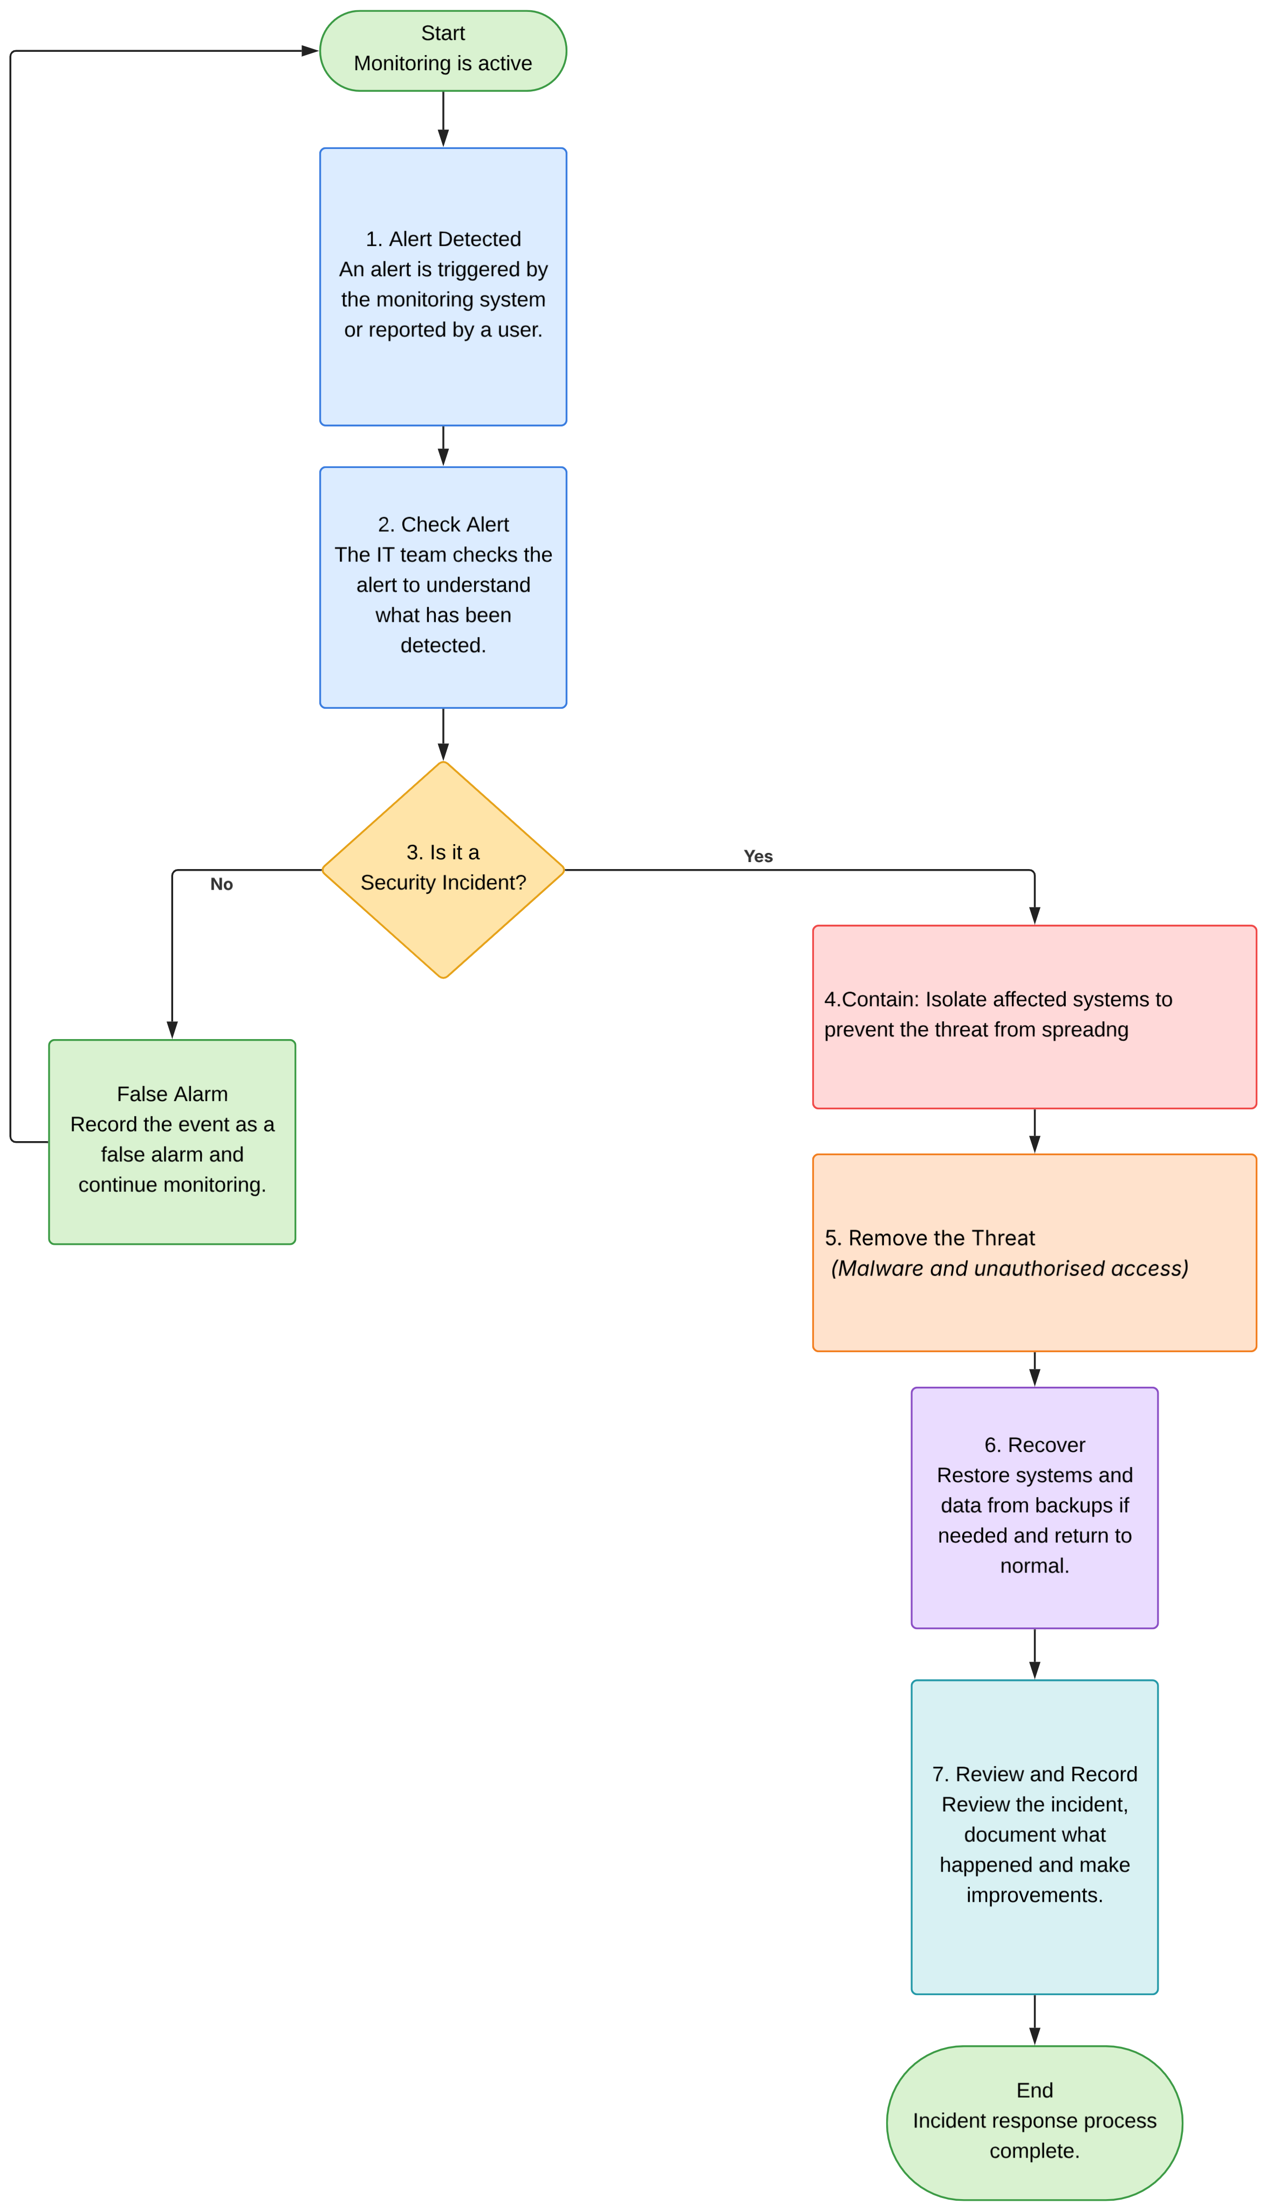

Figure 1: SFM Security Incident Response Process

6. Training and Awareness
Employees play an important role in keeping SFM secure because threats such as phishing and social engineering often target people rather than technology. A staff training programme should therefore be introduced to help employees understand common cyber threats and follow the company’s security policies.

6.1 Security Awareness Training
All new employees should receive basic cybersecurity training when they join SFM. This should cover strong passwords, multi-factor authentication, safe use of company devices and the correct handling of sensitive information [5]. Staff should also receive refresher training during the year so that important security practices are not forgotten.

6.2 Phishing and Social Engineering
Employees should be trained to recognise suspicious emails, links, attachments and unusual requests for information or payments. This is particularly important for procurement staff because they have already been targeted by phishing emails. SFM could also carry out simulated phishing exercises to help staff practise identifying suspicious messages.

6.3 Reporting Security Concerns
Employees should be encouraged to tell the IT security team if they notice suspicious emails, unusual activity on company systems or anything that may indicate a security incident. SFM should provide a simple reporting method so that concerns can be raised quickly. Reporting problems early would give the security team more time to investigate and respond before serious damage occurs.

6.4 Reviewing Staff Awareness
SFM should review the effectiveness of its training through short assessments, phishing exercises and records of completed training. Results can be used to identify areas where employees need additional support. This would help the company maintain security awareness rather than treating training as a one-time activity.

7. Conclusion
In conclusion, SFM faces a range of internal and external cyber threats because of its increased use of connected technology. Threats such as phishing, malware, ransomware, insider activity and unauthorised access could affect the company’s information and manufacturing operations.

The security policies and measures proposed in this report would help SFM reduce these risks by controlling access, protecting its network, keeping systems updated and maintaining secure backups. Regular monitoring and a clear incident response process would also help the company identify and respond to threats quickly. Staff training is equally important because employees need to understand how to recognise threats and follow security procedures.

By combining suitable technology, clear policies, regular monitoring and staff awareness, SFM can improve its overall cybersecurity and reduce the risk of serious disruption to its operations.

References
[1] National Cyber Security Centre, “Phishing attacks: defending your organisation,” 5 February 2018. [Online]. Available: https://www.ncsc.gov.uk/guidance/phishing. [Accessed 13 August 2026].

[2] C. Pascoe, S. Quinn and K. Scarfone, “The NIST Cybersecurity Framework (CSF) 2.0,” National Institute of Standards and Technology, Gaithersburg, MD, 2024.

[3] National Cyber Security Centre, “Mitigating malware and ransomware attacks,” National Cyber Security Centre, 13 February 2020. [Online]. Available: https://www.ncsc.gov.uk/guidance/mitigating-malware-and-ransomware-attacks. [Accessed 13 August 2026].

[4] Information Commissioner's Office, “Encryption and data protection,” Information Commissioner's Office, 2 September 2025. [Online]. Available: https://ico.org.uk/for-organisations/uk-gdpr-guidance-and-resources/security/encryption/encryption-and-data-protection. [Accessed 13 August 2026].

[5] National Cyber Security Centre, “Top Tips for Staff: help your staff keep your organisation safe online,” National Cyber Security Centre, 19 May 2025. [Online]. Available: https://www.ncsc.gov.uk/information/top-tips-for-staff. [Accessed 13 August 2026].

Appendix A


