
Assessment component: Financial performance and management of Tesla
Student ID: 2532591
Student Name: Meet Dilipbhai Patel
Course Name :- Financial Management
Lecturer Name :- Shengfeng Mai
Term :- February 2026
Submission Deadline :- 24th April 2026

TABLE OF CONTENTS
1. Introduction 3
2. Financial Health Check 3
2.1 Financial Performance (5-Year Analysis) 3
2.2 Profitability Analysis 4
2.3 Liquidity Analysis 5
2.4 Efficiency Analysis 6
2.5 Gearing (Solvency) Analysis 8
2.6 Investment Ratios 9
2.7 Cash Flow Analysis 10
2.8 Altman Z-Score Analysis 11
3. Working Capital Management Analysis 12
3.1 Cash Operating Cycle (Cash Conversion Cycle Analysis) 12
3.2 Liquidity Analysis and Working Capital Position 13
3.3 Working Capital Improvement Strategies 14
3.4 Short vs Long-Term Financing Analysis 15
4. Strategic Financial Restructuring Plan (Tesla Inc.) 15
4.1 Address Financial Problems 15
4.2 Financial Restructuring Options 16
4.3 Restructuring Impact 18
4.4 International and Ethical considerations 20
5. Investment Appraisal and Capital Budgeting (Tesla Inc.) 21
5.1 Three Investment Projects Proposed 21
5.2 Critical Examination of the Project Efficiency 22
5.3 Capital Rationing: Combination of Projects 26
5.4 Recommendation on Managing the Company Performance 26
5.5 Non-Financial Risk of the Projects 27
Conclusion 28
Reference List 29

1. Introduction
Tesla is a pioneering international EV company that leads the way in sustainable mobility. This report critically analyzes its financial performance in the period between 2021 and 2025 and examines its key ratios, working capital performance, and strategic issues. It also instills restructuring and investment plans to increase the long term shareholder value and financial sustainability.

2. Financial Health Check

2.1 Financial Performance (5-Year Analysis)
Income Statement Trends
Tesla shows a high revenue growth of $53,823 in 2021 to $97,690 in 2024, and a slight decrease to $94,827 in 2025, which implies transition to slow growth to market stabilisation. This expansion indicates the growth in the global demand of electric vehicles and entering into new markets. Nonetheless, the operating income was highest in 2022 of 13,656 and decreased consistently in 2025 to 4,849, which pointed to the increasing cost of operations and reduction in prices (Yahoo Finance, 2026). The net income also showed a similar trend, reaching a high of $14,974 in 2023 and then dropping sharply to 3,794 in 2025, indicating that profitability has been negatively impacted although revenues are performing well. The income statement, in general, shows that Tesla has reached scale, but retaining profitability is now more difficult.
Balance Sheet Position
The total assets of Tesla grew considerably between 2021 and 2025, to 137,806 compared to 62,131 in 2021, which can be seen as a sign of constant investment in the manufacturing capacity, technologies, and infrastructure. The total equity increased also by 30,189 to 82,137, which is a good indication of internal financing and growth in retained earnings. But the current liabilities have risen since 2021, when it was 19,705, to 2025, when it was 31,714, indicating more short-term financial obligations (Tesla, Inc., 2022). This increase in the level of liability can pose some strain on the liquidity unless effectively addressed. On the whole, the balance sheet indicates good growth and expansion, however, it also shows the growing financial commitments.

2.2 Profitability Analysis
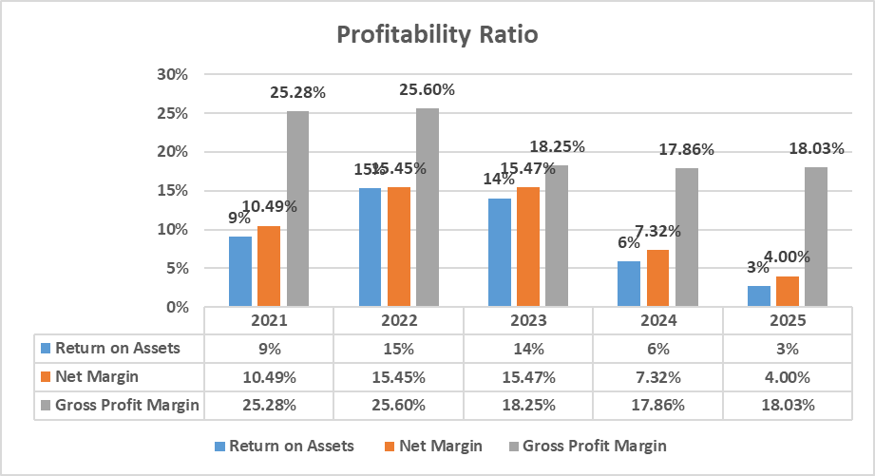
Chart 1: Profitability
(Source: Self-created)
Trends
The net profit margin of Tesla has increased to 15.47% in 2023 compared to 10.49% in 2021, indicating that the company has good operational efficiency, economies of scale, and cost control in the growth stage. Nevertheless, the margin dropped drastically to 4.00 percent in 2025, which shows that the margin is undergoing a lot of compression. This depreciation can be explained by the fact that there is a growing competition, aggressive pricing policies and costs of production increase (Tesla, Inc. 2023). The same behavior was observed in the case of Return on Assets (ROA) as it rose to 15% in 2022 and then dropped to 3% in 2025. This implies that Tesla has over time become less efficient in generating profits out of its asset base. The gross profit margin decreased as well, 25.60% in 2022, to 18.03% in 2025 indicating that the cost of sales has risen compared to revenue, maybe because of disruptions in the supply chain and increased costs of raw materials.
Strength
In the profitability ratios shows that Tesla has a high level of efficiency in its operations, technological position, and high scale production. The firm was able to exploit the growth in demand to enhance the margin in the initial years.
Threats
The great decrease in profitability post-2023 suggests the growing cost pressure and competition in the EV industry. Provided that the trend persists, it could lower the long-term profitability and the confidence of investors.

2.3 Liquidity Analysis
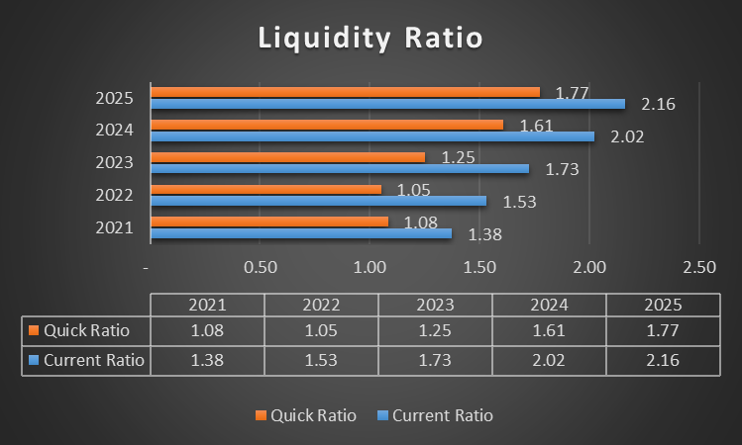
Chart 2: Liquidity
(Source: Self-created)
Trends
The current ratio of Tesla increased gradually: it was 1.38 in 2021 and 2.16 in 2025, which indicates a greater possibility of fulfilling short-term responsibilities. Likewise, the quick ratio rose by 1.08 to 1.77 indicating good liquidity without the inclusion of inventory (Tesla, Inc. 2024). These tendencies imply that Tesla has enhanced its financial standing in the short-term perspective during the past five years.
Strength
The upward trend in liquidity ratios indicates that Tesla has a high level of cash management and is capable of meeting its short-term needs. This is to keep stability in operations and minimize the possibility of liquidity crises.
Threats
But too high liquidity can also be a sign of underutilisation of assets, so that excess funds are not being efficiently invested. This may curtail possible returns and lower financial performance.

2.4 Efficiency Analysis
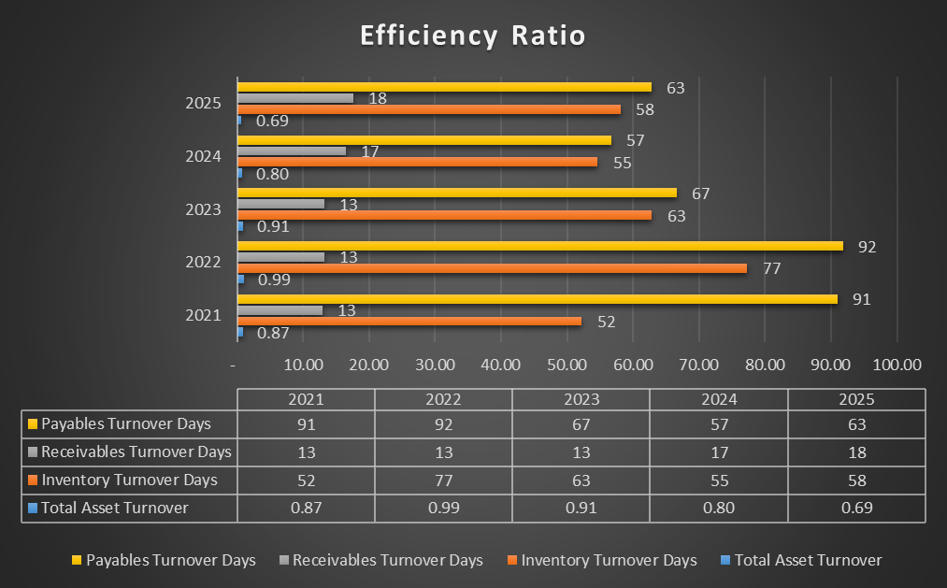
Chart 3: Efficiency Ratio
(Source: Self-created)
Trends
The 2022 inventory turnover days were 77 days as compared to 52 days in 2021, which shows slower inventory turnover in the year 2022. It however improved and stabilised later at 55-58 days indicating improved inventory management and demand alignment (Tesla, Inc. 2023). The period of collection of receivables did not change significantly, staying at 13 days between 2021 and 2023 and slightly rising to 18 days in 2025, which demonstrates effective management of credit and slight delays in the payments made to customers. The turnover days of payables decreased in 2025 compared to 2021 as 91 days were decreased to 63 days, indicating that Tesla is paying suppliers faster.
Strength
The comparatively low receivables turnover period and stabilised inventory turnover show that Tesla has an efficient operation management and that its products are in demand. All these are positive in working capital efficiency.
Threats
The decrease in the payables days will decrease the capacity of Tesla to rely on the supplier credit as a source of financing, hence the cash flow (McKingsley, 2024). Moreover, changes in the inventory turnover can represent the supply chain management inefficiencies.

2.5 Gearing (Solvency) Analysis
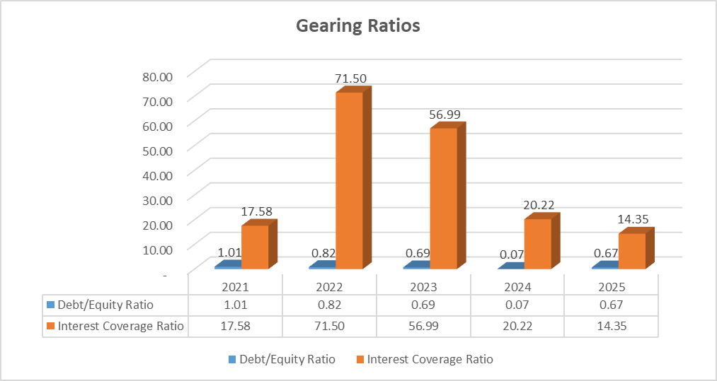
Chart 4: Gearing
(Source: Self-created)
Trends
The debt-to-equity ratio of Tesla has gone down and is now 0.67 in 2025 as compared to 1.01 in 2021, this indicates a reduced dependence on debt financing and a more robust equity base. This is indicative of better financial stability and reduced financial risk (Yahoo Finance, 2026). In both 2022 and 2025, interest coverage ratio was very high, at 71.50 and 14.35 respectively, which means that operating income has declined in comparison to interest coverage.
Strength
A decrease in the degree of gearing increases the financial stability of Tesla and mitigates the risk of high levels of debts (Li, 2025). This enhances investor confidence and offers more financial flexibility.
Threats
The interest coverage has decreased, which indicates that Tesla has been weakening in its capacity to cover interest payments. In case the profitability remains low, then it may be a threat to financial sustainability.

2.6 Investment Ratios
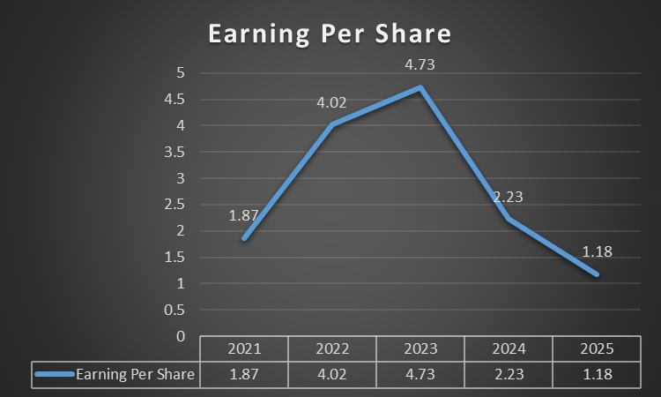
Chart 5: Investment Ratio
(Source: Self-created)
Trends
Profitability and shareholder returns have been very high as earnings per share (EPS) has grown to 4.73 in 2023 compared to 1.87 in 2021. Nevertheless, in 2025, the EPS dropped to 1.18, which implies lower profits to shareholders.
Strength
The growth trend in EPS indicates that Tesla has the potential to give high returns to investors and increase shareholder value (Huang, 202323).
Threats
The negative movement in EPS represents the decrease in profitability and might harm the mood and value of investors and shares, particularly in the competitive market.

2.7 Cash Flow Analysis
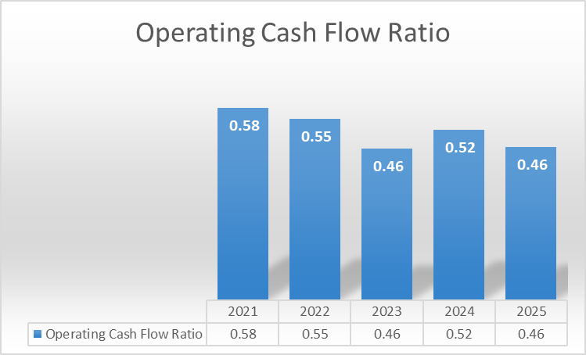
Chart 6: Cash Flow
(Source: Self-created)
Trends
Cash flow also had a relatively stable trend, as the cash flow increased between 11,497 in 2021 and 14,747 in 2025. Nevertheless, the operating cash flow ratio dropped to 0.46, which means that the company became less efficient in its cash generation in comparison to the current liabilities.
Operating cash flow remained relatively stable, increasing from $11,497 in 2021 to $14,747 in 2025 (Yahoo Finance, 2026). Nonetheless, the operating cash flow ratio decreased by 0.58 to 0.46, which means less efficiency in cash generation in comparison to the current liabilities.
This deterioration indicates that Tesla is not only generating cash but its liabilities are increasing at a higher rate, which affects the efficiency of the cash flow.
Strength
The presence of positive operating cash flow over the years is a sign that Tesla is able to produce enough cash to fund its business and investments.
Threats
The downward trend in the operating cash flow ratio implies that the pressure on the management of liquidity and the possible need to rely on external financing in case of further growth in liabilities increase.

2.8 Altman Z-Score Analysis
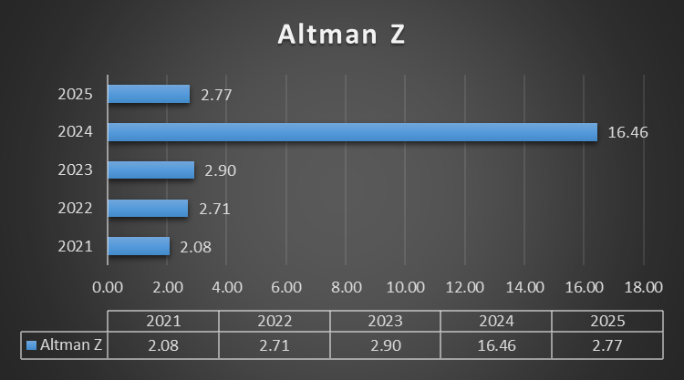
Chart 7: Altman Z-Score Analysis
(Source: Self-created)
The Altman Z-score of Tesla represents its changing financial stability over a period of five years. It has gone up to 2.90 in 2023, as compared to 2.08 in 2021, indicating better liquidity, retained earnings, and operational performance. The spike to 16.46 in 2024 is however abnormal, indicating possible inconsistency in the data or severe financial distortion (Tesla, Inc. 2022). The score decreases to 2.77 in 2025, which is the grey zone, meaning that Tesla has moderate financial risk. This is an indication of growing vulnerability and that there should be better profitability, working capital management, and financial resilience over the long term.

3. Working Capital Management Analysis

3.1 Cash Operating Cycle (Cash Conversion Cycle Analysis)
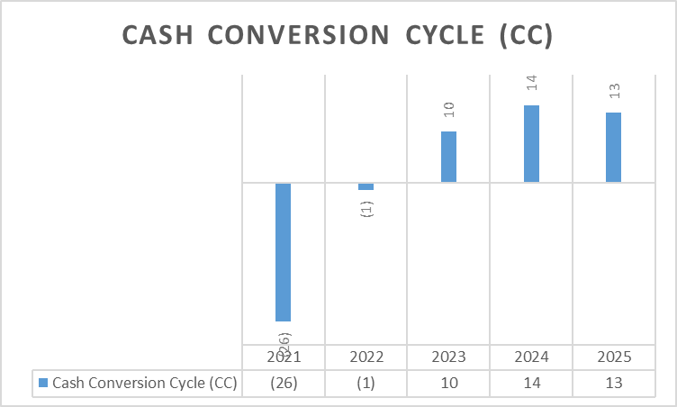
Chart 8: Cash operating Cycle
(Source: Self-created)
One of the metrics employed to analyze the working capital efficiency of Tesla is the Cash Conversion Cycle (CCC) that evaluates the speed at which Tesla turns its investments in its operations into cash inflows generated by customers (Kikkas, 2020). It gives a definite sign of liquidity management and short-term financial health.
The CCC of Tesla indicates a clear change in the efficiency of operations structure over the five-year period. As of 2021, the CCC stood at -26 days and in 2022, the company enhanced this metric slightly to -1 day, which reflects a very efficient working capital management where Tesla could receive cash payments and settle its suppliers. This vicious cycle practically meant that supplier credit was being applied as a type of short-term financing, enhancing liquidity (Li, 2025). But since 2023, the CCC has become positive, going to 10 days, 14 days in 2024 and 2025, respectively, and slightly. This change implies that it currently takes Tesla longer to transform operational inputs into cash inflows, and it is less efficient in managing liquidity.
This transition is also reflected in inventory turnover days. The number of days improved to 77 days in 2022 compared to 52 days in 2021, indicating short-term production planning inefficiency and supply chain disruptions in the case of expansion (Wang, 2025). Tesla, however, managed to lower their inventory levels in the following years to 63 days in 2023 and stabilised at 55-58 days in 2024-2025. This shows that there is better demand forecasting and better matching of production and sales.
The receivables days were stable at 13 days and in 2021-2023, despite the high credit control, it slightly rose to 17-18 days in 2024-2025 as it expanded on the global level and competitions intensified. In the meantime, the days of payables became much lower, 91-92 days to 57-63 days, which means that it is less dependent on supplier credit.

3.2 Liquidity Analysis and Working Capital Position
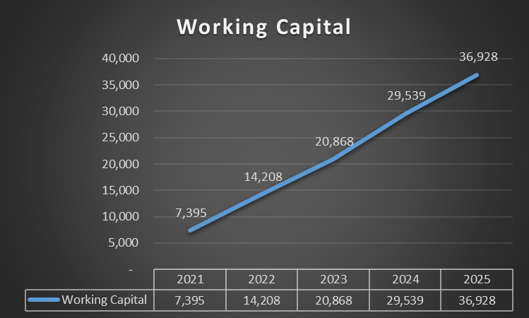
Chart 9: Working Capital
(Source: Self-created)
The working capital position of Tesla has significantly improved during the five years. In 2025, current assets grew to $68,642 million as compared to 2021, where the growth was to $27,100 million, whereas current liabilities also improved to 31,714 million compared to 19,705 million in 2021 (Tesla, Inc. 2022). Consequently, the working capital increased drastically by growing by a margin of 7,395 million to 36,928 million, which showed greater liquidity provision and expansion in its operations.
This expansion is a sign of enhanced short-term financial strength and expansion in the business. Nevertheless, much of the capital is invested in current assets including inventory and receivables that can decrease the efficiency of capital when it is not managed well. Although this contributes to the operation stability and growth, it may also restrict optimal resource utilisation (Wang, 2025). In general, Tesla has a high liquidity in absolute terms, but the growing working capital and the increasing Cash Conversion Cycle indicate the deterioration of efficiency in its cash use and increased dependence on internal funding of its activities.

3.3 Working Capital Improvement Strategies
To increase the level of liquidity Tesla ought to introduce specific working capital reforms based on its operational ability (Brás, 2025). To begin with, demand forecasting with integration of AI and production systems can help to optimise inventory levels, decrease holding costs, and improve the balance between supply and demand. This would directly decrease inventory days and enhance efficiency of cash flow.
Secondly, the reduction of the receivables days could be achieved by enhancing the receivables management by tightening credit control policies, electronic payment monitoring solutions, and incentives of early payment. Quickening of cash collection would enhance liquidity and help decrease working capital strain (Matevosyan, 2025). Tesla has the opportunity to renegotiate supplier contracts to increase payables days without damaging supplier relationships. Applying the supply chain finance solutions may enable the suppliers to be paid by financial institutions in advance and Tesla to enjoy longer payment terms. This enhances retention of cash without interfering with operations.
Also, global cash management systems that are centrally managed can enhance transparency of the cash flows in the various parts and subsidiaries and this will enable the liquidity to be optimally allocated and idle cash balances to be minimised (Ding, 2025). All these measures are meant to minimize CCC, increase liquidity efficiency, and create flexibility in operations in a capital-intensive industry.

3.4 Short vs Long-Term Financing Analysis
Tesla relies on both short-term and long-term sources of financing and both have varied implications in terms of liquidity, cost and financial risk.
Short -Term Financing
Trade credit and working capital financing are the most common types of short-term financing. Tesla has long payables in the past, Tesla enjoyed long payables of up to 92 days (2022), which offered a large amount of liquidity in the short term. Nonetheless, this dropped to 63 days (2025), which means that supplier financing was less relied upon (Chari and Ferreira 2025). Though short-term funding is flexible and less costly in the short-run, it exposes the company to greater liquidity risks particularly at a time when the CCC has switched to positive and cash is currently committed in operations.
Long -Term Financing
Long-term financing is indicated in the growth of asset of Tesla by a record of 62,131 million (2021) to 137,806 million (2025), indicating the high dependence on the long-term sources of capital like equity and long-term debt. This money can be used to finance large scale investments in Gigafactories, research and development and global expansion strategies. Long-term financing offers financial stability, encourages growth and minimizes the refinancing risk (Yahoo Finance, 2026). It, however, adds to long-term commitments and can water down returns of the shareholders in case of excessive use of equity financing.
It can be compared that short-term financing better provides flexibility in liquidity but compromises cash flow stability, whereas long-term financing provides stability but less financial flexibility (Oladele, 2025). The delicate balance is hence the key to sustaining both efficiency in operations and strategic development.

4. Strategic Financial Restructuring Plan (Tesla Inc.)

4.1 Address Financial Problems
Tesla has experienced a significant growth in revenue, which has grown over the past five years, starting at about $53.8 billion in 2021 and reaching up to 94.8 billion in 2025. This expansion is largely fuelled by increasing popularity of electric cars across the globe and the ongoing global expansion (Tesla, Inc. 2022). Nonetheless, the company has shown deteriorating profitability and operational efficiency despite its good performance in the top-line, which is a signal of structural financial pressure.
There is a significant margin compression as operating income that was approximately 13.6 billion in 2022 has been dropped to 4.8 billion in 2025. The main reasons behind this decline include increasing input costs, increased price competition and extensive investment in artificial intelligence and autonomous driving technology (Tesla, Inc. 2024). This has made net income more volatile, reflecting the strategic change in Tesla to long-term innovation and market leadership, instead of short-term profit maximisation.
Cost inflation of basic battery raw materials including lithium, nickel, and cobalt that have risen by 12-18 is one of the pressure factors. Simultaneously, Tesla engaged in aggressive discounts of 5-15% in major markets in order to outcompete its competitors, BYD and Volkswagen, further compressing margins (Tesla, Inc. 2024). There has also been a weakening in working capital efficiency. Despite the fact that the working capital grew to $36.93 billion in 2025, the Cash Conversion Cycle changed to +13 days in 2025, which was lower in terms of cash conversion, liquidity efficiency, and reliance on internal financing.

4.2 Financial Restructuring Options
Merger and Strategic Acquisition Strategy
Tesla needs to focus on selective acquisitions as opposed to massive mergers to enhance vertical integration and technology. Entering into strategic acquisition of battery material suppliers, AI chip developers or recycling technology companies would improve control over essential inputs and decrease reliance on external suppliers (Li, , 2025). It is anticipated that such acquisitions will lead to a cut in the production costs of about 8-12 per unit and enhancing the gross margins and stabilising the long-term cost structure. As much as acquisition costs can have a range of between 10-15 billion, it has long term advantages such as enhancing resilience in the supply chain, lowering price volatility risk, and gaining stronger control over technology.
Financially, this is in tandem with synergy theory where joint operations produce greater future cash flows, raising firm valuation when using discounted cash flow models.
Equity Injection and Sustainable Financing Strategy
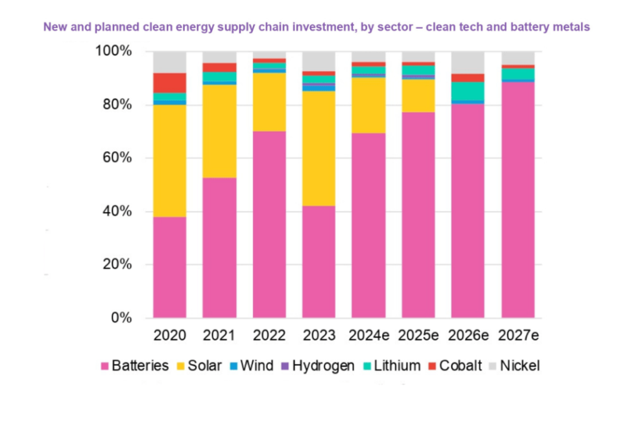
Chart 10: Equity Injection and Sustainable Financing Strategy
(Source: Hussain and Ghosh, 2025)
Equity financing or green bond issuance can be used to enhance Tesla capital structure. A possible equity issue of about 15-20 billion dollars would facilitate strategic investments in AI systems, battery development and international production (Hussain and Ghosh, 2025). This will water down the earnings per share, which has fallen to about 1.18 in 2025, but will go a long way in strengthening the balance sheets and minimizing reliance on debt financing. This helps to shift away leveraged expansion to innovation by using equity, and less risk of financial distress.
Alternatively, green bonds with the interest rate of 4-5% can be issued, which will give Tesla cheaper capital and enhance its ESG. This is also appealing to institutional investors who are interested in sustainable investments to enhance long-term valuation stability.
Supply Chain and Strategic Alliances
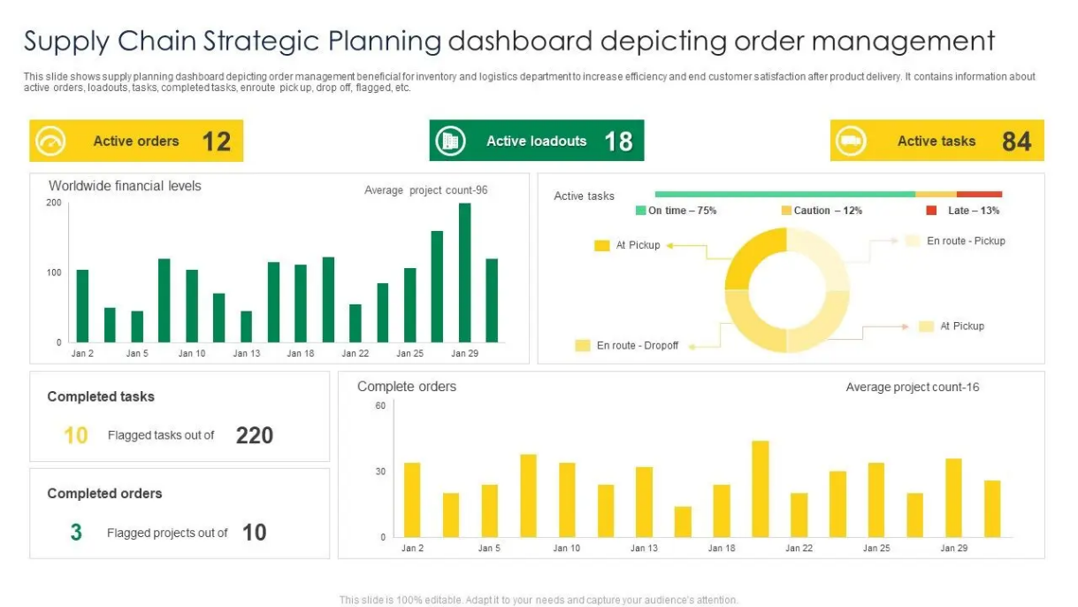
Chart 11: Supply Chain and strategic
(Source: Soliman, 2025)
Tesla should enhance their strategic partnerships. Lithium sourcing, semiconductor manufacturing, and AI hardware development partnerships can enhance supply chain stability and minimize cost volatility (Soliman, 2025). It is estimated that these alliances will lower the unit production expenses to about 8-10 percent, and enhance responsiveness in operations. This model increases flexibility over acquisitions, as Tesla is flexible to respond to changes in the market swiftly without massive capital commitments.

4.3 Restructuring Impact
Shareholder Value Impact
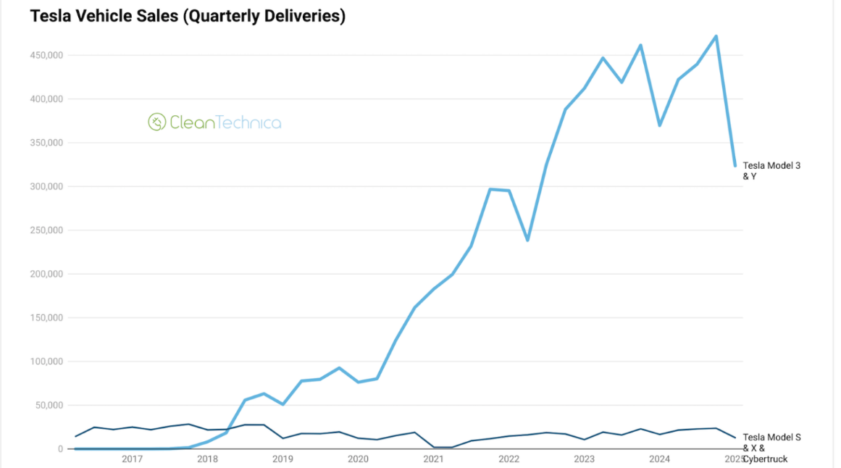
Chart 12: Shareholder Value Impact
(Source: Utama 2025)
A falling performance of earnings has had an adverse impact on Tesla shareholder value. EPS decreased to 1.18 (2025) (down to 4.73 (2023) indicating lower short-term profitability. Nonetheless, reorganization aims at enhancing long-term value in the shareholder wealth maximisation principle which focuses on discounted future cash flows than short-term earnings (Tesla, Inc. 2022). Return on invested capital is enhanced through asset optimisation and divestiture of non-core operations to reallocate resources to high-margin areas like AI-driven vehicles and autonomous systems (Utama 2025). Although issuing equity can lead to short-term dilution, it enhances valuation in the long-term by increasing growth sustainability and minimizing financial risk.
On the whole, reorganizing turns Tesla into a company with a value-based profitability that is driven by technological innovation instead of a volume-based one.
Debt Structure Impact
Tesla has a medium leverage ratio of about 0.67 (2025). Although this can be handled, a decline in the operating income means that there will be less capacity to cover interest and that the financial position will become more vulnerable (Yahoo Finance, 2026). An equity financing and asset divestment restructuring strategy lowers the level of debt, enhancing the stability of the capital structure. This is in line with the trade-off theory of capital structure which proposes optimum leverage ratios between tax advantages of debt and financial distress costs.
Reduced leverage enhances the stability of credit rating and it minimises the refinancing risk especially in a high global interest rate environment. It further increases financial stability and sustainability.
Operational Flexibility Impact
The current limitation of operational flexibility is escalating working capital requirement and reduced turnover of cash. The transformation of the Cash Conversion Cycle into a positive one of 13 days (2025) demonstrates less effective operation cash (Roy et al, 2025). Disposing of non-core assets can lead to a simpler operation and a more efficient allocation of capital. Strategic alliances also improve responsiveness of supply chains and lessen the reliance on one supplier.
Better capital structure enables Tesla to distribute resources in a more efficient way, making the company more agile in production scale, decision-making on innovation and global expansion.

4.4 International and Ethical considerations
Global Compliance and Taxation
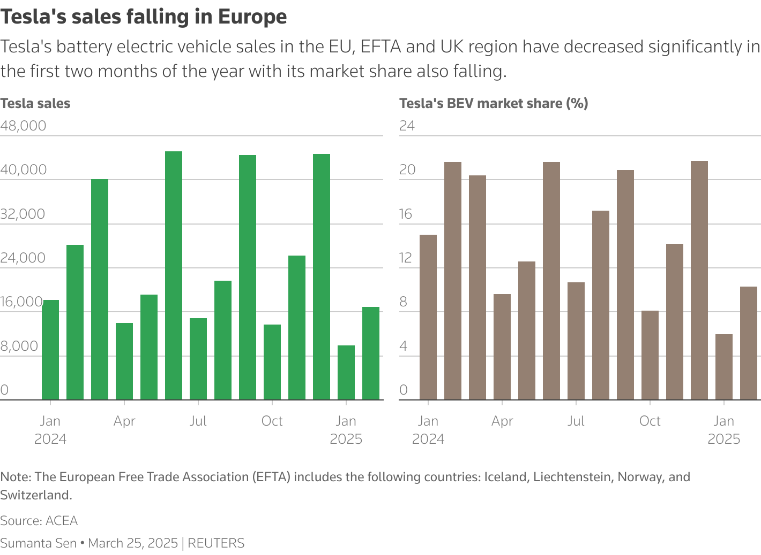
Chart 13: Global Compliance and Taxation
(Source: Fiegenbaum, 2026)
Tesla has operations in the region of various jurisdictions with a corporate tax rate of between 21-30 percent which has a big impact on net profitability. Inefficient tax organization might decrease net income by about 3-5 percent per annum (Fiegenbaum, 2026). This is why tax optimisation on the global level is a necessity, and minimum tax standards of the OECD are to be adhered to. The international structuring is effective to guarantee of the regulatory compliance and at the same time to maintain the profitability efficiency.
Currency Risk Management
Tesla faces the risk of foreign exchange volatility because of its revenue base around the world. An appreciation of the US dollar by 5 percent might cut the foreign revenues by about 2-3 billion dollars per year, especially in the European and Asian markets (Karaus, 2025). Mitigation of risks is done through forward contracts, hedging of currency and more localisation of production. Local production minimizes the exposure and builds natural hedge against currency fluctuations.
Inflation Impact
The cost of producing batteries has gone up by about 12-18 due to inflation in raw materials hence directly impacting profits. Lithium and nickel are the major materials that are volatile (Chari and Ferreira, 2025). Tesla needs to implement long term supplier agreements, vertical integration and recycling technology to lessen reliance on external raw materials. Such plans stabilise the cost frameworks and enhance long term margin stability.
ESG Considerations and Corporate Social Responsibility (CSR)
The restructuring of Tesla should be consistent with the expectations of ESG in terms of the growing interest of investors in sustainability. The sourcing of raw materials in ethical ways and being environmentally responsible in production processes is of essence (Ali and Jamil, 2025). ESG ratings are enhanced by investing in battery recycling, integration of renewable energy, and sustainable supply chains. High ESG performance has the ability to decrease cost of capital by an average of 1-2, improving the overall firm valuation in discounted cash flow models.

5. Investment Appraisal and Capital Budgeting (Tesla Inc.)

5.1 Three Investment Projects Proposed
Three mutually exclusive capital investment projects, Project A, Project B, and Project C, with an initial investment of 50 million, are under consideration by Tesla and have been analyzed at a cost of capital of 10 percent using NPV, IRR, ARR, PBP and PI. The cash inflows of project A are not evenly distributed, amounting to 10m, 12m, 14m, 10m and 8m, with a moderate initial performance and a decreasing returns. Project B offers steady inflows of 11m/year implying predictable yet low-growth performance. Project C has a back-loaded trend of 5m, 10m, 20m, 25m, and 5m indicating increased value creation that is delayed but could be increased during the mid-term (Zeng et al., 2025). These projects represent varying risk-return profiles: Project A has a moderate stability with decreasing efficiency, Project B is low-risk and low-return, whereas Project C has greater variability and its growth potential is stronger. Financially, Tesla would be better advised to focus on long-term discounted cash flow maximising projects and not accounting profits, in line with the principle of shareholder wealth maximisation.

5.2 Critical Examination of the Project Efficiency
Investment appraisal is done by both non-discount and discount approaches in order to provide a comprehensive assessment of financial performance and risk adjusted returns.
Project A
Project A exhibits a moderate recovery of the liquidity with Payback Period of about 4.4 years, which signifies that the initial investment is recovered a bit prior to the project completion. Nevertheless, the discounted performance demonstrates a lot of inefficiency.
Project A has a Net Present Value (NPV) of $8.68 million, which shows clearly that there is destruction of value at a discount rate of 10% (Tesla, Inc. 2023). This implies that the project does not make returns on it in order to cover the opportunity cost of capital.
Accounting Rate of Return (ARR) is 1.6, which is far less than the required threshold of profitability by Tesla, i.e., the accounting profitability is poor. Besides, the Internal Rate of Return (IRR) is 2.7 that is much less than the cost of capital of 10%, which proves that Project A is not financially viable (Yahoo Finance, 2026).
The cash inflows are relatively more stable in early years, but the decreasing trend in later years lowers the value creation in the long-term. Strategically, Project A does not pass the NPV decision rule, the main decision rule in investment acceptance in contemporary financial management. Project A is thus value-destroying and must be rejected.
Project B
Project B offers predictable and constant inflows of cash of 11 million every year and the Payback Period is a bit longer at 4.55 years, which means slower recoup of initial capital.
Its NPV however is -8.30 million in that it is also a negative value creation when discounted at 10% (Tesla, Inc., 2022). The ARR of 2.0% is much lower than the necessary returns, which means ineffective accounting profitability.
Project B does not satisfy the criteria of investment efficiency since the IRR of 3.3 is slightly greater than that of Project A but significantly lower than the cost of capital. Risk wise, Project B is not very volatile, with the cash flows being stable (Tesla, Inc. 2023). The opportunity cost of low-risk/low-return projects is great, however, in a high-growth industry like electric vehicles and autonomous technology. The amount of capital devoted to these projects might be used in areas of high growth in innovation, depleting the competitive advantage of Tesla in the long term.
Project C
Project C has the best financial and strategic performance compared with the other two projects. It features the shortest Payback Period of 3.6 years, which means that it is quicker to recover the capital and has better liquidity efficiency.
Though it has a negative NPV of -1.98 million, it is much nearer to breakeven than Projects A and B, which means it will retain value better based on the discounted cash flow analysis.
The ARR is 6.0 and much higher than other projects, indicating greater accounting profitability and greater utilisation of assets.
Most importantly, Project C has an IRR of 8.6, thus the nearest project to the discount of 10 percent. This is a sign of high cash flow efficiency in the mid-term and is more in line with the investment expectations of Tesla (Wang et al., 2025). Although not managing to do that entirely as to surpass the cost of capital, Project C shows the most effective balance between risk and returns. Its back-loaded cash flow presentation indicates the Tesla business model, which is highly innovative with returns being realized through long-term technological changes and not short-term returns.

5.3 Capital Rationing: Combination of Projects
Tesla has a capital constraint of $100 million, which implies that two out of the three projects can be chosen. Analysis of capital rationing is thus necessary to maximise the total value creation with limited capacity of investment.
Three options are considered:
- Project A + B give a cumulative NPV of -16.98 million as the worst financial performance and maximum value destruction.
- Project A + C would give a net NPV of -$10.66 million, which is a positive but negative figure on the whole.
- Project B + C will lead to the least negative NPV of -$10.29 million compared to all the combinations.
Despite the fact that all the combinations give negative NPVs based on the assumption of a high discount rate, the B + C is the best capital rationing decision, as it destroys the least value, and balances between stability (Project B) and growth (Project C).
Project C would be the preferred investment, based on a portfolio optimisation perspective, because of its higher IRR and comparatively more robust cash flow structure (Sibeko, 2025). Capital rationing thus affirms that Tesla ought to consider Project C even in restricted investment environments.

5.4 Recommendation on Managing the Company Performance
According to detailed capital budgeting analysis, Tesla ought to focus on Project C as the key investment alternative since it is more financially efficient and aligned to long term growth goals.
Project C has the best IRR (8.6%), shortest payback (3.6 years) and most preferable NPV (-$1.98 million) of all the alternatives (Wang, 2026). Though it is not entirely over 10% discount rate, it shows the best relative performance and the nearest to investment viability.
Project B can be viewed as a second stabilisation investment because of the certain flow of cash and lesser operational risk. Its low IRR (3.3) however makes it less appealing in a high growth industry. The project A is to be rejected because of the poor performance in all the financial metrics.
Project C is strategically aligned with the Tesla innovation-based model, especially in terms of AI integration, autonomous driving systems, and the next-generation battery technology. This helps in the long-term maximisation of shareholder wealth because investment choices are appraised on future discounted cash flows as opposed to the accounting performance in the short term.

5.5 Non-Financial Risk of the Projects

Fig 1: Non- financial risk
(Source: Self-created)
Customer Loyalty Risk
The level of innovation, product reliability and delivery performance are very sensitive in customer loyalty. Project C, though financially better, is associated with a greater technological risk because it is based on advanced systems of innovations, including AI and self-driving cars.
Any product development delays or technical breakdowns would have an adverse effect on customer trust and brand image. Nevertheless, an effective implementation would make Tesla much more brands loyal, differentiate, and retain long-term customers (Gupta et al., 2025). Thus, the risk of customer loyalty is moderate but is strategically positive in case of successful execution.
Political Risk
Tesla is a company with a presence in many countries across the world and faces a lot of political and regulatory risk. Profitability is directly influenced by changes in EV subsidies, import tariffs and environmental regulations. In the regional exposure, a 510 per cent tariff increment would decrease annual cash flows by about 35 million. Moreover, risks to operations are caused by geopolitical tensions in battery supply chains (lithium, cobalt, nickel).
Project C will be more vulnerable to political risk as it relies on the advanced systems of global supply chains and new technology ecosystems.
Regulatory and Market Risk
Government policies have a significant influence on the rates of EV adoption. Demand may diminish due to any form of subsidy reduction or increase of emission controls and impact adversely on the returns of projects (Aggarwal and Eldar, 2026). This uncertainty is especially applicable in Project C, which is largely dependent on the further market growth and the rate of technology adoption.
Technology Risk
The technological risk facing project C is greater because of its dependence on new technologies like AI-driven driving system and further development of batteries. Delay experienced in technological maturity or integration may result in lower returns.
Nevertheless, the successful implementation would greatly enhance the competitive edge and the profitability of Tesla in the long term.
Financial Risk Exposure
Tesla has an average leverage ratio of 0.67 (2025) which implies that it has controlled yet existing financial risk. The longer the payback period of projects, the more they are susceptible to liquidity limitations.
Project C is less susceptible to this risk because it is expected to cover the capital in a shorter time, hence the decrease in reliance on external financing and the efficiency of generating cash internally.

Conclusion
The financial analysis of Tesla shows that it has a high revenue growth and a decreasing profitability and efficiency. The long-term value creation is enhanced by strategic restructuring, working capital optimization, and the choice of Project C. In general, the competitiveness and shareholder wealth cannot be maintained without disciplined allocation of capital and risk management.

Reference List
Aggarwal, D. and Eldar, O., 2026. Disproportionate Influence: Rethinking Control in American Corporate Governance. Northwestern University Law Review, 120(6), pp.1573-1630.
Ali, M. and Jamil, M., 2025. Legal challenges and ESG due diligence in cross-border Mergers and Acquisitions (M&A) in the US.
Brás, G.J.T.F., 2025. Transitioning to electric vehicles: strategic, financial, and operational challenges for NOVA in the business in practice program.
Chari, M. and Ferreira, V.F.M., 2025. Strategy as What a Business Should Do Over Time to Succeed: A Case Study of Tesla, Inc. American Business Review, 28(1), p.15.
Chari, M. and Ferreira, V.F.M., 2025. Strategy as What a Business Should Do Over Time to Succeed: A Case Study of Tesla, Inc. American Business Review, 28(1), p.15.
Ding, R., 2025, July. Value Investing in the EV Industry: A Case Study of Tesla. In 2025 International Conference on Financial Risk and Investment Management (ICFRIM 2025) (pp. 929-937). Atlantis Press.
Fiegenbaum, I., 2026. The Controlling Shareholder Amendments Reconsidered. Available at SSRN 6061594.
Gupta, N., Urmetzer, F. and Ansari, S., 2025. Big-tech strategic partnerships in artificial intelligence.
Huang, W., 2023. Understanding Tesla’s Financial Strength: Analysis of Financial Reports and DuPont Analysis. Highlights in Business, Economics and Management, 6, pp.250-261.
Hussain, M. and Ghosh, J., 2025. The economic impact of artificial intelligence: A case study of DeepSeek R1. INTERNATIONAL JOURNAL OF RESEARCH, 8(1), pp.80-84.
Karaus, J., 2025. Sustainable sourcing of raw materials in the automotive industry.
Kikkas, O.A., 2020. Financial performance assessment of tesla, inc. and nissan motor company.
Li, L., 2025. Deferred Revenue and Profitability in Tesla’s Software-Integrated Model: A Case Study under ASC 606.
Li, X., 2025, November. Business Model Comparison between Tesla and BYD: From Supply Chain Integration to Core Technology Competition. In 2025 International Conference on Financial Innovation and Marketing Management (FIMM 2025) (pp. 642-650). Atlantis Press.
Li, Y., 2025, February. Financial Analysis of the Company Tesla. In International Workshop on Navigating the Digital Business Frontier for Sustainable Financial Innovation (ICDEBA 2024) (pp. 566-575). Atlantis Press.
Matevosyan, A.V., Grigoryan, A.Z., Matevosyan, M.H., Nersisyan, A.V. and Baghdasaryan, V.G., 2025. Proposed approach capital structure management related to AI: Evidence from automobile manufacturing companies. Journal of Trends and Challenges in Artificial Intelligence, 3(1), pp.39-46.
McKingsley, S., 2024. Analyzing CFO Leadership: Addressing Economic Challenges and Strategic Priorities. Open Access Cases, 1(2).
Oladele, O.K., 2025. The Influence of Strategic Management on Sustainable Business Development. Research Gate, February.
Roy, A., Ara, J., Ghodke, S. and Akter, J., 2025. Artificial intelligence in corporate financial strategy: transforming long-term investment and capital budgeting decisions. Journal of Economics, Finance and Accounting Studies, 7(5), pp.50-59.
Sibeko, F.M., 2025. Global Journal of Economic and Finance Research.
Soliman, M.H.A., 2025. Why Tesla Still Can’t Build Like Toyota: A Chapter-by-Chapter Analysis of Lean Thinking vs. Tech Hype. Personal Lean Publications.
Tesla, Inc. (2022) Annual Report 2022. Available at: https://www.annualreports.com/HostedData/AnnualReportArchive/t/NASDAQ_TSLA_2022.pdf (Accessed: 22 April 2026).
Tesla, Inc. (2023) Annual Report 2023. Available at: https://www.annualreports.com/HostedData/AnnualReportArchive/t/NASDAQ_TSLA_2023.pdf (Accessed: 22 April 2026).
Tesla, Inc. (2024) Annual Report 2024. Available at: https://www.annualreports.com/HostedData/AnnualReports/PDF/NASDAQ_TSLA_2024.pdf (Accessed: 22 April 2026).
Utama, G.B.C., Chusyairi, A. and Sahara, R., 2025. Identification of Stock Breakouts Using Support Vector Machine with Integrated Fundamental Data and Random Forest Prediction. Faktor Exacta, 18(1).
Wang, C., 2026. The Architecture of Control and Fiduciary Limits: Rethinking Superstar CEOs. forthcoming, Penn State Dickinson Law Review, 131.
Wang, X., Chi, Y. and Tian, L., 2025 Decoding the Ecological Symbiosis of NEV Enterprises Overseas: A Competitiveness Model Approach.
Wang, Y., 2025. Liquidity Management and Financial Stability in High-Growth Tech Companies. Advances in Economics, Management and Political Sciences, 146, pp.37-43.
Yahoo Finance (2026) Tesla, Inc. (TSLA) Financials. Available at: https://finance.yahoo.com/quote/TSLA/financials/ (Accessed: 22 April 2026).
Zeng, Y., Yao, X., Yang, S. and Hsu, W., 2025. Strategic Marketing Analysis of NIO: A Case Study on Electric Vehicle Industry in China. In SHS Web of Conferences (Vol. 215, p. 01006). EDP Sciences.

