

Digital skills and research methods
  - BMSW4003_BIRM

Research Report

Lecturer: Abdi Rahman
Student: Nicoleta Damian (2120244)

Abstract
This research report represents a great opportunity to understand what is the definition of digital skills; how digital tools can influence students life at UWTSD and how it can help the in becoming professionals at future work environment. For finding facts and considering students opinions that are learning at University of Wales Trinity Saint David we created an interesting and involving questionnaire, in this way obtaining the needed information and data. The number of participants in this survey involves 11 students from Birmingham Campus. During this research we find out what tools are having the best impact and take part in studying life. Some of the tools we are going to investigate are Microsoft Teams, Microsoft 365( OneDrive), PowerPoint, Excel as well as Document, Word. To create the questionnaire we used Microsoft Forms which completely make the survey created easily and creates favourable and quick responses.
Concluding all the above Microsoft Teams became the most used tool among students at UWTSD.

1
Contents
Abstract..……………………………………………………….1
Contents ……………………………………………………….2
Introduction……………………………………………………3
Research design……………………………………………4-5
Results ………………………………………………………6-8
Discussion……………………………………………………..9
Conclusion……………………………………………………10
Reference list…………………………………………………11
Appendix………………………………………………………12

2

Introduction
Digital skills are highly valued in today's work environment; information and communication technologies will be critical in the future. The capacity to discover, analyse, utilise, start sharing, and produce content using digital devices like computers and mobile phones is defined as digital qualifications.
The digital skills required for employment are becoming more sophisticated, and employers expect the great majority of their staff, not just a choose couple, to have them. Innovation is central to our lives, and as our reliance on the digital and online connectivity grows, our employees must evolve to meet the changing skill requirement.Hatlevik et al. (2015) define digital competence as "the skills, understanding, and attitudes that enable learners to use digital content for involvement, work, and solving problems, individually and in collaboration with others in a critical, fully accountable, and constructive way." (pag.124)
The term "information technology" refers to a "huge challenge of unequal access to and use of digital technologies, with special emphasis on the advantages of using digital technologies and the disadvantages of not using" (Vartanova and Gladkova, 2019, pag. 193)
Digital skills can be also described as "a range of capabilities to access and handle data using digital devices, communication systems, and networks." UNESCO (2018) The current report is based on a voluntary questionnaire, and on a holistic approach with ethical consideration, research methods and results. The main reason of the questioning was to discover what digital tools are students using and which ones are the best for communication with their peers and lecturers. Another main part of the researching was understanding and evaluation the use of contemporary technology to improve and make more effective the workplace and employability.
The aim of preparing survey research studies has indeed been split into eight steps for the reasons of this survey: • concern definition; • design of the research and interview questions formation; • pre-testing; • sample collection; • data selection; • data processing; • reporting of outcomes; and statistics data storage.
3
Research design
The current research study is particularly concerned with the questionnaire: Which digital collaboration tool is most commonly used at UWTSD?
My group choose this question out of other few, because it was in our vision one of the most interesting, as it involves lots of different ideas and preferences through the students. This research question fits a huge amount of options and tools where we intended to discover which ones are the easiest and more available to use during studying at UWTSD.
Several strategies were highlighted for the current research , a qualitative one with semi-structured interviews (choosing this specific type in order to analyse and observe participants' thoughts, beliefs on the topic), as follows:
The study sample was indeed about 25 interviews, as was presumed just half of them voluntarily completed the questionnaire.
Eligibility requirements were that students at the UWTSD Birmingham Branch Campus were taking part, semi-structured interviews, with only a eight formulated questions; questions that involves an quick, easy answer, it mostly was chosen out of the few available ones. For some questions the participants wrote their own ideas and thoughts.. As a result, here are all the questions used to analyse for this research:
•Which digital tool do you mainly use for collaboration at UWTSD?
•Are you confident in using MS Team to work with your peers or colleagues?
•What digital tool of the following are you using the most while studying at UWTSD?
• In your opinion, how important is online collaboration while studying at the university?
•Which of the following apps are you frequently using?
•Digital tools are very important in collaborating with colleagues and lecturers.
•Can you please offer a definition on syntagm “digital skills”?
4
•Have you participated in this research voluntarily ?
Linked to the last question it’s clearly deductible an ethical consideration which along with the ones above create a great environment for completing the questionnaire.
Concerning ethical considerations, it is critical to emphasise that certain concepts were taken into account and guided our survey, such as:
•voluntary involvement - attendees were not subjected to coercion in order to participate in this study;
•informed permission - respondents entered voluntarily into exploring, possessing all data they needed relating the research work; Informed consent is defined as permission given by a person who is fully aware of the potential outcomes that have been transmitted to them. Generally, this is given to a practitioner or researcher by a customer or research participant. It also addresses the advantages and disadvantages of their treatment or participation in research.( Philip Cleave, 2021)
•anonymity and personal privacy, which protected respondents' confidentiality. Must be mentioned that no names were used for this research, to protect confidentiality and to make the respondents feel comfortable to answer.
The following was the research timeline:
•Timeline for collection of data: The responses were collected among March 1st and April 1st, 2022. Based on the sample volume, it was thought to be an appropriate time period.
•Data analysis: The analysis of the evidence taken into account was in a timeframe among April 1st and April 7th 2022.
The primary hypothesis for the research study is that most commonly used digital tools for cooperation are Microsoft Teams, WhatsApp, or Microsoft 365. (OneDrive).

5
Results
A questionnaire is a quick and easy way to gather data from a large group of people in a short amount of time. As a consequence, the questionnaire design is critical to ensuring accurate data so that the results are easy to interpret and generalizable.
The results of this questionnaire entitled ‘ Which digital tool is most commonly used for collaboration at UWTSD?’ were predictable and outlined the most effective ways to collaborate at UWTSD.
As it stands the most used digital tool for collaboration is Microsoft Teams. This was an 100% answer of all 11 participants of the survey. Furthermore, it shows that Microsoft Teams it is incredibly app and can encourage cooperation among remote users or within a large university. Microsoft Teams can help with tasks, creations, and other organisational aspects.
Next two questions confirmed that this app represents a great opportunity to study and to collaborate, this can be seen in the following figures:
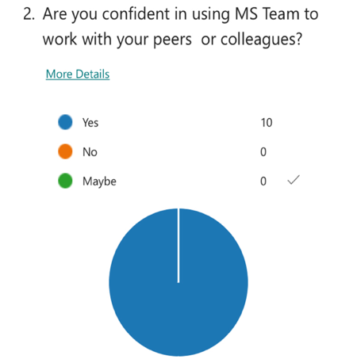
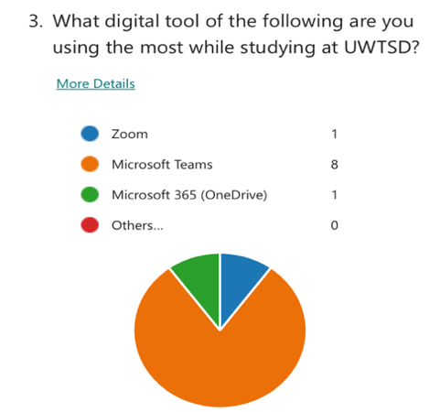

Ten survivors rated that online collaboration while studying at the university is highly critical and crucial.

6
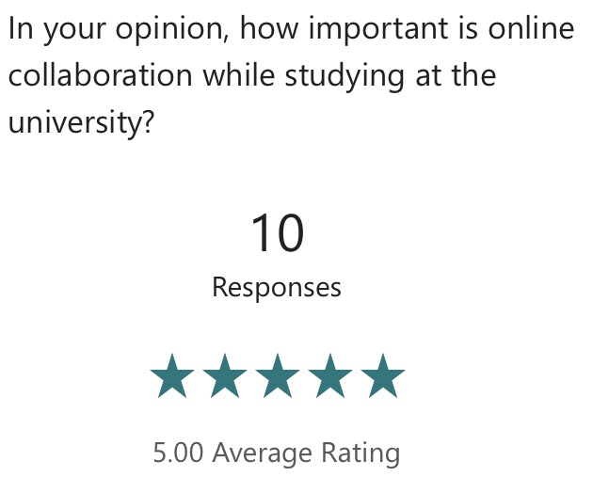
Through the answers gained from the participants it is also relevant to say that there are also a number of different tools used during studying, as for example: Microsoft Excel? Microsoft Word, Microsoft PowerPoint and others.
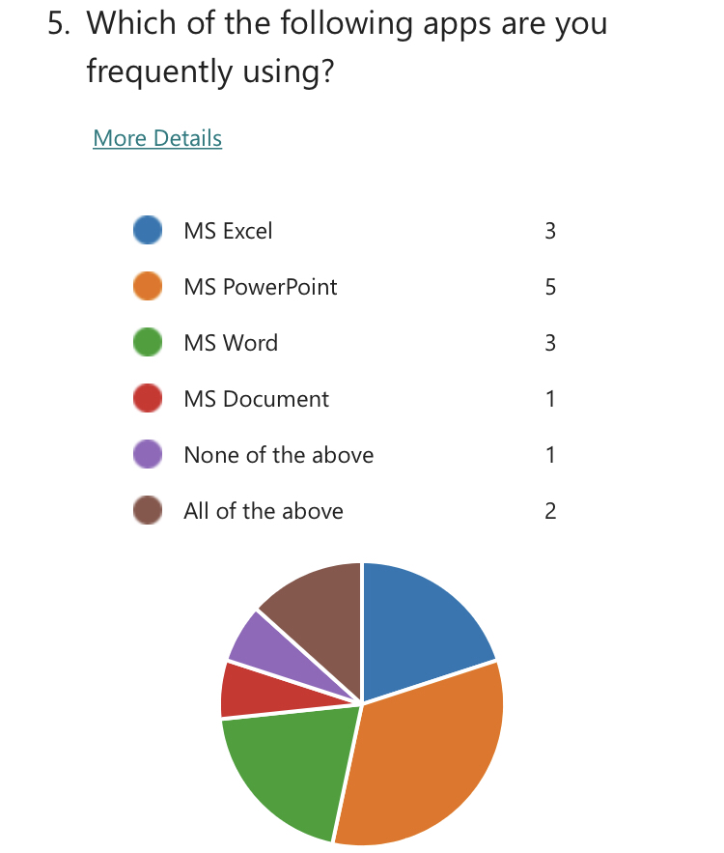
The diagram above is explaining perfectly which tool, excepting Teams is also an effective way to improve your studying. And it was rated that Microsoft PowerPoint is the second important part of collaborating at UWTSD:

7

All students agreed and strongly agreed as well with the fact that digital tools are very important in cooperation with peers and lecturers.
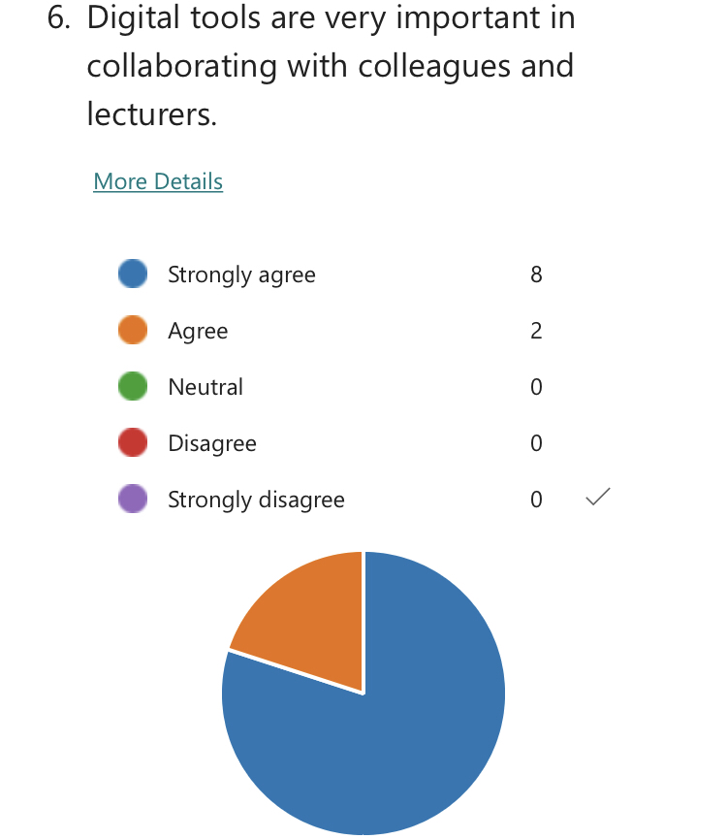
They responded and offered a short definitions of the syntagma “digital skills” that clearly present their understanding of it.
Some of the responses were: •’ability of research information online’; • ‘using digital devices, communication apps, and networks to access and get information’; • ‘use information on the internet’ • understanding how to stay safely online’.
The last question confirmed that all students take part in the study voluntarily as the results showed all 11 responses were yes at the last question ( Have you participate in this research voluntarily?)

8

Discussion
According to my colleagues that participated in the research questionnaire it is highly important to utilise digital tools and to develop digital skills in order to communicate and to succeed. As it was presented the results are impressive and they are generally the same as our hypothesises. Should mention that we ranked the apps deductible for our respondents opinions; it results that Microsoft Excel and Microsoft Document are the less used apps. A bit more often used is Microsoft Word, and the best and hardly used are Microsoft PowerPoint and Teams. According to the surveyed people they are impressively confident in using Teams to cooperate and discuss with university’s students and lecturers. As just one person answered that they use Microsoft 365(one drive) it appears that this app is also used but not as much as Teams.
Is important to pay attention that all students have a great amount of knowledge about digital skills and tools which is particularly because of studying ‘Digital skills and research methods’ at University of Wales Trinity Saint David.
The results confirmed the hypothesis and showed that Microsoft 365 (One Drive) and Microsoft Teams represents the best methods in collaboration within a study campus. It defines the easiest ways to gain knowledge and become professionals at the workplace.
The results perfectly fits with the literature included in the introduction, as the results come out as the presumption made before the students completed the questionnaire.

9
Conclusion
Concluding all the informations collected during the survey it results that digital skills are the abilities required to study and work in our rapidly changing world of technology. Current systems are indeed being quickly replaced by even more advanced models, so establishing a powerful digital set of skills and starting to feel confident in your ability to explore a continuously changing digital world will be critical for your future jobs. By studying digital skills and tools students will gain the following skills and knowledge:
studying how and when to use conform the suitable electronic devices, apps, software, and structures for discovering, evaluating, arranging, and providing data efficiently managing data properly and constructing good information security protocols; utilising various internet resources and tools to assist you in studying remotely and engaging successfully with your studying; better understand how to defend yourself, other classmates, and coworkers to remain safe in the digital world being able to interact and communicate in a digital environment.
By the research made and the literature used I can promptly say that the most commonly used digital tool used for collaboration at UWTSD is Microsoft teams and it connects not just the students to lecturers, but also students to students which creates a great understanding of the course. It makes studying more comfortable and easier for both students and professionals.

10
Reference list
Hatlevik, O. E., Guðmundsdóttir, G. B., Loi, M. (2015) “Examining factors predicting students’ digital competence”. Journal of Information Technology Education: Research, Vol. 14, pag. 123-137. Available at: http://www.jite.org/documents/Vol14/JITEV14ResearchP123-137Hatlevik0873.pdf. (Accessed: 7 April 2022)
Feijao, C., Flanagan, I., van Stolk, C., Gunashekar, S. (2021) The global digital skills gap. Current trend and future directions. Available at: https://www.rand.org/content/dam/rand/pubs/research_reports/RRA1500/RRA1533-1/RAND_RRA1533-1.pdf. (Accessed: 2 April 2022)
UNESCO (2018) Digital skills critical for jobs and social inclusion (15/03/2018). Available at: https://en.unesco.org/news/digital-skills-critical-jobs-and-social-inclusion. (Accessed: 8 April 2022)
Vartanova, E., Gladkova, A. (2019) “New forms of the digital divide”. In Trappel, J. (ed.) Digital media inequalities: Policies against divides, distrust and discrimination,Göteborg: Nordico, pag. 193-213. ( Accessed: 9 April 2022)
AAT Comment. (2019). Why digital skills are important for you and your workforce. [online] Available at: https://www.aatcomment.org.uk/aatpowerup/why-digital-skills-are-important-for-you-and-your-workforce/. ( Accessed: 5 April 2022)
UNLV. (2021). What Are Digital Skills & Why Are They Important? [online] Available at: https://digitalskills.unlv.edu/digital-marketing/what-are-digital-skills/. ( Accessed: 4 April 2022)
Cleave, P. (2021). What is Informed Consent? [online] SmartSurvey. Available at: https://www.smartsurvey.co.uk/blog/what-is-informed-consent. (Accessed: 9 April 2022)
Presenting survey results -Report writing. (n.d.). [online] Available at: https://www.qgso.qld.gov.au/issues/671/presenting-survey-results-report-writing.pdf. (Accessed: 9 April 2022)
11
Appendix
Which digital tool is most commonly used for collaboration at UWTSD?
How do we use technology to collaborate at UWTSD?

1.Which digital tool do you mainly use for collaboration at UWTSD?.
Enter your answer
2.Are you confident in using MS Team to work with your peers or colleagues?
Yes
No
Maybe
3.What digital tool of the following are you using the most while studying at UWTSD?
Zoom
Microsoft Teams
Microsoft 365 (OneDrive)
Others…
4.In your opinion, how important is online collaboration while studying at the university?
Rating: 1 to 5 stars.
5.Which of the following apps are you frequently using?
MS Excel
MS PowerPoint
12
MS Word
MS Document
None of the above
All of the above
6.Digital tools are very important in collaborating with colleagues and lecturers.
Strongly agree
Agree
Neutral
Disagree
Strongly disagree
7.Can you please offer a definition on syntagm “digital skills”?
Enter your answer
8.Have you participating in this research voluntary?
Yes
No

13

