BMSW4002

Effective Teamwork and Communication

Lecturer: Ejiro Esohwode

Models of Communication and Communication Skills

Ibrahim Youdjel Gazi

Student: 2018574

University of Wales Trinity Saint David

August 2021
Contents

Abstract 3
Models of Communication 4
Model 1 – Shannon and Weaver 4
Model 2 – Berlo’s SMCR Model of Communication 6
Model 3 – Schramm’s Model of Communication 7
Communication Skills 8
Types of Communication 8
Types of Verbal Communication Styles 9
Types Nonverbal Communication 10
Conclusion 12
References 13

Abstract

Models of communication are crucial in facilitating good communication processes. Numerous academics and researchers have studied communication models. As a result, this report is devoted to comprehending communication paradigms. When individuals gain knowledge about communication models, they may recognise the procedures that must be followed to conduct communication effectively. A model is a graphical representation of the way a variable behaves. It is a method, design, illustration, or explanation used to convey information about the structure and operation of items, things, schemes, tasks, and concepts. A communication model enables the generation of data in the form of a graphical checklist of several components. Individuals can effectively facilitate communication processes when communication models are executed effectively. The key portions of the paper discuss communication models, their objectives, functions, and communication skills.

Models of Communication

Theorists have developed communication models to enlighten and comprehend how communication can be improved. Researchers and academics have developed ever-more complex models to explain how we communicate over time.
Communication models are theoretical constructs used to describe an individual's communication method. The first key model of communication was developed in 1948 by Claude Elwood Shannon and published by Bell Laboratories with an overview by Warren Weaver. According to the fundamental concept, communication is the process of sending and receiving messages or information from one component (sender) to another component (receiver) (receiver).

Model 1 – Shannon and Weaver

Developed in 1948 by Claude Elwood Shannon, a mathematician and electronic engineer, and Warren Weaver, a scientist. Furthermore, the model has been dubbed the "mother of all models." This model depicts the transmission of a message from one source to another.
The Shannon Weaver Model's Concepts

Sender (Information source) – The sender is the person who creates the message, chooses the channel, and then sends it.
Encoder (Transmitter) – The encoder is the sender of the message who operates the device that converts the message to signals or binary data. Additionally, it could be a direct reference to the device.
Channel – A channel is the medium through which a message is transmitted.
Decoder (Receiver) – A decoder is a device that converts signals or binary data to messages, or the receiver is the device that interprets the signals.
Receiver (Destination) – The receiver is the person who receives the message or the location to which the message must be delivered. The receiver responds to the message.
Noise – Noise is any physical disturbance, such as the environment or people, that prevents the message from reaching the receiver.
Example of Shannon Weaver Model

Below is an experience of a scenario from my workplace which we experienced very recently:
I am sending a voice message via the security radio we use at my workplace to communicate with a staff member about delivery which I need him to go and sign for but due to the radio connection dropping, staff member did not get the message fully.
See message transcript below:
Me (Security Manager), “Sierra Oscar One, please could you go to the loading bay and check delivery is correct and sign”.
Sierra Oscar One (feedback), “could you repeat please as I only heard please could you go, and we were cut off”.
So, when we use the Shannon Weaver as an example here.
- Sender: Security Manager (me)
- Encoder: Telephone network company
- Channel: Mobile network & Wi-Fi
- Noise: Missing half voice message due to disruption buy loss of connection
- Decoder: Radio Walkie Talkie
- Receiver: Staff Member
Shannon Weaver Model Diagram:

Source: Businesstopia.net

Model 2 – Berlo’s SMCR Model of Communication

In the 1960s, David Berlo derived the Berlo's SMCR (Sender-Message-Channel-Receiver) model of communication from the Shannon and Weaver model. David Berlo demonstrated how his communication model is more efficient.

Berlo’s SMCR Model of communication components:

S – Sender
M - Message
C - Channel
R – Receiver

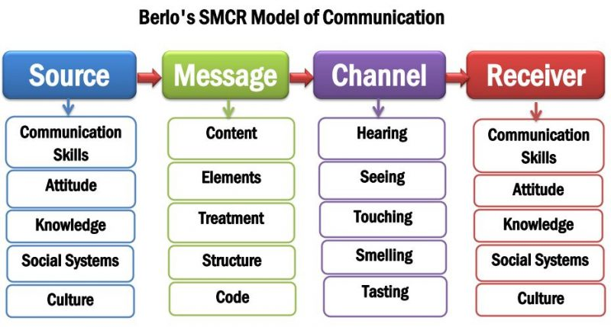
Source: Newsmoor.com

Model 3 – Schramm’s Model of Communication

Schramm's communication model is derived from the Shannon Weaver model. In 1954, Wilber Schramm proposed the communication model. According to Schramm's model, effective communication requires both coding and decoding. According to Schramm, communication is a two-way street between the first and second parties.
Schramm Model Diagram
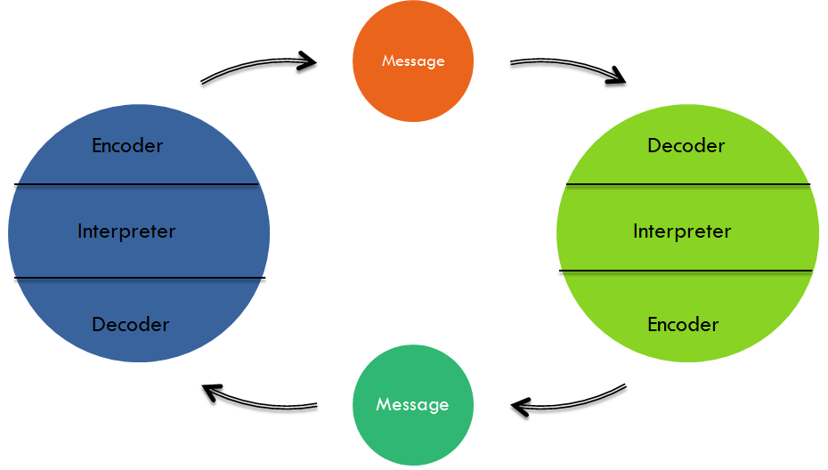
Source: Thinglink.com

Communication Skills

Whether we are aware of it or not, we are constantly communicating. Furthermore, considering the wide range of platforms and devices we utilise in our daily lives, as well as the multitasking required by our routines, most of us are adept communicators.
Some examples of communication in action are below:
- We spend quality time together before we leave for work, chatting with our families.
- Use of an application to order takeaway for lunch.
- Checking out Facebook timeline while listening to the news on a radio, on the way to the office.
- responding to e-mails
- videoconference with clients located on another continent, as well as with friends and family.
- sharing jokes with co-worker’s, friends, and family.
Workplace communication might be more formal than everyday conversation for many of us. The number of communication outlets has hit the roof recently. Telephone and email have been replaced by web-based meetings, videoconferencing, voice messages, and even online chat and instant messaging. Videos, PowerPoint presentations, blogs, software, social media platforms, and television can all be utilised to reach large audiences.

Types of Communication

Verbal and Non-Verbal
Verbal and non-verbal communication are two key techniques of conveying ideas, thoughts, and information. Verbal communication refers to the words we use, and Non-verbal communication refers to the non-verbal messages we convey by our body language, signs, and signals.
Oral and written communication are both verbal modes. Oral communication includes meetings, phone calls, videoconferences, and presentations. There are several ways to communicate in written form.
Both verbal and non-verbal communication are critical and can convey a variety of messages. It is critical for us to be aware of our own verbal and nonverbal communication, as well as the communication of others.
Speaking
Speaking or verbal communication is likely the most prevalent method of transmitting information in business, home, and social settings. Meetings can be held in person, over the phone, or by video conferencing. It's simple, simple, simple. Important nonverbal cues including facial emotions, voice tone, pitch, and body language can also be picked up on. This communication is extremely useful when resolving conflicts, building teams, or selling products.
Writing
This very effective communication ability includes email, business memos, formal letters, bulletin boards, posters, flyers, and PowerPoint presentations. Written communication is helpful for communicating difficult ideas and offering instructions. No room for misunderstanding. Writing also helps organisations function and creates a paper trail for future reference.
Reading
This is a challenging talent to learn because individuals, especially young people, are spending less time reading. Many people only read on social networking sites and instant messaging. Nonetheless, to be a successful employee, executive, manager, or CEO, you must master the skill of reading. In the preceding paragraph, it is the better part of writing!
Listening
Listening needs you to not only hear what someone says but also to absorb the information, analyse nonverbal cues, and filter the message objectively. Effective listening requires the ability to put oneself in another's shoes, which everyone desires - an empathic ear. Effective listening needs openness to new ideas, feedback, and innovations, positive interpersonal ties inside the organisation, willingness to remedy errors, and unwavering progress.

Types of Verbal Communication Styles

Verbal communication is divided into four types:
- Intrapersonal communication: Is a very private and limited form of communication. Silent conversations with ourselves are included. They are the roles we play between sender and receiver as we process our actions and ideas. Intrapersonal communication can be expressed vocally or as thoughts.
- Interpersonal communication: Is a one-on-one conversation between two people. In this style of communication, the sender and receiver roles are switched to ensure clear communication.
- Public communication: Is when a single person addresses a large group of individuals. This includes public speeches and election campaigns. The communicator has one sender and multiple only receivers.
- Small group communication: Requires more than two persons to execute. The small group size allows for clear interaction and communication. Small group communication includes team meetings, board meetings, and press conferences. It is difficult to comprehend such communications when there is no specific topic. Miscommunication occurs when information is not fully understood.

Types Nonverbal Communication

Non-verbal communication is classified as follows:
- Face: Facial expressions convey a person's mood. A person's facial expressions can convey various emotions without speaking. Unlike certain non-verbal means of communication, these expressions are universal. Every culture uses the same facial expressions for anger, surprise, joy, contempt, fear, and grief.
- Eye: Eye contact is a vital method of non-verbal communication because most people have a visual sense. Eye contact is the main conduit of interpersonal communication. The way you stare at someone might indicate affection, interest, attraction, or hate. Maintaining eye contact with the audience enhances the speaker's credibility. Also, eye contact allows you to measure the other person's interest and response.
- Body movement and posture: Body movement is a common nonverbal communication method. The way people sit, stand, walk, run, or hold their heads easily conveys many ideas and meanings. The world can convey a wide range of facts from your movements and posture. Unconscious movements and conscious movements are two types of body movements. For example, nervous people unconsciously bite their nails. A person pushing forward in enthusiasm to wish someone is under conscious control.
- Space: Space and distance are essential tools in nonverbal communication. A person feels more comfortable conversing in a more open situation when no one is invading his/her space. Everyone needs physical space, although the needs differ depending on the situation, culture, and friendship. Physical space communicates many indications of affection, dominance, closeness, and hostility. A person's importance and authority are easily conveyed to others by a well-decorated and spacious space.
- Gestures: Daily gestures make non-verbal conversation more exciting. It incorporates head, finger, arm, leg, and hand movements to communicate a message. They are intentional body gestures intended to express a specific message. However, the same gesture might represent different things in different cultures. Students employing head nods to show their teachers they are listening. Hands are also used to convey hello and goodbye.
- Touch: Touch is a typical nonverbal element that expresses a variety of emotions. However, a person's cultural background, gender, age, intimacy, and relative standing directly affects their approved touch modes. For example, when a student is touched behind in an examination hall, they assume the perpetrator wants to know something about them.
- Physiology: Physiology refers to changes in the body such quick blinking, sweating, or red skin. These unpredictable shifts convey personal conditions. Sweating indicates that a person is hot or has worked out.
- Paralanguage: Tones and timbres of voice are covered by paralanguage. Paralinguistic signals exclude direct word verbal translation. The elements of voice must be learned adequately to improve teacher effectiveness.

Conclusion

Numerous theories exist in the field of communication studies. The communication models discussed in this report, on the other hand, are central models of communication that demonstrate how communication occurs. Theories for communication studies are necessary to understand because they help us comprehend the critical components of communication in the twenty-first century.
Simply put, models serve as a visual representation of a theory. Communication has evolved into such a complex process over time, there are distinct communication models for distinct modes of communication. Some are more straightforward than others. Communication theory employs models to illustrate the true complexity of our interactions, whether in person, via email, or via a large news organisation. The more we comprehend it, the more effective communicators we become.

References

- Anon, (n.d.). Effective Communication: Verbal and Non-verbal, Classroom Communication. [online] Available at: https://ugcnetpaper1.com/important-study-material-for-communication-part-2/ [Accessed 28 Aug. 2021].
- Anon, (n.d.). Verbal and Non-Verbal Communication: Meaning and Types. [online] Available at: https://commercemates.com/verbal-and-non-verbal-communication/ [Accessed 28 Aug. 2021].
- Kent, H. (2021). Cultivating Communication Skills: Non Verbal Cues. [online] 4-H in the Panhandle. Available at: https://nwdistrict.ifas.ufl.edu/4hn/2021/01/22/cultivating-communication-skills-non-verbal-cues/. [Accessed 23 Aug. 2021].
- Maund, A., Schriek, M. and Tinkler, P.(2017). Certificate in Higher Education: Skills for the Workplace. London. SAGE Publications, pp. 67-85
- Toppr-guides. (2019). Toppr-guides. [online] Available at: https://www.toppr.com/guides/business-correspondence-and-reporting/communication/types-of-communication/. [Accessed 23 Aug. 2021].
- Valamis. (n.d.). 4 Types of Communication: Verbal, Non-verbal, Written, Visual. [online] Available at: https://www.valamis.com/hub/types-of-communication. [Accessed 27 Aug. 2021].

