University of Wales Trinity Saint David
Reducing the cost of the packing operation within the FSP1 process
Thomas Rosser
2214462
Apprenticeship in Mechanical and Manufacturing Engineering (BEng)
19th May 2025
Individual Project
Word Count - 10872


Declaration of Authenticity
This thesis is the result of the author’s original research. It has been composed by the author and has not been previously submitted for examination which has led to the award of a degree.


Sign: Date: 17/05/2025

Acknowledgements
I would like to express my sincere gratitude to all those who supported me throughout the course of this dissertation.
Firstly, I would like to thank my academic supervisors, Andrew and Mark, for their guidance, constructive feedback, and encouragement. Their support and insight were instrumental in shaping the direction of this work.
I am also grateful to my colleagues and mentors at Renishaw, particularly those involved in the FSP1 packaging process. Their technical input, openness to collaboration, and practical knowledge provided an invaluable foundation for the project. Special thanks go to the project team members for their continued engagement throughout each phase of the project.
To my classmates and tutors, thank you for your ongoing support, advice, and camaraderie throughout my studies as a part-time student.
Finally, I would like to thank my family and my fiancée for their unwavering patience, understanding, and support over the course of this degree - especially for tolerating the lack of DIY progress around the house.

Abstract
This dissertation examined and improved Renishaw's FSP1 packaging operation, which is a manual, low-volume manufacturing process for precision encoder scales. The Six Sigma DMAIC (Define, Measure, Analyse, Improve, and Control) framework was used in the study to identify inefficiencies, quantify process variation, and develop a validated improvement strategy.
Initial observations revealed that the process was labour-intensive, prone to human error, and lacked standardisation, resulting in long cycle times, unnecessary operator motion, and a 17% packaging error rate. The project identified root causes of workstation layout, manual documentation, and ineffective quality checks using time and motion studies, operator engagement, and benchmarking against an internal best-practice cell.
The improvement solution included re-designing the packaging workstation, integrating error-proofing tools (barcode scanning and a vision camera system), and implementing digital work instructions. Mock validation trials showed a 34% reduction in cycle time, complete elimination of packaging errors, and positive operator feedback. Financial analysis predicted an annual savings of £137,470, with a 655% return on investment and a two-month payback period.
Although full implementation was put on hold due to budget constraints, the project was completed ahead of schedule, with a validated and documented solution. The study adds to the existing literature by demonstrating the applicability of Lean Six Sigma in a low-volume, manual production environment, providing practical insights for future process improvement initiatives.

Table of Contents
Acknowledgements iii
Abstract iv
List of Figures viii
List of Tables ix
1. Introduction 1
2. Background information 3
2.1 Company Background 3
2.2 Product information 4
2.2.1 Optical Encoders 4
2.2.2 Linear Scale 5
3. Literature review 10
4. Methodological Framework 13
4.1 Six Sigma and the DMAIC Approach 13
4.2 Project Gantt Chart 14
5. Define 16
5.1 Problem Statement 16
5.2 The Problem statement 16
5.3 Process Overview (SIPOC) 17
5.4 Project Charter 18
5.5 Initial Observations 20
6. Measure 21
6.1 Data collection strategy 21
6.1.1 Data Sources and Capture Method 21
6.1.2 Validation of data collection methodology 22
6.2 Detailed Process Mapping 24
6.2.1 Flow Chart with task-element times 24
6.2.2 Spaghetti diagram of operator motion 24
6.3 Baseline Process Performance 25
6.3.1 Cycle Time and Task Element Durations 25
6.3.2 Operator Motion 25
6.3.3 Packaging error rate 26
6.3.4 Tool and Consumable Search Frequency 26
6.4 Secondary Data Collection for Cost benefit analysis 26
6.5 Summary of findings 27
7. Analyse 28
7.1 Data Analysis 28
7.1.1 Cycle Time 28
7.1.2 Task Timings 30
7.1.3 Operator movement data (From-To matrix) 32
7.1.4 Packaging errors and looking for tools/consumables 33
7.1.5 Data analysis summary 34
7.2 Root cause identification 35
7.2.1 Fish bone diagram 35
7.2.2 5 Why’s Technique 37
7.2.3 Root cause summary 38
7.3 Root cause validation 39
7.3.1 Cycle Time Observation 39
7.3.2 Workstation Layout Adjustment 39
7.3.3 Operator Surveys 40
7.3.4 Summary of findings 41
8. Improve 42
8.1 Overview of improve phase 42
8.2 Comparative Analysis of Packaging Cells 42
8.2.1 Gap analysis 44
8.2.2 Benchmarking 45
8.3 Concept Design 46
8.3.1 Poka-Yoke Integration 46
8.3.2 Standardised Work Implementation 47
8.3.3 Layout Optimisation 47
8.4 System Setup and Equipment Testing 48
8.5 Validation Activities and Results 50
8.5.1 Operator Usability and Workflow Evaluation 50
8.5.2 Time and Motion Comparison 51
8.5.3 Error Elimination Scenarios 51
8.5.4 System Integration Testing 51
8.5.5 Summary of validation results 51
8.6 Risk Assessment 52
8.6.1 Risk Register 52
8.6.2 Failure Mode Element Analysis (FMEA) 53
8.7 Cost benefit analysis 55
8.7.1 Implementation costs 55
8.7.2 Operational benefits 56
8.7.3 Return on investment (ROI) and Payback Period 56
8.8 Stakeholder meeting 57
9. Control 58
9.1 Installation and Commissioning Plan 58
9.2 Standardisation and Visual Control 58
9.3 Operator Training and Knowledge Transfer 59
9.4 Performance Monitoring and Error Prevention 59
9.5 Accountability and Routine Discipline 59
9.6 Handover and Sustainability Assurance 60
9.7 Change management strategy 60
10. Results and Discussion 62
11. Conclusion 63
12. Future Recommendations 64
References 66
Appendices 70
Appendix A – Gemba walk observation sheet 70
Appendix B – Cycle and task time raw data 71
Apprendix C – Operator motion measurement data 72
Appendix D – Packaging error data 72
Appendix E – Tool/Consumable search data 73
Appendix F – Root cause validation surveys 74
Appendix G – Quotes and price estimates for equipment 76
Appendix H – Installation and commissioning plan 80

List of Figures
Figure 1 - Touch-Trigger-Probe (Henderson, 2013) 3
Figure 2 - Renishaws Manufacturing Site (The Engineer, 2022) 3
Figure 3 - Renishaw Encoder (PBA Systems, 2021) 4
Figure 4 - Optical Encoder Diagram (Budimir, 2016) 5
Figure 5 - Linear raw material 6
Figure 6 - Auto Polisher 6
Figure 7 - Linear wash tanks 7
Figure 8 - Brillant disc saw 7
Figure 9 - Laser engraver 8
Figure 10 - Laser engraver markings 8
Figure 11 - Ablation and test LTB 9
Figure 12 - Packing station 9
Figure 13 - DMAIC diagram (Flynn, 2023) 13
Figure 14 - Gantt chart 15
Figure 15 - SIPOC Diagram 18
Figure 16 - Project Charter 19
Figure 17 - Process flow chart 24
Figure 18 - Motion diagram 25
Figure 19 - Cycle time graph 28
Figure 20 - Task timings graph 29
Figure 21 - From/To matrix 30
Figure 22 - Pinter location 31
Figure 23 - Pareto chart for errors found in buddy checking 32
Figure 24 - Parts with certificates 33
Figure 25 - Fishbone diagram 35
Figure 26 - Improved printer location 39
Figure 27 - Improved From-To matrix 39
Figure 28 - Benchmarked cell (FSP2) 42
Figure 29 - New workstation design 45
Figure 30 - Go/No-Go testing 47
Figure 31 - Barcode testing 48
Figure 32 - Improve validation set-up 49

List of Tables
Table 1 - Data collection plan 21
Table 2 - 5 Why, Inconsistent cycle times 36
Table 3 - 5 Why, Lengthy buddy checks 36
Table 4 - 5 Why, Poor workstation layout 36
Table 5 - 5 Why, Incorrect certificates packed with parts 37
Table 6 - Gap analysis 42
Table 7 - Benchmarking comparison 43
Table 8 - Validation results 50
Table 9 - Risk register 51
Table 10 - FMEA 52
Table 11 - Implementation cost 53
Table 12 - Operational benefits 54
Table 13 - ADKAR 59

Introduction
The pursuit of operational excellence has long been a pillar of modern manufacturing, especially in high-precision industries where quality, efficiency, and traceability are critical to customer satisfaction and long-term competitiveness. As technological innovation continues to transform the global manufacturing landscape, businesses are increasingly reliant on structured process improvement methodologies to identify inefficiencies and implement sustainable solutions. One such methodology is Lean Six Sigma, which combines statistical rigour with waste-reduction principles to achieve measurable performance gains in a variety of operational settings.
Renishaw, a precision engineering and metrology leader headquartered in the United Kingdom, exemplifies this commitment to continuous improvement. With a strong focus on research and development, the company produces a wide range of advanced products in fields such as additive manufacturing, spectroscopy, and medical instrumentation. Among its flagship products are optical encoders, which are used to precisely monitor motion and position in high-accuracy systems. These encoders include components such as the linear scale, which is subjected to stringent manufacturing and packaging processes to ensure the performance and reliability demanded by Renishaw's global customer base is met.
This dissertation focused on the FSP1 packaging operation for linear scale; a critical but labour-intensive process located at Renishaw's Miskin manufacturing facility. Despite the company's commitment to innovation, the packaging process was entirely manual, requiring skilled operators for tasks such as cleaning, visual inspection, sleeving, boxing, and documentation. This lack of innovation resulted in longer cycle times, variability in process performance, and a reliance on manual buddy checks to detect packaging errors. With the operation accounting for a significant portion of total production time and costs, there was a clear business case for a structured improvement initiative.
The overall goal of this study was to use the Six Sigma DMAIC framework (Define, Measure, Analyse, Improve, and Control) to investigate, optimise, and validate improvements to the FSP1 packaging process. Using this framework, the project aimed to identify the root causes of inefficiencies, develop data-driven solutions, and lay a solid foundation for ongoing performance monitoring. The study also sought to fill a gap in the existing literature by investigating the use of Lean Six Sigma in low-volume, manual assembly operations—a setting that is frequently overlooked in favour of more automated manufacturing environments.
This project demonstrated the practical value of Lean Six Sigma in improving operational efficiency within high-precision manual workflows by benchmarking internal processes, integrating visual and digital process control and validating proposed improvements using mock trials. The findings support Renishaw's continuous improvement strategy and provide a replicable model for similar operations looking to reduce costs, improve quality, and increase throughput without fully automating everything.

Background information

2.1 Company Background
Two engineers, Sir David McMurtry and John Deer working for Rolls Royce in the 1960s encountered a challenge whilst working on the development of the Concorde engine. This specific measurement challenge led these engineers to create a unique measuring tool called a Touch-Trigger-Probe (Figure 1). Sir David and John capitalised on this creation and commercialised the probe for sale under the cheapest company name available, Renishaw (Renishaw, 2022).
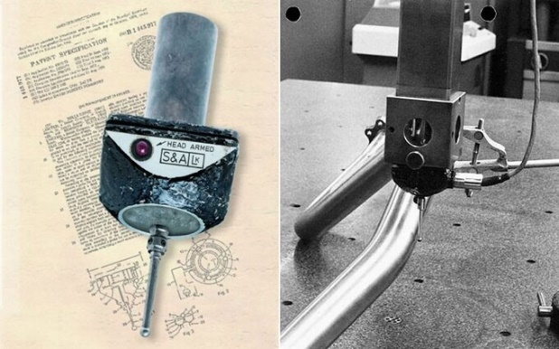
Figure 1 - Touch-Trigger-Probe (Henderson, 2013)
Now in 2025, Renishaw is a UK based global leader in precision engineering and metrology, operating in over 30 countries with more than 80 offices worldwide. Investing 13% into research and development from their annual revenue, Renishaw continues to be renowned for its innovation in product lines such as Additive manufacturing, Raman spectroscopy and neurological medical devices (Renishaw, 2020).
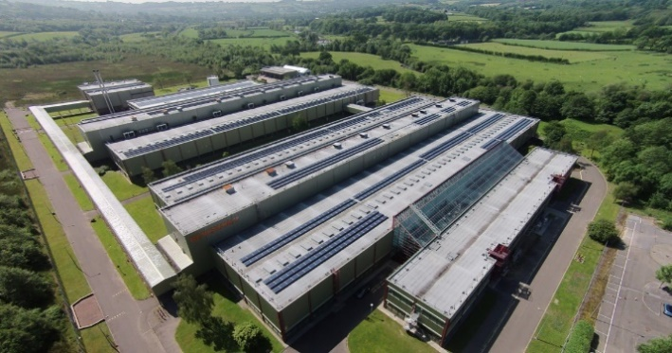
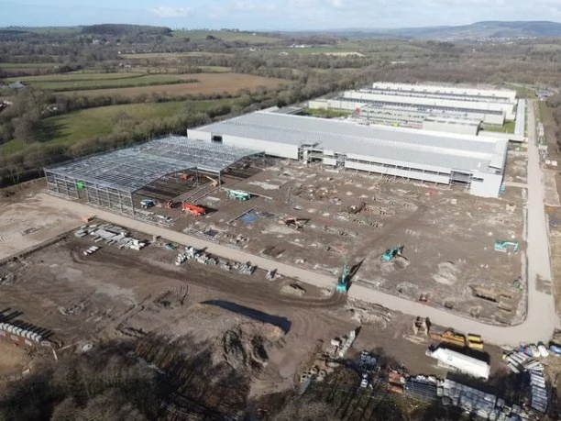
Most products and components are made in-house at their main manufacturing facility based in Miskin, South Wales which opened in 2014 (Figure 2). The Miskin manufacturing site with its extra 50-million-pound investment has now doubled in size and employs over 650 employees (Pockett, 2022).
Figure 2 - Renishaws Manufacturing Site (The Engineer, 2022)

Financially, Renishaw has a positive history with a cumulative growth of approximately 35% over the last five years. In the fiscal year ending in June 2024 their revenue reached £691.3 million with the previous year being £688.6 million. Respectively, their adjusted pre-tax profits stand at £122 million and £141 million (Renishaw, 2016).
With the future being at the forefront of Renishaws plan, it aims to achieve Net Zero by 2030 using sustainable energy sources such a solar which has been fitted to the roofs of the main UK buildings and the implementation of electric vehicle charging stations in their car parks (Pockett, 2022). Renishaw also contributes its time towards the future of engineering, putting on STEM activities for schools to attend their workshop and with the continuous employment of apprenticeships and graduate programs in a range of disciplines (Renishaw, 2025).

2.2 Product information

2.2.1 Optical Encoders
Renishaw are recognised globally for their Optical Encoders.
An encoder is a device that converts motion or position into electrical signals, they are commonly used in systems that require accurate measurement and motion control such as CNC machines and CMMs. The two main types of encoders rotary (rotational movement) and linear (straight line movement) (Figure3).
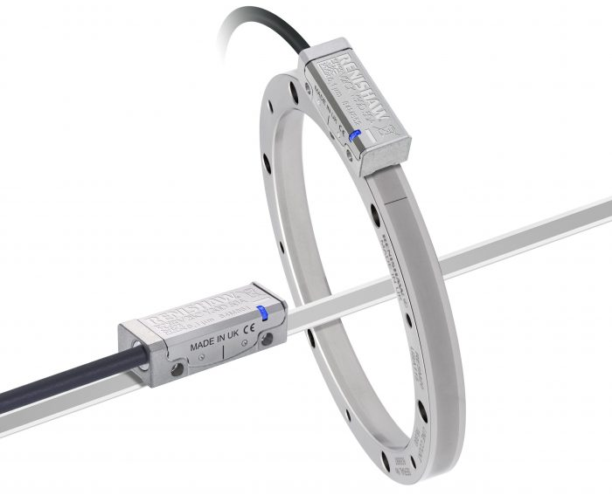
Figure 3 - Renishaw Encoder (PBA Systems, 2021)
An optical encoder works by detecting changes in patterns on scale. A scale can have one of two patterns, incremental (like a ruler) which counts incrementally using a reference mark for zero and absolute (like a barcode) which have combinations of unique line placements, each with their own distance (Figure 4).
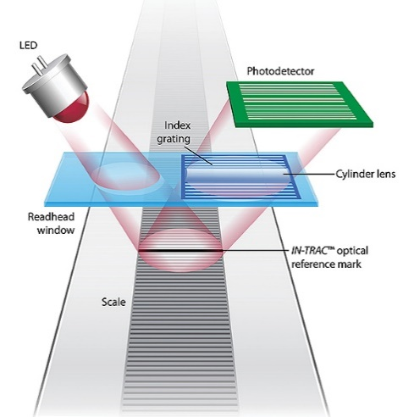
Figure 4 - Optical Encoder Diagram (Budimir, 2016)
The optical encoder reads these scales and sends signals to a control system, enabling precise measurement of position, speed and direction (Company, 2025) which can then be implemented into industrial automation, semiconductor manufacturing or Renishaw’s own neurosurgery equipment. Overall, encoders are a core component in close-loop feedback systems for precise control.
Renishaw began the development of their encoders in the 1980s. Now competing with large companies such as Heidenheim and Mitutoyo, Renishaw continues to continuously improve their encoder line widening the ranges and applications that the buyer can choose from to constantly chip away at the market share (Renishaw, 2025a).

Linear Scale
Both components of an optical encoder are manufactured in Renishaw’s main manufacturing site based in Miskin. There are three types of scales manufactured within Miskin, Linear, Rotary and Ribbon. This report coves an aspect of the Linear production process.
Linear scale begins with the incoming raw material which is blank Invar steel sheets. The invar steel is used for its impressive thermal qualities that do not affect the accuracy of the scale. The blank sheets are laser cut in house to 1.24m lengths with a width of 15mm and a thickness of 1.5mm. The parts are then sent over to the beginning of the scale process (Figure 5).
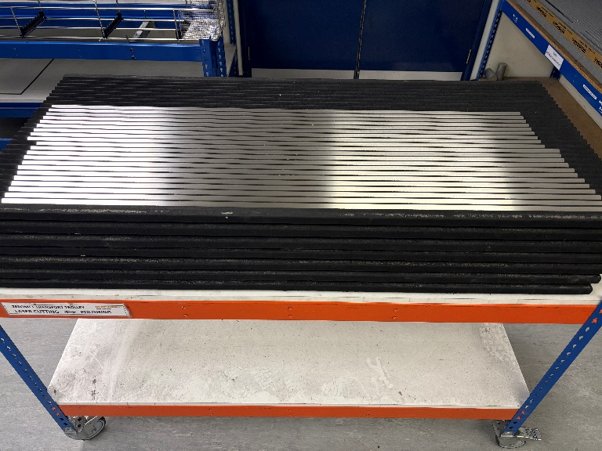
Figure 5 - Linear raw material
The lengths of material are then polished and buffed. This is done on Renishaw’s own automated polisher which presses a polishing/buffing mop onto the material and passes up and down the length of the part for the required number of times (Figure 6). For invar steel it is polished with 25 passes and buffed for 5, this is to achieve the specified surface roughness and reflectiveness.
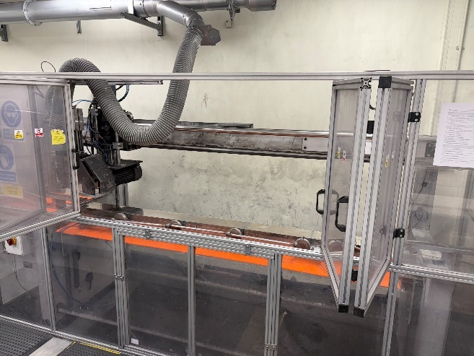
Figure 6 - Auto Polisher
The parts then go through a thorough cleaning process to remove any polishing compound. They are first washed in an ultrasonic tank containing cleaning detergent then they are rinsed in a freshwater tank and then dried using hot air in the third tank (Figure 7).
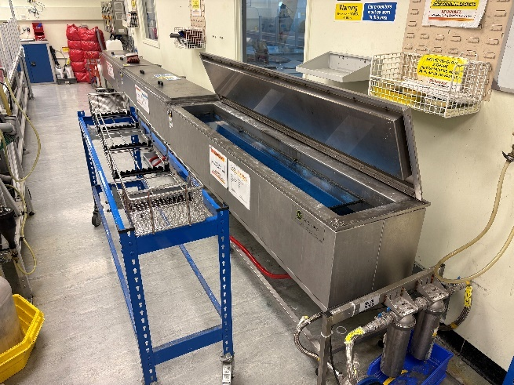
Figure 7 - Linear wash tanks
After cleaning, the parts are inspected for pitted holes or severe grain markings that could have been caused by the polisher. Once checked they are then sent to an external company to be nickel plated, the nickel plating plays a key role in the parts resistance to corrosion.
Once received back the parts are then placed into stock locations waiting for a job to be raised. Once a job is raised, the 1.24m stock length material are then cut into the requested length e.g. 100mm, using a Brillant disc saw (Figure 8), the coolant from the saw is then cleaned off and the part is placed onto the ablation shelf with the accompanying job sheet.
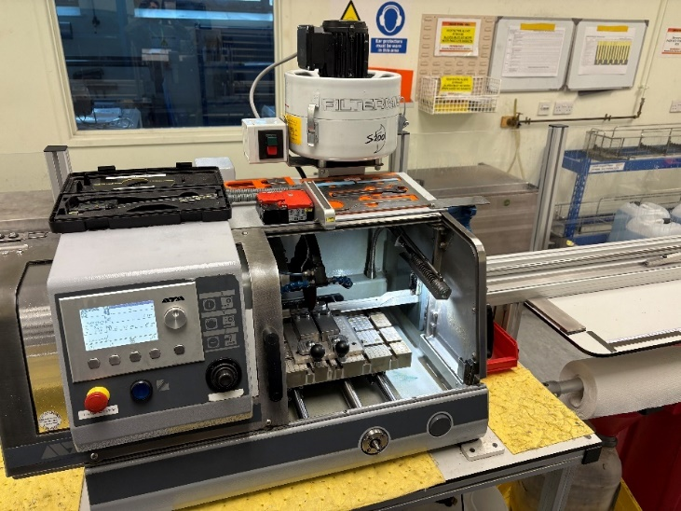
Figure 8 - Brillant disc saw
The parts are then laser marked (Figure 9). This is where they are given their unique identity – a serial number. The serial number is marked in text and in a 2D matrix format along with the Renishaw name, logo, part number and “MADE IN UK” (Figure 10).
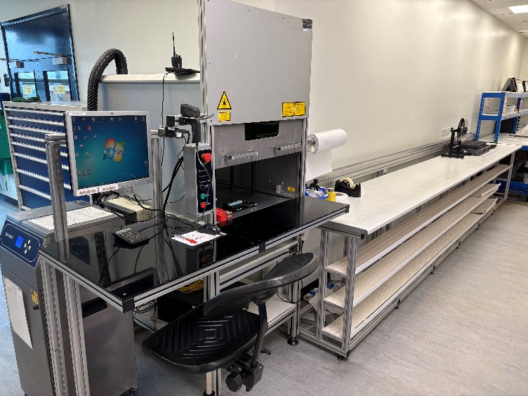
Figure 9 - Laser engraver
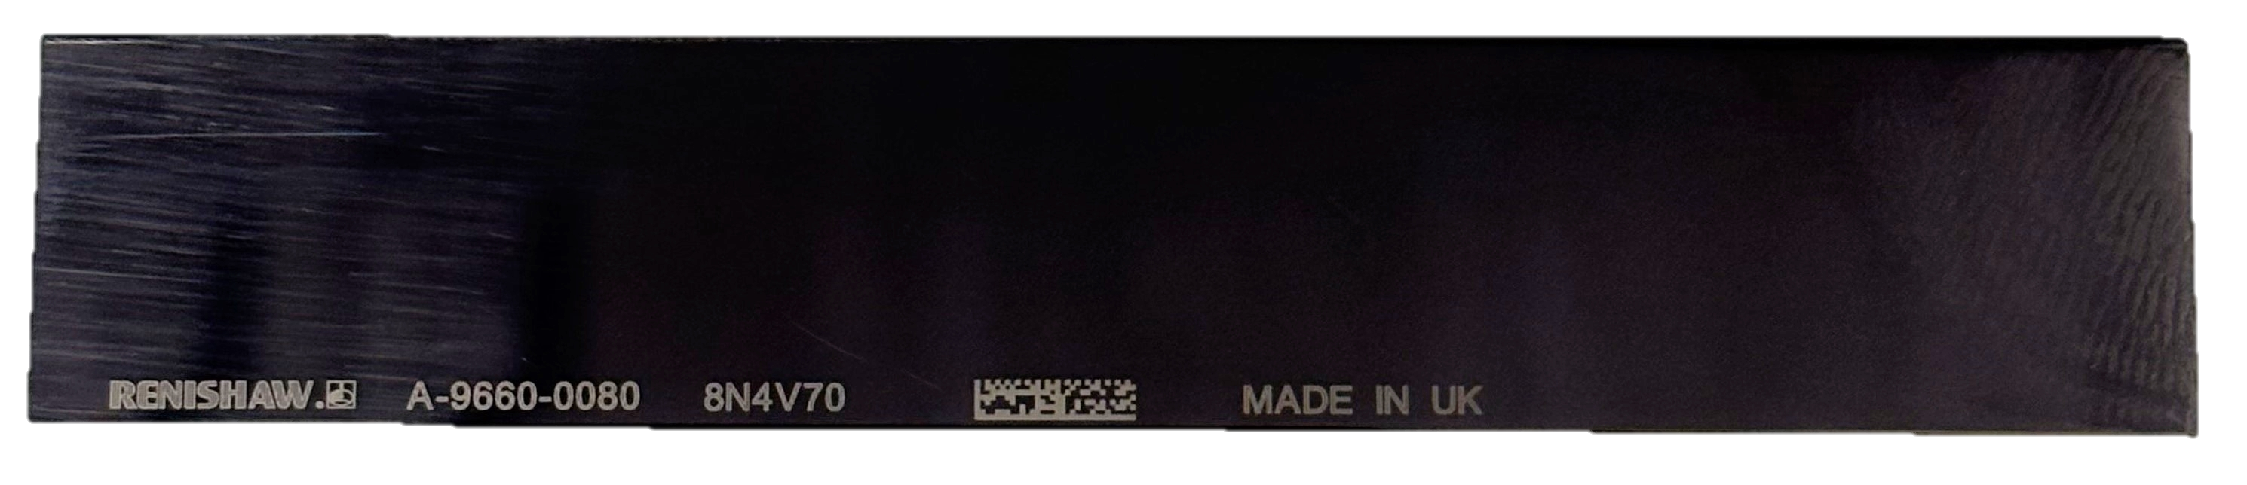
Figure 10 - Laser engraver markings

Ablation is the process of removing material from a solid substance (Coherent, 2025). At the beginning of the ablation process the parts are place onto a granite bed and held down with vacuum pressure (Figure 11). A Class 4 laser is then compressed and focused into a thin line feature which ablates material off the part in shapes of lines. These lines are then placed on the length of the parts using an air driven carriage. Once ablated, the parts remain on the granite bed and are tested using an optical encoder. The scale is tested for accuracy, gain and profile to ensure it is fit the customer to use.
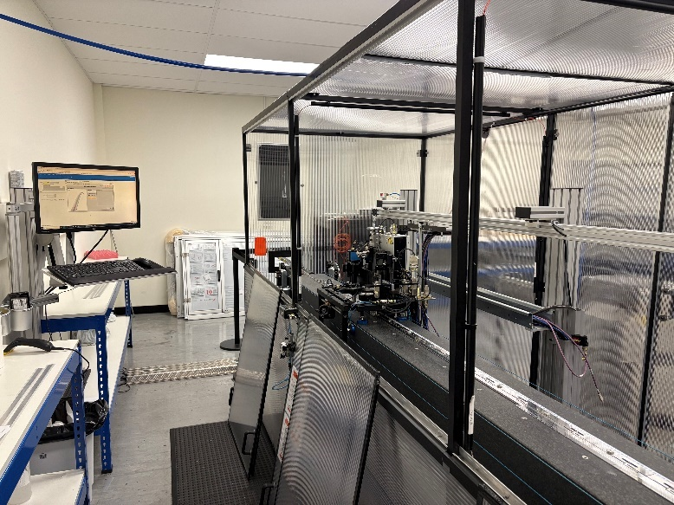
Figure 11 - Ablation and test LTB
The part is then sent upstairs to its packing cell where the part is cosmetically checked to a cosmetic standard before being sleeved, packed, buddy checked and sent to the stores which distributes the part to the required customer (Figure 12).
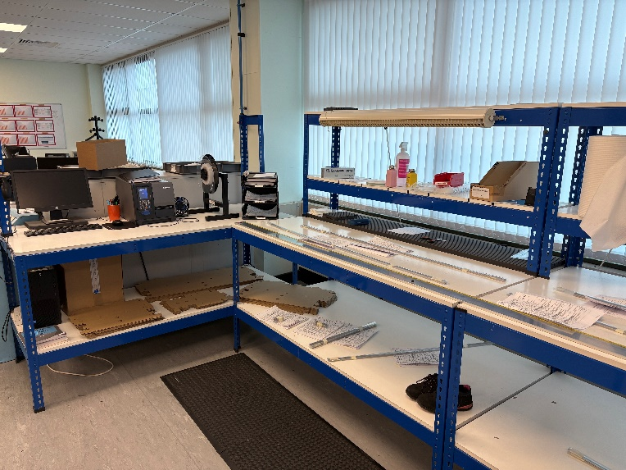
Figure 12 - Packing station

Literature review
The following literature review examines key Lean and Six Sigma principles as applied to manual assembly and packaging tasks, laying the groundwork for the process improvement strategy implemented in this project.
The combination of Lean and Six Sigma methodologies, known as Lean Six Sigma (LSS), is increasingly recognised as a powerful approach to improving processes in manufacturing environments. LSS combines Six Sigma's statistical rigour with Lean manufacturing's waste-reduction principles, resulting in improved operational efficiency and product quality (Vest & Gamm, 2009; Huang et al., 2023). Studies show that significant improvements in performance metrics such as defect rates and operational costs lead to increased customer satisfaction and organisational competitiveness (Huang et al., 2023; Trubetskaya et al., 2023).
A key feature of Lean Six Sigma is its structured problem-solving process, which is typically represented by the DMAIC framework (Define, Measure, Analyse, Improve, and Control). This framework focusses not only on quality improvement but also on identifying and mitigating the underlying causes of process inefficiencies. By way of example, Aggogeri and Mazzola showed that implementing the DMAIC approach in manufacturing systems resulted in significant performance improvements by reducing waste and improving product consistency (Pusporini et al., 2012). Furthermore, research has shown that LSS practices have a positive correlation with environmental performance, highlighting their relevance to modern manufacturing sustainability initiatives (Huang et al., 2023).
Specific applications of Lean Six Sigma have been found effective in optimising assembly and manual operations. Khisbulloh and Yudoko investigated how the methodology could improve Overall Equipment Effectiveness (OEE) by analysing startup times and aiming for improvements in operational efficiency (Khisbulloh & Yudoko, 2024). Their findings that the start-up duration can be reduced from 130 minutes to 43 minutes (67%) demonstrated how LSS tools systematically improve processes and reduce downtime—benefits that are critical in competitive manufacturing environments.
Bhaskar provided a comprehensive review, emphasising the importance of LSS in driving operational excellence across a variety of production environments. The review confirmed that LSS significantly aids in identifying and eliminating non-value-added activities, thereby promoting high levels of customer satisfaction and continuous improvement (Bhaskar 2020). This structured approach also promotes a data-driven culture of performance analytics, which is critical for long-term competitiveness in dynamic market conditions.
Furthermore, LSS has been linked to tangible financial gains. Hill documented the use of LSS in a Maintenance, Repair, and Overhaul (MRO) facility, where the resolution of Critical to Quality (CTQ) issues and a systemic focus on waste reduction resulted in measurable improvements in operational performance (Hill et al., 2017). By reducing the order-to-receipt time from 81days to 65 days their research showed that addressing variation and repeatability enhanced alignment with customer expectations and contributes to long-term profitability.
Case studies, such as those by Daniyan reinforce the practical value of LSS. Their work in a bogie assembly process demonstrated how combining Lean and Six Sigma facilitated reduced lead time 27.9% and improved the efficiency of the assembly process by by 46.8% (Daniyan et al., 2022). These findings confirm the adaptability of LSS for managing quality and efficiency in diverse manufacturing settings, including manual and semi-automated processes.
Recent developments additionally proved LSS's ability to integrate with Industry 4.0 technologies. Ibrahim and Kumar discussed how combining smart technologies and data analytics with LSS allows for more agile, innovative, and efficient manufacturing systems (Ibrahim & Kumar, 2024). This integration marks LSS's forward-thinking trajectory, reinforcing its value in digitised and data driven production environments.
While the literature supports the effectiveness of Lean Six Sigma in a variety of manufacturing contexts, there is a significant gap in its application to manual, low-volume packaging operations—particularly in high-precision industries. The majority of research focusses on automated or high-throughput systems, with little attention paid to environments where manual handling, operator motion, and semi-digital controls (such as barcode scanning and vision systems) are critical.
This study addressed that gap by applying the DMAIC framework to a manual packaging process, demonstrating how structured improvement tools can optimise manual workflows, reduce motion waste, and improve quality in the absence of full automation. The findings shed new light on how Lean Six Sigma can be successfully applied to hybrid manual environments, providing a scalable model for continuous improvement in situations where automation is limited.
Overall, the literature consistently supports Lean Six Sigma as a vital methodology for manufacturers aiming to reduce defects, enhance efficiency, and improve customer satisfaction. By integrating Lean and Six Sigma principles, organisations can develop robust frameworks for sustainable operational excellence (Antony et al., 2017; Chiarini & Bracci, 2013).
Overall, the literature strongly supports Lean Six Sigma as a critical methodology for manufacturers looking to reduce defects, increase efficiency, and improve customer satisfaction. Organisations can create strong frameworks for long-term operational excellence by combining Lean and Six Sigma principles (Antony et al., 2017; Chiarini & Bracci, 2013).

4. Methodological Framework

4.1 Six Sigma and the DMAIC Approach
This project's methodological foundation was built on the Six Sigma DMAIC framework, which is a well-established approach for improving complex, variable processes. DMAIC, or Define, Measure, Analyse, Improve, and Control, provided a structured roadmap for investigating performance gaps in Renishaw's FSP1 packaging operation. The approach was chosen due to the process's manual nature, high variability, and reliance on human input—all of which benefit from systematic analysis and root cause identification (Keller, 2011).
Each phase of the DMAIC framework as shown in Figure 13 played a unique role: the Define phase clarified the operational challenges and scope; the Measure phase established baseline performance using time and motion studies; Analyse identified inefficiencies and root causes; Improve developed and validated a practical solution based on internal benchmarking; and Control provided a sustainability strategy despite only partial implementation.
By combining empirical data and stakeholder insight, the framework ensured that the improvements were both measurable and operationally relevant. Its structured format enabled the incorporation of Lean principles such as motion waste reduction and error-proofing, further enhancing its suitability for high-precision, low-volume packaging environments.
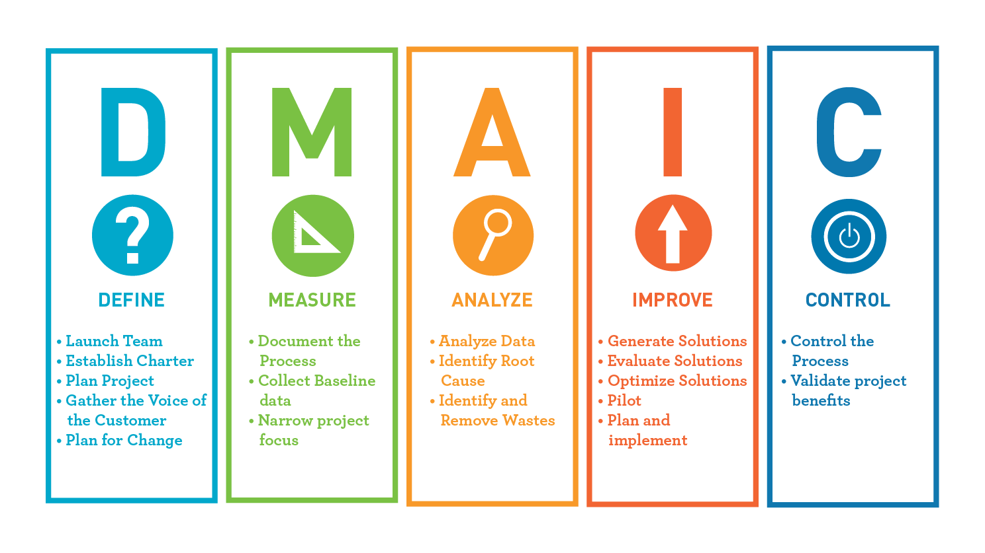
Figure 13 - DMAIC diagram (Flynn, 2023)

4.2 Project Gantt Chart
A Gantt chart was created from the beginning to ensure that project tasks were completed in a structured and timely manner. The Gantt chart was a visual project management tool that provided a timeline for each phase of the DMAIC cycle, as well as key milestones and deliverables. This facilitated effective time management and resource allocation, providing ample time for data collection, stakeholder engagement, and iterative validation of improvement actions (Geraldi and Lechter, 2012).
Tasks were scheduled to coincide with operational availability and academic deadlines, with a buffer period built in for unexpected delays. The Gantt chart also enabled progress monitoring, ensuring that the project stayed on track and allowing for early detection of any deviations from the original schedule.
The use of a project management tool, such as a Gantt chart, demonstrated the integration of professional practice skills and facilitated effective communication with project stakeholders. The Gantt chart created for this project can be seen in Figure 14.

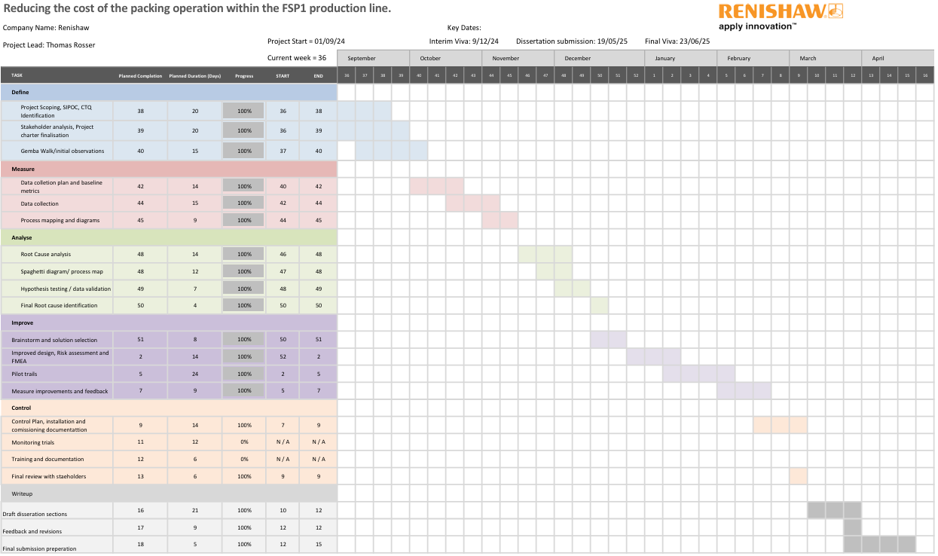
Figure 14 - Gantt chart

Define
The DMAIC framework's Define phase, which is its initial stage, concentrated on defining the problem, establishing precise goals, and defining the project's parameters. By using tools like the project charter and SIPOC diagram, it made sure that business needs and process performance were in line. This phase was useful for establishing a common understanding of the problem and providing a focused and structured starting point for the subsequent improvement work.

5.1 Problem Statement
A problem statement that is clear and focused was essential in this project as it set the foundation for identifying inefficiencies and guiding the improvement efforts. It defined the key challenges within the process and aligned the projects objectives with measurable goals. This statement helped drive the subsequent phases of the DMAIC framework, pinpointing root causes and implementing effective solutions (Miles, 2022).

5.2 The Problem statement
Renishaw's FSP1 packaging process is currently outdated, fully manual, and heavily reliant on operator input. The operation takes place on the factory floor in a shared space, where a single operator per shift cleans, cosmetically inspects, tapes, sleeves, boxes, and labels the Linear scale. The process has been allocated for 13.2 minutes per part, making it the second longest operation in the FSP1 workflow. This extended cycle time directly contributes to higher production costs and lower throughput.
Furthermore, due to the manual aspect of the operation the quality assurance relies on manual buddy checks, which increases the likelihood of packaging errors such as incorrect labelling or missing documentation. These issues can lead to rework, customer returns, and reputational damage. Internal engineering and management have raised concerns regarding inefficiencies, while external customers expect timely delivery and correctly packed parts.
A formal improvement is required to reduce waste, lower costs, and increase process reliability. This project will use the Six Sigma DMAIC framework to assess current performance, identify root causes of inefficiencies, and implement long-term solutions improving the data collected in the measure phase.

Process Overview (SIPOC)
The FSP1 packing operation is located on the factory floor amongst other scale packaging operations. The FSP1 packaging process handles high-precision components so they are packaged with extreme care not to damage the part and to ensure quality and traceability for both internal and external customers.
Once a part has passed its final testing process, it is sent to a packaging operator. Operators worked independently on a double-day shift schedule (06:00-14:00 and 14:00-22:00) and are responsible for completing the packing process following work instructions and SDPs (Standard disciple procedures).
Work instructions were physically stored in folders on the workstation. Operators followed these documents step by step, scanning and booking their job sheets using an electronic system called Syteline.
The packaging process involved multiple manual tasks, including cleaning each part with cloths and IPA (isopropyl alcohol), performing a visual inspection against a predefined cosmetic inspection standard, preparing tape, inserting the scale into a protective sleeve, and placing the sleeved part into a folded cardboard box. Each package needed to include a label showing the parts serial number and a certificate of the parts pass data.
Following packing, all parts are subjected to a mandatory buddy check by another trained operator from a different cell, during which common errors (such as incorrect labels, missing certificates, or incorrect items) are identified and corrected. Only after this check are the items transferred to the dispatch team in goods outward. From there, the parts are sent to internal departments or external organizations with global distribution.
In order to give a further structured understanding of this process a SIPOC diagram was developed (Figure 15). SIPOC (Suppliers, Inputs, Process, Outputs, Customers) is a well-known Six Sigma tool for visualising a high-level process and determining the scope of DMAIC-based interventions. SIPOC was chosen to support early-stage DMAIC activity in the define and measure phases by making the process more transparent by emphasising key inputs and outputs (Wedgwood, 2006).
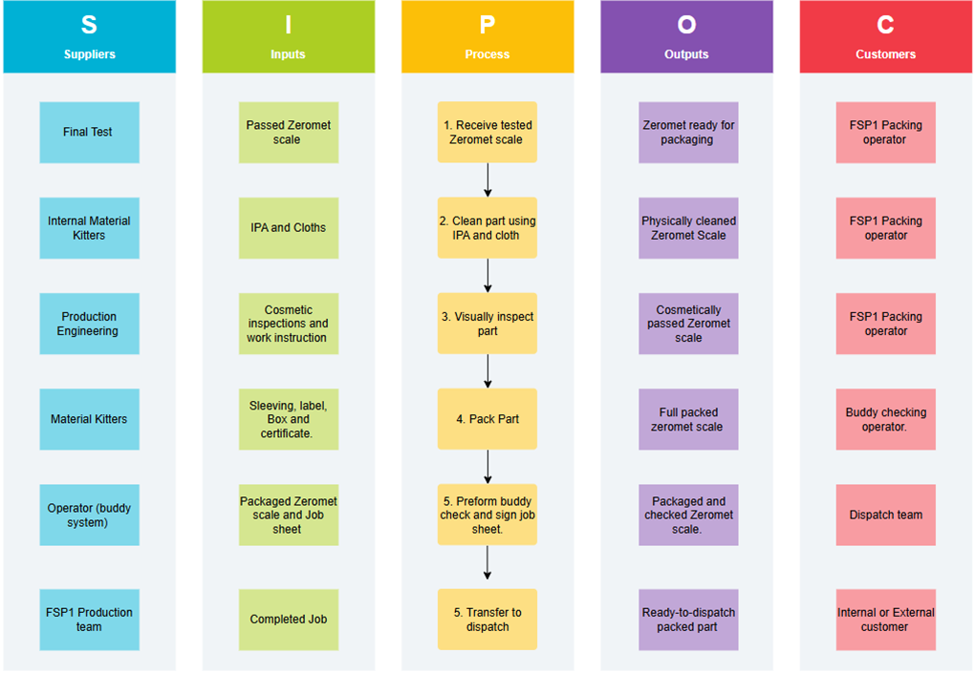
Figure 15 - SIPOC Diagram

5.4 Project Charter
A formal project charter was created to serve as the foundation for the improvement initiative (Figure 16). The charter outlined the project's purpose, objectives, scope, and key stakeholders. Its goal was to ensure alignment among all parties involved while also clearly communicating the project's business case (Pyzdek, 2003). This charter was always kept visible within the project workspace to remind the team members of the key foundations of the project.
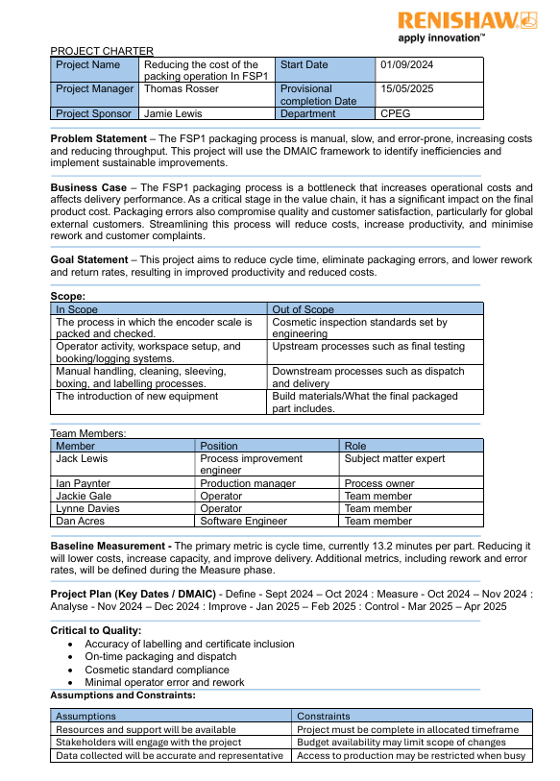
Figure 16 - Project Charter

5.5 Initial Observations
To aid the Define phase, an initial Gemba walk took place to observe the FSP1 packaging process in its operating setting. Gemba, which means "the actual place" in Japanese, refers to the factory floor where the packing process takes place and value is added to the product (Croft, 2023).

As well as gaining a better understanding of the process to assist with creating a process map, the first-hand observation provided a better grasp of how the packaging operation was carried out. It proved that the task was primarily manual, requiring the operator to complete sequential steps with little automation or ergonomic support. A completed Gemba walk observation sheet, used to support this analysis can be found in Appendix A. Several inefficiencies were discovered throughout this walk:

- The workstation's layout lacked logical flow, resulting in inefficient movement between tasks and equipment.

- The buddy check method, while necessary for quality, was time-consuming and frequently disrupted the second operator's workflow.

- The placement of tools and consumables (such as labels, tape, and certificates) was not optimal, resulting in slight delays as operators had to often reach or look for items.

- Printed work instructions had multiple steps and were sometimes difficult to follow, increasing the risk of errors.

- The process of matching certifications and labels to the appropriate part required operator attention and was prone to error.

These early findings helped to validate the concerns outlined in the problem statement, guided the focus areas for further investigation and assisted in the creation of both the process map and spaghetti diagram in the Measure phase.

Measure
The Measure phase of the DMAIC framework focused on quantifying current process performance within the FSP1 packaging operation. This phase aimed to establish a data-driven baseline by identifying key metrics such as cycle time, operator motion, and packaging error rates. These metrics were used to validate initial observations from the Define phase and to characterise the extent of inefficiencies present.
Data collection tools such as time-and-motion studies, error logs, and operator tracking were employed to gather primary data from live operations. The data was then analysed to reveal patterns of variation and operational delays. This enabled a structured comparison between actual performance and internal targets, providing an objective foundation for identifying root causes in the subsequent Analyse phase.

6.1 Data collection strategy
The goal of this section was to explain what primary data was collected, why each variable was chosen, and how measurements were taken on the shop floor. A structured collection plan was required to ensure that subsequent analysis was accurate and directly related to the problem statement and inefficiencies recognised during the Gemba walk.

6.1.1 Data Sources and Capture Method
A data collection plan is a structured approach used to define what data was gathered, how it was collected, and why it was necessary to support process analysis and decision-making (Kenett, Zonnenshain and Swarz, 2020). Table 1 summarises where variables were collected, collection instruments used, and the sampling plans used to ensure adequate coverage across shifts. Within the sampling plan operator A and B were mentioned, these were the operators on alternate shifts. Operator A was recorded on a morning shift (06:00-14:00) and Operator B was recorded on an afternoon shift (14:00-22:00).
Table 1 - Data collection plan
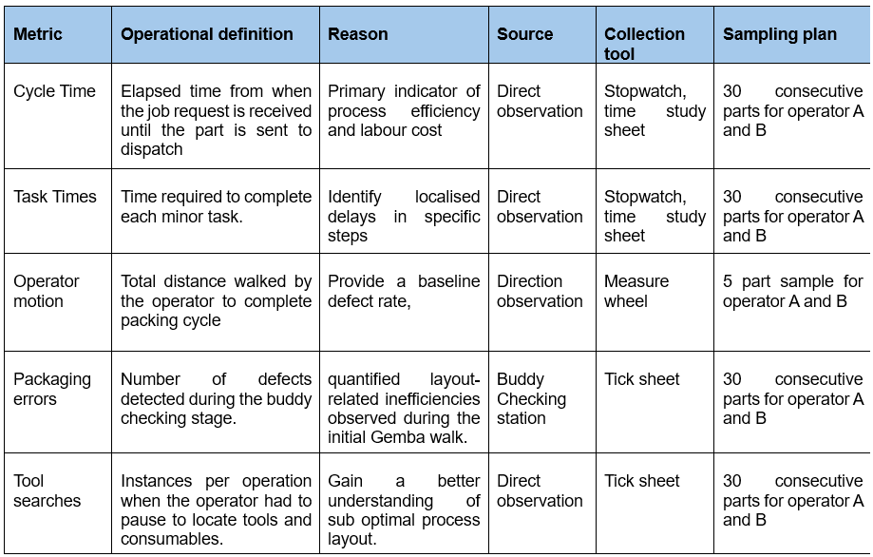

6.1.2 Validation of data collection methodology
To ensure the reliability and integrity of the data collected during the Measure phase, several validation steps were carried out. The goal of this was to minimise variation in collection methods while maintaining consistency across shifts and data types.
All time-and-motion observations were performed by the same person, eliminating inter-observer variability and ensuring a consistent approach to recording task durations, operator motion, and tool search events. The only exception was packaging error data, which was collected by buddy-checking operators. To reduce variation in this activity, the production supervisor instructed operators on how to properly use the tick sheet, and the form was kept in a visible location throughout the month to ensure consistent use.
Pilot runs were performed at the start of each observation window to validate the procedure and ensure that the data recording sheets were suitable for the purpose. These pilots also allowed the observer to confirm the clarity of each variable's definitions and gain confidence in the timing and measurement routines before full data collection began.
Before using any tools for data collection, they were all checked. The stopwatch was re-set and tested for responsiveness, the measure wheel was zeroed and verified over a known distance, and the tick sheets were checked for completeness. This ensured that measurement devices worked properly and did not introduce systematic errors.
Standard operating procedures were followed to ensure consistency, for example, the stopwatch was always set to start at the same point—when the operator received the job sheet—and stop once the part was placed on the “completed” shelf. To ensure that observations were comparable, task element times were recorded using a consistent set of task definitions.
Although formal training was not provided, a document was created to input data points to ensure consistency. The observer was also verbally told the start/stop criteria, task categories, and observation etiquette (e.g., no interference with the operator) in order to reduce bias and increase repeatability throughout the study.
Collectively, these steps ensured that the data collected during the Measure phase was consistent, representative, and suitable for use in the Analyse phase.

6.2 Detailed Process Mapping
Immediately after data collection and with the aid of the previously completed Gemba walk, observed operations were translated into two complimentary visuals: a process map and a spaghetti diagram. They gave a clear picture of work progress at the FSP1 packaging station.

6.2.1 Flow Chart with task-element times
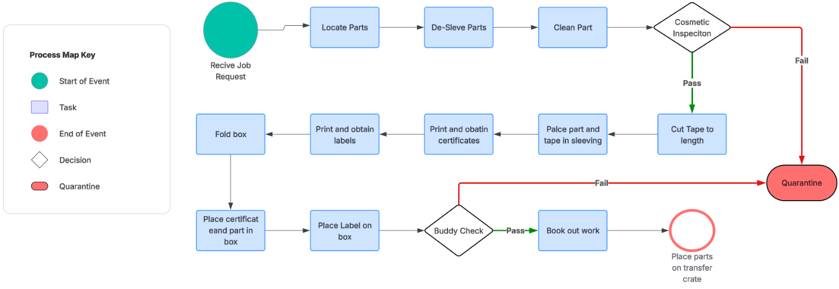
Figure 17 depicts the sequence of activities that occurred on the shop floor during the FSP1 packaging operation. This flowchart was developed based on observations from 60 packaging cycles (30 per operator) and was used to visualise the step-by-step flow of tasks within the process. It assisted in identifying the most time-consuming stages and provided a clear foundation for targeted process improvement initiatives (Frey et al., 2011).
Figure 17 - Process flow chart

6.2.2 Spaghetti diagram of operator motion
A measurement wheel was used to observe and record the movement of the operator across the workstation during the full cycle of packaging tasks. The operator's path was then transferred onto a scaled layout of the workstation, resulting in a spaghetti diagram that illustrated the typical routes taken throughout the process (Figure 18) (Atlassian, 2025). This visual representation highlighted areas of frequent movement and supported the identification of layout inefficiencies that could be addressed to optimise workflow and reduce non-value-added activity.
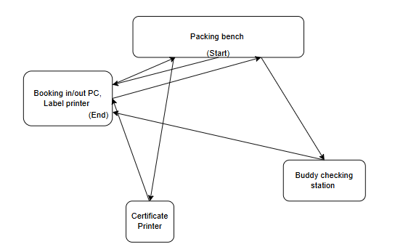
Figure 18 - Motion diagram

6.3 Baseline Process Performance
This section presents the FSP1 packaging process's baseline performance, which was collected following the data collection plan. The goal was to generate a quantifiable snapshot of the current process, identifying inefficiencies in terms of time, quality, and motion.

6.3.1 Cycle Time and Task Element Durations
A total of 60 packaging cycles were observed, with 30 from each operator. The average cycle time was 13.4 minutes. The longest process within the operation is the actual packaging of the part which takes on average 5 minutes with the buddy checking operation being the second longest taking 3.5 minutes. The raw data for the cycle time and task measurement can be found in appendix B.

6.3.2 Operator Motion
The operator's physical movement while packaging was measured with a measurement wheel. On average, the operators walked 17.1m per cycle, reinforcing previous findings from the Gemba walk regarding layout induced motion waste. The measurements taken can be found in appendix C.

6.3.3 Packaging error rate
Through the 60 parts packed, 10 packaging errors were recorded from the buddy checking process. The error rate was calculated to 17%, or 1 per every 6 parts. Their errors were due to the incorrect certificate packed with the part, an incorrect label on the box, the wrong box used and instances where the operator did not place their packing sticker on the box. The data recorded for the packaging error rate can be found in appendix D.

6.3.4 Tool and Consumable Search Frequency
Whilst measuring cycle time, operators were also observed for the number of times they paused to locate tool and consumables that were not on hand. Operators had to stop and locate these a total of 11 times, suggesting issues with workplace housekeeping and resources. The data collected for the tool and consumable search can be found in appendix E.

6.4 Secondary Data Collection for Cost benefit analysis
To establish the current cost FSP1 packaging process, internal production records and financial data from Renishaw’s production database system were reviewed (Renishaw, 2024). This quantitative analysis provided a detailed breakdown of operational time, labour costs, quality costs, and resource inefficiencies.
A total of 15,161 parts were processed through the packaging cell in the preceding 12 months. Based on an operational labour cost of £75.51 per hour and the operation taking a total of 0.244 hours, this resulted in an estimated annual packaging cost of £279,332,
In terms of quality performance, 43 parts were quarantined for internal re-work during the same period. These failures, typically detected during or after packaging, incurred an estimated £5,667.40 in labour-related rework costs.
Additionally, 8 formal CCARs (Customer Corrective Action Reports) were logged due to product returns linked to packing errors. Assuming these returns involved the highest-value product line, the total loss—factoring in product cost and labour—was estimated at £15,620. This also highlighted that the manual buddy check system was not fully effective at eliminating all errors before dispatch.
Overtime labour was authorised during five peak-demand months (February, March, August, September, and October), resulting in a total of 240 overtime hours at time-and-a-half pay. This incurred a further £18,122 in additional labour expenditure directly attributable to limitations in packaging throughput.

6.5 Summary of findings
The Measure phase established a data-driven baseline for the FSP1 packaging operation, which confirmed several inefficiencies discovered during the Define phase. The average cycle time was 13.4 minutes, with packaging and buddy checking identified as the two most time-consuming tasks. Spaghetti diagram analysis revealed excessive operator movement, with an average of 17.1 metres per cycle, indicating a suboptimal workstation layout.
Packaging quality was also discovered to be inconsistent, with an error rate of 17%, owing primarily to mislabelling and inaccurate documentation. Furthermore, operators were interrupted 11 times during the observed cycles to look for tools and consumables, indicating problems with workstation organisation and material availability.
Collectively, these findings provided clear evidence of process variation, motion waste, and quality risks, forming a robust foundation for root cause analysis and targeted improvement in the subsequent Analyse phase.

Analyse
The Analyse phase of the Six Sigma DMAIC methodology aimed to identify the root causes of inefficiencies and quality issues discovered during the Measure phase. It aimed to go beyond symptoms and systematically identify the underlying causes of extended cycle times, packaging errors, and delays in the FSP1 packaging operation. Using structured root cause analysis tools, this phase looked to validate hypotheses with data and lay the groundwork for the subsequent Improve phase (Mandal, 2012).

7.1 Data Analysis

7.1.1 Cycle Time
The average cycle time over 60 parts was 13.4 minutes, which aligns with the allocated 13.2 minutes the operator is allocated per job. The package timing is on the high side of the industry benchmarks range of 10-15 minutes per standard size packaging part, the exceptional performance ranges from 5-8 minutes (Team, 2025).
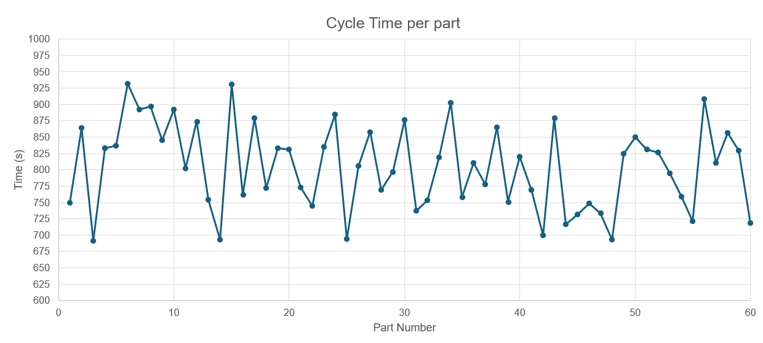
Figure 19 - Cycle time graph
The data in Figure 19 shows a wide range of timings taken to complete the cycle of the packing operation. The shortest time taken to complete the operation was 691 seconds (11.5 minutes), where the longest time taken to complete the operation was 932 seconds (15.5 minutes), this is a difference of 241 seconds or just over 4 minutes. This variation in process timings could be down to the operator, however the trend from this data shows that the vast difference in packaging times was consistent between operators. Therefore, the range of timings suggests that there is a lack of standardisation and process control which could contribute toward other issues such as packaging errors.

7.1.2 Task Timings
During the Measure phase, each category of packaging tasks was timed. Now visually represented with a Pareto chart (Figure 20), this chart assisted in identifying the most time-consuming aspects of the process. Approximately 70% of the total operation time was spent on two key stages: "Package Part" and "Buddy Check."
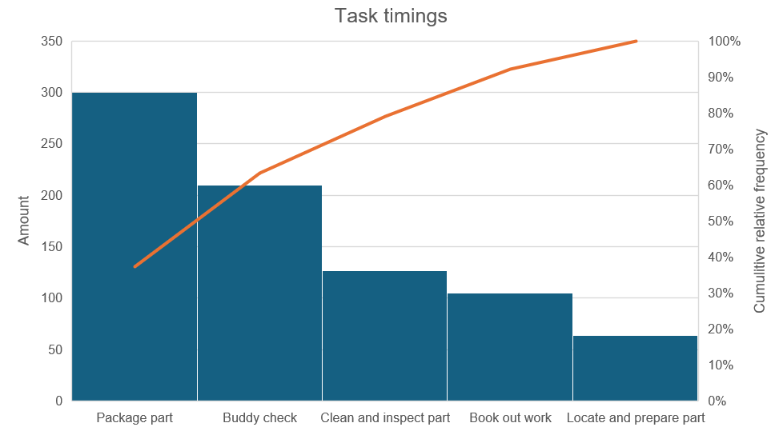
Figure 20 - Task timings graph
The "Package Part" category had several steps, including cutting tape, sleeving the part, folding the box, and inserting labels and certificates. However, the "Buddy Check" was a simple visual check to ensure the part was packed correctly. While the packaging step added value, the buddy check provided quality assurance but caused additional labour and process disruption.
Notably, the buddy check required a second operator—often drawn from a different packaging cell—to pause their own task and assist, thereby reducing throughput in their original workstation. This highlights a line balancing issue, where tasks and time are distributed unevenly across cells. The primary operator is overburdened with repetitive manual tasks, while the quality verification process is performed irregularly and lacks integration, leading to inefficiencies in both workflow and labour utilisation
Addressing this imbalance through layout re-design or digital poka-yoke systems may reduce interruptions and result in a more balanced and continuous flow, ultimately improving overall cycle time and operational reliability.

7.1.3 Operator movement data (From-To matrix)
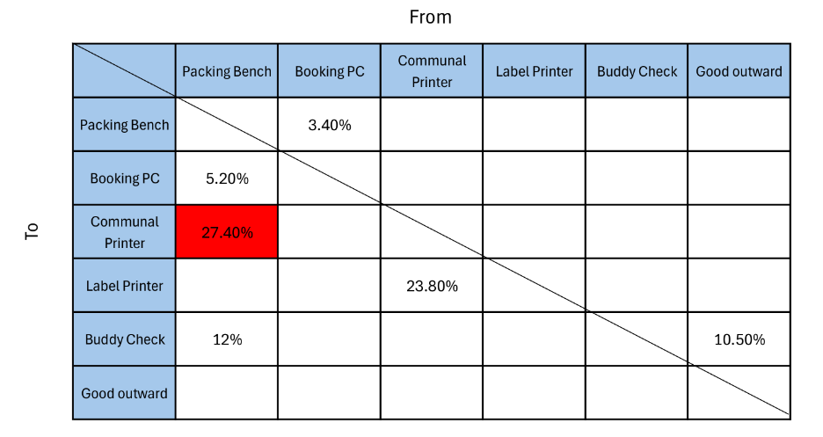
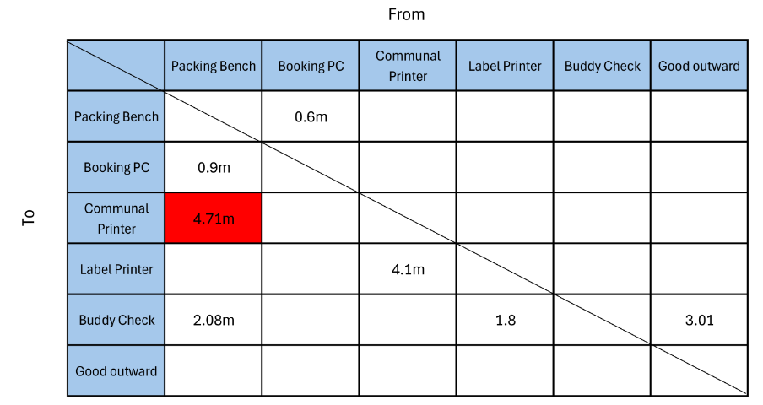
Operator movement data was analysed using a from-to matrix to quantify the physical distances travelled between workstation elements during a full packaging cycle (Institute for Manufacturing, 2016). Figure 21 depicts the matrix, which captures the one-way travel distances between key locations including the packing bench, booking PC, communal printer, label printer, buddy check station and goods outward shelf.
Figure 21 - From/To matrix

The matrix exposed several inefficiencies in layout design. The distance between the packing bench and the communal printer was the longest, measuring 4.71 metres one way, this contributed to 27% of the total movement of the operator (Figure 22). Additional high-movement steps included getting to the label printer (4.1 m) and the goods outward shelf (3.01 m). The total travel distance per cycle was calculated to be 17.1 metres, indicating a significant amount of operator motion that added no value to the product while increasing the overall cycle time.
This analysis supported the findings of the initial Gemba walk: workstation elements are poorly located necessitating excessive walking and disrupting task flow. The movement of shared resources (such as printers) contributes significantly to waste and disrupts ergonomic efficiency.
From a Lean standpoint, the layout suffers from a lack of flow efficiency, and the motion waste identified here is an obvious candidate for reduction during the Improve phase. Re-arranging workstation elements to reduce high-frequency or long-distance moves—for example, moving the certificate and label printers closer to the packing area—could significantly reduce motion, improve cycle time, and align with lean layout principles.
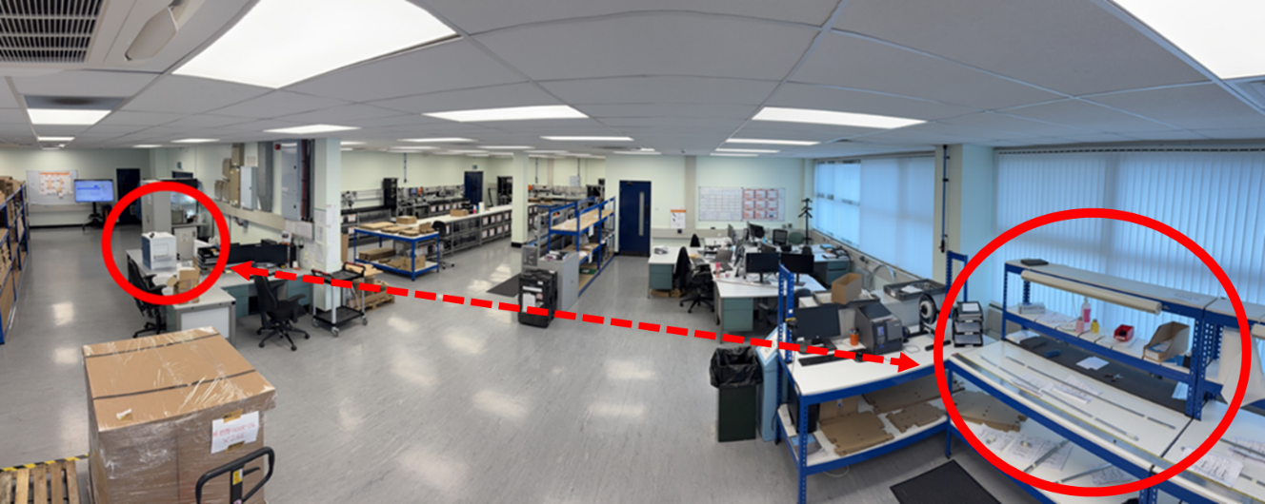
Figure 22 - Pinter location

7.1.4 Packaging errors and looking for tools/consumables
Following production for 60 parts, the buddy checking process found failures in 10 parts. This is 1 part in every 6 parts checks. Another Pareto chart was used to analyse the packing errors (Figure 23).
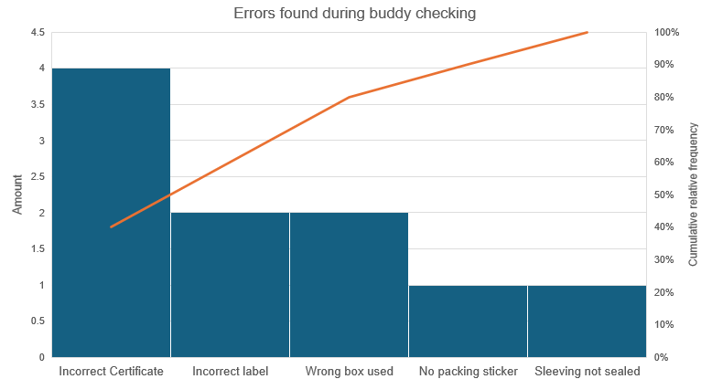
Figure 23 - Pareto chart for errors found in buddy checking
This Pareto analysis clearly highlights that the incorrect certificate being in the box is the largest failure mode. This is a common issue due to the operator printing out the certificates at once and getting them confused with one another (Figure 24). Based on the observed defect rate of 10 errors in 60 parts, the process demonstrated a Six Sigma performance level of approximately 1.5 sigma, which reflects a high level of process variation and falls significantly short of industry best practices (Keller, 2011). This further reinforces the need for error-proofing measures to reduce reliance on manual checks.
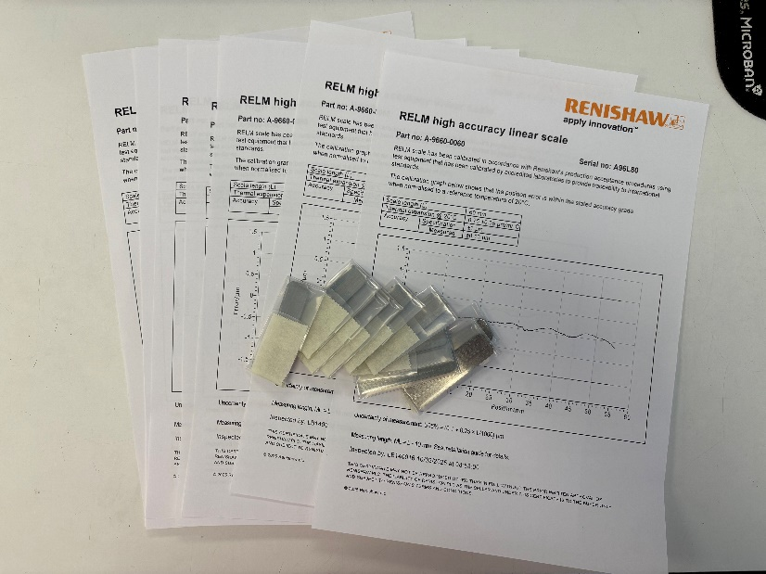
Figure 24 - Parts with certificates
A large factor in making mistakes can be an interruption to workflow, evidence of this can be shown from the figures collected for when the operator needs to search for tools and consumables. For over 60 parts, the operators had to search for equipment like scissors, consumables and labels a total of 11 times, all of these removing the operator from their workstation and disrupting their workflow.

7.1.5 Data analysis summary
The analysis identified several recurring inefficiencies in the FSP1 packaging process. Notable issues included significant variation in cycle times, long operator movement distances, frequent interruptions due to buddy checking, and certificate handling errors.
These findings indicated systemic flaws in the process flow, workstation layout, and task standardisation. To better understand the underlying causes of these inefficiencies, a structured root cause analysis was performed using cause-and-effect diagrams and the 5 Whys method.

7.2 Root cause identification
A cause-and-effect diagram was first created to capture a wide range of potential causes contributing to the observed packaging issues. This visual tool paved the way for identifying root causes by categorising potential contributors into standard categories such as Method, Manpower, Machine, Material, Measurement, and Environment.
Following this, the causes stated in the graphic were cross-checked against data acquired during the Measure and Analyse phases. By overlaying qualitative and quantitative evidence, the most relevant and impactful possible causes were identified. The top three causes were then submitted to a 5 Whys analysis to investigate the underlying reasons for their occurrence and determine if they represented root causes or surface-level symptoms.
Finally, to validate these root cause hypotheses, further measurements and informal operator interviews were performed. This stage guaranteed that the results reached were supported by empirical data and real-world operator experience.

7.2.1 Fish bone diagram
The Fishbone diagram, also known as the Ishikawa or Cause-and-Effect diagram, was used to visually organise potential causes of inefficiencies into key categories such as people, materials, methods, and equipment. This structured approach enabled a thorough investigation of factors influencing performance, making it easier to identify major areas for improvement (Gooch, 2007).
It was chosen for its ability to present complex cause-and-effect relationships in an understandable, systematic manner. The Fishbone diagram which can be seen in Figure 25 presented the issue at the head of the fish (High cycle time and packaging errors) then the bones are categorised as the main factors contributing e.g. process, materials and equipment. The smaller bones are then the potential causes within this category.
From this diagram there were multiple causes defined that contribute toward high cycle times and packaging errors. However, working towards all of these causes in the improve stage would be tricky and potentially lead to unsuccessful suggestions due to their complexity. To narrow these down and highlight the root causes, another lean tool called the 5-Whys was used.

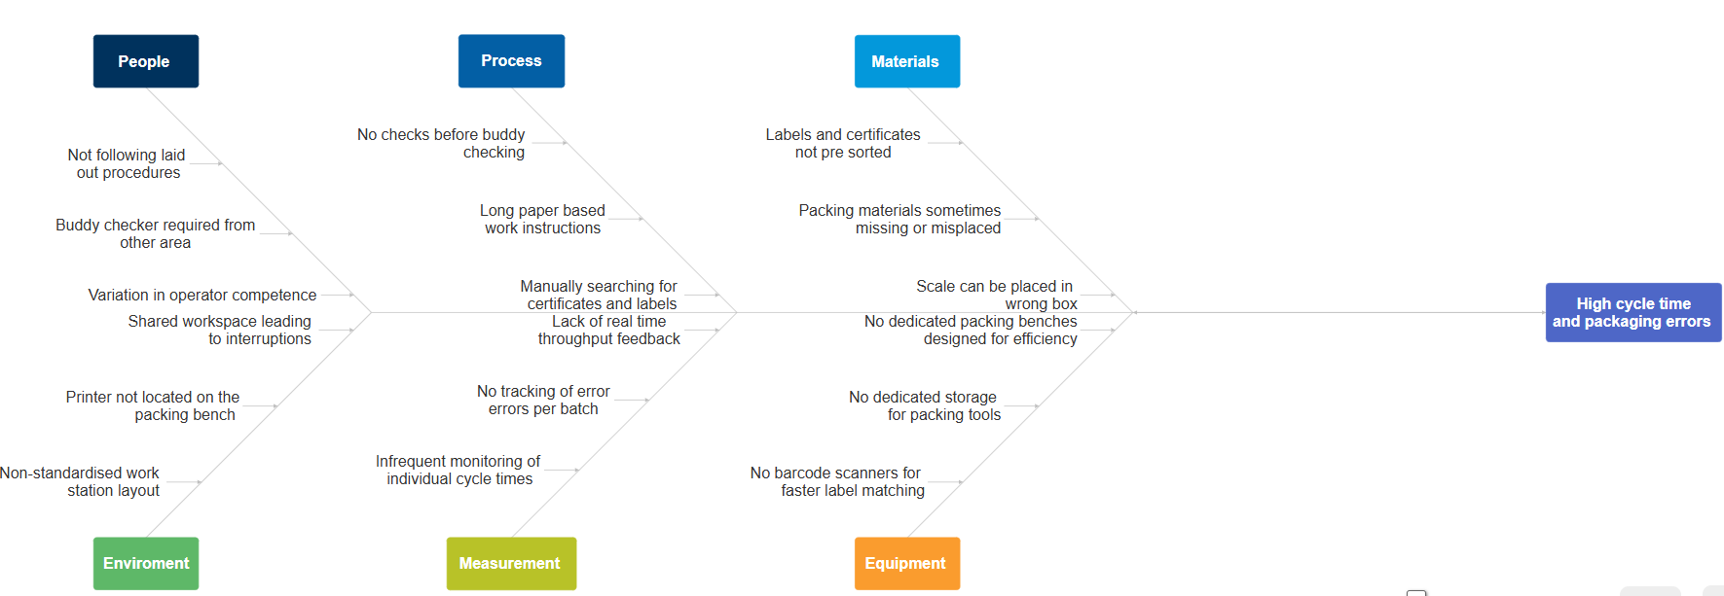
Figure 25 - Fishbone diagram

7.2.2 5 Why’s Technique
The 5Whys technique was used to systematically investigate the underlying causes of key performance issues identified during the Measurement phase. This method involved repeatedly asking "Why?" to each problem, which allowed for deeper exploration beyond surface-level symptoms (Murugaiah et al., 2010) (Table 2, 3, 4, 5).
It provided a simple yet effective method for tracing problems back to their root causes, which could be addressed through targeted improvements. Four issues were chosen for further root cause analysis due to their mention within the cause-and-effect diagram and having extensive data backing from the data analysis phase. These were:
Inconsistent cycle times with a range of 4 minutes.
Poor process layout due to operator motion of 17.1m.
Incorrect certificates being packed due to being 40% of the overall error found.
Length buddy checks consuming 3.5 mins of another operator’s time.

Problem: Inconsistent cycle times
Table 2 - 5 Why, Inconsistent cycle times
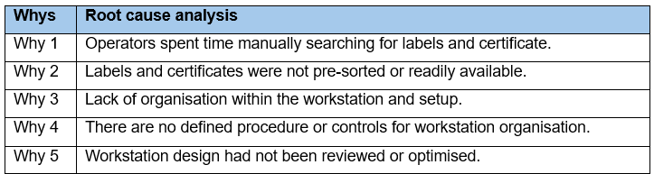
Problem: Lengthy Buddy Checks:
Table 3 - 5 Why, Lengthy buddy checks
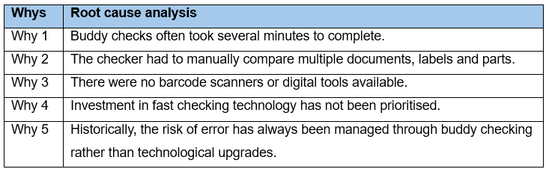
Problem: Poor Workstation layout:
Table 4 - 5 Why, Poor workstation layout
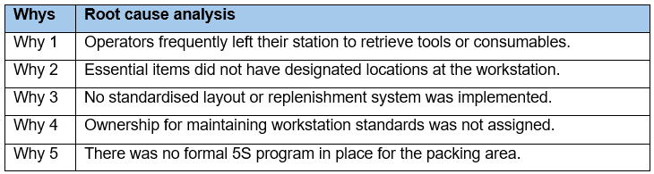
Problem: Incorrect certificates packed with parts:
Table 5 - 5 Why, Incorrect certificates packed with parts
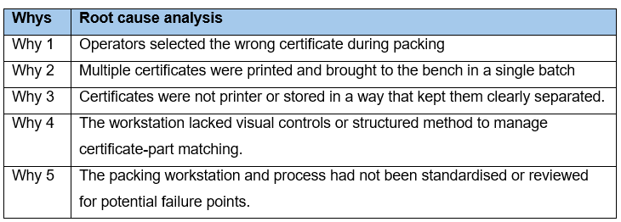

7.2.3 Root cause summary
The 5 Whys method was used to conduct root cause analysis on four key issues identified during data analysis: inconsistent cycle times, lengthy buddy checks, poor workstation layout, and incorrectly packed certificates.
Although these issues appeared to be separate, the 5 Whys analysis revealed that they all stemmed from the same underlying cause. In each case, problems arose from a lack of standardisation in workstation layout, processes, and control methods.
Inconsistent cycle times and buddy check delays, for example, were associated with a lack of visual controls, disorganised tools, and reliance on manual practices. Similarly, batch printing without structured document handling resulted in certificate errors, while workstation inefficiencies were caused by non-standard layouts and the lack of a 5S approach.
The findings were summarised as follows:
The root cause across all issues was a lack of standardisation in workstation setup, procedures, and error-prevention measures.
This conclusion provided a clear direction for the Improve phase, which included implementing standardised layouts, structured workflows, and basic visual or digital controls to reduce variation, increase efficiency, and reduce quality issues.

7.3 Root cause validation
To validate the suspected root cause, three targeted activities were carried out: time observation, workstation adjustment, and operator interviews.

7.3.1 Cycle Time Observation
An operator was shadowed throughout the entire packaging cycle. Each step of the process was monitored to ensure part accuracy, simulating the role normally performed during buddy checks. The time required to complete the cycle was recorded. When buddy checks were removed from the process the average cycle time decreased from the baseline 13.4 to 9.8 minutes. This indicated that buddy checks had a significant impact on overall process time.

7.3.2 Workstation Layout Adjustment
As a practical solution, the certificate printer was temporarily moved right next to the packaging bench (Figure 26). A repeated motion study was used to track operator movement following this change. The relocation reduced the average walking distance by 6.81 metres per cycle which can be seen in the improved From-To matrix in figure 27, supporting the hypothesis that inefficient workstation layout contributed to inefficiencies.
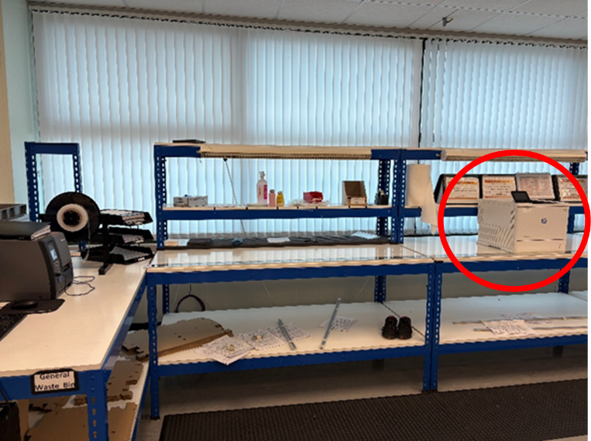
Figure 26 - Improved printer location

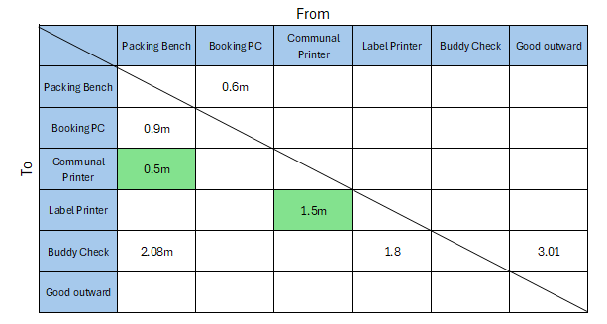
Figure 27 - Improved From-To matrix

7.3.3 Operator Surveys
Structured surveys with packaging operators were conducted to gather qualitative information. The questions focused on perceived bottlenecks, documentation clarity, material access, and workstation organisation. The respondents consistently expressed dissatisfaction with unnecessary movement, a lack of visual controls, and lengthy/confusing work instructions. Operators strongly advocated for layout improvements and digital or visual aids to reduce errors and delays. The completed surveys can be found in appendix F.

7.3.4 Summary of findings
The findings confirmed the initial root cause identified by the 5 Whys analysis: a lack of standardisation in workstation configuration and process control. All three validation methods provided consistent evidence that inefficient layout and reliance on manual error-checking lengthened cycle time and increased the risk of errors. The findings supported the need for targeted improvements in process standardisation, material organisation, and error-proofing.

Improve

8.1 Overview of improve phase
The improvement phase aimed to create a solution that directly addressed the validated root cause identified in the Analyse phase.
To address this, a newly developed packaging bench within a separate Renishaw cell was used as a benchmark. This workstation was purpose-built with integrated process controls, poka-yoke features, and layout standardisation, removing the need for the buddy checking process. The improvement strategy therefore focused on adapting this proven design for the FSP1 area.
Although full implementation of the improved workstation was not possible within the project's timeframe due to budget constraints, a proposal was developed to test the solution using loaned components and simulated setups. This enabled validation of the proposed benefits, such as reduced operator movement, elimination of buddy checks, and shorter cycle times. The enhancement was thus both evidence-based and forward-compatible with future investment.

Comparative Analysis of Packaging Cells
To develop an improved packaging process for the FSP1 operation, a benchmark study was carried out on an adjacent packaging cell at Renishaw's Miskin manufacturing site. Although both cells operate in the same general area, the benchmarked cell was designed and built in 2019 to pack a newer line of encoder scale (Figure 28). In contrast, the current FSP1 packaging line was relocated to the same area in 2014.

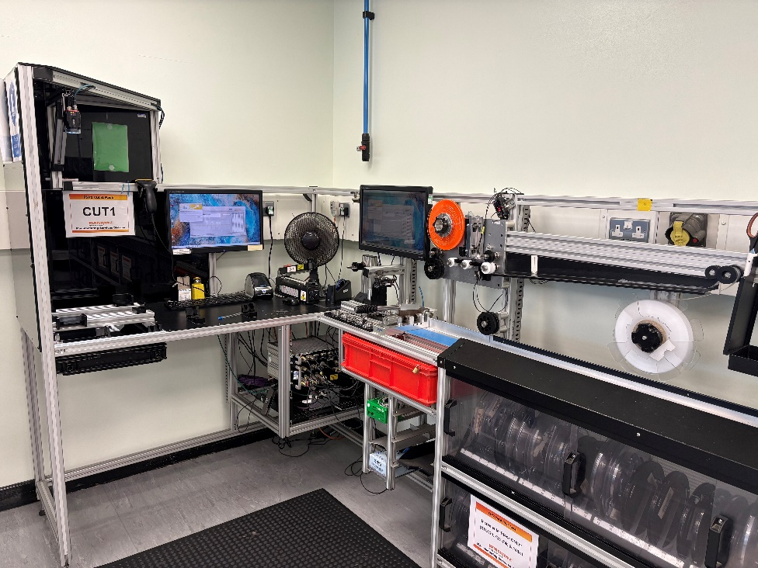
Figure 28 - Benchmarked cell (FSP2)

The benchmarked cell used several design principles to enhance efficiency, process control, and error prevention. The workstation was very compact, with clearly labelled storage areas for all tools and consumables, allowing for a lean layout while minimising unnecessary movement. Furthermore, the cell used digital work instructions delivered via touch screen monitors, guiding the operator through step-by-step procedures based on a dynamic cutting list and eliminating the need for booking in and out jobs.
For better quality control, the system included several Poka-Yoke mechanisms, such as sensors to verify proper tape application, a camera to confirm the part was correctly placed and labelled within the box, and a barcode scanner to validate that the correct part was selected for packaging. Collectively, these measures eliminated the reliance on manual buddy checks, resulting in a more standardised and repeatable process. These sensors were all linked to the electronic work instructions allowing a step-locked process.
The performance and layout of this packaging cell served as a reference model for the proposed improvements to the FSP1 line, with modifications to meet the specific process needs.

8.2.1 Gap analysis
A structured gap analysis was used to compare the existing FSP1 packaging workstation to the benchmark packaging cell (Stefaniak, 2015) (Table 6). The following key differences were identified in layout, process control, and standardisation:
Table 6 - Gap analysis
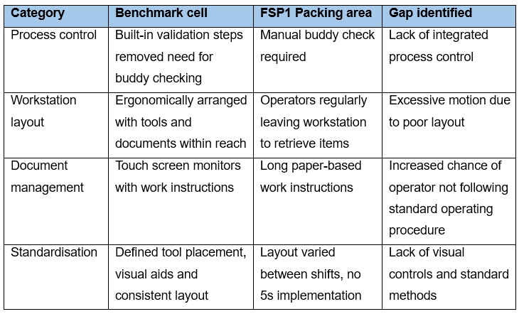
The analysis confirmed that inefficiencies in the FSP1 process were directly caused by the absence of key control and layout features in the benchmark cell. These results supported the analysis phase, problem statement and the proposed improvement strategy of tailoring the benchmark cell to FSP1 requirements.

8.2.2 Benchmarking
After the initial observations and gap analysis, quantitative benchmarking was used to evaluate the performance of the newer packaging cell (Hasselbring, 2021). The goal was to determine whether tailoring its features would result in measurable improvements to the FSP1 packaging process. The following key metrics were captured during the observation of the benchmark cell (Table 7):
Table 7 - Benchmarking comparison
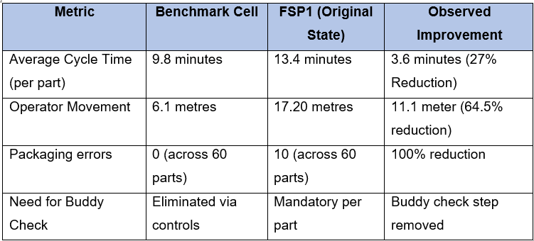
This benchmarking exercise proved the capability of tailoring a design to the newer packing bench, with significant improvements in all of the metrics.

8.3 Concept Design
The concept design for the improved FSP1 packaging bench was developed to address the validated root causes by adapting key features from the benchmarked cell using a CAD software. Figure 29 shows the detailed design of the new packaging system. The design incorporated the Six Sigma principles of Poka-Yoke, standardised work, and layout optimisation, all of which aimed to reduce process variation, eliminate waste, and improve operational efficiency.

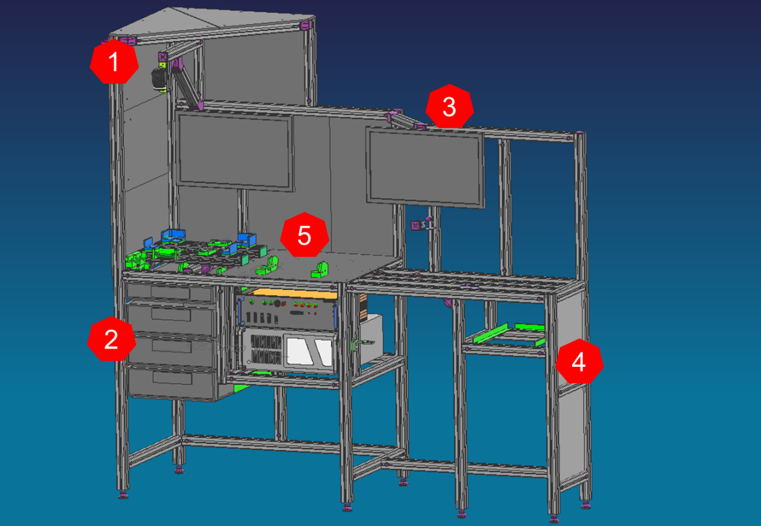
Figure 29 - New workstation design

8.3.1 Poka-Yoke Integration
This design incorporates several error-proofing mechanisms to eliminate the reliance on manual inspections and the likelihood of human error. These included implementing a barcode scanning system to ensure that each part, certificate and label matched and met the work order requirements.
In addition, a vision system (1) that uses camera-based Go/No-Go inspection would ensure that the part is being packed correctly such as; checking the correct box is used, tape is included with the part and the label is placed onto the box.
The barcode scanner is a standalone unit that will be kept in a holder however the vision camera will be fixed above the packing station, shrouded by acrylic so its imaging will not be affected by the environment lighting. The packaging boxes will be placed in fixture that fits the required box and allows the vision camera to perform more accurately (5).

8.3.2 Standardised Work Implementation
The re-designed bench was created to ensure that all operators completed their tasks consistently. A touchscreen interface (3) would be used to display interactive, step-by-step instructions based on the cutting list, reducing the need for printed manuals and individual interpretation. As well as this, the Poke-Yoke systems will be integrated into the software creating it into a step-locked process. With this implementation, operators must follow the digital work instructions and scan/show the part when they are asked to.
All essential materials, such as labels, tape, and certificates, would be stored in clearly labelled compartments (2). This arrangement would ensure that each operator carried out the same set of tasks, reducing variability, increasing training effectiveness, and improving process repeatability across shifts.
There was sufficient space allocated for tools and equipment that are kept on the packing bench, however the organisation of this equipment was not designed in the drawing, and they may need to be re-arranged during pilot trials (5).

8.3.3 Layout Optimisation
Significant changes were also planned for the physical layout of the packaging workstation. Using time and motion analysis, the design repositioned the label and certificate printers into the packaging bench (4), reducing unnecessary travel during the packaging cycle.
Consumables and tools would be placed within the operator's ergonomic reach to improve access and reduce unnecessary motion. The new layout, influenced by the compact and efficient footprint of the 2019 benchmarked packaging cell, was expected to significantly reduce non-value-added activity and contribute to a measurable decrease in total cycle time.

8.4 System Setup and Equipment Testing
To avoid interfering with live production, the proposed improvements were tested in a mock workstation first. A loaned ‘KEYENCE CV-X series Intuitive Vision System’ was configured to perform go/no-go inspections, such as confirming proper box selection, label application, and tape sleeving (Keyence, 2025). Figure 30 shows the Go/No-Go tests that look place.
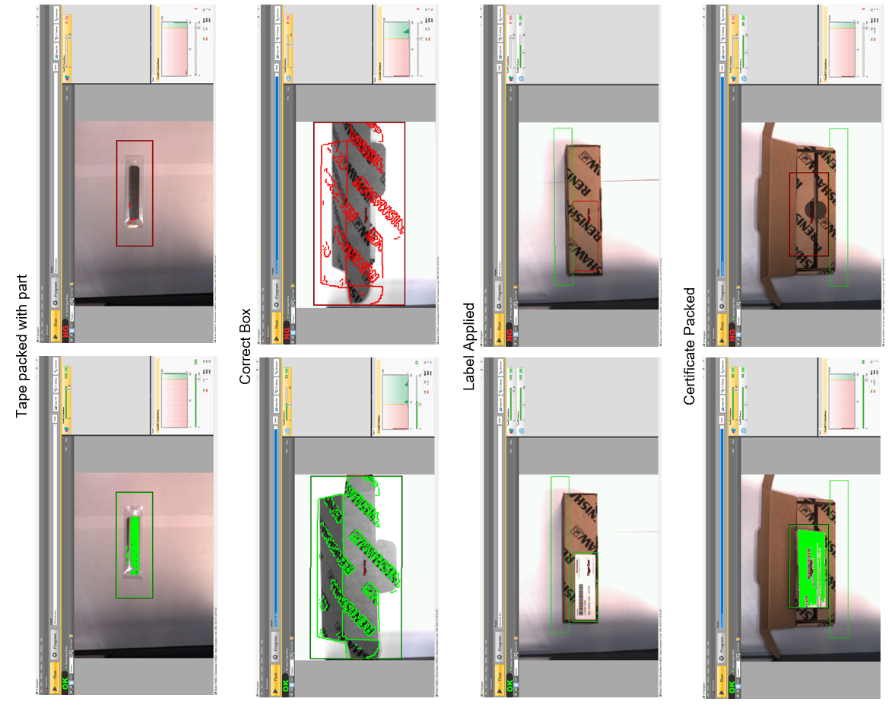
Figure 30 - Go/No-Go testing

A 2D matrix barcode scanner, which had previously been implemented in other FSP1 operations, was tested for compatibility with Windows 11 and LabVIEW 2016. It successfully verified part serial numbers against the label and certificate, thereby facilitating traceability and error prevention (Figure 31).
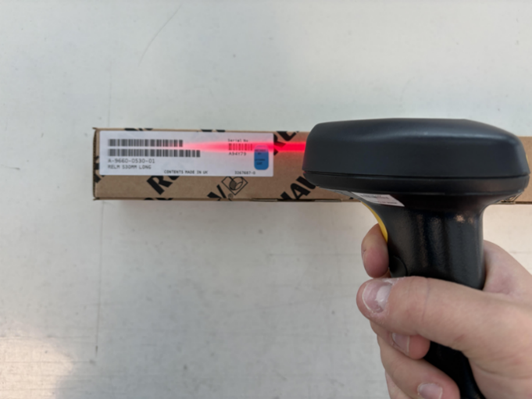
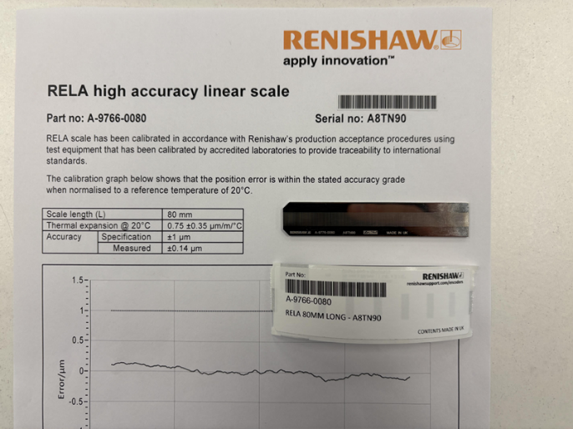
Figure 31 - Barcode testing
A touchscreen monitor was ordered internally, and prototype software based on the benchmarked cell was installed. This mimicked a cutting list, step-by-step instructions, and sensor-controlled task progression. The project team integrated and monitored all components to ensure they met operational requirements.

8.5 Validation Activities and Results
Following system setup (Figure 32), a series of validation trials were carried out to determine the feasibility and efficiency of the proposed packaging improvements. These tests centred on usability, performance improvement and Poka-Yoke effectiveness.
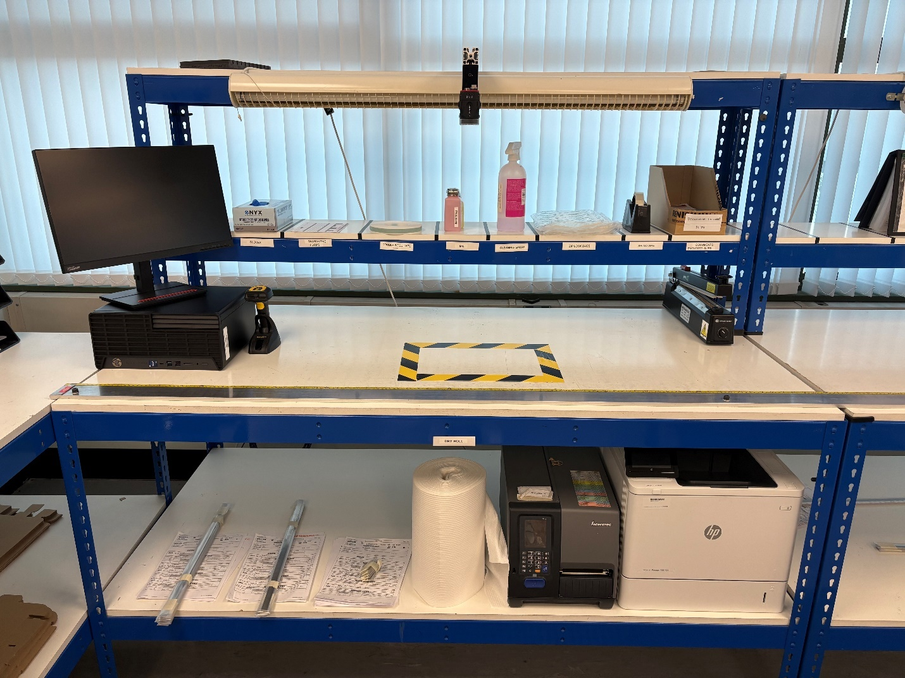
Figure 32 - Improve validation set-up

8.5.1 Operator Usability and Workflow Evaluation
Operators interacted with the mock setup by performing simulated packaging tasks on the touchscreen monitor, barcode scanner, and visual camera. Feedback emphasised the clarity of instructions, intuitive layout, and reduced cognitive load. The guided, step-by-step process was well received, indicating high user adaptability.

8.5.2 Time and Motion Comparison
A direct comparison of the current FSP1 process and the improved layout revealed measurable benefits. Removing the manual buddy check and replacing it with visual and scanning controls reduced the average cycle time 13.4 minutes to 8.8 minutes. Furthermore, motion measurements revealed a 10.8 metre reduction in operator movement because of improved bench layout and integrated equipment.

8.5.3 Error Elimination Scenarios
Simulated failure modes (e.g., incorrect part, missing label, missing tape) were used to assess the proposed system's error-detection capability. The barcode scanner and vision camera correctly identified all anomalies, demonstrating the effectiveness of the integrated Poka-Yoke mechanism.

8.5.4 System Integration Testing
Although full integration with Syteline was not possible given project constraints, preliminary tests with temporary software confirmed compatibility with existing data inputs. The system accepted barcode scans and supported label generation, indicating a viable foundation for future integrations.

8.5.5 Summary of validation results
The results from the trial of this design were very positive and can be seen in Table 8.
Table 8 - Validation results
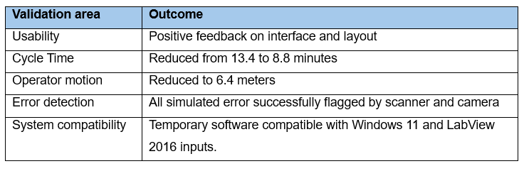

8.6 Risk Assessment
A thorough risk assessment was conducted to ensure the viability of the proposed packaging improvements. The assessment aimed to identify risks that could have an impact on implementation, functionality, and long-term operation. This was accomplished by combining a Risk Register with a simplified Failure Modes and Effects Analysis (FMEA).

8.6.1 Risk Register
A risk register was created to document potential threats to project success, such as technical, operational, and logistical issues (Table 9). Each risk was assessed according to its likelihood and potential impact. Mitigation strategies were then proposed to help reduce exposure (Bell, 2022).
Table 9 - Risk register
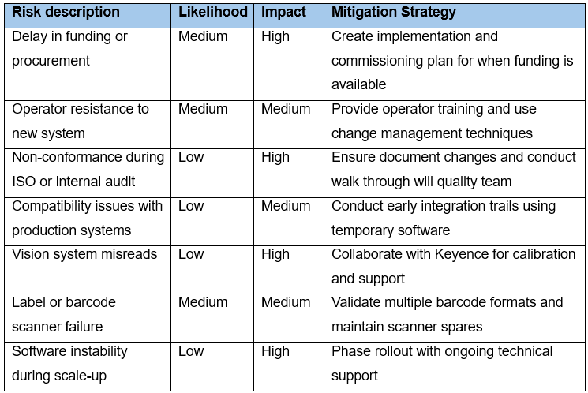

8.6.2 Failure Mode Element Analysis (FMEA)
A Failure Modes and Effects Analysis (FMEA) was conducted to identify and mitigate potential risks associated with the proposed improvements to the FSP1 packaging workstation (Table 10). The analysis evaluated failure scenarios across key digital and ergonomic features, including the barcode scanner, vision system, touchscreen interface, and Poka-Yoke elements. Each failure was assessed using Six Sigma risk criteria—Severity (S), Occurrence (O), and Detection (D)—with Risk Priority Numbers (RPNs) used to guide mitigation priorities (Alruqi et al., 2021)
Colour coding was applied to the FMEA using standard Six Sigma thresholds: RPN ≥ 100 (red, high risk), 50–99 (amber, moderate risk), and <50 (green, low risk), allowing for clear visual prioritisation of mitigation efforts.
Most failure modes were categorised as moderate risk, with RPNs between 42 and 108. The highest risk—“Operator bypasses scanning or camera check” (RPN 135) and the second highest risk “Step locked process fails to prevent skip” (RPN108) —posed significant quality concerns and these could affect Critical to Quality factors, they were addressed through enforced step-locking, putting a maintenance check in place and refresher training. Other moderate risks, such as camera misalignment (RPN 60) and touchscreen input errors (RPN 96), were mitigated through calibration routines and interface improvements. Even low-risk items, like interface confusion, were incorporated into the improvement strategy to support long-term reliability.
Overall, the FMEA confirmed that, while new technologies posed potential hazards, they were well understood and manageable. Proposed mitigations were targeted, realistic, and, in some cases, validated during pilot testing, indicating that the revised design is ready for adoption.
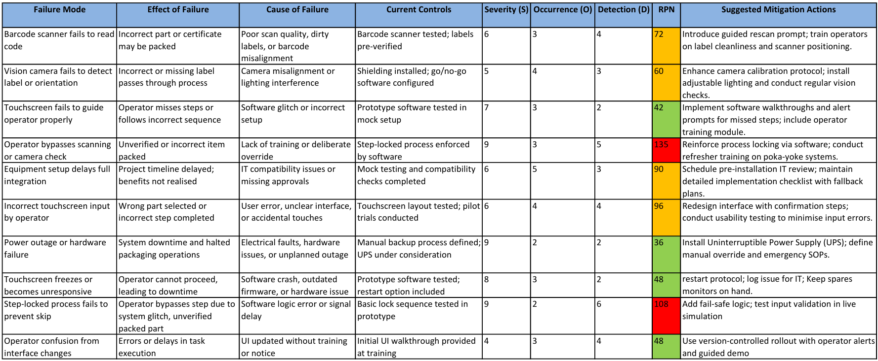
Table 10 - FMEA

8.7 Cost benefit analysis
A detailed cost-benefit analysis was conducted to assess the financial justification for the proposed improvement. This assessment considered the anticipated reduction in labour costs, waste, and rework, as well as the capital and development costs associated with implementing the new packaging workstation (IMD, 2024). In accordance with Six Sigma's data-driven decision-making principles, both quantitative and qualitative factors were evaluated to determine the solution's economic feasibility.

8.7.1 Implementation costs
The initial cost of implementing the improved workstation were calculated using quotes from supplied for the equipment which can be seen in appendix G and an estimated amount of labour time required to build/implemented the equipment at the standard operating cost of £75.51 (Renishaw, 2024) (Table 11).
Table 11 - Implementation cost
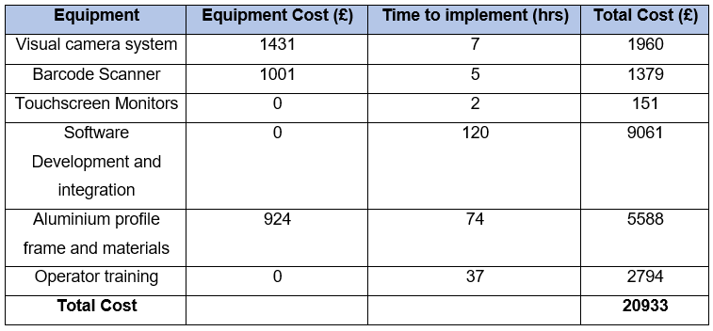
The estimated total investment including equipment and time totalled to £20,933

8.7.2 Operational benefits
With the secondary data from the measure phase, the operational benefits of the project were estimated (Table 12).
Table 12 - Operational benefits
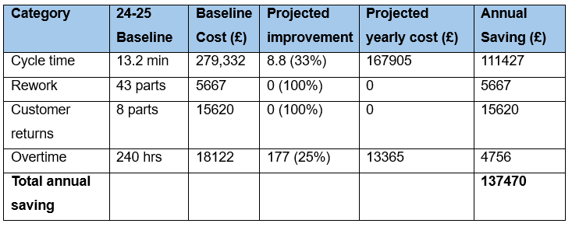
The cost-benefit analysis revealed that the proposed improvements could result in significant financial benefits. The estimated annual savings were £137,470 because of shorter cycle times, elimination of rework and customer returns, and reduced overtime requirements. These findings reinforced the project's economic viability and reinforced the case for full implementation.

8.7.3 Return on investment (ROI) and Payback Period
To determine the financial viability of the proposed improvements, a Return on Investment (ROI) calculation was planned. This metric was chosen to assess the effectiveness of the capital and resource investments required for implementation. The proposed solution's total cost included equipment procurement or loan arrangements, integrated software development, and time set aside by the internal project team for setup and validation.
The anticipated operational savings were derived from reductions in labour time, overtime, rework, and customer return costs, as described in Section 6.6.2. The ROI was calculated based on these recurring annual savings calculated in 6.7.2.
If the improvements are sustained there will be a ROI of 655% per annum with a payback period of the initial investment with two months.

8.8 Stakeholder meeting
Following the completion of the Improve phase, stakeholders attended a review meeting to present the validated improvement concept, associated risk assessments, and financial case for implementation. While the proposed changes were approved in principle, the project sponsor confirmed that immediate implementation was not possible due to funding constraints associated with a current ongoing high-priority project.
As a result, the project was parked rather than terminated. The improvement solution is still documented and validated, and it has been added to the Continuous Improvement register for future deployment. When funds become available, the solution will be ready for immediate implementation with minimal delays.
The Control phase was developed in advance of its eventual implementation. It describes the governance, monitoring methods, and control mechanisms that will keep the process stable and improvements sustainable once the changes are implemented. This forward-thinking approach ensures that the solution is not only ready but also backed by a strong framework for long-term success.

Control
The Control phase was designed to ensure that the proposed improvements to the FSP1 packaging operation would be sustained once implemented. While full deployment was postponed due to financial constraints, a proactive control strategy was developed to ensure process stability, quality, and operator compliance once implementation begins. All aspects of the control phase are intended to prevent regression to baseline performance while reinforcing Lean and Six Sigma principles.

9.1 Installation and Commissioning Plan
An Installation and Commissioning Plan was developed to provide a well-covered approach to deploying the new bench once the funds are available. This plan, which was included in Appendix H, outlined key steps such as acquiring the equipment, setup and testing. To avoid operational disruption, installation was recommended to take place during low-production periods (for example, a factory shutdown) (Turner, 2025).
The plan specified the necessary resources, key personnel and a minimum four-day commissioning period. Critical commissioning tests, such as verifying sensor detection logic and barcode scanning accuracy, were also suggested to ensure reliability prior to the process going live.

9.2 Standardisation and Visual Control
Standardisation measures should be developed to maintain consistency and reduce variation once the process is operational (Hessing, 2014a). Revised Standard Operating Procedures (SOPs) should be written and uploaded to the new software to document the entire packaging process, including scanner use, error handling steps, and system interaction. These SOPs will be reinforced with visual controls such as labelled tool placements, workstation layout diagrams, and mounted images of acceptable and unacceptable packaging conditions.
The new workstation design follows 5S principles, ensuring that tools and consumables are stored in clearly marked areas to reduce motion waste and delays. It is critical that 5s check sheets be used to assist operators with their checks, and that 5s workspaces be enforced by production management.

9.3 Operator Training and Knowledge Transfer
A "train-the-trainer" model will be used to ensure that operators are fully capable of performing the new process (Mani, 2024). The Process Engineer will train a designated Trainer, who will then provide on-the-job training to all packaging operators. This approach was chosen to ensure consistency across shifts while also facilitating long-term knowledge transfer.
Practical training will be provided in barcode scanning, system alert interpretation, and the use of vision system outputs. Operators will also be guided through the updated SOPs and shown how to escalate faults. When deemed appropriate by the Trainer, each operator will be considered competent. All training will be documented, with records kept for quality assurance and audit readiness.

9.4 Performance Monitoring and Error Prevention
Post-implementation control will be based on two key performance indicators: average cycle time per part and packaging error rate. These indicators are directly related to the project's original goals of increasing efficiency and reducing defects. The new packaging software system will automatically capture performance data (DeLadurantey, 2023).
Initially, the Process Engineering team will review KPI data daily to ensure early detection of anomalies. Once performance has stabilised, reviews will be conducted on a weekly basis. Eventually, an alert system will be implemented to notify engineering staff when KPIs deviate from expected thresholds, allowing for timely intervention and reinforcing continuous improvement.

9.5 Accountability and Routine Discipline
Daily routine control will be implemented via operator checklists that confirm equipment validation, consumable availability, and workstation cleanliness. Operators will complete and sign these checklists at the start of each shift, with Production Supervisors in charge of oversight. This promotes frontline accountability while allowing for early detection of issues like missing tools or scanner misalignment.
The barcode scanner and vision system will undergo preventative maintenance, such as sensor calibration and basic functionality checks. The Engineering team will oversee maintenance quarterly to ensure hardware stability. To effectively manage issues, a tiered escalation structure will be implemented, starting with the operator and progressing to the Lead Operator, Production Trainer, Production Supervisor, and Engineering as needed.

9.6 Handover and Sustainability Assurance
Following implementation, the project team's formal handover to the production department will be completed. This handover will include finalised SOPs and work instructions, completed training records, and confirmation that all operators have been certified for the new process. Syteline booking automation will be enabled, and all supporting control documentation will be uploaded to the quality drive for easy access and audit compliance.
To maintain process gains, the Process Engineering team will assist with monthly performance audits and continuous improvement reviews during the initial post-implementation phase. Where necessary, refresher training will be provided, and any early indications of performance drift will be investigated. This approach ensures that improvements are not only implemented, but also integrated into daily operations, laying a solid foundation for future scalability.

9.7 Change management strategy
To ensure that the proposed improvements are adopted successfully, a structured change management strategy must be implemented alongside the future deployment of the redesigned FSP1 packaging workstation. This strategy would seek to reduce resistance, encourage operator participation, and integrate the improvements into routine practice.
The ADKAR model (Awareness, Desire, Knowledge, Ability, Reinforcement) would provide the guiding framework (Mullins, 2016) (Table 13):
Table 13 - ADKAR
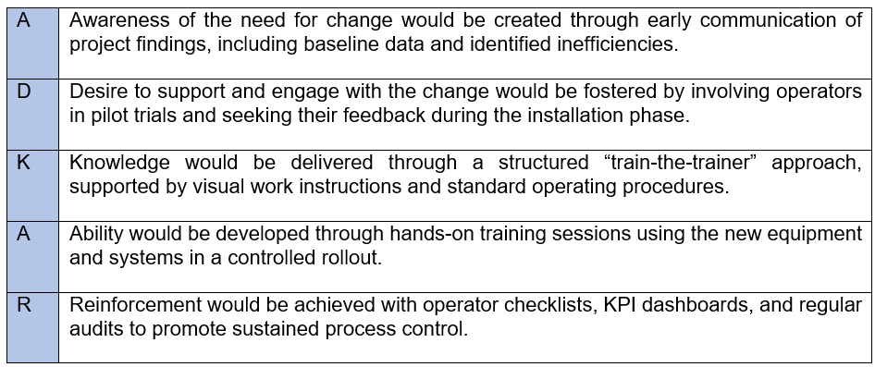
Anticipated challenges, such as resistance to new technology or disruption of familiar routines, would be addressed with clear communication, peer-led training, and assurance that the improvements were intended to supplement rather than replace operator contributions.
Leadership involvement from production management and the project sponsor would be required to reinforce expectations and provide visible support. A defined feedback process and escalation structure would also ensure that concerns were raised and addressed in a timely manner during early implementation.
Integrating a formal change management approach into the control strategy will help to ensure that technical improvements will not only be implemented effectively but also sustained due to operator acceptance and organisational readiness.

10. Results and Discussion
The structured application of the DMAIC methodology resulted in several measurable improvements to the FSP1 packaging process. The Define phase defined the business problem, the Measure and Analyse phases quantified inefficiencies and identified root causes, and the Improve and Control phases facilitated solution development and sustainability planning.
The most significant improvement was a 34% reduction in average cycle time per unit, from 13.4 to 8.8 minutes. This result was largely due to the elimination of the buddy check process and an improved workstation layout. Operator motion was also reduced, with the walking distance per packaging cycle dropping from 17.1 meters to 6.3 meters. These changes were consistent with Lean principles by eliminating non-value-adding movement and improving ergonomic flow.
During the validation trials, the error rate was reduced to zero. The original error rate of 17%, which was primarily caused by incorrect labels or mismatched certificates, was eliminated by using barcode scanning and a vision camera for packaging verification. These Poka-Yoke controls replaced manual inspection and increased quality assurance consistency.
Operator engagement was positive, with feedback emphasising improved clarity, reduced mental workload, and confidence in the new digital instruction system. These findings supported the ADKAR model, highlighting the importance of change management in securing adoption.
Financially, the project showed great potential. Annual savings of approximately £137,470 were predicted, with an implementation cost of £20,933. This yielded a projected return on investment of 655% and a two-month payback period.
Although full implementation was delayed due to funding constraints, this allowed the project to be completed earlier than planned. As shown in the original Gantt chart, this change allowed for more time to focus on risk assessments, operator trials, and the development of a full control strategy for future deployment.
The project also addressed a gap in the literature discovered during the early review. Previous research had primarily focused on high-volume or automated settings, whereas this study demonstrated the effective use of Lean Six Sigma tools in a low-volume, manual packaging context. As a result, the findings provide new insights into the viability of structured improvement methodologies in hybrid manual environments.

11. Conclusion
This project used the Six Sigma DMAIC framework to reduce inefficiencies in Renishaw's FSP1 packaging operation. The investigation discovered that the main problems of long cycle times, excessive operator motion, and quality variation were caused by poor layout, inconsistent work practices, and reliance on manual error-checking.
The subsequent development of a revised workstation, which included standardised layouts, barcode verification, vision-based error detection, and digital guidance, demonstrated significant process improvements during validation. These improvements included a significant reduction in cycle time, the removal of recorded errors, and increased user satisfaction. The proposed solution was also shown to be financially beneficial, with a high return on investment and minimal capital outlay.
Although implementation was halted due to budget constraints, the project was completed ahead of schedule, allowing for the creation of a detailed control plan and a validated design ready for future use.
In addition to practical results, the study addressed a well-known gap in the academic literature regarding the application of Lean Six Sigma in low-volume, manual operations. By demonstrating the method's effectiveness in this setting, the findings contribute to a better understanding of how structured improvement tools can be used effectively in a variety of manufacturing environments.

Future Recommendations
The most immediate recommendation from this study is to fully implement the re-designed packaging workstation. This includes setting up the integrated vision camera, barcode scanning unit, and touchscreen work instruction interface. These technologies were validated in mock trials and showed a high potential for reducing variation, increasing operator efficiency, and eliminating packaging defects. Full-scale deployment, once capital funding is available, would allow these benefits to be realised in live production conditions.
The re-designed workstation should also be integrated with Renishaw's resource planning tool, Syteline. This would enable automated job tracking, digital booking, and real-time performance data collection. This integration would increase traceability, improve production scheduling accuracy, and reduce administrative overheads.
Digitising packing documentation could provide even more benefits. Replacing printed certificates with digital records that are automatically linked to part serial numbers would eliminate the risk of paperwork errors even more and lower the operator's administrative burden. This is consistent with the trend towards paperless manufacturing, Renishaw’s drive to becoming net-zero and would help improve traceability across the board.
In terms of physical workflow, the use of semi-automated box folding equipment is recommended. Manual box preparation was one of the longest sub-tasks observed during the Measure phase, contributing to cycle time variability. Using a standardised folding mechanism could reduce manual handling, improve repeatability, and support ergonomic safety objectives.
The creation of live performance dashboards is also strongly recommended. Key performance indicators (KPIs) such as cycle time, error rate, and workstation status would be displayed in real time, providing operators and supervisors with immediate process visibility. This would not only facilitate faster decision-making, but it would also strengthen accountability and promote continuous improvement practices.
In the long run, Renishaw may consider incorporating artificial intelligence into its packaging verification systems. AI-powered image recognition may enable more sophisticated detection of cosmetic or dimensional flaws, especially in high-precision applications where visual quality is critical. Predictive analytics can also be used to anticipate process drift, allowing for proactive interventions.
Finally, the validated DMAIC methodology and design principles used in this project should be considered for use in other manual or semi-manual processes at Renishaw. The issues addressed in the FSP1 packaging cell, such as variation, motion waste, and quality control, are likely to occur in similar operations. Replicating the improvement framework could increase efficiencies and foster a culture of structured, data-driven process improvement throughout the organisation.

References
Alruqi, M., Baumers, M., Branson, D. and Farndon, R. (2021). A Structured Approach for Synchronising the Applications of Failure Mode and Effects Analysis. Management Systems in Production Engineering, 29(3), pp.165–177. doi:https://doi.org/10.2478/mspe-2021-0021.
Antony, J., Snee, R. and Hoerl, R. (2017). Lean Six Sigma: yesterday, today and tomorrow. International Journal of Quality & Reliability Management, 34(7), pp.1073–1093. doi:https://doi.org/10.1108/ijqrm-03-2016-0035.
Atlassian (2025). Spaghetti Diagram: A Visual Tool for Process Improvement | Atlassian. [online] Atlassian. Available at: https://www.atlassian.com/work-management/project-management/spaghetti-diagram [Accessed 16 May 2025].
Bell, M. (2022). Introduction to Risk Assessment in Project Management. [online] Project Management Academy Resources. Available at: https://projectmanagementacademy.net/resources/blog/risk-assessment-in-project-management/.
Bhaskar, H.L. (2020). Lean Six Sigma in Manufacturing: A Comprehensive Review. Lean Manufacturing and Six Sigma - Behind the Mask, [online] pp.1–29. doi:https://doi.org/10.5772/intechopen.89859.
Budimir, M. (2016). Encoders help linear motion stages reach higher levels of accuracy. [online] Linear Motion Tips. Available at: https://www.linearmotiontips.com/gaining-measurement-edge/ [Accessed 16 May 2025].
Chiarini, A. and Bracci, E. (2013). Implementing Lean Six Sigma in healthcare: issues from Italy. Public Money & Management, 33(5), pp.361–368. doi:https://doi.org/10.1080/09540962.2013.817126.
Coherent (2025). What is Laser Ablation? - Definition and Meaning | Coherent. [online] www.coherent.com. Available at: https://www.coherent.com/news/glossary/laser-ablation.
Company, E.P. (2025). Article | What Is an Optical Encoder? [online] www.encoder.com. Available at: https://www.encoder.com/article-what-is-an-optical-encoder.
Croft, D. (2023). Guide: Gemba Walk - Learn Lean Sigma. [online] www.learnleansigma.com. Available at: https://www.learnleansigma.com/guides/gemba-walk/.
Daniyan, I., Adeodu, A., Mpofu, K., Maladzhi, R. and Kana-Kana Katumba, M.G. (2022). Application of lean Six Sigma methodology using DMAIC approach for the improvement of bogie assembly process in the railcar industry. Heliyon, [online] 8(3), p.e09043. doi:https://doi.org/10.1016/j.heliyon.2022.e09043.
DeLadurantey, C. (2023). Control Phase of DMAIC: How to Maintain Your Improvements. [online] Six Sigma Online. Available at: https://www.sixsigmaonline.org/dmaic-control-phase/.
Flynn (2023). DMAIC: a problem-solving methodology commonly used in Six Sigma. [online] Goodyearrubber.com. Available at: https://www.goodyearrubber.com/dmaic-a-problem-solving-methodology-commonly-used-in-six-sigma/.
Frey, D.D., Shuichi Fukuda, Georg Rock and Springerlink (Online Service (2011). Improving Complex Systems Today : Proceedings of the 18th ISPE International Conference on Concurrent Engineering. London: Springer London, pp.327–334.
Geraldi, J. and Lechter, T. (2012). Gantt Charts Revisited: A Critical Analysis of Its Roots and Implications to the Management of Projects Today. International Journal of Managing Projects in Business, 5(4), pp.578–594. doi:https://doi.org/10.1108/17538371211268889.
Gooch, J.W. (2007). Cause-and-effect diagram (fishbone diagram). Springer eBooks, pp.168–168. doi:https://doi.org/10.1007/978-0-387-30160-0_2026.
Hasselbring, W. (2021). Benchmarking as Empirical Standard in Software Engineering Research. Evaluation and Assessment in Software Engineering. doi:https://doi.org/10.1145/3463274.3463361.
Henderson, C. (2013). escenic. [online] The Telegraph. Available at: https://www.telegraph.co.uk/finance/newsbysector/industry/10431802/David-McMurtry-a-career-in-pictures.html [Accessed 16 May 2025].
Hessing, T. (2014a). Control Phase (DMAIC). [online] Six Sigma Study Guide. Available at: https://sixsigmastudyguide.com/control-phase/.
Hessing, T. (2014b). Measure Phase (DMAIC). [online] Six Sigma Study Guide. Available at: https://sixsigmastudyguide.com/measure-phase-dmaic/.
Hill, J., Thomas, A.J., Mason-Jones, R.K. and El-Kateb, S. (2017). The implementation of a Lean Six Sigma framework to enhance operational performance in an MRO facility. Production & Manufacturing Research, [online] 6(1), pp.26–48. doi:https://doi.org/10.1080/21693277.2017.1417179.
Huang, J., Irfan, M., Fatima, S.S. and Shahid, R.M. (2023). The role of lean six sigma in driving sustainable manufacturing practices: an analysis of the relationship between lean six sigma principles, data-driven decision making, and environmental performance. Frontiers in Environmental Science, 11. doi:https://doi.org/10.3389/fenvs.2023.1184488.
Ibrahim, A. and Kumar, G. (2024). Selection of Industry 4.0 technologies for Lean Six Sigma integration using fuzzy DEMATEL approach. International journal of lean six sigma. doi:https://doi.org/10.1108/ijlss-05-2023-0090.
IMD. (2024). A Complete Guide to Successful Customer Analysis. [online] Available at: https://www.imd.org/blog/strategy/cost-benefit-analysis/.
Institute for Manufacturing. (2016). From/to Chart. [online] Available at: https://www.ifm.eng.cam.ac.uk/research/dstools/fromto-chart/.
Keller, P. (2011). Six sigma demystified. Maidenhead: Mcgraw-Hill Professional.
Kenett, R.S., Zonnenshain, A. and Swarz, R.S. (2020). Systems Engineering as a Data‐Driven and Evidence‐Based Discipline. INCOSE International Symposium, 30(1), pp.757–770. doi:https://doi.org/10.1002/j.2334-5837.2020.00753.x.
Keyence. (2025). KEYENCE UK & Ireland. [online] Available at: https://www.keyence.co.uk/ss/products/vision/application-selecting/contents.jsp?category_id=c02&ad_local=cbtt [Accessed 16 May 2025].
Khisbulloh, W. and Yudoko, G. (2024). OEE improvement through reducing start up duration using lean Six Sigma methodology in manufacturing. Journal of Multidisciplinary Academic and Practice Studies, 2(3), pp.459–475. doi:https://doi.org/10.35912/jomaps.v2i3.2226.
Mandal, P. (2012). Improving process improvement: executing the analyze and improve phases of DMAIC better. International Journal of Lean Six Sigma, 3(3), pp.231–250. doi:https://doi.org/10.1108/20401461211282727.
Mani, M. (2024). The Importance of Training Operators on Construction Equipment Efficiency. [online] Orbiting Web. Available at: https://orbitingweb.com/blog/importance-of-training-on-construction-equipment-efficiency/ [Accessed 18 May 2025].
Miles, M. (2022). How to Write a Problem Statement (With 3 Examples). [online] www.betterup.com. Available at: https://www.betterup.com/blog/problem-statement.
Mullins, L.J. (2016). Management & Organisational Behaviour. 11th ed. Harlow: Pearson.
Murugaiah, U., Jebaraj Benjamin, S., Srikamaladevi Marathamuthu, M. and Muthaiyah, S. (2010). Scrap loss reduction using the 5‐whys analysis. International Journal of Quality & Reliability Management, 27(5), pp.527–540. doi:https://doi.org/10.1108/02656711011043517.
PBA Systems. (2021). Renishaw Encoder - PBA Systems - Experts in Ultra-precision Motion Control and Mechatronic Solutions. [online] Available at: https://www.pbasystems.com.sg/product/rh200-linear-encoder-system/ [Accessed 16 May 2025].
Pockett, C. (2022). Renishaw-Announces-Investment-Of-Over-50-Million-For-UK-Manufacturing-Site. [online] Ukexportnews.co.uk. Available at: https://www.ukexportnews.co.uk/news/5341/Renishaw-Announces-Investment-Of-Over-50-Million-For-UK-Manufacturing-Site [Accessed 13 Apr. 2025].
Pusporini, P., Abhary, K. and Luong, L.H.S. (2012). Environmental Performance as Key Performance Indicators in the Lean Six-Sigma Methodology. Advanced Materials Research, 488-489, pp.1082–1086. doi:https://doi.org/10.4028/www.scientific.net/amr.488-489.1082.
Pyzdek, T. (2003). The Six Sigma project planner : a step-by-step guide to leading a Six Sigma project through DMAIC. New York: Mcgraw-Hill.
Renishaw (2016). Renishaw: Financial information. [online] Renishaw. Available at: https://www.renishaw.com/en/financial-information--21974.
Renishaw (2020). Renishaw: About Renishaw. [online] Renishaw. Available at: https://www.renishaw.com/en/about-renishaw--6432.
Renishaw (2022). Renishaw: Our history. [online] Renishaw. Available at: https://www.renishaw.com/en/our-history--32458.
Renishaw (2024). Syteline . Internal database accessed for operational costs and yearly scale production data.
Renishaw (2025a). Renishaw: Open optical encoders. [online] Renishaw. Available at: https://www.renishaw.com/en/optical-encoders--6433 [Accessed 14 Apr. 2025].
Renishaw (2025b). Renishaw: Working with schools. [online] Renishaw. Available at: https://www.renishaw.com/en/working-with-schools--34611 [Accessed 13 Apr. 2025].
Stefaniak, J.E. (2015). Cases on Human Performance Improvement Technologies. IGI Global, pp.1–17.
The Engineer. (2022). Renishaw to invest £50m at Miskin site - The Engineer. [online] Available at: https://www.theengineer.co.uk/content/news/renishaw-to-invest-50m-at-miskin-site [Accessed 16 May 2025].
Trubetskaya, A., McDermott, O. and Ryan, A. (2023). Application of Design for Lean Six Sigma to strategic space management. The TQM Journal, 35(9), pp.42–58. doi:https://doi.org/10.1108/tqm-11-2022-0328.
Turner, C. (2025). How to Write an Implementation Plan: A Step-by-Step Guide for Project Success - Thornton And Lowe. [online] Thornton And Lowe. Available at: https://thorntonandlowe.com/how-to-write-an-implementation-plan/.
Vest, J.R. and Gamm, L.D. (2009). A critical review of the research literature on Six Sigma, Lean and StuderGroup’s Hardwiring Excellence in the United States: the need to demonstrate and communicate the effectiveness of transformation strategies in healthcare. Implementation Science, [online] 4(1). doi:https://doi.org/10.1186/1748-5908-4-35.
Wedgwood, I.D. (2006). Lean sigma : a practitioner’s guide. Upper Saddle River, Nj: Prentice Hall.

Appendices

Appendix A – Gemba walk observation sheet
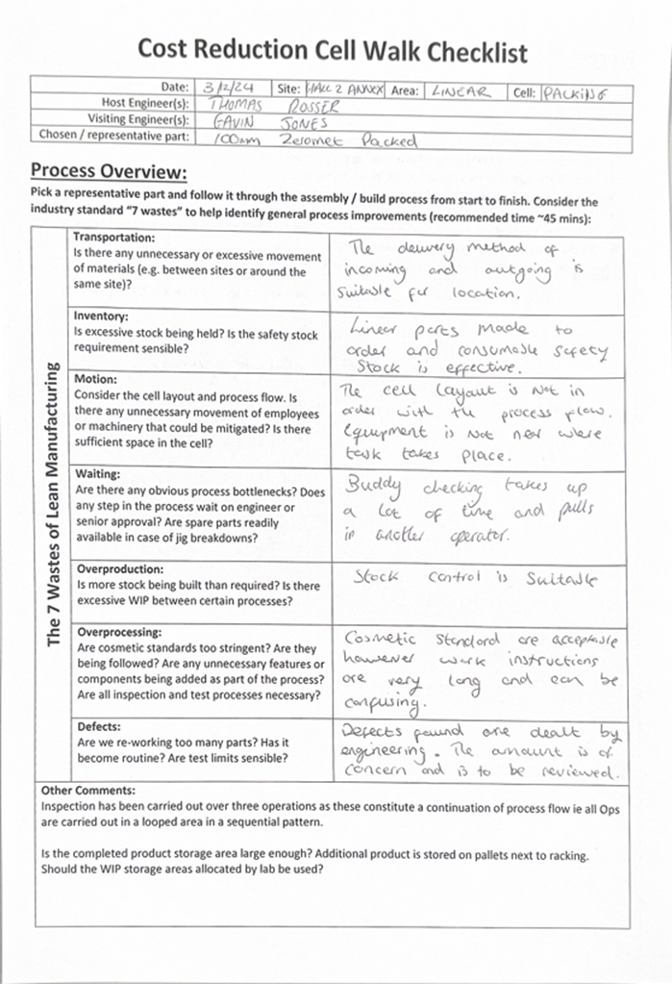

Appendix B – Cycle and task time raw data
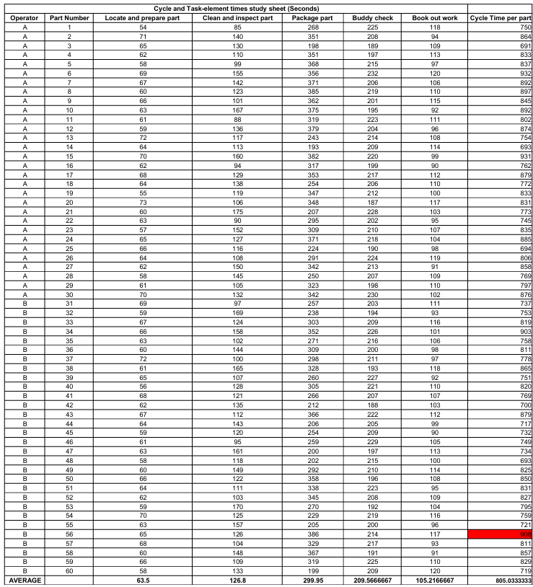

Apprendix C – Operator motion measurement data

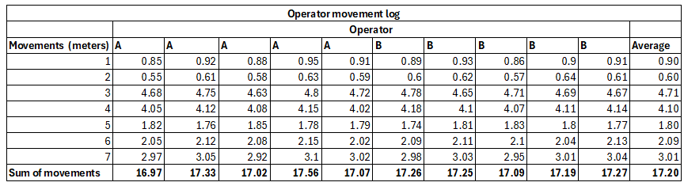

Appendix D – Packaging error data
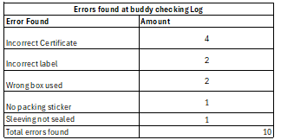

Appendix E – Tool/Consumable search data
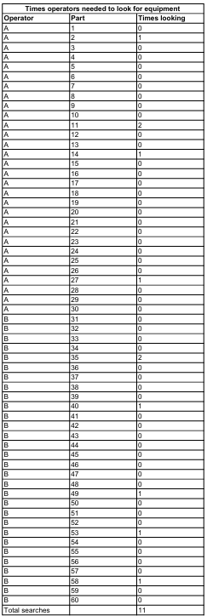

Appendix F – Root cause validation surveys


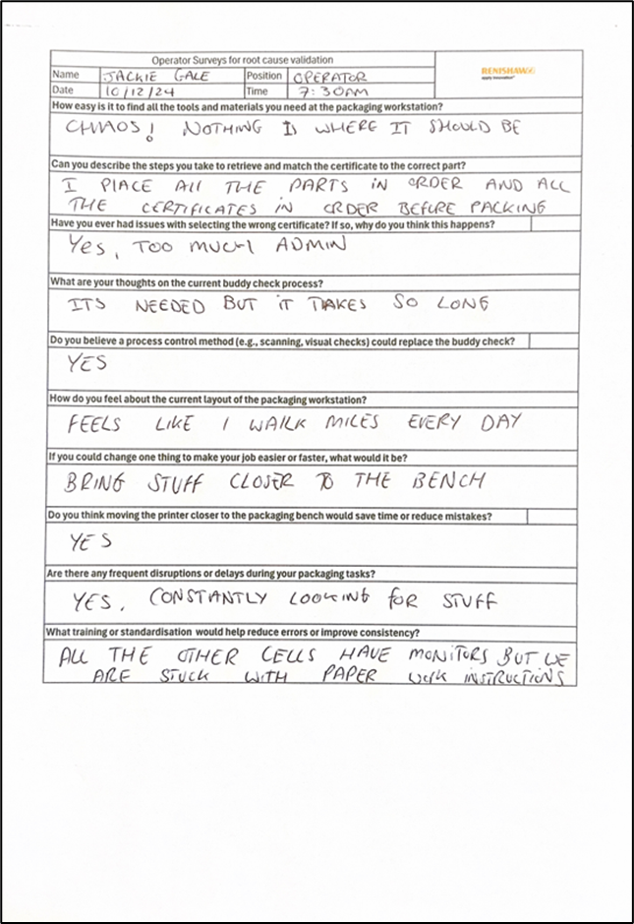

Appendix G – Quotes and price estimates for equipment
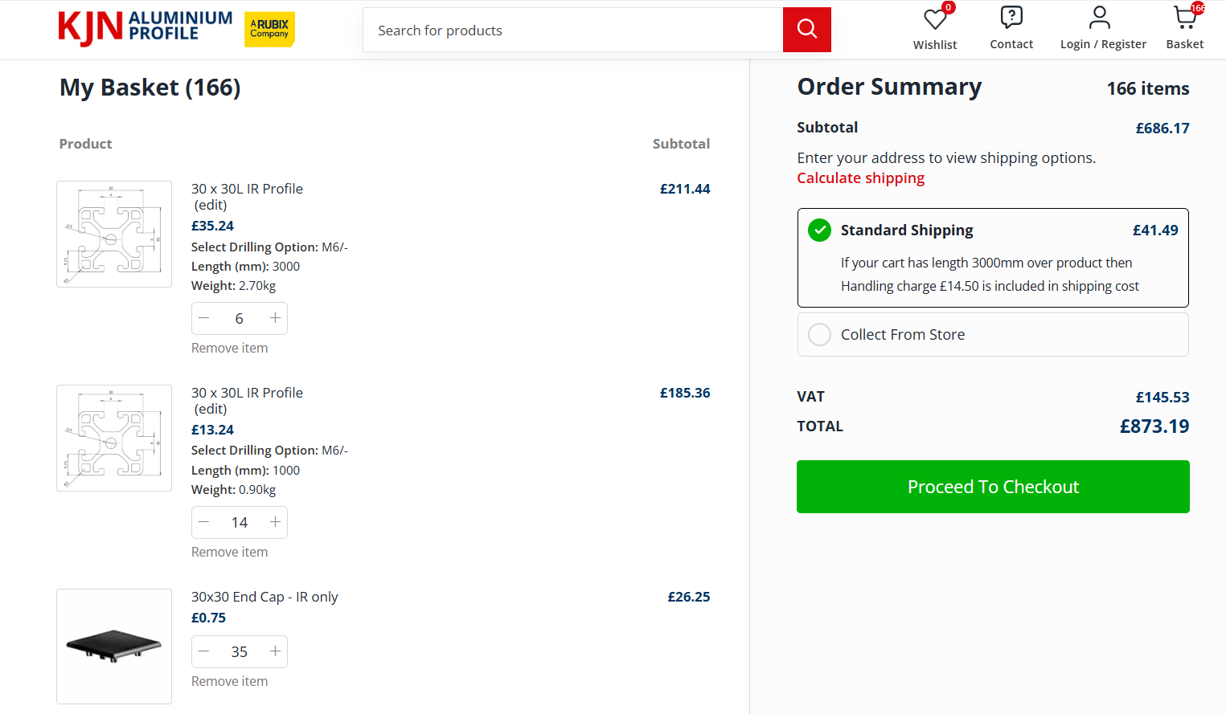
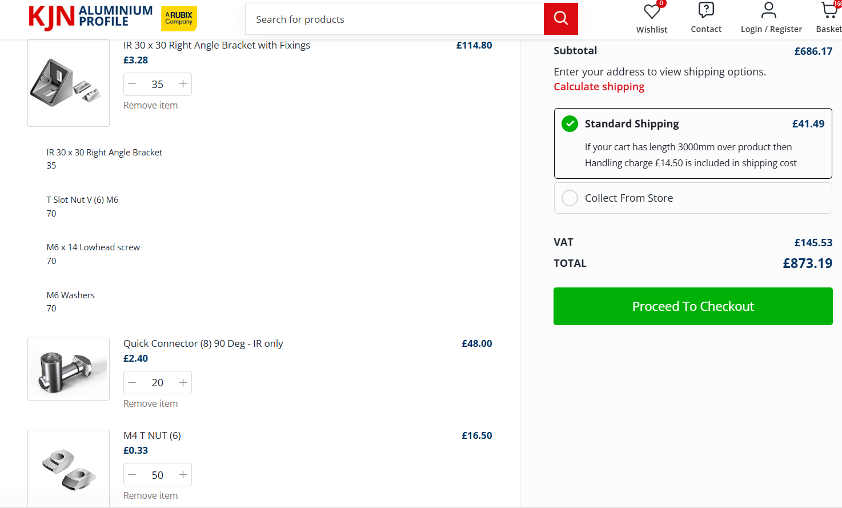
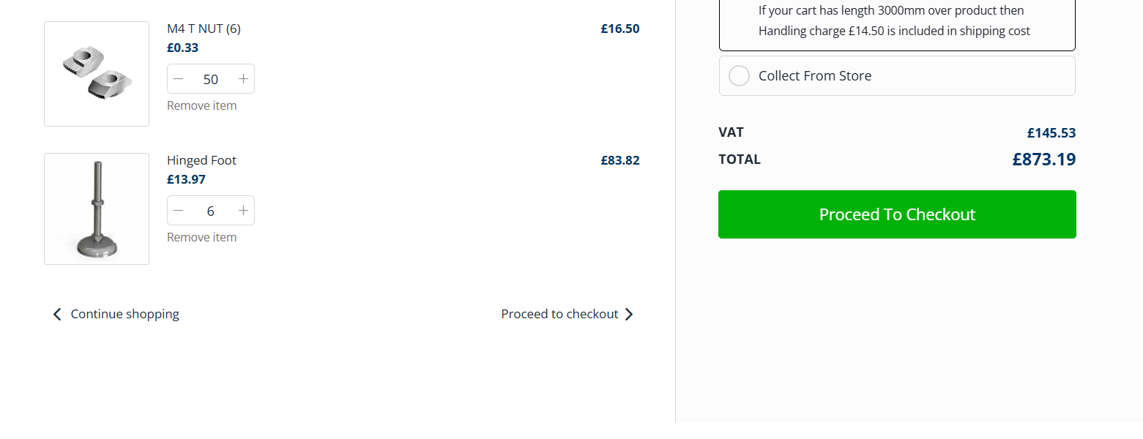
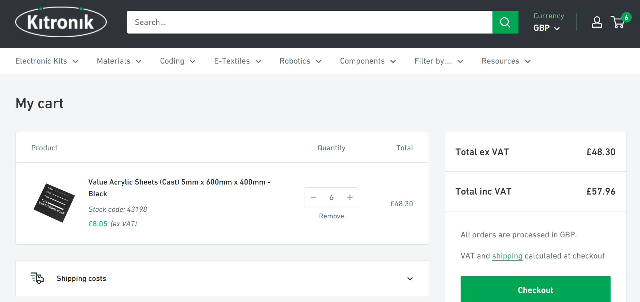
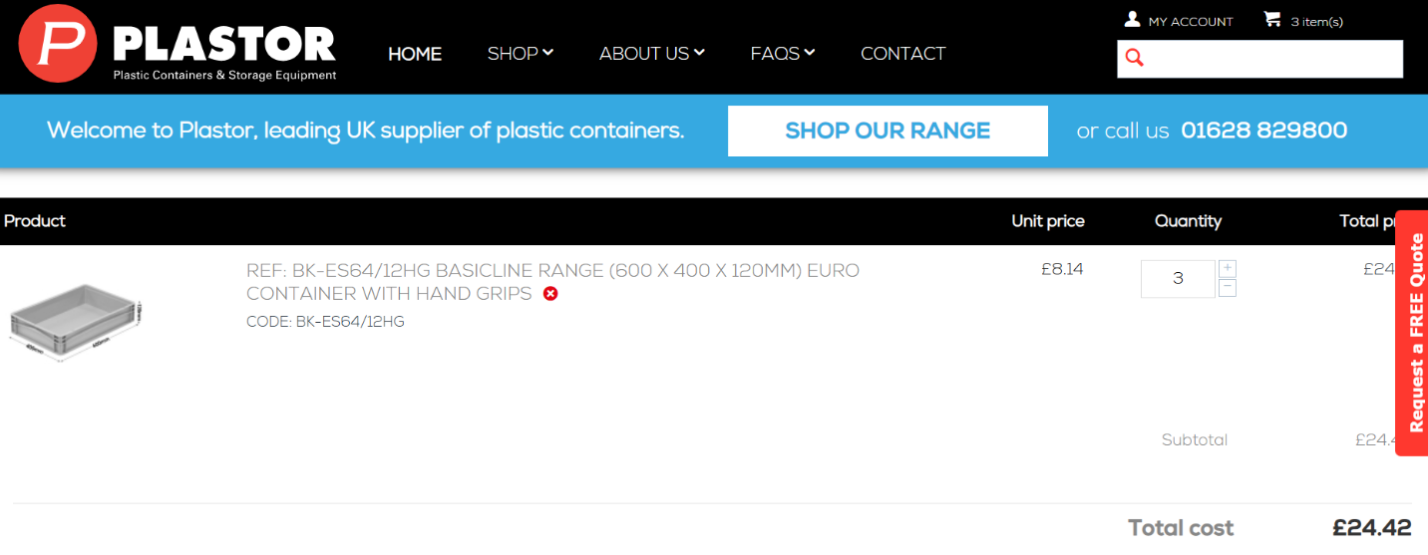


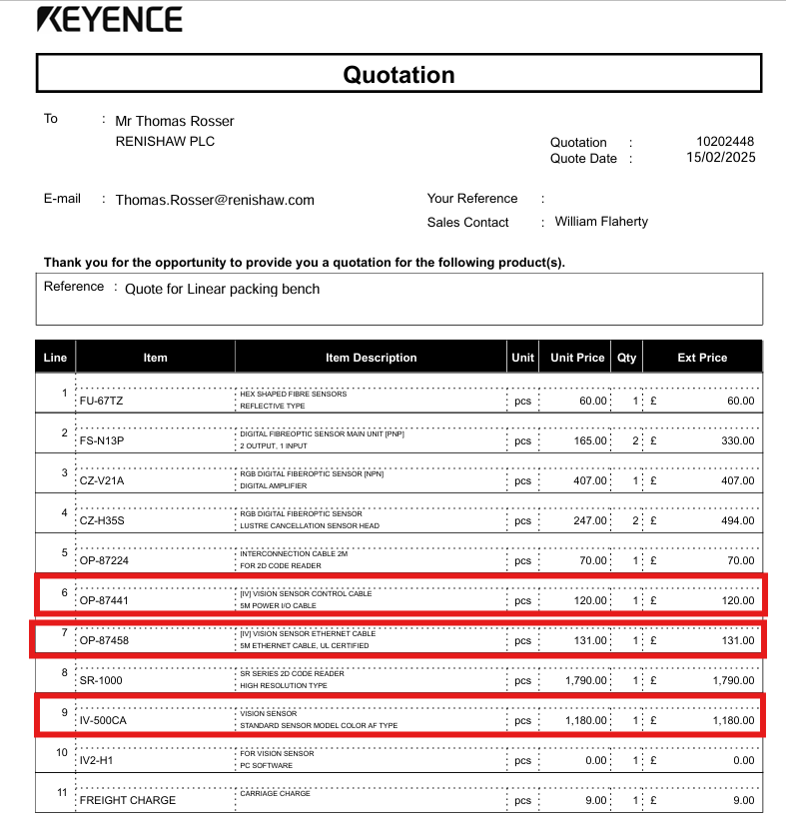

Appendix H – Installation and commissioning plan



