
BMMB7026 MANAGING MARKETING CHANGE
Organisation: AstraZeneca

[DATE]

Student Name: Fozley Rabby
Student ID:2515911

Executive Summary
In this report, critical examination of the current marketing strategy of AstraZeneca has been carried out, which is based on assessing the success of the campaigns and challenges that the company encounters in the competitive global pharmaceutical market. The discussion examines the marketing operations of AstraZeneca through PESTLE and the Five Forces model. The discussion also reflects the factors that influence its marketing strategies such as political policies, economic factors, technological changes, and the presence of fierce competition.
The report has mentioned that AstraZeneca has strengths in advancing scientific innovation and care in patients on major therapeutic segments including oncology and respiratory diseases. A number of weaknesses include long-term sustainability of its pricing policies, lack of interaction with patients, and its use of traditional marketing platforms. The equity-based global health efforts of the company such as cost-based vaccine prices have financial risks.
Based on such conclusions, the report suggests the measures which could be used to make the marketing strategy at AstraZeneca better, through the introduction of tiered pricing models, increased number of patient-centered campaigns, faster digital transformation and more sustainability marketing with measurable objectives. The recommendations are practical within the available resources of AstraZeneca and will assist the firm in consolidating its market presence and responding to the changing healthcare trends.

Contents
Executive Summary 2
Introduction 4
Task 1: Critical Evaluation of AstraZeneca’s Marketing Activity 5
Concept and Importance of Marketing 5
Macro and Micro Marketing Environment 5
Target Market(s) 10
Marketing Mix (4Ps) 11
Communication Media Mix and Evaluation 12
Measuring Success and Effectiveness 13
Task 2: Conclusion Addressing the Shortcomings of AstraZeneca's Marketing Strategy 14
Task 3: Recommendations to Improve AstraZeneca’s Marketing Strategy 16
References 18

Introduction
AstraZeneca is a multinational biopharmaceutical company that has diverse marketing operations to expand and compete in the healthcare sector. Its marketing policy is meant to fulfill the demands of the patients, health care providers, and respond to such changes as regulations, economic changes, and new technologies (Ainuram, 2024). In this report, the current marketing activities of AstraZeneca are reviewed with the aim of establishing their effectiveness in targeting the target audience and helping the company in achieving its objectives. It will study the way the company utilises its marketing resources, the reaction to the market conditions and the choice of the suitable media channels. The weaknesses of the current strategy are also pointed out in the report and recommendations are given to improve them. The aim is to provide recommendations on how AstraZeneca can enhance its marketing to meet the challenges in the future to remain competitive in the market.

Task 1: Critical Evaluation of AstraZeneca’s Marketing Activity

Concept and Importance of Marketing
Marketing is a core business aspect of AstraZeneca, which is especially important in the pharmaceutical sector that is highly competitive and regulated. AstraZeneca spends about 10-12 percentage of its revenue on sales and marketing which is high in relation to other industries (Conley, Wolcott and Wong, 2017). This investment indicates that the company has realised the importance of marketing in the creation of brand credibility and creation of the trust and the establishment of itself as a medical innovation leader (Willigers, 2020). Promotion of the products such as Tagrisso (lung cancer) and Imfinzi (oncology) is a significant part of the marketing undertakings of AstraZeneca (Timmins, 2022). It is also promoting the company image of science and care towards patients.
These measures are noteworthy. However, there are a number of challenges that the firm is dealing with. For example, the efficiency of the global marketing strategy of AstraZeneca can be doubted concerning the regional differences in access to healthcare (Ainuram, 2024). The marketing efforts of AstraZeneca in the emerging markets especially in promoting products such as Tagrisso has to cope with the challenges of affordability, price laws and local competition that is offered by the generics, which may constrain the viability of their expensive drugs (Shaikh et al., 2025). A possible gap is the assumption that worldwide marketing campaigns will be translated across the various markets equally, and in this case, AstraZeneca can do a better job in localisation. Also, according to (Singh, 2024), although AstraZeneca is increasingly investing in digital marketing, its use of traditional medical conferences and printed media in some markets might become a threat of ineffectiveness particularly when it is competing with other digitally more responsive rivals such as Roche and Merck. Accordingly, although the marketing plan adopted by AstraZeneca is highly consistent with its innovation-oriented objectives, inconsistencies in the implementation of its international campaigns require important re-assessments (Team, 2025).

Macro and Micro Marketing Environment
The macro and micro environments in organisations are external and internal forces that affect the activities of AstraZeneca. They also determine organisation’s response to pressure on the competition, regulatory and strategic choices.
Macro Environment Analysis (PESTLE)
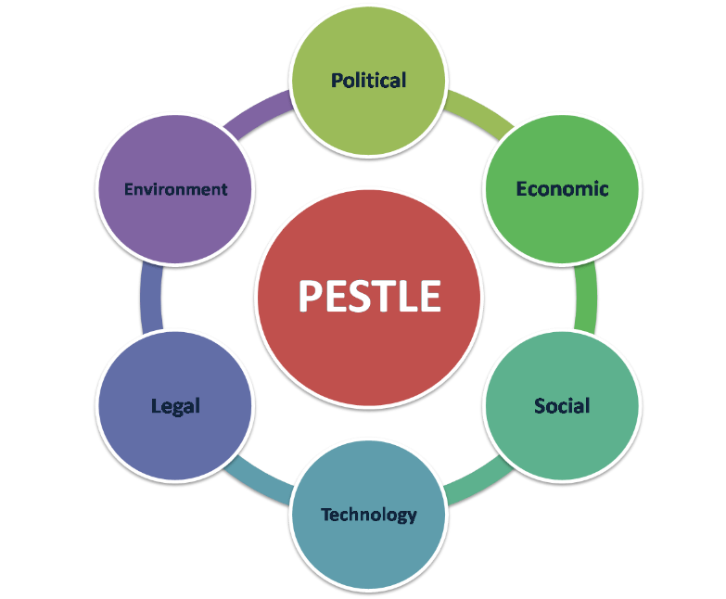
Figure: PESTLE Analysis
Source: (Perera, 2017)
Political: The international business of AstraZeneca has to adhere to intricate political laws. In more controlled markets such as the U.S and the European markets, AstraZeneca is bound to follow provisions of the FDA and EMA that affect the marketing of drugs (Ghadanian and Schafheutle, 2024). As illustrated, when marketing Tagrisso (treatment of lung cancer), there were stringent regulations that had to be followed when dealing with drug labels and advertisement regulations by the FDA (Shaikh et al., 2025).
Nevertheless, the move by AstraZeneca to sell the COVID-19 vaccine at low cost to the poor countries also put the company at risk of financial losses since it restricts profitability on such countries (Garrison, 2020). This plan could have strengthened the reputation of AstraZeneca but left the question of the profitability and sustainability in the long-term, as the company incurred expenses of manufacturing and delivering the vaccines (Zec, 2024).
Economic: The AstraZeneca marketing strategies are greatly affected by the economic factors. Pricing strategies in developed markets should have a balance between the expensive cost of R&D and access by the patients. In the U.S. where prices of drugs are negotiated with insurers, AstraZeneca will be able to charge more of their products such as oncology treatments (Majidi and Khorshidi, 2024). Yet, in emerging markets, where financial possibilities are constrained by the state of economy, AstraZeneca has to collaborate with governments and non-governmental organisations, to provide access to necessary medication at a reasonable cost (Elsakka et al., 2024).
Social: The marketing of AstraZeneca is influenced by social trends such as preventative healthcare and the control of chronic diseases. The increasing cases of asthma, COPD, and oncology have necessitated the AstraZeneca interest in the long-term management of the disease via campaigns such as Breath Easy (Gong and Tawil, 2024). These campaigns enable patients with information regarding management of the disease, a move that is consistent with the requirements of the society regarding patient-centered care. Nonetheless, the marketing of AstraZeneca can be enhanced by targeting younger age groups of people, who are vulnerable to diseases like asthma or diabetes as they are usually not represented in the long-term care marketing campaigns (Zec, 2024).
Technological: The AstraZeneca marketing strategies have been changed due to the technological advancements. The firm has adopted online marketing resources such as e-detailing and webinars to reach out to the healthcare practitioners (Adkonkar, Angrish and Bansal, 2022). These tools became necessary during the COVID-19 pandemic when doctors were restricted in the number of in-person interactions. Digital channels also allow AstraZeneca to monitor measures of engagement like social media activities and web traffic, and the company measures the success of its campaigns though this method (Mia, 2025).
Nevertheless, digital fatigue also presents a challenge to AstraZeneca especially in areas where digital platforms do not have equivalent access and usage by healthcare professionals (van Boven et al., 2025). Moreover, it is possible that online resources will not be able to offer such a degree of personal interaction with physicians, which can influence the quality of interaction in some other fields of treatment (Shaikh et al., 2025).
Legal: The issue that AstraZeneca can be concerned about is legal regulation in the field of drug marketing and advertising. The company should comply with stringent regulations about the prescription drug advertisement especially in the areas where there is the prohibition of direct-to-consumer marketing (Iglesias et al., 2025). AstraZeneca in these markets targets its marketing by healthcare professionals, by offering them clinical trial data and scientific information. This will make sure that AstraZeneca is in line with the regulatory body, but will also reduce its capacity to directly target patients (Runiewicz-Wardyn and Eliashvili, 2022).
The legal environment of the pharmaceutical industry is also a challenge as far as intellectual property (IP) is concerned (Malik and Ullah, 2024). AstraZeneca should also keep to distinguish its products by emphasising the clinical value of its innovative therapies and personalised treatments.
Environmental: Sustainability is an issue that is emerging as a significant concern in the pharmaceutical industry. The concept of Ambition Zero Carbon by AstraZeneca that set itself as a goal to become carbon neutral by 2025 is an important element of its marketing strategy (Zec, 2024). The company also encourages its environment friendliness through numerous campaigns attracting more and more environmentally conscious consumers. Through its corporate messages, AstraZeneca has been able to equate with the increasing market requirements of corporate responsibility (Mia, 2025).
Nevertheless, the success of sustainability marketing is a controversial issue. Making sustainability marketing claims that lack strong evidence may stain the reputation of the business as long as the stakeholders feel that the advertisement is inadequate or untruthful.
Micro Environment Analysis (Porters five Forces)
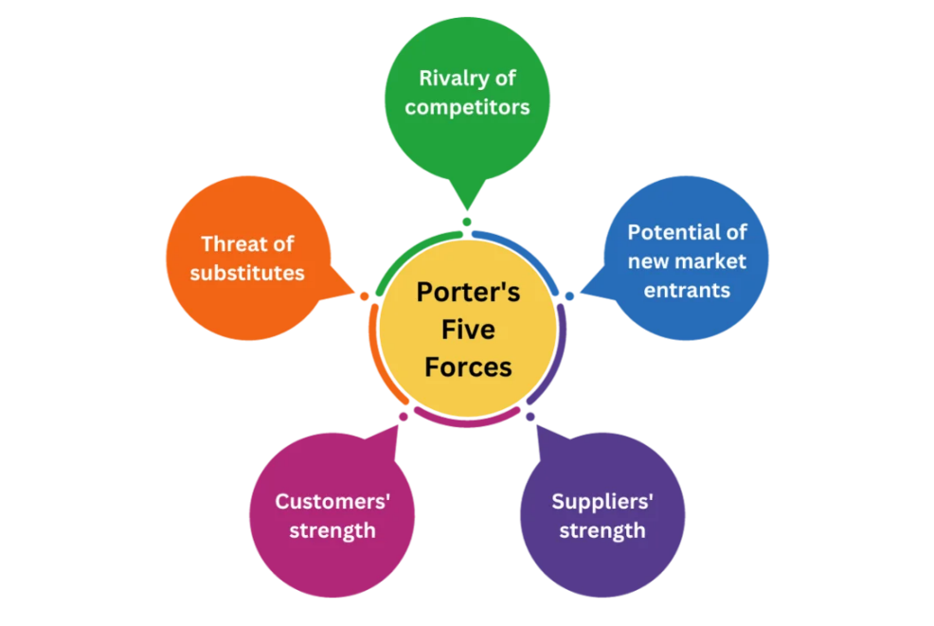
Figure: Porter’s Five Forces Model
Source: (Maxim, 2021)
Threat of New Entrants: The barriers to entry of the pharmaceutical industry are very high, such as the huge amount of money companies spend to conduct their research, regulatory challenges and protection of intellectual property that keep the threat of new entrants low (Revalska, 2021). AstraZeneca has a good standing in the market, brand recognition and is patented, which keeps away the emergence of new competitors. Nevertheless, new biotech companies can become problematic in the future, particularly in such innovations as the gene therapies and biologics.
Bargaining Power of Suppliers: Supplier bargaining power in the industry AstraZeneca is operating is moderate. Although the company buys raw materials and active ingredients with different suppliers, some of its specialised ingredients, such as oncology treatments, provide some leverage of suppliers due to its high demand products (Mia, 2025). Nonetheless, AstraZeneca eliminates these risks through diversification and long-term contracts with suppliers. This is one of the methods to guarantee stability in the supply chain (Ahmed and Schippert, 2020). However, the power of suppliers is still an issue, particularly when a high quality of ingredients is needed.
Bargaining Power of Buyers: Buyers bargaining power is high and especially when the healthcare is regulated by the government and the prices of drug and reimbursement conditions are negotiated. Governments regulate the prices in the public healthcare system, and AstraZeneca has to negotiate around such price regulators (Mensa Sorato et al., 2020). Nevertheless, buyers are less powerful in the private markets, such as the U.S., and AstraZeneca is able to make higher prices on its innovative treatment (Tulum, Andreoni and Lazonick, 2022).
Threat of Substitutes: Threat of substitutes is moderate. With the approach of the patent of the AstraZeneca products, the company encounters the generic drug competition. Nevertheless, AstraZeneca makes a distinction of targeted therapies and personalised medicine that are harder to imitate using generic drugs (Huhmann and Limbu, 2016). AstraZeneca is less vulnerable to the effects of substitution because the firm specialises in high demand therapeutic fields such as cardiovascular diseases and oncology, although the generic drug market is still a problem in certain therapeutic fields (Malik and Ullah, 2024).
Industry Rivalry: The pharmaceutical industry has a lot of rivalry among the industries, especially in therapeutic sectors such as oncology. AstraZeneca is in competition with such giant companies as Pfizer, Merck, and Novartis. The strategic direction of the company involves differentiation of products based on scientific excellence and clinical efficacy (Conley, Wolcott and Wong, 2017). Nevertheless, there is a need to be in a position of constant innovation to ensure that it is ahead of its competitors. AstraZeneca has a good R&D pipeline and can introduce new treatments, which provides a competitive advantage (Revalska, 2021).
Both the macro and micro environmental factors greatly impact on the marketing strategy of AstraZeneca. Scientific innovation and personalised medicine also allow AstraZeneca to be differentiated, but the company still has to overcome generic rivalry and pricing pressures.

Target Market(s)
AstraZeneca employs segmentation, targeting and positioning (STP) strategy to access its audiences. The STP strategy of AstraZeneca is broken down as below:
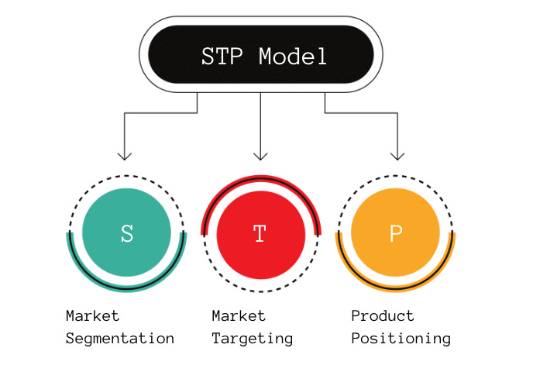
Figure: STP Model
Source: (Kampamba, 2015)
Segmentation: AstraZeneca divides the market on the basis of the disease type, demographics, and geographic location. The company specialises in high needs therapeutic segments, such as oncology, respiratory, cardiovascular and diabetes (Gautam and Pan, 2016). In these areas of therapy, AstraZeneca further differentiates by the age, sex, lifestyle and severity of conditions. For example:
- Oncology: Divided by cancer type (e.g. lung, breast) or cancer stage (e.g. early-stage vs. metastatic) (Morgan et al., 2018).
- Respiratory: Divided according to the age group (children, adults) and the severity of asthma or COPD (Soler-Cataluña et al., 2023).
- Cardiovascular: Risk factors segments (e.g., hypertension, high cholesterol) and comorbidities segments (e.g., diabetes) (Morgan et al., 2018).
Targeting: AstraZeneca mainly appeals to the professionals in the healthcare field, such as the oncologists, pulmonologists, and cardiologists. For instance, the marketing activities of Tagrisso by the company are aimed at oncologists and involve scientific data and evidence of clinical trials (Iglesias et al., 2025). The patient-oriented marketing of AstraZeneca is aimed at people with chronic diseases (COPD or asthma) and is oriented at increasing their awareness of the condition and treatment adherence (Soler-Cataluña et al., 2023).
Positioning: AstraZeneca identifies itself as a leader in the pharmaceutical sector. It focuses on its dominance in scientific studies and innovative therapies. The positioning of the company is on the basis of the patient-centered care and the positive real-life advances that its therapies bring. As an example, within the oncology segment, AstraZeneca is marketing life-saving therapy and individual medicine to the patients of particular types of cancer (Cowling et al., 2023). AstraZeneca focuses on its leadership in delivering precision therapies. This is the obvious distinction between it and the competition.

Marketing Mix (4Ps)
The marketing mix of AstraZeneca helps it to achieve the organisational objectives and reach its maximum level of market penetration.
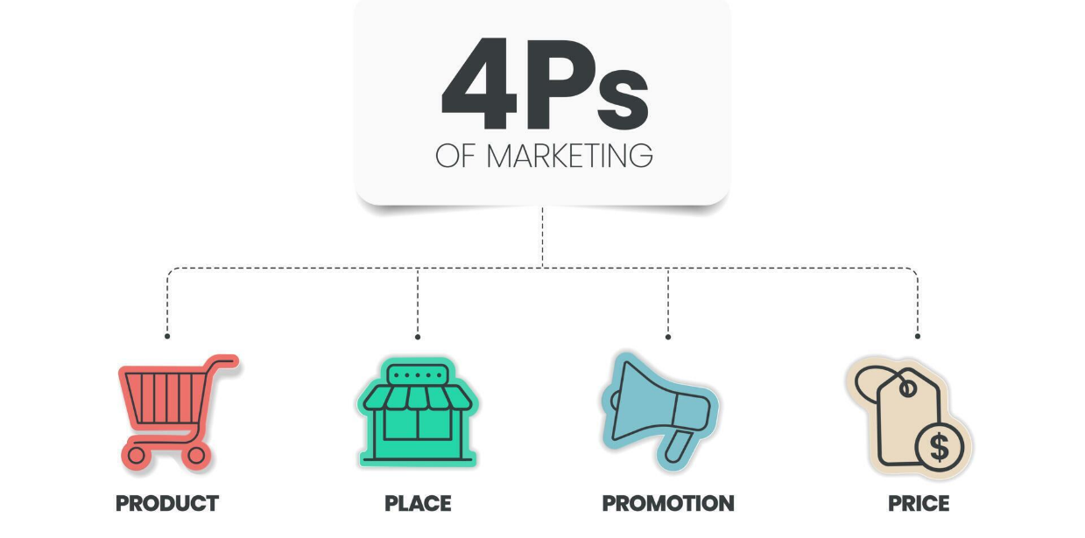
Figure: Marketing Mix (4Ps)
Source: (Raewf and Thabit, 2018)
Product: AstraZeneca has a number of products, especially in oncology, respiratory, as well as cardiovascular treatments. The company puts a lot of focus on the innovation that is driving its drugs like Tagrisso and Symbicort (Timmins, 2022). Scientific evidence and findings of clinical trials are commonly used to market the products of AstraZeneca as a company of medical innovation.
Price: AstraZeneca uses value-based pricing of its high-cost drugs, the prices are determined according to the clinical outcomes and value that is provided to the patients (Gonçalves, 2022). For illustration, AstraZeneca collaborates with governments and healthcare institutions in low-income countries to provide life-saving therapies. These countries received the COVID-19 vaccine at the cost price. This proves that AstraZeneca cares about health equity in the world (Garrison, 2020).
Place: AstraZeneca employs the global distribution channel. Hence, its products can be found in both the developed and emerging markets. The company collaborates with local distributors in the emerging markets like Africa and Asia in an effort to enhance the access to its products (Fisher, Okediji and Sampath, 2022). Another work of AstraZeneca includes collaboration with hospitals and clinics to make its drugs accessible to the public health systems.
Promotion: AstraZeneca employs a multimedia approach (TV, print) and online (social media, SEO, email marketing) advertising. As an illustration, oncology campaigns launched by AstraZeneca involve professional medical workers and patients with the help of clinical information and patient testimonies (Huhmann and Limbu, 2016). E-detailing and virtual medical conferences are of rising importance in the process of accessing healthcare professionals, especially in the pandemic. To engage patients, the marketing of AstraZeneca is directed at awareness campaigns like Breathe Easy among the asthma patients (Gong and Tawil, 2024).

Communication Media Mix and Evaluation
AstraZeneca uses a wide range of media channels, with a significant focus on the digital media. The engagement of healthcare professionals and dissemination of research is done through social media including LinkedIn, Twitter, and Facebook (Marcec and Likic, 2022). Indicatively, in the case of the COVID-19 vaccine rollout, AstraZeneca relied on LinkedIn to update on the distribution of the vaccines and the results of the clinical trials (Garrison, 2020).
To engage the patients, AstraZeneca applies TV advertisements, print media, and social media with the main emphasis on patient education and awareness of chronic diseases such as asthma and COPD (Kostikas et al., 2024). Breathe Easy campaign relied on TV advertising and use of social media to inform patients on how to manage asthma and the need to comply with the medication.
The campaigns have already been successful in terms of engagement. Digital marketing campaigns organised by AstraZeneca, such as paid social campaigns, have resulted in high growth in the number of searches of such products as Tagrisso and Symbicort (Malik and Ullah, 2024).

Measuring Success and Effectiveness
AstraZeneca measures the success of its marketing operations through different measures:
Sales and Market Share: AstraZeneca monitors sales results prior to and subsequent to the launch of products. To illustrate, the Tagrisso debut gave the company a great deal of market share in the oncology market.
Engagement Metrics: AstraZeneca measures engagement based on the traffic of the websites, social media responses, and click-throughs. Some of its products have also grown branded search volume by 93% as a result of its digital campaigns.
Brand awareness: AstraZeneca carries out surveys to assess brand awareness among the professionals and patients in the healthcare field.
Customer Satisfaction: The company relies on the patient feedback surveys and the healthcare professional satisfaction surveys to determine the success of its marketing strategies (Kostikas et al., 2024).
Marketing strategy adopted by AstraZeneca is very effective as it establishes the organisation as a pioneer in the pharmaceutical industry. With the help of the traditional and digital media, AstraZeneca is able to reach out to healthcare professionals and patients. Nonetheless, patient engagement can be optimised further with the use of digital channels, particularly in the emerging markets.

Task 2: Conclusion Addressing the Shortcomings of AstraZeneca's Marketing Strategy
The marketing strategy of AstraZeneca has shown itself to be effective to tackle global health problems especially in oncology and respiratory diseases by focusing on scientific innovation and patient-centred care (Ainuram, 2024). Yet, a number of crucial flaws of the existing marketing strategy should be mentioned in order to guarantee future development, leading the market, and ability to adapt to the changing industry trends.
First, although AstraZeneca has shown excellent dedication to global health equity in providing its COVID-19 vaccine at the cost to low-income nations, this business model has long-term financial consequences (Garrison, 2020). The results of AstraZeneca pricing being below that of crucial treatments may lead to loss of profitability which may affect its capacity to invest in future development and research of drugs.
Secondly, AstraZeneca marketing is scientific-based in advertising its therapies, especially via medical practitioners. Although this is necessary to ensure credibility, it may restrict the target of the company to those patients who might be unable to comprehend the clinical complexity. It is possible that AstraZeneca is able to expand its marketing tactics to the patient (van Boven et al., 2025). AstraZeneca will be able to increase adherence rates and create a stronger patient engagement by paying more attention to the direct education about the benefits of treatment and long-term results (Kostikas et al., 2024). This would also enable filling in gaps in prevention and early intervention in strategic therapeutic areas such as respiratory diseases and cardiovascular health where the youths are still under-targeted.
Also, using traditional marketing tools such as medical conferences, print materials may be restricting AstraZeneca in an increasingly digital world. Although AstraZeneca has adjusted to digital solutions, it has not fully integrated digital strategies in marketing to its patients (Huhmann and Limbu, 2016). E-detailing and digital meetings have worked in the engagement of healthcare providers, but AstraZeneca must hasten its digital adoption to make sure that it reaches a wider group, such as younger, tech-powered patients and healthcare providers in the new markets (Malik and Ullah, 2024).
Finally, the sustainability activities that AstraZeneca provides should be more transparent and have a more tangible effect. As much as the Ambition Zero Carbon campaign focuses on the environmental responsibility of the company, there is a need to have a greater focus on evidence of actual progress to prevent the greenwashing image (Marcec and Likic, 2022).
To sum up, though scientific rigour and global coverage are strong points of AstraZeneca, the marketing strategy used by the company needs to change to cover these crucial gaps. Greener pricing strategies, more patient-oriented marketing, enhanced digital engagement as well as more quantifiable sustainability pledges will enable AstraZeneca to not only retain its competitive advantage but also establish better relationships with healthcare providers and patients (Carla, 2025).

Task 3: Recommendations to Improve AstraZeneca’s Marketing Strategy
According to the findings of Task 2, some recommendations can be offered to improve the marketing strategy of AstraZeneca. The recommendations are aimed at the improvement of the mentioned inefficiencies in pricing, patient engagement, digital transformation and sustainability efforts, and making sure that they are administrable within the company current resources.
Implement Tiered Pricing Models for Global Access and Profitability
Although the pricing of the COVID-19 vaccine at cost exhibited corporate social responsibility at AstraZeneca, the strategy is detrimental to financial sustainability in the long run. One of the more achievable resolutions is the tiered pricing system in which AstraZeneca is willing to give low-income nations a discounted price but keep the much-elevated prices in the developed economies (Mia, 2025). This would guarantee cheap access to the underserved groups and profitability in the more profitable markets. To adopt this model, AstraZeneca can collaborate with international health organisations and this would be in line with the company being committed to global health equity without financial growth (Abbas, 2021).
Shift Focus to Patient-Centric Marketing
The marketing of AstraZeneca is very scientific with the target being professionals in healthcare. Nevertheless, the necessity to directly approach patients in a manner that is easy to understand, convenient and reader friendly is increasing (Kostikas et al., 2024). AstraZeneca ought to increase its patient-centered campaigns, which no longer will be based on medical conferences and print media, but on digital platforms, including social media and patient education applications. Although successful, the Breathe Easy campaign on asthma can be modified in terms of prevention and early-stage management of the disease, and target a younger population (Li et al., 2025). This change can be cost-effective since AstraZeneca has already invested in HCP engagement software used digitally and can modify it to serve patient education with few extra funds.
Speed up Digital Transformation
AstraZeneca has succeeded in digital marketing especially in e-detailing and webinars. But it can be improved in terms of the use of digital strategies to reach patients. More interactive content should also be embraced by the company, such as virtual patient forums, web-based treatments, and digital storytelling so that the digital transformation can be accelerated (Marcec and Likic, 2022). The AI-based marketing resources can be applied to provide patients with the content that will be adapted to the unique needs to enhance the engagement and treatment compliance. It is in line with emerging trends in the pharmaceutical industry, whereby digital-first strategies are becoming the norm (Iglesias et al., 2025). The entry barrier of shifting to a complete digital ecosystem is not unrealistic, since AstraZeneca already has technological frameworks that will be used to implement the transition.
Make Sustainability Marketing More Transparent and Goal-oriented
Ambition Zero Carbon program of AstraZeneca is a good move towards sustainability. However, its marketing has to be more transparent and supported by facts. AstraZeneca can do better by establishing specific sustainability goals and by periodically reporting its sustainability progress using annual sustainability reports and by communicating with the broader public (Mazzucato, Doyle and Kuehn Von Burgsdorff, 2024). Also, AstraZeneca can create a sustainability campaign targeting consumers and show that the company is focused on green activities in its operations, including energy-efficient production and sustainable packaging (Arora, 2025). Such a strategy would be appealing to environmental conscious consumers, as well as health care providers, and can be rolled out progressively at low incremental cost by using the already existing environmental activities at AstraZeneca (Ainuram, 2024).
Grow Market Segmentation and Localise Campaigns
AstraZeneca needs to intensify its market segmentation processes, particularly in the emerging markets where there is a wide disparity in economic and cultural aspects. Although vaccination campaigns such as COVID-19 are global, the local circumstances demand personalised communication (Ghadanian and Schafheutle, 2024). AstraZeneca can change its approach to use regional marketing units to develop specific messages that address local healthcare needs and practices (Leask et al., 2021). To illustrate, this is where asthma medications sold in South Asia would focus on allergy control whereas in Europe the focus may be on lifestyle and prevention (Dhar et al., 2020). This localisation would enable AstraZeneca to be closer to patients in various areas.
The above stated strategies are in line with commitment to global health equity, patient-centric care and scientific innovation by AstraZeneca.

References
Abbas, M.Z. (2021). COVID-19 and the global public health: Tiered pricing of pharmaceutical drugs as a price-reducing policy tool. Journal of Generic Medicines, 17(3), pp.115-121.
Adkonkar, A., Angrish, A.K. and Bansal, S.K. (2022). A paradigm shift in pharmaceutical marketing. Paradigm Shift in Marketing and Finance, 107.
Ahmed, S. and Schippert, O. (2020). Improving Planning Stability: A case study of Planning at AstraZeneca.
Ainuram, J. (2024). Strategy to increase the share of sales in the pharmaceutical market.
Arora, P. (2025). Benefits and Challenges of Green Marketing in the Pharmaceutical Industry. In Green Marketing Perspectives (pp. 273-284). Emerald Publishing Limited.
Carla (2025). How Product Marketing Transforms Patient Engagement in Healthcare. [online] HealthPoint. Available at: https://healthpoint.com/business/how-product-marketing-transforms-patient-engagement-in-healthcare/ [Accessed 5 Jan. 2026].
Conley, J.G., Wolcott, R.C. and Wong, E. (2017). AstraZeneca, Prilosec, and Nexium: Marketing challenges in the launch of a second-generation drug. Kellogg School of Management Cases, pp.1-20.
Cowling, T., Nayakarathna, R., Wills, A.L., Tankala, D., Paul Roc, N. and Barakat, S. (2023). Early access for innovative oncology medicines: a different story in each nation. Journal of Medical Economics, 26(1), pp.944-953.
Dhar, R., Ip, M., Kulkarni, T., Kim, S.H., Perng, D.W., Yao, X., Iwanaga, T. and Siyue Koh, M. (2020). Challenges faced in managing adult asthma: a perspective from Asian countries. Respirology, 25(12), pp.1235-1242.
Elsakka, F., Alketbi, S.A., Qanbour, D.S., Alkilany, I. and Nobanee, H. (2024). A Financial Analysis of Pfizer & AstraZeneca and the Impact of Scandals on Financial Ratios. Available at SSRN 5073862.
Fisher, W., Okediji, R.L. and Sampath, P.G. (2022). Fostering production of pharmaceutical products in developing countries. Mich. J. Int'l L., 43, p.1.
Garrison, C. (2020). How the ‘Oxford’Covid-19 vaccine became the ‘AstraZeneca’Covid-19 vaccine. Medicines law & policy.
Gautam, A. and Pan, X. (2016). The changing model of big pharma: impact of key trends. Drug discovery today, 21(3), pp.379-384.
Ghadanian, M. and Schafheutle, E. (2024). Comparison between European Medicines Agency and US Food and Drug Administration in granting accelerated marketing authorizations for Covid-19 medicines and their utilized regulations. Therapeutic Innovation & Regulatory Science, 58(1), pp.79-113.
Gonçalves, E. (2022). Value-based pricing for advanced therapy medicinal products: emerging affordability solutions. The European Journal of Health Economics, 23(2), pp.155-163.
Gong, L. and Tawil, B. (2024). A Review of Chronic Obstructive Pulmonary Disease (COPD) and its Effects, Treatment Market, Products, and Upcoming Developments. Scholastic Medical Sciences, 2, pp.01-10.
Huhmann, B.A. and Limbu, Y.B. (2016). Content and compliance of pharmaceutical social media marketing. Marketing Intelligence & Planning, 34(7), pp.977-999.
Iglesias, I., Marinich, J.A., Anechina, L.R., Cortés, M. and Pérez Domínguez, A. (2025). Understanding the national healthcare ecosystem to position Medical Affairs as a strategic element: lessons learned from AstraZeneca Spain. Pharmaceutical Medicine, 39(1), pp.39-50.
Kampamba, J. (2015). An analysis of the potential target market through the application of the STP principle/model. Mediterranean Journal of Social Sciences, 6(4), p.324.
Kostikas, K., Iliopoulou, A., Galanakis, P., Mathioudakis, N. and Papista, C. (2024). Patients' insights on symptoms, daily life and treatment related to asthma and chronic obstructive pulmonary disease through social media listening analysis. Pneumon, 37(4).
Leask, J., Carlson, S.J., Attwell, K., Clark, K.K., Kaufman, J., Hughes, C., Frawley, J., Cashman, P., Seal, H., Wiley, K. and Steffens, M. (2021). Communicating with patients and the public about COVID-19 vaccine safety: recommendations from the Collaboration on Social Science and Immunisation. Med J Aust, 215(1), pp.9-12.
Li, Y., Tang, X., Zhang, R., Lei, Y., Wang, D., Wang, Z. and Li, W. (2025). Research progress in early states of chronic obstructive pulmonary disease: a narrative review on PRISm, pre-COPD, young COPD and mild COPD. Expert Review of Respiratory Medicine, 19(10), pp.1063-1079.
Majidi, A. and Khorshidi, Z. (2024). A Comprehensive Financial Analysis of AstraZeneca in the Face of Global Crises.
Malik, F. and Ullah, S.J. (2024). Impact Of Intellectual Property Rights On The Competitiveness Of The Pharmaceutical Sector. Competitive Research Journal Archive, 2(02), pp.26-37.
Marcec, R. and Likic, R. (2022). Using twitter for sentiment analysis towards AstraZeneca/Oxford, Pfizer/BioNTech and Moderna COVID-19 vaccines. Postgraduate medical journal, 98(1161), pp.544-550.
Maxim, L.G. (2021). STRATEGIC ANALYSIS MODEL. PORTER'S 5 FORCES MODEL: CASE STUDY. Turkuaz Uluslararası Sosyo-Ekonomik Stratejik Araştırmalar Dergisi, 3(2), pp.1-7.
Mazzucato, M., Doyle, S. and Kuehn Von Burgsdorff, L. (2024). Mission-oriented industrial strategy: global insights.
Mensa Sorato, M., Davari, M., Abdollahi Asl, A., Soleymani, F. and Kebriaeezadeh, A. (2020). Why healthcare market needs government intervention to improve access to essential medicines and healthcare efficiency: a scoping review from pharmaceutical price regulation perspective. Journal of Pharmaceutical Health Services Research, 11(4), pp.321-333.
Mia, D. (2025). SUSTAINABLE INNOVATION IN GLOBAL PHARMA: STRATEGIC LEADERSHIP FOR LONG-TERM IMPACT IN RESPIRATORY AND PANDEMIC-DRIVEN PORTFOLIOS.
Morgan, P., Brown, D.G., Lennard, S., Anderton, M.J., Barrett, J.C., Eriksson, U., Fidock, M., Hamren, B., Johnson, A., March, R.E. and Matcham, J. (2018). Impact of a five-dimensional framework on R&D productivity at AstraZeneca. Nature reviews Drug discovery, 17(3), pp.167-181.
Perera, R. (2017). The PESTLE analysis (Vol. 1). Avissawella, Sri Lanka: Nerdynaut.
Raewf, M. and Thabit, T.H. (2018). The evaluation of marketing mix elements: A case study. International Journal of Social Sciences & Educational Studies, 4(4), pp.1-11.
Revalska, P.S. (2021). AstraZeneca Going Beyond (Master's thesis, Universidade NOVA de Lisboa (Portugal)).
Runiewicz-Wardyn, M. and Eliashvili, T. (2022). Open innovation practices and open innovation culture in the life-sciences clusters. The case of AstraZeneca. European Journal of Business and Management Research, 7(1), pp.35-43.
Shaikh, R., Yadav, K., Thummar, K., Maheriya, B. and Chauhan, S. (2025). Development of complex generics: Insights into trends, challenges, and market opportunities. Journal of Generic Medicines, 21(1), pp.4-16.
Singh, P.V. (2024). AstraZeneca’s Innovations and Global Health Impact. [online] BioCascades. Available at: https://biocascades.com/articles/exploring-astrazeneca-innovations-impact-future/.
Soler-Cataluña, J.J., Miravitlles, M., Fernández-Villar, A., Izquierdo, J.L., García-Rivero, J.L., Cosio, B.G., López-Campos, J.L. and Agustí, A. (2023). Exacerbations in COPD: a personalised approach to care. The Lancet Respiratory Medicine, 11(3), pp.224-226.
Team, E. (2025). AstraZeneca Marketing Strategy 2025: A Case Study | ProjectPractical.com. [online] ProjectPractical.com. Available at: https://www.projectpractical.com/astrazeneca-marketing-strategy/.
Timmins, P. (2022). Industry update: the latest developments in the field of therapeutic delivery, August 2022. Therapeutic Delivery, 13(9), pp.429-444.
Tulum, Ö., Andreoni, A. and Lazonick, W. (2022). From financialisation to innovation in UK Big pharma: AstraZeneca and GlaxoSmithKline. Cambridge University Press.
van Boven, J.F., Costello, R.W., Roes, K.C., Brusselle, G.G., Hansen, K., Krishnan, J.A., Brightling, C.E., Roche, N., Siddiqui, S., Kirenga, B.J. and Pinnock, H. (2025). Augmenting clinical trials in asthma through digital technology, decentralised designs, and person-centric endpoints: opportunities and challenges. The Lancet Respiratory Medicine, 13(2), pp.177-188.
Willigers, B. (2020). How advanced analytics create (Core) value: an example from a pharmaceutical company, AstraZeneca. Journal of Business Analytics, 3(2), pp.122-137.
Zec, D.N. (2024). Media framing of sustainability: The case of British pharmaceutical companies (2000–2020). Sustainable Development, 32(4), pp.4001-4019.

