Effective Team Working and Communication (BMSW4002)
Student: sERGEY KAMBUROV (2133450)

module leader: Anita Nan

UWTSD

2022

Introduction……………………………………………………………………………2

- Models of communication……………………………………………2
- Types of communications……………………………………………4
- Advantages and disadvantages of technical communication.…...6

Conclusion…………………………………………………………...………………..7

References ……………………………………………………………………………8

Introduction
In this report will be discussed models of communication, the communication skills, advantages and disadvantages of communication. It is involved a sender, a massage and a receiver. Communication skills its basically availability to effectively communicate. Its ability to understand what conversation companion means and to be understood by him, to have the ability to negotiate, to have ability to achieve.

Models of communication
K. Shannon and W. Weaver model
K. Shannon and W. Weaver model was developed in 1948 a mathematical theory of communication. This theory was originally developed with the aim of separating background noise from the useful information that is transmitted by the source. Overcoming noise, according to Shannon, can be achieved through the use of signal redundancy (repetition of parts of the message in order to prevent communication failure).

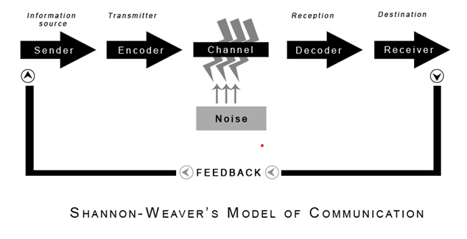
Img. 1 (communicationtheory, n.d.)
In the case studying example of Maria and Pedro conversation we can see that Pedro is working on construction site and could not understand what was Maria said to him when she called and ask to buy chicken, because of the noise coming from the background which explains by Shannon-Weaver’s model when noise is distracting the channel.
An example from my work, when I am driving a conversation on the phone with my manager complicates the noisy operation of the car engine and the noise coming from passing vehicles so that sometimes I do not understand what they are trying to say to me and ask to say that again several times. (communicationtheory, n.d.)
Berol’s communication model
It was proposed by D. Berlo in 1960. It is called by the name of its constituent elements in the form of the abbreviation SMCR:
According to Berlo, this model contain a detailed analysis of each of the elements of the communication process. The source and recipient are analysed in terms of their communication skills, knowledge, their social affiliation, cultural characteristics, socio-psychological attitudes, determining the reactions of the individual in relation to all objects and situations with which the installation is associated. The channels of communication according to Berlo, are the five sense organs through which information is received. This model is, perhaps the simplest and most convenient for getting acquainted with the features of a particular communication process, due to which it can be considered basic when considering individual elements of the communication process. However, it has the same drawback as a number of models described above: it is monologue, one-way - it cannot be considered complete without taking into account the result of communication and feedback. (Janse, 2018)
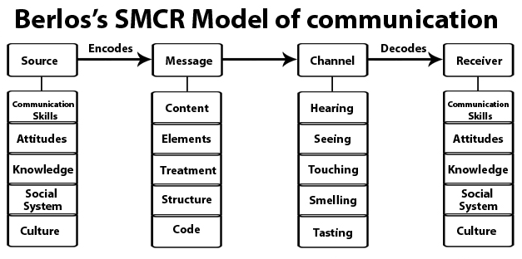
Img. 2 (communicationtheory, n.d.)
In the example of the story about the professor and people from the village, we can come to the conclusion that when the professor tried to ask for help he used words that were not familiar to them. And they didn’t help him continuing doing what whey were doing. The misunderstanding happened because professor used words to explain that he is in trouble to non-educated people. If he explained with simple words he would get helped.

Osgood-Schramm circular model
The final solution to the simplified interpretation of communication as a unidirectional linear process was the Osgood-Schramm circular model. Its main identified feature is the postulation of the circular nature of the communicative process. Another feature is that Schramm and Osgood show their attention to the behavior of the main participants in communication - the sender and the recipient, making special demands on the encoding, decoding and interpretation of messages. The review defined "communications" conducted by W. Schramm, including due to the fact that their use is a set of information signs. This set includes not only facts, objects, but also emotions, latent meanings ("silent language"). Adequacy of detection includes areas in which the experiences of the communicator and the recipient are similar, in which signs of personality recognition are found. The communicator and the recipient have an "observation fund", a "correspondence frame" and the area in which they can successfully communicate is in the "overlap" of their "framework". The success of communication also depends on the expectations that arise when communicating with a friend. According to Schramm, it is wrong to think that the communication process has a beginning or an end. In fact, it is endless. A possible point of criticism of this model is that it creates the impression of a process of "equality" of the parties in communication. Meanwhile, this process is often unbalanced, especially when it comes to communications. In terms of the recipient and the sender are not so equal phenomena of communication and the circular model, which equalizes them as links in the same chain, the proportion of their participation in the communication process is inadequate.
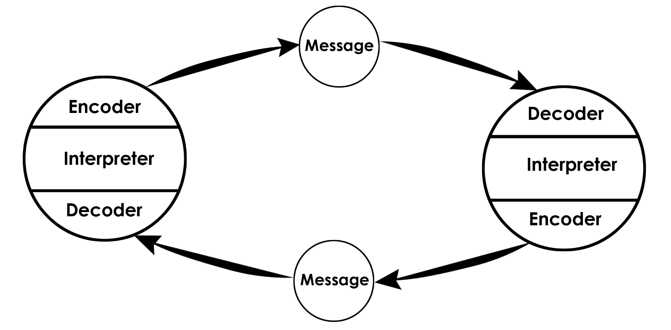
Img. 3 (communicationtheory, n.d.)
The main encoding device is the human brain. Here, the encoder and decoder are not separated from the communicator. The very process of communication means the ability of the communicator to use the language. (communicationtheory, n.d.)
Types of communication
Verbal communication
Verbal communication is the transfer of information from one person to another through speech and its adequate perception by the other side. This is the most versatile and common way to communicate. Let's take a closer look at how words do the job of conveying information. But first, let's answer the question: is there much around us or inside of us that we could not describe in words? At least inaccurately, uncertainly, approximately? Perhaps not enough. But words are the main fund of our sign system. Speech communication is a motivated living process of interaction between the participants of communication, which is aimed at the implementation of a specific, vital goal setting, proceeds on the basis of feedback in specific types of speech activity. Written speech is verbal (verbal) communication through written texts; speech based on a visually perceived stable fixation of language structures, primarily in the form of a written text. Verbal communication can cause a positive or negative emotional response. That is why each individual simply needs to know and correctly apply the rules, norms and techniques of speech interaction. For the effectiveness of communications and success in life, any person should master the art of rhetoric. (skillsyouneed, n.d.)
Non-verbal communication
Non-verbal communication is the transfer of information through any communication channels other than verbal. These can be gestures, facial expressions, a change in posture, intonation and manner of speech, the timbre of the voice, or certain demonstrative actions. Depending on the topic of conversation, the ratio between the verbal and non-verbal components of communication can vary widely. In general, during communication, we convey information in two ways: verbal and non-verbal. For example, when one person says to another: “I caught such a fish!”, He uses both channels. In words (verbally), he reports that he caught a fish, and with his hands (non-verbally) he shows its size, that is, he supplements the information with important facts. (skillsyouneed, n.d.)
Active listening
Active listening is a method of demonstrating attention and reflecting the feelings of the interlocutor in a conversation in order to allow the interlocutor to freely express feelings and thoughts. Active listening is the key to successful partnerships. In a married life, active listening will help build rapport between partners. Use the method of active listening at work when communicating with clients or colleagues. The client will be satisfied with the service if he sees that he is listened to and understood. And in the team it will create a comfortable atmosphere. The method of active listening is effective both in professional activities and in everyday life. Listen to what people are saying to you and let them know you are listening. (studycorgi, n.d.)
Formal communication
Formal communication usually refers to the formal exchange of information. Regardless of your role in an organisation, knowing how to communicate formally and recognising formal communication can help improve your communication with colleagues and company management. Understanding and using all types of formal communication can be a valuable skill, but it takes to research and practice. In this article, we will discuss what formal communication is, why it's important, what types of formal communication exist, and tips on how to improve formal communication.
Formal communication is a communicative style that is used in professional and institutional contexts. This is a regimented method in which the use of colloquial words is not allowed, as the tone used must always be cultured and aseptic. In the same way, we can also refer to the formal exchange of information as the flow of information that occurs between different levels within the hierarchy of an organization and which will be concluded within the mentioned set of norms. (Team, n.d.)
Types of Formal Communication
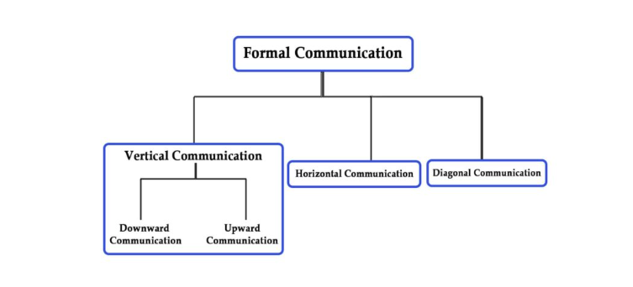
Img. 4 (parsadi, n.d.)
Informal communication
Informal communication is all kinds of personal contacts that occur outside of official relations. In simple terms, it means a conversation between people without restrictions and compliance with the rules. And informal communication most often occurs spontaneously. To make contact with someone, a person does not need to formulate phrases in advance, come up with topics and prepare his thoughts.

Advantages and disadvantages of technical communication
As a result of technological progress, electronic means of communication have appeared at the disposal of people. They helped change the usual system of interaction in organizations, created many new opportunities, and somewhere even changed the very structure of management in the organisation. Thanks to electronic systems, it has become easier to decentralise management, to carry it out in a new way. Due to the Internet, the number of users has increased, it has become possible to organise communication between students and university in real time over long distances with the possibility of instant exchange of information. This helps to save time and resources. Electronic communication outperforms traditional communications by reducing time and distance as a barrier to corporate communication.
1) Knowing the phone number of the person with whom the communication takes place. Most often, a person has no more than two phone numbers and it is longer-term, unlike an email address, which is easy to change or forget the password.
2) Confidentiality - compared to communication in other systems, messengers provide the privacy necessary for more personal matters.
3) In instant messengers, it is possible to quickly send, not only text, but also images, videos, location. Plus, there is the opportunity to call if necessary absolutely free of charge, regardless of the region in which the communication participants are located.
4) The ability to communicate in real time and with a delay, that is, if the message in the messenger was sent after business hours, then you can answer both immediately and later. This is considered more or less acceptable orate communication.
Disadvantage of implementing presence of an appropriate specialist in the IT department, who is able to eliminate the problem that has arisen. A technical failure or program error can lead to blocking the work of both a student and the entire university. (graduateway, n.d.)

Conclusion
In conclusion I would like to point on importance of communication between students, lecturers and university management. All the types of communication I mentioned in this report are using in day to day in our lives, which playing a big role in study process.

References
Anon. (n.d.) Nonverbal communication [Online]
Available at: https://www.skillsyouneed.com/ips/nonverbal-communication.html
(Accessed: 7 October 2022).
Anon. (n.d.) Berlos smcr model of communication, communicationtheory.org. [Online]
Available at: https://www.communicationtheory.org/berlos-smcr-model-of-communication/
(Accessed 06 11 2022).
Anon. (n.d.) osgood schramm model of communication, communicationtheory.org. [Online]
Available at: https://www.communicationtheory.org/osgood-schramm-model-of-communication/
(Accessed 06 11 2022).
communicationtheory (n.d.) shannon and weaver model of communication, communicationtheory.org. [Online]
Available at: https://www.communicationtheory.org/shannon-and-weaver-model-of-communication/
(Accessed 05 11 2022).
graduateway (n.d.) advantages and disadvantages of communication technology, graduateway.com. [Online]
Available at: https:// graduateway.com/advantages-and-disadvantages-of-communication-technology/
(Accessed 10 11 2022).
Janse B., 2018. communication methods berlos smcr model of communication, toolshero.com. [Online]
Available at: https://www.toolshero.com/communication-methods/berlos-smcr-model-of-communication/
(Accessed 06 11 2022).
parsadi (n.d.) formal communication, parsadi.com. [Online]
Available at: https://parsadi.com/formal-communication formal-communication /
(Accessed 08 11 2022).
skillsyouneed (n.d.) verbal communication, skillsyouneed.com. [Online]
Available at: https://www.skillsyouneed.com/ips/verbal-communication.html
(Accessed 07 11 2022).
studycorgi (n.d.) active listening method of communication, studycorgi.com. [Online]
Available at: https://studycorgi.com/active-listening-method-of-communication/
(Accessed 16 11 2022).
Team, I. E. (n.d.) formal communication, indeed.com. [Online]
Available at: https://www.indeed.com/career-advice/career-development/formal-communication
(Accessed 07 11 2022).

