RESEARCH AND CASE SCENARIO IN DATA SECURITY AND COMPLIANcE
Appendix
Jacob John Hopkins
Student University of Wales Trinity St David, Swansea, Wales
2003836@student.uwtsd.ac.uk

Appendix A ^{[2]}
The Data Protection Act
The Data Protection Act 2018 controls how your personal information is used by organisations, businesses or the government.
The Data Protection Act 2018 is the UK’s implementation of the General Data Protection Regulation (GDPR).
Everyone responsible for using personal data has to follow strict rules called ‘data protection principles’. They must make sure the information is:
used fairly, lawfully and transparently
used for specified, explicit purposes
used in a way that is adequate, relevant and limited to only what is necessary
accurate and, where necessary, kept up to date
kept for no longer than is necessary
handled in a way that ensures appropriate security, including protection against unlawful or unauthorised processing, access, loss, destruction or damage
There is stronger legal protection for more sensitive information, such as:
race
ethnic background
political opinions
religious beliefs
trade union membership
genetics
biometrics (where used for identification)
health
sex life or orientation
There are separate safeguards for personal data relating to criminal convictions and offences.
Your rights
Under the Data Protection Act 2018, you have the right to find out what information the government and other organisations store about you. These include the right to:
be informed about how your data is being used
access personal data
have incorrect data updated
have data erased
stop or restrict the processing of your data
data portability (allowing you to get and reuse your data for different services)
object to how your data is processed in certain circumstances
You also have rights when an organisation is using your personal data for:
automated decision-making processes (without human involvement)
profiling, for example to predict your behaviour or interests

Appendix B ^{[11]}
Regardless of the social network, users continue to be fooled online by persons claiming to be somebody else. Unlike the physical world, individuals can misrepresent everything about themselves when they communicate online, ranging not only from their names and business affiliations (something that is fairly easy to do in person as well), but also extending to their gender, age, and location (identifiers that are far more difficult to fake in person). Years ago investigators called these types of people confidence or con men. Perhaps as a result of the high-tech times, con artists are now referred to as being engaged in social engineering. It should come as no surprise to learn that the Federal Bureau of Investigation (FBI) is investigating classic investment fraud schemes, such as Ponzi schemes, that are now being carried out in virtual worlds. Other con artists are able to conduct identity theft crimes by misidentifying themselves on social networking sites and then tricking their victims into giving them their account names and passwords as well as other personally identifiable information. In addition to identity theft crimes, child predators routinely use social networking sites to locate and communicate with future victims and other paedophiles. In at least one publicized case from 2018, an individual attempted to extort nude photos of teenage girls after he gained control of their email and social networking accounts. That particular FBI investigation led to an 18-year federal sentence for the offender, reflecting that these crimes are serious and will not be tolerated.3Social engineering is the broad term for any attack that relies on fooling people into taking action or divulging information. Social engineering has been defined in several ways as is shown in Box 1.1.
BOX 1.1DEFINITIONS OF SOCIAL ENGINEERING.
The act of deceiving an individual into revealing sensitive information by associating with the individual to gain confidence and trust. Source: NIST SP 800-63-2 under Social Engineering [superseded]An attempt to trick someone into revealing information (e.g., a password) that can be used to attack systems or networks.
Source(s): CNSSI 4009-2015 (NIST SP 800-61 Rev. 2), NIST SP 800-61 Rev. 2 under Social Engineering, NIST SP 800-82 Rev. 2 under Social Engineering (NIST SP 800-61)
A general term for attackers trying to trick people into revealing sensitive information or performing certain actions, such as downloading and executing files that appear to be benign but are actually malicious.
Source: NIST SP 800-114 under Social Engineering [superseded]

Appendix C ^{[12]}
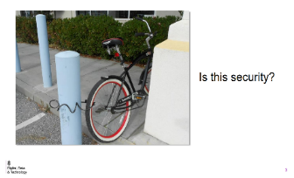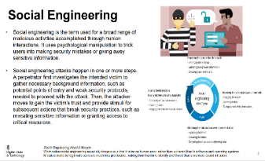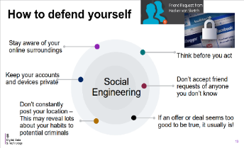

Appendix D ^{[14]}
Magnetic Stripe Cards
The three basic ways the cards can be attacked is through reading, copying, and creation of cards. Note that all of these attacks also apply to the new UID-based system, with the exception of the reading attack. This attack becomes a moot point under the new system since the UID number is also printed on the front of the card, so it would be much easier to simply look at the card and obtain the UID. Also note that only the reading and copying attacks require the attacker to have physical access to the card. The creation attack can be carried out without any physical access to the card.
Under the current system, simply reading someone's card can be considered an attack since it reveals that person's SSN to the attacker. Knowing someone's name and SSN is the basis for off campus identity theft, so this is quite a serious problem. This attack does not require any specialized knowledge of electronics; all the attacker needs is a commercial magnetic card reader which attaches to a computer. These devices are available on the Internet for as little as $30 and are easy to set up and operate.
Another attack is the copying of an existing card. This can also be achieved without any electronics expertise—commercial card reader/writer combinations are also available on the Internet for about $240-300. These units allow someone to read in a card and then write out a copy of that card onto a blank card. As far as the system is concerned, this copy is identical to the original. The only difference is that the copy will not have the proper credentials printed on the front of the card, so it will not work for human identification purposes.
A more sophisticated attack on the cards is the creation of cards based purely on information (as opposed to having physical access to someone's card). The two pieces of information an attacker needs to re-create the magnetic stripe on someone's card is that person's SSN (or UID under the new system) and a rough idea of how many times he has lost his card (the issue code). In most cases, SSNs would be fairly easy to social engineer, especially since many students are still used to utilizing them as student identification numbers. UIDs are public identifiers and are readily available, as discussed below. An attacker does not need to know the exact issue code since he can always start at a low number and keep incrementing it until it works. In the worst case, he will be successful in the current system after at most 10 attempts, since the issue code is a one-digit field (with possible values 0-9). Under the new system, the issue code is a two-digit field and could in theory reach up to 99. In practice, however, the issue code will be much lower than 99 or even nine, probably closer to two or three, so the attacker would need even less time to find the correct one.
The most dangerous variation of the copying and creation attacks is to alter the data on an existing UMD ID card (for example, the attacker's own card). This preserves the authenticity of the front of the card but allows the attacker to put someone else's information on the back and get into buildings or make purchases in that person's name. The only way to detect this attack would be to look up the SSN (or UID) from the back of the card in the student database and compare it Magnetic Swipe Card System Security Page 10 of 26 to the name on the front. This is almost never done in practice—not by cashiers, and especially not at passive door readers.
Note that these attacks also imply that the current method of card revocation (incrementing the issue code) is not at all secure. If an attacker finds a lost (and deactivated) card, he can simply copy that card and start incrementing the issue code until the card works (most likely after incrementing it once).
Finally, there is the issue of using personal identification number (PIN) codes in addition to magnetic stripe cards. As mentioned above, Lenel readers with keypads are available, so it would be possible to require each student to type in his PIN code every time he swipes his card. This would indeed protect against the creation and copying attacks presented in this section, since the attacker would separately need to obtain the PIN associated with the card being copied. However, adding a PIN number does not protect against any of the three attacks below because it would also be transmitted unencrypted and could be just as easily sniffed as the number of the card. However, with hundreds of readers on campus, the cost of upgrading them all to include keypads would be prohibitive, and it would be much more sensible to switch to a more secure access control system altogether.

Appendix E ^{[15]}
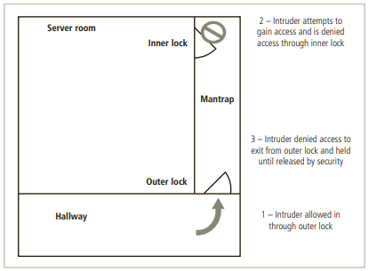

Appendix F ^{[18]}
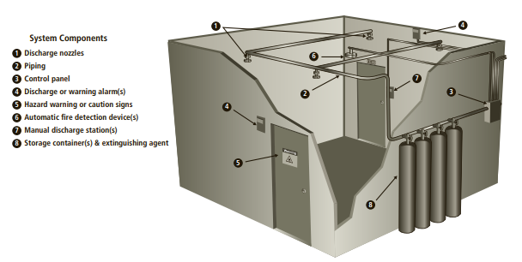

Appendix G ^{[19]}
IV. EXPERIMENTAL RESULTS
In order to evaluate the reliability of SSDs, we have conducted comprehensive experiments by employing our proposed test platform. The Host System as a part of test platform includes Intel(R) Core (TM) i5 and 8GB DDR3 RAM (froy Hynix Semiconductor) that are connected to a Z97- A motherboard from ASUSTeK computer incorporation. The running operating system on the Host System is Ubuntu 17.04 with the kernel version 4.10.0-19-generic. The experiments are performed on six SSDs from different vendors. Table I provides the detailed information about the characteristics of the SSDs in our experiments.
The experiments are performed to reveal the impact of workload dependant parameters such as workload WSS, requests size, requests type (read/write), requests access pattern (sequential/random), and sequence of accesses (RAR, RAW, WAR, and WAW). In addition, we have investigated the effect of SSDs internal volatile DRAM cache and the impact of time intervals between the completion of the request and power outage on the failure rate. The results of the experiments reveal three types of failure namely data failure, FWA, and IO error. In Section III-B, we have elaborated the failure detection mechanism that have been employed in our test platform.
Impact of Time Interval After Request Completion and Power Outage
In this section, we analyze the impact of time interval between the completion of the request (i.e., when the ACK signal is received in the application layer) and power outage occurrence. The IO requests are submitted to random address (uniform random distribution) with varying size between 4KB and 1MB and the power fault is injected to the SSD in variable time intervals after completion of the request. The experimental results show that the power fault not only may disturb the currently writing data, it may corrupt the previously written data which was finished completely. Conducted experiments on the SSDs (depicted in Table I) reveal that on average 700ms after receiving ACK signal of the request in application layer, the power fault can corrupt the corresponding request which was successfully written on the SSD. The reason of such failure can be due to the volatile DRAM cache of the SSD where write pending requests are kept. We have also performed experiments by disabling the SSD internal cache where the results reveal the similar failures in such conditions.
Impact of Request Type
In this section, we evaluate the vulnerability of read/write requests that are submitted to the SSD under power failures. To this end, we have generated the workloads with random access pattern (uniform random distribution) with varying size between 4KB and 1MB where the type of requests varies from fully write to fully read (i.e., the percentage of write operation is 100%, 80%, 50%, 20%, and 0%). In these experiments, more than 300 power faults are injected to the SSD during 24,000
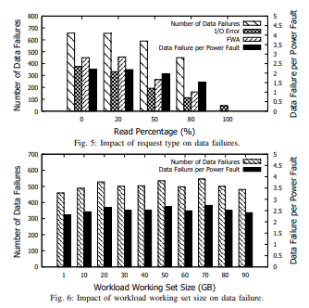
requests. As depicted in Fig. 5, it can be seen that by decreasing the percentage of write requests in the workload, the ratio of data failure decreases where in fully read workload, there is no data failure, however, the IO error is occurred due to disk unavailability during power failure. The workloads with write requests are vulnerable to both data failure and FWA failures where we detect about two data failure per power fault in our experiments.
Impact of Workload Working Set Size (WSS)
In this section, we perform experiments to reveal the impact of power fault on the ratio of data failures in different workloads with different WSS. To this end, we have generated the workloads with varying WSS from 1GB up to 90GB. The size of requests is considered random between 4KB and 1MB and the requests are submitted to the SSD with uniform random-access pattern. In these experiments, we have injected more than 200 power faults to the SSD during 16, 000 requests. Fig. 6 demonstrates that the workloads WSS has no significant impact on the ratio of data failures. Instead, the data failure is significantly affected by the access patterns of the request (i.e., locality of IO requests) rather than the workload WSS which is investigated in the next section.
Impact of Requests Access Pattern (Random/Sequential)
In this section, we investigate the impact of requests access pattern on the failure rate. The experiments of this section are done by submitting the IO requests of two different workloads where the first one is consist of fully uniform random write operations while the second one includes fully sequential write operations. The request size in both workloads varies between 4KB and 1MB and the WSS of both workloads is considered to be equal to 64GB. In these experiments, SSDs experience more than 300 power faults during 24, 000 requests. Note that the experiments of this section include two independent experiments where the running workload on the platform is different. It is important to note that in the workloads with sequential access pattern, FTL only keeps the first address in the mapping table where such scheme reduces the amount of table entries but on the other hand may have significant impact on the failure rate due to power loss (particularly in case of map table failure which is kept in the volatile DRAM cache). The results of the experiments prove such claim and reveal that the ratio of data failure in a workload with sequential access pattern is about 14% more than the workload with random access pattern.
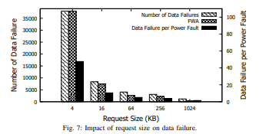
Impact of Request Size
In this section, we investigate the impact of request size on the failure rate under power faults. To this end, we submit the requests of the workload which includes the write requests with uniform random-access pattern to the SSD. The request size of the workloads is constant in each experiment where it varies between 4KB and 1MB in different experiments. In these experiments, the SSD experiences more than 800 power failure where the number of requests is more than 64, 000. As shown in Fig. 7, the ratio of data failure in the workload with smaller request size (e.g., 4KB) is significantly more than the workload with larger request size. The main reason of such behavior is due to the different number of committed request per time. In a equal time interval, the number of requests with smaller size is significantly larger than the requests with larger size. Therefore, occurring a power failure can affect larger number of requests in the workloads with smaller request sizes. It can be seen from Fig. 7 that most of the failures in the workload with 4KB request size is from FWA type where the ACK is received in the application through the SSD but the data is not written. This may be due to the impact of power failure on volatile DRAM cache inside of the SSD while the experiments on the SSDs with disabled cache suffer from FWA failure.
Impact of Requested IOPS Submitted to the SSD
Here we evaluate the impact of requested Input/Output Per Second (IOPS) (i.e., the number of operations that are submitted to the SSD in one second) by the workload on the failure ratio under power faults. To this end, we have generated various workloads with different requested IOPS. The workloads include uniform random write requests where the requests size varies between 4KB to 1MB. In each experiment, more than 600 power faults are injected to the SSDs. Fig. 8 depicts the responded IOPS of the SSD and also the number of failures in each experiment based on requested IOPS for each workload. It can be seen that by increasing the ratio of the requested IOPS, the responded IOPS by the SSD increases up to 6900 (the responded IOPS saturates when we send the requests with more than 7000 IOPS to the SSD). The results reveal that data failure increases by increasing the requested IOPS until the responded IOPS saturates where increasing the requested IOPS has no impact on the failure rate. This is because the SSD responds to only a limited number of requests (about 6900 uniform random writes in our experiments) where the fault only affects the responded IOPS.
Impact of Sequence of the Accesses
In this section, we have performed experiments to evaluate the vulnerability of the SSDs under power failure with the workloads by different sequence of the accesses including RAR, WAR, WAW, and RAW. In these experiments, each request is submitted on the address of the previously completed request. As depicted in Fig. 9, there is significantly large number of failures due to power failure in the accesses with the WAW pattern. This is due to the large number of write operations in the workload with WAW accesses. The results reveal that power failure after a WAW sequence may affect
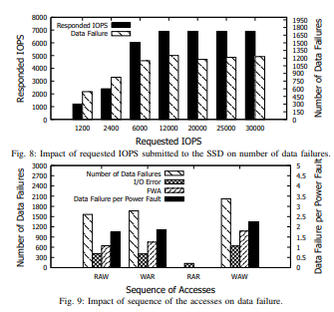
both of written data (corresponding to write operation) and the previously written data in that address. Such failures are experienced in the accesses with WAR and RAW sequences while similar to the workloads with fully read request, there is no data failure in the workload with RAR accesses. Note that in the workloads with WAR, WAW, and RAW accesses, SSDs experience considerable number of failures from FWA type.
V. CONCLUSIONS
In this paper, we investigated the impact of workload dependent parameters on the failure ratio of the SSDs under power outage. To this end, we presented a fault injection and failure detection platform which injects the realistic power faults to the under-test SSDs. During power failure, SSDs experience the exact voltage drop behavior that occurs during power failures in data centres. The results of our experiments reveal that the failure ratio in SSDs due to power outage is significantly affected by the parameters of the running workloads in the application layer. In addition, we show that failures in SSDs are not only due to volatile DRAM cache but also we observe similar failures in SSDs with disabled internal cache.

Appendix H ^{[20]}
GDPR
Fines/Penalties
National authorities can or must assess fines for specific data protection violations in accordance with the General Data Protection Regulation. The fines are applied in addition to or instead of further remedies or corrective powers, such as the order to end a violation, an instruction to adjust the data processing to comply with the GDPR, as well as the power to impose a temporary or definitive limitation including a ban on data processing. For the provisions which relate to processors, he may be subject to sanctions directly and/or in conjunction with the controller.
The fines must be effective, proportionate and dissuasive for each individual case. For the decision of whether and what level of penalty can be assessed, the authorities have a statutory catalogue of criteria which it must consider for their decision. Among other things, intentional infringement, a failure to take measures to mitigate the damage which occurred, or lack of collaboration with authorities can increase the penalties. For especially severe violations, listed in Art. 83(5) GDPR, the fine framework can be up to 20 million euros, or in the case of an undertaking, up to 4 % of their total global turnover of the preceding fiscal year, whichever is higher. But even the catalogue of less severe violations in Art. 83(4) GDPR sets forth fines of up to 10 million euros, or, in the case of an undertaking, up to 2% of its entire global turnover of the preceding fiscal year, whichever is higher. Especially important here, is that the term “undertaking” is equivalent to that used in Art. 101 and 102 of the Treaty on the Functioning of the European Union (TFEU). According to case law of the European Court of Justice, “the concept of an undertaking encompasses every entity engaged in an economic activity, regardless of the legal status of the entity or the way in which it is financed”. An undertaking can therefore not only consist of one individual company in the sense of a legal person, but also out of several natural persons or corporate entities. Thus, a whole group can be treated as one undertaking and its total worldwide annual turnover can be used to calculate the fine for a GDPR infringement of one of its companies. In addition, each Member State shall lay down rules on other penalties for infringements of the Regulation which are not already covered by Art. 83. Those are most likely criminal penalties for certain violations of the GDPR or penalties for infringements of national rules which were adopted based on flexibility clauses of the GDPR. The national penalties must also be effective, proportionate and act as a deterrent.
A punishable situation in a company can be revealed through proactive inspection activities conducted by the data protection authorities, by an unsatisfied employee or by customers or potential customers who complain to the authorities, through the company making a self-denunciation, or by the press in general, especially through investigative journalism.
The Enforcement Tracker gives an overview of reported fines and penalties which data protection authorities within the EU have imposed so far.

