DS 1 Template

My Screenshots/Photos

Screenshot/Photo 1
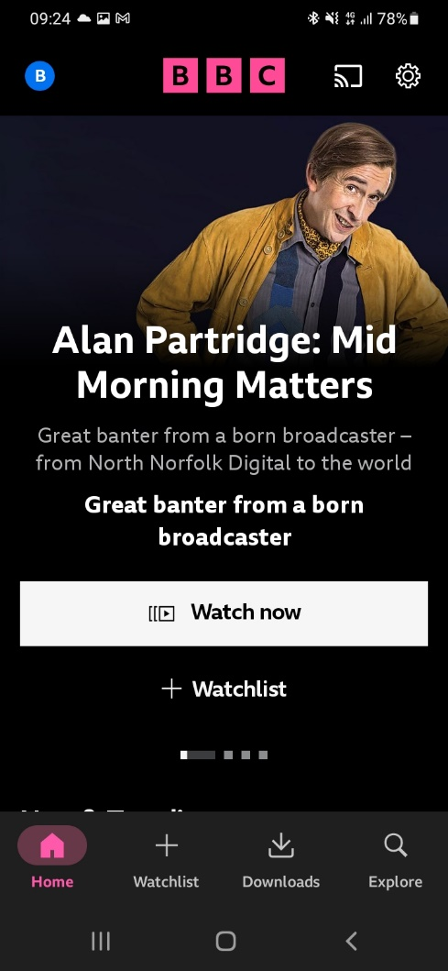 this shows how I access my bbc iplayer app.

Screenshot/Photo 2
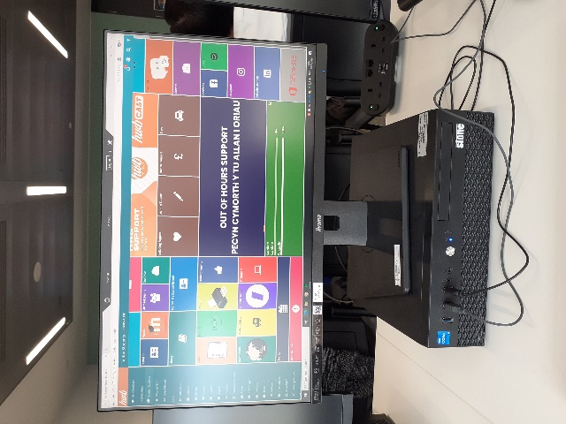 this shows how I access my Moodle

Screenshot/Photo 3
[Insert Photo/Screenshot below]
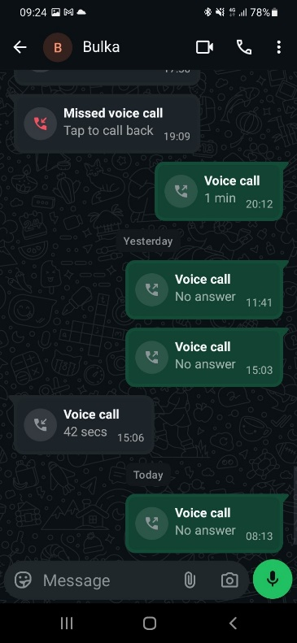
This shows how I access my WhatsApp to communicate with friends and family

Screenshot/Photo 4
[Insert Photo/Screenshot below]
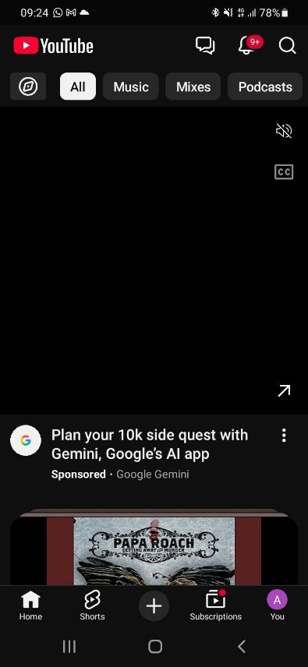
This image shows how I access my youtube app to listen to music

