Jasmin Owen
Actor Singer Dancer
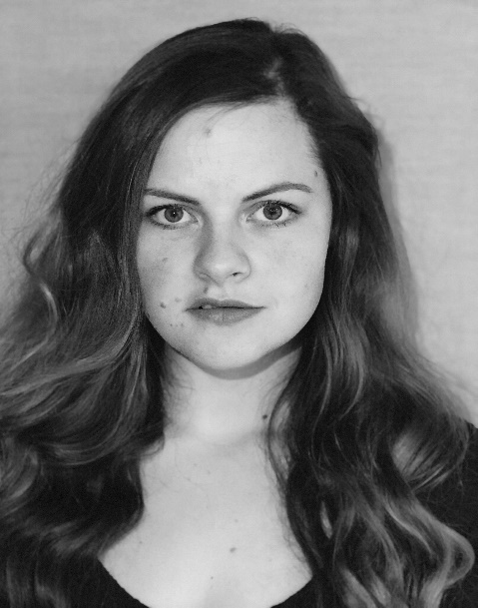
Phone: 07584653815
Email: jasminowen1993@gmail.com
Location: Carmarthen
Holds full UK Driving License
Height: 5ft6 (170cm)
Weight: 10st 8lbs (68kg)
Playing age: 18 – 32years
Appearance: White (pale)
Eye Colour: Hazel
Hair Colour: Auburn dyed (natural dark brown)
Hair length: Long
Credits:
Stage | Short Film | Other
2013, Actor, “Keepers Of the Castle”, Simon Haslam, Merry Makers Pembroke Castle, | 2017, Lizzie, “Be Yourself”, Keiron Self, Media to Motion, UWTSD | 2017, Singer, Preseli Pete and the Merrymakers, “Rock The Castle” , Pemboke Castle
2012, Gameshow Host/ DSM, “Crime of your life” Touring Theatre, Simon Haslam, Dyfed Powys Police | 2009, School Pupil, “Y Egin/The Bulb”, It’s My Shout | 2017, Roleplay, Actor, Dyfed Powys Police.
2011, PC Kirsty Evans & Cerys, “Crime of your life” Touring Theatre, Simon Haslam, Dyfed Powys Police |  | 2013-2017, Entertainer, (Singer/Actor in Children’s shows) Bluestone resorts
 |  | 2013, Roleplay, Actor, Training for LSA. Pembrokeshire College

Skills:
Accents: English*, Welsh*, Liverpool
(*=native)
Language: English*, Welsh
(*=Fluent)
Music(instrument/singing): Mezzo Soprano singer* (Variable styles) Ukulele, Percussion.
(*=Highly skilled)
Sports: Running, Dancing, Badminton*, Swimming*,
(*=Highly skilled)
Other: Stilt Walker, Balloon Model, face painter, Level 1 trained stage combat.

Training:
Trinity Saint David University

