Major Project

Alice James

Proposal

For this series of work, I decided to work along the subject of plastic pollution. I had started this project with a completely different idea of destroying my images but after thinking about my ideas and other ways to destroy an image I started to think about photographing destruction.

While going down this route, I was thinking about using old photographs and using them for my work. I researched into plastic pollution and decided that this was the subject I wanted to work with.

I wanted to find an interesting way to create images related with plastic pollution. As I wanted to use old images for this series of work, I thought about using images I had taken of the environment. Using these images, I wanted to overlay plastic images over the photos of the environmental objects, such as trees, grass, the sea etc.

For this I will experiment with this idea and see what the best outcome will be for me.

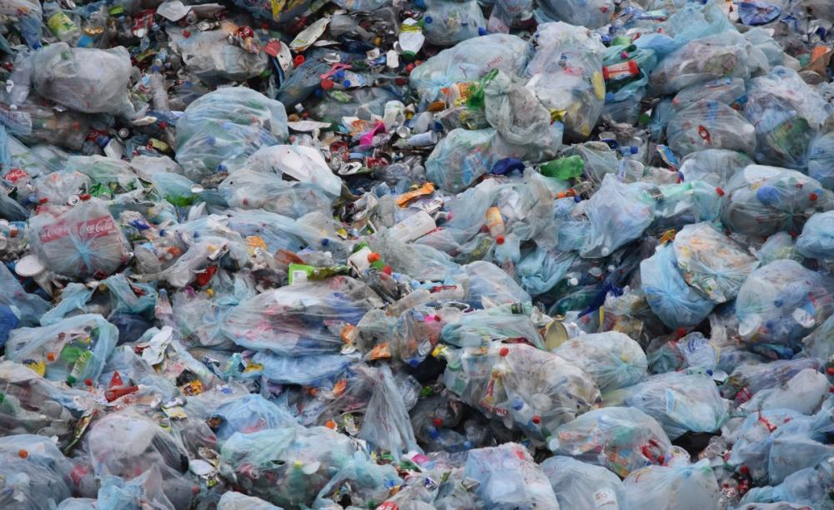
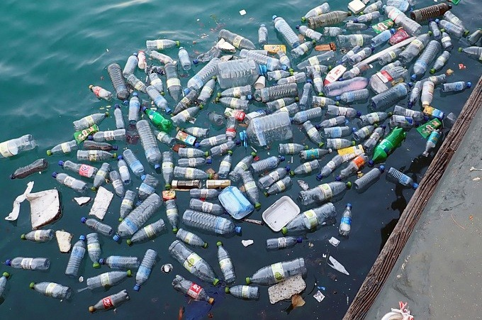
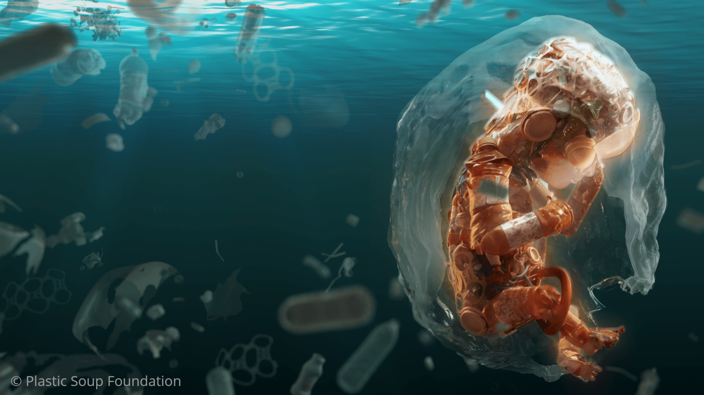
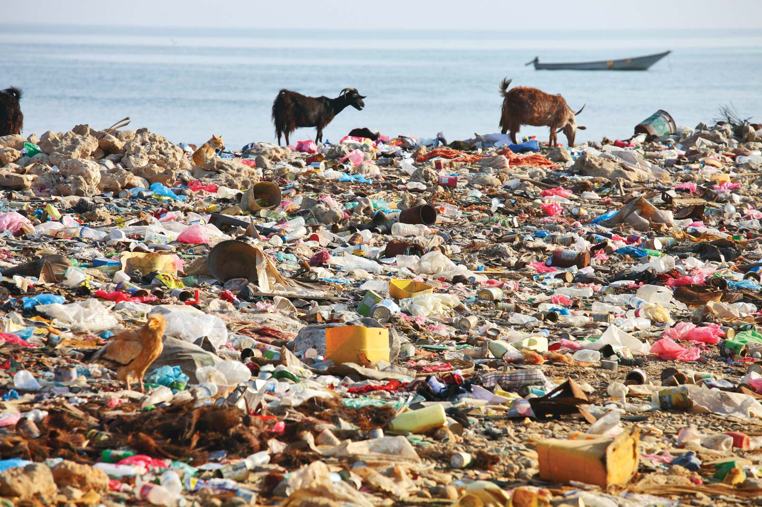
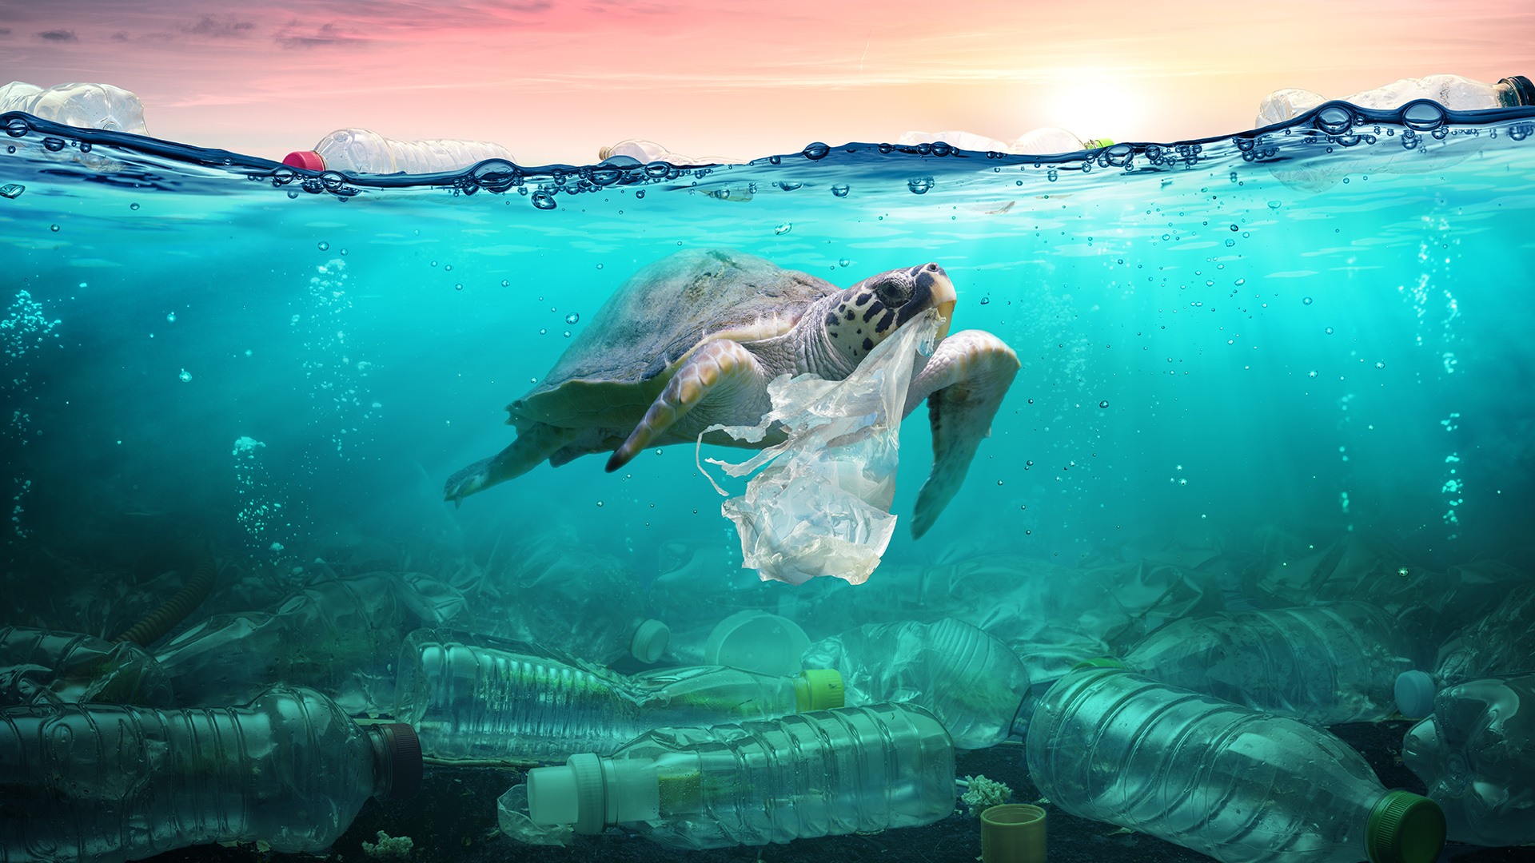
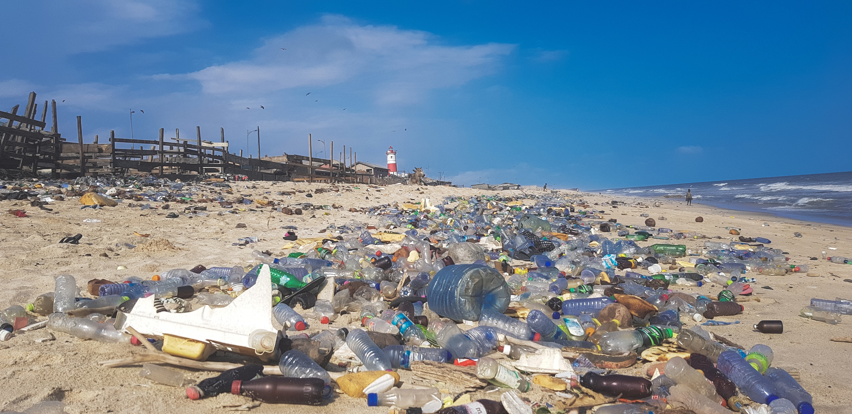
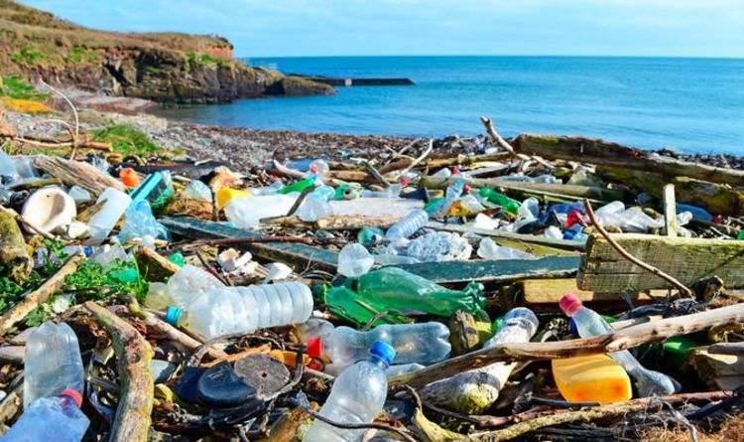
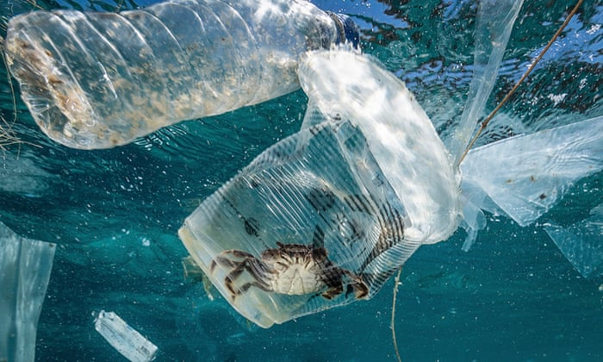
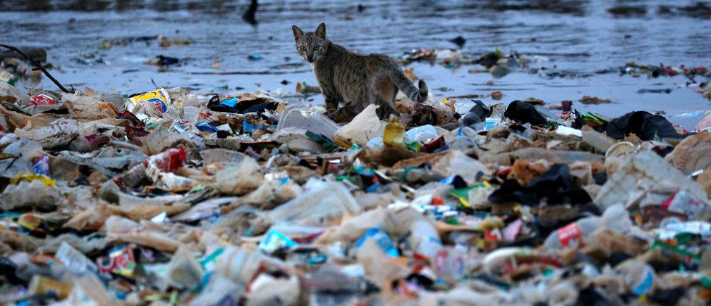
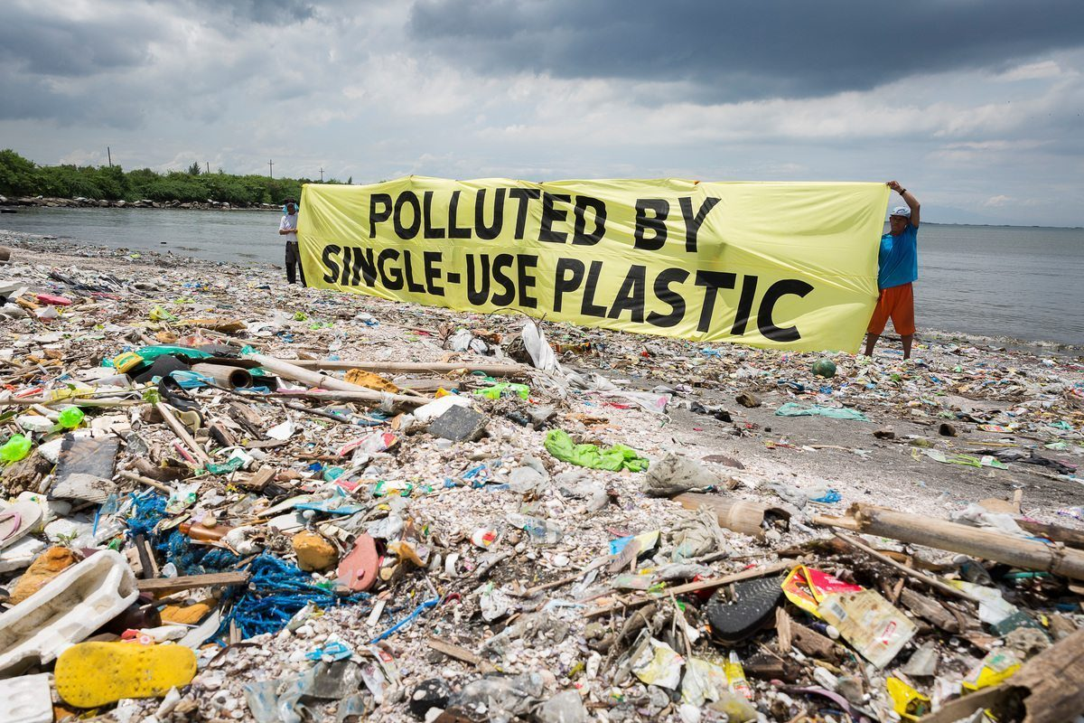
Moodboard
Mindmap

Plastic Sheet

Photoshop

Manipulation

Double exposure

Quite clear but crumpled to show it’s plastic
Sea
Trees

Rocks

Sand

35mm images
Black and white

Nature photographs

Complete overlay

Plastic
Pollution

Plants

Plastic Pollution
(Information from NationalGeographic.com)

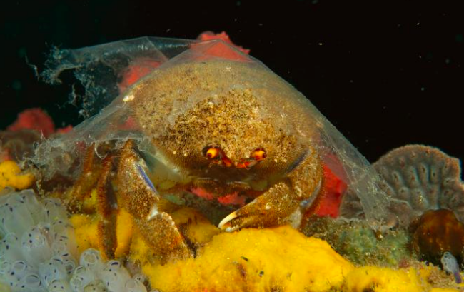
Plastic pollution has become one of the most pressing environmental issues due to the fact disposable plastic is rapidly increasing in production, which overwhelms the worlds ability to deal with them.

Plastic pollution is a lot more visible in developing nations because they have poor garbage collection systems. Although, even in developed countries, especially those with low recycling rates, have trouble collecting discarded plastics.

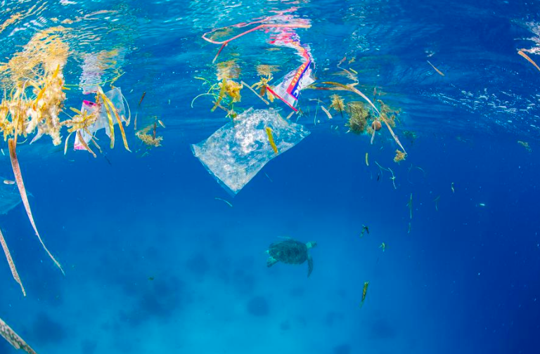
According to the plastic pollution section of National Geographic’s website, it says that plastics that are made from fossil fuels are just over a century old. The production and development of thousands of new plastics sky rocketed after the second world war and transformed the modern age where a life without plastics would be unrecognizable today. The website also says that plastics revolutionised medicine with life-saving devices, that made space travel possible, while also saving lives with helmets, incubators and equipment for clean drinking water. The downside to this though is that 40% of plastics produced every year are single-use. The very convenience of plastics led us to become a throw away culture. Single-use products, for example plastic bags and food wrappers, have a lifespan of mere minutes to hours yet they will live in the environment for hundreds of years.

Plastic by the numbers
(information from NationalGeographic.com)

- Half of all plastics ever manufactured have been made in the last 15 years.

- Production increased exponentially, from 2.3 million tonnes in 1950 to 448 million tonnes by 2015. Production is expected to double by 2050.

- Every year, about 8 million tonnes of plastic waste escapes into the oceans from coastal nations. That’s the equivalent of setting five garbage bags full of trash on every foot of coastline around the world.

- Plastics often contain additives making them stronger, more flexible and durable. But many of these additives can extend the life of products if they become litter, with some estimates ranging to at least 400 years to break down.

RESEARCH
Andy Hughes

Andy Hughes is a British artist who studied fine art in Cardiff University before getting a scholarship to study photography at Royal College of Art in London began exploring into plastic waste in 1989. He created photographs of washed up materials along the coastline and explores the littoral zone and plastic waste from places such as Wales and Cornwall to Alaska and California.

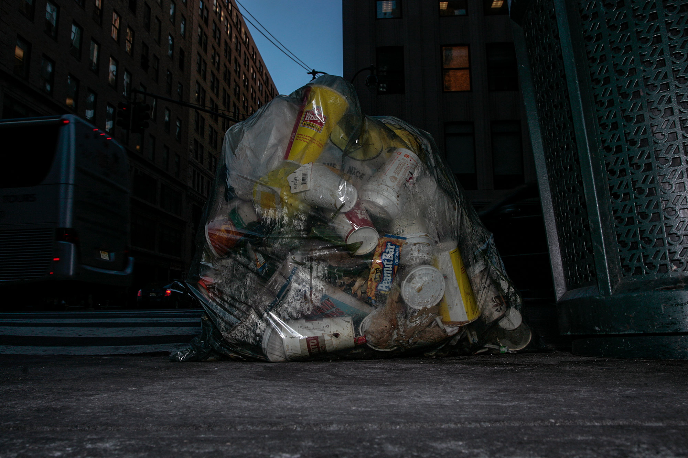
On the opening page of his website it states “..his continued obsession seems even more relevant – as the world continues to wake up to the problems associated with mass consumerism and a throw-away global society, his work seems even more prescient.” This small quote says that this is an issue that has been resent for a long time and we still struggle with it all around the world.

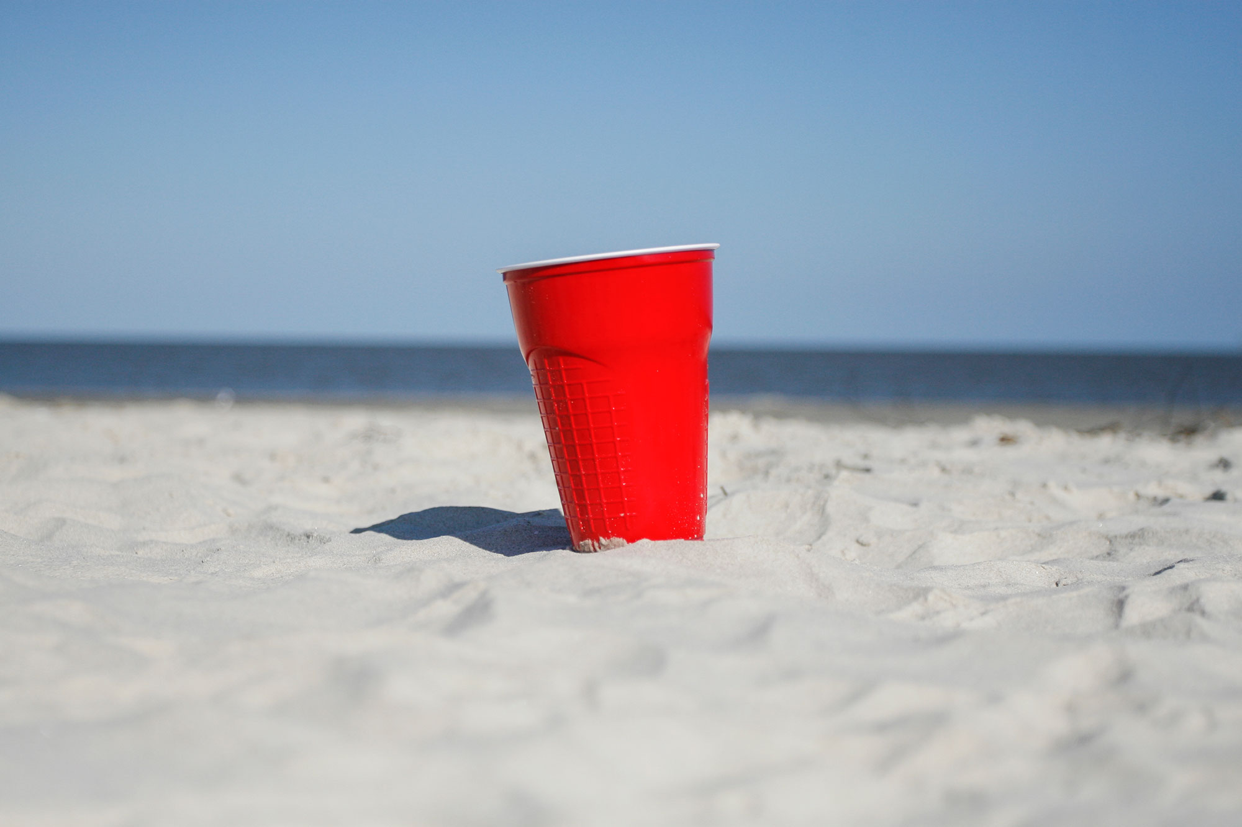
Andy’s methodology utilises traditional photographic materials and digital technologies that encourage viewers to question the nature of materials in relationship to waste. He challenges the agency of waste by many visual means and juxtaposition.

A series of work by Andy that I particularly enjoy is ‘Once.’ Once is a project based on the items that we use once and then throw away. A statement on his website about this project says “…all manner of convenience driven items such as coffee cups, bottled water, sandwich cartons start their life in all habitats and locations from the remotest outpost of human settlements to the urban sprawls of major cities. This jettisoned trash falls from the human hand and mouth to the ground, it settles for a while then begins one of the many journeys, sometimes a long and protracted one that may mean travelling many hundreds and sometimes thousands of miles. From the cafes and streets, to the sewer, to the river and out to sea, sometimes ingested by marine life and sea birds or else to come to rest on some remote atoll in the middle of the pacific.”

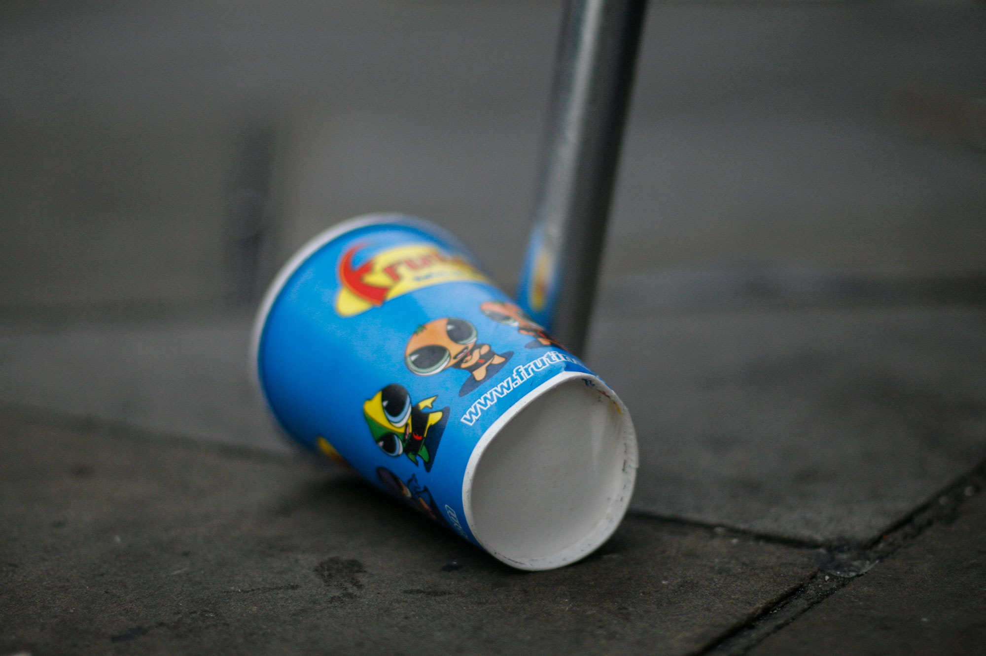
I think that this is an incredibly strong and eye opening series of work. When using a one use item we often do not think of it being one use and the effect that item can have on the planet. His images are something we see every day but often ignore, perhaps not out of intended ignorance but we’ve become so used to plastic litter in our environment that seeing photographs like this is just eye opening.
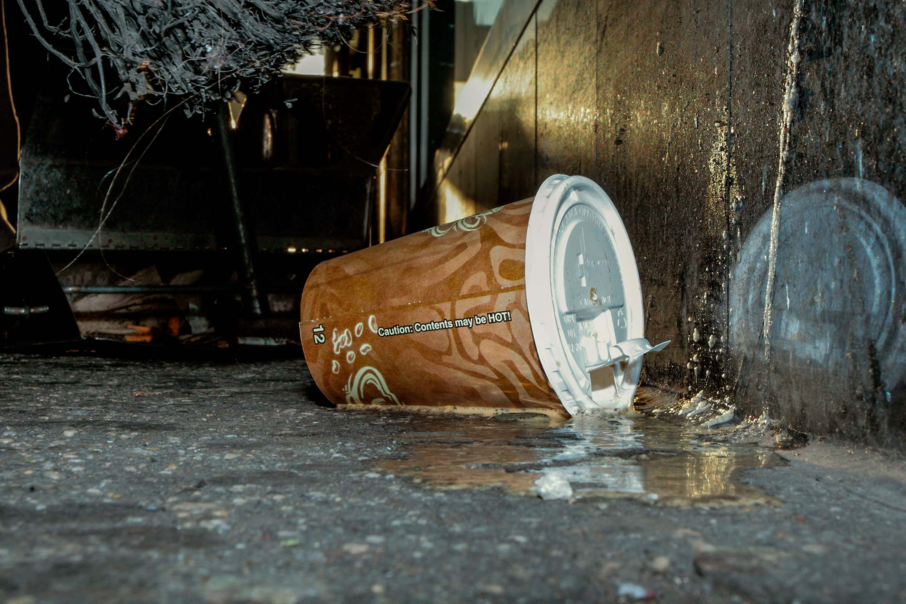

Overlays chosen

1. 2.

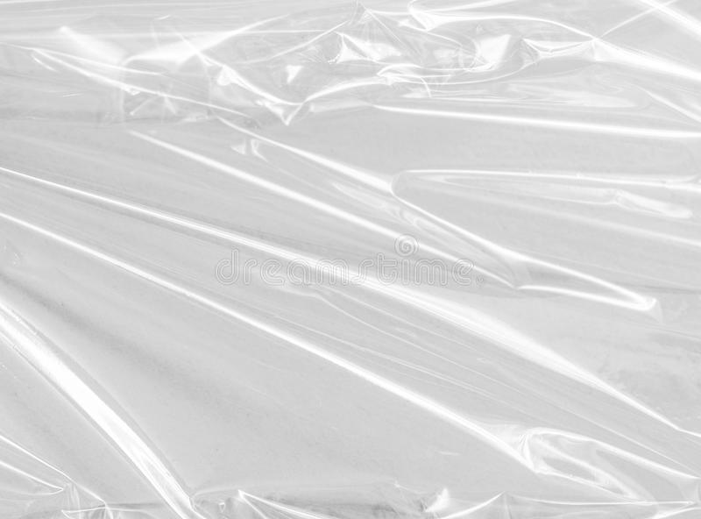

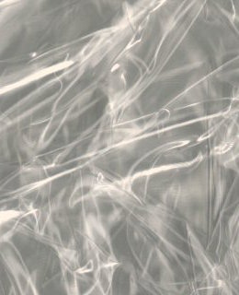

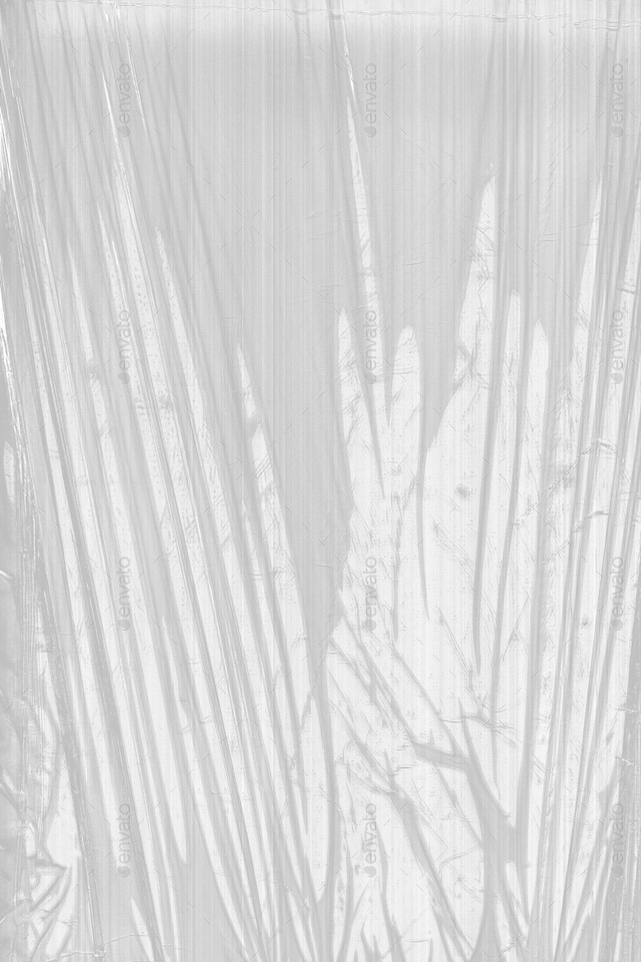

3. 4.

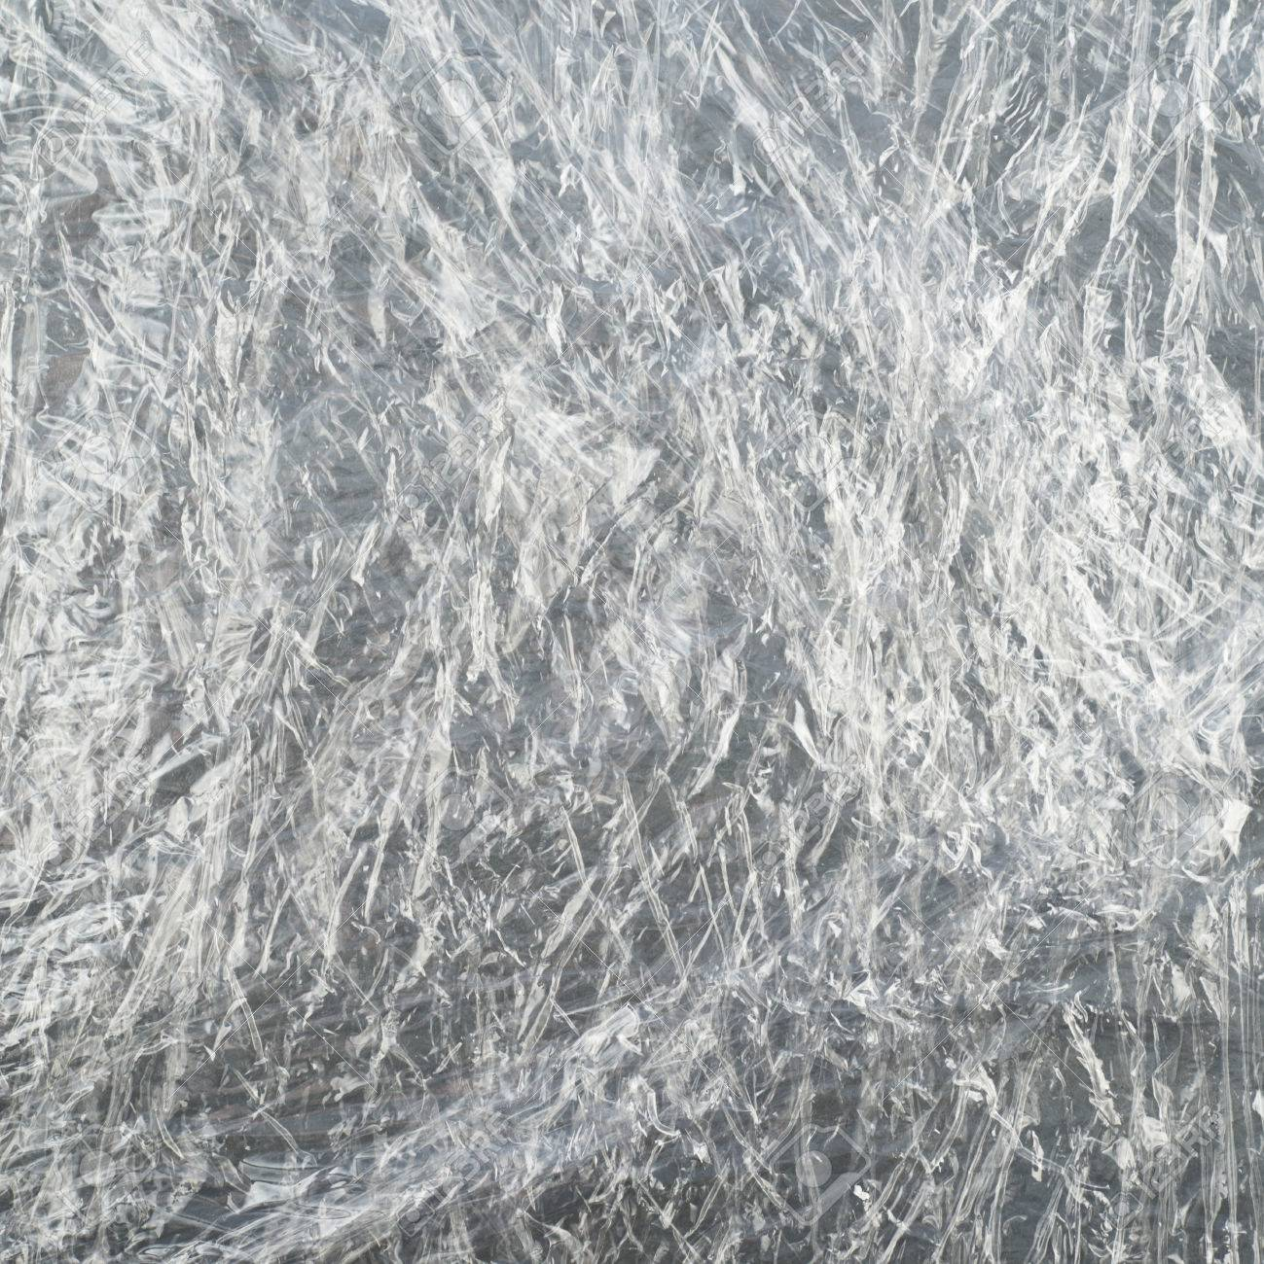

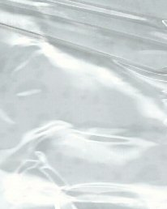

5. 6.

7.
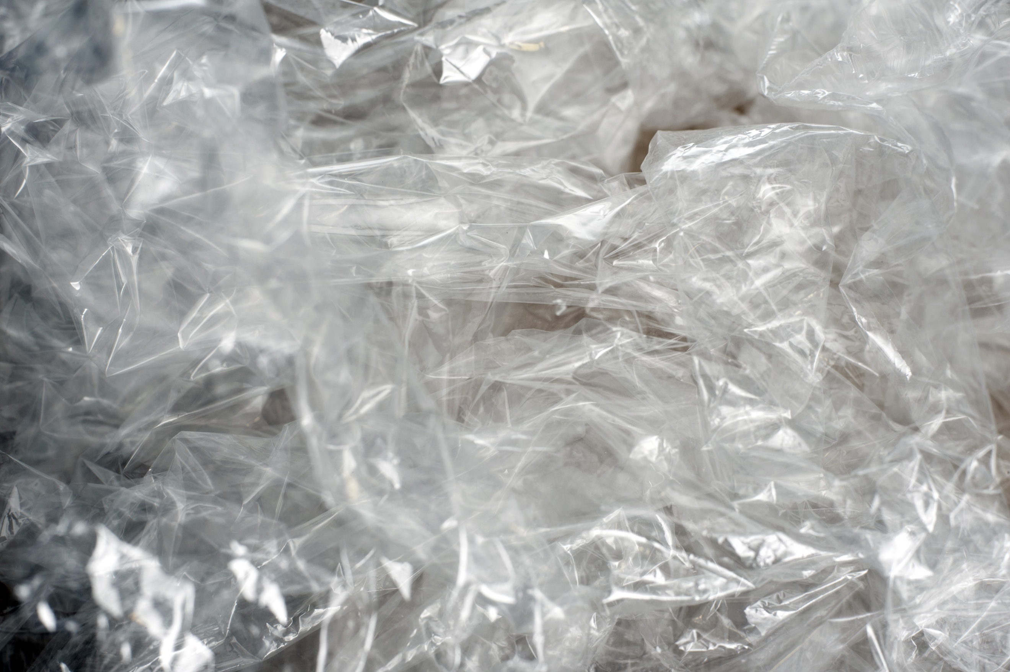

Overlays Chosen cont.

These are my chosen overlays to experiment with for this series of work. I want to experiment with all of these and see which ones work for me. I am unsure of how many I want to use at this point in time so experimenting with them will let me decide which and how many will be useful to me. I will experiment with them with photographs that I have chosen for this project as these are the images I need them to work with.
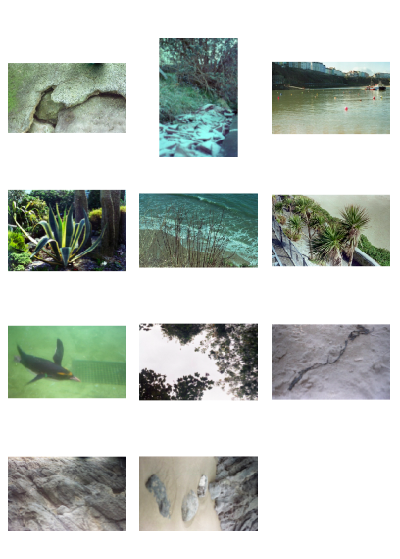
Images Chosen.
Images Chosen cont.

These are my chosen images for this project. I have chosen environmental images, such as animals, rocks, sand, trees, plants and the sea, that I already had in my archive. I have done this because I wanted photographs from various times of the year. I have ones from winter, to summer and some from the seasons between. I have done this because a lot of plastic pollution images are shot on the seaside which always looks like summer so I wanted to show that this is an all year round issue.

All of these images are shot on 35mm colour film but I wanted to turn them black and white. Experimenting with these will let me decide if black and white would work or if it would be better to leave them black and white.

I have chosen 11 images to work with, although I do not think my final piece will involve all 11 images. When I progress further with my work I can narrow down to the images I want to use.

Experimenting

I have experimented with various images to decide if this is the route I want to go down and which method works for me. These following images are what I have currently experimented with and alongside them are the pros and cons of each experiment.

I have put my original image into Photoshop and overlaid it with one of the images from the overlays chosen. The process of this will be included further on.

Image 1
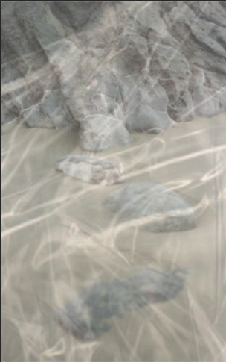

Background Image

I think I’d rather this image black and white over the coloured image. Although I wanted my images to be black and white I thought I’d experiment with a colour image just to see how it would look and I think that the colour just doesn’t stand out enough. I feel as though there needs to be a lot of concentration on the background where as it should just stand out. There’s not enough contrast for me and I think a black and white image would work a lot better.

Overlay Image 1

This is the first overlaid image. Overlay image 1 just doesn’t look right for me. I think that the creases on the plastic are just a bit too bright and stands out too much which takes away from the background image. Another issue that I have is that you can’t tell that it’s plastic which is something I don’t want for my images.
Experimenting cont

Image 2
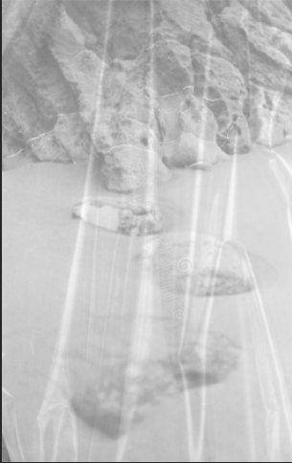
Background Image

I kept the same image for the background but changed the colour to black and white as colour didn’t work for me in the previous image. I think that this looks a lot better as the background stands out a lot more. From here I am going to produce all my photographs in black and white as I think this would work a lot more. Although I like it black and white, a lot more contrast will be needed to make the background stand out even more.

Overlay image 2

This is the second overlay image. I think that this overlay is too shiny and just ruins the whole photograph. I think as a whole the image looks better than the last but this overlay just doesn’t work for me as it still doesn’t look right.

Experimenting cont.

Image 3
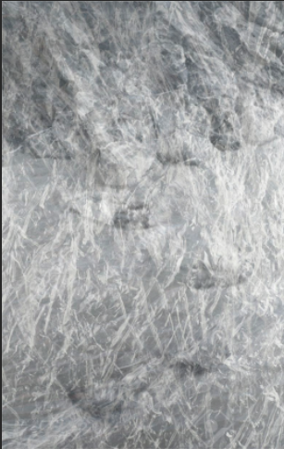
Background Image

I kept the background image the same as the last, still black and white but needs more contrast again.

Overlay Image 3

I do not like this image at all. I thought that this overlay would have been good because the plastic is very crumpled but when put onto the image it just ruins it as you cannot see the background image at all. This overlay is not going to be used.

Experimenting cont.

Image 4
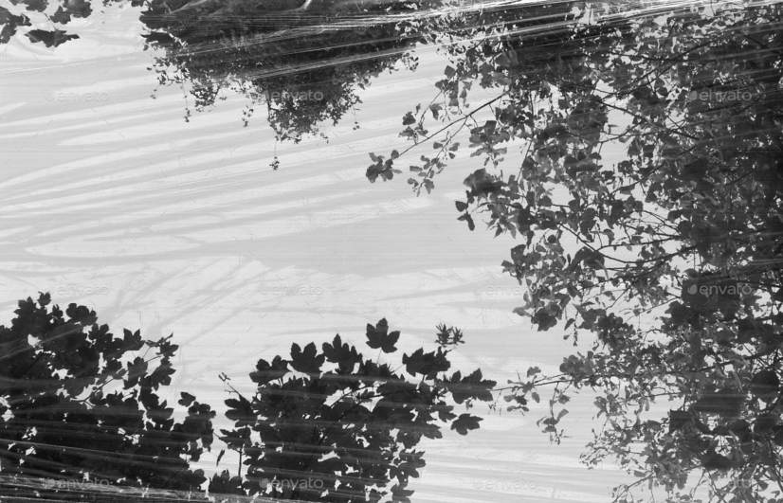

Background Image

This image is different to the last. I wanted to use a different image to see if this method would still work like I wanted it to and it does. I turned the image black and white again and I think this is just right for my photographs. I think the amount of contrast is good and a high contrast is what my images need to show the details in the background images.

Overlay Image 4

This is the fourth overlay image and I cannot say I like how this works. I think that it’s too light and too transparent that it’s hard to make out on the image. I think the one I need has to look more like plastic.

Experimenting cont.

Image 5

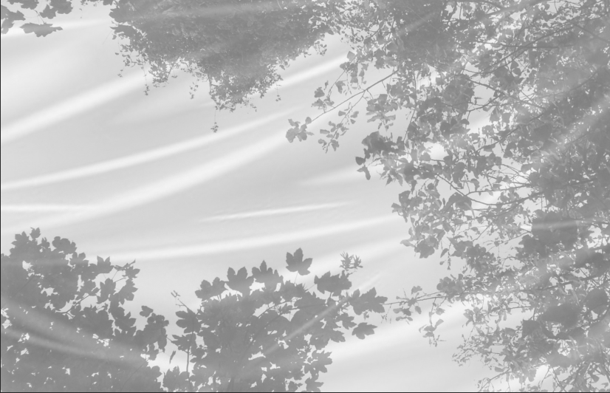

Overlay Image 5

This is the fifth overlay image. This overlay is just too plain and too cloudy for what I want for my images. There’s not enough creases in the image and it’s not obvious that the overlay is plastic. This image just doesn’t look right for me.

Experimenting cont.

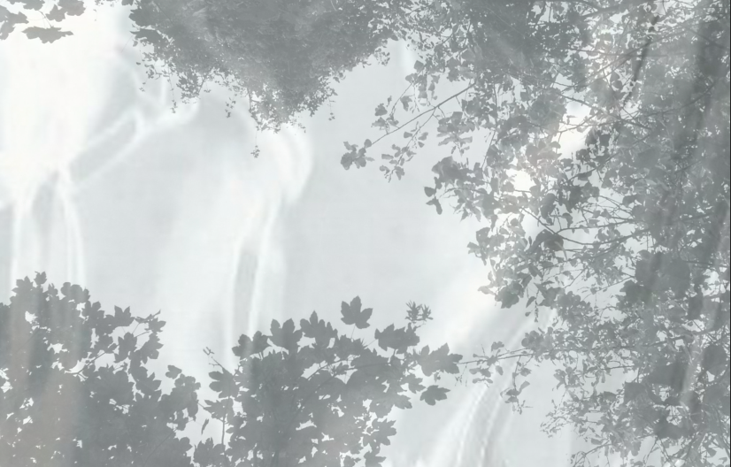
Image 6

Overlay Image 6

This overlay image is the sixth one I’ve experimented with. This one is a lot like the last, it’s too cloudy of an image and it just doesn’t work at all. I don’t think it works for me one bit.

Experimenting cont.

Image 7
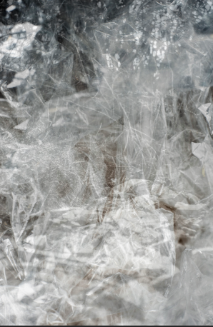

Background Image

I changed the background image again just to see how it would work and kept the black and white theme. I think it needs more contrast but it still work.

Overlay Image 7

I think that this overlay really works for me. I really like the slight colour tone in the plastic wrap. You can see that it is plastic and with a bit of work the background image could stand out a lot more. With more experimenting I think this overlay would really work.

Experimenting cont.

Image 8
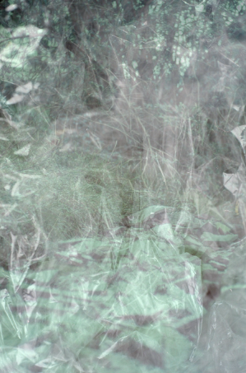

Background Image

I know I wanted to use overlay 7 but I wanted to see again how it would work with a colour image beneath. I think by looking at this that I still want to work with black and white rather than colour as it just works better.

Chosen Overlay Image:

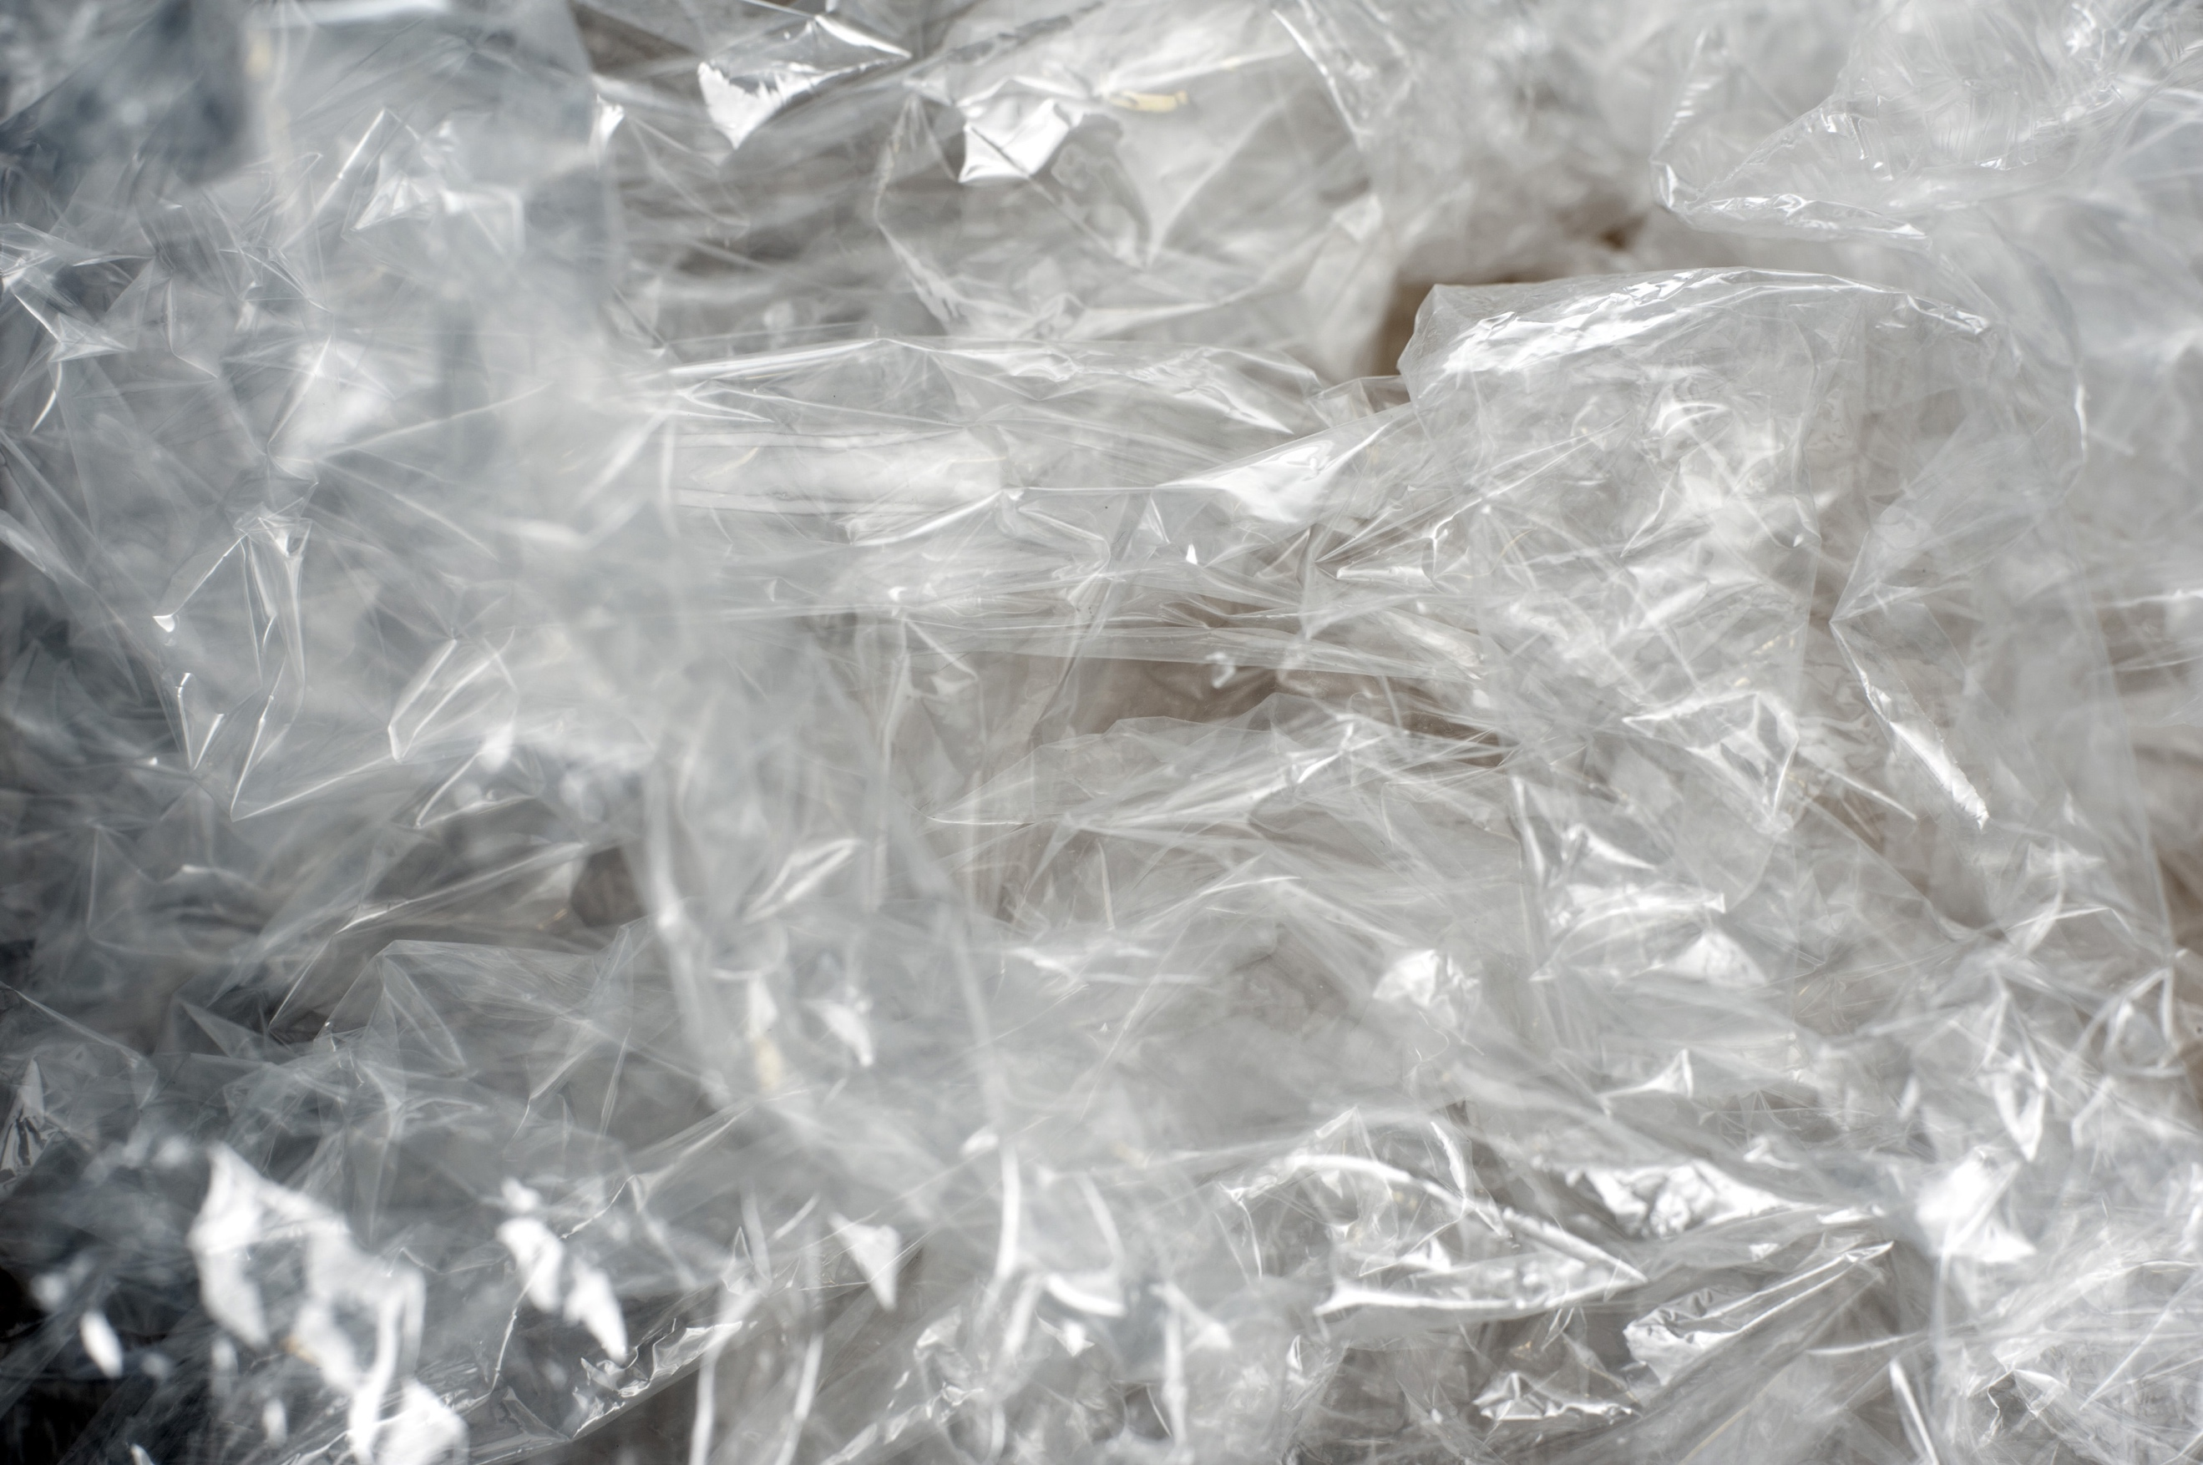
What I need for my images.

Background Image Overlay

• Black and white • Drop opacity (different • High contrast percentage depending on image) • Higher contrast

Social Media

Bio for work:
my body of work delves into plastic pollution and the connection it has to the nature and environment that we see on a daily basis. The global issue of plastic pollution that is created by a man made product wanted me to, with photo manipulation, explores this environmental crisis further.
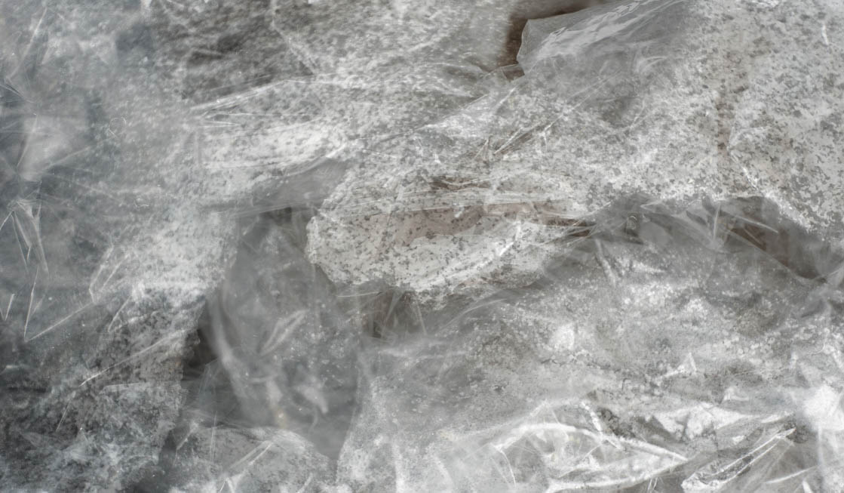
Images for social media:

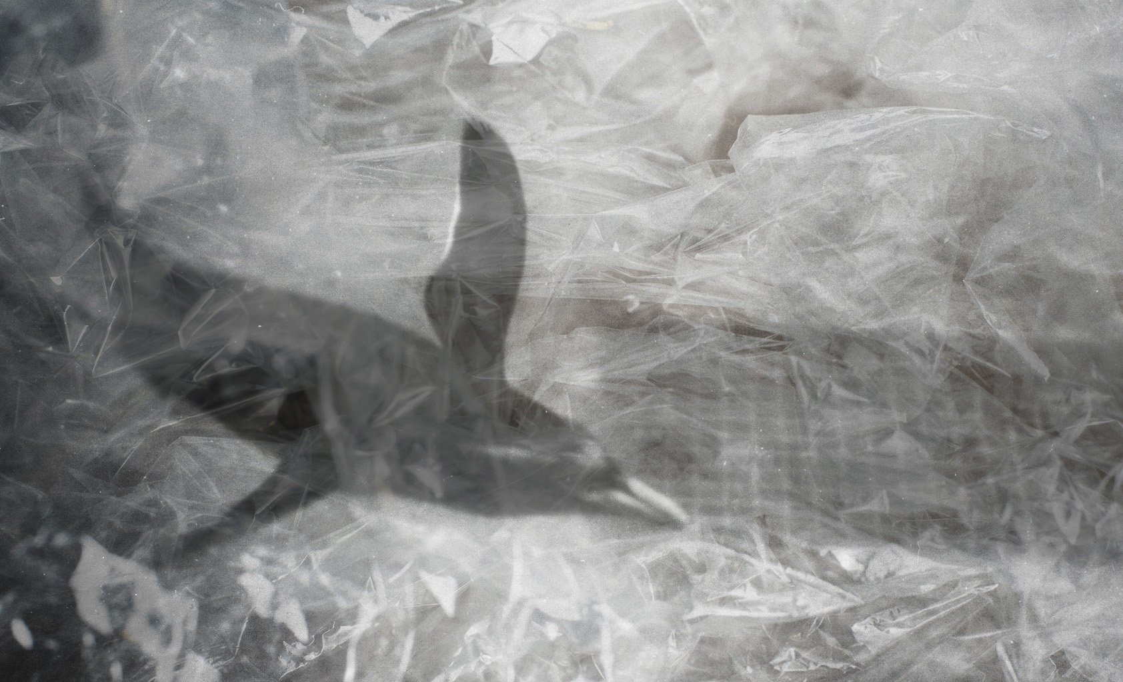
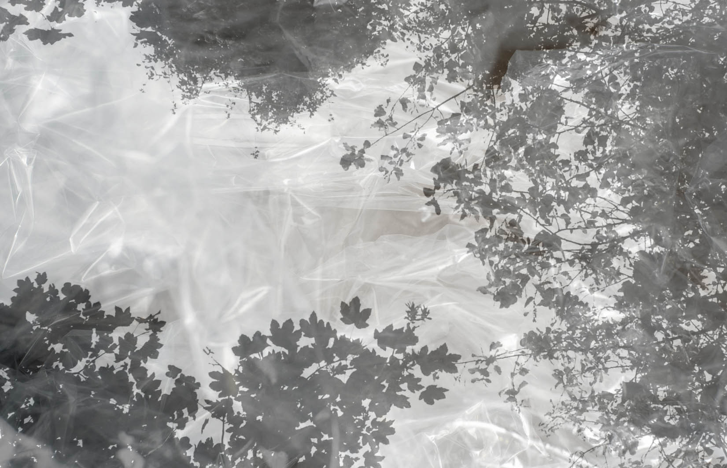
Turning my images black and white

Although my photographs were originally shot on 35mm colour film, for this project I decided that I wanted my images to be black and white.

I wanted black and white images because I needed a very high contrast in my images. This high contrast is vital to me because I want the viewer to still be able to see some of the original image underneath the overlaid image. I don’t think I would have achieved this with colour images.

The process to do this was extremely easy but I thought I would include it in my research anyway.

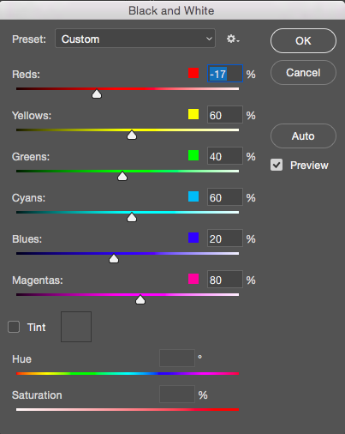
Firstly I opened the image in Photoshop and cleaned up my photo from any marks, scratches, dust etc. This needed to be done due to the images having being shot on film.

After this I went into image -> adjustments -> black and white to change the image. From here I changed some of the colouring in the image.

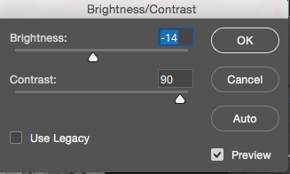
The last step before saving was to change the contrast and brightness if needed. On more or less all of the images I turned the contrast up to 100 so the blacks in the image really stood out.

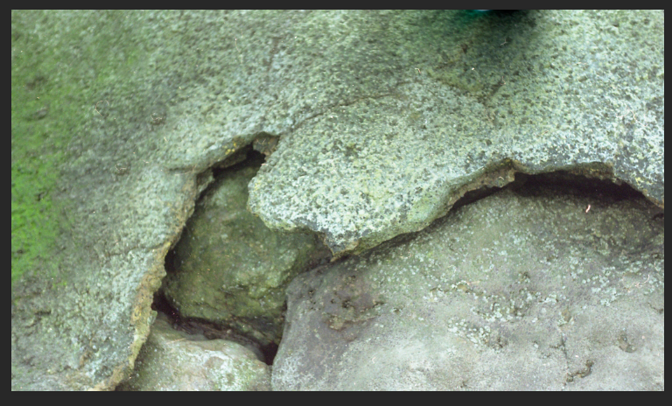
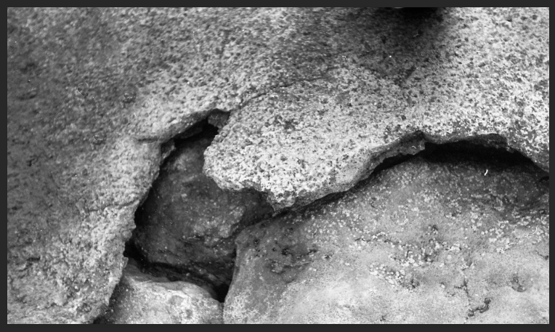

How I created my images

Here is the method that I used to create the images in my experimental work that I will use for my final pieces of work.

- Firstly I opened the background image in Photoshop, this image is my own image that I want to use. Once I had opened this I tidied up the image from any marks that hadn’t already been done.
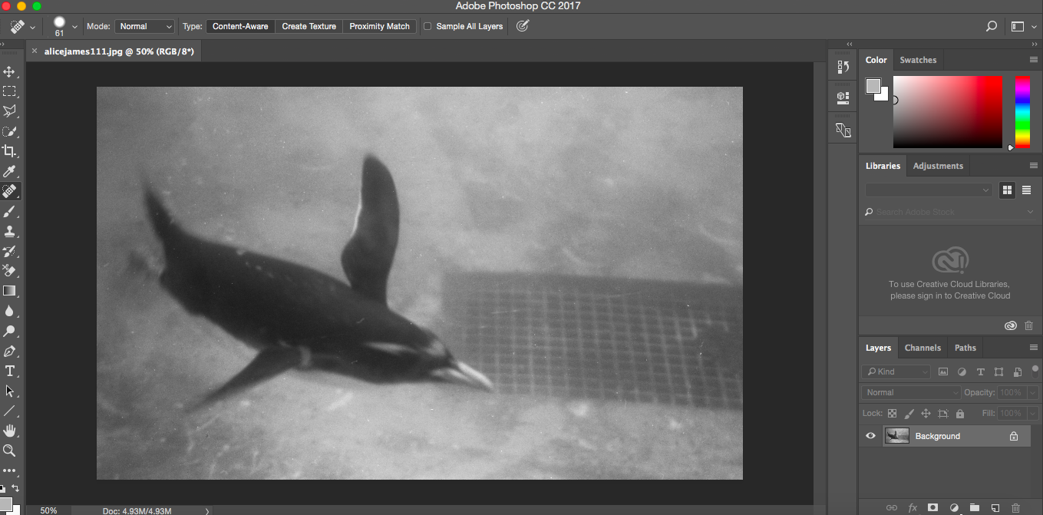

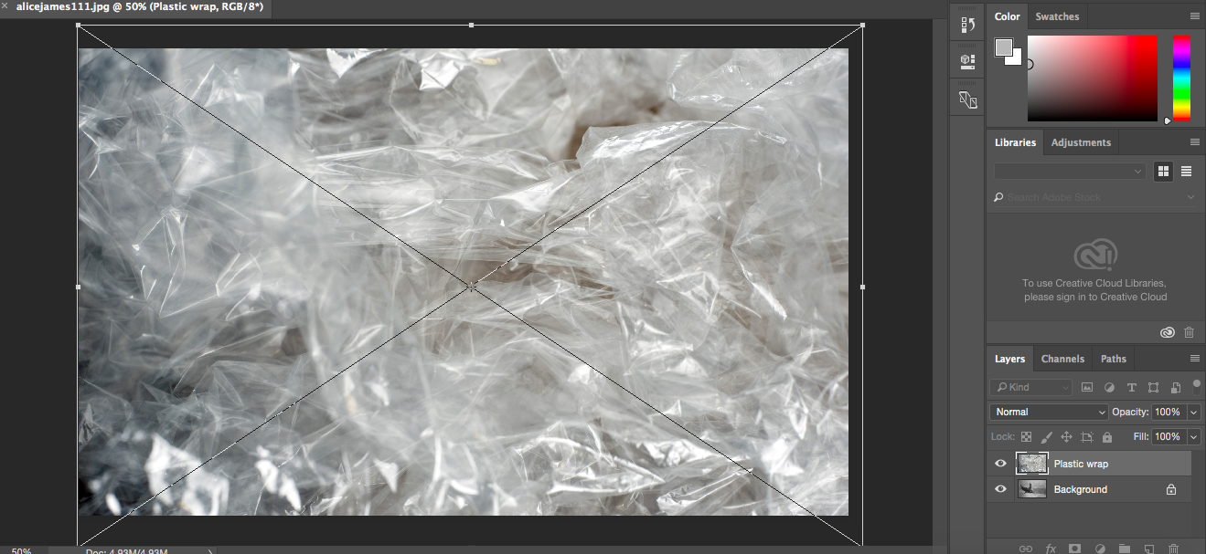
- Secondly, I dragged the chosen photograph of plastic overlay on to the photograph and adjusted the size, or where I wanted it to sit, before placing it.
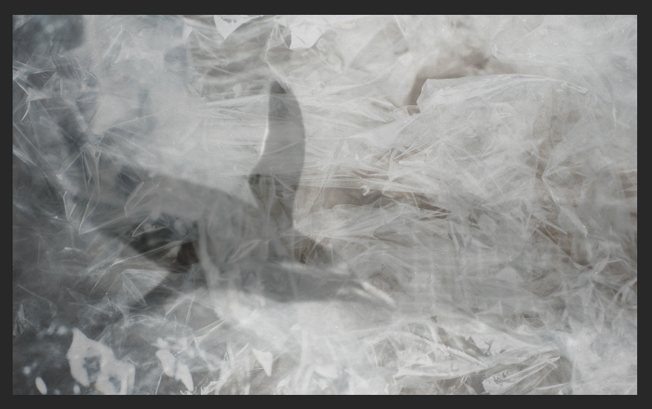
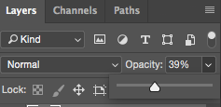
- From here I changed the opacity (which differs for every image) until I had an image see through enough to view the image underneath but still could see the plastic wrap on top.

- Lastly, I changed the contrast of the overlaid image, turning it up to 100 to make the creases darker which gives a better image in my opinion.
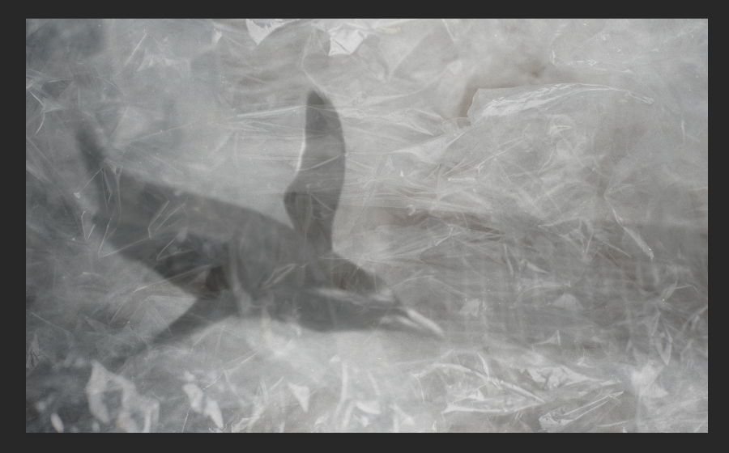
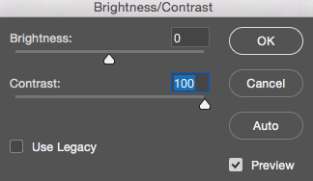

RESEARCH

Mandy Barker

Mandy Barker, an international award-winning photographer, creates work that involves marine plastic debris. From creating this work over the past 10 years, she’s received global recognition. Mandy works with scientists as she aims to raise awareness about plastic pollution within the world’s oceans while also showing the harmful effect on marine life and ultimately ourselves.

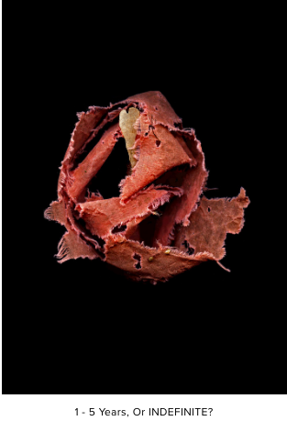
Barker made a significant achievement in 2019 when she took part in the ‘Henderson Island Plastic Pollution Expedition’ where she recorded data and photographed marine plastic pollution that has now become part of the archives which is accessible to other modern day explorers and scholars.

Along with this, Mandy has attained many remarkable achievements, another one of them being awarded The Royal Photographic Society’s Environmental Bursary in 2012. This enabled her to join scientists in a research expedition that travelled from Japan to Hawaii to examine the accumulation of marine plastic debris from the tsunami debris field in the Pacific Ocean.

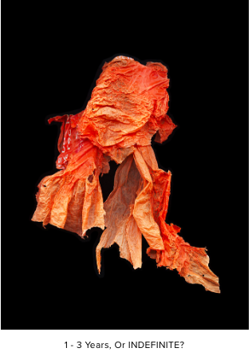
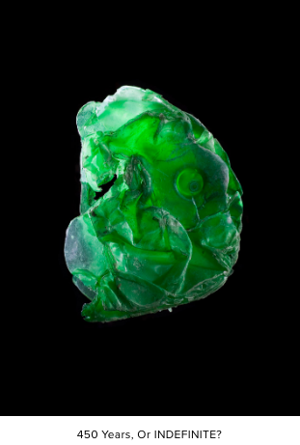
Her website hold a quote from Mandy where she talks about her work that says “The aim of my work is to engage with and simulate an emotional response in the viewer by combining a contradiction between initial aesthetic attraction along with the subsequent message of awareness. The research process is a vital part of my development as the images I make are based on scientific fact, essential to the integrity of my work. The impact of marine plastic is an area I have documented for more than 10 years and am committed to pursuing through visual interpretation, and in collaboration with science I hope it will ultimately lead to positive action in tackling this increasing environmental problem, which is currently a global concern.

Mandy has many amazing projects that she has created over the past 10 years. One project in particular that has stood out to me is her series of work called ‘Indefinite.’

This series of work consists of debris found scattered along the shoreline. In the description of this project, she says how this debris had existed for varying amounts of time in the sea and collectively conveys the story of a marine environment.

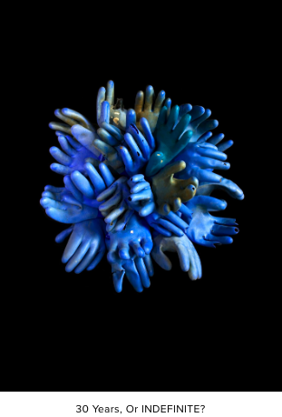
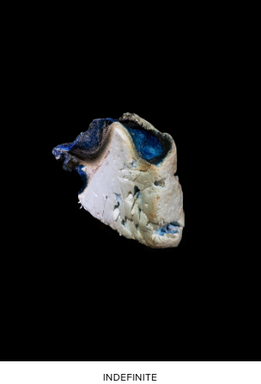
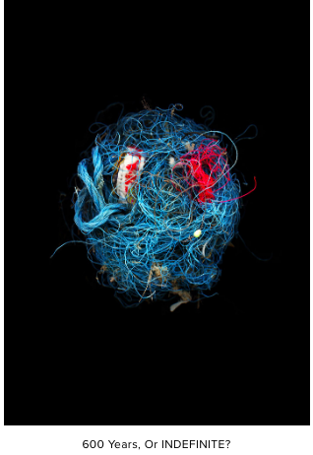
The titles of the individual images are the estimated time for how long it would take for that particular item to degrade in the sea. These objects within the photographs are shown as they were found, unwashed and unaltered. Mandy says on her website that the forms of the objects are similar to sea creatures but are completely from manmade plastics which are the very materials that are fatal to the animals and organisms as the breakdown of these plastics is ultimately going to be ingested by the sea life as micro plastic particles.

