How can we improve pupil involvement through the choice of activities?

Contents

Introduction/ Research context Page 3

Literature Review Page 4

Methodology Page 6

Ethical Considerations Page 9

Lesson study Page 11

Conclusion and Recommendations Page 16

References Page 17

Appendix Page 19

While on Professional Teaching Experience (PTE) I experienced the teaching of ‘Mastery' within the context of a mathematics lesson. Children were all given the same level of problem and the process in which they accessed the problem was given as a choice. Children were encouraged to aim for a challenge and access it in a way they felt was better for them. What choice would help each child was predetermined by the teacher, but they were still encouraged to figure out for themselves and the teacher guided them in this decision. This idea of choice was of great interest to me as my perception of a class was the idea that a teacher constructs the activities with ability in mind and children are told what activities they experience. This idea that children get an opportunity to decide and feel responsible for their learning informed my decision to see how choice has an impact on their learning. The aim of this research is to see can incorporating this choice into a planned lesson improve a child's motivation and involvement in the lesson.

Research Context

The research will take place in schools within the Yr Athrofa partnership. School A is a medium sized inner-city school with around 40% of children eligible for free school meals. School B is a Medium sized school on the outskirts of a small town with 5% of children eligible for free school meals. We will be conducting our research within two Foundation phase classrooms. One is a year 2 the other is a reception class. The year 2 class has 33 children and the reception class has 23 children.
I discussed with my partner on the environment that the research would take place. We found that focussed activities were ability led and children were not given choice in their activities. Throughout my Professional Teaching Experience upon reflection of my lessons, I found that children's engagement was a topic that I found very difficult to fully develop my lessons. We decided as a pair that we would focus on how choice would affect children's engagement within a lesson and see how this would improve our own practice in engaging children.

Literature review

Children's motivation to learn can affect the way they perform in their learning. Behaviour towards learning can be affected in that the motivation of the children is low and the role of motivation within the classroom can be very important. Intrinsic motivation is a form of motivation that comes from within and individuals perform tasks without any external influences (Jordan, et al., 2008). As the children engage in learning through their own want to complete a task they are learning has been shown to improve (Pintrich & Schunk, 1996). Academic intrinsic motivation has been shown to improve attainment as children experience an enjoyment of learning through their own processes and ‘mastery' of learning areas (Gottfried, 2009, p. 1) children who feel they have ‘mastery' of a specific skill or area of learning are motivated. When this is removed with the need for ‘performance' there has been a decline in the academic achievements particularly when children progress through the educational system. (Gottfried, 2009, p. 1)
White (1957 as cited in Pintich & Schunk, 1996, p. 259) explore that competency in activities and within the environment promoted the person's belief of having mastered an area he referred to this as ‘effectance motivation'. I relation to a classroom setting this can be interpreted as children who are competent in their environment are more likely to succeed. However, Harter (1978 as cited in Pintich & Schunk, 1996) found that external influences also have a role on how children master their environment. She identified that how the children are rewarded and how difficult challenges are attribute to their ‘effectance motivation'. She explored the idea that success in mastering an area increases ‘effectance motivation' and intrinsic motivation in the children this can come from external rewards or the social environment. She highlighted that the way these rewards and environments are presented to the child can increase or decrease intrinsic motivation, for example modelling to a child approval of their attempts and show them that independence of adult support is positive a child is likely to have an increased sense of intrinsic motivation that of a child that is shown a need for dependency on adults and is shown disapproval of achieving ‘mastery' in their ability.
Stipek (1993) explored why children in a class vary in their intrinsic motivation when presented with a piece of work. She saw that children who feel they are being challenged were able to intrinsically motivate themselves. However, children who found the task too difficult or too easy were seen to lack the motivation. This idea of a challenge is explored further by Harter and Connell (1984 as cited in Pintrich & Schunk, 1996) as she found most children enjoy the challenge, but their intrinsic motivation is influenced by the challenge set and the relevance to their values. They also explored that children's intrinsic motivation to learn and complete a task can be influenced by five different areas.
‘1. Preference for challenge rather than for easy work
2. Incentive to work to satisfy one's own interest and curiosity rather than working to please the teacher and obtain good grades
3. Independent mastery attempts rather than dependence on the teacher
4. Independent judgment rather than reliance on teacher's judgment
5. Internal criteria for success and failure rather than external criteria' (Pintrich & Schunk, 1996, p .263)

As these areas influence intrinsic motivation Pintrich and Schunk (1996) explore how this has implications for a class and their learning. They believe in theory that these areas can influence children's learning but how can it be established within a school setting. Lepper and Hodell (1989) found that to enhance these areas and improve children's intrinsic motivation the children should be given four ways to access their learning through challenging goals, opportunities to explore discrepancies, be given choice in activities and explore learning through activities that explore fantasy as a stimulus (as cited in Pintrich & Schunk, 1996). These ways to access learning are visible in a classroom, however, they are not always used to their full effect.

The idea of children having control over their activities has influenced us in our research. The research shows that teachers control over what tasks are completed and how they are to be completed can have a negative effect on the children's motivation (Stipek, 1993). Ryan and Grolnick (1986 as cited in Stipek, 1993, p. 108) found that children's ‘competence' and ‘self-worth' were closely associated with the feeling of control they felt within their environment. It is argued that children need this choice but also needs to be monitored in the choice they are given.

Methodology

The methodology used in our research was lesson study which is a form of action research that looks to improve teachers practice. It is ‘professional development practice' for teachers to use within their class to further improve their teaching and the learning of the children (Stepanek et al, 2006, p. 2). Teachers collaboratively plan, observe and analyse lessons to increase their pedagogical knowledge of how best to improve learning within their classroom. (Dudley, 2014). The idea of lesson study is to ‘refine' the teaching that happens in the classroom as Dudley (2014, p. 3) acknowledges that many successful teachers have gone through training to make them as successful as they are, however, they are still ‘largely blind' to the majority of what is happening within the classroom. He also acknowledges how teachers can prioritise while teaching but in doing so miss elements that may need to be improved within their class. Lesson study is used to counteract this as it gives a view of the learning in ‘much sharper detail than is usually possible' (Dudley, 2014 p. 4) as it involves a teacher observing an area to improve.
To conduct a lesson study teachers use data that they collected to identify a focus area to improve. Many areas can be a focus of the lesson study:
- The learning of the class.
- Target pupils needs.
- Area of the curriculum e.g (Science or Creative writing).
- Specific pedagogical approach. (DCFS, 2008)
The focus of the research will inform the teachers on future practice but also can reform the future practices of all teachers. To conduct the lesson study teachers collaboratively plan the lesson to focus on the area they have identified. The lesson will be planned with this focus in mind throughout and will be an area to develop during the teaching of the lesson (DFE, 2009). The planned lesson will consider resources needed for the focus of the lesson and possible outcomes and activity the children will show. (DFE, 2009).
As part of lesson study, three pupils are identified to be observed. In some cases, these are pupils who have been identified as not attaining or ‘underperforming' (DFE, 2009, p. 8). However, it can also be a cross-section of the class with pupils from low, middle or high attainment. Within our research, we chose to focus on three pupils with varying progress in their attainment.
Our sample will consist of six children, three from each class, that had given assent with parental consent. Children were chosen at random from the three ability groups that had provided the consent needed (Lambert, 2012). Once identified these children will be observed in the lesson.
Throughout lesson study, the non-teaching teacher observes the planned lesson and the focus children in their learning. The non-teaching teacher will be a non-participant observer as they will remain ‘detached from those you are observing' (Sharp, 2012, p. 84). As a non-participant observer, the teacher can look at the children's actions and behaviour in more detail and within a classroom setting this is seen as a good practice within a classroom environment (Sharp, 2012).
Throughout the lesson study, the observation will focus on the topic we have identified in our pre-planning as a group. An observation schedule will be used within our observations to identify trends and keep to the focus topic. A semi-structured observation schedule will be used as for the observer it sets a clear guide to the behaviour that is to be observed but also can be adapted for any behaviour that has not been accounted for (Sharp, 2012). The observation will take place within the taught lesson with the non-participant teacher documenting the children's behaviour every two minutes for a detailed observation of the children. By using an observation schedule, we can gather information that can ‘confirm, extend or contradict other data' we have collected and give us a fuller picture of the information acquired (Lambert, 2012, p. 106). However, to objectively observe the situation can be difficult as we are influenced by our own ideas and what we perceive at the time. Also, as we are observing social behaviour we must be aware of how the behaviour is influenced by the presence of the observer and the knowledge that one is being observed (Robson, 2011 as cited in Lambert, 2012).
The observation schedule is a modified version of the Leuven scale (Lavers, n. d ). We have used observation notes in conjunction with this to note any activity that may affect the children's involvement at that time. We have condensed the five areas of the Leuven scale into four as this has made it easier for us to monitor involvement while continuing to collect observational notes.

Once the lesson is taught and observed by the non–teaching teacher the focused children are interviewed. Pupil's voice is important in lesson study as ‘pupils have a vital role to play in working with professionals to improve the quality of their learning experiences' (Welsh Government, 2011, p.5) Collaboratively the lesson study teachers discuss possible questions to ask the focussed children. These are determined before the planned lesson, with a focus on finding out the children's ideas on the lesson and directly analysing the topic identified as a focus. (Dudley, 2012). Interviews are conducted at the end of the lesson so that the children still have some understanding of the lesson they have participated. The interviews are semi-structured as the pre-planned questions are asked to the children but drawing from answers given we can ask additional questions in response to what they say. (Lambert, 2012). As the children have been pre-determined before the lesson is taught the interview will take place as a focused group, where the children answer questions and discuss as a group. Using interviews as a method allows us to ‘explore interviewees' attitudes, opinions and feelings' in more detail and as we are using a semi structured interviewing process we can adapt the questions to highlight the information will be useful for us in our research (Lambert, 2012, p. 105). However, as we are interviewing children the answers may be basic with some tendencies to stray off topic, as an interviewer we must refrain from leading questions and showing the children we agree with the answers given as the children will be influenced by this. The questions themselves need to be understandable to the children but also the answers are given may give answers they think the researcher wants to hear (Lambert, 2012).
The interviews will be audio recorded alongside recorded notes taken during the interview. This is to provide a better overview of the interview that took place as it is not taken from memory and as a pair we are able to discuss the answers given. We will transcribe the children's answers focussing on the data that is relevant to the topic. Any data from the interviews that are not relevant to the research will not be collected. (Lambert, 2012).
Upon completion of the lesson and interview, the teacher reflects on the lesson that has been taught. The reflection is used to gain the perspective of the teacher's thoughts on the lesson and any observations that they highlighted during the lesson. As a pair, we took the ARC model as a base for our reflection as we had used it previously within our teaching practice. The questions we used within our reflection focused on the topic we had chosen as we wanted our data to reflect this.
Once the lesson is taught and observed and the children have been interviewed a discussion takes place between the teachers to revise the data that has been collected. The findings from the first taught lesson are used to inform how the second lesson is taught. The lesson study is repeated with observing teacher of the first lesson teaching and delivering the second lesson. The lesson is reviewed in the same process as the first lesson. The lesson study looks to see that the information gathered in the first lesson informs how the learning is to improve in the second lesson (DFE, 2009). The process is outlined in figure 1:

Figure 1 (Dudley, 2014)

Ethical Considerations

There are many ethical considerations when conducting research with regards to children. Throughout this process, we have considered ethical issues that may arise and understand the right way to conduct this research (Denscome, 2002). We have gained ethical approval for this research by submitting an ethics form to the university ethics committee. As researchers, we must ‘act responsibly in the pursuit of truth' and understand that we bring our own objectivity to situations (Denscome, 2002, p. 177).
My research will take place as part of a normal lesson with all children participating in the lesson. Throughout the observation and teaching, I will adhere to the code of conduct of the school and adhere to the schools safeguarding policy which I have read.
When working with children we must follow article 3 and 12 of the United Nations Convention on the Rights of the Child. We must consider that the research does put the interests of the child at the forefront of the research and they should have a voice to express what happens to them. To give informed consent is a right of the children involved (BERA, 2011). The children involved in our research were informed before the lessons were taught with explanations that had been written with the age of the children in mind. Children were asked to give their assent to participate in the research by showing thumbs up, the teacher was present to sign she had witnessed the assent being given. All children will be included in the lesson and they will be reassured that there will be no adverse consequence to not being involved if they have chosen not to give their assent. Every child during the lesson will be given the same opportunities during the lesson and have access to the content of the lesson.
Consent was obtained from the children's parents beforehand in the form of a consent letter where they were informed that research would be taking place in their child's class (UWTSD, 2017). While collecting our data we must be aware that children who have parental consent may not wish to partake in the research and to adhere to their right to not give their assent. (UWTSD, 2017). If they do not have parental consent they will not be part of the research in any way even though but will still partake in the lesson. Also, if a child has given assent at the beginning of the lesson but seems distressed in any way during the focussed interview or during the lesson, the interview or observation of that child will cease, and it will be explained that there are no adverse consequences to withdrawing.
Confidentiality and anonymity of the participants must be upheld throughout the research process. No data collected should have any data that identifies the participants as the research includes working with children (BERA, 2011).
The focussed interview will take place in the school library with an internal door to the junior corridor and windows with a glass fire door on the external wall. The children will be interviewed by myself and my fellow student. I understand that I am a figure of authority for the children and I will not pressurise them into answering the questions. They will be made aware that they can withdraw at any time.

Lesson Study

The first lesson was taught in School A with my partner teaching and me as the observer. The children in the class were grouped by ability and would partake in 15-minute focussed tasks as part of their learning day. The first planned lesson was a mathematics session focussing on the value of money where the children were given three different activities to choose from (Appendix D). The activities were very different and involved varying ways to access the learning objective. The activities were presented to the whole class at the beginning of the lesson with ability groups accessing the focussed activity at different intervals during the lesson. As an observer, I would observe the children in 15-minute blocks focussing on their engagement during the focussed task. As the three children were of varying ability I would observe one child at a time as they were grouped in ability groups.
The children were presented again with the choices when they began the focused group activities. Each child chose the activity and was supported during the 15- minute activity if needed. Each child during the 15-minute was measured on their engagement every two minutes. Child A was the first to be observed and was part of the lower ability group. Child A was presented with the options and chose Activity 2 (Appendix D) which was the activity that the other children in the group had chosen. This was noted as an interesting development as this was an area we had not considered in our pre-planning of the external influences on the children's extrinsic motivation as they were motivated by these external factors (Jordan, 2008). For the following children, this was an area that I had decided to note as an observation as this was something we would need to consider for our next lesson.
Child A was very dependent on the teacher and was only engaged in the activity for the moments when an interaction with the teacher took place (Appendix C). Throughout the duration of the observation only once was Child A fully absorbed in the activity and this was with the full support of the teacher. This supports Harter's idea that children will only experience increased intrinsic motivation when shown the opportunity to be independent of an adult (1978, as cited in Pintich & Schunk 1996). Child A was very dependent on the adult I felt this influenced the data we collected as the child was not engaged as we had predicted by being given the choice of activity. While interviewed Child A did not give an answer (Appendix A) when questioned on why they had chosen this activity and through my observation it was clear that Child A had not made an informed decision of their choice. The external influences had overtaken the child's ability to make the informed choice. My partner agreed as upon reflection of her lesson she felt that the teacher's influence had an impact on the choices taken by the children (Appendix E).
During the second observed session Child B chose Activity 1. The child was presented the activity before the other children arrived to start the activity. The teacher was more enthusiastic about Activity 2 and the child was obviously swayed to pick the activity that was presented with the most enthusiasm. Child B mirrored the teacher's enthusiasm when picking his choice. However, unlike Child A, Child B remained fully engaged throughout the activity and maintained a level 4 of involvement during the activity. Child B had been modeled approval of an activity and in the process had an increased motivation when on activity (Harter, 1978 as cited in Pintich & Schunk, 1996). During the interview Child B was very vocal on how they had enjoyed the activity as ‘it was fun' (Appendix A), this supported the level of involvement that Child B experienced during the lesson. Although Child B's intrinsic motivation had been triggered by the teacher his motivation to carry on the activity was an enjoyment of the activity he had chosen. This, in turn, supports Ryan and Grolnick (1986, as cited in Stipek, 1993, p. 108) idea of children's competence stems from a feeling of control and as Child B felt in control of the activity he had chosen his competence increased.
When introduced to the activities at the beginning of the lesson children were then assigned areas to work within. Child C although not part of the first focussed group started the activity along his classmates as he had decided he wanted to participate in the activities as he was able to choose. He showed an excitement on having the choice and was fully engaged in the activity for the majority of the morning session. He also remained fully engaged when he sought to help other children with their activity by forms of encouragement and praise. Child C displayed activity that supports Harter and Connell idea that Child C's intrinsic motivation was influenced by the child's want to complete the activity for their own interest (1984, as cited in Pintrich & Schunk, 1996). This was also supported by the self-affirmation Child C displayed whilst completing the activity which kept his motivation to complete the activity high. When interviewed Child C supported this by expressing that they had worked better as they were able to choose the activity (Appendix A).
Upon reflection of the first lesson, we found that a teacher's influence on a child can take the focus off the choice of the child. It was interesting to see how child C had been intrinsically motivated by the choice alone. We had wanted to see the full impact of this in the next lesson and see if the circumstances that made Child C engage fully would influence the children in the follow-up lesson. We were aware to fully explore the influence of a child's intrinsic motivation on their want to complete a task we would need to ensure that teachers' influences were minimum and to avoid discrepancies in our research. To avoid this the children will be presented with the activities at the beginning of the lesson and asked what colour sheet they would choose. This was to ensure that the teacher's influence did not affect their choice, so we could measure their engagement from the choice alone.

In our post-lesson discussion, we discussed the differences between the activities given to the children and that they were very practical activities. Upon reflection of the activities, we had wanted to explore if the choice would influence their intrinsic motivation with less practical activities. As Child A and Child C in the first observed lesson chose the same activity which of the three activities given was very practical and involved enhancing the child's ability to be creative. Whereas the other activities although practical were more skills based. As we were focusing on choice as a form to increase intrinsic motivation our choices given would need to counteract other areas that motivate intrinsic motivation as we needed to understand did choice effect this and to improve practice would we include it within future lessons. Upon reflection, we would need to consider how Lepper and Hodell's (1989) challenge, curiosity, choice, and fantasy play a role in influencing intrinsic motivation. When creating the activities that the children would complete the follow-up lesson we would need to create activities that only focused on choice and remove the other influences.

The second lesson was whole class teaching with the children picking their activity at the beginning of the lesson. The children were explained what each activity involved before they chose. To make sure I as the teacher did not influence their choice I remained enthusiastic about all the different activities and only referred to them by colour when asking the children for their choice. However, it was noted by my partner and within my reflection of the lesson that as I had colour coded the sheets and proceeded to ask who would like the ‘blue' sheet first, many of the children chose blue (Appendix D). My partner had decided to ask the children had the colour influence their choice with many replying that ‘blue' was their favorite colour. This was interesting to note as all the focussed children in the second lesson chose the blue activity.

Once the children had chosen their activity my partner observed the children for 15 minutes to remain the same as the first lesson. As the children chose the same activities discussion between the children was more obvious as they were comparing and helping each other. Child A maintained level 3 and 4 throughout the session (Appendix F) even when presented with an error in their work. Child A carried on and corrected their mistake. Upon reflection of this many children had misunderstood the instruction given this I attributed to the explanations given at the beginning of the lesson. As identified in my reflection I found that the need for the children to be on task quickly meant that the explanations were rushed as I did not want the children to choose the last activity I had explained. Child A and Child B had both started the activity incorrect however this did not affect their involvement during the session (Appendix F). This supports Ryan and Grolnick (1986, as cited in Stipek, 1993) idea that children feeling of control can influence their feelings towards a task. Both children acknowledged their mistakes and carried on with the activity with the same amount of involvement as they displayed a high level of intrinsic motivation that had stemmed from their initial choice and external influences did not diminish their motivation.

When interviewed Child A and B showed a high level of excitement towards being given a choice of activity which was reflected in the lesson as well. Both children showed an excitement during the class lesson and afterwards. When Child A was questioned why they had chosen that activity they said they had found it difficult to choose as they wanted to complete all the activities presented. Child A explained that they enjoyed the choice as they were able to choose something they were able to do (Appendix B). Child A was intrinsically motivated by the level of challenge that was presented to them and they felt they were performing at a better level with a task that they identified at their level. The choice has allowed Child A to make an informed decision on the how they felt they could achieve. However, when asked if they would like more choice in their lessons, Child A answer of ‘sometimes yes, sometimes no' which was interesting as they were fully engaged throughout when presented with a choice. It could be argued that the child has a pre-determination of intrinsic motivation and is used to ‘mastering' their learning whereas the choice had no influence on the engagement that was displayed.

Child C showed an enthusiasm to engage with the activity at the beginning but as Child C was of a low attaining group they were dependant on adult support and as the lesson progressed their engagement was attributed to the help they received with their activity. When interviewed they were not able to justify why they had made that choice. As most of the class had chosen the blue activity it can be argued that Child C was influenced by this and had chosen like their peers. However, Child C did recognise they had worked better with being given a choice (Appendix B).

Upon reflection of the lesson, I found my classroom management could have attributed to the children losing motivation as the lesson progressed. The children were sat in mixed ability tables and had chosen different activities it was very difficult to monitor. As they had chosen different activities they were less peer support and their work was independent (Appendix G).
The finding of our research indicates that choice on its own cannot influence the child's intrinsic motivation, but it can attribute to it. Throughout our lesson study, we found that many other influences can work in conjunction with giving children choice. Our finding supports the literature that intrinsic motivation is influenced by many areas as identified by Harter and Connell (1984, as cited in Pintrich & Schunk, 1996) where the five areas identified were influencing the learning in the classroom. Only one child in the six we observed displayed intrinsic motivation from the choice alone. Although the choice had initiated the motivation for the learners, other factors could be attributed to their persistence to be involved or lack of motivation in some instances.
In reflection of the data, it can be concluded that the environment has a big impact on the learning and the children are needed to be encouraged to feel they can ‘master' their own learning as they will be able to access their learning at a higher level. This supports Harter's (1978 as cited in Pintich & Schunk 1996) idea that external influences let the child react to their learning. This reaction to their learning can impact on the child's involvement and motivation to learn.

Conclusions

In conclusion of our research we found to progress within our own practice we would need to explore our influence as a teacher in allowing children choice and feeling independent to make informed decisions.

Recommendations

References
BERA, B. E. R. A., 2011. Ethical Guidelines For Educational Research. [Online]
Available at: file:///C:/Users/User/Desktop/2018%20BERA%20ethical%20guidelines.pdf
[Accessed 12 April 2018].
Denscome, M., 2002. Ground Rules for Good Research a 10 point guide for social researchers. Berkshire : Open University Press.
Dudley, P., 2014. Lesson Study: A Study Handbook. [Online]
Available at: www.Lessonstudy.co.uk
[Accessed 10 April 2018].
Education, D. O., 2009. Improving subject pedagogy through Lesson Study Handbook for leading teachers in Mathematics and English. [Online]
Available at: file:///C:/Users/User/Desktop/2018%20Improving%20subject%20pedagogy%20through%20Lesson%20Study.pdf
[Accessed 10 April 2018].
Families, D. f. C. S. a., 2008. Improving practice and progression through Lesson Study. [Online]
Available at: file:///C:/Users/User/AppData/Local/Packages/Microsoft.MicrosoftEdge_8wekyb3d8bbwe/TempState/Downloads/pri_slt_cpd_imp_prac_prog.pdf
[Accessed 10 April 2018].
Gottfried, A. M. G. G. A. &. O. P., 2009. A latent curve model of parental motivational pracitces and developmental decline in math and science academic intrinsic motivation. Journal of Education Psychology, 101(3), pp. 729 - 739.
Government, W., 2011. Pupil Participation – Good Practice Guide. [Online]
Available at: file:///C:/Users/User/AppData/Local/Packages/Microsoft.MicrosoftEdge_8wekyb3d8bbwe/TempState/Downloads/GoodPracticeGuide.pdf
[Accessed 10 April 2018 ].
Jordan, A., Carlile, O. & Stack, A., 2008. Approaches to LEarning A Guide for Teachers. Berkshire: Open University Press.
Lambert, M., 2012. A Beginner's Guide to Doing Your Education Research Project. London: SAGE.
Lavers, F., n. d . Leuven Scale. [Online]
Available at: https://scilt.org.uk/Portals/24/Library/resources/hmi/Leuven_Scale.pdf
[Accessed 10 April 2018].
Pintrich, P. & Schunk, D., 1996. Motivation in Education Theory, Research, and Applications. New Jersey: Prentice-Hall.
Sharp, J., 2012. Success with your Education Reserach Project. 2nd ed. London: SAGE.
Stepanek, J. ,. A. G. L. M. ,. M. M. a. M. M., 2006. Leading Lesson Study : A Practical Guide for Teachers and Facilitators. Thousand Oaks: SAGE Publications.
Stipek, D. J., 1993. Motivation To Learn From Theory to Practice. 2nd ed. Massachusetts: Allyn and Bacon.
UWTSD, U. W. T. S. D., 2017. Research Ethics & Integrity Code of Practice. [Online]
Available at: http://www.uwtsd.ac.uk/media/uwtsd-website/content-assets/documents/research/research-ethics-integrity-code-practice.pdf
[Accessed 12 April 2018].

Appendix A

Lesson One Focussed Interview Transcript

Child A

T: Did you enjoy the lesson?

C: Yes

T: Why?

C: (shrugged, don’t know)
T: What do you think about being able to choose your activities?
C: It is fun.
T: Why did you choose this activity?
C: No answer
T: What made you make that choice?
C: For fun
T: Do you think you worked better today because you chose the task?
C: Yes
T: Why do you think that?
C: No answer
T: Would you like more choice in all your lessons?
C: Yes
T: Why do you think that?
C: No answer
T: How do you think I could make this lesson better?
C: Don’t know

Child B

T: Did you enjoy the lesson?

C: Yes, it was fun.

T: Why?

C: Because it was like doing magic
T: What do you think about being able to choose your activities?
C: I liked it.
T: Why did you choose this activity?
C: It was like doing magic
T: What made you make that choice?
C: Don’t know
T: Do you think you worked better today because you chose the task?
C: Yes
T: Why do you think that?
C: It was my task.
T: Would you like more choice in all your lessons?
C: Yes
T: Why do you think that?
C: I like to choose.
T: How do you think I could make this lesson better?
C: Do more magic.

Child C

T: Did you enjoy the lesson?

C: Yes

T: Why?

C: I liked choosing
T: What do you think about being able to choose your activities?
C: It was fun
T: Why did you choose this activity?
C: It looks good
T: What made you make that choice?
C: I wanted to try it
T: Do you think you worked better today because you chose the task?
C: Yes
T: Why do you think that?
C: Don’t know
T: Would you like more choice in all your lessons?
C: Yes
T: Why do you think that?
C: It’s fun and it’s what I want to do
T: How do you think I could make this lesson better?
C: Things we can choose.

Appendix B
Lesson Two Focussed Interview Transcript.
Child A

T: Did you enjoy the lesson?

C: Yes

T: Why?

C: I like writing and I like maths.
T: What do you think about being able to choose your activities?
C: It was hard.
T: Why did you choose this activity?
C: I couldn’t choose, I wanted to do all of them.
T: What made you make that choice?
C: I like colouring and writing
T: Do you think you worked better today because you chose the task?
C: Yes, Idid got explanations as well.
T: Why do you think that?
C: We can choose something that we can actually do
T: Would you like more choice in all your lessons?
C: Sometimes yes, sometimes not.
T: Why do you think that?
C: It was difficult to choose.
T: How do you think I could make this lesson better?
C: I liked it as it was, more writing, more writing.

Child B

T: Did you enjoy the lesson?

C: Yes

T: Why?

C: Because we get to colour in the squares.
T: What do you think about being able to choose your activities?
C: No, it was easy
T: Why did you choose this activity?
C: I chose the blue because I wanted to colour in the squares.
T: What made you make that choice?
C: I wanted to colour in.
T: Do you think you worked better today because you chose the task?
C: Yes
T: Why do you think that?
C: I liked doing the colouring
T: Would you like more choice in all your lessons?
C: Yes
T: Why do you think that?
C: I liked it.
T: How do you think I could make this lesson better?
C: More colouring in.

Child C

T: Did you enjoy the lesson?

C: No

T: Why?

C: It was a little hard.
T: What do you think about being able to choose your activities?
C: Not sure
T: Why did you choose this activity?
C: I like blue.
T: What made you make that choice?
C: (shrugged)
T: Do you think you worked better today because you chose the task?
C: Yes
T: Why do you think that?
C: because it looked a bit easy.
T: Would you like more choice in all your lessons?
C: Sometimes.
T: Why do you think that?
C: Don’t know
T: How do you think I could make this lesson better?
C: Don’t know

Appendix C
Lesson One Observations
Tracking observations Date:27.03.18
No of Adults present : 5
No. of children: 24
Time | Description Of Activity | Grouping | Level of Involvement
9.30  9.32  9.34  9.36  9.38  9.40  9.42 | Child : A - Cutting activity – picked the one in front of them.  Sorting out resources they need.  Needed direction but fully concentrating.  After every step asks teacher for what to do next.  Distracted by the other group.  Watching other children.  Keeps stopping to ask the teacher.  Teacher talking to another child. | SG  SG  SG  SG  SG  SG  SG | 3  4  3  2  1  2  1
9.55  9.57  9.59  10.01  10.03  10.05 | Child: B – Rubbing activity – Picked the one he saw another child was doing.  Straight into activity.  Looking for different coins – asking teacher to check.  Fully engaged in activity.  Choosing different coins.  Looking at other children for support.  Fully engaged. | SG  SG  SG  SG  SG  SG | 4  4  4  4  4  4
10.09  10.11  10.13  10.15  10.17  10.19 | Child: C – Cutting activity – had already made up his mind.  Straight into activity.  Running around to get what they need.  Sat fully concentrating – shouting out self-praise.  Looking around but still cutting.  Talking to another child explaining what to do.  Talking while colouring. | SG  SG  SG  SG  SG  SG | 4  3  4  3  4  3
Grouping
WG – Whole Group
SG – Small Group
P – Pair
I – Individual
Level of Involvement
1 – No activity
2 frequently distracted
3- Fairly continuous activity
4 – absorbed in activity

Appendix D
Lesson One Lesson Plan

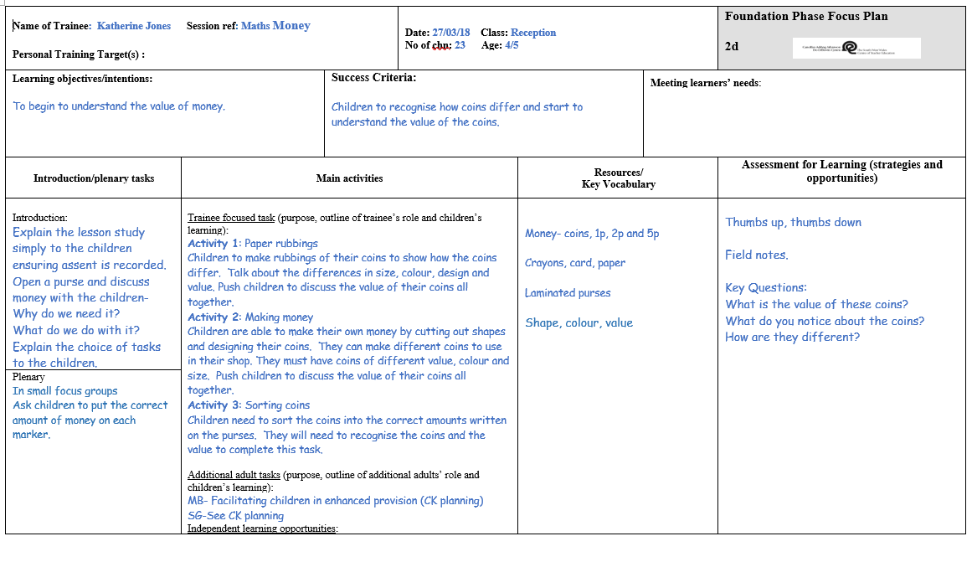

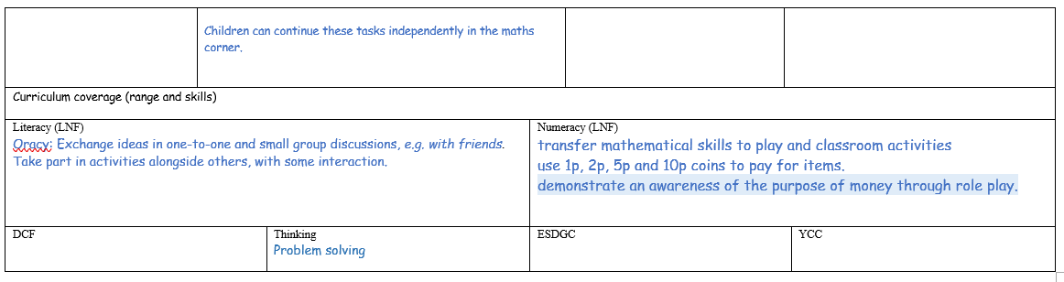

Appendix E
Lesson One Reflection

Model Beirniad Wedi Adfyfyrio (BWA)

Assisted Reflective Conclusions (ARC) Model

Dyddiad/Date:

Digwyddiad critigol (Ffocws)/Critical incident (focus):
Profiad/ Experience

Teimladau/  Feelings  Beth yw eich teimladau ynghylch y profiad?  “What are your feelings regarding the experience?” | This lesson went very well. All children were engaged in the tasks set. The class were excited and enjoyed the session.
Cofio a Deall/  Remember and Understand  “Can you list any factors that influenced the learning /experience?”  “What were the elements of the learning experience that were disappointing?” | The teachers input when initially explaining the tasks influenced the children’s decisions when choosing their task. The children would often choose the last task the teacher mentioned. Also, the children were more likely to choose the task closest to them on the table. They would also choose a task because their friend had chosen the same one.
Gwerthuso a dadansoddi/  Evaluate and analyse  What was the relationship between the resources prepared and the effectiveness of the learning?  “What will you keep the same to ensure effective teaching and learning in the next lesson?”  How did the children react to being given a choice of activities? | The resources had a huge impact on the learning. Children often opted for the more creative task when given the choice.  Keep the short introduction, to ensure the children understand the activities. Give examples of your expectations.  Very well, all children were engaged and motivated throughout the session. One child in particular stayed on the maths table for the whole session despite his group finishing within the first half of the session.
Casgliadau a chamau gweithredu/  Conclusions and actions  How will you use your reflection today to move forward?  What is the most important piece of feedback gained?  Beth ydych yn mynd i’w wneud nesaf?  “What will you do next?” | I am aware that as a teacher I have influenced the class more than I realised, although not intentionally, my tone of voice and how I spoke about a certain task had a huge impact on the choices that were made and the learning that took place.  For the next research lesson I have identified that there is a need to name the tasks A,B,C or 1,2,3 rather than referring to them as coin making or coin sorting etc, as unintentionally I have influenced the children by talking about the individual tasks.  Introduce the activities and explain the different tasks for the children to choose. Name each activity A,B,C so not to influence the children’s decision with informative or exciting names.  Organise resources –perhaps using boxes for children to choose, this will keep the tables more organised and less chaotic.
Y profiad newydd / Transformed experience

Appendix F
Lesson Two Observation Schedule
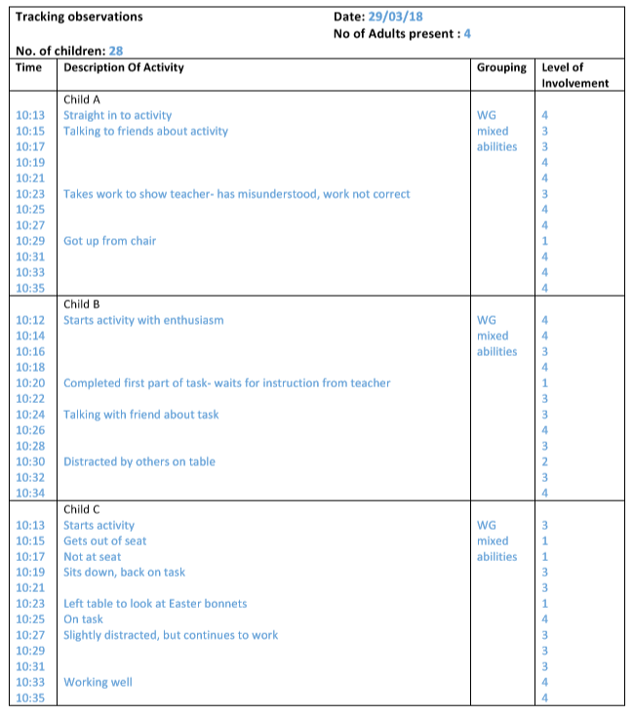
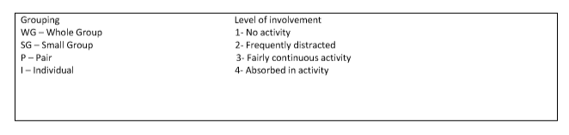
Appendix D
Appendix G
Lesson Two Reflection

Model Beirniad Wedi Adfyfyrio (BWA)

Assisted Reflective Conclusions (ARC) Model

Dyddiad/Date: 29.03.18

Digwyddiad critigol (Ffocws)/Critical incident (focus): Research
Profiad/ Experience

Teimladau/  Feelings  Beth yw eich teimladau ynghylch y profiad?  “What are your feelings regarding the experience?” | I felt the lesson did not go very well. The children were engaged but I didn’t explain the activities very well and because of this children kept changing their minds at the beginning of the lesson.
Cofio a Deall/  Remember and Understand  “Can you list any factors that influenced the learning /experience?”  How did the use of resources impact the learning?  “What were the elements of the learning experience that were disappointing?” | We had decided before the lesson that I would try and not influence the children in their choice. The children were supposed to pick from three choices that I would lay on the table. But as I had moved the children to their seats before they made their choice. I called out the colour of the first choice and majority of the class got up to choose that colour. I had influenced the children’s choice.  As I had colour coded the resources (blue, red and yellow). Most of the children chose the blue activity. We later found out in the focused interview that this was the children’s favorite colour.  As there were three different activities, my attention was torn between the different children and this meant that some had started the activity wrong. This meant that the children’s motivation wasn’t as high as I had wanted.
Gwerthuso a dadansoddi/  Evaluate and analyse  What was the relationship between the resources prepared and the effectiveness of the learning?  “What will you keep the same to ensure effective teaching and learning in the next lesson?”  How did the children react to being given a choice of activities? | As I had colour coded the resources the children were able to see clearly what they were picking. The children had individual sheets to complete. This however didn’t give the children an opportunity to collaborate with their peers as they some were sat next to someone that were completing a different activity.  Getting the children on activity as soon as possible.  The children in the class were excited to be given a choice. They were all motivated at the start and all the children rushed to start their activity. Throughout the lesson most of the children were engaged.
Casgliadau a chamau gweithredu/  Conclusions and actions  How will you use your reflection today to move forward?  What is the most important piece of feedback gained?  Beth ydych yn mynd i’w wneud nesaf?  “What will you do next?” | Although the children were more engaged in the lesson. I feel that if they had collaborated in their learning they would have learnt more effectively. (Vygotsky).  That the teachers influence in children’s choices is very apparent in the lesson. I felt that the way it is presented activities can also enthuse a class. The activity that was the most popular I felt that I had engaged the children more when explaining it. This as a step forward for my teaching is to enthuse the children in all activities and lessons so they are more engaged.  Giving choice in the activity worked for some of the children but not all. As the children had three very different activities and my time was split three ways. I will still look to include choice in my lesson but vary the activities slightly as to not confuse the children in their learning.
Y profiad newydd / Transformed experience

Appendix H
Lesson Two Lesson Plan



