Student Name: [Andreea Gama]  Student ID: 2219781  Module Title:[Foreign Languages & Cultural Awareness  Module Code:[BMIH5003]  Lecturer:[Heidi Prosser  Date: 09/02/2024 | 
ASSIGNMENT 1: PORTFOLIO
(4 Components)

Component 1: Professional Reflection (500 words +/- 10%)

Weighting: 25%
Post-COVID owing to labour shortage it has become extremely difficult for hotels to find adequate staff let alone multi-lingual or bi-lingual staff (Huang et al., 2020). The hotel industry took the most unintended hit of COVID-19. New and amateur staff members like me were failing to handle the pressure of customers returning at a higher standard.
While performing my responsibilities in my placement hotel in Premiere as a receptionist I encountered a challenging scenario. My first language is English and I barely understand Chinese. On a fine day, I received a call from a Chinese-speaking customer who wanted to reserve a room. Usually, I get assistance from my supervisor if any confusion or situation arises but at that time my supervisor was not around. The guest wanted to book one room with a single-bed facility but due to the language barrier, I could not understand the dialect and booked a room with only one bed. After a long tiring day when the guest wanted to check in the misunderstanding came to light. Though the confusion created a fuss but Chinese being their usual self responded with grace. There were no rooms available according to their need and as a result, the guest had to look for other options. My sincere apology could not do any good to them as the reputation and professionalism of the hotel crew were questioned.
In the service sector, satisfying a guest is mandatory to maintain the goodwill of an establishment. The guest must feel comfortable and valued. One mistake of mine changed the idea of the guest regarding hotel management and service. Losing a potential client because of language inefficiency is an opportunity for competitors (Manhas and Tukamushaba, 2015). After the loss of reputation, my supervisor penalized me for my mistakes as the reputation of the hotel was a stake because of me. As a part of my profession, it is extremely important to have great command over languages and the ability to handle an unwanted situation with professionalism.
Language and culture are closely knitted and in this increasingly globalized world being in the hospitality sector, I must enhance my language proficiency and problem-solving skills (Christiansen, Branch and Karmowska, 2020). In order to avoid such mistakes I must develop my knowledge and understanding regarding consumer psychology and learn more about diverse perspectives of cultures. This will broaden my understanding of human psychology and behaviour and assist me to excel in my career further. Taking courses on prevalent language-speaking platforms is mandatory to broaden my speaking capacity. In the hospitality sector being proficient in language is mandatory. English, Spanish, and Mandarin are the most spoken languages in the world (Vukovic-Vojnovic and Nicin, 2012). Gaining adeptness in universal languages will broaden my career horizon.
And apart from that professional training platforms may help to develop interpersonal skills which will teach me to understand consumer psychology better. Also, the help of technology can be taken to solve a situation in crucial times (Nam et al., 2021). The virtual call centre with the help of artificial Intelligence can assist in giving the correct answer to client's queries.

References
Christiansen, B., Branch, J.D. and Karmowska, J. (2020) Cultural Factors and Performance in 21st Century Businesses. Hershey : IGI Global.
Huang, A., Makridis, C., Baker, M., Medeiros, M. and Guo, Z. (2020) Understanding the impact of COVID-19 intervention policies on the hospitality labor market. International Journal of Hospitality Management, 91, p.102660.
Manhas, P.S. and Tukamushaba, E.K. (2015) Understanding service experience and its impact on brand image in hospitality sector. International Journal of Hospitality Management, 45, pp.77-87.
Nam, K., Dutt, C.S., Chathoth, P., Daghfous, A. and Khan, M.S. (2021) The adoption of artificial intelligence and robotics in the hotel industry: prospects and challenges. Electronic Markets, 31, pp.553-574.
Vukovic-Vojnovic, D. and Nicin, M. (2012) English as a global language in the tourism industry: A case study. The English of tourism, pp.3-18.

Component 2: Training Plan (500 words +/- 10%)

Weighting: 25%

Identified cultural misunderstanding (in a few words) :
Receptionist’s lack of language proficiency and cultural awarness create cultural misunderstanding.
Training plan (Why/What//Who/Where/When):
The staff training plan for Premier Inn Bridgend (M4, J35) hotel is developed here based on the reflection of component 1. The objectives of the training plan are to enhance employees’ ability to understand consumer psychology, to make staff realize the importance of language competence and to develop a sense of cultural awareness among employees. The training plan includes comprehensive discussion, mock situations, presentation and feedback (Ushakov et al., 2020). The duration of the training will be 6 hours.
The reason why the training is developed should be communicated clearly to let the staff of Premiere Inn Bridgend understand the importance of language proficiency and how to tackle unexpected situations. With such training facts and pieces of evidence should be presented to ensure authenticity and employee inclusion is mandatory to make the session an interactive one.
Consumer Psychology will ensure that employees can deepen and expand their knowledge of consumer behaviour in the tourism and hospitality sectors (Swarbrooke and Horner, 2007. Based on varied cultural orientations people may react in different ways. Employees of hotels must track clients' expectations and handle situations that are not so pleasing. For this purpose, employees should be sensitive and responsive towards clients needs. Unhappy clients may create a negative impact on the hotel service which may lead to long-term consequences (Jaykumar, Fukey and Balasubramanian, 2014).
In the hospitality industry communication is the key. Every employee should develop their proficiency in language and communication. Without the sense of proper communication ambiguity may arise accompanied by unprofessionalism may ruin the hotel’s goodwill. Guidelines and training should be provided on how employees should groom themselves to maintain a well-dignified persona with the skill of communicational efficacy (Kharouf et al., 2019). The topic of discussion must not skip the following aspects of importance of verbal and non-verbal communication, how to avoid assumptions, and the importance of maintaining professional behavior. Mock situations can be used to develop employees' practical outlook towards intercultural communication.
Employees from the hospitality industry must develop cultural awareness which will assist them in creating a positive impression towards their clients (Abramson and Moran, 2018). Beliefs, customs, norms, traditions etc. vary from one culture to another and what is expected in one culture can be bewildering to another. The similarities and differences that cultures have should be roughly outlined. Employees of the respective hotel must have a good understanding of mostly visited clients' culture, origin, history, etiquette, mode of behaviour etc. (McGraw-Hilhristiansen, Branch and Karmowska, 2020).
The employee training program should ensure employee engagement in all aspects and their feedback should be received to gauge the effectuality of the plan (Ushakov et al., 2020). Employees must not feel intimidated or apprehensive. They should take the training as a foundation for withstanding future professional challenges.
The outcomes of the plan should be considered and conclude how hospitality and hotel management employees should look forward to their jobs and responsibilities. Ideas should be given on how to manage challenging situations, and suggestions should be given from professionals. The feedback from the employees will be taken to find the gap between employee expectations and the training program deliverables.

References
Abramson, N.R. and Moran, R. (2018) Managing Cultural Differences: Global Leadership for the 21st Century. 10th Ed. Abingdon: Routledge.
Jaykumar, V., Fukey, L.N. and Balasubramanian, K. (2014) Hotel managers perspective of managerial competency among graduating students of hotel management programme. Procedia-Social and Behavioral Sciences, 144, pp.328-342.
Kharouf, H., Sekhon, H., Fazal-e-Hasan, S.M., Hickman, E. and Mortimer, G. (2019) The role of effective communication and trustworthiness in determining guests’ loyalty. Journal of Hospitality Marketing & Management, 28(2), pp.240-262.
McGraw-Hilhristiansen, B., Branch, J.D. and Karmowska, J. (2020) Cultural Factors and Performance in 21st Century Businesses. Hershey : IGI Global.
Swarbrooke, J. and Horner, S. (2007) Consumer behaviour in tourism. Routledge.
Ushakov, R.N., Kryukova, E.M., Khetagurova, V.S., Mukhomorova, I.V. and Zelenov, V.V. (2020) Efficiency of hotel management. Training of specialists in hotel industry field. Journal of Environmental Management & Tourism, 11(2 (42)), pp.388-395.

Component 3: Student Self-Reflection (500 words +/- 10%)

Weighting: 25%
Having cultural awareness is mandatory for people involved in the tourism and hospitality sector. Without having proper knowledge, ideas and training job responsibilities may remain unfulfilled (Oriade et al., 2021). By implementing the Driscoll Model of Reflection, I will demonstrate the importance of cultural awareness via experience-based learning.
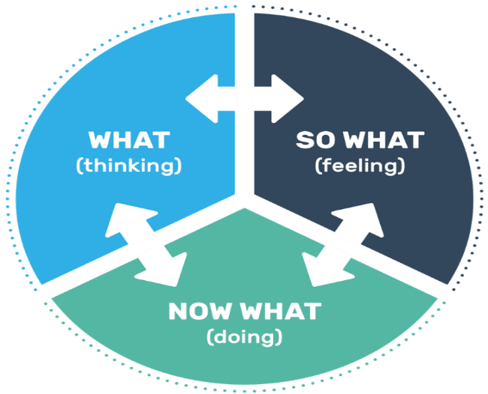
Figure 1: Driscoll Model of Reflection (Gladd, 2020)
Step 1: What
As a student what I learnt is we as a society need to expose ourselves and get in touch with the culture around us to better comprehend the situation. Without having a global understanding regarding culture, a hospitality sector employee can not flourish in his or her career (Hofstede, Hofstede and Minkov, 2010). How people from one culture react may be exaggerated for people of another. Chinese people are generally calm and poised and believe in subtlety, and collectivism on the other side British people are bold and prefer individualism (Wenxin and Yue, 2022). The goal is to learn the similarities and differences between people around the globe. With cultural awareness and assertiveness, every person’s role and responsibility become well-defined and easier to perform. In my scenario, my inability to understand Mandarin language created a miscommunication which later led to harm the reputation of the hotel. The experience was not positive, but I understood how challenging the hospitality sector can be.
Step 2: So What?
As a fresher and non-speaker of Chinese the respective guest has been graceful towards the situation. Even though I made an apology, yet it did not aid their hardship. The guests responded with dignity and looked out for other options. These left an overwhelming impact on me regarding Chinese culture and how respectful they are towards others. Mistakes are not regarded as turpitude in their culture. As an individual, the client represented a whole society. This is what circumscribes as cultural sensitivity one being respectful towards others. But for my professional outlook, I made a huge mistake in reservation and my supervisor penalized me. This part of my experience also aided in my career to take work more responsibly and reliably. As an employee everyone should develop such sense. Effective communication is a prerequisite for developing long-term communication with clients and leaving less scope for misjudgement (Abramson and Moran, 2018).
Step 3: Now What?
The experience has changed my view regarding a respective culture and the importance of cultural awareness became more significant to me. My professional commitment remained unchecked because of my lack of proficiency in language. For people in the hospitality industry language barrier can be a great challenge (Deresky, 2017). The negative outcomes could have been prevented if as an undergrad student, I learnt the basics of popular languages around the world. To better prepare myself I should have got into a training program where my conceptual ideas could meet practical examples and gain a better idea of world culture and heritage. If I am exposed to similar situations, I am well aware of the complexities of professional responsibilities and may handle the situation with more maturity.
This is why experiences are important. Negative or positive both enhances the horizon of one’s adaptability.

References
Abramson, N.R. and Moran, R. (2018) Managing Cultural Differences: Global Leadership for the 21st Century. 10th Ed. Abingdon: Routledge.
Deresky, H. (2017) International Management: Managing Across Borders and Cultures: Text and Cases. 9th Ed. Harlow: Pearson Education Ltd.
Gladd, J. (2020) John Driscoll’s ‘What?’ Cycle of Reflection. [online] idaho.pressbooks.pub. Available at: https://idaho.pressbooks.pub/write/chapter/john-driscolls-what-cycle-of-reflection/ [Accessed 3 Feb. 2024].
Hofstede, G., Hofstede, G.J. and Minkov, M. (2010) Cultures and organizations: software of the mind. 3rd Ed. New York: McGraw-Hill.
Oriade, A., Osinaike, A., Aduhene, K. and Wang, Y. (2021) Sustainability awareness, management practices and organisational culture in hotels: Evidence from developing countries. International Journal of Hospitality Management, 92, p.102699.
Wenxin, Z. and Yue, W. (2022) An Analysis on Sino-UK Cultural Differences in Education from the Perspective of Hofstede’s Cultural Dimensions Theory (A Case Study of Are Our Kids Tough Enough?). Journal on Education, 4(2), pp.373-384.

Component 4: Training Presentation (6 Slides)

Weighting: 25%
[Introduction slide, e.g. assignment title, student name/ID, module title/code, date, hotel logo]
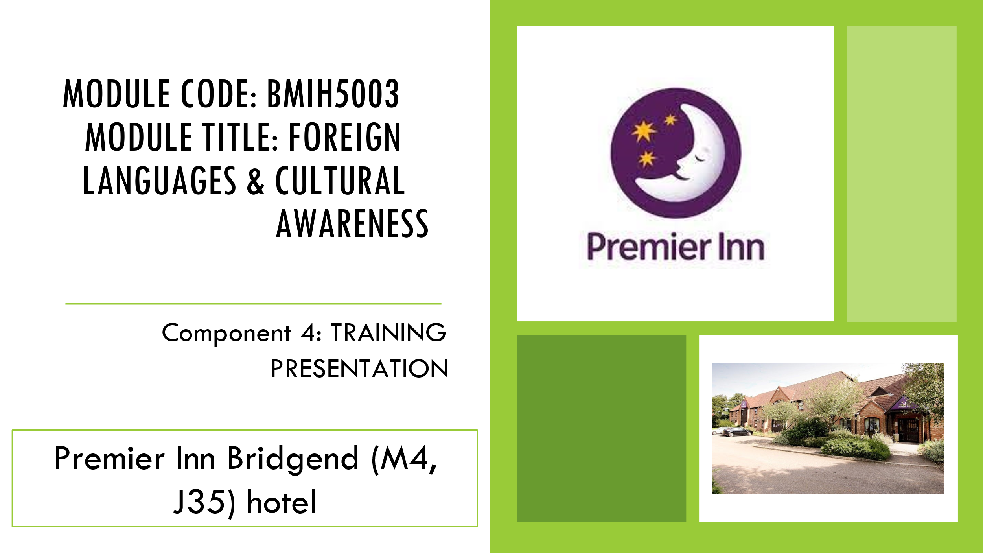
[Content Slide 1]
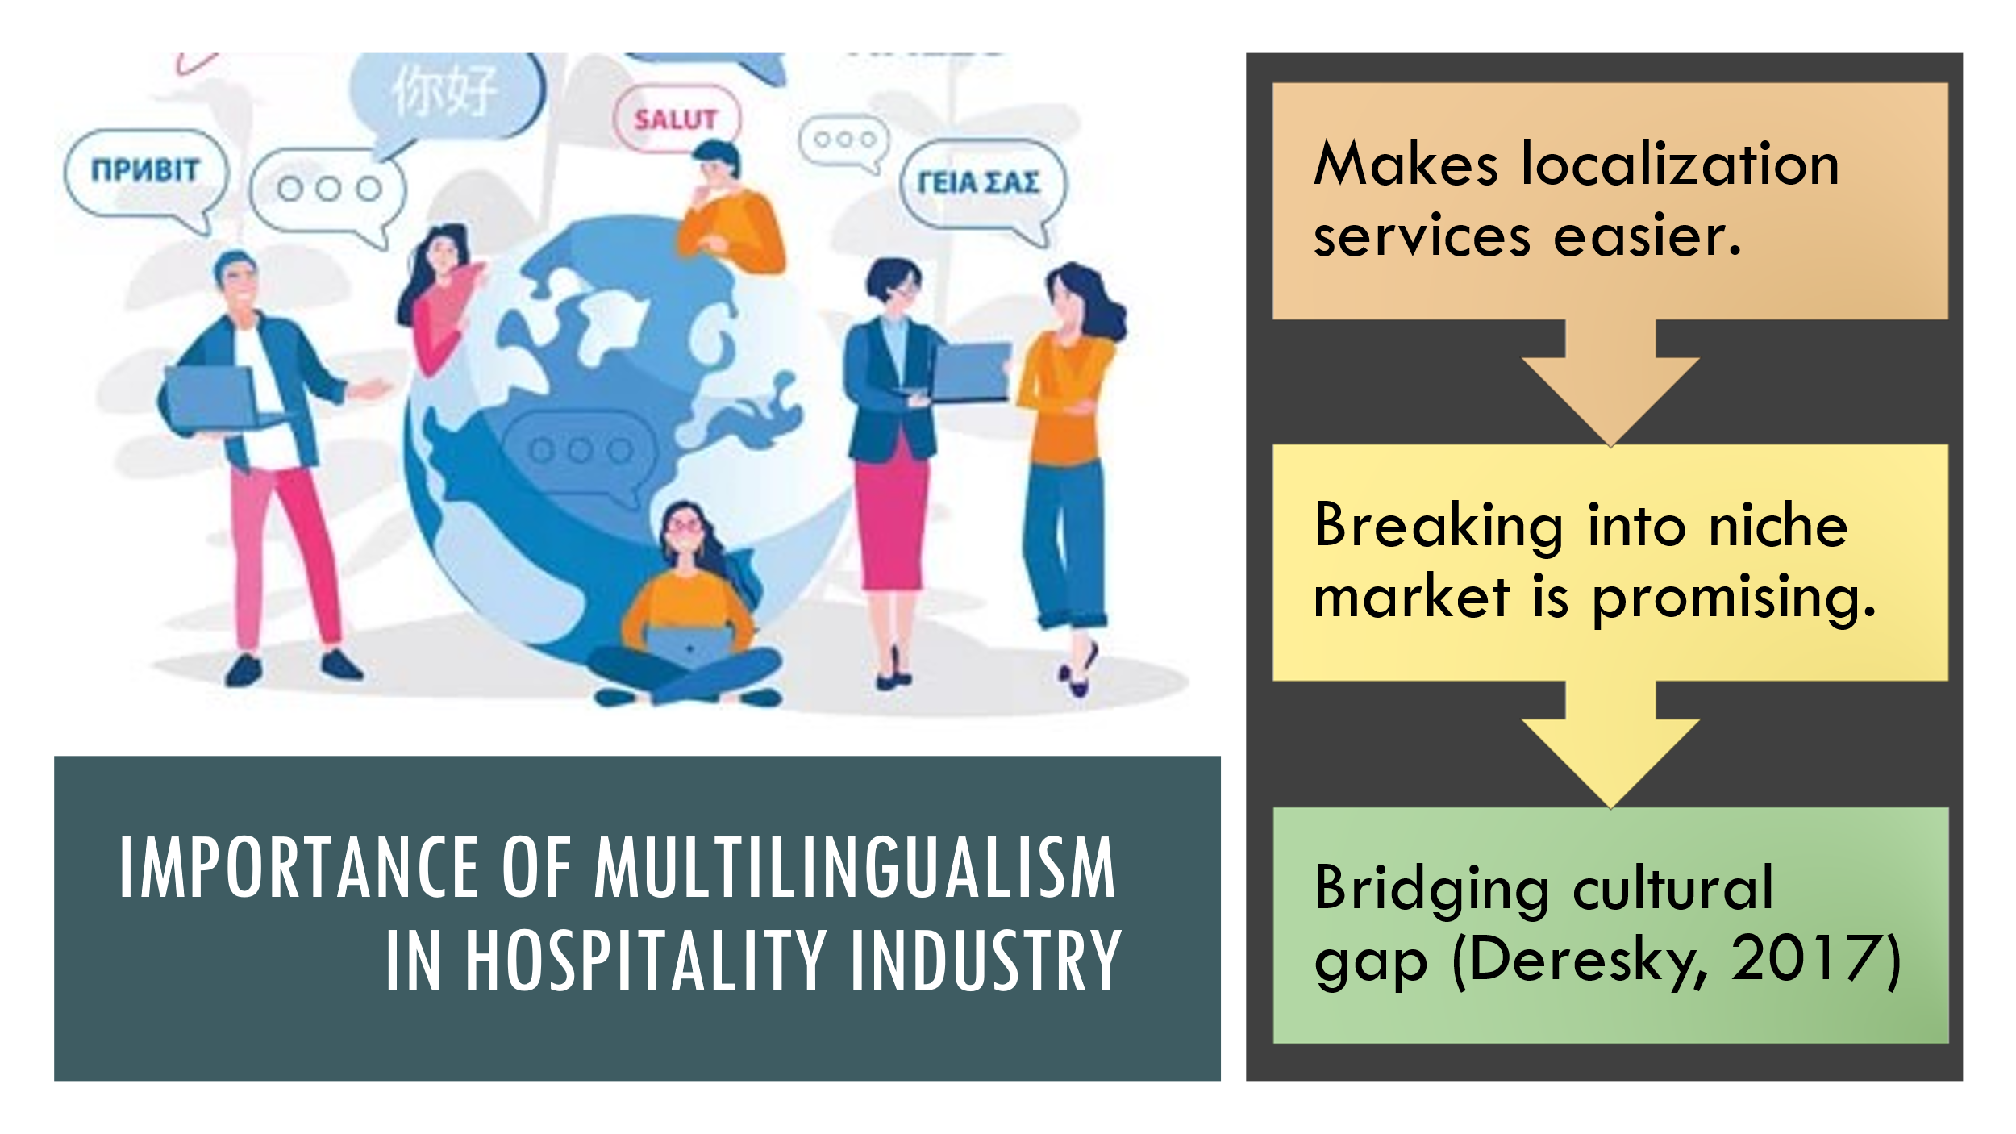
The demand for multilingual employees in the hospitality sector is increasing. The employees of Premier Inn Bridgend can reduce such cultural gaps by being sensitive and considerate while communicating is mandatory. Dealing with international client using their native language can make communication more meaningful.

[Content Slide 2]
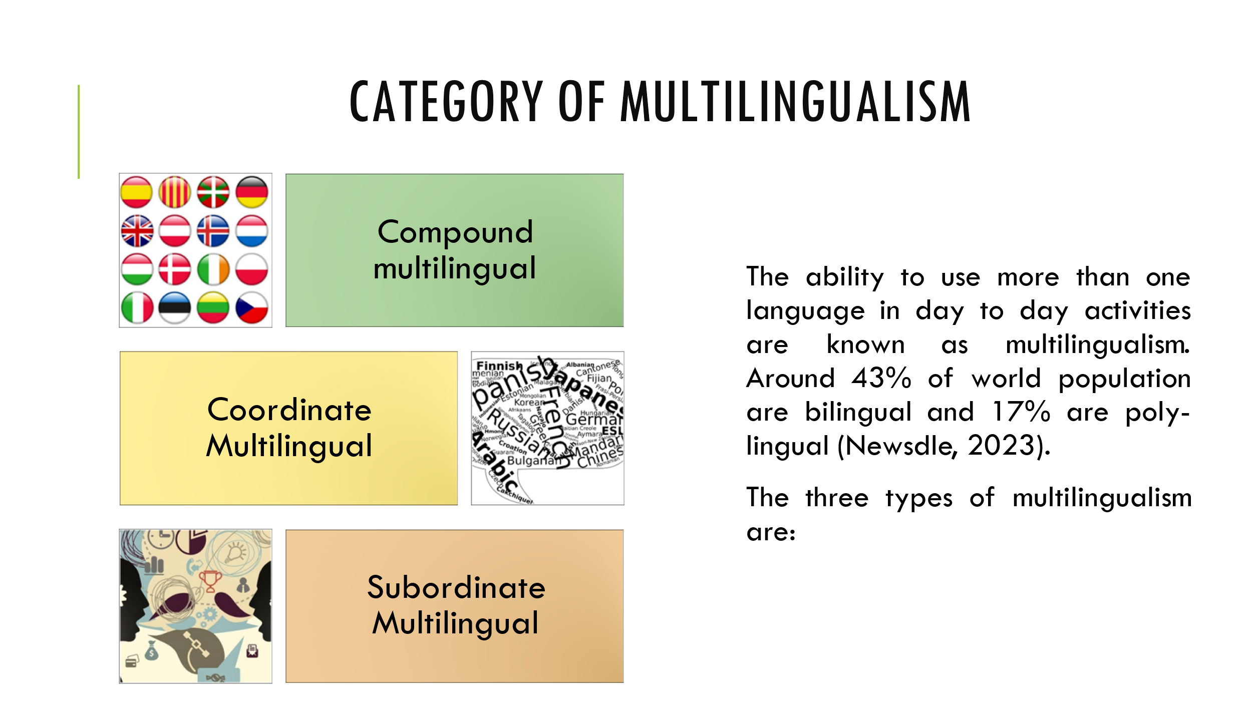
The employees of Premier Inn Bridgend should adopt these three types of multilingualism-
Compound multilingual is the one where a person grows up in a family where mother and father speak different languages, coordinate multilingual is where a person speaks one language at home and uses another language in the office and subordinate multilingual is where a user learns a language by filtering it through another language.

[Content Slide 3]
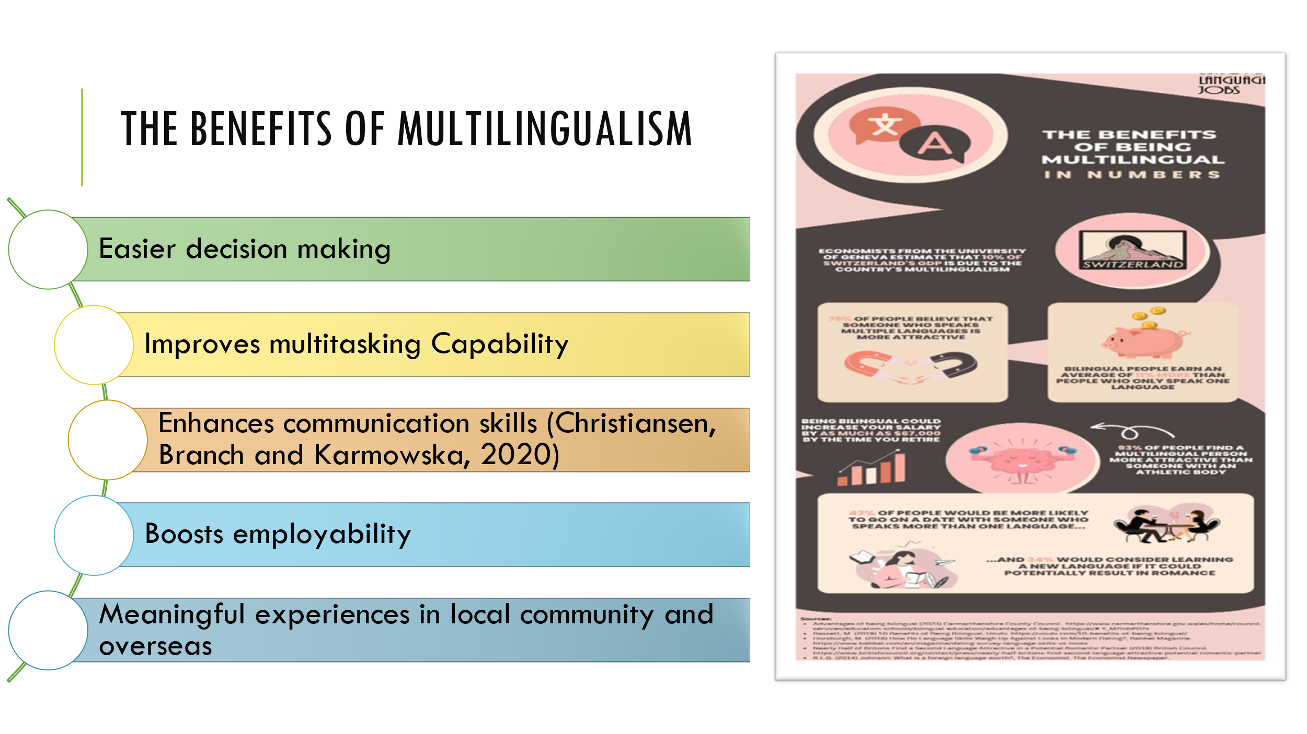
Being multilingual makes decision-making for employees easier and more compatible. The ability to multitask is enhanced in people who can speak more than one language. In the hospitality sector, multilingualism can also bring heightened sensitivity towards cultural awareness. Intercultural communication is improved through speaking different languages with clients. For employability, multilingualism opens various opportunities. According to The Economist, being bilingual could increase staffs salary by 2% over 40 years.

[Content Slide 4]
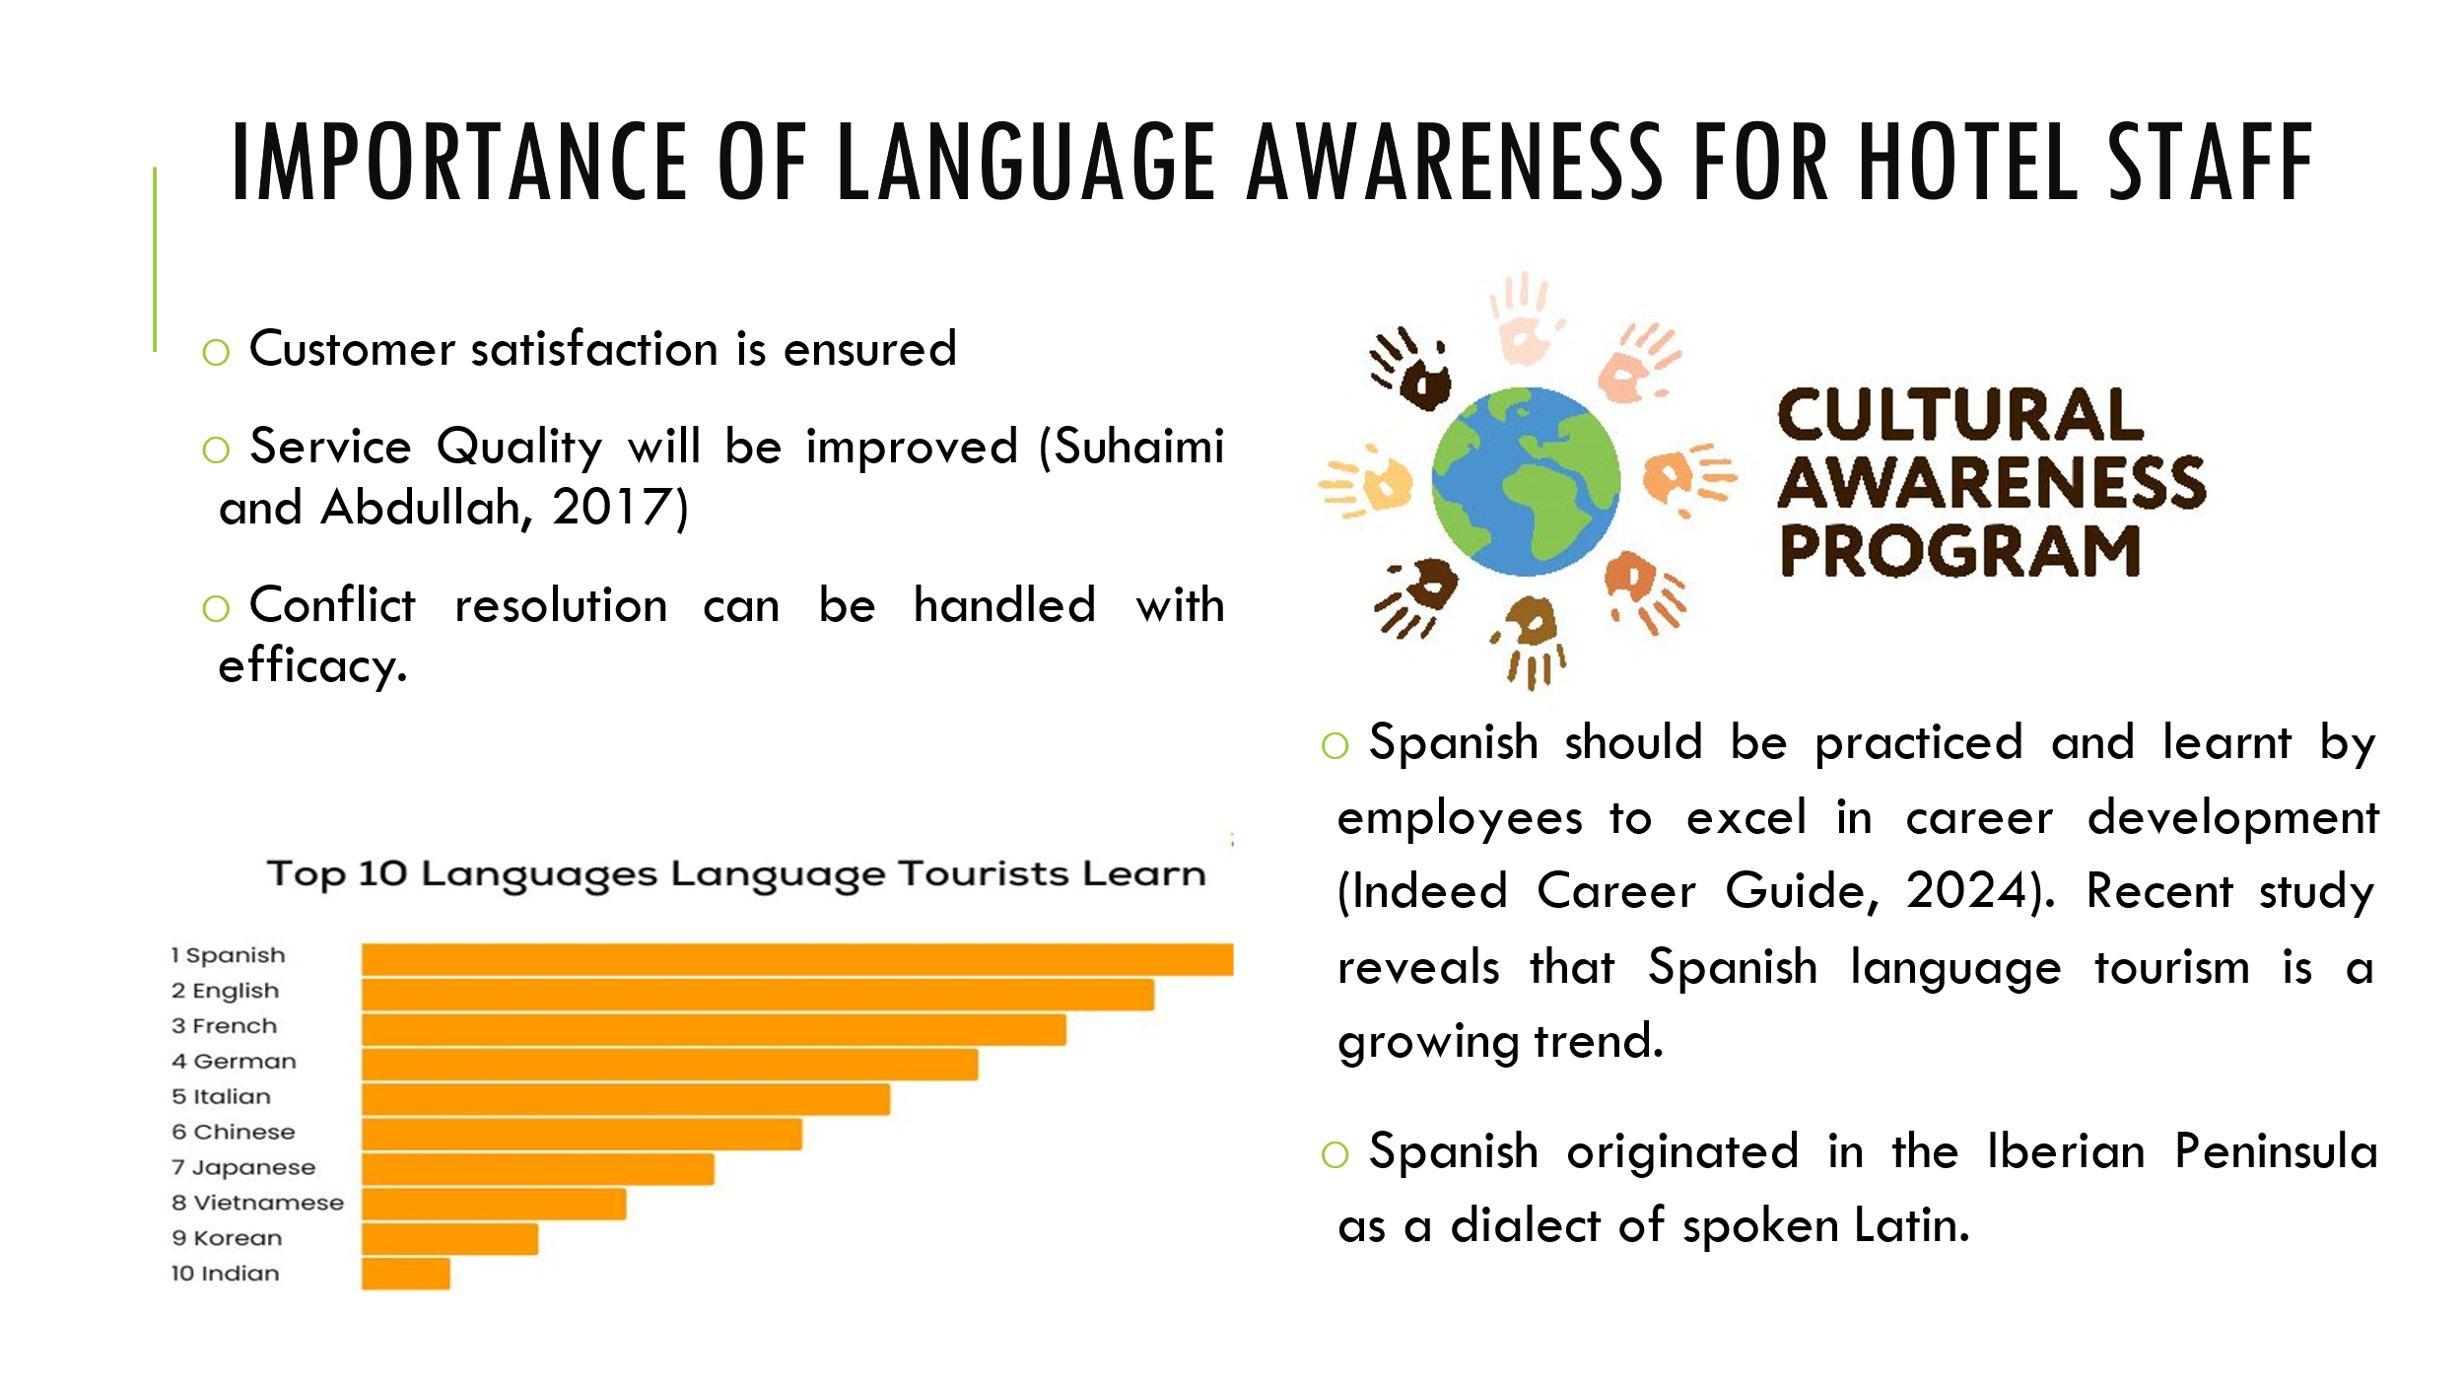
Customer satisfaction is guaranteed by the Premier Inn Bridgend staff's knowledge of languages. When hotel staff can connect well with guests, they can provide personalized services, resolve concerns, and create positive involvement, leading to higher customer satisfaction and loyalty.
Service Quality will be improved through all-out communication among all departments of the hotel. Being in the service industry conflict resolution becomes a prominent aspect and having cultural awareness can assist in resolving issues more professionally. Spanish should be the language that must be learnt by the employees to cope with the upcoming trends. For English speakers, Spanish is one of the easiest to learn.

[Content Slide 5]
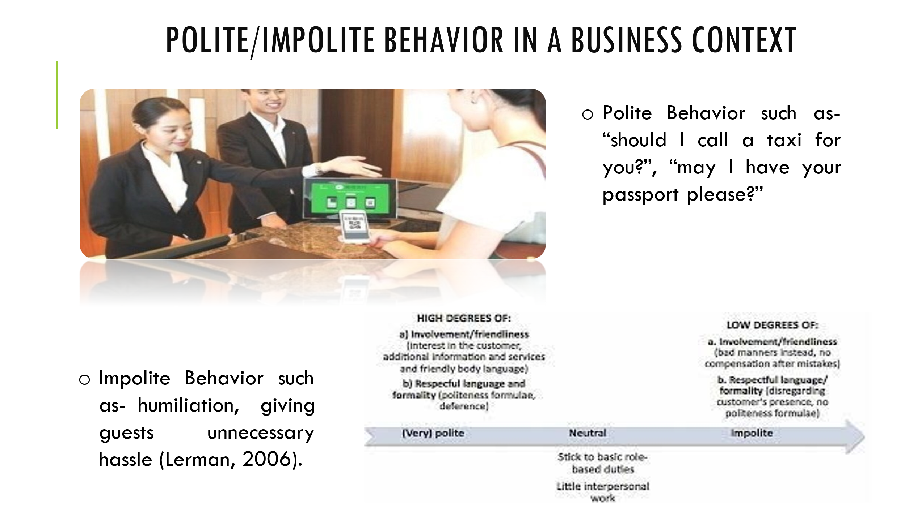
The hospitality industry requires guests to be treated politely and respectfully, such as "should I call a taxi for you?" and "may I have your passport please?" Unfriendly language and disregard for customers can lead to humiliation, unnecessary hassle, etc. For instance, at the Hotel Indigo Newcastle, an IHG Hotel, staff is polite to ensure guests have fun.

References (no screenshots):
Christiansen, B., Branch, J.D. and Karmowska, J. (2020) Cultural Factors and Performance in 21st Century Businesses. Hershey : IGI Global.
Deresky, H. (2017) International Management: Managing Across Borders and Cultures: Text and Cases. 9th Ed. Harlow: Pearson Education Ltd.
Indeed Career Guide. (2024) 10 Career Benefits of Learning Spanish as a Second Language. [online] Available at: https://www.indeed.com/career-advice/career-development/benefits-of-learning-spanish [Accessed 4 Feb. 2024].
Lerman, D. (2006) Consumer politeness and complaining behavior. Journal of Services Marketing, 20(2), 92-100.
Newsdle. (2023) How Many People in the World are Bilingual? [online] Available at: https://www.newsdle.com/blog/world-population-bilingual-percentage [Accessed 4 Feb. 2024].
Suhaimi, N.I.B. and Abdullah, A.B. (2017) The Role of Multilingualism in Enhancing Tourism Sector in Malaysia. International Journal of Academic Research in Business and Social Sciences, 7(7), pp.2222-6990.

