University of Wales Trinity Saint David

Dissertation Research Proposal
A Critical Analysis of the use of Brand Ambassadors within the Cosmetic Industry.

By Kimberly Hopkins
P148033

Contents Page

1. Introduction 3
1.1 Title of Research 3
1.2 Research Aim 3
1.3 Research Question 3
1.4 Research Objectives 3
1.5 Rationale 3
1.6 Contextual Analysis of Literature Review (Mini) 4
2. Proposed Research Methodology 6
2.1 Methodology 6
2.2 Collect data and analyse data 7
2.3 Techniques and Procedures 7
2.4 Time Horizon 7
2.5 Method Choice 8
2.6 Research Strategy 8
2.7 Research Approach 8
2.8 Quantitative Approach 8
2.9 Qualitative Approach 9
3. Sample 10
4. Data Analysis 11
5. Limitation and Ethical Requirements 11
5.1 Limitations 11
5.2 Ethical Requirements 12
5.3 Reliability and Validity 12
6. Resources and Planning 12
6.1 Resources 12
6.2 Gantt Chart 13
14
7.0 References / Bibliography 15

Introduction

1.1 Title of Research
A critical analysis of the use of brand ambassadors within the cosmetic industry.

1.2 Research Aim

The overall aim for this research project is to critically analyse, the impact brand ambassadors have on consumer’s perception of brands within the cosmetic industry.

1.3 Research Question
- Why are, brand ambassadors being used within the cosmetic industry by brands?
- Are the brand ambassadors trust worthy?
- To which extend do brand ambassadors influence the consumers, within the cosmetic industry?

Research Objectives

- To critical analysis of the academic literature on brand advocates and the increase in the use of brand ambassadors.

- To explore consumer’s perception of brand ambassadors within cosmetic industry.

- To make recommendations on how organisations can engage with brand ambassadors.

1.5 Rationale

The research project investigates contemporary issues in regards to brand ambassadors and their influence over consumers within the cosmetic industry, which is currently a hot topic. The author has identified a gap in the current marketing research, which does not identify if and how brand ambassadors contribute to consumers buying decisions and the level of trust associated with the brand ambassadors.
In recent years, there has been advancements in technology, which has directly affected consumer behaviour in regards to access to the internet and social media platforms. Consumers can now build up relationships with brands and have a two-way communication exchange online, where traditional there was a one-way exchange of communication from brands to consumers only.
According to Roderick (2017, p. 1) This has led to an increase in brand ambassadors within the cosmetic industry such as L’Oréal Beauty Squad utilises the ambassadress to create content for them; which L’Oréal has stated this campaign is ‘more than selling’ it is about spread ‘confidence within young people’. (Loreal, 2017)

1.6 Contextual Analysis of Literature Review (Mini)

In recent, years advancements within digital technologies, has had a direct impact on marketing communications, and how marketers are interacting with their consumers. Marketing has had a dramatic shift to a two-way communication channel, unlike the early years of traditional marketing, which focused on a one directional communication channel, from organisation to consumers. The rise in social media marketing and influencer marketing has exploded in the last few years, due to the digital technology and access to the internet. Consumers have changed their buying behaviour to accommodate their new way for communicating via the internet and how they interacting online with peer reviews. (Chaffey & Chadwick, 2016)
The social media platforms have formed an environment for, consumers to share dialect and opinions on brands and products, which has indirectly caused a two-way communication channel between brands and consumers. Whereas, traditional marketing concentrated on a one way channel from brands to consumers. (Chaffey & Smith, 2013)
In recent years, there has been an increase in brand ambassadors used within the cosmetic industry, with the likes of L’Oréal and Benefit using brand ambassadors as a part of their marketing campaigns. More and more companies have started using these brand ambassadors, to promote their products online. The use of celebrities, to endorse brands has been seen for quite some time, particularly in sport and through sponsorship. However, the shift in this role is evident in a number of different industries such as the cosmetic industry. According to Digital Marketing Community (2017, p.1), ‘57% of beauty fans’, ages between 16-64 females are ‘more likely to follow brands’ and brand ambassords that they are thinking of purchasing from and According to Bloglovin (2017, p.4) ‘71% of Marketers’ believe that brand ambassadors help to grow awareness for brands through social media platforms, which contributes to sales.
According to Hayzlett (2015, p. 1) ‘A brand ambassador is someone who eats, lives and breathes your brand’. Unlike a celebrity spokesperson who endorses a brand or products. Brand ambassadors can build ‘brand awareness’ and reach a wider audience’. (Hayzlett, 2015, p. 1)
These brand ambassadors, are seen as advocates or ambassadors, which use their knowledge or expertise of the products to influence consumers buying decision.
According to Emarketer (2016), influencers help with authenticity of brands and helps to build trust between brands and consumers. Similarly, Marketing Dive’s research (cited in Dinesh, 2017) states, consumers trusts their connections and networks on social media plateforms and a more likely to engage with influencers and brands their have already built relationships with.
However, Chahal (2017) states the main challenge for brands is to find advocates that are genuine and passionate about their brand and products. As the increase of brand ambassadors are using their presence and power for ‘self enhancement’ and not for the good of brand or the consumer. (Langner, et al., 2013, p. 31)
There is very little research that identifies that brand ambassadors have a direct impact on consumers during their purcahsing decision. The current research shows that companies are finding it hard to track return on investment in reagrds to these brand ammabssadors due to not having a clear framework that tracks the brand embassadors and to establish how much influence they have over consumers. (Rogers, 2017)

Proposed Research Methodology

2.1 Methodology

According to Saunders (cited in Blumberg, et al., 2011, p. 4) business research is defined as ‘a systematic inquiry whose objectives is to provide the information that will allow managerial problems to be solved’. However, for an ‘accurate and valuable’ collect of research, to be collated successfully, appropriate methods of research must be carried out. (Smith, et al., 2012)
Saunders, et al., (2009) developed a ‘Research Onion’, which is seen in figure 1, which encompasses multiple layers that must be considered prior to conducting research. Each layer represents a specific way of carrying out research and the way research should be conducting for effective and positive outcome.
Figure 2.1 The Research Onion (see on next page)
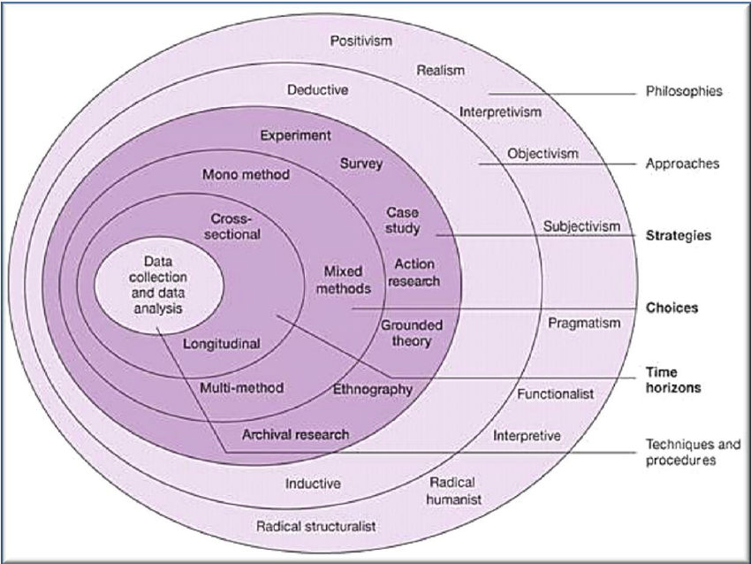
(Source Mark Saunders, Phillip Lewis, and Adrian Thornhill 2007)

2.2 Collect data and analyse data
This research project will collect data and analyse data on consumer’s perception on brand ambassadors within the cosmetic industry.

2.3 Techniques and Procedures
Multiple techniques and procedures will be used, to gather data for this particular research project.

2.4 Time Horizon
This project will focus on a cross section of time.

2.5 Method Choice
Mixed methods choice of data collection. (Triangulation)

2.6 Research Strategy
According to Greetham (2014, p. 193) quantitative ‘measures empirical data expressed in numbers’ and qualitative ‘expressed in words describing attitudes, feelings, opinions, customs and beliefs’. The strategies used will be online surveys, and focus groups. Also known as a triangulation mixed method approach, of quantitative and qualitative research approaches, that evaluate the extend, to which the findings are consistent with current theory of brand ambassadors.

2.7 Research Approach
According to Ghauri, et al., (1995, p. 8) inductive draws general conclusions from empirical observations. This process goes from assumption to conclusion.
An inductive approach will be used to ‘focus on individual meaning of a complex situation’ regarding consumers and brand ambassadors within the cosmetic industry. (Creswell, 2014, p. 4)

2.8 Quantitative Approach

A quantitative approach is associated with a positivism philosophy. A quantitative approach will be used in a form of an online survey, to address the consumer’s acknowledgment and ‘strength of opinions’ of brand ambassadors. Through using qualitative approach in regards to the online survey, this allows a larger primary data capture of consumer’s acknowledgements of brand ambassadors, which then can be further investigated with a focus group. The advantages of carrying out online survey is to target a wider audience and to gather a large response. (Saunders, et al., 2016)

2.9 Qualitative Approach

A qualitative approach through two sets of focus group will address the perception consumers have if any in regards to brand ambassador. (Greetham, 2014, p. 193)
According to O'Gorman and Maclntosh (2015, p. 128) the limitation for carrying out a focus group are ‘difficult to organise’ and possible issues with controlling participants. A Gantt chart will be used to schedule focus groups to ensure all participants can attend and a Semi-structured focus group will be followed to ensure sufficient and accurate data is collected. Prior to the focus group, a summary of the survey results will be communicated, to participants to identify whether the participants want to participate within focus group. Using a qualitative approach it allows for a thorough investigation into consumer’s perception of brand ambassadors to identify, whether brand ambassadors affect the consumer or not. The advantages of carry out focus group is that allows to ‘examine what and how they think and why they think in a special way about the issue of importance’, (Liamputtong, 2011, p. 5).

2.10 Philosophy
According to Saunders, et al., (2009, p. 108) the research philosophy shapes the outer layer of the onion, which ‘underpins your research strategy and the methods used’.
This study embarks on both paradigms, a positivist philosophy and an interpretivist philosophy. According to a paradigm is defined as a ‘broader view or a set of assumptions that are preserved by someone’. Taylor, et al (2007) (cited in Saunders, et al., 2016).
The positivist philosophy will identify a ‘single true answer’, which the online survey will address to gather data on general perception and attitudes towards brand ambassadors within the cosmetic industry. (Collis & Hussey, 2014)
The interpretivist philosophy looks at ‘understanding differences between humans as social actors’ meaning the research intends to focus on understanding individual’s perception of brand ambassadors within the cosmetic industry. (Saunders, et al., 2016, p. 140) (Collis & Hussey, 2014)
Both positivism and an interpretivist philosophy is highly appropriate as the research seeks to gather generalisations of consumer perception with online survey’s and secondly carry out an interpretative philosophy in a form of focus group to gather in-depth understanding of consumer’s perceptions on brand ambassadors.

3. Sample

3.1 Sample Selection and Size and Limitations
A minimum of 100 responses will be required. The respondents will be ages 18+. According to O'Gorman and Macintosh (2015, p. 162) the sample selection is recognised as a ‘quota’ as there is a minimum responses required for analysis within this research project. From the results of the online survey, a focus group will then investigate further.
The focus group will investigate the specific issues concerning customer’s perceptions and opinions in regards to the brand ambassadors, which will be identified during the online survey. Two focus groups will be held with a range of age groups and mix gender. However, limitations for both methods will be time constraints and resources need to carry out primary research. In addition, bias could occur due to facilitation of the focus group.
Prior to online survey being published, there will be a pilot study to ensure there are no errors and to highlight are issues or adjustments that need to be amended prior publication. This is essential for a successful survey according to O'Gorman and Macintosh, (2015). This will be carried out on friends and family due to time and resouce contraints.

4. Data Analysis
The use of automation analysis tool on Survey Monkey will identify result of the online survey. At least one statistical test will be carried out with the results of the survey. Once result have been collected then visual, charts will be formulated to clearly display results for each question. This will be easy to read and interpret the data. (Saunders, et al., 2016)
The result will then be used, within two sets of focus groups to challenge and investigate issues further. The collection of data from focus groups will be recorded through recordings then a transcript will be draw up as evidence. Thematic evaluation will be carried out with the results of the focus group, which will be compared with online survey to formulate the results.

Limitation and Ethical Requirements

5.1 Limitations
Limitations of collecting of primary data will be in relation to time constraints and resources. The use of a Gantt chart will help with time management of the project. The scheduling tool helps to organise and focus the project within a period. (Project Management, 2015)
Faciliation of the focus group will need some consideration to esnure no influence come from the researcher.

5.2 Ethical Requirements
Due to the nature of this research, the researcher will uphold their ethical responsibility as a researcher and as a student at UWTSD; to ensure minimum risk to all participants during my research will be adhered too.

5.3 Reliability and Validity

According to Saunders, et al., (2016) validity of the data collected will be low in regards to the online survey. Validity will be high in regards to the focus group due to a semi-structure approach and time will be spent in introducing the topic and to put participants at ease prior to the session. However, bias can occur due to the researcher facilaition of the focus group. Researcher needs to be aware or refrain in contribute to focus group. Reliability will also be high due to the nature of research being carried which will be accurate and honest for the participants.

Resources and Planning

6.1 Resources

According to O'Gorman and Maclntosh (2015) is vital part to a successful research project. Without planning and resources it would be not possible to carry out a research project in a particle timeframe, as planning is needed to ensure the correct stages of the research at carried out at certain times during the whole process before moving onto next stage.
Within this research project resources such as computer systems and databases to access information and secondary research on my topic as well as textbook from the uwtsd library. Online software such as survey moneky will be used to develop and analyse data of the online survey. A safe environment (room) to carry out two focus groups will be needed. Other general stationary supplier and voice recording devices will be used as a part of collect data form the focus group.

6.2 Gantt Chart

There is a Gantt chart attached which has schedules and date to follow, this aims to ensure time management is applied to the research project and gives focus and attention to what needs to be do and by when. The Gantt chart identifies tasks all the way through the research project including the final submission date, which is May 14th 2018.
Figure 6.1 Gantt chart. (See on next page)

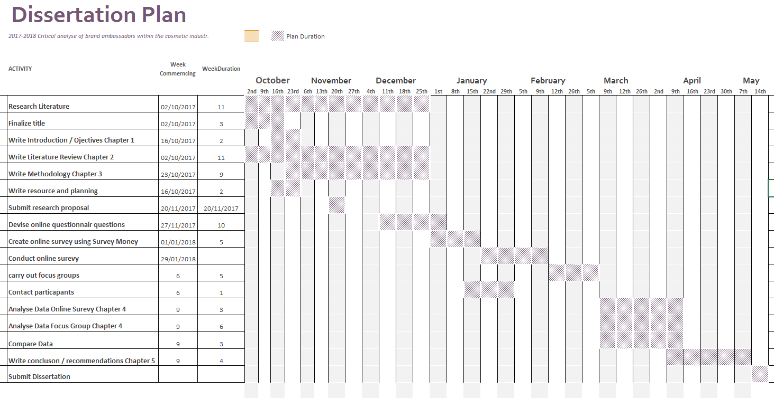

7.0 References / Bibliography

APM, 2017 . Influencing. [Online]
Available at: https://www.apm.org.uk/body-of-knowledge/people/interpersonal-skills/influencing/
[Accessed 4 April 2017].
Bloglovin , 2017. How Marketers are leveraging influencer marketing. Bloglovin Survey 2017, February, pp. 3-15.
Blumberg, B., Cooper, D. R. & Schindler, P. S., 2011. Business Research Methods. 3rd ed. London: Mc Graw Hill Education.
Chaffey, D. & Chadwick, F. E., 2016. Digital Marketing. 6th ed. Harlow: Pearson Education Limited.
Chaffey, D. & Smith, P. R., 2013. Emarketing Excellence. 4th ed. London: Routledge.
Chahal, M., 2017. The Future of Social Insight. Marketing Week Online.
Collis, J. & Hussey, R., 2014. Business Research: A Practical Guide for Undergraduate and Postgraduate Students. 4th ed. Hampshire: Palgrave Macmillan Highier Education.
ContentMarketingInstitute, 2013. Research UK marketeres are confident, lack strategy. [Online]
Available at: http://contentmarketinginstitute.com/2013/12/uk-2014-content-marketing-research/
[Accessed 24 September 2017].
Creswell, J. W., 2014. Research Design: Qualitative, Quantitative, and Mixed Methods Approaches. 4th ed. London: SAGE Publication Ltd.
Digital Marketing Community, 2017. Beauty Fans 2017. [Online]
Available at: http://digitalmarketingcommunity.com/researches/infographic-beauty-fans-2017-globalwebindex/
[Accessed 12 November 2017].
Dinesh, D., 2017. Why micro-influencers are a social media marketing imperative for 2017. Econtent, 40(3), p. 15.
Emarketer, 2016. Influencers your powerful brand advocates. [Online]
Available at: https://www.emarketer.com/Article/Influencers-Your-Most-Powerful-Brand-Advocates/1013454
[Accessed 14 October 2017].
Fill, C. & Turnbull, S., 2016. Marketing Communications. 7th ed. Harlow: Pearson Education Ltd.
Greetham, B., 2014. How to write your undergraduate dissertation. 2nd ed. London: Palgrave.
Hayzlett, J., 2015. Brand Ambassadors. [Online]
Available at: https://www.entrepreneur.com/article/246773
[Accessed 17 October 2017].
Hubspot, 2016. Inbound Marketing. [Online]
Available at: https://www.hubspot.com/inbound-marketing
[Accessed 24 September 2017].
Jaward, C., 2017. Dissertation 2017 - 2018. Swansea: Caroline Jaward.
Jobber, D., 2010. Principles and Practices of Marketing. 6th ed. Berkshire: McGraw-Hill Higher Education.
Jobber, D. & Chadwick, F. E., 2013. Priniciples and Practices of Marketing. Berkshire: McGraw-Hill Higher Education.
Kotler, P. & Armstrong, G., 2010. Principles of Marketing. 13th ed. London: Pearson Education.
Kotler, P. & Armstrong, G., 2014. Principles of Marketing. Fourteenth Edition ed. Harlow: Pearson Education Limited.
Langner, S., Hennigs, N. & Wiedmann, K.-P., 2013. Social Persuasion: taregting social identities through social influencers. Journal of Consumer Marketing, 30(1), pp. 31-48.
Liamputtong, P., 2011. Principles and Practcies - Focus Groups. [Online]
Available at: http://methods.sagepub.com/book/focus-group-methodology/n3.xml
[Accessed 20 October 2017].
Marandi, E. & Little, E., 2003. Relationship Marketing Management. London: Thomson Learning.
Masterson, R. & Pickton, D., 2014. Marketing an introduction. Third Edition ed. London: Sage.
MOZ, 2016. SEO and Digital Trends in 2017. [Online]
Available at: https://moz.com/blog/seo-and-digital-trends-in-2017
[Accessed 8 October 2017].
O'Gorman, K. & Macintosh, R., 2015. Research Methods Business Managment. 2nd ed. Oxford: Goodfellow Publishers Limited.
Palmer, R., Cockton, J. & Cooper, G., 2007. Managing Marketing. Oxford: Elsevier.
Project Management, 2015. Project Managment. [Online]
Available at: https://project-management.com/what-is-a-gantt-chart/
[Accessed 20 October 2017].
Roderick, L., 2017. Loreals Mentoring Porgramme. [Online]
Available at: https://www.marketingweek.com/2017/02/23/loreal-mentorship-programme/
[Accessed 17 October 2017].
Rogers, . C., 2017. Whats the ROI of influencer marketing. [Online]
Available at: https://www.marketingweek.com/2017/08/30/roi-look-like-world-influencer-marketing/
[Accessed 07 November 2017].
Saunders, M., Lewis, P. & Thornhill, A., 2016. Research Methods for Business Students. 6th ed. Harlow: Prentice Hall.
Saunders, M., Lewis, P. & Thornhill, A., 2016. Research Methods for Business Students. 7th ed. Harlow: Pearson Education Limited.
Saunders, M., Thornhill, A. & Lewis, P., 2009. Research Methods for Business Students. 5th ed. Essex: Pearson Education Ltd.
Smart Insights, 2017. Paid Search Marketing. [Online]
Available at: http://www.smartinsights.com/paid-search-marketing-ppc/
[Accessed 13 October 2017].
Smith, M. E., Thorpe, R. & Jackson, P., 2012. Management Research. 4th ed. London: SAGE Publications Ltd.
Target Internet, 2017. Digital vs Traditional media the environmental impact. [Online]
Available at: https://www.targetinternet.com/digital-vs-traditional-media-the-environmental-impact/
[Accessed 4 October 2017].

