Sunila Khan: 1813037
Lecture: Paul Ranson
BMSW5104: Managing Projects in the Organization
Date: 02 April 2021

Table of Contents
Introduction 3
Business history 3
Project Management 3
Diagram of Sponsors Stakeholders 4
The Vintners project 5
Microsoft planner 5
Waterfall Approach 5
Gantt Chart 6
Gantt Chart Diagram 7
Iron Triangle 7
Scope 8
User Stories Using Trello 10
Time 10
The standard project/product technique 10
The Delphi Technique 11
Poll Everywhere 11
Cost 11
Wisdom of Crowd 11
The Project Cycle and Monitoring the Project 12
Conclusion 12
Reference list 14

Introduction
This report highlights as a project manager, which technique is useful to reduce the risk of project failure. This report is about Vintners family. how they can use different technique to move their business one place to another place. This report is discussing about project manager technique in the organisation like waterfall approach, Gantt chart, iron triangle, Scope, time, cost and wisdom of crowd. by using all these techniques in any project business can survive and avoid all the consequences.

Business history
Vintners’ family run an antique shop for many years. Their third generation run the family business. Their grandfather bought this shop before 30 years ago. Doreen is working as an accountant for 10 years. Denis drives the car around the country looking for antique stuff. Suha is a daughter of a family friend. She worked in a shop about three years and handle customer service. Omar working in a warehouse and sort out all the stuff and make sure everything is okay. They own the shop in Shirley but now have an offer from local Tesco. They also own the warehouse in sparkhill that is full of stock. Warehouse using for just storage. There are no electricity, phone, or internet. Dennis and Doreen watched the TV show called Salvage Hunter. They want to make a business-like Salvage hunter. They want to organise warehouse, basically move their business from Shirley to sparkhill and get ready for everyone for the work.

Project Management
We all been involved in some sort of project in our lives, for example organise parties, birthday planning etc. Project management based on planning goals and teamwork. Entire team like, sponsor, stakeholder form a project steering group who should be involved in the planning exercise. Team must know what they are responsible for, so they are also going to be aware to deliver their best. As a project manager, I try to help Vintners family by using my techniques, they can reduce the risk for project failure. According to Heagney (2016) “project management is the application of knowledge, skill, tools and technique to project activities to achieve project requirements. Project management is also accomplished task in the organization. In other words project management is process of initiating, planning, executing monitoring and closing.”

Projects can go wrong sometimes, and it could be many reasons behind this. Sometime lack of knowledge and experience and sometime people do not plan well. Failure of project is a very painful experience for everyone. Their direction is based on instinct rather than a plan. Following video link is about how people did not interact with each other and it is a project that go wrong call 7 Redlines. Seven Redlines is one of the examples, if people do not work as a team, chances are high for a project to fail easily that is why It is important to create a plan before execute anything. A plan can define different number of ways and techniques. In my report I explain some techniques which should help to reduce risk of plan failure. (Beinerts, L., 2014).

Diagram of Sponsors Stakeholders

Doreen is a very good experience accountant. She worked as an accountant for ten years. Denis is very good to research in the market and find lot of good antique stuff around the countries. Suha is very responsible and trustworthy family friend and she worked for them for three years. Omar work in warehouse and is very good to repair all the broken stuff which Denis bring in from around the country and me Sunila khan here to help this family as a project manager to reduce risk of the plan failure.

The Vintners project
- Move business Shirley to Sparkhill.
- Changing the way, they do business.
- Setting online business.
- Restock all the equipment.
- Recruit new staff.
- Place for packing and shipping.
- Renew office.
- New electric.
- Internet and phone connection.
- Moving existing stuff.

Microsoft planner
Microsoft planner is a great working in the task. Planner provides a hub for all your team members in the group to create plans. For example, as a project manager I can check out my board I can see my tasks in different buckets, and I can look at charts and scheduling and planner integrates with things like teams and share with Vintners family. Microsoft planner is a great way for ideal meeting, deadlines, and specifications. (Microsoft mechanics, 2016).

Waterfall Approach
Waterfall delivering a project in a stages or phases. Waterfall model finishes one phase before another phase can begin. Simple waterfall model has six phases which are:
- Require.
- Design.
- Implementation.
- Verification.
- Deployment.
- Maintenance.
As a project manager I would suggest to the Vintners family waterfall approach in the organisation and start with the requirement. Start with the concept of the idea what the customer wants. Another stakeholder should be involved, what they require in their organization according to their needs. For example, Sparkhill building need an electricity in the building. All the requirements need to be approved and move to another phase.
Design phase includes the logical design and physical design. We need to do sketch first, what kind of design Vintners want in the new building for easy packaging and storage stuff. When the design phase is finished, implementation phase will start. For example, how many workers we need to work in Sparkill building to finish the job. Verification phase will be held to make sure everything works perfectly and analyse properly. Some testing processes may take place in deployment stage. At the end maintenance phase come which support any Department. According to Adenowo, et al, (2013). “Waterfall model is a traditional approach and easy to understand. Waterfall theory break up project based on activities and it is easy to understand.”

Gantt Chart
Gantt chart is a useful tool. If more than one person working in a project, Gantt chart help to organise the schedule. It is not only giving start and end date to the task, but also which task completed by when. Gantt chart is used in project management that will show the length of time tasks in the project and helps the project run more smoothly because you can easily see the order of tasks and you can see project progress in terms of where you are now and where you should be progress in the future.
It is also providing a time allotment, that can help more planning, action you will take in your project, monitor the project and help to decide which other tasks are independent of each other and should need to be done first before the other tasks start. For example, if I must do new electricity in the building and roof repairing and furnish my room, my priority will be repairing the roof first and then electricity and then furnish the room. Gantt chart is the same process, it is given the idea which task should complete first, and which task is independent each other.
Gantt chart Is responsible for each task. Gantt chart give us idea, who is responsible for each task and how long each task would take. Basically, give us a clear idea order of things. you can start filling in your Gantt chart showing the order of activities where things can happen at the same time and where one task must be complete before others can start. Once you have the Gantt chart designed and agreed by everyone on the project. you can use this one document to keep your team, stakeholders, and anyone else interested informed and work as a team in same project.

Gantt Chart Diagram
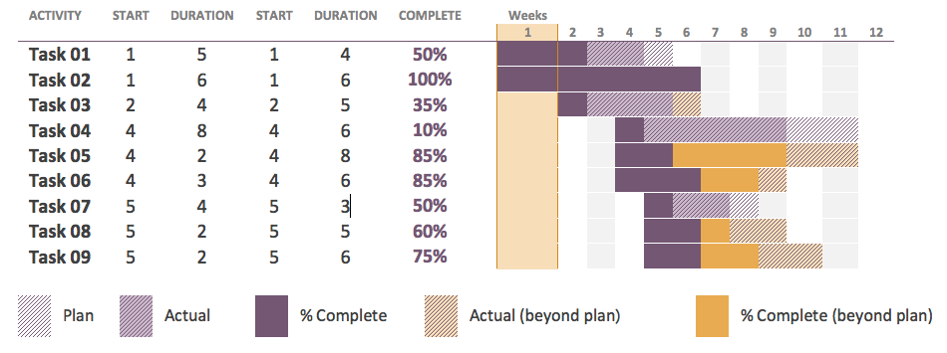

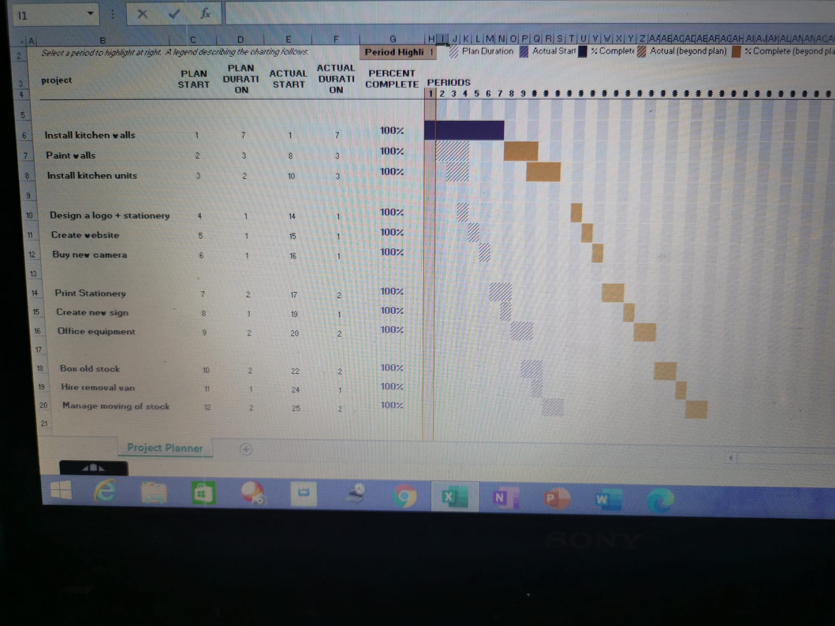
This Gantt Chart above shows a project to be completed within a 28-day period and which elements of the project rely on others before they can be started.

Iron Triangle
As a project manager I can advise Vintner’s family to use the iron triangle. Iron triangle framework help explain organisation that if they reduce cost then scope must reduce and time increase. This framework is great way to explaining any project development.
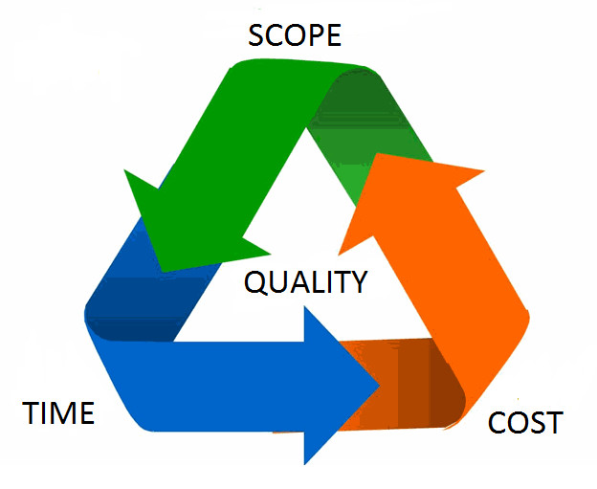
(Ravichandran, 2017).
The purpose of the iron triangle apply to the organisation is to measure scope, time, cost and quality. If more things involve in the project, it is harder to deliver, for example, if you have less time, it is harder to complete everything on time that is effect to complete the project. More task and less money effect the whole scope. Concept of the iron triangle is quality constantly will remain the same.

Scope
As a project manager, I must find out the problem first. I need to identify where is the problem and which element cause problem. According to Heagney (2016) “A problem is a gap between where you are now and where you want to be with obstacle that prevent you closing the gap easily.”
Use critical thinking to help you to find out the problem and their solutions. As a project manager if you are thinking properly that will help to succeed the project and less mistake. We need to use some techniques to be thinking to find out the problem which faced by Vintner's family. Most of the project management use user story technique to help them to think slowly. According to Daniel, (2017). “Critical thinking provides evidence and judgement and tells us how human mind is work in different situations.”
User stories is a traditionally technique which is called in Japanese Kanban. We use whiteboard and a piece of paper to identify all problems which is written by various stakeholder, clients, managers, employees all the people are involving in the project.
As a project manager I want to ask each stakeholder to describe a problem which needs to be addressed. My suggestion is for Vintner’s family, they can use a software programme called Trello to help us to create user stories. I am going to start Trello called to do list add if I click add list button that way Trello give me another list. I can add more information for example as a project manager I suggest to Vintner family, they need to install a security camera in the building to avoid the any consequences. If I write just security camera in my list. it is not good enough to describe the problem. If I click add button then go to the description, that way I can add more details and click safe button.
“User story is a popular method of collecting data to identify the problem in the organization.” (ResearchGate. 2016).
If Vintner’s family reduce the risk of project failure, they can use technique called Chevron technique. First collect all the stories and then categorise in three parts. For example, must have, want to have and nice to have. Idea behind this technique is which are the most important thing so project cannot be execute without these things. It is very important we can use this technique at the beginning of the project to identify things we need to prioritise and complete understanding what we try to deliver and what is it that customer want.

User Stories Using Trello
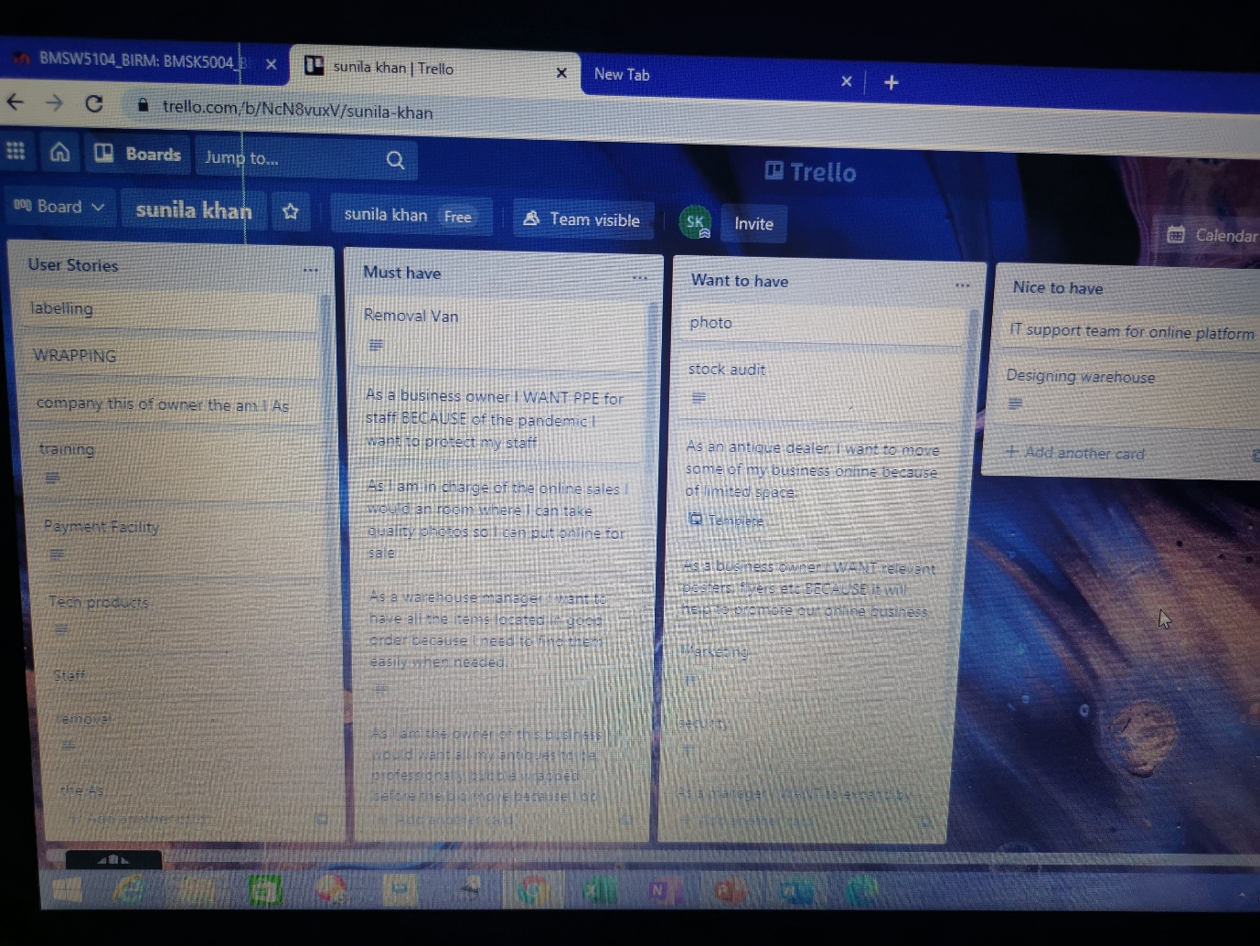

Time
Time management is very important to complete any kind of project. This is another aspect in the iron triangle. As a project manager I need to work it out how much time is required for completing this project. We cannot start any project without estimate of process. Exercise of planning is giving kind of the experience of planning project. Planning is also giving you opportunity where did you start. According to Roberts, (2011). “Every estimate is an informed or educated guess.” I can use variety of techniques to estimate of time. I can use Robert project technique for the time estimate. Robert project technique split the estimate into two dimensions. This is kind of easy to assume the estimate. First question is how complex the task and the answer are low, medium all high. Second question is what size of the project? Answer is small, medium or large.

The standard project/product technique
Size / Complexity | Low | Medium | High
Small | 1 | 3 | 5
Medium | 4 | 8 | 11
large | 7 | 12 | 19

The Delphi Technique
Purpose of the Delphi technique is rather than relying just one answer go to more individual research. for example, by using Robert project technique of numbers, ask the people by showing them the number what did they think. Did we increase number of the time or number of the cost? The Delphi technique is all about an estimate through meeting, questionnaire, and survey.

Poll Everywhere
Poll Everywhere is a very beneficial technique in this modern and digital world. As a project management, it is a good way to engage all the employees in the project. Because of busy schedule or some other reason cannot attend all the meeting. Poll Everywhere is a good way to present your activities through Poll Everywhere app. Once you share your screen, conversation begin with employees. You can also receive a quick feedback from all your colleagues rather than a long wait. “Poll Everywhere is very efficient way for the communication, improving employee’s engagement and also is a great way to quickly take a vote or gather feedback from your other team member.” (Polleverywhere.com. 2020).

Cost
Any project if things change, time and cost will surely change too. If cost change then again time and scope will change. When we look at the situation in our life from our perspective that's why sometimes we're making a wrong decision. As a project manager I would suggest applying wisdom of crowd technique in the organisation.

Wisdom of Crowd
Wisdom of crowd is a great way to know other people’s perspective. Wisdom of crowd is collective opinion of the group of individuals rather than a single opinion. For example, ln 1906 unfortunate cow was the subject of a guess. The weight competition one of the village person who guess closest, would win the slaughtered animals meat. The amazing thing was nobody guessed correctly and yet everybody got it right. I give you example of Jellybeans. I did ask 160 people how many Jellybeans in the jar, most of the people have wrong answer only two or three people near the right answer but if I add all the answer together Take the average, I got a combined answer of entire group. Average guess is 4,515 an actual Jellybean was 4,510. Individually they just guess but collectively we have a right answer. According to Herzog, and Hertwig, (2009). “Wisdom of crowd is provided average quantitative estimate of a group of individuals is consistently more accurate than the typical estimate and is sometimes even the best estimate.”

The Project Cycle and Monitoring the Project
We start in the project cycle with a plan. Then execute the plan delegate to the people who are working in the same project at that point you need to monitor progress and make sure, it is all go with the plan well. At this point you need to make a report and present to the project sponsors. Sometime project managers need to change control the direction. In that case you need to recreate the entire document again and communicate to the team what you are doing next. According to Roberts, (2011). “If something does not happen according to plan, in that case some corrective action is needed.”

This is a huge responsibility of project manager to monitor all the progress and keep an eye on everyone in the team, did they distribute or not? Regular reviews and meetings will be helpful to monitor the project activities. Stand up meeting is a way to know company employees’ interest, confidence and motivations.

Conclusion
In this report as a project manager, I gathered information about different type of techniques. which I did apply Vintner’s family business to reduce the project failure. In my report I found Microsoft planner, which is a very useful tool to keep up to date things for the team. I also found waterfall approach, which is based on each other phase. I gathered information about Gantt chart which is another useful tool to use in the organisation and for any project. Gantt chart give us an idea, when the project can start and how long does it take to complete the project.
I also discuss iron triangle. Iron triangle is another great tool to find out project scope, time and cost which is very beneficial for decision-making process and making decisions. I also found project product technique and wisdom of crowd which helps in accurately estimating a figure. As a project manager I found some good techniques which can be useful in any organisation to avoid any plan failure and success.

Reference list
Adenowo, A.A. and Adenowo, B.A., 2013. Software Engineering Methodologies: A Review of the Waterfall Model and Object-Oriented Approach. International Journal of Scientific & Engineering Research, 4(7), pp.427-434. [Accessed: 29 March 2021].
beinerts, L., 2014. The Expert (Short Comedy Sketch). [video] Available at: <https://www.youtube.com/watch?v=BKorP55Aqvg> [Accessed 1 April 2021].
Daniel, K., 2017. Thinking, fast and slow. [Accessed: 29 March 2021].
Heagney, J., 2016. Fundamentals of project management. P.4. [Accessed: 29 March 2021].
Heagney, J., 2016. Fundamentals of project management. P.60. [Accessed: 29 March 2021].
Herzog, S.M. and Hertwig, R., 2009. The wisdom of many in one mind: Improving individual judgments with dialectical bootstrapping. Psychological Science, 20(2), pp.23-237. [Accessed: 29 March 2021].
Microsoft mechanics., 2016. [video] Available at: <https://www.youtube.com/watch?v=p82hS0K32fA> [Accessed 1 April 2021].
Polleverywhere.com. 2020. [online] Available at: <https://www.polleverywhere.com/Poll-Everywhere-Employee-Engagement-Ebook-2020.pdf?utm_campaign=Corp> [Accessed 1 April 2021].
ResearchGate. 2016. (PDF) The Use and Effectiveness of User Stories in Practice. [online] Available at: <https://www.researchgate.net/publication/312702795_The_Use_and_Effectiveness_of_User_Stories_in_Practice> [Accessed 29 March 2021].
Roberts, P., 2011. Effective project management. London, UK: Kogan Page, p.114. [Accessed: 29 March 2021].
Roberts, P., 2011. Effective project management. London, UK: Kogan Page, p.188. [Accessed: 29 March 2021].
Ravichandran, D., 2017. iron triangle project management - Google Search. [online] Google.com. Available at: <https://www.google.com/search?q=iron+triangle+project+management&tbm=isch&ved> [Accessed 1 April 2021].

