What impact does a specialist teaching facility have upon education for children and young people with autism?
Chapter 1
Background
Around one in one hundred children and young people are affected by autism and in the UK alone 100,000 children and young people are suffering with autism spectrum disorder. 70% of children with autism are educated within mainstream schools and the remaining 30% are put in special education facilities in which they have a care plan to assist learning and development. (Ambitious About Autism, 2017)
Gillberg (2009) defines autism as a behavioural syndrome, in which the nerve system and medical conditions combine together. It is stated as a spectrum disorder and is different in every individual. The topic of this piece of writing is based on how the education system works to help children with autism and how the different education settings work. According to the BBC (2015) someone with special educational needs is a child who is finding it difficult to learn and develop the same way as other people their age, this is then supported with special education teachers or assistants after an assessment has been undertaken to understand where the needs must be met in order for the child to gain achievements from education.
Similar to this Barnard et al (2000) states that autism spectrum disorder is a hidden disorder and doesn’t portray itself physically like most other disabilities. It is hard to diagnose someone as autistic and give them a statement as awareness of it is so low, and the issues surrounding it can be difficult to identify especially at a young age, and with the issue of it affecting individuals differently putting a care plan in place can be difficult but putting a care plan in place is at the forefront of educational professional’s responsibility to ensure that children gain educational attainment in order to live a life like everyone else.
Allinder (1994) states that there are two different ways to assess a child’s need if they have special education needs, this includes autism. The way to assess what is best for the child according to this journal article is to recognise what setting best suits the individual, these settings range from either keeping them in mainstream schools or having them in special education schools. A special education school is defined by theschoolrun.com (2018) as a school for children with learning and behavioural difficulties, they support children with all sorts of problems mainly disability, the main reason these schools are in place are to offer the education to children that mainstream schools cannot. They state that 2 per cent of school aged children attend special educational schools in order to gain achievements from education, and have support with their disability. This links to the subject matter due to children with autism being supported within these special education schools in order to get extra care and support as well as learning and development.

Justification
The reason this question was picked was in order to gain an understanding into the educational attainment of children and young people with autism within a school setting. The topic is interesting as it will give an insight on what works best for children with autism with regards to what they achieve from school, there are plenty of sources of information on the two topics with regards to special teaching facilities as well as mainstream schools, but none that connect the two in order to understand what works best for the children or if different children work better in the different settings. There is a gap in this field as having more of an understanding in how autism works will help professionals in the educational field understand autism spectrum disorder and the best way to care for the children and help them learn in the way that will suit them best.
Aim and Objectives
The aim of this research is to find out whether children with autism gain a better school experience through mainstream school or through special teaching facilities.
In order to reach the aim, objectives are put in place, these break down the aim to answer the question, the objectives are as follows;
- To define what autism is in order to give the reader an understanding of what is is.
- To examine mainstream schools and special education facilities in order to see what they offer with regards to education outcome for children with autism.
- To evaluate using journal articles whether and how the different settings are appropriate for children with autism and the effects the two settings have on the children.
- To find out which of the settings is most appropriate for the children in order to recommend ways in which the facilities could be improved in order for future children to gain the best from their educations
Chapter 2
Methodology and Justification: Systematic Review
A systematic review is a wide range of healthcare studies that have been summarised and have the best sources of information in them in order to gain knowledge and understanding in a subject matter. The studies are carefully reviewed in order to ensure they give reliable information and are a good source to use. (Consumers.cochrane.org, 2018)
A systematic review will be used to answer the question in order to ensure the best sources are being used to understand the subject and see what research has already been carried out in the field to compare the findings in order to answer the question. It is important to have reliable sources in order to achieve the best findings.
There are positive aspects to using a systematic review these are that they are thorough and therefore the information that’s obtained within the work is relevant. They can be used in order to make a comparison as a systematic review brings together many sources and research conducted in a subject matter in order for someone doing research to get an answer. Systematic reviews are useful to understand a weakness in primary research as they have high validity for use within research materials.
But there are also some limitations to using this method and these are that some smaller studies can be quoted and recognised in bigger studies and they go under looked, meaning they are not always original research. Another drawback is linked to the language they are wrote in, they are more often than not written in English and therefore countries with first languages other than English have no access. (Biondi-Zoccai et al., 2011)
Methodology and Justification: CASP
Critical Appraisal Skills Programme (CASP), is defined by Public Health Resource Unit (2006) as a tool used in many settings mainly health, and is used as a critical appraisal tool in order to understand research material in order to use it within research projects and understand whether the source is reliable or not.
CASP will be used in order to assess literature used within the research to answer the question in order to understand whether the journals used are reliable and relevant to the research needed in order to answer the question and assess the education settings for children with autism.
An example of how CASP is used is included in the appendix, and it shows the ways in which literature is assessed in order to conclude whether the work is reliable to use within the research.
Ethics
This question will be answered using secondary research only, with this in mind ethics need to be taken into consideration when looking at the research materials within in the literature.
The author of the initial research must ensure that the work they carry out does not bring harm to anyone they use within the study, this will then mean the research conducted was done ethically and therefore suitable to use in order to gain information on the subject matter.
Any data obtained to use in order to answer the question must be cited and referenced in order to meet ethical rules to ensure that plagiarism is not used within the research. In relation to this, a reliable journal and sources of research should be used in order to obtain true and up to date sources of information to ensure that the question is answered from the best research. (Brinkkemper, 2011)
Chapter 3
Planning
Below is a GANNT chart which puts into perspective the timescale needed in order to gather information, assess the research and conclude from the research the best outcome for children with autism in order to answer the question.
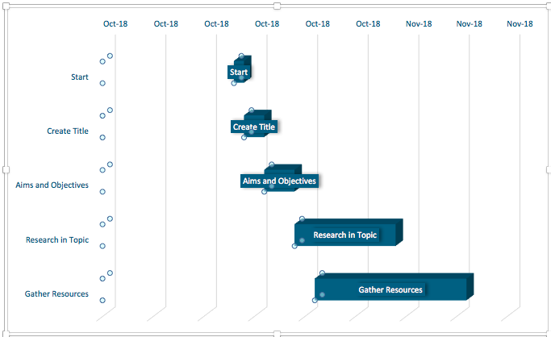

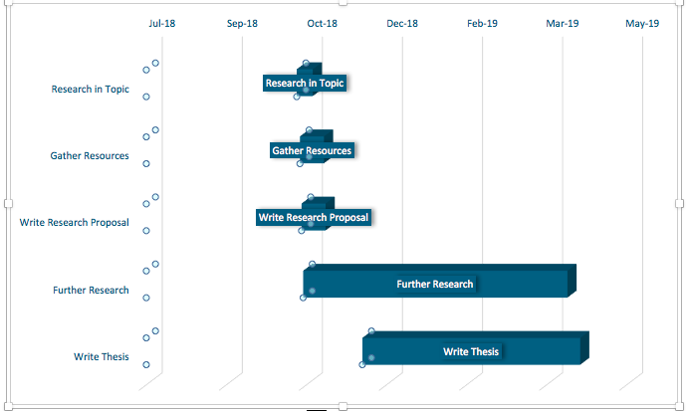

Reference List
Gillberg, C. (2009). What is Autism? International Review of Psychiatry, 2(1), pp.61-66.
Bbc.co.uk. (2018). BBC - Schools Parents - How to identify SEN. [online] Available at: http://www.bbc.co.uk/schools/parents/identifying_sen/ [Accessed 25 Oct. 2018].

Allinder, R. (1994) The Relationship Between Efficacy and the Instructional Practice of Special Education Teachers and Consultants. Sage Jounrals

TheSchoolRun. (2018). What is a special school?. [online] Available at: https://www.theschoolrun.com/what-is-a-special-school [Accessed 29 Oct. 2018].

Ambitious about Autism. (2018). Stats and facts. [online] Available at: https://www.ambitiousaboutautism.org.uk/stats-and-facts [Accessed 1 Nov. 2018].

Consumers.cochrane.org. (2018). What is a systematic review?. [online] Available at: https://consumers.cochrane.org/what-systematic-review [Accessed 1 Nov. 2018].

Biondi-Zoccai, G., Lotrionte, M., Landoni, G. and Modena, M. (2011). The rough guide to systematic reviews and meta-analyses. HSR, 3(3), pp.161-173.

Public Health Resource Unit (2006). The Critical Skills Appraisal Programme: making sense of evidence. Public Health Resource Unit, England. Retrieved from: http://www.casp-uk.net/ [Accessed 1 Nov. 2018]
Brinkkemper S (2011) Ethics in Research and Experimentation Code Conduct for Scientific Research
Experimentation in Software Engineering : Wohlin, Chapter 2.11
Brinkkemper S (2011) Ethics in Research and Experimentation. Code of conduct for scientific research experimentation in software engineering : Wohlin, Chapter 2.11 page 2-5
Barnard J, Prior A, Potter D (2000) Inclusion and Ausitm, Is it working? The National Autistic Society page 5
Teaching and Teacher Education (2000) Student teachers attitudes towards the inclusion of children with special needs in the ordinary school Pergamon Vol 16 277-293
Scott M. Myers, MD, Chris Plauche ́ Johnson, MD, Med (2007) Management of Children with Autism Spectrum Disorders American Academy of Paediatrics page 1162
Williams, Wright, Callaghan, Coughlan (2002) do children with autism learn to read more readily by computer assisted instruction or traditional book methods? The National Autistic Society vol 6(1) page 1362

Bibliography
https://www.tandfonline.com/doi/pdf/10.3109/09540269009028272?needAccess=true
http://www.bbc.co.uk/schools/parents/identifying_sen/
http://journals.sagepub.com/doi/abs/10.1177/088840649401700203
https://www.theschoolrun.com/what-is-a-special-school
https://www.ambitiousaboutautism.org.uk/stats-and-facts
https://consumers.cochrane.org/what-systematic-review
https://www.ncbi.nlm.nih.gov/pmc/articles/PMC3484632/
https://www.nccmt.ca/knowledge-repositories/search/87
http://www.cs.uu.nl/docs/vakken/arm/handouts/M7-ethics.pdf
file:///Volumes/ANGHARAD%20B/Research%20Material/Educating%20Children%20with%20Autism%20-%20National%20Research%20Council,%20Division%20of%20Behavioral%20and%20Social%20Scienc.webarchive

Appendix
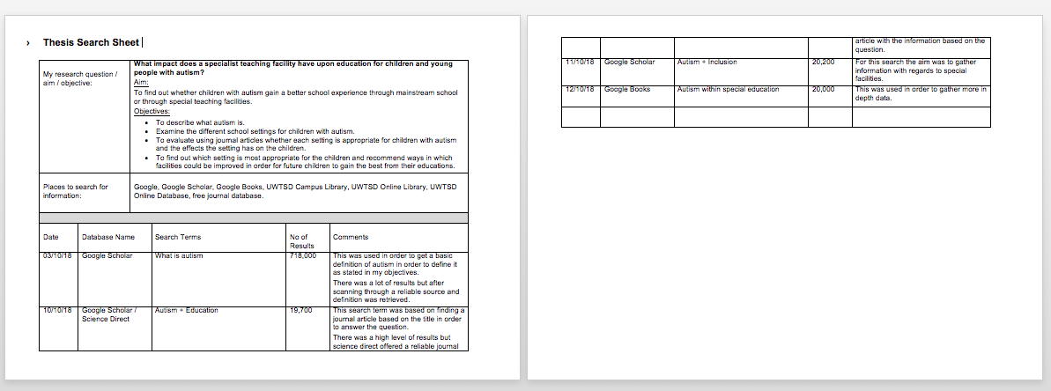
Thesis search sheet was used in order to track search terms

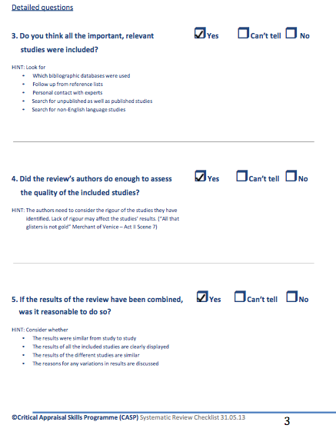
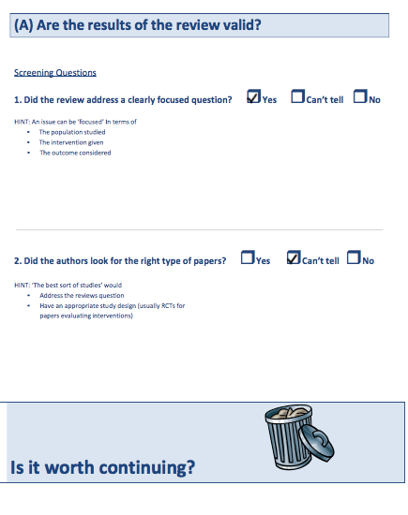
CASP form



