Luke Evans

BIT

Business Information Systems

Due 14/01/2019

Contents
Luke Evans 1
BIT 1
Business Information Systems 1
Due 14/01/2019 1
Introduction 3
Data Set Analysis, Significant Attributes and sales categories/subcategories 3
Variation of Sales over time 4
Accessories Category Sales Variation 4
Bikes Category Sales Variation 4
Clothing Category Sales Variation 4
Components Category Sales Variation 4
Trends 5
Forecasts 5
Basket analysis 5
SWOT Analysis 6
Bibliography 7
Appendix 8

Introduction
To preface this report, Screenshot 1 in the Appendix will be referred to throughout due to it containing all relevant data apart from profits and the region for which the data will be analysed for is Canada (CA). The goal of this report is to find what significance the data has for the company is question, “Adventureworks”. The data provided will be displayed through the software, Tableau and shows the company’s sales over a select period of time [1]. It should be stated that the Adventureworks database was not used directly in Tableau, the workbook with all necessary joins set up was. The data set is unable to display the total profit for the company due to the each products manufacturing cost not being provided.

Data Set Analysis, Significant Attributes and sales categories/subcategories
The data set is laid out over 4 years, from the start of 2001, to the end of 2004. The data shown is the doing of a “SUM” being created which is, quantity of a product sold multiplied by its specific unit price. This calculation would output the total amount of money earned from that product over the recorded time. For this set of data, the currency has been set to British pounds.
This data set has significant attributes that can be analysed; these include the number of instances found, any relevant figures and values that are missing from the data.
There were a couple relevant figures that were found throughout the data. One significant figure was the sales of Road bikes during 2002 which made £1,262,448,15 and this is the highest income the company gets from one subcategory over the entire time they record the data. It can be seen that Road bikes overall almost bring the highest income every single year for the company and the only figure that doesn’t match up with this is in 2004 when Road bikes sold £175,126.46 worth of products, whereas Touring bikes sold £220,145.56 worth of products that year. The next relevant figured that has to be looked at is the income for the company from the subcategory Road bikes across all recorded year because it is the highest grand total of all subcategories at an income of £2,706,809.32. The Bikes category had another relevant figure which was the grand total of their income from all years recorded; compared to the grand total of the other categories, bikes has the highest by far with a total income of £4,917,389.24.
All that can be said about profit is that it is highly likely that the company made a profit from the Bikes category products each year due to the sheer amount of income they get.
Another significant figure would be that according to the data, the Accessories category makes the least amount of income for the company with a grand total of £48,137.19 over all recorded years. This category also contains the subcategory with the least amount of income per year, Tires and Tubes only earned the company £56.33 over the recorded years.
There are a number of subcategories that have missing figures in every year apart from 2003 where they sold at least 1 of each product. In 2001 the subcategories to have missing figures in the Accessories category were Bike Racks, Bottles and Cages, Cleaners, Hydration Packs, Locks, Pumps and Tires and Tubes. In 2002 the subcategories to have missing figures in the Accessories category were Bike Racks, Bottles and Cages, Cleaners, Hydration Packs and Tires and Tubes. In 2004 the subcategories to have missing figures in the Accessories category were Locks and Pumps.
In 2001 the subcategories to have missing figures in the Bikes category were just touring Bikes. In 2002 the subcategories to have missing figures in the Bikes category were just touring bikes. 2004 was as instance for the Bikes category because it’s only category and year which isn’t 2003 where the company managed to make a sale on all the subcategory products.
In 2001 the subcategories to have missing figures in the Clothing category were Bib-Shorts, Gloves, Shorts, Tights and Vests. In 2002 the subcategories to have missing figures in the Clothing category were just Vests. In 2004 the subcategories to have missing figures in the Clothing category were Bib-Shorts and Tights.
In 2001 the subcategories to have missing figures in the Components category were Bottom Brackets, Brakes, Chains, Cranksets, Derailleur’s, Forks, Handlebars, Pedals, Saddles, Touring Frames and Wheels. In 2002 the subcategories to have missing figures in the Components category were Bottom Brackets, Brakes, Chains, Cranksets, Derailleur’s, Pedals, Saddles and Touring Frames. In 2004 the subcategories to have missing figures in the Components category were Forks and Wheels.

Variation of Sales over time
Each subcategory has a variation in sales from 2001-2004. Obviously some products were not present for the full recorded time but the variation between the years can still be seen by looking at the data set.

Accessories Category Sales Variation
The category overall can be analysed for the variation in the sales income simply by looking at the data. This category starts its sales with 1 subcategory in 2001 with a total of £5,147.56 for that year which was the lowest income for the category over the recorded time. The sales climb as 2 more subcategories are introduce in 2002 and then peaks during 2003 with a total income of £22,049.59 with that year having this category have 8 subcategories. The sales dramatically dropped in 2004 in comparison to the previous year with a total of £11,638.13 as well as the removal of 2 subcategories from the market.

Bikes Category Sales Variation
The category overall can be analysed for the variation in the sales income simply by looking at the data. The category starts its sales in 2001 with a total of £1,369,573.68 with a total of 2 products. The category peaks its sales income in 2002 with a total of £1,963,945.96 with 2 products still. The sales slowly decline until 2004 where it reaches its lowest income from sales at £469, 819.88 as well as having 3 subcategories. This category yielded the highest income per year for the company

Clothing Category Sales Variation
The category overall can be analysed for the variation in the sales income simply by looking at the data. This category begins in 2001 with its lowest sales income for the recorded time with a total of £7,947.94 with 3 subcategories. The sales continue of a decline and peak in 2003 with a total of £55, 913.13 with 8 total subcategories. The following year of 2004 saw the sales income dramatically drop with a total of £23,492.39 and the removal of 2 subcategories.

Components Category Sales Variation
The category overall can be analysed for the variation in the sales income simply by looking at the data. This category begins 2001 with an income total of £129,577.29 for that year with 2 subcategories. The sales for this category peak in 2002 for a total income of £2,254,431.24 with 5 subcategories. The sales steadily decline until 2004 where they reach the categories lowest for any year with a total of £571,139.08 and 11 subcategories.

Trends
Trends in data can be seen as patterns of change which can be used to say that the data has tendencies [2].
A noticed trend that occurs throughout the data is that for every category is that in 2004, the sales always drop significantly compared to their previous year. In fact, this is the case with literally every sub category that has both 2003 and 2004 recorded. Sales across the company and pretty much cut in half in almost every subcategory which shows when examining the grand total.
One other trend that becomes very clear is that the majority of money earned each year and overall is from selling products from the bikes category. The maximum amount of money they earned from one category in a year was from the bike category with a total of £1,963,945.96 in 2002. This shows that the customers of this company spending the most amount of money on this category and perhaps more variation and addition of new products could increase sales in this category by even more.

Forecasts
Forecasting is a way of analysing data and predicting the future going off of the current information. Forecasts can end up being wrong but it gives a company something to go off when making changes to increase the amount of sales and income them get [3].
A forecast can be made for the data; when you look at the Bikes category in particular, you can see that the sales steading climb over 2001 and 2002. Then in 2003 the sales peaked when they introduced the subcategory touring bikes, but then then the sales cut in half for each subcategory in that category. This could possibly show that due to a new product being introduced, an influx of sales happen all in one year which means that a lot less people will need a bike the following year. It may suggest that it will steadily climb in the coming years once more until they have a spike in sales due to the introduction of another new product. Introducing new products more frequently across all categories can increase the amount of sales in a certain year.

Basket analysis
Basket analysis is a technique that is a form of data mining which can be used for identifying combinations of products that are often purchased together [4]. This can benefit a company as they can see where they could possibly implement some sort of promotion involving a special deal with the two products.
There is no clear data to show that items have been purchased in combination, but there are some recommendation of deals that the company can offer in later years to increase the sales of certain products. One example would be the subcategory Mountain Bikes that drastically dropped in sales during 2004. The sales may be increased for the following year if a special deal in put in place, such as combining mountain bikes with helmets. This combination bundle should increase the sales of each of these products at the cost of a small loss of profit. The same can be said if the company were to add a new product under a new subcategory in the Bikes Category. The sales of the new product would sky rocket in comparison to previous years due to the deal with added helmets.

SWOT Analysis
SWOT analysis is a useful tool that will be used to discover the strengths, weaknesses, opportunities and threats for the company from their data set. SWOT is an analysis tool that involves splitting the 4 sections into boxes which will create a diagram that is easy it read [5]. See Screenshot 2 in the Appendix for an example of a SWOT analysis diagram.
 | Helpful | Harmful
Internal origin | Strengths:  - Ability to utilise more products for their categories.  - Road bikes are a strength as it’s the subcategory with the highest income overall.  - The Bike category as a whole is a strength to the company due to its high income. | Weaknesses:  - Uncertainty of when the number of sales will drop for a category.  - Tires and Tubes Subcategory is technically a weakness because it bring in the least income overall.
External origin | Opportunities:  - A gap in their market can allow the company to invest in a new product with this new level of customer demand. | Threats:  - Other organisations selling products for cheaper.  - Other companies discovering and utilising them first.

Bibliography

[1] | Tableau, [Online]. Available: https://www.tableau.com/trial/tableau-software?utm_campaign_id=2017049&utm_campaign=Prospecting-CORE-ALL-ALL-ALL-ALL&utm_medium=Paid+Search&utm_source=Google+Search&utm_language=EN&utm_country=UKI&kw=tableau&adgroup=CTX-Brand-Core-EN-E&adused=284749282246. [Accessed 5 January 2019].
[2] | “trend,” Business Dictionary, [Online]. Available: http://www.businessdictionary.com/definition/trend.html. [Accessed 5 January 2019].
[3] | G. Knight, in Analyzing Business Data with Excel: Forecasting, Statistics, and Data Management, O'Reilly Media, Inc, Workload Forecasting , pp. 42-43.
[4] | “A Gentle Introduction on Market Basket Analysis — Association Rules,” datascienceplus, 2 October 2017. [Online]. Available: https://datascienceplus.com/a-gentle-introduction-on-market-basket-analysis%E2%80%8A-%E2%80%8Aassociation-rules/. [Accessed 7 January 2019].
[5] | A. Sarsby, “Introducing SWOT,” in SWOT Analysis, Lulu.com, 2016, pp. 3-4.
[6] | [Online]. Available: https://upload.wikimedia.org/wikipedia/commons/thumb/0/0b/SWOT_en.svg/1200px-SWOT_en.svg.png. [Accessed 6 January 2019].

Appendix

Screenshot 1:
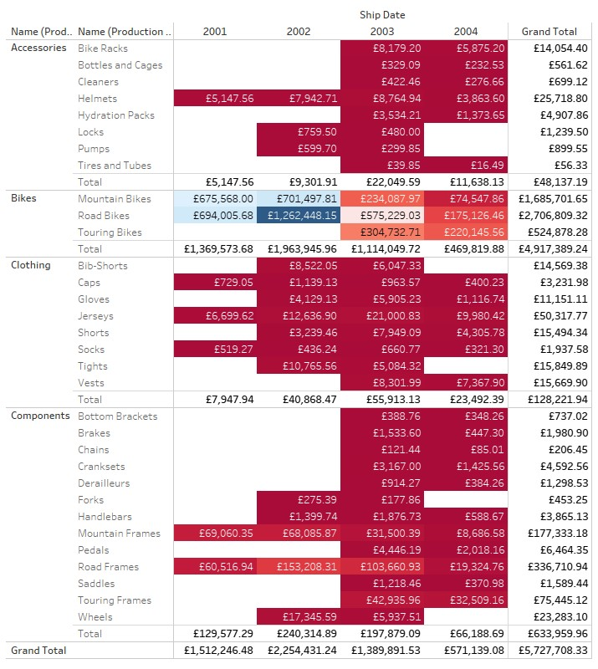

Screenshot 2 [6]:
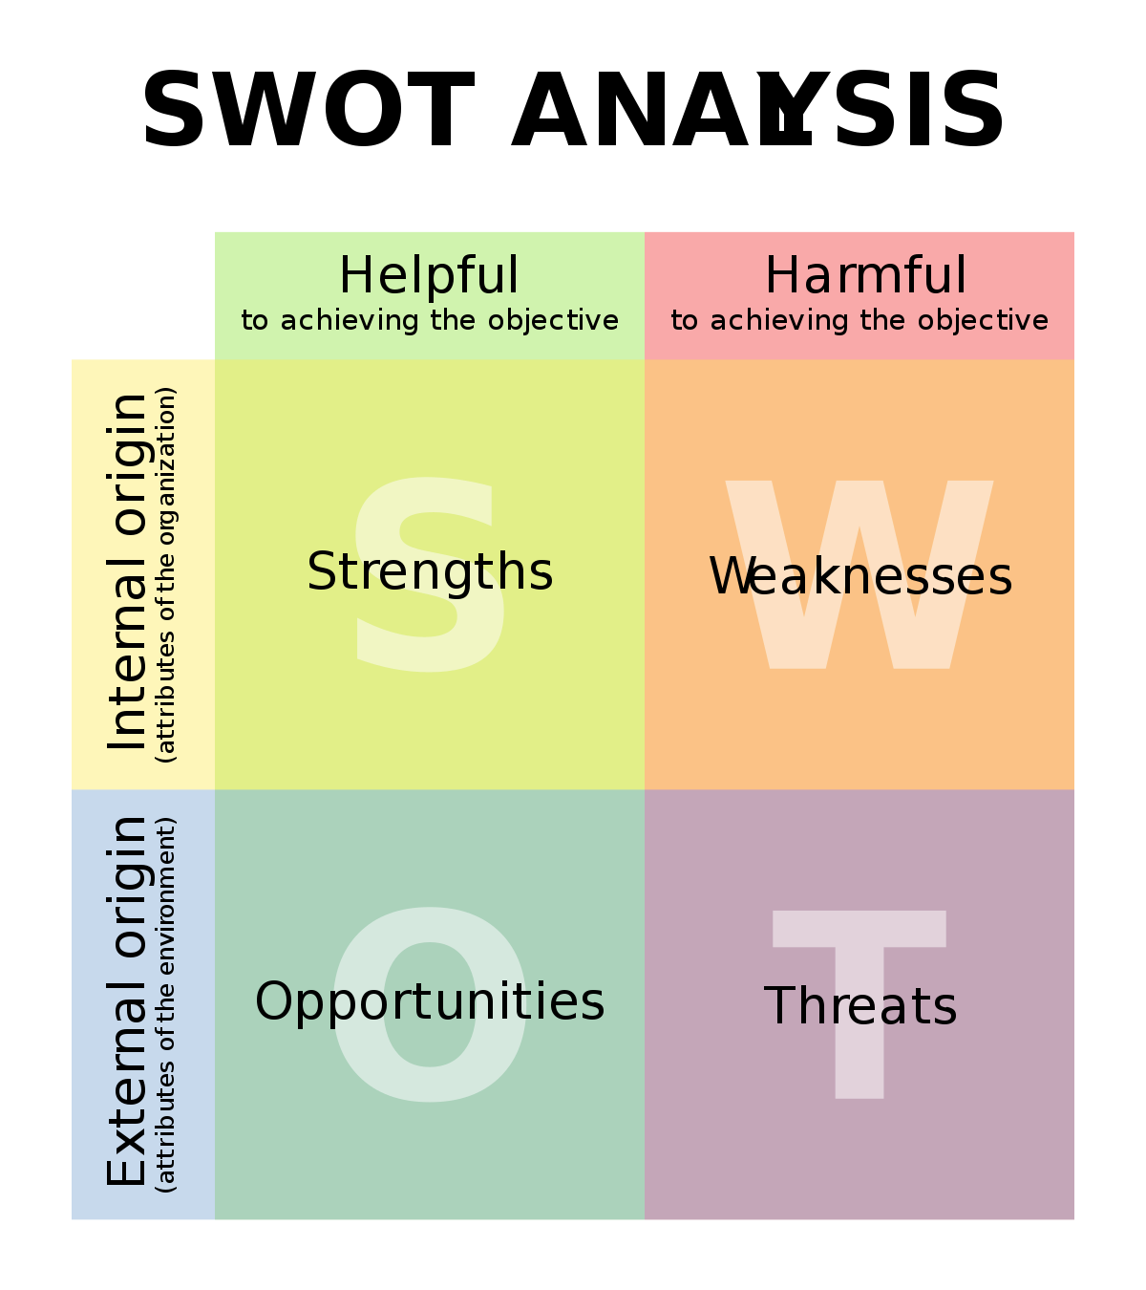
Accessories subcategories Sales Variation (Example)
The subcategories for the Accessories category have variation in sales income over their time on the market. The Bike Racks subcategory begins in 2003 at a peak of £8,179.20 and then in 2004 dropped to its lowest of £5,875.20. The Bottles and Cages subcategory begins in 2003 at a peak of £329.09 and then in 2004 dropped to its lowest of £232.53. The Cleaners subcategory begins in 2003 at a peak of £422.46 and then in 2004 dropped to its lowest of £276.66. The Helmets subcategory begins in 2001 at £5,147.56, continues through to peak at 2003 with an income of £8,764.94 and then in 2004 dropped to its lowest of £3,863.60. The Hydration Packs subcategory begins in 2003 at a peak of £3,534.21 and then in 2004 dropped to its lowest of £1,373.65. The Locks subcategory begins in 2002 at a peak of £759.50 and then in 2003 dropped to its lowest of £480.00 for its last year on the market. The Pumps subcategory begins in 2002 at a peak of £599.70 and then in 2003 dropped to its lowest of £299.85 for its last year on the market. The Tires and Tubes subcategory begins in 2003 at a peak of £39.85 and then in 2004 dropped to its lowest of £16.49.

