
Professional Career Development
Student Name | Samia waseem
Student ID | 2123965
Module Leader | Olubukola Adegbite
Module Code | BMSW4005
Date of Submission | 06/04/2023 15:00
Word Count | 1938

Contents
Introduction 3
1.1 SWOT Analysis 3
1.1.1 Explanation of SWOT Analysis 4
1.2 Personal Development Plan (PDP) 5
1.2.1 Explanation of the PDP 5
2.1 Reflection on Theories 5
3.1 Gibbs Reflective Model 7
3.1.1 Description: 7
3.1.2 Feelings: 7
3.1.3 Evaluation: 8
3.1.4 Analysis: 8
3.1.5 Conclusion: 8
3.1.6 Action Plan: 9
References 9

Introduction
The purpose of this assignment is to assess my own skill set and competencies using the analytical tools that I have learned in the module, including SWOT Analysis and Personal Development Plan (PDP). I will also reflect on the learning style theories that I have learned and explain how they have impacted me in improving my workplace related knowledge and practices. Finally, I will use a suitable reflective model (Gibbs) to assess the concepts that I have learned from this module. Through this assignment, I aim to gain a deeper understanding of my strengths, weaknesses, opportunities, and threats, and create a personalized development plan that will guide my future growth. I will also identify my preferred learning style and how I can use it to enhance my performance in the workplace. The reflective model will allow me to analyze my experiences and emotions, facilitating a more personalized and meaningful learning experience.

1.1 SWOT Analysis
In academia and business, SWOT analysis is one of the most commonly used strategic planning tool to effective measure the internal and external strengths and weaknesses; opportunities and threats of an organization or person (Leigh, 2010). Similarly, I will apply this tool for my personal analysis.
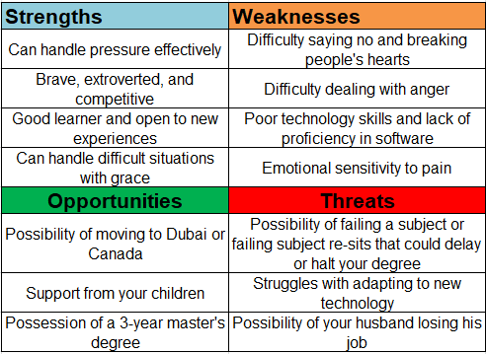

1.1.1 Explanation of SWOT Analysis
The SWOT analysis table 1 above provides a thorough assessment of my individual strengths, weaknesses, opportunities, and threats. My personal SWOT analysis identified my strengths, including my ability to handle pressure effectively, bravery, extroverted nature, competitiveness, and my capability to handle difficult situations with grace. However, I also recognized my weaknesses such as difficulty saying no, struggles with dealing with anger, emotional sensitivity to pain, and lack of proficiency in software and IT related tasks. The analysis also highlighted opportunities such as I will be moving to Dubai or Canada, possessing a 3-year master's degree, and having the support of my children. All of these incidents are likely to shape the future course of action for myself. On the other hand, potential threats include the possibility of failing a subject or re-sit, struggle with adapting to new technology, and the possibility of my husband losing his job, which can impact my professional career adversely. The SWOT analysis provides a foundation for creating a personal development plan to capitalize on strengths, address weaknesses, and prepare for potential threats while taking advantage of available opportunities because SWOT Analysis is the tool to zoom in to the personal capabilities (GÜREL, 2017).

1.2 Personal Development Plan (PDP)
As per theory, PDP is a structured tool to identify the key personal and professional aims and targets of an individual to design a suitable roadmap for oneself that helps achieve the long-term and short-term goals (Beausaert et al., 2013).
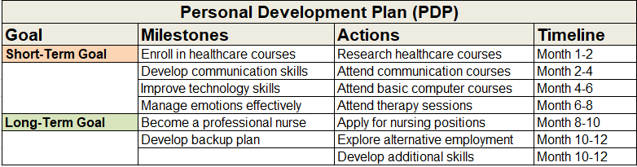

1.2.1 Explanation of the PDP
The Personal Development Plan (PDP) table outlines specific goals, milestones, actions, and timelines for achieving personal and professional growth. The short-term goals involve enrolling in healthcare courses, attending communication and basic computer courses, and attending therapy sessions to improve emotional management skills. These goals are expected to be achieved within the first six months. The long-term goal is to become a professional nurse, with the timeline for applying for nursing positions set between months 8 and 10. Developing a backup plan and exploring alternative employment options are milestones to be achieved between months 10 and 12 because research studies have found that alternative plans help better handling the contingencies (Napolitano & Freund, 2016). Developing additional skills is also a priority during this time. Overall, the PDP aims to support continuous personal and professional development through achievable goals and clear timelines.

2.1 Reflection on Theories
Learning style theories refer to the various approaches to learning that individuals use to acquire knowledge and skills. These theories have been developed based on the premise that people learn in different ways, and understanding one's learning style can help in improving the learning process (Sieber & Andrew, 2005). In this reflective report, I will discuss the learning style theories that I have learned during my module and how they have impacted my workplace experience in real-time.
Initially, I was unaware of the different learning styles and how they can impact the learning process because I never studied any such theory. However, after learning about various learning style theories, such as Kolb's model, Honey & Mumford's theory, and Neil Fleming's VARK model, I realized that my preferred learning style is the Kolb model (Bergsteiner et al., 2010). And there is a fair reason behind this likeness. The Kolb model of learning focuses on four stages, including concrete experience, reflective observation, abstract conceptualization, and active experimentation (Morris, 2019). According to this model, individuals learn through a cycle that involves experiencing, reflecting, thinking, and acting. And that is very true for my case because I always through these four stages. But before knowing this theory, I had no conscious idea of the systematic process I used to learn. This theory really inspired my cognition because I can relate to the process of learning.
Understanding my preferred learning style has impacted my workplace experience in several ways. Firstly, it has enabled me to recognize the areas in which I excel and those that need improvement because I focused on myself: analyzed myself, critiqued, and then conceptualized that where I am and what am I doing. For instance, I realized that I learn best through hands-on experiences and reflecting on these experiences. Therefore, I have been able to seek out opportunities that allow me to apply my knowledge and skills practically. Theory without application is a dull experience for me because I am instinctively creative. And the activities during the module helped me practically apply the theory and get hands-on experience.
Additionally, understanding my learning style has allowed me to adapt my learning approach to different situations. For example, I have learned to take notes and reflect on my experiences during meetings or presentations, which has helped me retain information better. Based on my notes taking habit, I am able to write the reflection report for myself. Besides critiquing myself on the basis of notes and brainstorming, I kept the log of my learning that actually showed me my real-time progress. And this is sheer experimentation.
Moreover, recognizing my learning style has also helped me to communicate more effectively with my colleagues because better having the critical perception of things give foundational support to better communicate ideas (Morreale, 2001). By understanding their learning styles, I can adapt my communication and learning approach to ensure that the information is being conveyed effectively. Furthermore, understanding learning style theories has also helped me to develop a more effective training and development program in my workplace because I am aware that in my care taker profession I have to make vulnerable humans learn things which are really important for them. And now the learning theories have equipped me to impart my trainings systematically to the learners because I know which method of learning will be suitable for them. By taking into account the different learning styles of employees, I can develop training materials that cater to their individual needs and preferences, which can lead to better engagement and knowledge retention.
In conclusion, learning style theories have had a significant impact on my workplace experience in care taking. Understanding my preferred learning style has enabled me to recognize my strengths and weaknesses, adapt my learning approach to different situations, communicate more effectively with my colleagues, and develop a more effective training and development program. Overall, I believe that knowledge of learning style theories is essential in improving the learning process and maximizing the potential of individuals in the workplace (Yousef et al., 2020).

3.1 Gibbs Reflective Model
The Gibbs Reflective Model is a tool for examining experiences in detail and gaining insights. It involves several structured stages, including description of the event, reflection on emotions, evaluation of the experience, analysis of different perspectives, drawing conclusions, and creating an action plan. This model enables uncovering hidden insights and lessons to promote personal growth and development. Like the nurturing of a seed into a beautiful flower, it helps individuals to learn from their experiences and blossom (Adeani et al., 2020).
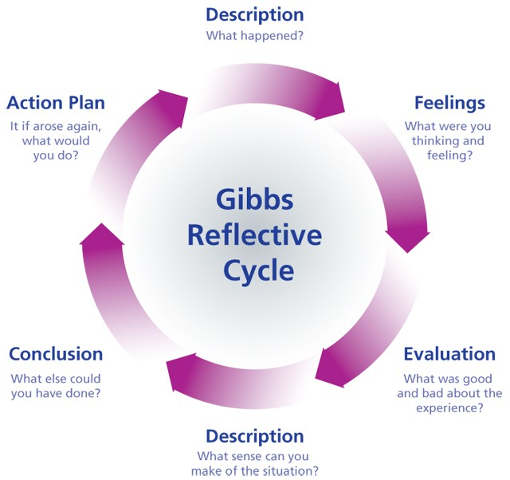

3.1.1 Description:
In this reflective report, I will be discussing the various theories and concepts I have learned in my class, focusing on personal development plan, learning log, self-awareness, learning styles, career development process, and employment legislation in the UK. Additionally, I will be reflecting on my short-term and long-term goals and how these theories and concepts have helped me in formulating my personal development plan.

3.1.2 Feelings:
Initially, I felt overwhelmed with the amount of information and theories that I had to comprehend. However, as I delved deeper into the topics, I realized the significance of these theories and how they can help me in my personal and professional development. Learning about self-awareness and self-evaluation processes, personal SWOT analysis, and Johari Window helped me gain insight into my strengths and weaknesses, which I believe will assist me in achieving my long-term goals.

3.1.3 Evaluation:
Learning about various learning styles, such as Kolb, Honey & Alan, and Neil, was an eye-opener. I realized that my preferred learning style is the Kolb model, which focuses on concrete experience, reflective observation, abstract conceptualization, and active experimentation. Understanding my learning style will help me in developing a learning plan that best suits me.
Similarly, learning about career development processes, such as Discover Yourself, Explore options, Make choices, and Take action, was beneficial. It allowed me to reflect on my skills, interests, and values, which will help me in identifying the right career path for myself. Additionally, learning about employment legislation in the UK was insightful as it highlighted the legal aspects of employment that I should be aware of.

3.1.4 Analysis:
Overall, I believe that the theories and concepts I have learned in this class are crucial for personal and professional development. They have helped me in identifying my strengths and weaknesses, understanding my learning style, and formulating a personal development plan that is achievable and has clear timelines.
Additionally, the knowledge I have gained about employment legislation in the UK has helped me understand my rights and responsibilities as an employee, which will be useful when I start my career. The career development process has also helped me in identifying the skills and knowledge required for the nursing profession, which I plan to pursue.

3.1.5 Conclusion:
In conclusion, the theories and concepts I have learned in this class have been insightful and have helped me in formulating my personal development plan. I believe that the knowledge I have gained about self-awareness, learning styles, career development, and employment legislation will be beneficial for me in my personal and professional life.

3.1.6 Action Plan:
To achieve my short-term goals, I plan to enroll in healthcare courses, attend communication and basic computer courses, and attend therapy sessions to improve my emotional management skills within the first six months. In the following two months, I plan to explore internship opportunities and graduate schemes to gain relevant experience.
Between months eight and ten, I plan to apply for nursing positions, and between months ten and twelve, I aim to develop a backup plan and explore alternative employment options. Additionally, I will focus on developing additional skills, such as communication, leadership, and teamwork skills, during this time.
To support my personal and professional development, I will regularly reflect on my progress and adjust my plan as required. I will also seek feedback from my mentors and peers to identify areas for improvement and work on them. Overall, my personal development plan aims to support my continuous learning and growth, enabling me to achieve my long-term goal of becoming a professional nurse.

References
Adeani, I.S., Febriani, R.B. and Syafryadin, S. (2020) “Using Gibbs� reflective cycle in making reflections of Literary Analysis,” Indonesian EFL Journal, 6(2), p. 139. Available at: https://doi.org/10.25134/ieflj.v6i2.3382.
Beausaert, S. et al. (2013) “Effect of using a personal development plan on learning and development,” Journal of Workplace Learning, 25(3), pp. 145–158. Available at: https://doi.org/10.1108/13665621311306538.
Bergsteiner, H., Avery, G.C. and Neumann, R. (2010) “Kolb's experiential learning model: Critique from a modelling perspective,” Studies in Continuing Education, 32(1), pp. 29–46. Available at: https://doi.org/10.1080/01580370903534355.
GÜREL, E. (2017) “SWOT analysis: A theoretical review,” Journal of International Social Research, 10(51), pp. 994–1006. Available at: https://doi.org/10.17719/jisr.2017.1832.
Leigh, D. (2010) “SWOT analysis,” Handbook of Improving Performance in the Workplace: Volumes 1-3, pp. 115–140. Available at: https://doi.org/10.1002/9780470592663.ch24.
Morreale, S.P. (2001) Communication: Motivation, knowledge, Skills, Google Books. Peter Lang. Available at: https://books.google.com/books/about/Communication.html?id=OQpTMwEACAAJ (Accessed: March 4, 2023).
Morris, T.H. (2019) “Experiential learning – A systematic review and revision of Kolb’s model,” Interactive Learning Environments, 28(8), pp. 1064–1077. Available at: https://doi.org/10.1080/10494820.2019.1570279.
Napolitano, C.M. and Freund, A.M. (2016) “On the use and usefulness of backup plans,” Perspectives on Psychological Science, 11(1), pp. 56–73. Available at: https://doi.org/10.1177/1745691615596991.
Sieber, V. and Andrew, D. (2005) “Learning technologies and learning theories,” Encyclopedia of Distance Learning, pp. 1248–1256. Available at: https://doi.org/10.4018/978-1-59140-555-9.ch185.
Yousef, A., Salah, R. and Makram, E. (2020) “Investigating different educational blog characteristics to support collaborative learning based on connectivism learning theory,” Proceedings of the 12th International Conference on Computer Supported Education [Preprint]. Available at: https://doi.org/10.5220/0009425601180129.

