
Reflective Project Report
Ethan Langdon

May 11, 2023
University of Wales Trinity Saint David

Executive Summary
This reflective report investigates a project and how it has been managed. Eurobond Door is a well-known manufacturer for steel doors and door frames for the past three decades, and over this time has built a large customer base. There are a range of fire doors that they manufacture, with the EI Door being its newest. The EI Door project is a new fire door that has recently been introduced into the company of Eurobond Doors, with EI standing for ‘Integrity and Insulation’. The design of this door has been specifically created to have a higher tolerance to smoke spreading in the event of a fire and it also prevent the spread of the fire.
Also, this company decided to choose the tasks for their employees by using a strength-finder to identifying the employee’s skills that they are best at to ‘match’ them with a task that they will do well at and this would then also mean that the task in hand will be done to a high standard. This report also explores the research of having the employees of the company to -buy-in to the new project and how strength-based management can have a positive impact on the workforce of the company. It states that by having a rewards system for employees who have been see to excel at their work and have gone above and beyond what has been asked have been rewarded with gift cards or ticket to experiences and this has boosted the moral of employees and motivated them into accepting the new project more seamlessly. Also, the definition of change has been defined and the way in which different people perceive change differently has been considered and discussed.
The methodology section discusses qualitative and quantitative data and how this can be used to get general feedback from the workforce about how they feel that the new project has been progressing and if they could see any improvements that may need to be made, and this gives an opportunity for them to ask questions about any queries in relation to the project that they may have so these can be addressed by management later. Additionally, a Gantt Chart and project plan has been included to give a brief overview of the timescale of this project and a plan of how the project will be completed in a step-by-step process.
Table of Contents
Executive Summary 1
Introduction 2
Main Findings 2
Research 2
What will this report achieve? 4
Methodology 4
Gantt chart 5
Project Plan 5
Analysis of the project 7
What was learnt from this project? 9
Conclusion 10
Bibliography 10

Introduction
Eurobond doors Limited is a major manufacturer for high-quality steel doors and door frames. They have been supplying these products to customers in the construction industry for the past three decades. The steel doors produced by this company come in a few variations, these include; security doors, acoustic doors, blast resistant doors, fire doors and now their latest project, EI doors. These products have been supplied and used in a multiple of sectors, the most common sectors include; commercial, industrial, and public buildings. Over the last three decades, Eurobond Doors has established a good reputation for their reliability, customer service and innovation (Eurobond Doors, n.d).
In the more recent years, Eurobond doors has been developing a new product, this product is called the EI door. The EI door is a fire-rated door that has been specifically designed to create a higher protection against the spread of smoke during a fire and help reduce the spread of fire. This product is set to revolutionise the fire protection industry as well as being the first EI door to be fixed in place without the need to fill the frames with concrete afterwards. This in turn, will save a vast amount of time on construction sites as it means that the door can be screwed into the clear opening and adjusted, instead of having to pour the concrete in and wait for the concrete to set over a multitude of hours. As the EI project was introduced, it created a massive change within the company and how it operates. One of the changes within the project was the introduction of a new machine, and this aims to aid the process for the new product. Another change within Eurobond Door was and the introduction of new processes and programmes on multiple machines.
This project was started because this specific door was requested by a wide range of our customers, from this we identified a gap in the market, to fill this gap the EI project was started. When this project was first put forward to the rest of the company there was resistance from employees due to the significance of change to their working environment. Over the course of the project employees warmed up to the project and started to embrace and help in further developing the EI project. A few employees even took some time to put forward ideas of their own to make processes easier or quicker. The introduction of a new machine also brought in a learning curve for new operators and the project team, this learning curve pushed the team to develop old skills they have not used for a while or to acquire new skills to cope with this new change. There has been an analysis of the project added also.

Main Findings

Research
The EI door is a door that abides by the European standards, these doors are most used in data centres and various commercial settings that require the integrity and insulation standards. Having this standard on a door means that it can prevent and withstand the spread of fire, this is what gives the door its integrity. These doors are also used to prevent heat transfer, this is used to prevent any flammable or combustible materials near the door do not burn or explode, this is what gives the door its insulation. The door needs this type of protection so that the area around the door can be used as a safe escape route during an emergency (CEN-CENELEC, 2014).
To help in ensuring that this project ran smoothly and that all employees bought into the idea, employee buy-in was investigated to attempt to get employees to interact and show more interest in the project. Although there is a physical enactment with the project, the biggest task was to encourage the employees to ‘buy-in’ to the changes that the project was bringing in. There were a range of factors that were explored when it came to getting the employees to buy-in to the changes in which the project has created; some of these included committing to the change, accepting the project, providing support specifically towards their initiatives and their decisions. To ensure that these factors were achieved to a high standard, the theory of social exchange was used in order to get employees to engage and display commitment to the changes that the project has brought. This has been suggested in the book ‘Exchange and Power in Social Life’ (1964) that the principles of social exchange theory can be determined by looking into an individual’s chances of deciding based on what they perceive to be the benefits and the costs (Blau, 2964)
A positive way to execute the decisions that have been made by employees can include rewards when they have gone ‘above and beyond’ the task in which they have been set to aid the development of the task in order to attempt to make the task at hand more efficient, straightforward, and even safer to complete. Within this project, this concept was executed by the development of a ‘Employee Spotlight Programme’ which aimed to highlight and individual employee’s achievements within the company and then rewarding them with thing such as tickets for experiences or gift cards. Figure 3 (EDB Spotlight award) this shows an example of an employee who has been selected for the Employee Support programme’ as they had gone beyond what was expected of them and it has aided the development of the project. When the employees are motivated further, they are more willing to take part in the project and the changes in which it brings. This is illustrated in the book ‘Work and Motivation (1964) states that by giving an incentive such as physical rewards to the individuals within the company, this will help to increase the relationship between their performance and reward.
Strength based management was also used within this project. The book ‘Now Discover Your Strengths’ by Buckingham and Clifton (2001) suggests that an assessment tool named ‘Strength Finder’ is known as a method of management called strength-based management’. This is when the management is based off the confidence that all the employees tend to exceed expectations when the attention is on their strengths rather than attending to improving their weaknesses. This approach can be heavily utilised by ensuring tasks are matched with the employee’s strengths and result in maximum utilization of their skills and the task is then completed usually to a high standard. Additionally, this method improved the employee’s morale as they will begin to create a positive environment where they are able to work on the tasks that the excel at and potentially enjoy doing.
The method of Strength-based management gives advantages to several principles and key techniques. One of these being the strength-assessment, and this is used to recognise an employee’s skills and abilities, and this usually happens by using assessments such as Strength-finder (Gallup, nd) Also, there is another method named talent matching. This is used after once the skills and abilities have been identified and this aids managers to assign the most suitable jobs to the employees who have advanced skills needed for the task. Although this cannot always be achieved, there needs to be some balance between what the tasks requires and the skills that occur naturally with the team of employees. The collaboration of the team can massively benefit from this method as the teams can be formed to ensure that each member has different skillsets and this in turn will build a team with a diverse skillset and this can result in a massive increase in their performance in their work. Additionally, development from an individual level is used in order to help enhance the employee’s skills further in ways such as mentoring and coaching from managers or other employees. Finally, the feedback and recognition are a vital section of any method of management because showing gratefulness of their contribution to the project and providing them feedback on their work can aid the employees to understand where they can improve further but more important, they know that they are appreciation for their work within the project (Buckingham and Clifton, 2001)
As a change was introduced investigating how change is perceived was also beneficial. Change can be defined as a process in which something develops into something that is different to what it was originally. Change can take place in a wide range of forms such as change within circumstances, physical changes, and changes within the behaviours. Also, change can also be intention or unintentional, and voluntary or involuntary; and they can also happen gradually over the course of a period, or they can be very sudden. Change is perceived in a huge range of ways can this can differ from individual to individual, and there are factors that can influence this. Factors can include: personal experiences, expectations from the individual, beliefs, and personality. From the various perceptions of change, some individuals see it as an opportunity to progress and improve within their job role, while others may view it as a negative move and create friction and conflict as they believe it is a disruption to the way they have worked. (Barron and Hulleman, 2015)
Also, it is suggested that the individual’s perception on change can be hugely affected by the type of change that is occurring around them or to them. An example of this is if the change is viewed as a positive action, then the reaction from the employees tends to be more optimistic and embrace the change that the new project has brought. However, if the change is viewed as a negative action, then this can cause friction from the employees and they lose motivation and not accept the change as easily. Also, if the change is perceived as inevitable and means that the company is progressing with the forever-evolving technology, then this tends to be accepted easier than changes that are seen as ‘luxury’ or ‘not needed’. The perception of change is seen as intricate and multi-layered, and this means that it is usually influenced by a huge number of factors. (Oreg and Sverdlik, 2011)

What will this report achieve?
This report will aim to evaluate on the management of this project and discover the importance of employee buy-in in relation to the overall success of this project success. In the dynamic of a competitive business, effective project management and the support of employees are an essential asset for achieving the desirable outcome. Consequently, it is crucial to investigate how the project was managed and how the employee buy-in had played a key role in shaping the outcome of the project.
The main objective of this report will be to evaluate the projects management and how it contributed to the outcome of the project, by investigating the elements involved in this such as, project planning, resource allocation, risk management, communication, and their decision-making process, from evaluating these key areas an insight can be gained into the key factors that had an influence on the overall project’s performance. Also, from understanding these key factors is a vital part of identifying strengths, addressing the weaknesses and aids to refine project management approaches. Furthermore, this report will also recognise the critical factor of employee buy-in and how it contributed to the project’s outcome.
By investigating the relationship between the management of the project and the employee buy-in, the report will aim to bring into light the interdependences and dynamic between these two factors. When project management is handled effectively it has the potential to foster employee engagement, meanwhile employee buy-in can aid in enhancing the effectiveness of the project management. This report will provide an understanding on how these factors will interact and how they will contribute to the project’s success.

Methodology
When a change happens in an organisation every employee will naturally resist the change. This is usually due to the employees may not possess the experience or motivation to recognise when an urgent change is needed. This change could also come with a hesitation from the employees as it causes uncertainty and may cause doubts regarding job security (Bateh, Castaneda & Farah, 2013). Accomplishing employee buy-in can be seen as getting the employees to accept and actively aiding in the process. Factors that influence this may include, actively involving employees in decisions, continuously asking for feedback through the entire process while using this feedback to aid the development process. Another method to help increase employee buy-in is to have often and clear communication to help the employee understand why the change has come about and what it can entail. The issue that is faced with employee buy-in is that it is difficult to measure as it is qualitative data.
One way to turn qualitative data into quantitative data was to carry out a survey that asked questions that employees can answers on a scale from 1-10, this will then be able to formatted as quantitative data and can be further assessed rather than having an answer that could be open to interpretation (Joshi, Kale, Chandel & Pal, 2015). When asking question answered to be desired are about, feedback, happiness, relationship and personal growth, questions in these areas can be answered using the Likert scale as shown in Figure 1.
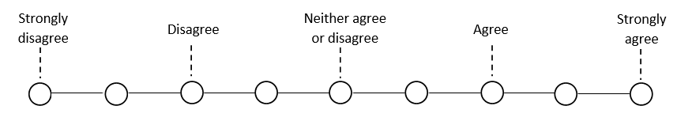
Figure 1 (Likert scale)
This questionnaire and scale combination can also be used to evaluate whether the project was managed effectively by slightly adjusting the questions to be able to question management on their time keeping, employee involvement, employee development, innovation, and communication. This data can then be turned from qualitative to quantitative so it can be further evaluated and improvements can be suggested or implemented.

Gantt chart
 | Week commencing
Task | 02/01/23 | 09/01/23 | 16/01/23 | 23/01/23 | 30/01/23 | 06/02/23 | 13/02/23 | 20/02/23
New programmes on RAS
New programmes on HFE
Batch Run
Address NCR’s
Operator training
Table 1 (project Gantt chart)

Project Plan
During this project there were some key tasks that needed to be completed. The first task that needed to be completed was to ensure that all programmes were set up correctly on each machine, this included the RAS and HFE. The RAS up down bend is a panel bending machine that is used to primarily fold Door Skins. These skins are what make up the external shape of the door. After the skin is folded on the RAS, it is placed on a pallet and sent for powder coating. Then, once the skins have been coated, they are sent to the bonding area of the factory as they are now ready to be filled and clipped together, before being pressed together to set the glue. To get the all the programmes completed on the RAS, it requires a programme for the active and static door. The HFE is a press break that is used to fold the frames that go with the door, to get the programmes completed on the HFE there will be a programme for the head of the door, the side frames, and the inserts for these two components. The next step was testing these programmes by running a batch trail of the required components, this allowed for the programmes to be tested and adjusted before moving any further.
The next task to complete was to conduct an operator survey to gain an idea on where the employees stand on this project. From knowing these actions can be taken to aid in increasing employee buy-in. Ensuring that the employees buy-in the project or change will have a massive impact on the project, this is due to employee buy-in having a direct impact on motivation, teamwork, and creativity. This will in turn have an impact on the projects overall success rate. From seeing the research on this area, it was decided that increasing employee buy-in was vital to increase to the success rate of this project (Vroom, 1964). At the end of the implementation for the employee buy-in increase, another survey will be taken to analyse if any progress was made. The final step was to run a batch run of doors through the newly implemented production programmes and processes. During the batch run any issues raised will be noted down and rectified so the trail will be able to continue. The batch run can also be used as an opportunity to train operators on the new programmes and processes introduced.

Analysis of the project
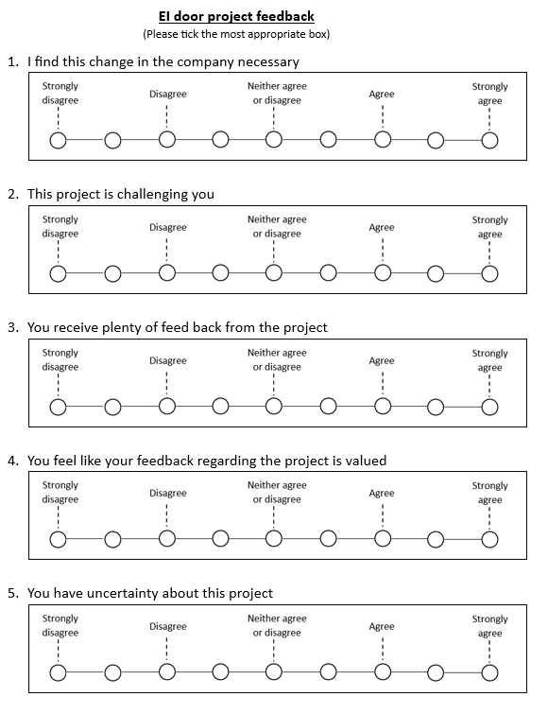
Figure 2 (EBD EI project questionnaire)
As can be seen in Figure 2 (EBD EI project questionnaire), this was the questionnaire handed out to multiple employees to gain an understanding on where employees stood on this project. This questionnaire also allowed for areas to be highted that needed improvement or even areas that already have employees on board with. When this questionnaire was handed out it was given to a select few that worked in the affected areas of the project, this included, the RAS and HFE. To quantify the data received from this questionnaire it was decided that the “strongly disagree” would relate to a -2 score and “strongly agree” would relate to a +2 score, using this system the scores were recorded in a table as shown in Table 2 (EBD EI questionnaire results).
Operator |  | 02/01/2023 (before project started) |  |  |  |  |  | 06/02/2023 (during project)
Last | First | Q1 | Q2 | Q3 | Q4 | Q5 | Avg | Q1 | Q2 | Q3 | Q4 | Q5 | Avg
Mathews | Blake | -1 | -2 | 0 | -1 | -2 | -1.2 | 1 | 2 | 0 | 1 | 2 | 1.2
Griffiths | David | -2 | 0 | 1 | -1 | -2 | -0.8 | 0 | 2 | 1 | 2 | 2 | 1.4
Davies | Barrie | -2 | 0 | -2 | -1 | 2 | -0.6 | 2 | 0 | 1 | 1 | 0 | 0.8
Williams | Chay | 0 | -2 | 1 | 0 | 1 | 0 | 2 | 2 | 1 | 2 | 1 | 1.6
Guy | Eddy | -1 | -2 | 0 | -1 | -1 | -1 | 0 | 1 | 2 | 2 | 1 | 1.2
Lewis | Rhideon | -2 | 0 | -1 | -1 | 0 | -0.8 | 0 | 1 | 1 | 1 | 1 | 0.8
 |  |  |  |  | Average |  | -0.7 |  |  |  | Average |  | 1.4
Table 2 (EBD EI questionnaire results)
As shown in Table 2 (EBD EI questionnaire results), the average result from before the project started came out to be -0.7, this showed that as an overall the employees had a negative opinion the project and that things needed to be changed in order to help increase the average. By increasing the average, it would also increase the likely hood that the project will succeed. A decision by management was them made that a few corrective actions should be implemented to aid in increasing the employee’s opinion. The changes implemented were, the spotlight award and the company newsletter.
The spotlight award was implemented to give the employees a reward and recognition for going beyond their usual everyday tasks or aiding the innovation process to make new processes easier or safer. This idea was implemented after an employee had shown great effort in aiding the EI project using a pro-active mindset to help further the project, this helped massively to get others to move forward with the change and stop resisting it and start to encouraging it. As seen in Figure 3 (EDB Spotlight award) it shows that Joel Lang won this award and most importantly it highlights why he won this award. This allows for feedback to come back to the employees to show what the company is looking for. This will also help the employee to decide based on the costs and benefits that they preserve (Blau, 1964). As this reward was run once a month it also provided regular feedback to the employee to help them improve in areas and to show appreciation for their work (Buckingham & Clifton, 2001).

Figure 3 (EDB Spotlight award)
To raise further awareness for the EI project the company newsletter was also introduced to communicate on how the EI project is going, what changes the project is bringing to the company and what employees may be able to do to help further. As seen in Figure 4 (EBD Newsletter segment) there is a segment from the EBD newsletter, in this newsletter it outlines successes and key points that the project had already achieved. From this newsletter being introduced it brough in much needed attention to the project allowing employees to be made further aware of the on-going project. From the additional attention it gained, it has allowed employees to make an informed action upon the project, that will relate to how it will affect their role and or their workplace. (Atkinson, 1968)
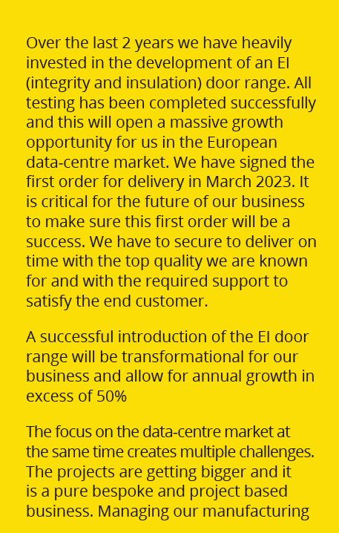
Figure 4 (EBD Newsletter segment)
As shown in Table 2 (EBD EI questionnaire results) the results for the questionnaire taken during the project shown that across the board employees had a more positive opinion. This table shows that before the project started there was an average score of -0.7, this told the company that there was an overall negative opinion on the project, after implementing some counter measure to increase this opinion, the average score was increased to 1.4, this showing that the opinion has increased. From the opinion changing for the better on this project, this has made It more likely that this project will succeed from the extra aid from the employees. This became very apparent when on multiple occasions useful suggestions were put forward by employees, these also included ideas that allowed the project to advance quicker and with less issue.

What was learnt from this project?
During this project it became apparent at the start that the employees did not have a very positive opinion, after the survey was conducted the areas for improvement become apparent. Measure was introduced to aid in increasing the communication between the employees and the project progress and to raise the overall opinion on the project. This served to be a great idea as during the project a continuous improvement was seen from all employees involved, these improvements saw new ideas being put forward, methods being developed by operators and even some employees going out of their way to make sure that the project team had all the help they required. This shows that from increasing employee buy-in it is possible to get employees to become more involved in projects while being able to contribute useful and much needed suggestions, also from the employee buy-in increasing the projects overall success percentage seemed to increase.
Another key aspect that was seen in this project was how the strength-based management was used to have key employees attending to tasks that suit their skills, from this it was seen that many employees excelled in their tasks as they already possessed the required skills needed to complete their job. This allowed the project to be carried out smoothly and efficiently, while employees also reported that they felt that their skills in that area had improved from carrying out these tasks. This showing that strength-based management can be a great option for delegating tasks to employees.

Conclusion
This report has investigated a new project that has been introduced into Eurobond Doors and how this project has been managed. Overall, the project was managed well and it allowed for plenty of employee feedback in order to allow developments to be made to improve the manufacturing of the new EI door. Although change can be perceived in many ways, the implementation of the ‘Spotlight Award’ scheme meant that more employees were motivated to welcome the new project and work hard to ensure that it is made to a high standard. Strength-based management has also been a positive addition to this project as it has allowed the employees to be paired with a task that they should excel at and therefore allow them to feel more content when asked to complete the tasks in hand.
A major factor of the success of the project has been getting the employees to buy-in to the idea of the new project for it to be better accepted and by getting the employees onboard, it can help the quality of the work that is being completed as the morale will be at a high level and the employees will be more content in their work. The second factor that played a large part was using strength-based management to delegate tasks was a good decision as it allowed the appropriate skills to be matched with the jobs that would most suit them, this showed had powerful this management technique can be as there were little issues to worry about due to lack of skill.

Bibliography
Eurobond Doors. (n.d.) [Online]. Available at: https://www.eurobonddoors.co.uk/ (Accessed: 15/05/2023)
Vroom, V. H. (1964). Work and motivation. New York: Wiley.
CEN-CENELEC. (2014, October 31). EN 16034:2014. Pedestrian doorsets, industrial, commercial, garage doors and openable windows - Product standard, performance characteristics - Fire resisting and/or smoke control characteristics. Brussels, Belgium : CEN-CENELEC.
Bateh, J., Castaneda, M. E., & Farah, J. E. (2013). Employee ResistanceTo Organizational Change. International Journal of Management & Information Systems, 113-116.
Joshi, A., Kale, S., Chandel, S., & Pal, D. K. (2015). Likert Scale: Explored and Explain. British Journal of Applied Science & Technology , 396-403.
Blau, P. M., (1964). Exchange and Power in Social Life. New York: Wiley.
Buckingham, M. and Clifton, D.O., 2001. Now, Discover Your Strengths. London: Simon & Schuster UK.
Atkinson, R. C., & Shiffrin, R. M. (1968). Human memory: A proposed system and its control processes. In B. A. Campbell (Ed.), The Psychology of Learning and Motivation (Vol. 2, pp. 89-195). Academic Press
Gallup. (n.d.). StrengthsFinder 2.0. [Online] Available at: https://www.gallup.com/cliftonstrengths/en/strengthsfinder.aspx (Accessed: 09/05/2023)
Buckingham, M. and Clifton, D.O., 2001. Now, Discover Your Strengths. London: Simon & Schuster UK.
Oreg, S., & Sverdlik, N. (2011). Ambivalence toward imposed change: The conflict between dispositional resistance to change and the orientation toward the change. Journal of Applied Psychology, 96(2), 337-349. doi: 10.1037/a0021109.
Barron, K. E. and Hulleman, C. S. (2015) 'Expectancy-value-cost model of motivation', in Wright, J. D. (ed.) International Encyclopedia of the Social & Behavioral Sciences. Elsevier, pp. 435-441. doi: 10.1016/B978-0-08-097086-8.92030-5.

