Lara Terzi (P148014)

Software Engineering Principles

Group Software Development

Gordon Dickers & Andrew Baker
1. Planning 3
1.1. Introduction and Overview 3
1.2. Key Stakeholders Identified 3
1.3. Team Members and Responsibilities 4
1.4. Functional and Non-Function Requirements 4
1.5. Use Cases Derived from Scenario 6
1.5.1. Use case Diagram 1: 6
1.5.1.1. Use case 1.1. 6
1.5.1.2. Use case 1.2. 8
1.5.1.3. Use case 1.3. 10
1.5.1.4. Use case 1.4. 12
1.5.1.5. Use case 1.5. 14
1.5.2. Use Case Diagram 2: 17
1.5.2.1. Use case 2.1. 18
1.5.2.2. Use case 2.2. 20
1.5.2.3. 22
1.6. Identified Requirements for First Iteration 24
1.7. Plan for Requirements for Second Iteration 24
1.8. Legislation and Ethics 25
2. Design 25
2.1. UML Class Diagram 25
2.1.1. Application 25
2.1.2. Database 26
2.2. Sequence Diagrams 27
2.3. User Interface Design Prototypes 27
3. Programming 29
3.1. First Iteration Code Implementation 29
3.2. Testing 30
3.3. Version Control 35
4. Group contribution 35
4.1. Individual Contribution and Team Work Discussion 35
4.2. Design to Requirements Matrix 36
5. Appendices 36
6. References 41
7. Citations 41

Planning

Introduction and Overview
TourMe is an application whose two main purposes are to improve a tourist’s experience and to increase a museum’s efficiency in conducting tours, thus removing the need for tour guides and ensuring that tourists can take their time viewing and understanding each artifact at their own pace.
This application will allow for two menus, the first of which only appears as the user has opened the application. This first menu only has one functional button, the “Press me now and listen” button. Once this button is pressed, the application gives the user an audio description of the first room of the museum and asks the user to enter a number to identify which of the artifacts they would like to know more about. Once the chosen artifact has been recognized, the user is given a brief audio description of said artifact. The second menu will then appear, allowing the user to determine their continuation of the tour by the choice of 5 buttons. The first two buttons allow the user to hear a repetition of the first menu’s audio descriptions, as the first choice enables the user to listen to the first room’s audio description again while the second enables the user to listen to the first artifact’s chosen’s description. The third button executes a function which gives the user a further description of the artifact they chose in the first menu. The fourth button concedes the user to enter another artifact in the room that they are in, and lastly, the fifth button allows the user to continue onto the next room of the tour. The second menu is then repeated until the user has moved onto and finished all the rooms in the museum.
This application will rely on a board at the entrance of each museum which would give the user instructions on how to use it. This information would also contain the location of the download link in the museum’s website, which is specific to that museum. The museum would also need to provide headphones for each person that enters the building as most people do not carry their headphones around with them.

Key Stakeholders Identified
When identifying this project’s stakeholders, one must mention not only the application’s internal stakeholders (the entities within a business), but also the external stakeholders (anyone who is affected by the business). When it comes to the internal stakeholders, some of the main entities would include the people working in top management, for instance the president and price president of the business, any directors and division managers, and the company’s board of directors. Investors are extremely important, if not the most important, members of the internal stakeholders of a business as they enable the business to commence, grow, and succeed with the money they invest into the company. In addition, any person working on the project’s team would also be included, for instance the project’s manager, the developers, and anyone working full or part time to make the project a success. Furthermore, resource managers as well as any associate working for the company but not for the specific project itself would also be a part of the internal stakeholders. As EZ is still a startup company comprised of only two people, Lara Terzi and Lewis Ireson make up all the internal stakeholders excluding the investors. EZ’s sole investor is the University of Wales Trinity Saint David as it was their software that was used to create the TourMe application. Upon EZ reaching the success needed to enlarge the company, staff will be hired, and the company will have different names for each of the named internal stakeholders
The external stakeholders, however, are slightly more complex as this includes all people who could and would be affected by the company. This would include not only the tour guides who lose their jobs with the creation of TourMe, but also the tourism development’s stakeholders, for example any national and/or foreign governments associated with each of the museums who eventually use the application. The contractors and possibly subcontractors who awarded EZ TourMe’s contract would also be included. The suppliers of the museum would also be members of the external stakeholders as a museum’s success determines the number of artifacts they buy from said supplier. Tourists would also be affected thus they too would be included in the external stakeholders.

Team Members and Responsibilities
EZ is a small startup company comprised of a software engineer, Lara Terzi, and a computer games developer, Lewis Ireson, who were awarded the contract of creating the TourMe application. The responsibilities were structured as such; the planning and coding of the prototype to be done by both Lara Terzi and Lewis Ireson in the C++ language using Microsoft’s Visual Studio application. The write up for the functional requirements to be done by Lara Terzi whilst the non-functional requirements to be done by Lewis Ireson. Each member was to write about two use cases derived from scenarios. Lara Terzi was to identify the requirements for the first iteration and Lewis Ireson was to plan the requirements for the second iteration. Lara Terzi and Lewis Ireson were to discuss and write about the project’s legislative and ethical issues collectively, as was the design portion of the project. Each member was then to run various tests on the program written.

Functional and Non-Function Requirements
Functional requirements could be defined as “any requirement which specifies what the system should do”[1] whilst non-functional requirements specify “how the system performs a certain function”[1].
The functional requirements for the TourMe application would include any of the policies and procedures that the EZ company incorporates into all its applications as well as any of the contracting company’s policies and procedures. EZ’s policies and procedures include the assurance that the programming code used in its applications is not plagiarized, and that each application follows the ISO C++ standards to ensure good coding practice. All of EZ’s programs must also follow ethical standards approved by various computing institutes. Another one of TourMe’s functional requirement is the assurance that the requirements stated in the project’s initiation document are enforced in the application itself. Finally, each project’s initiation document must be precise, organized, and must ensure that the steps to complete the project are clear, direct, and as precise as possible.
TourMe’s non-functional requirements for the system’s performance include the application’s response time which, due to the application’s small size, takes less time than the PC monitor’s response time. An application’s scalability is a test which determines how able an application is to expand its workload, and as TourMe’s database only contains information about the museum’s rooms and its artifacts, it is safe to say that the application is very capable in increasing its workload. Another non-functional requirement is the program’s availability testing which is done by running the application and checking how long the down time is. When using Microsoft’s Visual Studio application, the built-in build and debugging tools test the availability for the programmer. As the TourMe does not contain any bugs or errors, the program is deemed to have high availability and reliability. As this program’s first iteration relies heavily on the input of new data directly into the code, its recoverability is ensured with backups after each data entry. A museum needs only add the number of rooms and artifacts in the building, and which artifact is in which room. Because of this, the museum’s management team can create as many backups as they please, once they have completed entering or modifying their data, which can be recovered efficiently if there is ever a failure in the system, thus the program has high data integrity, recoverability, manageability, and maintainability. The program also has quite high security as anyone would be allowed to obtain the skeleton for their museum, but once the museum’s rooms and artifacts have been added to the skeleton, they can then upload it to their secure websites for their clients to download. This ensures that the program’s security aligns with the security that the museum has on their computer and that on their website.

Use Cases Derived from Scenario

Use case Diagram 1:
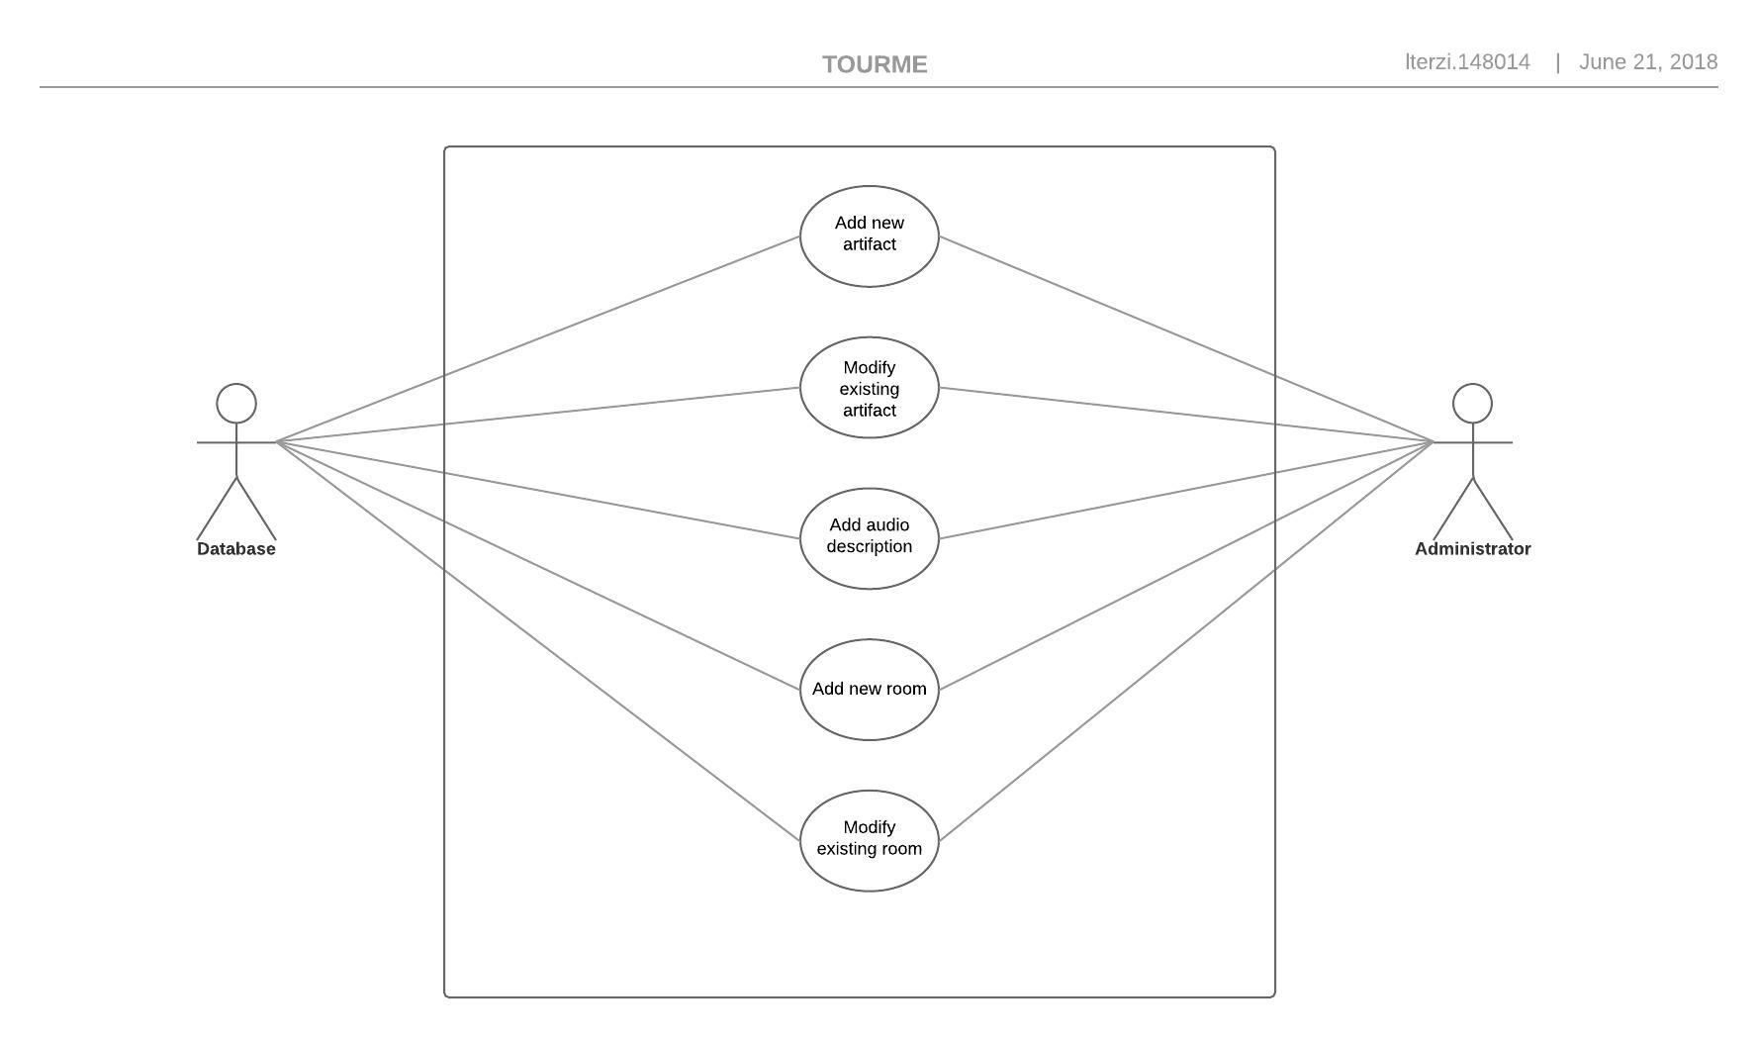
Figure 1

Use case 1.1.
USE CASE 1.1. | Add new artifact.
Goal in Context | Add artifact information to database, including artifact number, and which room the artifact is in.
Scope & Level | System database.
Preconditions | The number of the artifact that came before this one is known, as the artifact ID autoincrements.
Success End Condition | The artifact has been added, and all the artifact’s data is now included in the database. The system outputs a “artifact successfully added” message. The administrator is then taken back to the main menu.
Failed End Condition | Output of an error message, explaining that the artifact was not added to the database. Two options are then given, the first to try again and the second to go back to the main menu.
Primary,  Secondary Actors | The museum’s administrator, or the one with the authority to access the database.  The database the artifact is being added to.
Trigger | Artifact addition request enters the system.
DESCRIPTION | Step | Action
 | 1 | Administrator clicks option named “Enter new artifact”.
 | 2 | System opens a blank form with autoincremented artifact ID.
 | 3 | Administrator inputs artifact’s room number into the form.
 | 4 | Administrator presses the finished option.
 | 5 | System returns a “Artifact addition successful” message.
 | 6 | Administrator is returned to the main menu.
EXTENSIONS | Step | Branching Action
 | 2a | Autoincrementing was unsuccessful so the artifact’s ID is already existing.  Autoincrement error 2a1.

RELATED INFORMATION | 1.1. Add new artifact.
Priority: | Top.
Performance | 2 minutes.
Frequency | When first creating the database, around 100 – 200 per day. When adding artifacts to an existing database, 1-10 per day depending on how many artifacts the museum buys that day.
Channels to actors | Database.
OPEN ISSUES | What if the artifact uses an already existing ID?
Due Date | First iteration’s prototype.

Use case 1.2.
USE CASE 1.2. | Modify existing artifact.
Goal in Context | Modify any of the artifact’s data which has been previously entered into the database.
Scope & Level | System database.
Preconditions | The artifact’s data has already been entered into the database.
Success End Condition | The artifact has been modified, all the data entered into the database has been updated. The system outputs a “artifact has been successfully modified” message. The administrator is then taken back to the main menu.
Failed End Condition | The system outputs a “artifact modification unsuccessful” message. The administrator is then given the option to try the action again, or to go back to the main menu.
Primary,  Secondary Actors | The museum’s administrator, or the one with the authority to access the database.  The database containing the already existing artifact.
Trigger | Artifact modification request is entered into the system.
DESCRIPTION | Step | Action
 | 1 | Administrator clicks option named “Modify existing artifact”.
 | 2 | System opens a form with all the data on the existing artifact.
 | 3 | Administrator changes the data that needs to be changed.
 | 4 | Administrator presses the finished option.
 | 5 | System outputs “Modification successful” message.
 | 6 | Administrator is returned to the main menu.
EXTENSIONS | Step | Branching Action
 | 5a | No changes were made to the artifact form.  No changes made message error 5a1.

RELATED INFORMATION | 1.2. Modify existing artifact.
Priority: | Top.
Performance | 2 minutes.
Frequency | 1 time per day.
Channels to actors | Database.
OPEN ISSUES | What if no modification was made to the data?
Due Date | First iteration’s prototype.

Use case 1.3.
USE CASE 1.3. | Add audio description.
Goal in Context | Add audio descriptions to an existing room or artifact
Scope & Level | System database.
Preconditions | The artifact or room’s data has already been entered into the database.
Success End Condition | The audio description has been added to the existing artifact or room’s data form in the database.
Failed End Condition | The system outputs a “audio addition unsuccessful” message. The administrator is then given the option to try the action again, or to go back to the main menu.
Primary,  Secondary Actors | The museum’s administrator, or the one with the authority to access the database.  The database containing the already existing artifact.
Trigger | Audio entered request is made to the system.
DESCRIPTION | Step | Action
 | 1 | Administrator clicks option named “Add audio description”.
 | 2 | System asks administrator to enter weather they want to add the description to a room or to an artifact and to enter the room or artifact’s ID.
 | 3 | Administrator inputs audio description file path into the system.
 | 4 | Administrator presses the finished option.
 | 5 | System outputs “Addition successful” message.
 | 6 | Administrator is returned to the main menu.
EXTENSIONS | Step | Branching Action
 | 3a | Artifact contains the same audio description as an already existing artifact.  Existing audio error 3a1.
 | 3b | File path does not lead to audio description.  Misleading file path error 3b1.

RELATED INFORMATION | 1.3. Add audio description.
Priority: | Top.
Performance | 1 minute.
Frequency | When first creating the database, around 100 – 200 per day. When adding artifacts to an existing database, 1-10 per day depending on how many artifacts the museum buys that day.
Channels to actors | Database.
OPEN ISSUES | What if the artifact uses an audio description that is already used in a previous artifact?  What if the path does not lead to an audio description?
Due Date | First iteration’s prototype.

Use case 1.4.
USE CASE 1.4. | Add new room.
Goal in Context | Add room information to database.
Scope & Level | System database.
Preconditions | The number of the room that came before this one is known, as the room’s ID is autoincrementing.
Success End Condition | The room has been added, and all the room’s data is now included in the database. The system outputs a “room successfully added” message. The administrator is then taken back to the main menu.
Failed End Condition | The system outputs a “room addition unsuccessful” message. The administrator is then given the option to try the action again, or to go back to the main menu.
Primary,  Secondary Actors | The museum’s administrator, or the one with the authority to access the database.  The database containing the already existing artifact.
Trigger | Room entered request is entered into the system.
DESCRIPTION | Step | Action
 | 1 | Administrator clicks option named “Add new room”.
 | 2 | System opens a blank form with autoincremented room ID.
 | 3 | Administrator inputs room name into the system.
 | 4 | Administrator presses the finished option.
 | 5 | System outputs “Addition successful” message.
 | 6 | Administrator is returned to the main menu.
EXTENSIONS | Step | Branching Action
 | 2a | Room contains the same ID as an already existing room.  Existing ID error 2a1.
 | 3a | Room contains the same name as an already existing room.  Existing name error 3a1.

RELATED INFORMATION | 1.4. Add new room.
Priority: | Top.
Performance | 1 minute.
Frequency | When first creating the database, around 1-3 per day. When adding rooms to an existing database, 1 per day.
Channels to actors | Database.
OPEN ISSUES | What if the room’s ID is the same as another room’s?  What if the room’s name is the same as another room’s?
Due Date | First iteration’s prototype.

Use case 1.5.
USE CASE 1.5. | Modify existing room.
Goal in Context | Modify room information to database.
Scope & Level | System database.
Preconditions | The room’s data has already been entered into the database.
Success End Condition | The room has been modified, all the data entered into the database has been updated. The system outputs a “room has been successfully modified” message. The administrator is then taken back to the main menu.
Failed End Condition | The system outputs a “room modification unsuccessful” message. The administrator is then given the option to try the action again, or to go back to the main menu.
Primary,  Secondary Actors | The museum’s administrator, or the one with the authority to access the database.  The database containing the already existing artifact.
Trigger | Room modification request is entered into the system.
DESCRIPTION | Step | Action
 | 1 | Administrator clicks option named “Modify existing room”.
 | 2 | System opens a form with all the data on the existing room.
 | 3 | Administrator changes all the data that needs to be changed.
 | 4 | Administrator presses the finished option.
 | 5 | System outputs “Modification successful” message.
 | 6 | Administrator is returned to the main menu.
EXTENSIONS | Step | Branching Action
 | 2a | Room contains the same ID as an already existing room.  Existing ID error 2a1.
 | 3a | Room contains the same name as an already existing room.  Existing name error 3a1.

RELATED INFORMATION | 1.5. Modify existing room.
Priority: | Top.
Performance | 1 minute.
Frequency | 1 per day.
Channels to actors | Database.
OPEN ISSUES | What if the room’s ID is the same as another room’s?  What if the room’s name is the same as another room’s?
Due Date | First iteration’s prototype.

Use Case Diagram 2:
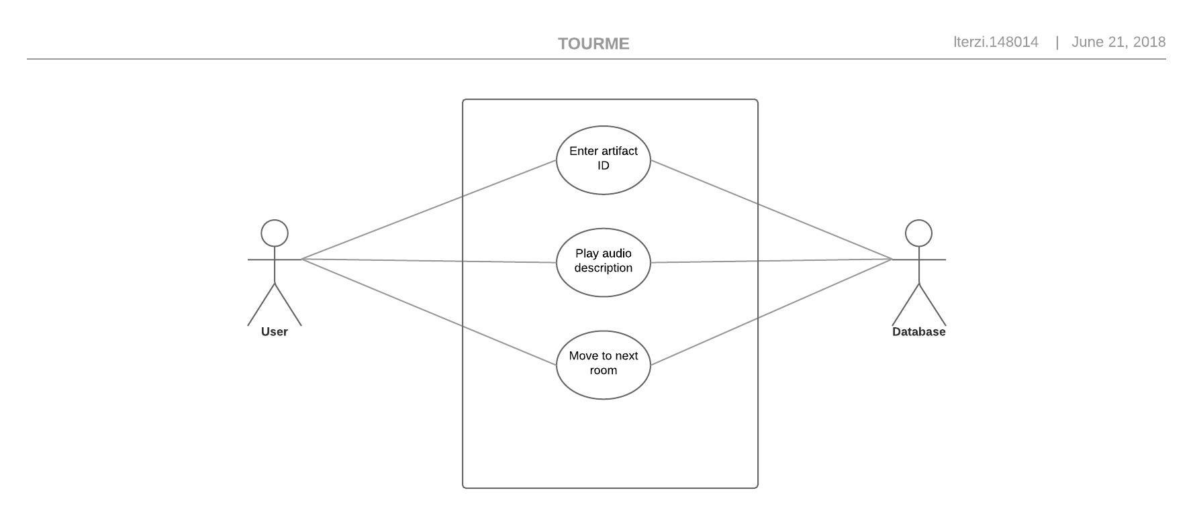
Figure 2

Use case 2.1.
USE CASE 2.1. | Enter artifact ID.
Goal in Context | User enters the artifact they are interested in’s ID into the system.
Scope & Level | Database.
Preconditions | The application is linked to the database and all it’s information is at the application’s disposal.
Success End Condition | The information on the artifact is given to the user.
Failed End Condition | Output of an error message, explaining that the artifact has not been found. Three options are then given, the first to try again, the second to enter another artifact’s ID into the application, and the third to go back to the main menu.
Primary,  Secondary Actors | The tourist.  The database that contains all artifacts’ data.
Trigger | Artifact information request made to the system.
DESCRIPTION | Step | Action
 | 1 | User clicks option “Enter artifact ID”.
 | 2 | User walks to artifact and enters the number located under it.
 | 3 | The system accesses the database and retrieves the information of the artifact with the ID entered by the tourist.
 | 4 | System returns a “Artifact found” message.
 | 5 | System plays artifact’s audio description.
 | 6 | User is returned to the main menu.
EXTENSIONS | Step | Branching Action
 | 2a | User enters an invalid artifact ID.  Invalid artifact ID error 2a1.

RELATED INFORMATION | 2.1. Enter artifact ID.
Priority: | Top.
Performance | 15 seconds.
Frequency | 500-10,000 per day depending on museum size and popularity.
Channels to actors | Database.
OPEN ISSUES | What if the user enters an invalid ID?
Due Date | First iteration’s prototype.
Superordinates | Name of use case | Use case number
 | Move to next room | 2.3.

Use case 2.2.
USE CASE 2.2. | Play audio description.
Goal in Context | User is played an audio description.
Scope & Level | Database.
Preconditions | The audio description is accessible from the database
Success End Condition | The audio description has been successfully played for the user.
Failed End Condition | Output of an error message, explaining that the audio description could not be played. Two options are then given, the first to try again, and the second to go back to the main menu.
Primary,  Secondary Actors | The tourist.  The database that contains all audio descriptions.
Trigger | Audio description play request made to the system.
DESCRIPTION | Step | Action
 | 1 | User clicks option “Play audio description”.
 | 2 | The system accesses the database and retrieves the audio description of the artifact with the ID entered by the tourist.
 | 3 | System returns a “Audio description found” message.
 | 4 | System plays artifact’s audio description.
 | 5 | User is returned to the main menu.
EXTENSIONS | Step | Branching Action
 | 2a | User enters an invalid artifact ID.  Invalid artifact ID error 2a1.

RELATED INFORMATION | 2.2. Play audio description.
Priority: | Top.
Performance | 2 minutes.
Frequency | 500-10,000 per day depending on museum size and popularity.
Channels to actors | Database.
OPEN ISSUES | What if the user enters an invalid ID?
Due Date | First iteration’s prototype.
Superordinates | Name of use case | Use case number
 | Move to next room | USE CASE 2.3.

1.5.2.3.
USE CASE 2.3. | Move to next room.
Goal in Context | User enters the next room on the tour.
Scope & Level | Database.
Preconditions | The application knows which room the user is in and knows which room the user is next on the tour.
Success End Condition | The user is directed to the next room on the tour and the room’s audio description is played.
Failed End Condition | Output of an error message, explaining that there was an error directing the user to the next room and to find someone working in the museum to ask for their assistance. The user is then returned to the main menu.
Primary,  Secondary Actors | The tourist.  The database that contains all rooms’ data.
Trigger | Room information request made to the system.
DESCRIPTION | Step | Action
 | 1 | User clicks option “Move to next room”.
 | 2 | User is directed to the next room on the tour.
 | 3 | The system accesses the database and retrieves the audio description of the room the user has just walked into.
 | 4 | System returns the room’s name as a message.
 | 5 | System plays room’s audio description.
 | 6 | System asks user to input an artifact’s ID into the application.
 | 7 | User inputs artifact’s ID into the system.
 | 8 | The system accesses the database and retrieves the audio description of the artifact the user has entered.
 | 9 | System returns a “audio description found” message.
 | 10 | System plays artifact’s audio description.
 | 11 | User is returned to the main menu.
EXTENSIONS | Step | Branching Action
 | 1a | No more rooms to view.  Tour finished error 1a1.
 | 7a | User enters invalid artifact ID.  Invalid artifact error 7a1.
 | 7b | User enters artifact that is in a different room than the one they are in.  Invalid artifact in room error 7b1.

RELATED INFORMATION | 2.3. Move to next room.
Priority: | Top.
Performance | 2 minutes.
Frequency | 100-1,000 per day depending on museum size and popularity.
Channels to actors | Database.
OPEN ISSUES | What if there are no more rooms to view in the museum?  What if the user enters an invalid artifact ID?  What if the user enters an artifact’s ID which is of an artifact located in a different room?
Due Date | First iteration’s prototype.

Identified Requirements for First Iteration
This project’s requirements were stated under the MoSCoW requirement scheme. These include ‘Must do’ requirements, ‘Should do’ requirements, ‘Could do’ requirements, and lastly ‘Won’t do’ requirements.
The requirements for the first iteration, stated under the must do components, are as such;
- Must have two menus
- The first (starter) menu must only have one button
- The second (main) menu must have 5 buttons the user can press
- The user must be allowed to listen to the room’s description as many times as they wish
- The user must be allowed to listen to the artifact’s description as many times as they wish
- The user must be allowed to listen to an artifact’s further description as many times as they wish
- The user must be allowed to listen to any artifact’s description they wish
- The user must be allowed to access the next room’s data

Plan for Requirements for Second Iteration
The project’s second iteration will increase efficiency by ensuring that all errors of the project’s first iteration are solved. The second iteration will also include the should do and could do components of the MoSCoW requirement scheme.

The requirements stated under the should do components are as such;
- The user should be able to use the GPS function on their handheld device to travel around the museum
- The application should leave space for advertisements
- The application should be downloaded from an app store instead of each museum’s website
- The application should ask the user to enter the museum’s serial number in order to know what museum they are in and what room and artifact descriptions they should play
- The client should be able to view how many people are in the heritage sight
- The client should be able to view each artifact’s popularity
- The application should email users a short survey for customer satisfaction
The requirements stated under the could do components are as such;
- The application could have an option to change language
- The application could have a view option, where one can open a camera feature on the application and zoom in on artifacts in case of museum population
- The application could have a paid version which removes advertisements
- The application could ask the user for a star rating of each artifact

Legislation and Ethics
This application will have open-source licensing as it will be available to any museum or company that goes on the EZ website. They would then own their copy of the application and could do as they pleased with it. This includes modifying it and selling the modified version to different museums and companies. The application will follow the Association for Computing Machinery’s code of ethics and professional conduct as well as the software engineering code of ethics and professional practice. These are some of the ethical guidelines which have been approved by the IEEE.

Design

UML Class Diagram

Application
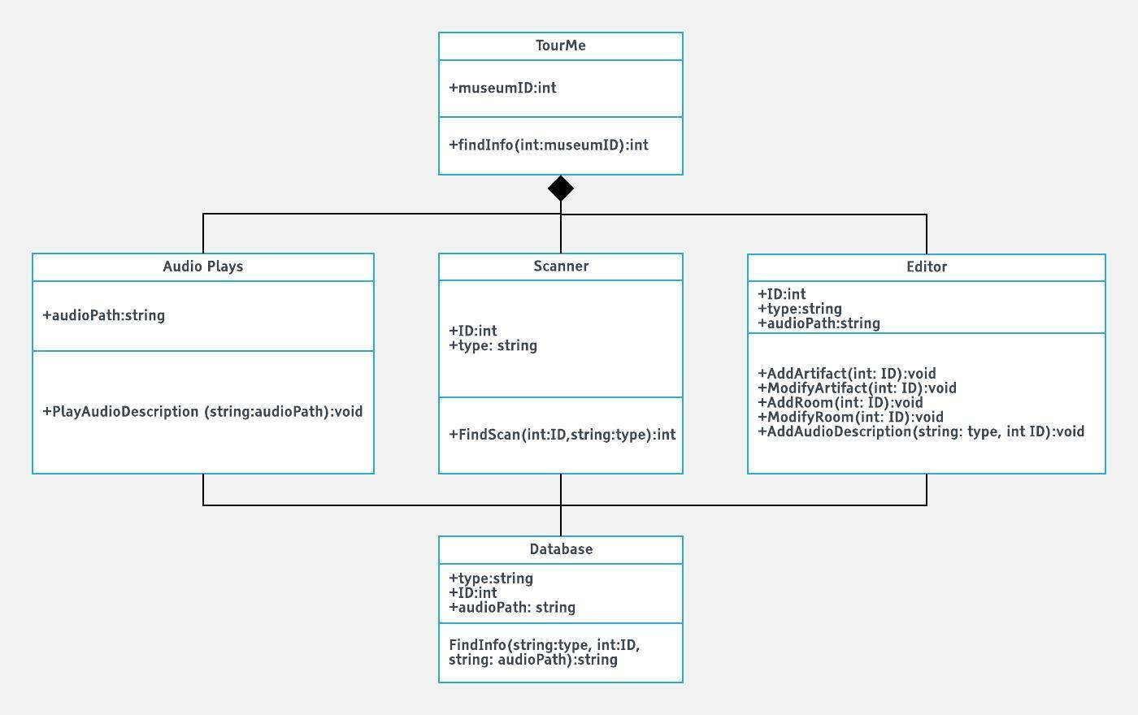
Figure 3

Database
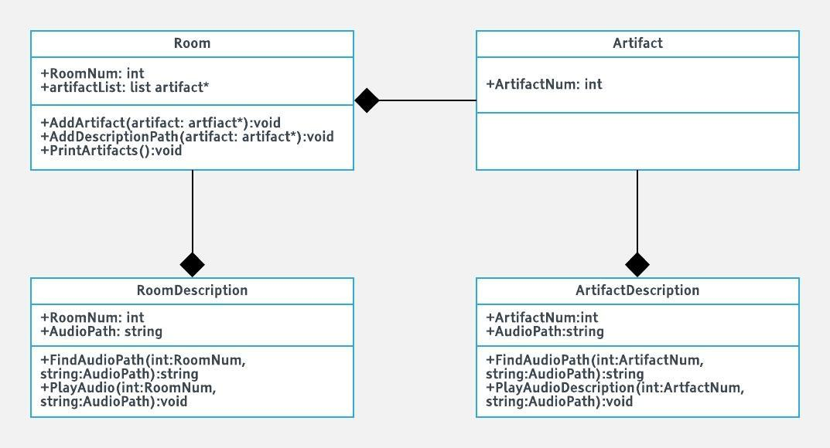
Figure 4

Sequence Diagrams
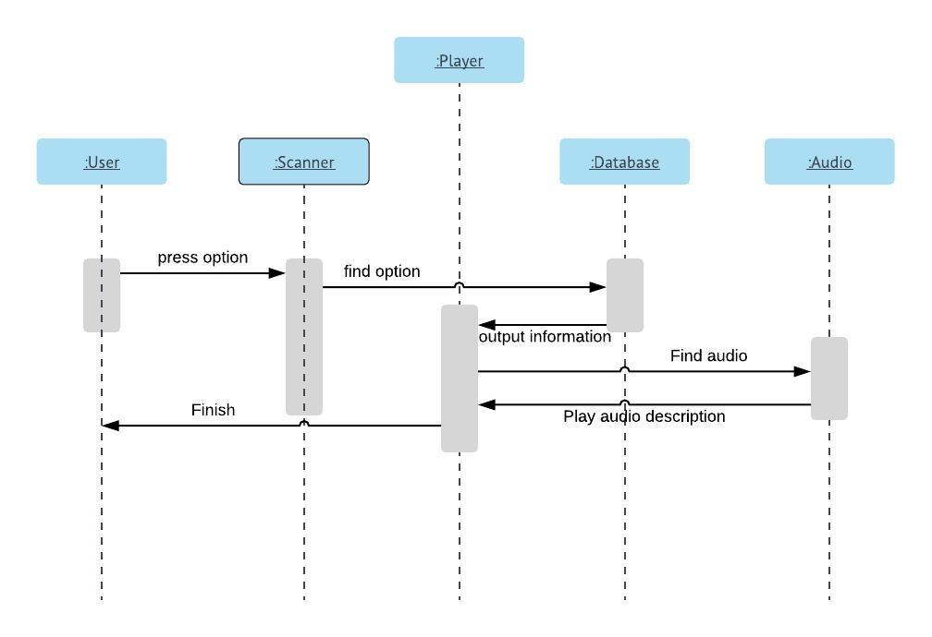
Figure 5

User Interface Design Prototypes
Menu 1: First menu (only comes when the application first starts up).
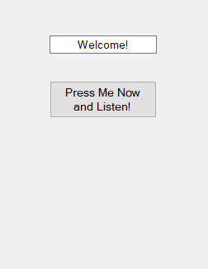
Figure 6

Menu 2: Main menu (is repeated after every button’s function is completed).
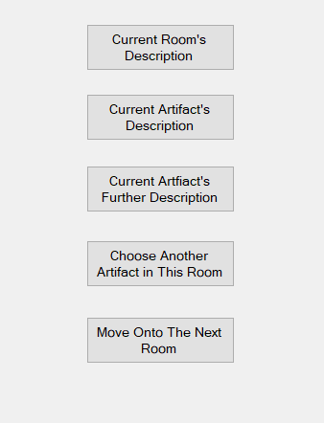
Figure 7

Menu 3: (Player that shows up when user is playing an audio description).
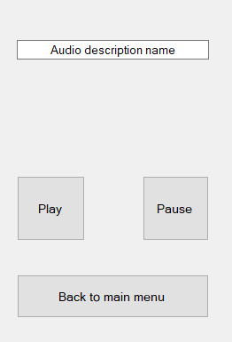
Figure 8

Programming

First Iteration Code Implementation
Room.h
#pragma once
#include <list>
#include "Artifact.h"

using namespace std;

class Room
{
public:
Room(int roomNum);
~Room();

int RoomNum;

list<Artifact*> artifactList;

void AddArtifact(Artifact * artifact);
void AddDescriptionPath(Artifact * artifact);
void PrintArtifacts();
};

The <list> library is included in the room.h file to enable the creation of the artifactList list. Using namespace std ensures that the user does not have to add std:: in front of the cin and cout functions. The “artifact.h” header file is included in this file because the artifactList takes the artifacts declared in the artifact.h file’s class as parameters to creating the list. The room class is stated as a public class because it can be accessed by any other file in the program, if desired. AddArtifact is a function that takes the artifact class’s member as the parameter to add said artifact to the list, this happens every time a new artifact is added, and the code is compiled. The AddDescriptionPath function takes the same artifact as it’s parameter to creating the path to the artifact’s audio description. The PrintArtifact does not take in any parameters, it’s purpose it to print out all the artifacts in the artifactList.

Testing
Test 1: The application uses two different menus.
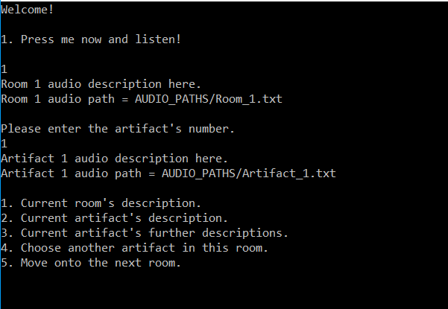
Figure 9

Test 2: The user enters an invalid choice.
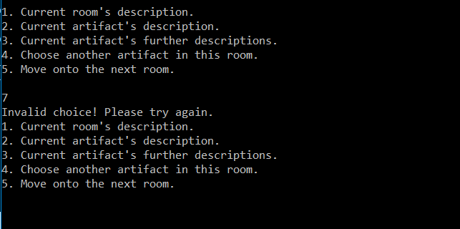
Figure 10

Test 3: The application closes when the tour is finished.
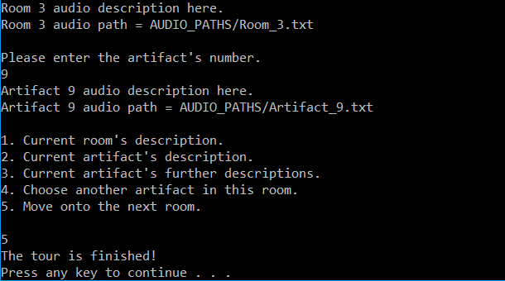
Figure 11

Test 4: The user repeats an artifact’s description numerous times.
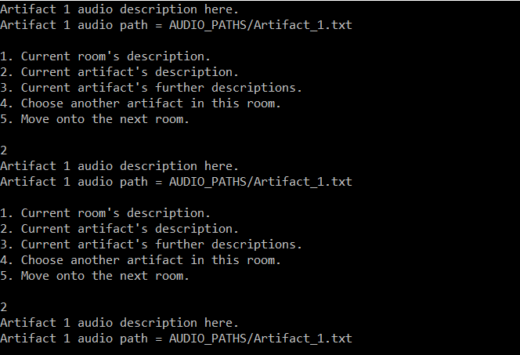
Figure 12

Test 5: Artifact 7’s audio description plays when the user enters artifact 7.
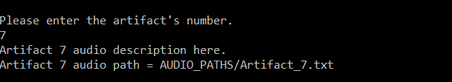
Figure 13

Test 6: Room 2’s audio description when the user enters room 2.
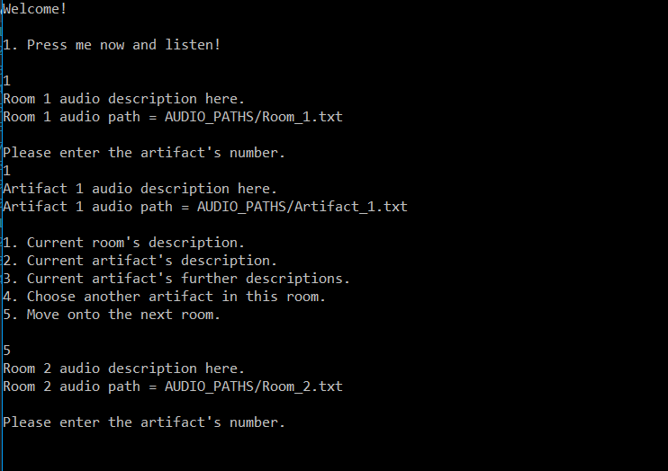
Figure 14

Test 7: The user repeats a room’s description numerous times.
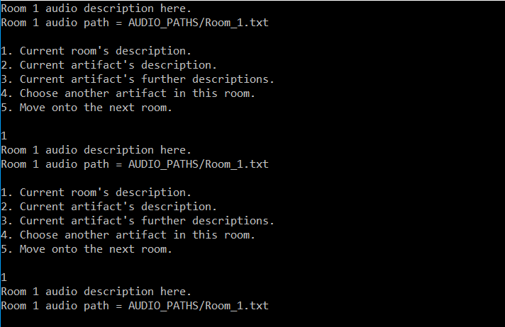
Figure 15

Test 8: The user repeats an artifact’s further description numerous times.
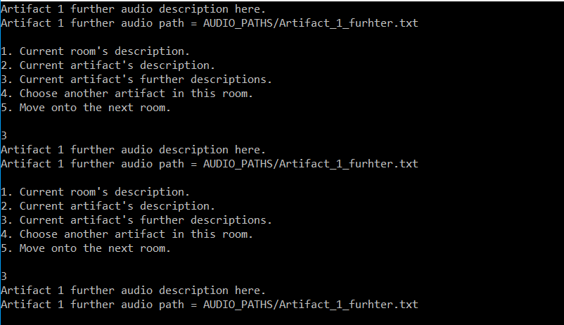
Figure 16

Version Control
This repository on BitBucket was used to update the application: https://bitbucket.org/laraterziSEP/ez_tourme/src. Version control was used as a way of ensuring that changes made from one team member would not drastically impact the work done by the other. By using version control, we ensured that anything added by one team member could be added by the other. In this case, two versions of the prototype were added to BitBucket. The first was uploaded when thought to be on the verge of completion. The other, however, was quite majorly updated to solve some stack issues created by the never-ending loop of functions in the first version.
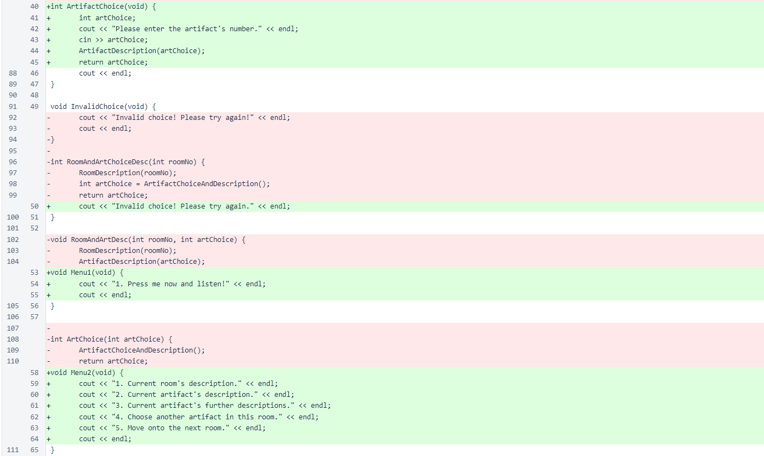
See BitBucket snippet revisions below:

Group contribution

Individual Contribution and Team Work Discussion
The initial team members’ responsibilities did not go as planned as Lewis Ireson did not contribute to the project’s creation, only to a very small amount of planning. Therefore, the programming of the application as well as all the whole written planning section was done by Lara Terzi. This was also the case for the design aspect of the project and the information written on this project’s prototype.
As for the team discussion, the only 3 times that the group met up, these were the discussion’s subjects:
- Ideas discussed on the 27th of May
- Flow chart was planned and written down on the 28th of May
- Prototype programming commenced on the 29th of May

Design to Requirements Matrix
Requirement type | Explanation | Proof
Functional requirement 1 | Policies and procedures | Section 1.8
First iteration requirement 1 | Must have 2 menus | Section 2.3
First iteration requirement 2 | The first menu must only have one button the user can press | Section 2.3 Figure 6
First iteration requirement 3 | The second menu must have five buttons the user can press | Section 2.3 Figure 7
First iteration requirement 4 | The user can listen to a room’s description as many times as they wish | Section 3.2 Figure 15
First iteration requirement 5 | The user can listen to an artifact’s description as many times as they with | Section 3.2 Figure 12
First iteration requirement 6 | The user can listen to an artifact’s further description as many times as they wish | Section 3.2 Figure 16
First iteration requirement 7 | The user can access the next room’s data | Section 3.2 Figure 14

Appendices
Room.h
#pragma once
#include <iostream>
#include <list>
#include "Artifact.h"

using namespace std;

class Room
{
public:
Room(int roomNum);
~Room();

int RoomNum;

list<Artifact*> artifactList;

void AddArtifact(Artifact * artifact);
void AddDescriptionPath(Artifact * artifact);
void PrintArtifacts();
};

Room.cpp
#include "Room.h"

Room::Room(int roomNum)
{
RoomNum = roomNum;
}

Room::~Room()
{
}

void Room::AddArtifact(Artifact* artifact)
{
artifactList.push_back(artifact);
}

void Room::AddDescriptionPath(Artifact* artifact)
{

}

void Room::PrintArtifacts(void)
{
list<Artifact*>::iterator it;

for (it = artifactList.begin(); it != artifactList.end(); it++)
{
cout << (*it)->ArtifactNum << endl;
}
}

Artifact.h
#pragma once
#include <iostream>
using namespace std;

class Artifact
{
public:
Artifact(int artifactNum);
~Artifact();

int ArtifactNum;
};

Artifact.cpp
#include "Artifact.h"

Artifact::Artifact(int artifactNum)
{
ArtifactNum = artifactNum;
}

Artifact::~Artifact()
{
}

Functions.h
#pragma once
#include <iostream>
#include <fstream>
#include <sstream>
using namespace std;

ifstream openFile;

void RoomDescription(int i) {
cout << "Room " << i << " audio description here." << endl;
stringstream ss;
ss << "AUDIO_PATHS/Room_" << i << ".txt";
openFile.open(ss.str());

cout << "Room " << i << " audio path = AUDIO_PATHS/Room_" << i << ".txt" << endl;
cout << endl;
}

void ArtifactDescription(int i) {
cout << "Artifact " << i << " audio description here." << endl;
stringstream ss;
ss << "AUDIO_PATHS/Artifact_" << i << ".txt";
openFile.open(ss.str());

cout << "Artifact " << i << " audio path = AUDIO_PATHS/Artifact_" << i << ".txt" << endl;
cout << endl;
}

void ArtifactFurtherDescription(int i) {
cout << "Artifact " << i << " further audio description here." << endl;
stringstream ss;
ss << "AUDIO_PATHS/Artifact_" << i << "_further.txt";
openFile.open(ss.str());

cout << "Artifact " << i << " further audio path = AUDIO_PATHS/Artifact_" << i << "_furhter.txt" << endl;
cout << endl;
}

int ArtifactChoice(void) {
int artChoice;
cout << "Please enter the artifact's number." << endl;
cin >> artChoice;
ArtifactDescription(artChoice);
return artChoice;
cout << endl;
}

void InvalidChoice(void) {
cout << "Invalid choice! Please try again." << endl;
}

void Menu1(void) {
cout << "1. Press me now and listen!" << endl;
cout << endl;
}

void Menu2(void) {
cout << "1. Current room's description." << endl;
cout << "2. Current artifact's description." << endl;
cout << "3. Current artifact's further descriptions." << endl;
cout << "4. Choose another artifact in this room." << endl;
cout << "5. Move onto the next room." << endl;
cout << endl;
}

int ChoiceMenu1(int roomNo) {
RoomDescription(roomNo);
int artChoice = ArtifactChoice();

return artChoice;
}

Main.cpp
#include "Artifact.h"
#include "Room.h"
#include "Functions.h"

int roomNo = 1;
int choice;
int artChoice;
bool repeat = true;

int main() {
Room *room1 = new Room(1);
Room *room2 = new Room(2);
Room *room3 = new Room(3);

Artifact *a1 = new Artifact(1);
Artifact *a2 = new Artifact(2);
Artifact *a3 = new Artifact(3);
Artifact *a4 = new Artifact(4);
Artifact *a5 = new Artifact(5);
Artifact *a6 = new Artifact(6);
Artifact *a7 = new Artifact(7);
Artifact *a8 = new Artifact(8);
Artifact *a9 = new Artifact(9);

room1->AddArtifact(a1);
room1->AddArtifact(a2);
room1->AddArtifact(a3);

room2->AddArtifact(a4);
room2->AddArtifact(a5);
room2->AddArtifact(a6);

room3->AddArtifact(a7);
room3->AddArtifact(a8);
room3->AddArtifact(a9);

cout << "Welcome!" << endl << endl;

Menu1();
cin >> choice;
while (choice < 1 || choice > 1) {
InvalidChoice();
cin >> choice;
}

artChoice = ChoiceMenu1(roomNo);

while (repeat == true) {
Menu2();
cin >> choice;
switch (choice) {
case 1:
RoomDescription(roomNo);
break;

case 2:
ArtifactDescription(artChoice);
break;

case 3:
ArtifactFurtherDescription(artChoice);
break;
case 4:
ArtifactChoice();
break;
case 5:
roomNo++;
if (roomNo == 4) {
cout << "The tour is finished!" << endl;
repeat = false;
break;
}
else {
ChoiceMenu1(roomNo);
break;
}
default:
InvalidChoice();
}
}

system("pause");
return roomNo;
}

References
[1] “Stakeholder”, Investopedia, 2018. [Online]. Available: https://www.investopedia.com/terms/s/stakeholder.asp. [Accessed: 08-Jun-2018].
[2] “Stakeholders in tourism development according to UNWTO”, safecoastaltourism.org, 2018. [Online]. Available: http://www.safecoastaltourism.org/article/stakeholders-tourism-development-according-unwto. [Accessed: 06-Jun-2018].
[3] “Stakeholder Management – Project Management”, Opentextb.ca, 2018. [Online]. Available: https://opentextbc.ca/projectmanagement/chapter/chapter-5-project-stakeholders-project-management/. [Accessed: 17-Jun-2018].
[4] I. Sommerville, Software Engineering, 8th ed. Harlow, United Kingdom: Addison-Wesley, 1982.
[5] R. S. Pressman, Software Engineering: A Practitioner’s Approach, 8th ed. New York: McGraw-Hill, 2014.

Citations
[1] U.Eriksson, “The difference between functional and non-functional requirements”, ReQtest, 2018. [Online]. Available: https://reqtest.com/requirements-blog/understanding-the-difference-between-functional-and-non-functional-requirements/. [Accessed:08-Jun-2018].

