Reflective review of learning journey.

Module code: BMSK4005
Student name: Stephanie Gordon
Student number: 1813658

Contents Page

Executive summary Page 3
Introduction Page 4
SWOT analysis Page 5
GO MAD Page 6 & 7
Learning style questionnaire Page 8
Personal development plan and conclusion Page 9 & 10

Executive Summary
This report was produced in order to do a reflective review on my learning journey. It will include a SWOT analysis on myself and explain how converting my weaknesses into strengths will benefit me in the future. After this I will apply a GO MAD thinking model which will help me to define my goals and help me plan more effectively, I will also be applying two learning style questionnaires in my report and explain how they are relevant and suited to me.

Introduction

In this review of my learning journey I will be conducting a SWOT analysis on myself, this will highlight my strengths, weaknesses, opportunities and threats not only in academics, but also in my social life and any other activity I take. “You are most likely to succeed in life if you use your talents to their fullest extent. Similarly, you'll suffer fewer problems if you know what your weaknesses are, and if you manage these weaknesses so that they don't matter in the work you do.” (Pasteur,2019)

Learning Theory
I will then go on to explain about my learning theory which will describe how knowledge is received and processed during my learning experience. One of the theories I found useful was Maslow’s Hierarchy of Needs and from researching this I believe this would be the theory best suited to me. It helps to set your goals from the very bottom which are basic and easy to achieve to gradually reaching the top which would be your end goal and much harder to reach and succeed in. By using this theory goals can be seen clearly and set in stages which then make it easier to follow. “What motivates human behaviour? The Maslow's hierarchy of needs is one of the best-known theories of motivation. According to humanist psychologist Abraham Maslow, our actions are motivated in order to achieve certain needs.” (Cherry,2018)
Go M.A.D

For this part of my review I will be applying a GO MAD thinking model which will help define my goals, help me plan more effectively and act and measure plans. The Go M.A.D model is made up of three levels and has helped me recognise if my thoughts are helpful or not and how different thinking leads to different actions and different results. “The Go M.A.D. Results Framework and solution focused thinking methodology enables people to accelerate results and improve productivity.” (gomadthinking.com,2019)

Learning Style Questionnaire
From looking and doing different learning style questionnaires I found that the Honey and Mumford style suited me, I found it easy to do and according to Honey and Mumford there are four typical learners these are activist, reflector, theorist and pragmatist (eln,2017) it helped me find the correct learning style suited to me and showed how knowing my learning style will help me make better decisions in the present and in the future. “According to the theory, different people naturally gravitate toward a particular learning style. Therefore, to achieve optimum learning, Honey and Mumford argue that one must identify his natural learning style, understand it and find ways to learn that complement the style.” (Watson,2019)

SWOT Analysis
A SWOT analysis is one of the most renowned tools for analysis. Its key purpose is to identify strategies that will help me highlight my strengths (s), weaknesses (w), opportunities (o), and threats (t). It is a useful and quick tool for taking stock of my situation.
From conducting a SWOT analysis on myself I have learned that overcoming my weaknesses will help me turn them into strengths, which will then benefit me in the future as they will then develop into opportunities, this may be in my everyday home life or in a future business setting. With this plan, I will work hard to perfect my strengths the best I can, correct the weaknesses I have and make them into my strong points, make effective use of the opportunities within my abilities and recognise and avoid any negative effect that the threats in my SWOT analysis may have.
Strengths | Weaknesses | Opportunities | Threats
Work well with others | Time keeping | Learn to drive | Being late for work or university
Helpful | Asking for help | Learning and achieving new skills | Competition
Follow instructions well | Unable to drive | Better job prospects
Good communication | Presentations/public speaking | Passing the university course
Good listening skills | Speaking clearly
Confident | Money management

From conducting a swot analysis on myself I have realised that I can convert one of my weaknesses which is not being able to drive into an opportunity. I will do this by first researching then contacting a driving instructor and then learn how to drive, this will then benefit me in the future as it will give me better job prospects as I will be able to travel further for work. Once I have passed my test this will then be converted into a strength.
As one of my weaknesses is time keeping, I feel like this could also progress into one of my threats if I do not manage my time keeping better, bad time keeping could make me late for future job prospects, university, taking my children to school or for any other important places I need to be on time for. In order to turn this into a strength I will need to manage my time better, this could mean leaving my house earlier, setting my alarm for an earlier time or even preparing clothes and packed lunches the night before, by doing this it will save me time in the morning and will ensure I am where I need to be at the required time.
Confidence is one of my strong points and could help me be successful in a management roll and give me more determination which will then result in me having better relationships with staff and have better quality of work. Having self confidence will help me communicate more effectively, whether this may be at future job prospects or during everyday life. I believe confidence is crucial in order to succeed. “Among the top trait’s employers look for when hiring or promoting a candidate are interpersonal skills, professionalism and enthusiasm; all by products of confidence (Kaplan professional, 2017)

GO M.A.D (making a difference)
“The Go MAD Thinking methodology, developed by Andy Gilbert, has been used in over 40 countries across the world to help organisations, teams and individuals accelerate results and enable change.” (Linked in, 2018) This model helps us examine the way we see ourselves, being aware of how we behave, improve judgement, develop our personal growth, evaluate beliefs, values and motives.
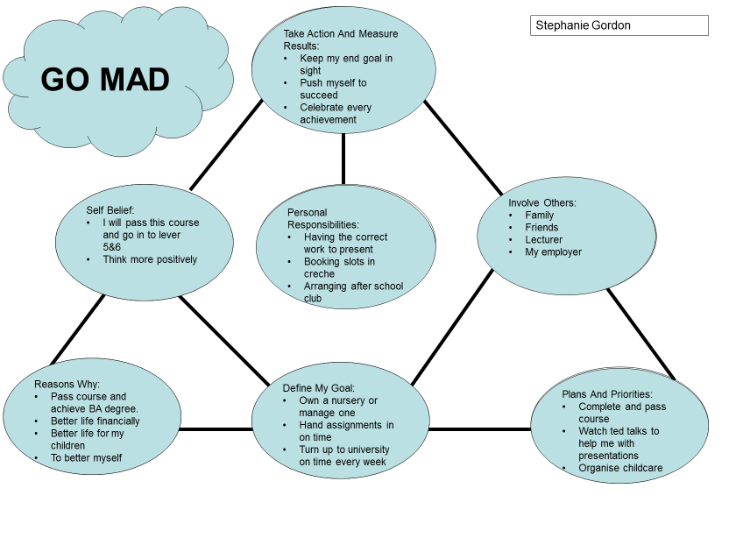The GO M.A.D model has helped me put things into perspective and to see where I want to be in 5 years time and what I need to do to get there. By doing the framework I have realised that planning and looking at what needs to be achieved is essential in order to get the result I want. In order to finish university, I am going to hand in all my assignments on time and to the best of my ability in order to get a good mark and pass this course. I will measure my progress by getting good feedback off my lecturers and aiming to get above 40% on any assignments I am given. By doing this course in university it will give me and my children better opportunities in the future as I will have better job prospects which will then essentially pay better and keep a steady income coming into our home, it will also have a good impact on my children as if they see me succeeding in education it will make them want to attend school and do well, having better educational skills myself will also benefit my children as it well help them to read and write better. “Children whose parents are more educated and have better jobs and higher incomes tend to have stronger math and reading skills than their peers.” (Albin,2015) this has also made me realise that having help off family and friends will play an important part in my education as without them helping with childcare attending
university and work would not be possible. After passing this course and receiving my BA certificate re enrolling and attending university to complete level 5 and 6 will give me a better understanding of what it takes to become a manager, it will help me to build my confidence more and as one of my weaknesses is giving presentations furthering my education will help me to improve this.

Learning Style Questionnaires
Honey and Mumford
The Honey and Mumford learning styles were developed by Peter Honey and Alan Mumford, there are four typical learners, these are activist, theorists, pragmatists and reflectors. An activist is those who learn by doing, theorists are learners that like to understand the theory behind the actions, pragmatist are people who need to be able to see how to put the learning practice in the real world and a reflector is a person who learns by observing and thinking about what happened. The questionnaire is designed to find out your preferred learning styles and will help pin point your learning preferences. “Honey and Mumford identified four different styles of learning: "activist," "theorist", "reflector" and "pragmatist." According to the theory, different people naturally gravitate toward a particular learning style.” (Watson,2019)
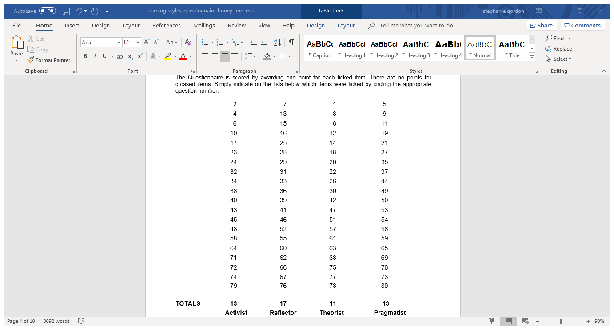
From looking and doing different learning style questionnaires I found that the Honey and Mumford style suited me, it was easy to follow and do. It helped me to find my correct learning style and how knowing what style I am will help me to make better decisions. After doing the Honey and Mumford questionnaire I have found out that I am a reflector, this means that I like to think things through thoroughly before coming to any conclusion. Being a reflector, I can enjoy observing others and listen to them well in order to get the drift of the discussion and making my own points. I am now aware that I learn best from watching over activities, being able to stand back from events and listen and learn, allowed to think before acting and by being able to reach a decision in my own time without pressure.” You learn something new every day” (Kapur,2017) It has also made me aware that I learn least from being involved in situations which require action without planning, when I am being rushed from one activity to another and when I am forced to play a role in front of on lookers.

VARK
The VARK questionnaire aims to find out your preferences for the way you work with information. It has helped people to understand each other and has also helped them to learn more effectively. “VARK tells you something about yourself that you may or may not know. It can be used to understand your boss, your colleagues, your parents, your workmates, your partner, your customers, your teacher, your relatives, your clients and yourself.” (VARK,2019)
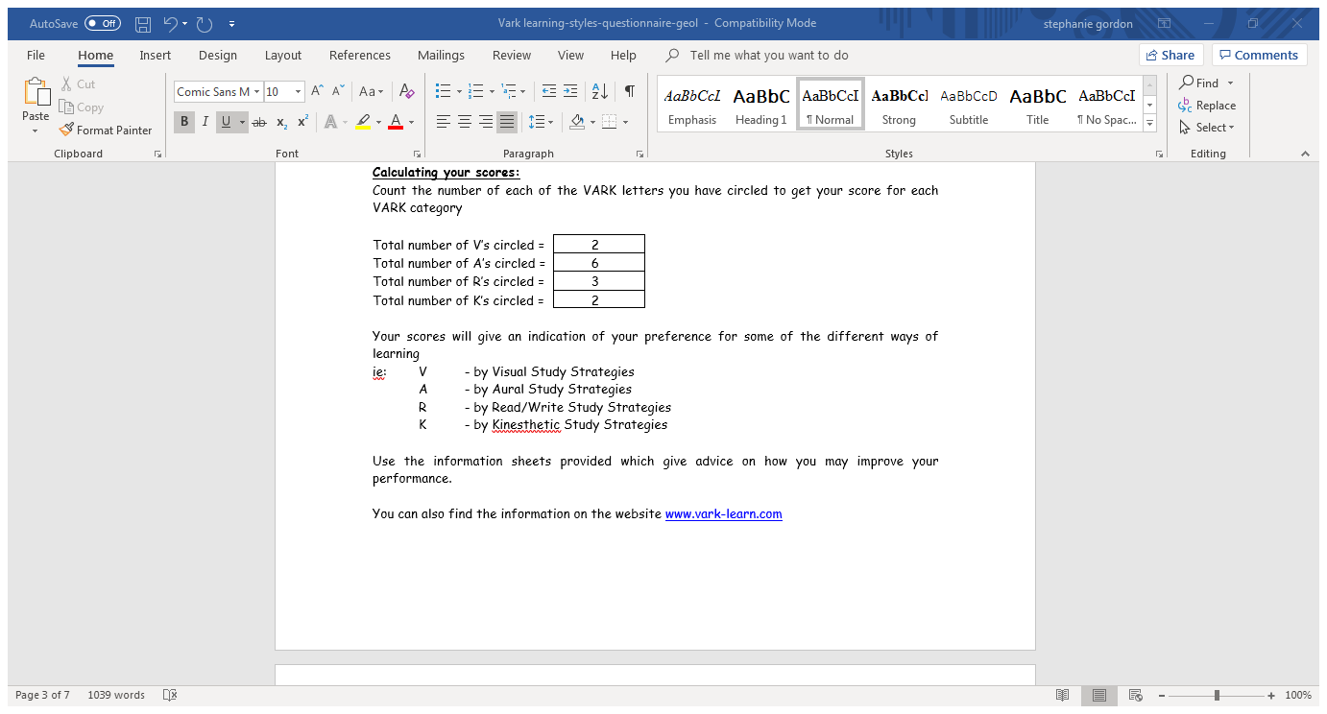
From doing the VARK questionnaire I have found that I am an auditory learner, this mode describes a preference for information that is heard or spoken. Being an auditory learner, I have found that I learn better from lectures, tutorials, group discussions and speaking. In order to make sure I learn effectively I will discuss topics in more detail with my lecturer in order to have a better understanding of what I am doing and how it needs to be done, I will be sure to ask questions to ensure I have all the relevant information needed to perform the task given. “One special advantage of this style is that you assimilate and retain information without having to see it in texts or pictures. However, the difficulty of learning among silently reading learners – in a library, for example – is one disadvantage.” (Smith,2018)

Personal Development Plan

A personal development plan is a written account on self-reflection and improvement, this plan is used to fulfil academic, personal, or career-based goals. It works by establishing your aims, recognise your strengths and weaknesses, and identifying the need for improvement. The plan consists of your own personalised actions that will help you to achieve them. “The most important project you will ever be involved in is your own life.” (Morrison,2007)
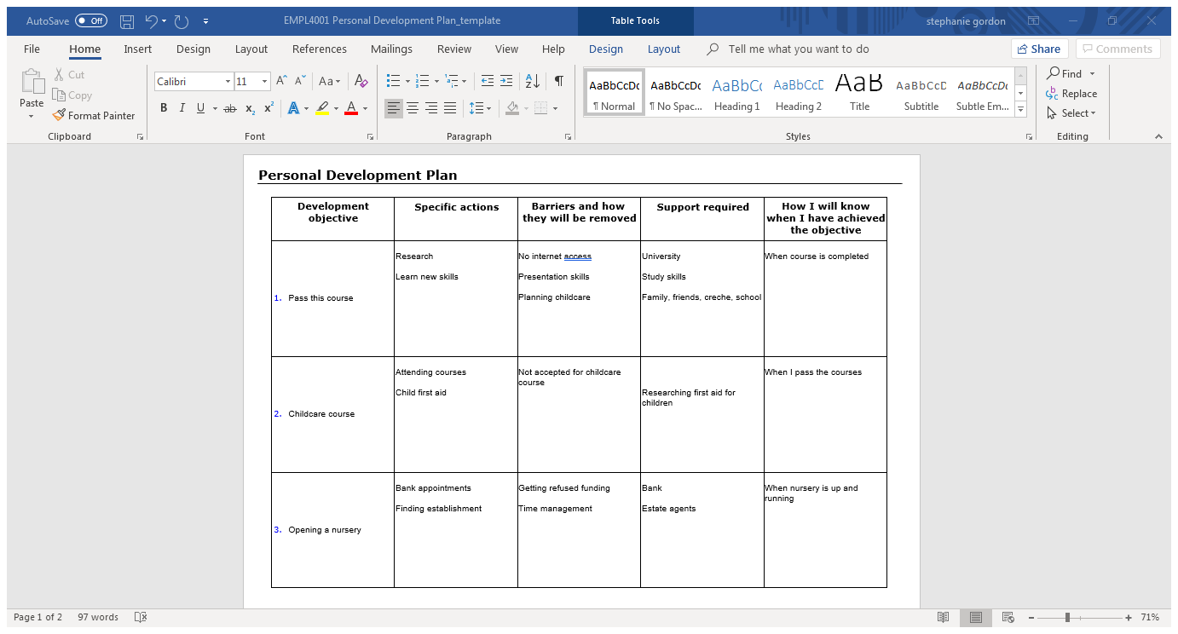

Conclusion
In conclusion this report on my reflective review my learning journey has helped me to deepen my quality of learning, in the form of understanding my own learning process. It has helped me realise that I am a reflective learner and that I will think things through thoroughly before coming to any conclusion on things, this will help me in the future as when I finish university and go to open my own business thinking things through thoroughly will be crucial when making decisions, whether this may be hiring staff, the location of my nursery or simply deciding on whether I should accept a bank loan or rent an establishment until I have saved enough to buy my own.
Upon reflecting on my learning journey, it has helped me realise my goals and where I want to be in 5 years time, one of them goals are to pass my course and receive my BA certificate. I know that to do this I will need to attend university every day in order to gather the correct skills I will need and to hand all my assignments I am given in on time. what I plan on doing to make this possible is attending any study skills classes I need to in order o learn better academically and to have manage my time correctly in order to arrive to lectures on time. Opening a nursery is something I am passionate about, doing a GO MAD model has helped me to do this as I now know exactly what I need to do to achieve this.

Reference list

Advantages & Disadvantages of Different Learning Styles | Synonym

Classroom.synonym.com. (2019). Advantages & Disadvantages of Different Learning Styles | Synonym. [online] Available at: https://classroom.synonym.com/advantages-disadvantages-different-learning-styles-2873.html [Accessed 06 Mar. 2019].

Go MAD Thinking

Gomadthinking.com. (2019). Go MAD Thinking. [online] Available at: https://www.gomadthinking.com/ [Accessed 3 Mar. 2019].

Why is confidence in the workplace important and how do I improve mine? | Kaplan Professional

Kaplan Professional. (2015). Why is confidence in the workplace important and how do I improve mine? | Kaplan Professional. [online] Available at: https://www.kaplanprofessional.edu.au/blog/why-is-confidence-in-the-workplace-important-and-how-do-i-improve-mine/ [Accessed 3 Mar. 2019].

Go MAD Thinking

Gomadthinking.com. (2019). Go MAD Thinking. [online] Available at: https://www.gomadthinking.com/ [Accessed 5 Mar. 2019].

SWOT Analysis - Definition, Advantages and Limitations

Managementstudyguide.com. (2019). SWOT Analysis - Definition, Advantages and Limitations. [online] Available at: http://managementstudyguide.com/swot-analysis.htm [Accessed 1 Mar. 2019].

Honey and Mumford Learning Styles

ELN Resources. (2017). Honey and Mumford Learning Styles. [online] Available at: https://resources.eln.io/honey-and-mumford-learning-styles/ [Accessed 5 Mar. 2019].

Anon

Theclassroom.com. (2019). [online] Available at: https://www.theclassroom.com/honey-mumford-learning-style-theory-10038576.html [Accessed 6 Mar. 2019].

Anon

Teach.its.uiowa.edu. (2019). [online] Available at: https://teach.its.uiowa.edu/sites/teach.its.uiowa.edu/files/docs/docs/VARK_ed.pdf [Accessed 6 Mar. 2019].

Children more likely to succeed academically if parents believe they're college bound

University of California. (2015). Children more likely to succeed academically if parents believe they're college bound. [online] Available at: https://www.universityofcalifornia.edu/news/children-more-likely-succeed-academically-if-parents-believe-theyre-college-bound [Accessed 5 Mar. 2019].

Introduction to VARK | VARK

Vark-learn.com. (2019). Introduction to VARK | VARK. [online] Available at: http://vark-learn.com/introduction-to-vark/ [Accessed 6 Mar. 2019].

