Worksheet 4: Routing & Packet Filtering

Network Operating Systems and Services (ACCA5023)
april 2021

Abstract
This report will firstly narrate the practical tasks set out in the Network Operating Systems and Services (NOSS) Worksheet 4. Namely, testing the functionality of ARP and routing tables. The second section of the report will describe the deployment of an FTP server and test the functionality. Thirdly, there is a description of remote access LAN routing and testing the functionality. Next there is a description of implementing packet filtering within the LAN routing implemented previously. Finally, there is a discussion of High Availability and an example of organisational security policies.

Table of Contents
Abstract 1
Table of Contents 2
Table of Figures 3
1 Task 1: Utilising ARP and Routing Tables 5
2 Task 2: Deploy core services (FTP Server) 7
3 Task 3: Routing and Remote Access Service 17
3.1 Installing and configuring remote access 17
3.2 Testing the remote access connections 21
3.3 Task 3 observations 26
4 Task 4: IP Packet Filtering 28
4.1 Filter 1 - Stopping ‘anyone’ in PrivateNet1 from Pinging the Router Firewall Service 28
4.2 Filter 2 - Restrict Access to FTP Service running on Server2 to only hosts in PrivateNet2 30
4.3 Filter 3 - Only allow specific hosts in PrivateNet1 to access the FTPService running on Server2 32
5 Task 5: Failover Clustering for high availability systems/services 35
5.1 Failover cluster setup screenshots 36
6 Task 6: Observational Tasks 42
6.1 Network Policy 42
6.1.1 Network Design 42
6.1.2 IPS / HIDS 42
6.1.3 Change Management 42
6.2 High Availability Policy 42
7 References 45

Table of Figures
Figure 1 - Server 1 ARP table 5
Figure 2 - Server 1 to Client 1 ping attempts 5
Figure 3 - Server 1 ARP table after ping 6
Figure 4 - Server 1 routing table 6
Figure 5 - Server 2 pending restart 7
Figure 6 - Server 2 installing updates 7
Figure 7 - FTP server installation 8
Figure 8 - ftpuser account creation 8
Figure 9 - 1STFPSITE ftp site 9
Figure 10 - 1STFPSITE binding 9
Figure 11 - FTP user access 10
Figure 12 - FTP banner message 10
Figure 13 - ftproot permissions 11
Figure 14 - FTP_Uploads folder 11
Figure 15 - ftpfile2upload.txt 12
Figure 16 - FTP site authentication 12
Figure 17 - Configuration of local client directory 13
Figure 18 - FTPuser NTFS permissions 13
Figure 19 - FTP access denied 14
Figure 20 - FTP authorisation rules 14
Figure 21 - FTProot read only 15
Figure 22 - FTP transfer successful 15
Figure 23 - Uploaded file in FTProot 16
Figure 24 - Windows updates on Server 1 17
Figure 25 - Remote Access installation 17
Figure 26 - RA deployed with VPN only 18
Figure 27 - LAN Routing configuration 18
Figure 28 - Enabling RIP 19
Figure 29 - RIP network interfaces 19
Figure 30 - Installing LAN routing on Server 2 20
Figure 31 - Server 2 RIP interfaces 20
Figure 32 - Ping from Server 1 to Server 2 21
Figure 33 - Ping from Client 1 to Client 2 error 21
Figure 34 - Server 1 router discovery 22
Figure 35 - Server 2 Router discovery 22
Figure 36 - Client 1 default gateway 23
Figure 37 - Client 2 default gateway 23
Figure 38 - Ping from Client 1 to Client 2 error 24
Figure 39 - Server 1 routing table 24
Figure 40 - Ping from Client 1 to Client 2 successful 25
Figure 41 - Ping from Client 2 to Client 1 successful 25
Figure 42 - Example routing table[3] 26
Figure 43 - Filter 1 28
Figure 44 - Filter 1 tests successful 29
Figure 45 - Filter 2 30
Figure 46 - Filter 2 test failure 30
Figure 47 - Filter 2 reapplied 31
Figure 48 - Filter 2 test successful 31
Figure 49 - Filter 3 rule 1 32
Figure 50 - Filter 3 rule 2 32
Figure 51 - Filter 3 rule 3 33
Figure 52 - Filter 3 test 1 successful 33
Figure 53 - Filter 3 test 2 successful 34
Figure 54 - Filter 3 test 3 successful 34

Task 1: Utilising ARP and Routing Tables
Viewing the ARP table of Server 1 shows few entries, this is because entries in the ARP table are flushed after a few minutes without use[1].
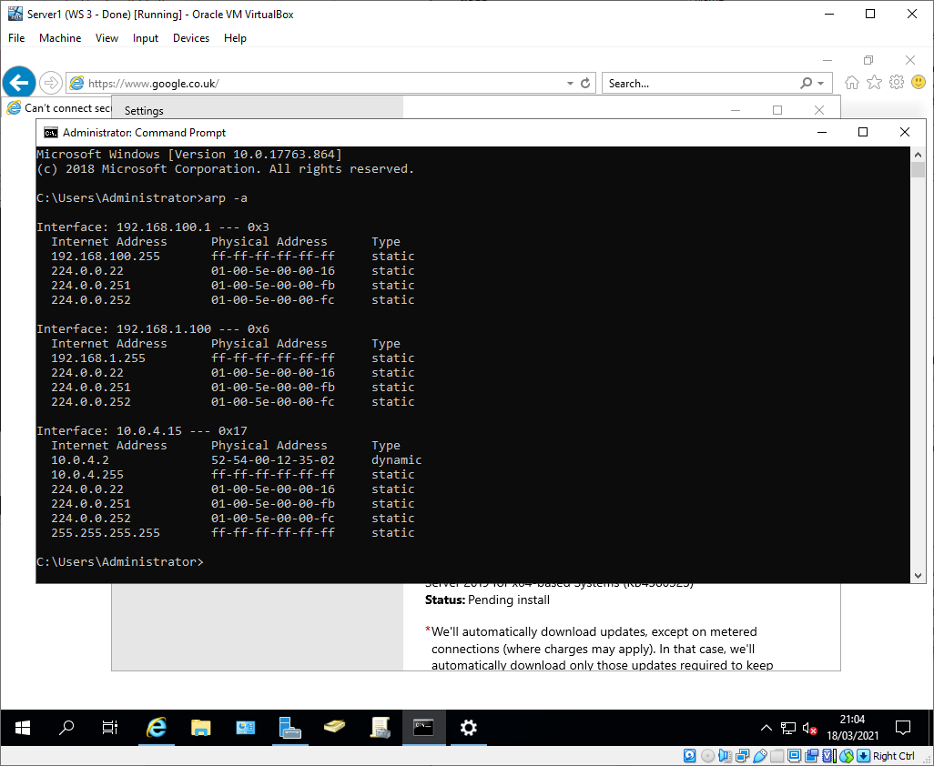
Figure 1 - Server 1 ARP table
To add new entries on the list, other devices on the network were pinged. The first ping attempts between Server 1 and Client 1 failed because the destination VM running, subsequent pings were successful.
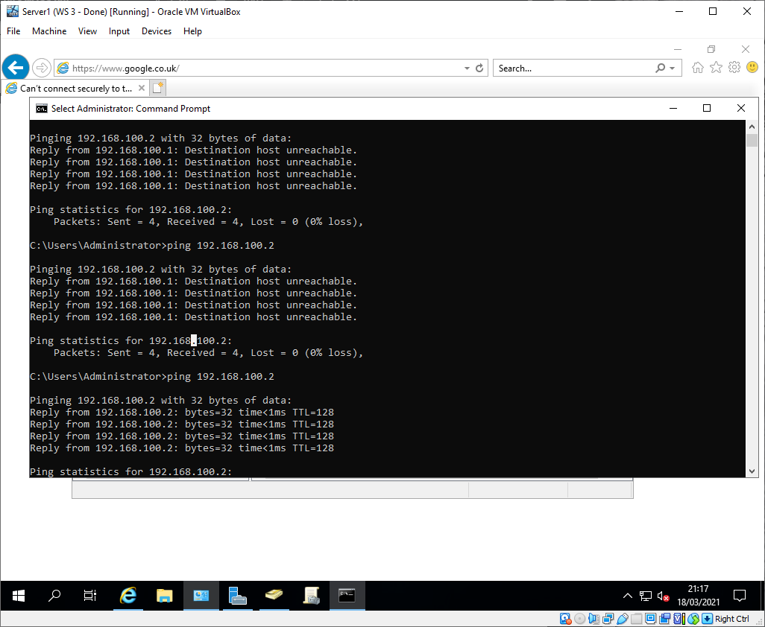
Figure 2 - Server 1 to Client 1 ping attempts
After the ping was successful the ARP table showed an entry for 192.168.100.2 as expected.
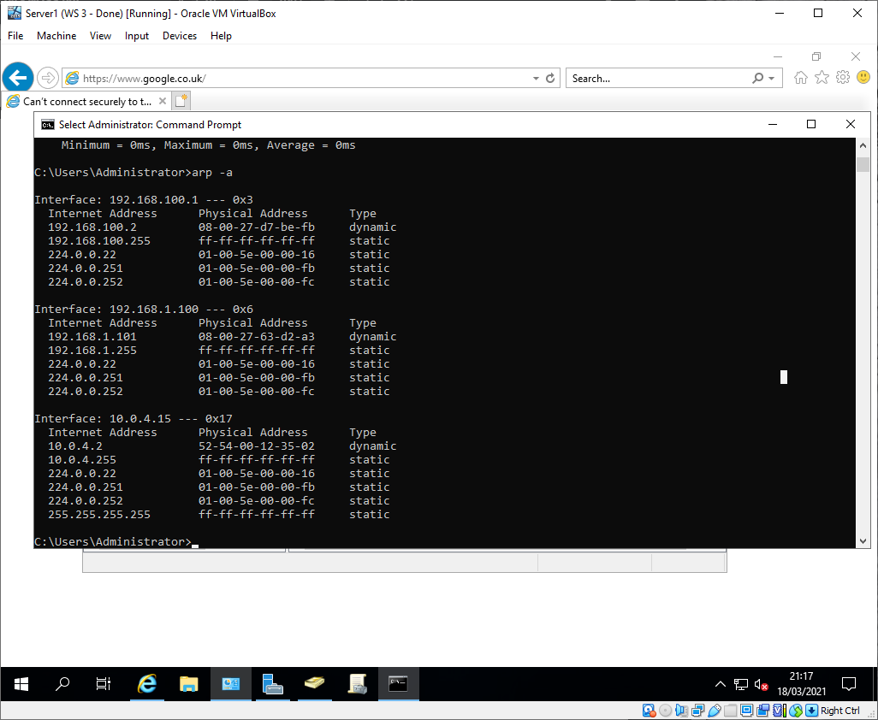
Figure 3 - Server 1 ARP table after ping

The route print command shows that the default route on Server 1 is through the additional interface (10.0.4.15) that was added for internet connectivity.
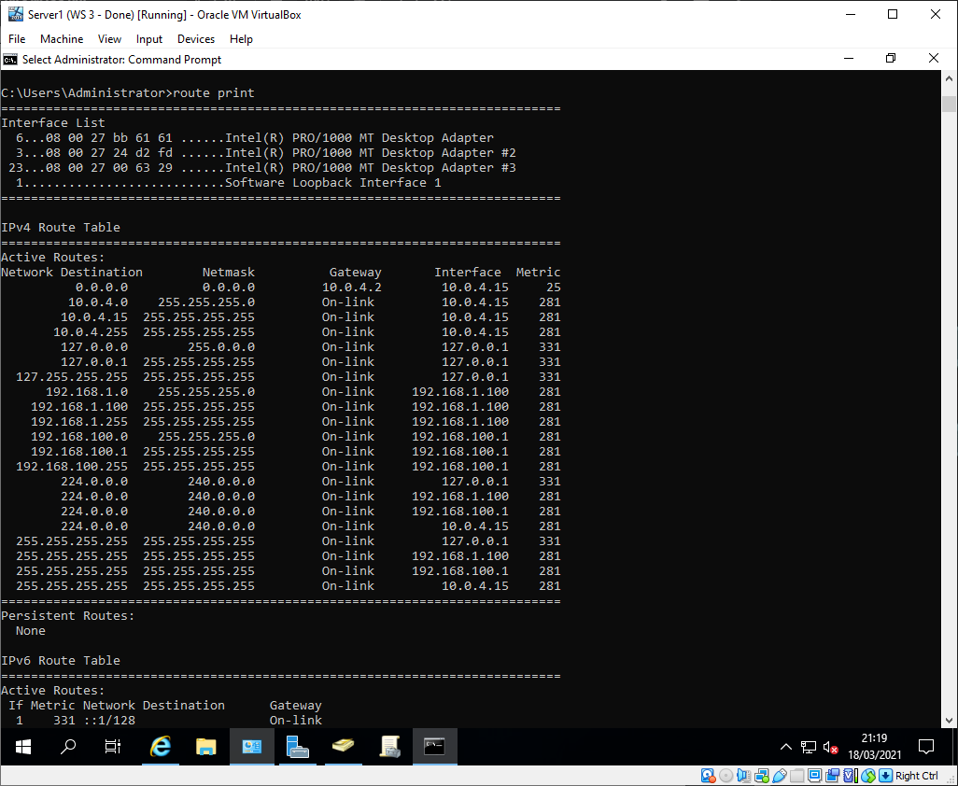
Figure 4 - Server 1 routing table

Task 2: Deploy core services (FTP Server)
Server 2 required a restart which could have affected the FTP server role addition, as such it that was completed first.
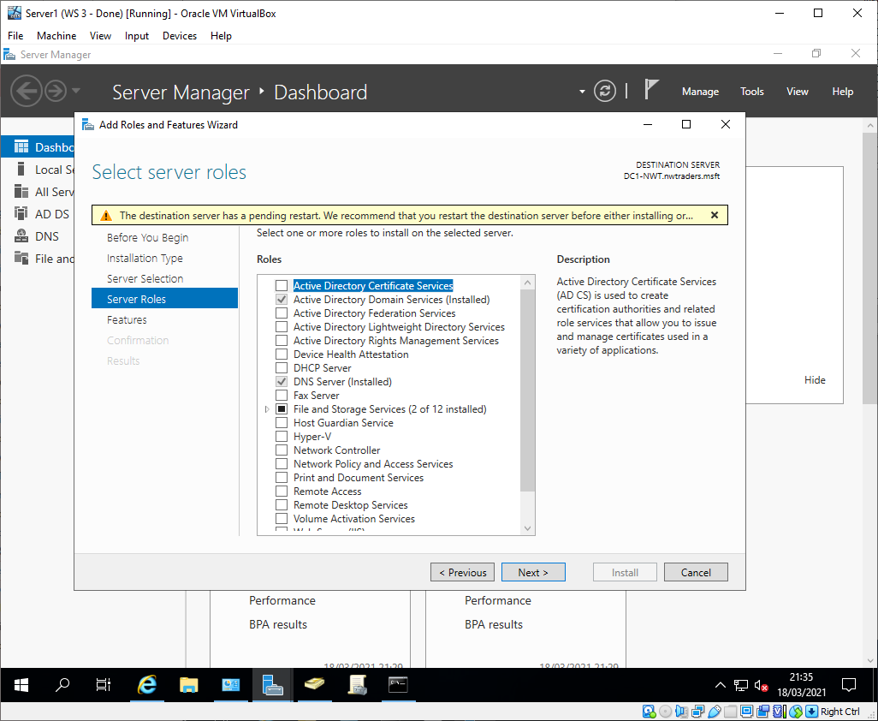
Figure 5 - Server 2 pending restart
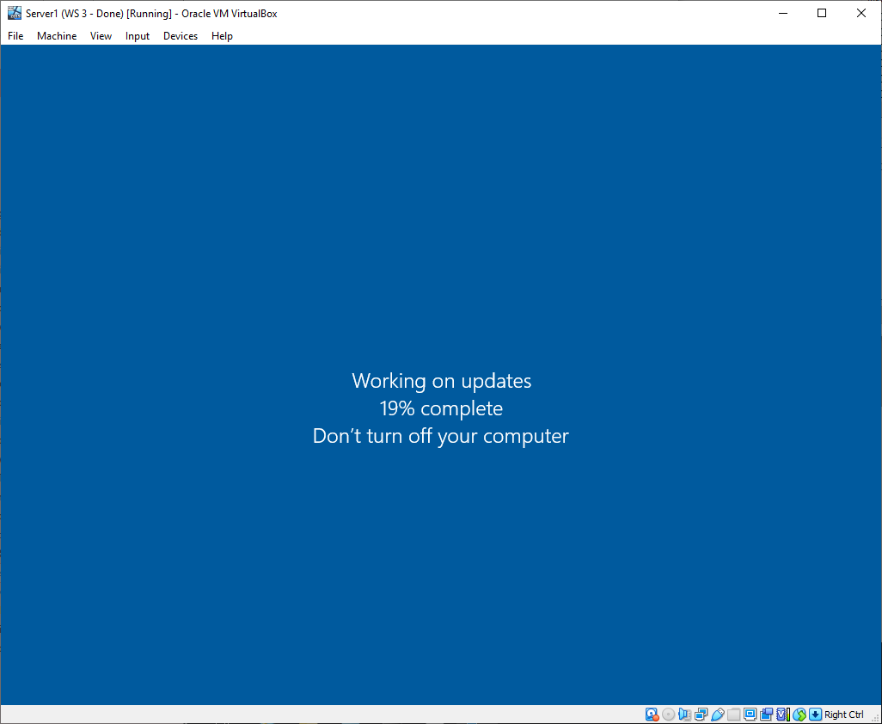
Figure 6 - Server 2 installing updates

After the updates were installed, IIS manager and FTP Server were installed as features on Server 2.
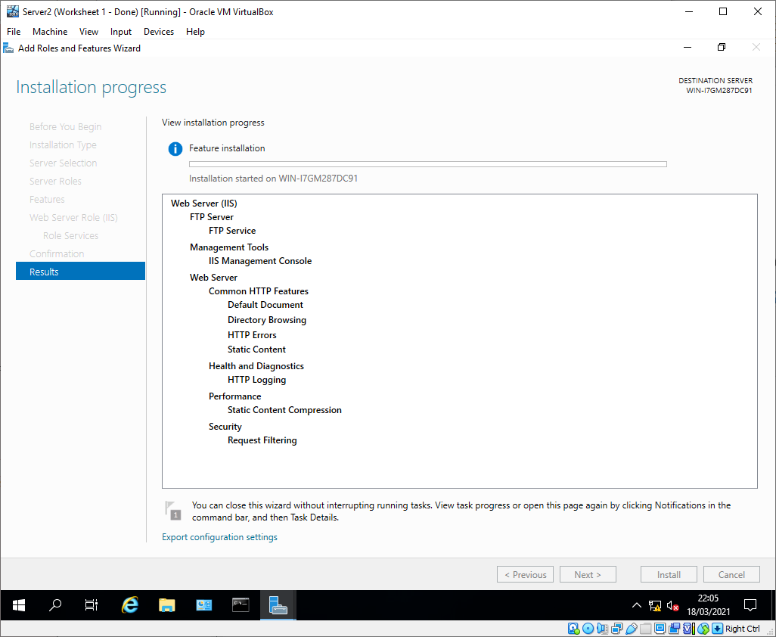
Figure 7 - FTP server installation
A new local account (ftpuser) was created on Server 2 using computer management.
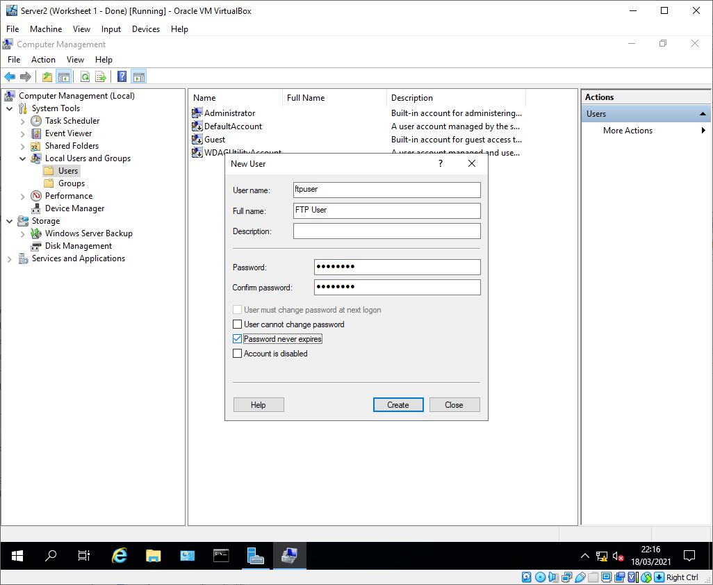
Figure 8 - ftpuser account creation

Once the account was created, a new FTP site (1STFPSITE) was created in IIS manager and bound to port 21.
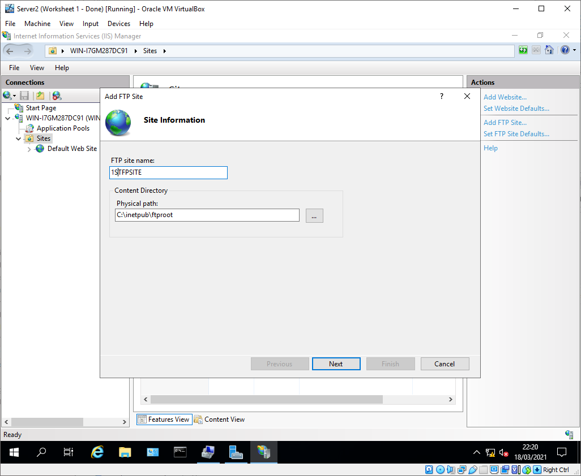
Figure 9 - 1STFPSITE ftp site
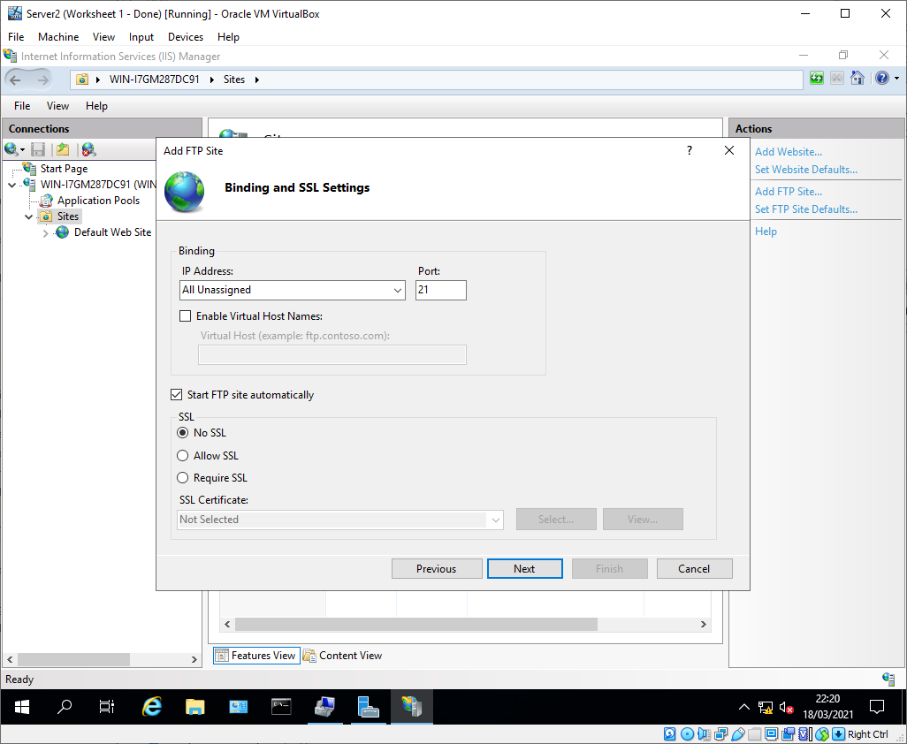
Figure 10 - 1STFPSITE binding

‘Ftpuser’ was then given access to the FTP site.
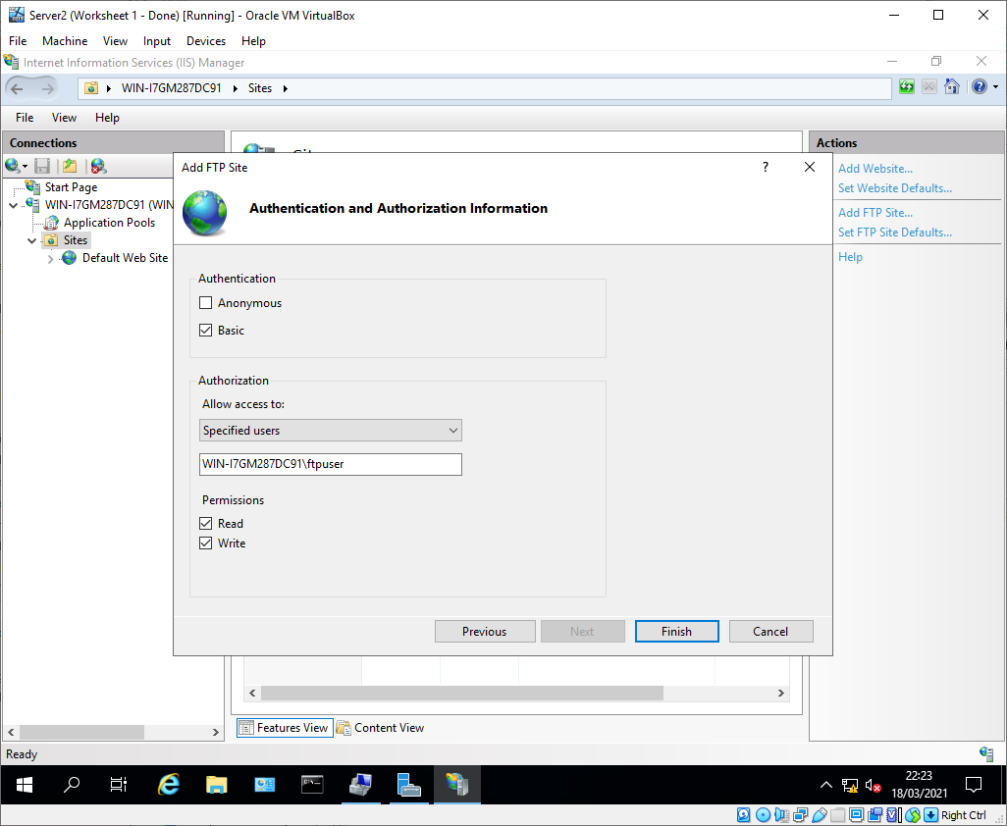
Figure 11 - FTP user access

A welcome banner is then configured for the FTP site, acting as a legal notice for any unauthorised users[2].
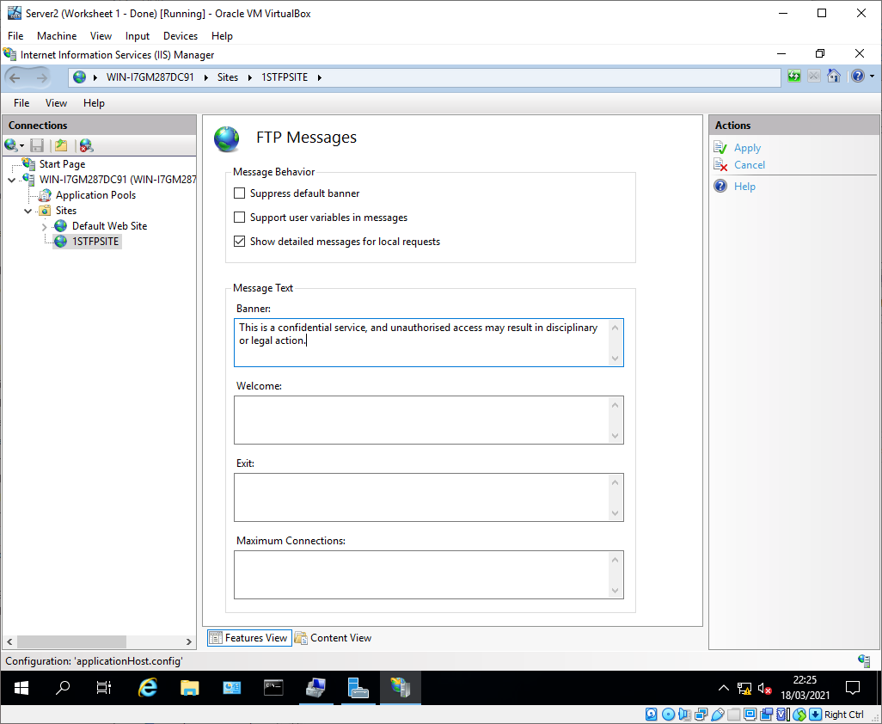
Figure 12 - FTP banner message

FTPuser was then given access to the FTP server working directory ‘C:\inetpub\ftproot’ and an uploads sub-folder was created.
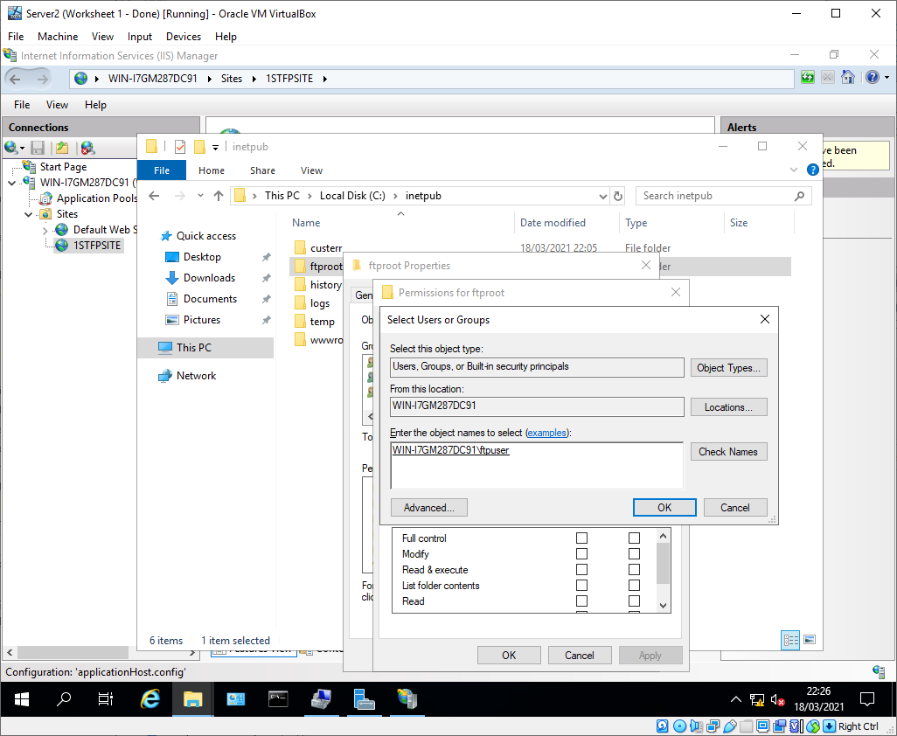
Figure 13 - ftproot permissions

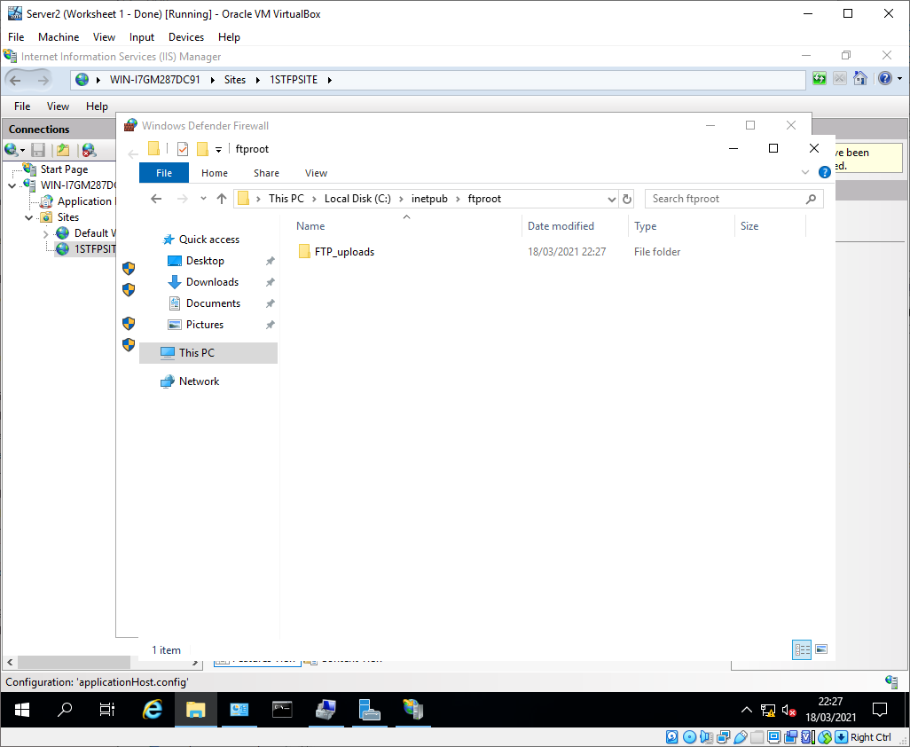
Figure 14 - FTP_Uploads folder

A folder ‘C:\FTPFiles’ was created on Client 2 with a file ‘ftpfile2upload.txt’, in preparation for testing the FTP site.
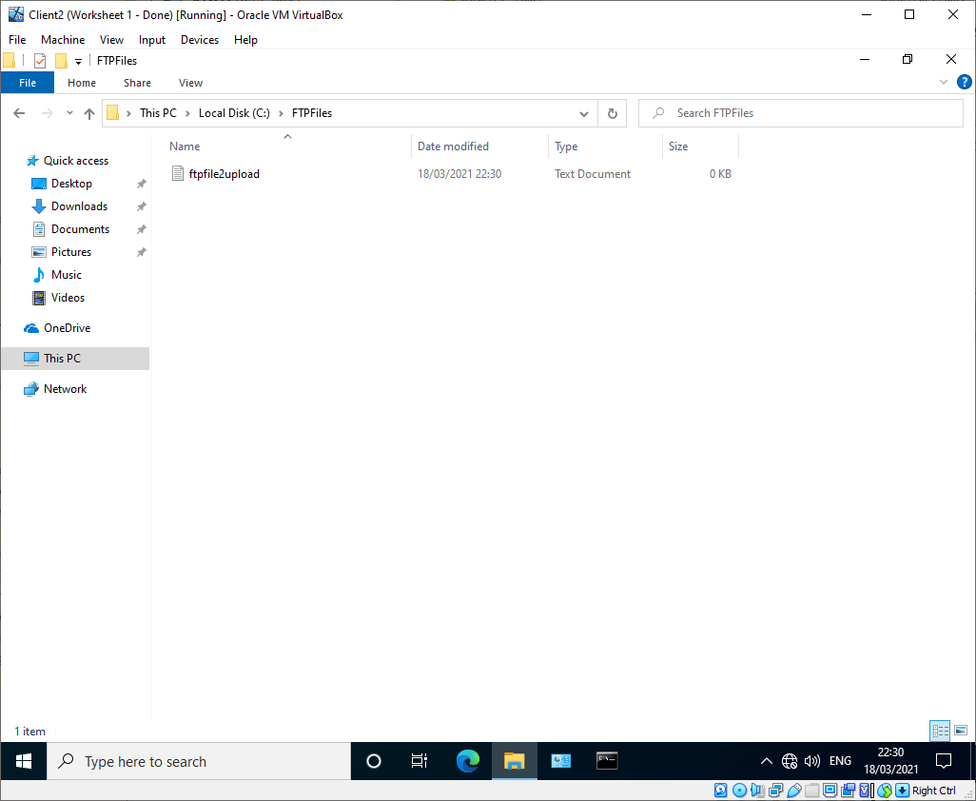
Figure 15 - ftpfile2upload.txt

Using command prompt on Client 2, a connection was made to the FTP site hosted on Server 2, which showed the banner message and allowed ftpuser to log in.
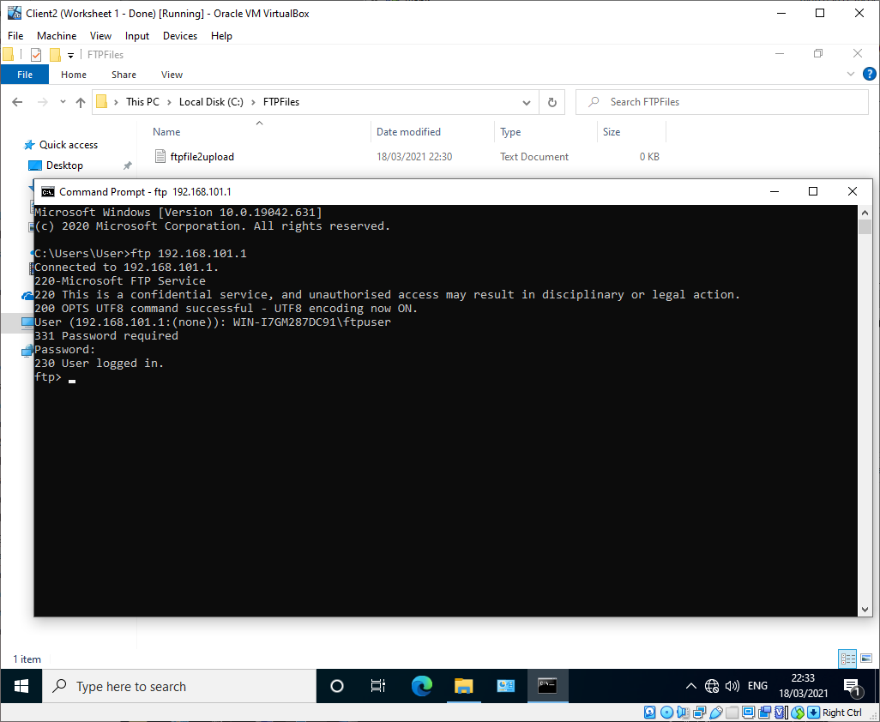
Figure 16 - FTP site authentication
Once the connection was established, the local client directory was specified (C:\FTPFiles) and it was attempted to upload the ftpfile2upload.txt file to the FTP server directory. This was not successful.
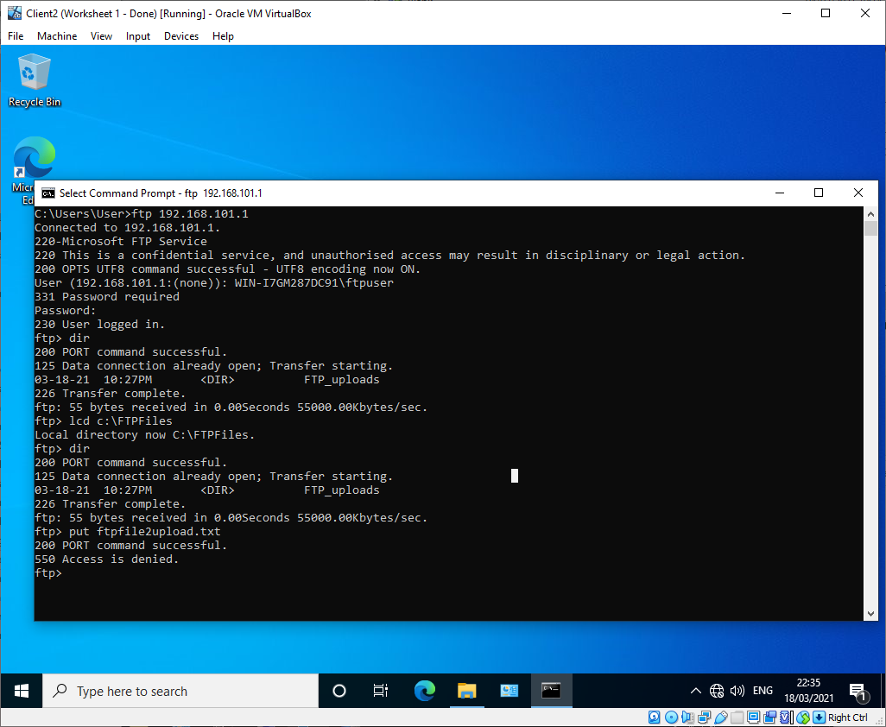
Figure 17 - Configuration of local client directory
Investigation into the failure found ‘ftpuser’ did not have NTFS write permissions on the FTP server root folder, this was resolved.
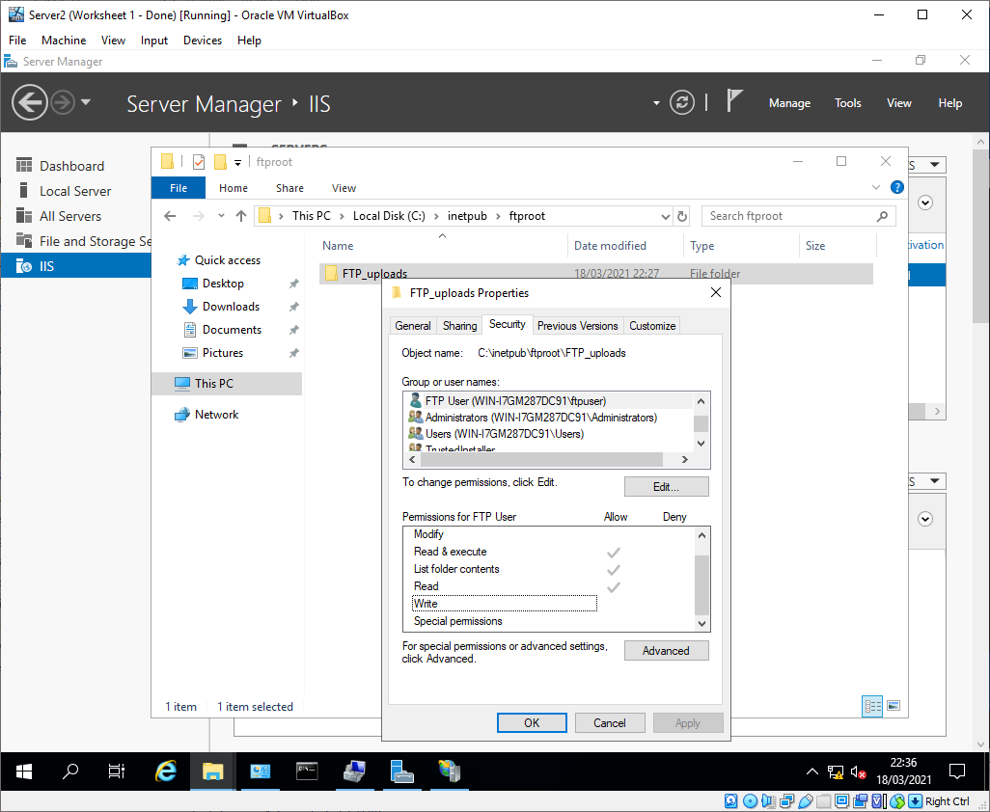
Figure 18 - FTPuser NTFS permissions
Unfortunately, this didn’t resolve the access issue.
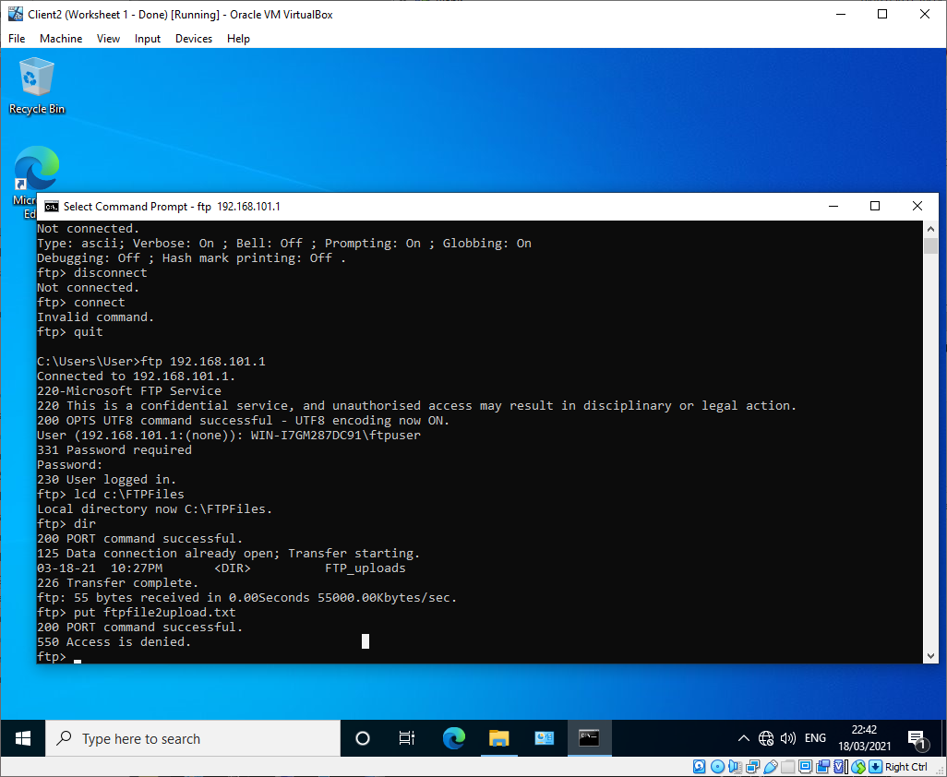
Figure 19 - FTP access denied

Additional FTP authorisation rules were put in place to test whether the permission issue was on the FTP server side, rather than directory NTFS permissions, but this didn’t resolve the issue either and were removed.
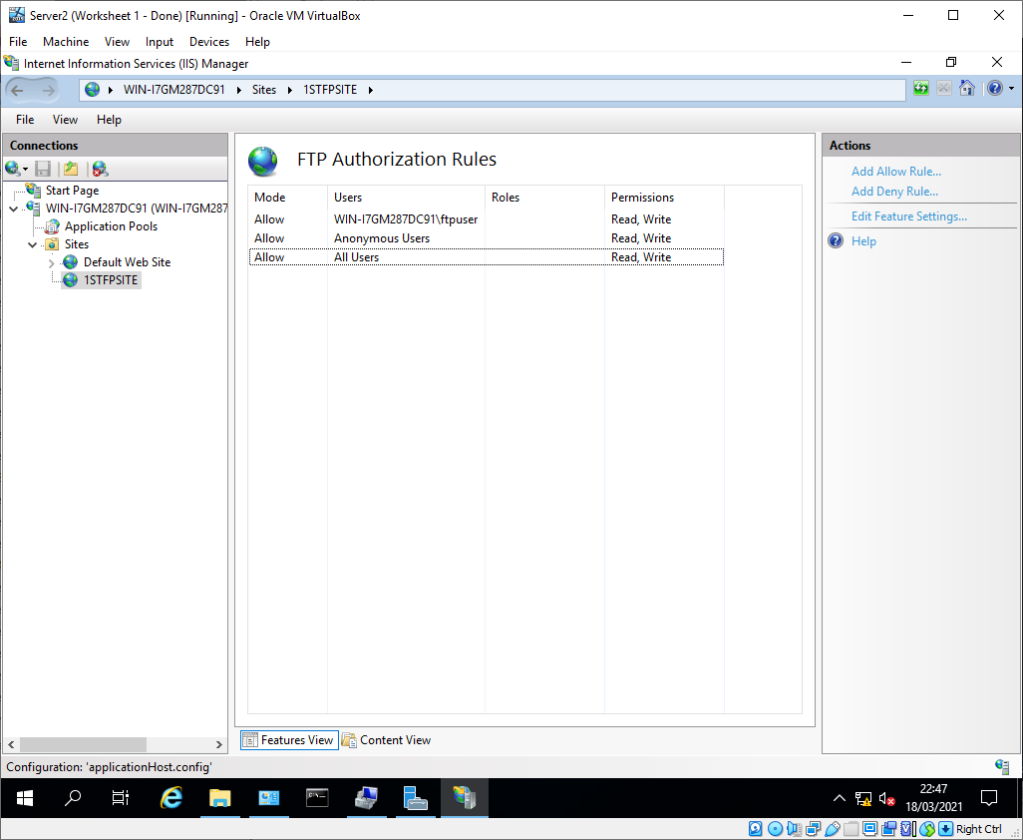
Figure 20 - FTP authorisation rules
Further investigations found that the ‘ftproot’ folder on Server 2 was set to read only, this was resolved.
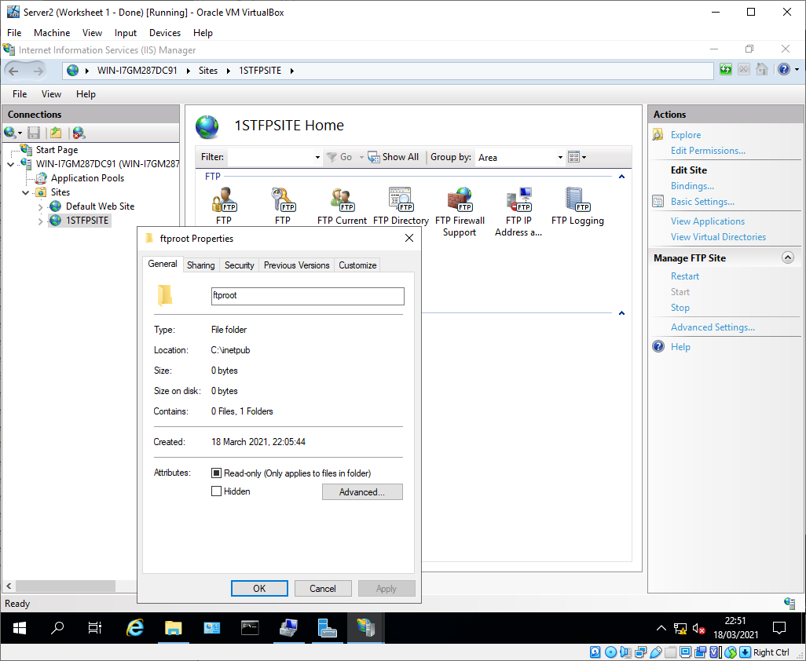
Figure 21 - FTProot read only
This change resolved the access issues with the FTP server.
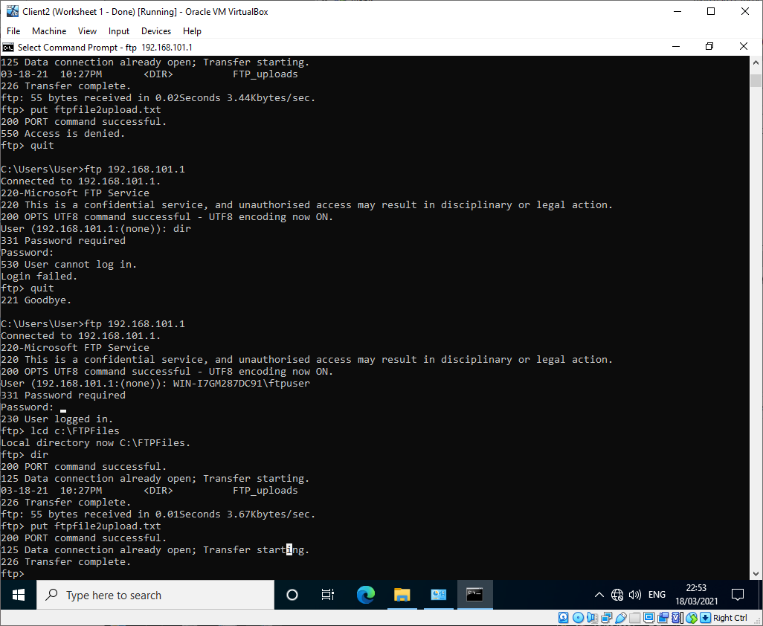
Figure 22 - FTP transfer successful
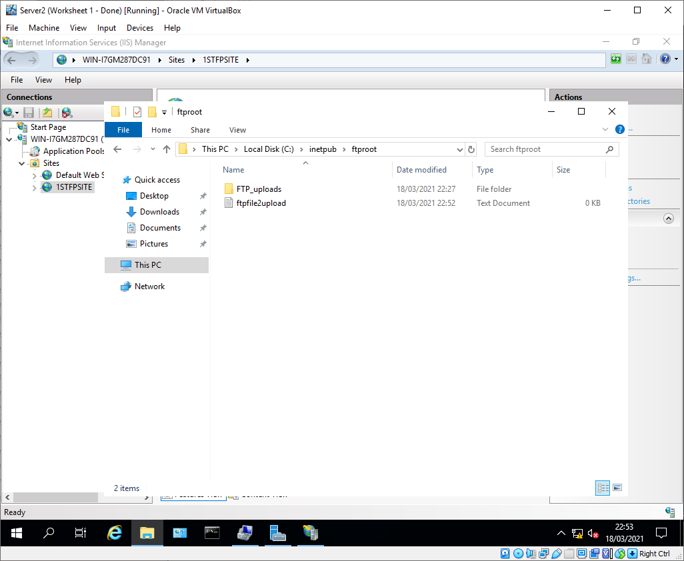
Figure 23 - Uploaded file in FTProot

Task 3: Routing and Remote Access Service

Installing and configuring remote access
Server 1 required some updates which were installed before any additional roles were added.
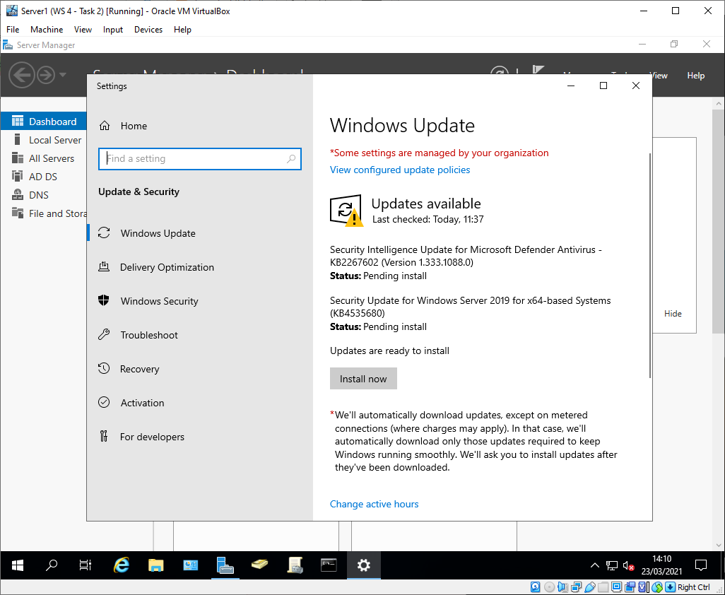
Figure 24 - Windows updates on Server 1

Remote access and all depenancies were installed on Server 1.
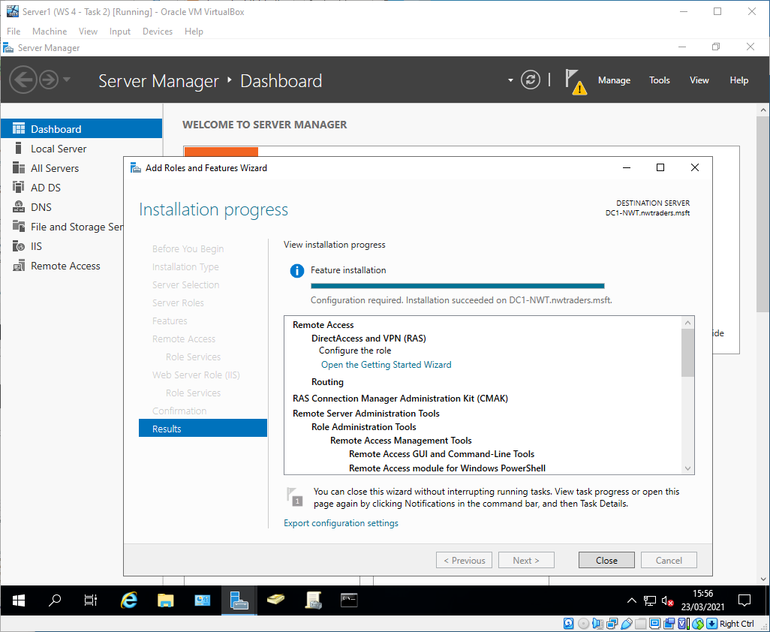
Figure 25 - Remote Access installation
Remote access was configured with ‘VPN only’.
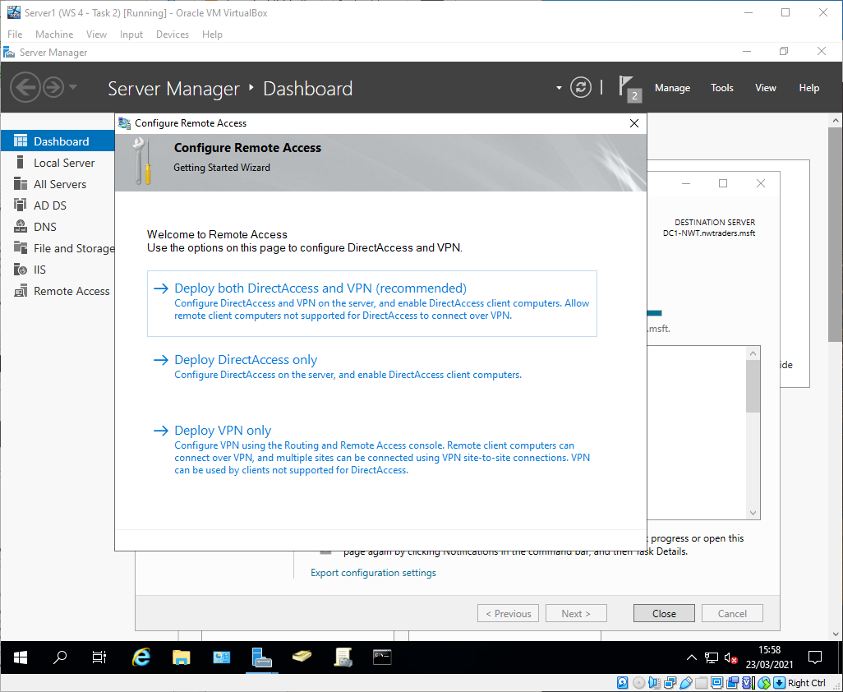
Figure 26 - RA deployed with VPN only

LAN Routing was enabled on Server 1 and RIP was enabled on IPv4.
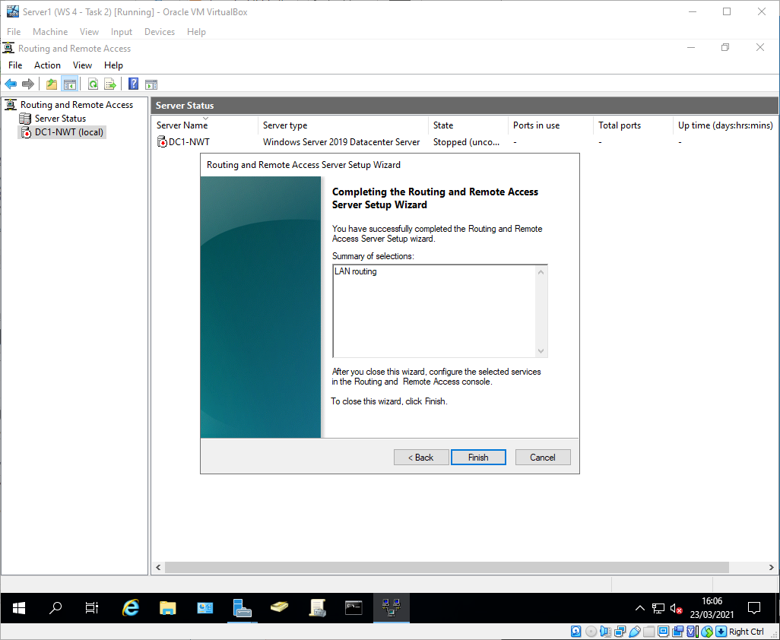
Figure 27 - LAN Routing configuration

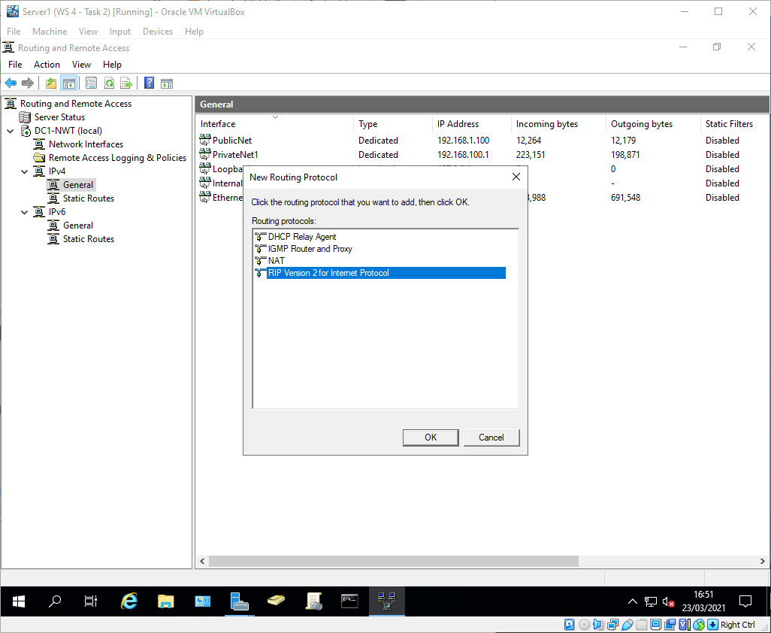
Figure 28 - Enabling RIP

Each interface (PublicNet and PrivateNet1) were added to the RIP protocol.
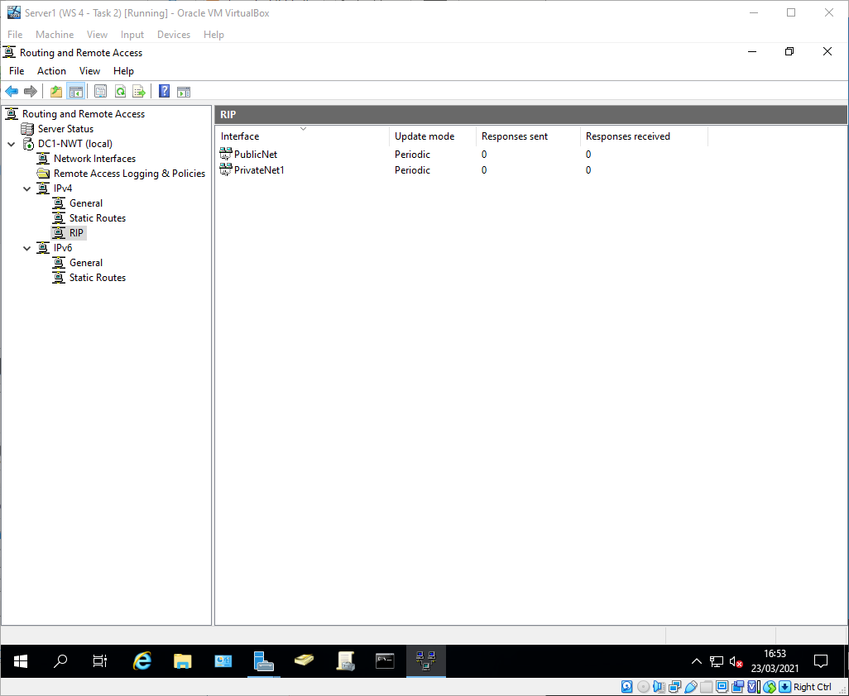
Figure 29 - RIP network interfaces

The same configuration method was employed to install RA and add RIP to Server 2.
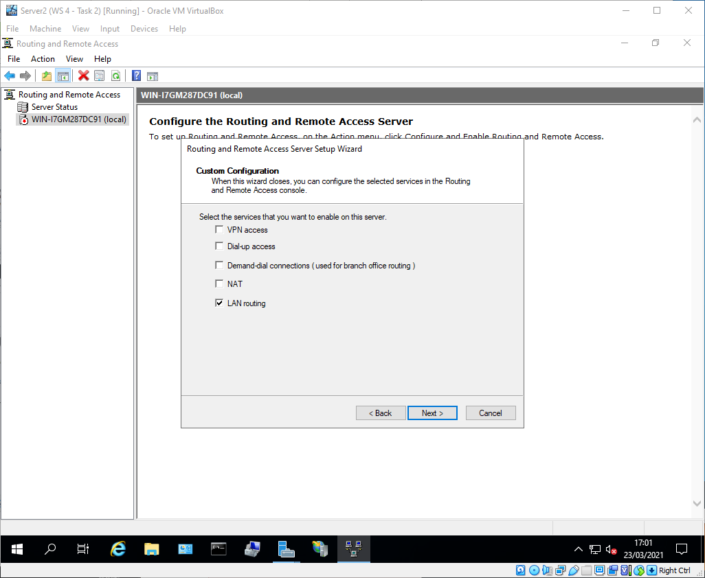
Figure 30 - Installing LAN routing on Server 2

The interfaces added to RIP on Server 2 were PublicNet and PrivateNet2.
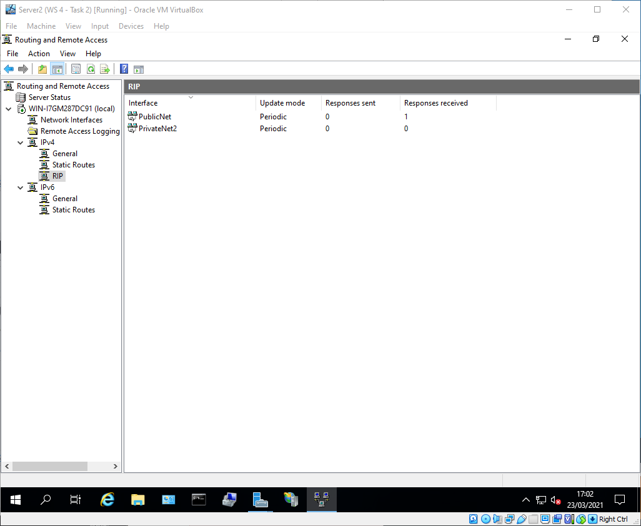
Figure 31 - Server 2 RIP interfaces

Testing the remote access connections
Server 1 was able to ping Server 2 using the PublicNet IP addresses, meaning the PublicNet LAN is working correctly.
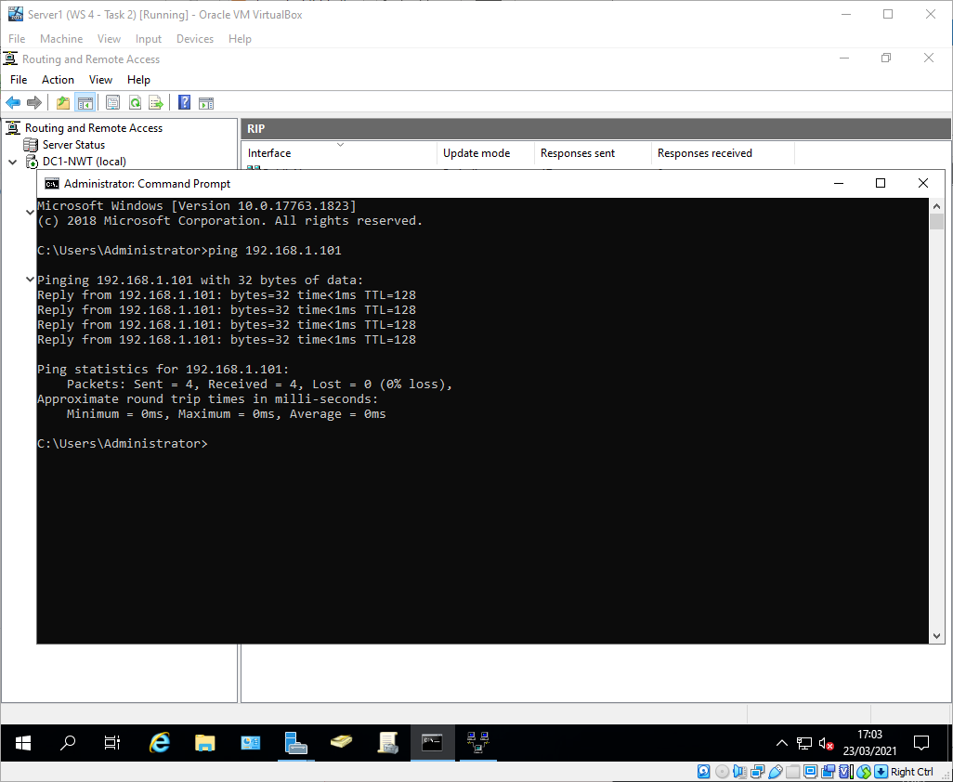
Figure 32 - Ping from Server 1 to Server 2
The ping from Client 1 to Client 2 failed, meaning the routers aren’t configured correctly to route packets between the LANs.
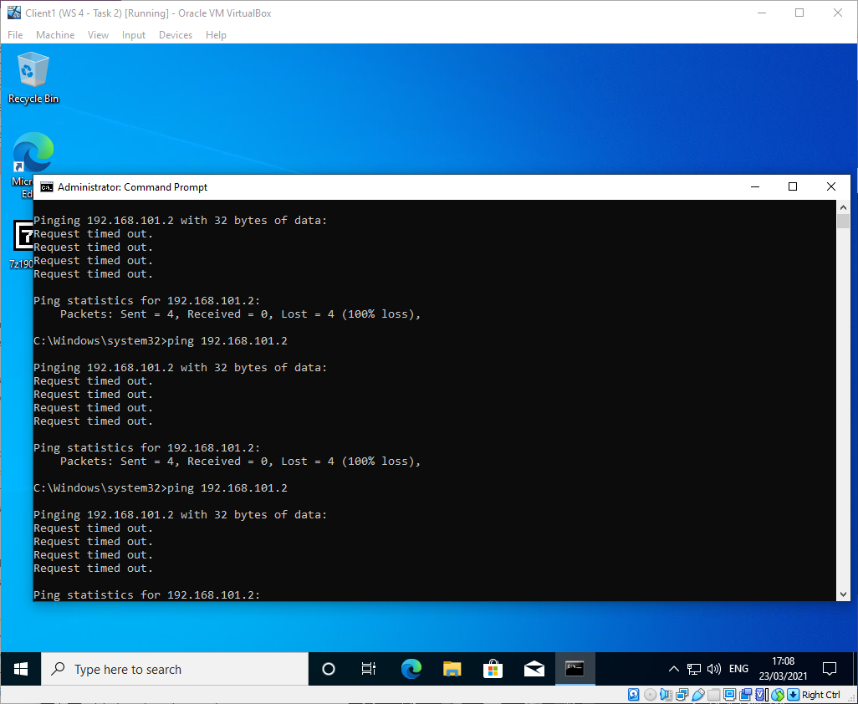
Figure 33 - Ping from Client 1 to Client 2 error
As a troubleshooting step it was checked that the routers were able to discover each other, which they were.
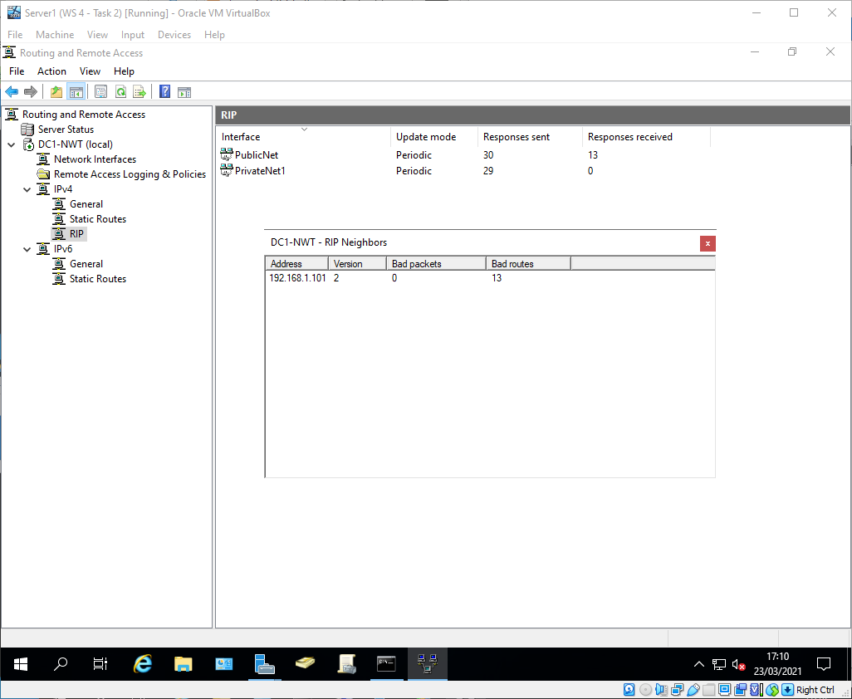
Figure 34 - Server 1 router discovery

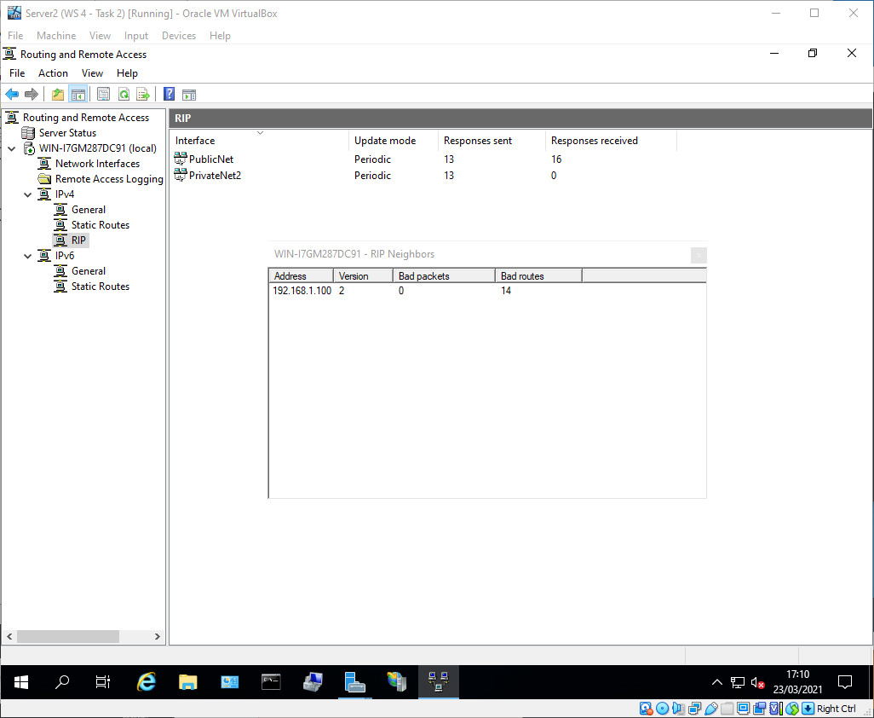
Figure 35 - Server 2 Router discovery

Further investigations found both Clients did not have default gateways configured, this was resolved.
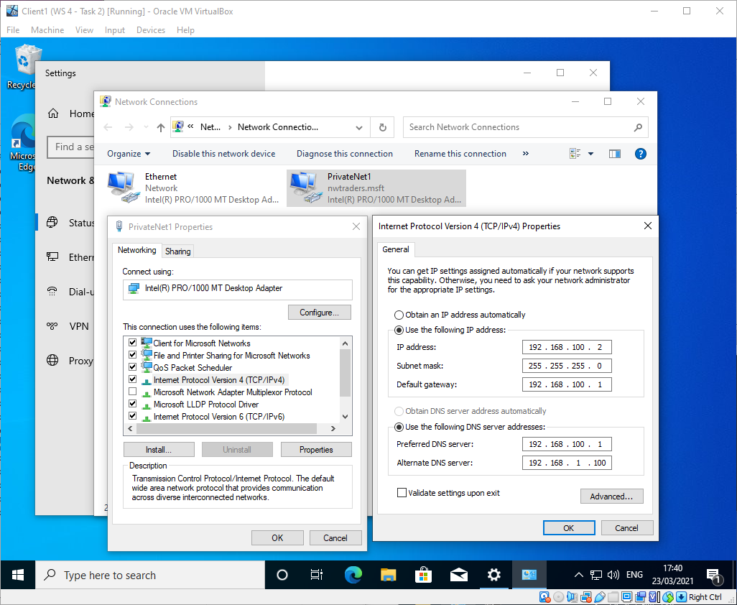
Figure 36 - Client 1 default gateway

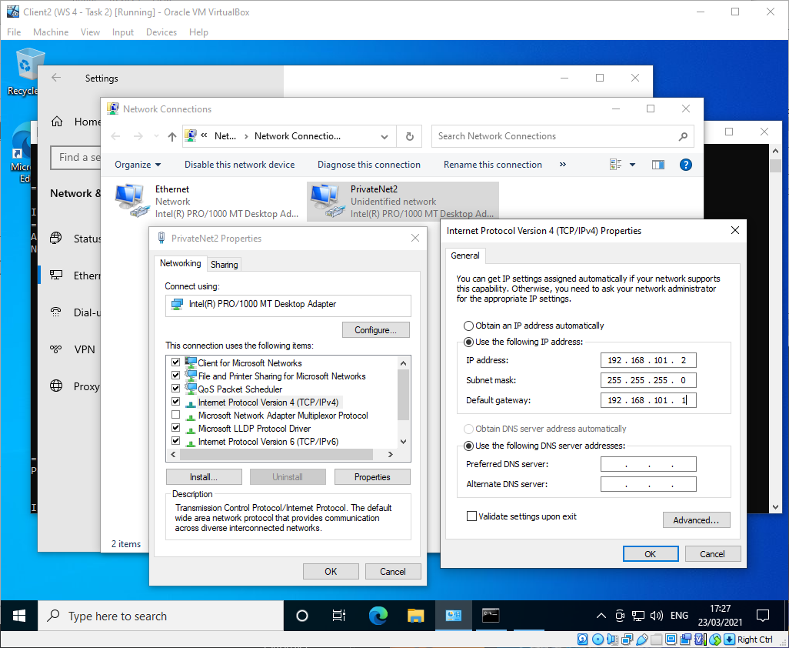
Figure 37 - Client 2 default gateway

This did not resolve the routing issue as Client 1 was still unable to ping Client 2.
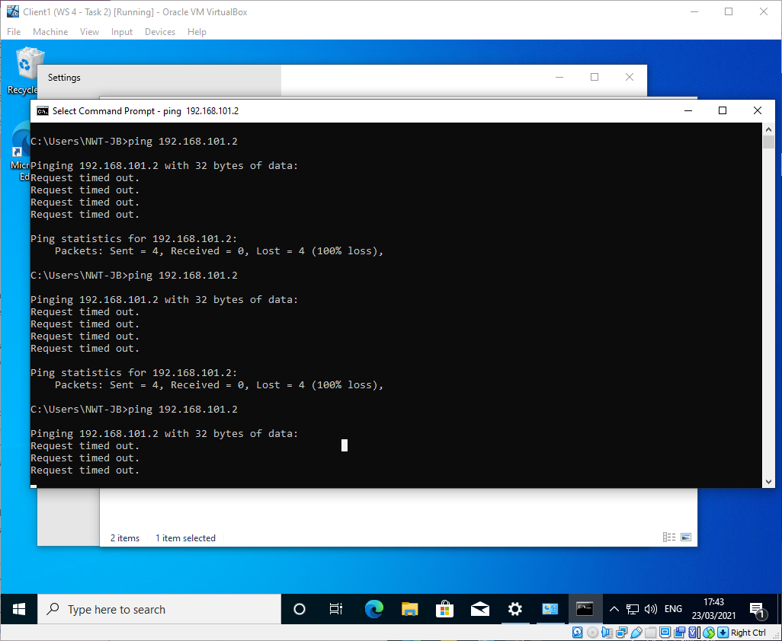
Figure 38 - Ping from Client 1 to Client 2 error

The routing table on Server 1 showed that the correct interfaces were selected for the RIP routes.
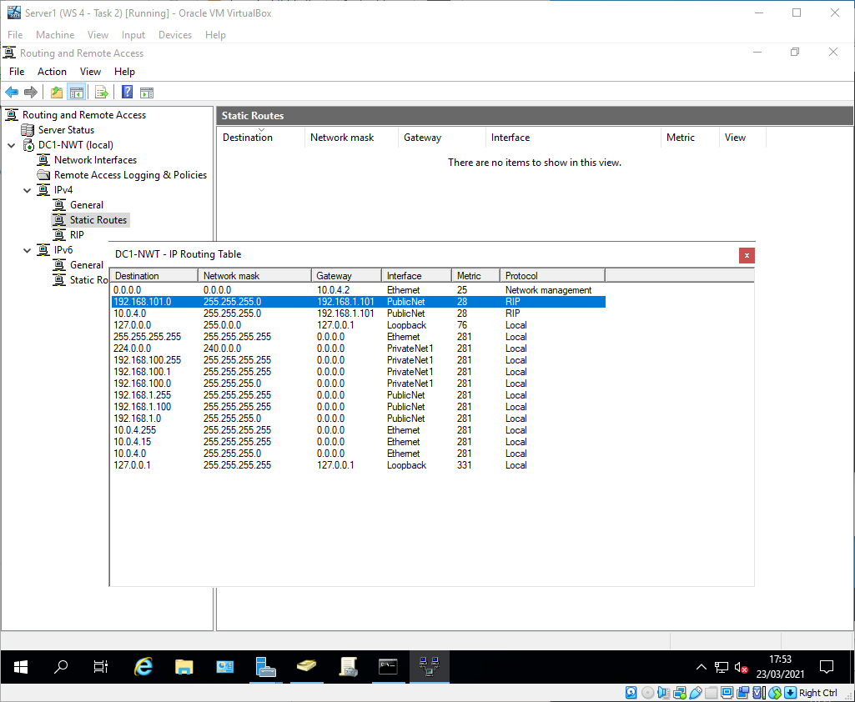
Figure 39 - Server 1 routing table
After further investigation it was found that the additional "Ethernet" NAT adapter which had been configured on both servers to allow for the VMs to connect to the internet for windows updates were still acting as the default route. Once this was disabled, the connection tests were successful:
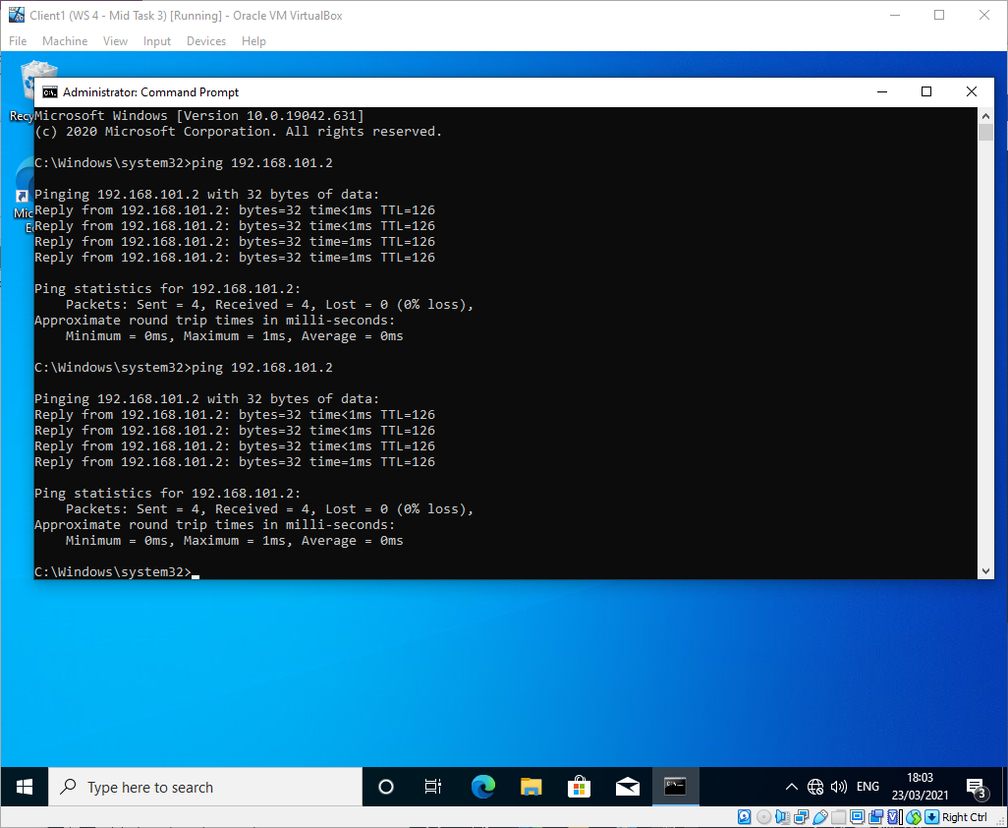
Figure 40 - Ping from Client 1 to Client 2 successful

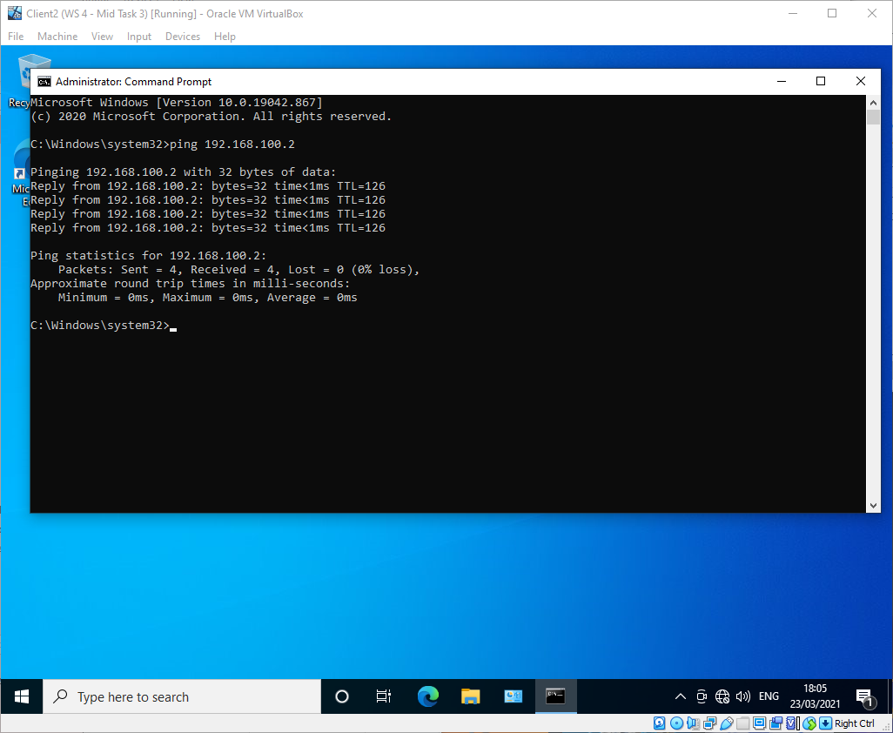
Figure 41 - Ping from Client 2 to Client 1 successful

Task 3 observations
Routers reference which networks they are able to connect to via their routing tables. An example of a routing table is pictured below in figure 42.
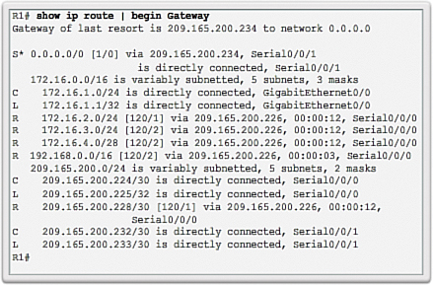
Figure 42 - Example routing table[3]
There are several columns in the routing table, with each row having at least the ‘Route Source’, the ‘Destination Network’ and the ‘Outgoing Interface’. The route source represents how the router learned of the route, the destination network identifies the destination network, and the outgoing interface identifies the interface the router would use to forward packets on the route.
Route Source | Destination Network | Outgoing Interface
C | 172.16.1.0/24 is directly connected | GigabitEthernet 0/0

For example, the row above means that the network 172.16.1.0/24 is directly connected to the router on interface G0/0.
Some rows have more columns than the minimum three, such as the row below. The ‘administrative distance’ is determined by the route source, with certain protocols being more “trustworthy” than others, it tells the router which route to use if there are more than one available for the same network. The ‘metric’ is determined by the length of the route, and tells the router which route to use if the administrative distance is the same for two routes to the same network. The ‘next hop’ is the IPv4 address of the next router to forward traffic to. The ‘route timestamp’ is when the route was last used.
Route Source | Destination Network | Administrative Distance and Metric | Next Hop | Route Timestamp | Outgoing Interface
R | 172.16.4.0/28 | [120/2] | Via 209.165.200.226 | 00:00:12 | Serial0/0/0

For example, the row above means that the network 172.16.4.0/28 was discovered using RIP, the IP address of the next router in the route is 209.165.200.226, and the last time the route was used was 12 seconds ago.

Task 4: IP Packet Filtering

Filter 1 - Stopping ‘anyone’ in PrivateNet1 from Pinging the Router Firewall Service
On Server 1, an inbound filter was created on interface PrivateNet1, this will filter any ICMP traffic coming into the router from PrivateNet1 (i.e. Client 1).
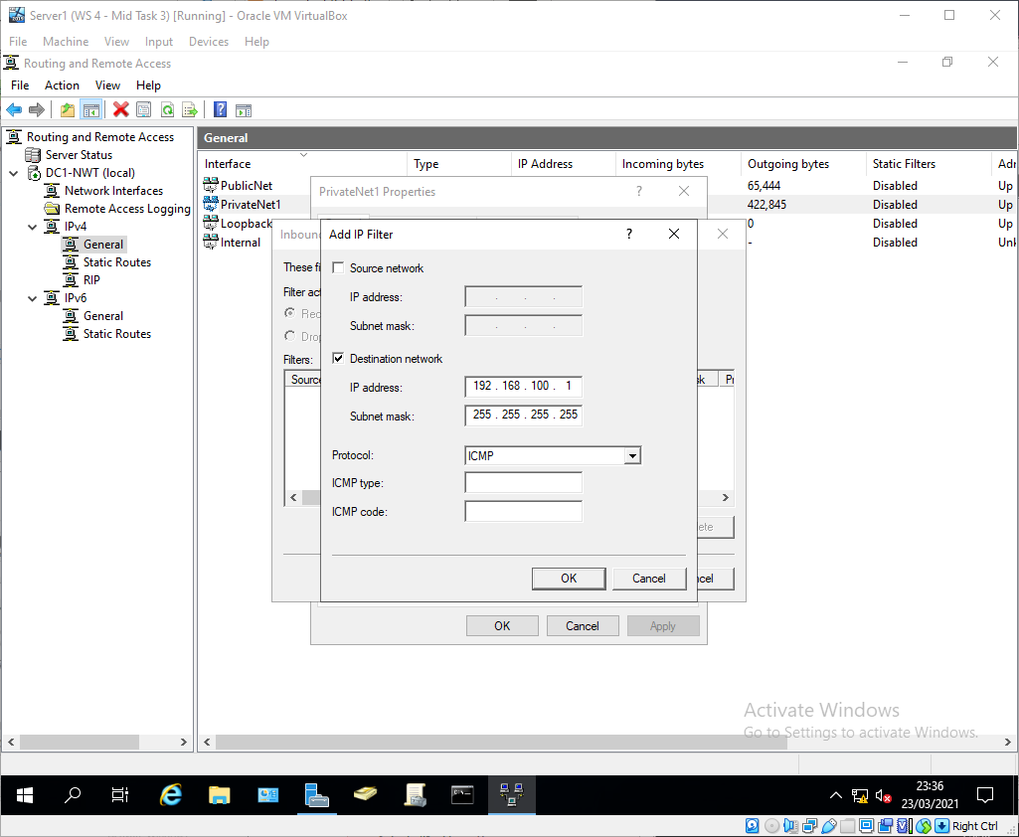
Figure 43 - Filter 1

The filter was then tested, with Client 1 able to ping everything but the private interface on Server 1 as expected.
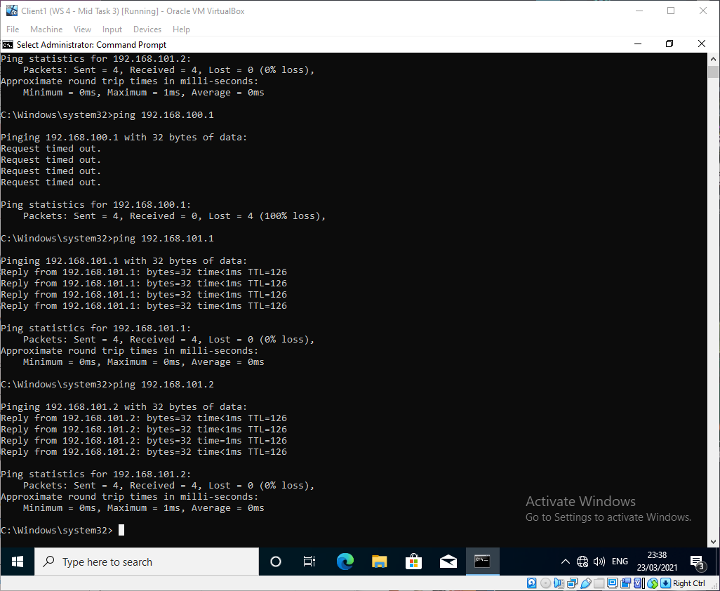
Figure 44 - Filter 1 tests successful

Client 2 was still able to ping 192.168.100.1 because the packet filter only applies to traffic inbound on interface "PrivateNet1" on Server 1 and the traffic from client 2 came through "PublicNet"

Filter 2 - Restrict Access to FTP Service running on Server2 to only hosts in PrivateNet2
On Server 1, an outbound filter was created on interface PublicNet, this will filter any FTP traffic going to Server 2 through the router.
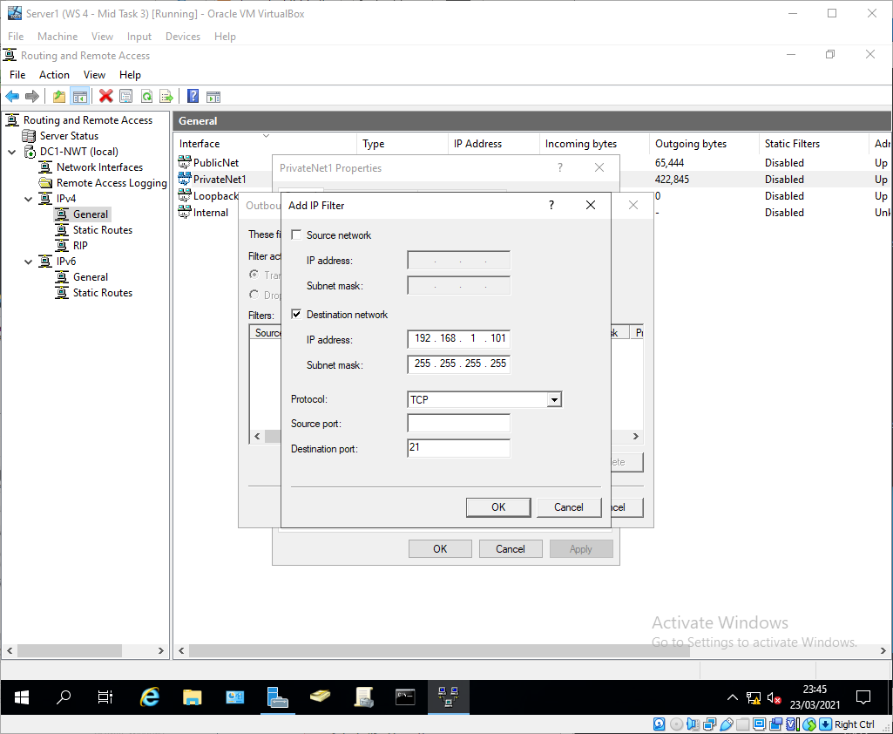
Figure 45 - Filter 2
The filter was tested, and the FTP connection was still made despite the filter.
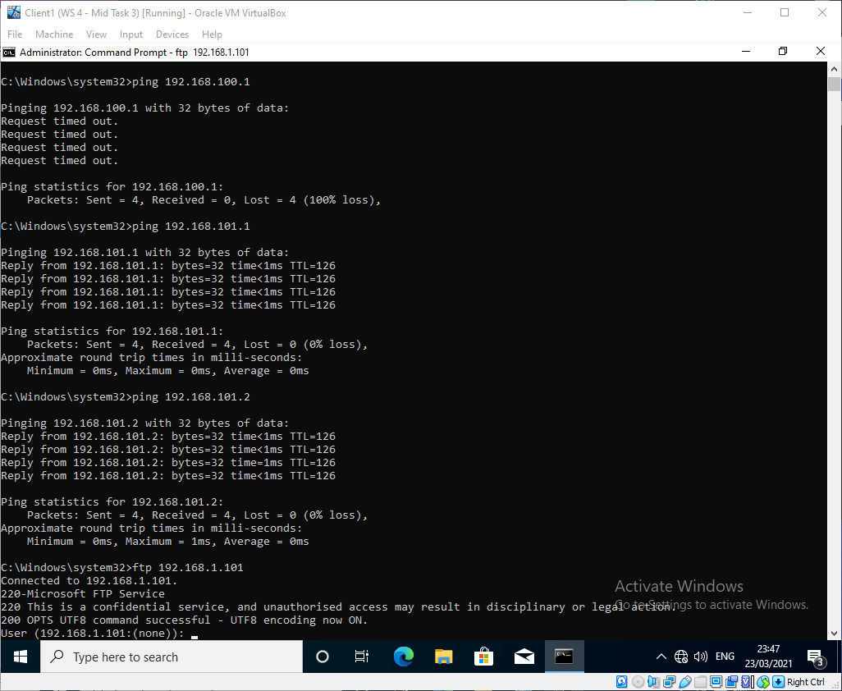
Figure 46 - Filter 2 test failure
After an investigation it was found that the filter had been applied on the PrivateNet1 interface instead of PublicNet, which is why the connection was still available.
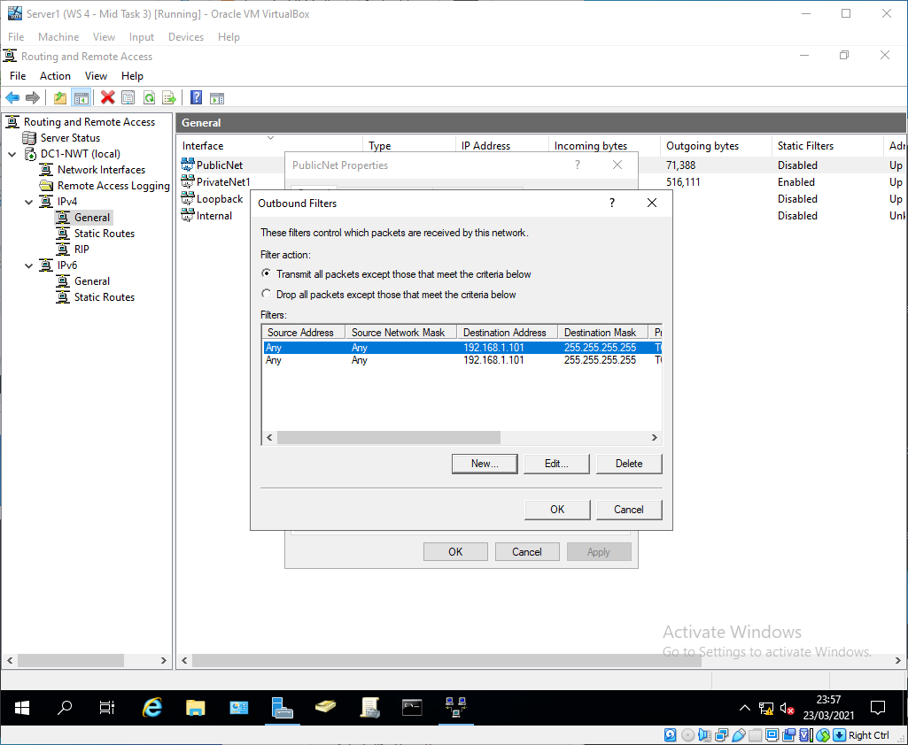
Figure 47 - Filter 2 reapplied
The same filters were applied to the PublicNet interface which stopped FTP traffic from client 1 whilst still allowing ICMP requests.
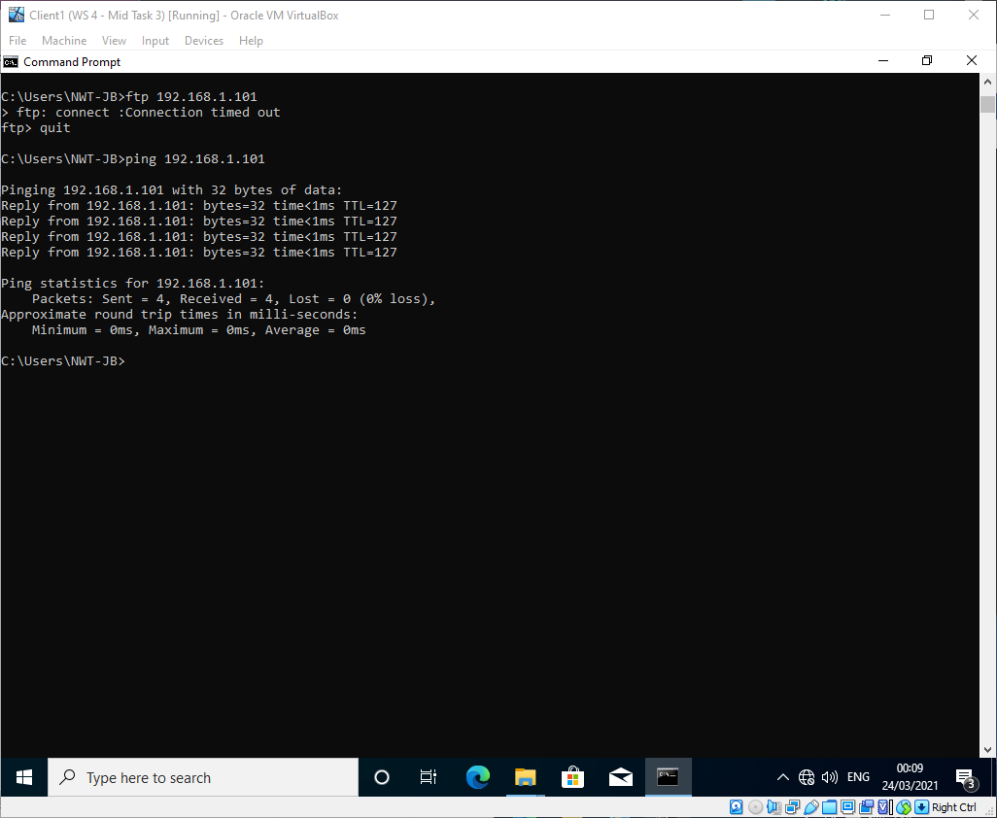
Figure 48 - Filter 2 test successful

Filter 3 - Only allow specific hosts in PrivateNet1 to access the FTPService running on Server2
To ensure that non-FTP traffic was still able to come from PrivateNet1 to server 2, the "Drop all packets except those that meet the criteria below" option would not have worked. As such a specific block was put in place for 192.168.100.1 and 192.168.1.100
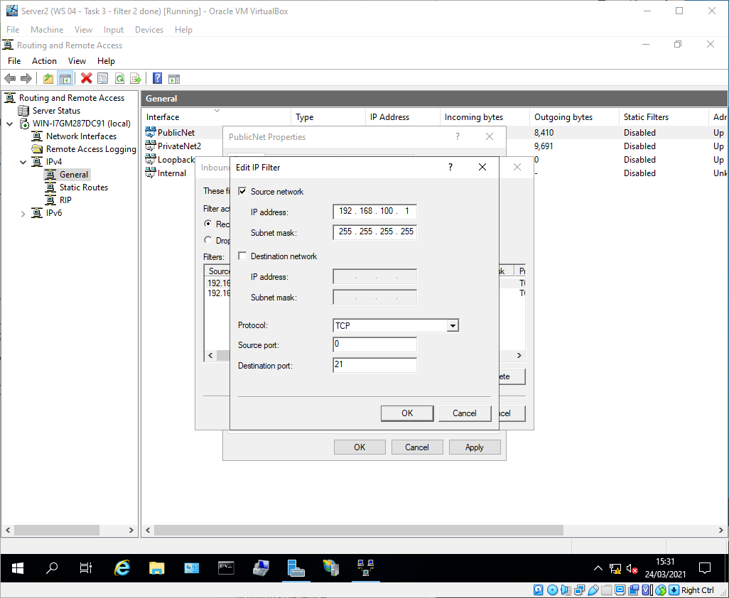
Figure 49 - Filter 3 rule 1
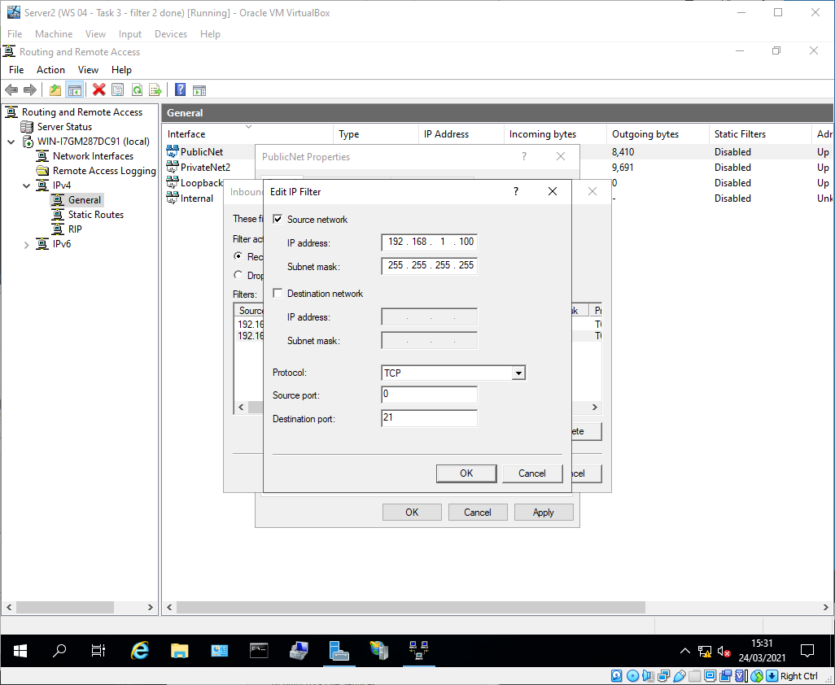
Figure 50 - Filter 3 rule 2
FTP (TCP 21) was blocked from any IP on PricvateNet2 interface on server 2.
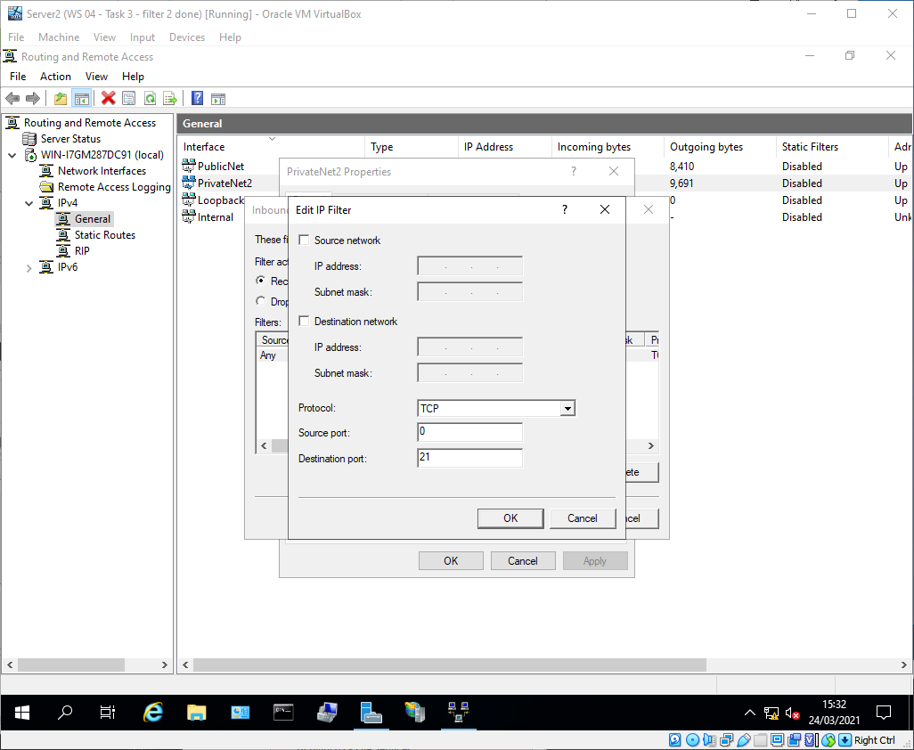
Figure 51 - Filter 3 rule 3

The tests show that Client 2 wasn't able to connect via FTP to server 2, Client 1 was able to access it as required, and Server 1 was also unable to connect via FTP to the server 2.
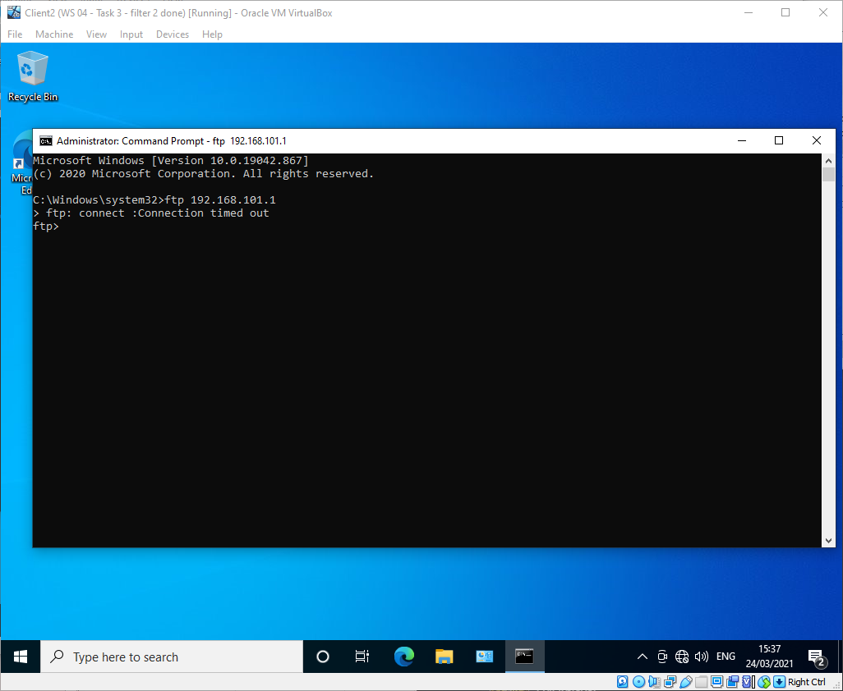
Figure 52 - Filter 3 test 1 successful

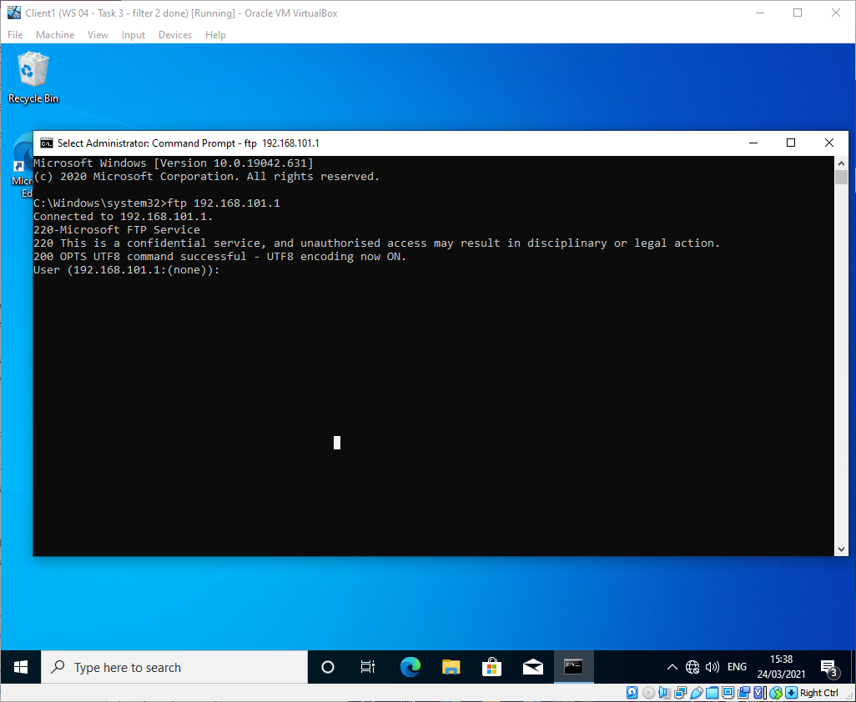
Figure 53 - Filter 3 test 2 successful

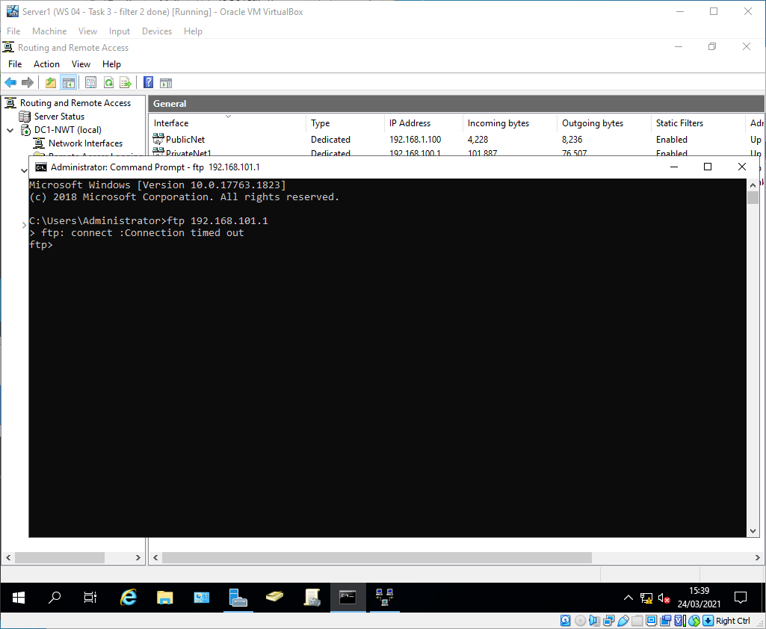
Figure 54 - Filter 3 test 3 successful

Task 5: Failover Clustering for high availability systems/services
Microsoft Failover Clustering (MFC) is a system component that allows applications and services to provide High Availability (HA) through combining a set of hosts (virtual or physical) into a single Failover Cluster. MFC is an active/passive clustering solution which means that only one of the hosts will provide the role/service at any one time[4]. Should the host currently providing the role become unavailable, MFC will automatically transfer the role to another host in the cluster, providing minimal downtime for users without requiring administrator intervention.
The hosts must pass a number of pre-requisite tests in order to be added into a failover cluster.
- The hosts must all be running on the same version of Windows Server
- The hosts must meet the Failover Clustering Hardware Requirements[5]
- The hosts must all be joined to the same Active Directory Domain
- The hosts must all be able to connect to shared storage, either attached, or SMB3.0 file shares for servers that are running Hyper-V

Consideration should be given to whether the hosts in a cluster should be geographically resilient, as well as the resiliency of the network links that join the hosts.
An example of a role that could benefit from a HA cluster is a web server hosting an organisational website. The HA cluster would provide resilience, whilst still allowing for a single IP to access the site via its DNS record.

Failover cluster setup screenshots
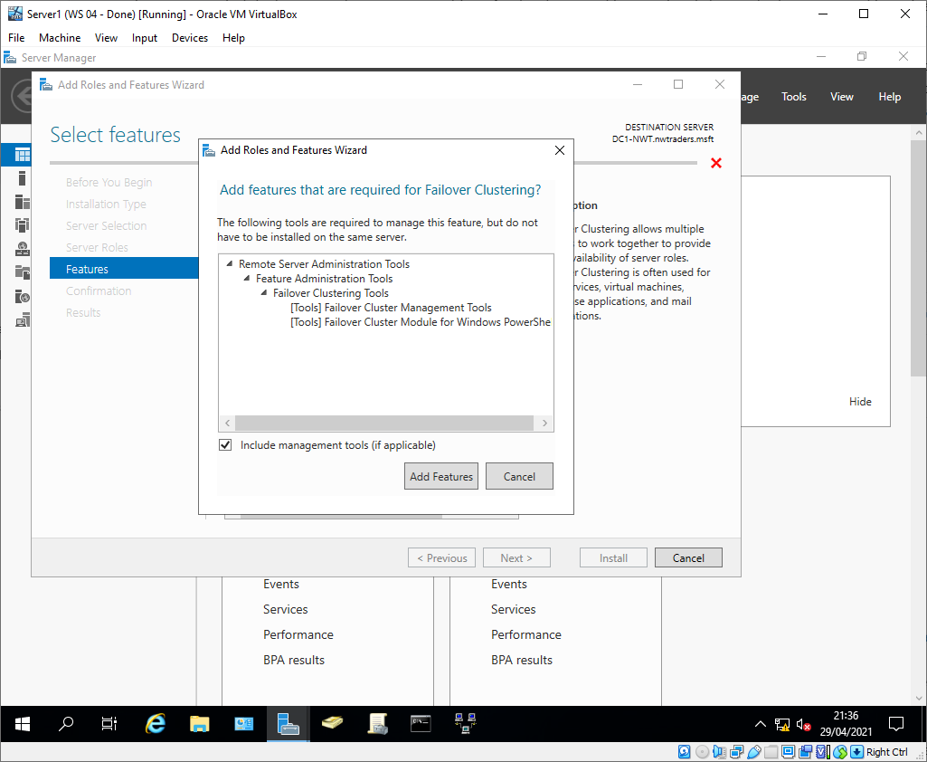

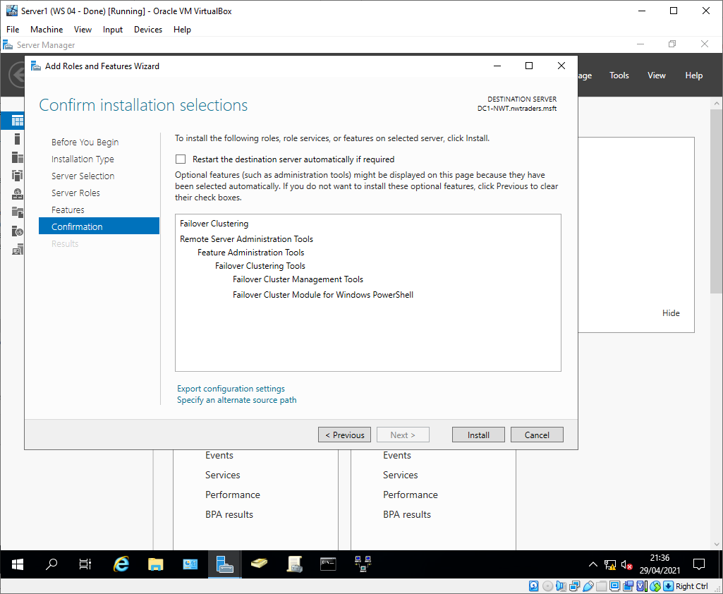

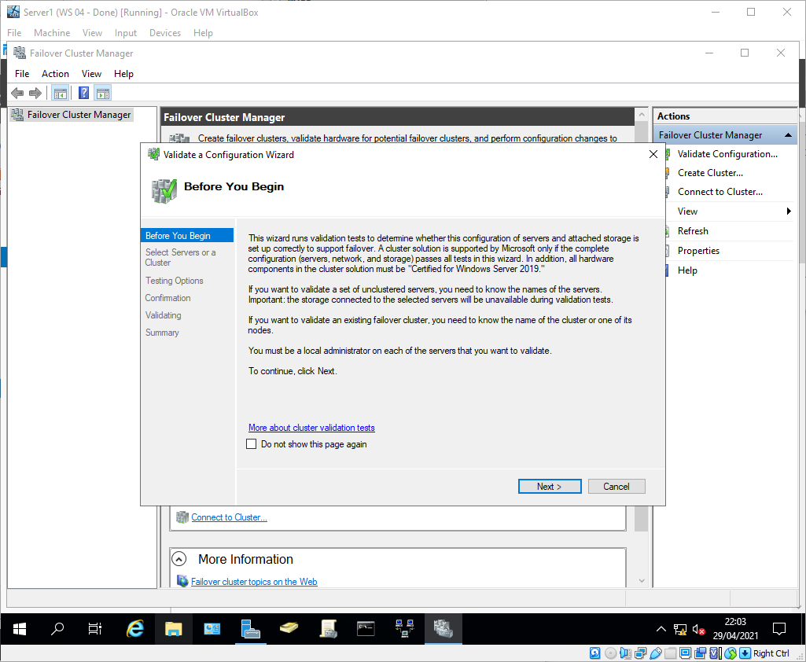

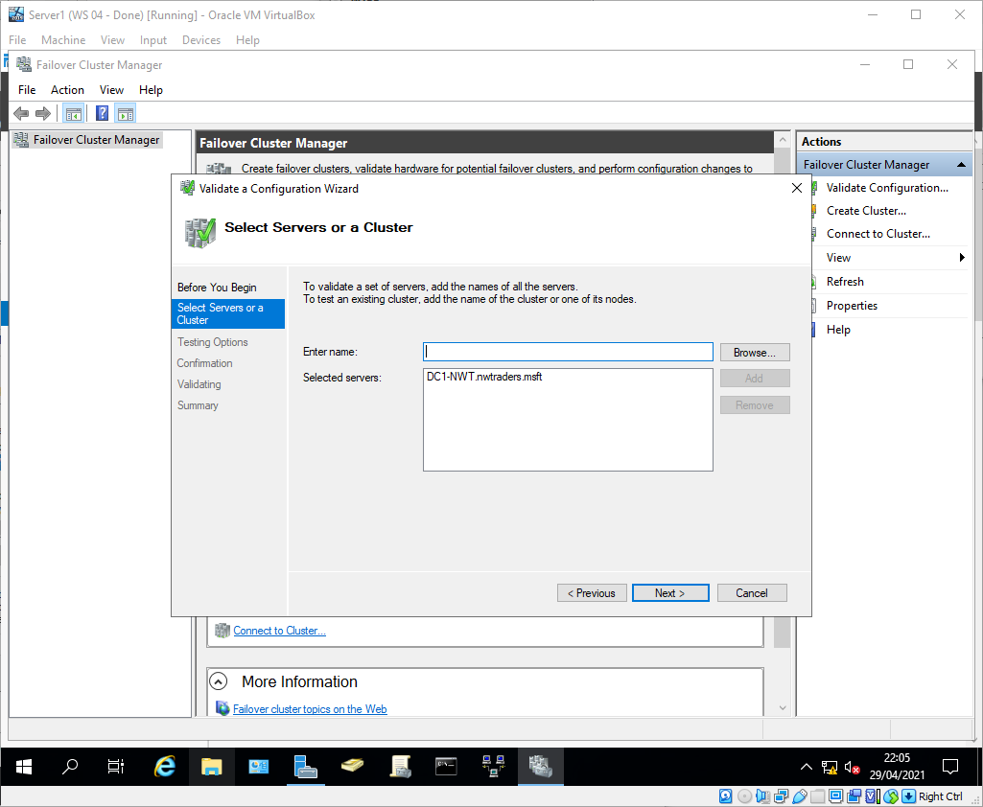

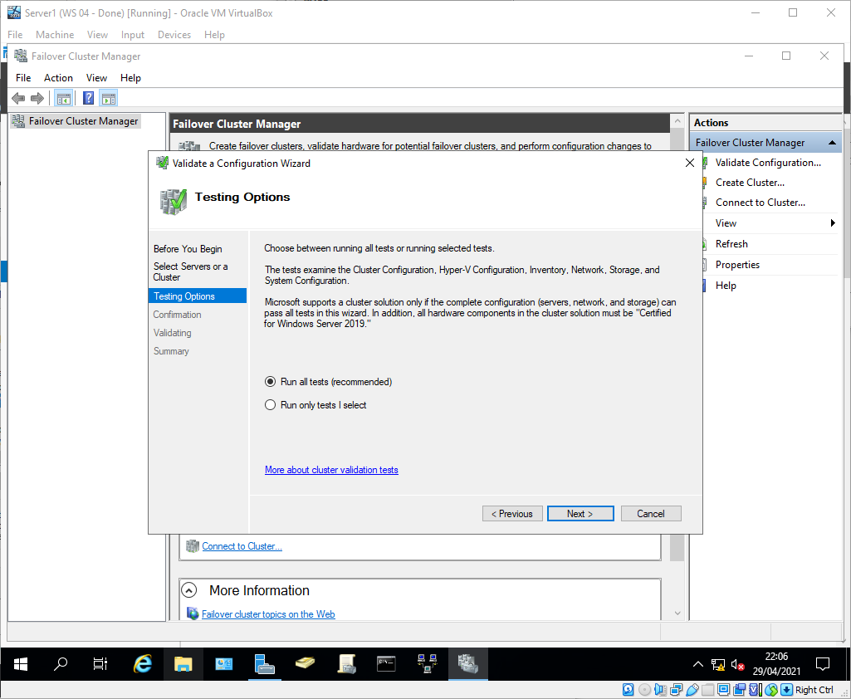

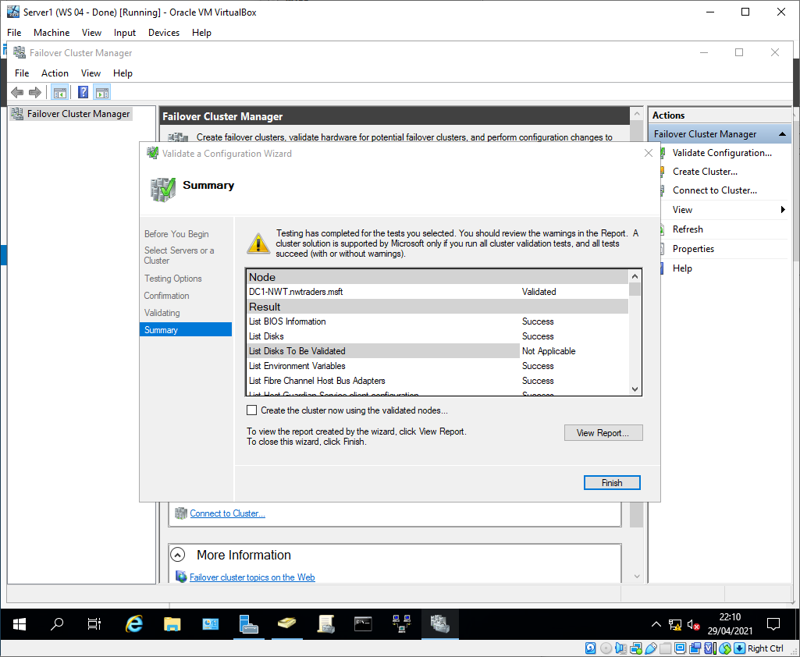

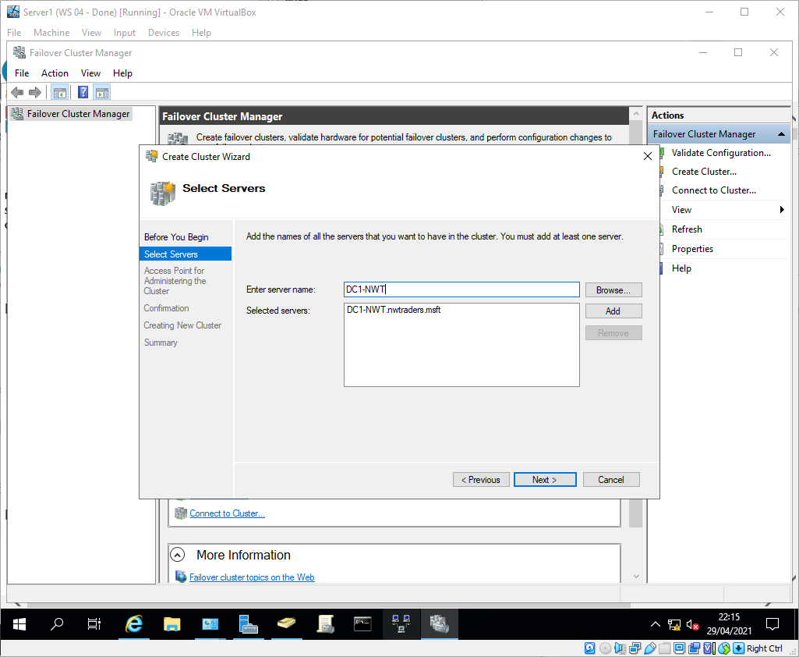

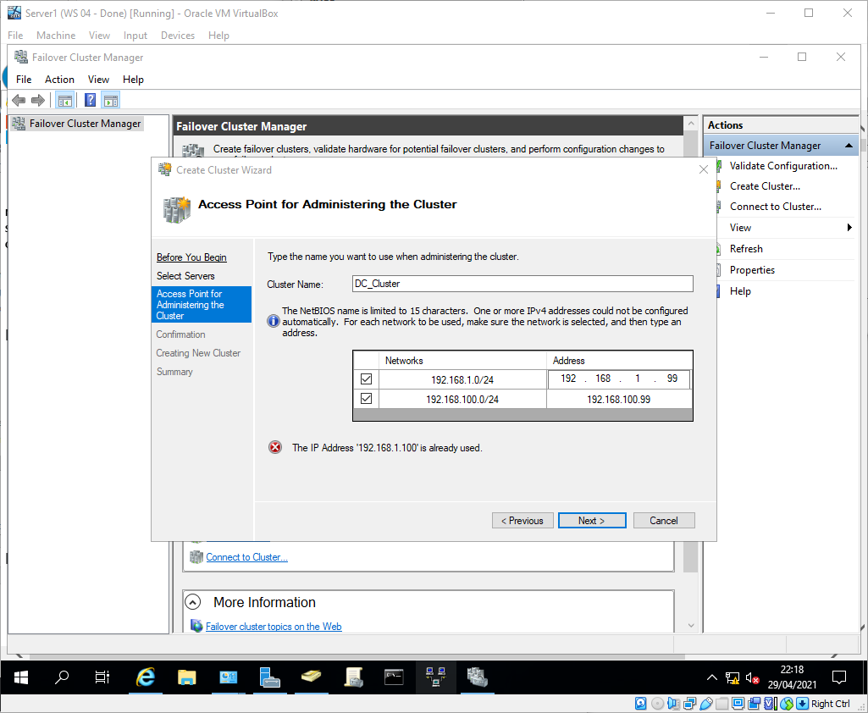

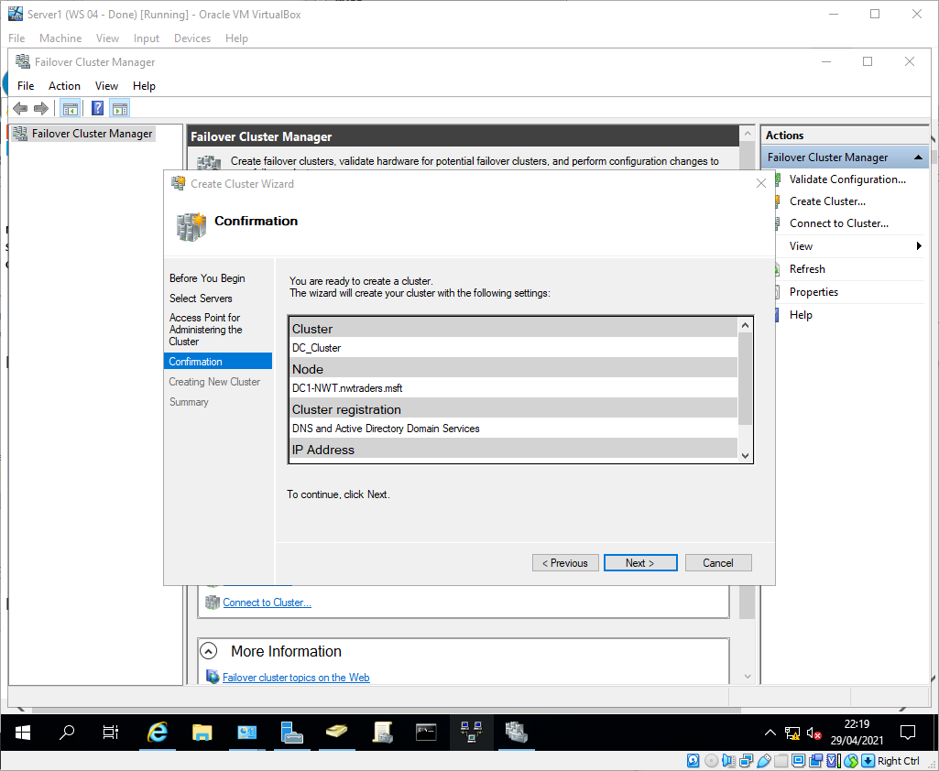

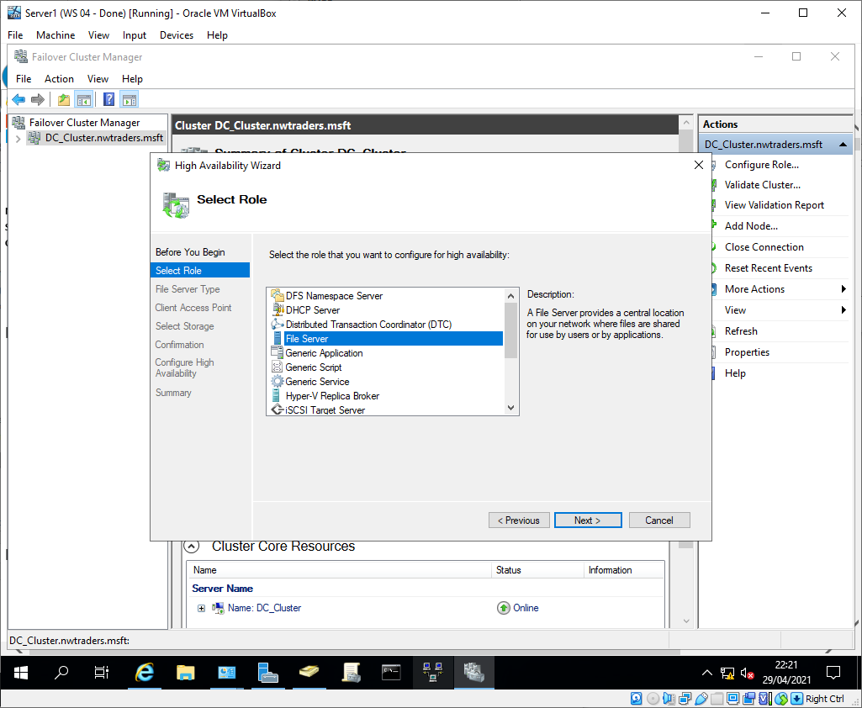

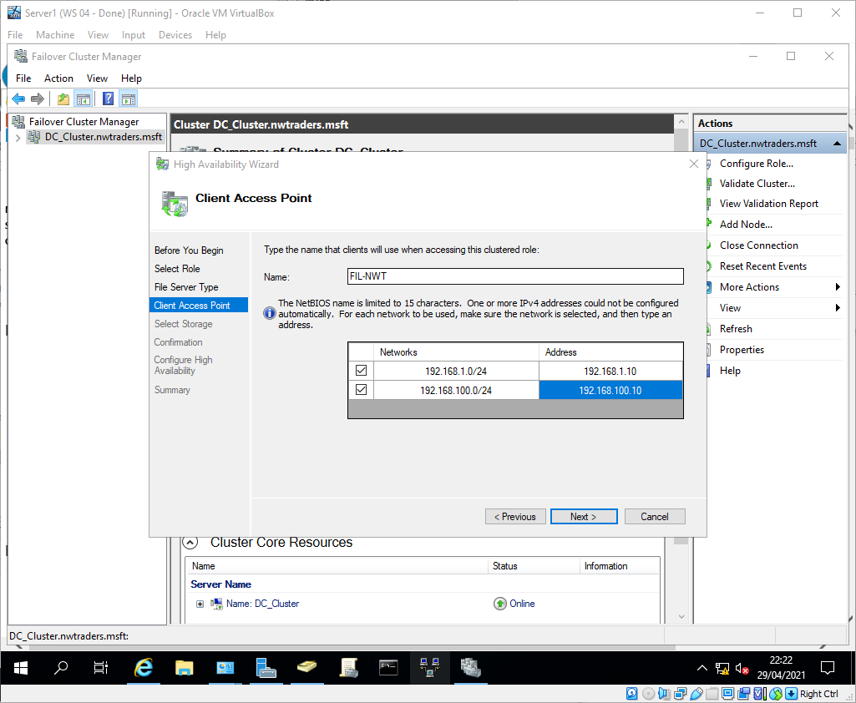

Task 6: Observational Tasks
Well written, communicated and effectively implemented security policies are fundamental to the effectiveness of an organisations security controls[6]. An international standard like ISO 27001[7], or Cyber Essentials Plus [8]. Another important factor in the effectiveness of policies is that they have to be championed by the upper levels of management, senior management must understand, agree with, and actively comply to cyber security best practices. If senior management are seen to be ignoring security policies, other staff members will follow their example.

Network Policy

Network Design
The organisational network should follow the three-tier hierarchical design[9] to allow for the optimisation of network resources. The network will be segmented such that high value systems and information is located physically and logically separated from high risk systems such as internet facing web servers[10].

IPS / HIDS
There will be systems in place that will detect and block malicious traffic both through the use of signatures and heuristics. There will be Endpoint Protection systems employed on both clients and servers. This is to reduce the chances of malicious software or traffic from negatively affecting the network[11].

Change Management
All network changes must be approved by a Change Advisory Board (CAB) as managed through the ITIL process[12]. This ensures that the risks posed by the change are carefully weighed against the benefits, and allows for changes to be prioritised according to their urgency. The Information Security Team will sit on the CAB to ensure that the change complies with best practice and will not compromise the security of the network.

High Availability Policy
Part of the CIA triad of information security is availability. As such it is incredibly important in an enterprise environment. When defining availability requirements for services, the impact of those services being unavailable must first be quantified. There have been criteria created which are assessed to give a criticality rating of Critical, High, Medium, or Low.
The criteria are as follows[13]:
- Lost sales and income
- Regulatory fines and legal implications
- Contractual penalties or loss of contractual bonuses
- Customer dissatisfaction or withdrawal
- Delay of business plan execution or strategic initiatives
- Knock-on effect on other services

For instance, assessing the internet connectivity ‘service’ against these criteria. The knock-on effect is substantial, with all e-commerce for the organisation ending, causing lost sales and significant customer dissatisfaction. As such, the internet connectivity ‘service’ is rated as a Critical criticality service, and requires significant investment to ensure that it is Continuously Available (CA) 24/7/365.

In contrast, when the internal instant messaging service is assessed against the criteria, it is classed as a Medium criticality service. This is because it will not directly affect sales, there are no regulatory or legal implications, it is not a customer facing service so there is no reputational damage to consider, and it does not affect any other services. This is compounded by the fact that there are other messaging services available for users during downtime such as the email service. This Medium rating means that whilst the service is expected to have some High Availability (HA), there is a specified service level that allows acceptable levels of downtime.

The different criticality ratings require different levels of availability:
Critical services – These services should be Continuously Available (CA)[14]. This means the system should be designed to operate 24/7/365 with both resilience and redundancy in place to handle planned and unexpected outages, the service must be geographically resilient. An example of this would be the internet connectivity service, it is supported by geographically resilient and redundant links to the main ISP, with a backup link to a separate ISP should the main one be unavailable.

High Services – These services should have Continuously Operations (CO)[15]. This means the system should be designed to operate 24/7 with both resilience and redundancy in place to handle planned and unexpected outages, the service should be geographically resilient. An example of this would be the web store service, which is supported by geographically resilient web servers acting in a high availability cluster.

Medium Services – These services should have High Availability (HA)[16]. This means the system should be designed to operate with redundancy in place to handle planned and unexpected outages. The service may be geographically resilient, but it isn’t required. An example of this would be the instant messaging service. It has HA systems in place, but is not geographically resilient.

Low Services - These services should be Continuously Available (CA). This means the system should be designed to operate with an expected level of downtime. The service may have HA systems in place but they aren’t required. An example of this would be the legacy SharePoint 2013 service. As this has been superseded by SharePoint Online as the standard shared team storage solution, it no longer requires availability of service. The storage is redundant, with regular backups, but the web server is not.

References
[1] “Address Resolution Protocol caching behavior - Windows Server | Microsoft Docs.” [Online]. Available: https://docs.microsoft.com/en-us/troubleshoot/windows-server/networking/address-resolution-protocol-arp-caching-behavior. [Accessed: 29-Apr-2021].
[2] “What do I need to include in my Cisco login banner? - Beaming,” Beaming.co.uk, 11-Apr-2019. [Online]. Available: https://www.beaming.co.uk/knowledge-base/what-do-i-need-to-include-in-my-cisco-login-banner/. [Accessed: 29-Apr-2021].
[3] “The Routing Table (3.5) > Cisco Networking Academy’s Introduction to Routing Dynamically | Cisco Press,” Cisco Press, 24-Mar-2014. [Online]. Available: https://www.ciscopress.com/articles/article.asp?p=2180210&seqNum=12. [Accessed: 29-Apr-2021].
[4] “How to set up and manage a Hyper-V Failover Cluster, Step by step,” Altaro, 2020. [Online]. Available: https://www.altaro.com/hyper-v/failover-cluster-manager/. [Accessed: 29-Apr-2021].
[5] “Failover Clustering Hardware Requirements and Storage Options | Microsoft Docs,” Microsoft, 2017. [Online]. Available: https://docs.microsoft.com/en-us/previous-versions/windows/it-pro/windows-server-2012-r2-and-2012/jj612869(v%3Dws.11). [Accessed: 29-Apr-2021].
[6] “NCSC - Policy and Procedure,” NCSC, 2018. [Online]. Available: https://www.ncsc.gov.uk/guidance/b1-service-protection-policies-and-processes. [Accessed: 15-Jan-2019].
[7] “ISO/IEC 27001 Information security management,” ISO, 2018. [Online]. Available: https://www.iso.org/isoiec-27001-information-security.html. [Accessed: 15-Jan-2019].
[8] “About Cyber Essentials - NCSC.GOV.UK,” NCSC, 2020. [Online]. Available: https://www.ncsc.gov.uk/cyberessentials/overview. [Accessed: 30-Apr-2021].
[9] Cisco Networking Academy, “Hierarchical Network Design Overview (1.1) &gt; Cisco Networking Academy Connecting Networks Companion Guide: Hierarchical Network Design,” Cisco Press, 2014. [Online]. Available: http://www.ciscopress.com/articles/article.asp?p=2202410&seqNum=4. [Accessed: 12-Jan-2019].
[10] “Network Security Design Should Consider 5 Critical Components,” SecureOps, 2020. [Online]. Available: https://secureops.com/2018/08/29/effective-network-security-design/. [Accessed: 30-Apr-2021].
[11] “Cisco ASA IPS Module - Cisco,” Cisco. [Online]. Available: https://www.cisco.com/c/en/us/td/docs/security/asa/quick_start/ips/ips_qsg.html. [Accessed: 14-Jan-2021].
[12] “ITIL Change Management Basics – BMC Software | Blogs,” BMC, 2020. [Online]. Available: https://www.bmc.com/blogs/itil-change-management/. [Accessed: 30-Apr-2021].
[13] “Identifying Key Business Processes for Business Continuity Planning,” TRP, 2012. [Online]. Available: https://www.emergency-response-planning.com/blog/bid/55556/identifying-key-business-processes-for-business-continuity-planning. [Accessed: 29-Apr-2021].
[14] R. Jones, “Continuous Availability,” Gartner, 2012. [Online]. Available: https://www.gartner.com/en/documents/2075827/continuous-availability. [Accessed: 30-Apr-2021].
[15] S. Watts, “Continuous Operations Explained – BMC Software | Blogs,” BMC, 2020. [Online]. Available: https://www.bmc.com/blogs/continuous-operations/. [Accessed: 30-Apr-2021].
[16] P. Yifat, “High Availability Cluster: Concepts and Architecture,” NetApp, 18-Nov-2020. [Online]. Available: https://cloud.netapp.com/blog/cvo-blg-high-availability-cluster-concepts-and-architecture. [Accessed: 30-Apr-2021].

