GLOBAL BUSINESS ENVIRONMENT
ASSIGNMENT :1

NAME: JANNAT
STUDENT ID :2239865
MODULE CODE : LCBB4005
MODULE NAME : GBE
LECTURER: HOANG NGUYEN
TOPIC : PROPOSING EAST ASIA EXPANSION FOR 'TAILS AND THE UNEXPECTED': A MARKETING REPORT

Executive summary
The report provides an in-depth analysis of "The Tales and the Unexpected," a UK-based vintage fashion brand's potential foray into the East Asian market. It delves into brand positioning techniques while emphasizing socio-cultural nuances. With a focus on sustainability, the document identifies product offerings and key manufacturers in East Asia. The blueprint for a revamped business model is charted, ensuring seamless integration into the East Asian market landscape, covering distribution, logistics, and sales strategies. Furthermore, innovative marketing strategies are presented, pinpointing pivotal marketing partners essential for a successful East Asian expansion.
Table of Contents
Executive summary 2
Introduction 4
Overview of the business 4
Fashion Market Analysis of UK 5
Market research of East Asian fashion industry 6
Pest Analysis 7
Porter’s 5 forces analysis 10
Brand positioning and intellectual property 11
7Cs of Brand Positioning 12
Intellectual property (IP) protection 14
Buying 14
Product and product range 14
Manufacturers 15
Consideration of key buying metrics 15
Sustainability of post-consumer use of the product 16
Business Model 16
Logistics and Sales 16
Marketing strategy and marketing channels 17
Marketing Partners 17
Campaign 17
Conclusion 18
References 19

Introduction

This report delves into the ambitious plans of "Tales and the Unexpected," a quintessential British menswear brand known for its vintage designs, as it eyes the East Asian market for expansion, particularly in China. Born from a lineage of family expertise in the fashion realm, the brand has firmly rooted itself in the sartorial landscape of the UK. The company's ethos revolves around marrying fashion with ethics, and as such, it seeks sustainable and ethically-aligned manufacturing partners in its Eastern venture. To truly comprehend the potential of this move, this report will provide an in-depth analysis of the brand's current market standing, its unique selling propositions, and the viability of its Eastward expansion. Additionally, we will undertake a comprehensive market research focused on the dynamic fashion sector of East Asia, aiming to discern the evolving consumer preferences and detect emergent market trends.

Overview of the business
Established in 1979 by Mark Williams, Tales and the Unexpected began its journey as a purveyor of vintage attire. Originally, the company showcased its unique offerings at Jacob’s antiques centre in Cardiff (Tails and the Unexpected, 2023). Over time, it transitioned its primary base to the picturesque Welsh coastal town of Penarth. While a significant portion of its transactions now occurs online, the physical store continues to attract patrons from South Wales and the West of England. Within the bustling UK fashion landscape, the brand carved out its niche, notably within the distinctive men's wear segment (Tails and the Unexpected, 2023).Embracing its quintessential British identity, the company prides itself on celebrating the artistry in traditional clothing. Its products, revered as high-end in the UK fashion spectrum, align with an “order to make” approach. This means customers commission their desired pieces first, limiting the brand's inventory of ready-to-wear items. Functioning as a family enterprise, Tales and the Unexpected boasts an annual turnover of £175.9K, translating to a revenue just shy of £76.7K (Tails and the Unexpected, 2023). Led by two active directors and supported by an active secretary director, this flourishing SME employs a compact team of 10.

Fashion Market Analysis of UK
Within the United Kingdom, the fashion industry stands as one of the foremost contributors to the nation's revenue stream. With the apparel segment alone amassing a substantial £55 billion, its significance cannot be understated (Zhang et al., 2021). Anticipated to ascend further, projections suggest the UK's fashion market will burgeon to an impressive £65 billion by the close of 2026. The landscape comprises a rich tapestry of over 11,330 specialized clothing stores, each playing a distinct role in the industry's vibrancy. Moreover, the presence of 205 wholesalers generating £10 million or more underscores the market's robust ecosystem (Zhang et al., 2021). Charting its trajectory, the UK's fashion sector has navigated significant growth since 2014, witnessing an upward surge in fortunes. While the pandemic posed formidable challenges, the industry demonstrated resilience, poised to rebound by an estimated 22% from 2015 figures (Slater and Demangeot, 2021). This dynamic journey underscores the industry's adaptability and enduring influence on the nation's economic fabric.
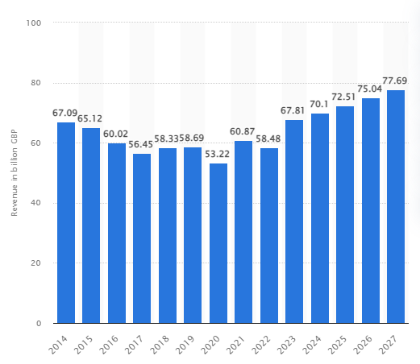
Figure 1: Expected Rise of UK’s Fashion Industry
(Source: Apparel market in the UK, 2022)
The UK fashion market can be broadly segmented into luxury fashion and mainstream attire. Within this bifurcation, the luxury domain—where 'Deals and the Unexpected' operates—is projected to experience a 10% growth in 2023, in stark contrast to the mainstream sector's modest 2% forecasted uptick. A burgeoning trend in the UK's fashion conscious consumers is an inclination towards sustainable and recycled products, with a staggering 60% showcasing this preference (Robert, 2023).Brands in the UK are confronted with a pressing need to reposition themselves, given the discerning customers' declining interest in non-recycled products. Emblematic of this shift is Patagonia, a direct rival to 'Tales and their Expectation', which has garnered significant advantage by aligning with brands offering entirely recycled products (Goworek et al., 2020). Amplifying this dynamic is the pervasive reach of social media. A compelling 74% of UK customers identify brands based on their consistent visibility on digital platforms.However, UK fashion entrepreneurs grapple with formidable challenges. The industry is under the dual pressure of addressing the climate crisis and navigating the socio-economic aftershocks of the pandemic, not to mention the complexities introduced by Brexit's trade regulations (Nash, 2019). Such conundrums have spurred brands, like Tails and the Unexpected, to contemplate expansion into East Asia, where the fashion milieu is experiencing a renaissance.

Market research of East Asian fashion industry
The East Asian fashion industry is among the largest generators of economies since the entire revenue amounts to £453.9bn as of 2023, however the market is expected to grow annually by 3.6% till 2027 (Li et al. 2020). In contrast to men's wear sold by tales and the unexpected, women’s apparel market volume is around 46% of the entire revenue and amounts to £244.10bn in 2023. According to the Global scale, the East Asian fashion industry is the second largest after the United States fashion industry as per person revenue is marked at £272.9 as of 2023 (Su et al. 2019).
China, one of the leading countries in Eastern Asia accounts for more than 28% of global luxury fashion apparel consumption, the social E-Commerce ecosystem present in Eastern Asia accounts for the largest marketing activities. The expected volume growth of the fashion industry in Eastern Asia is 39.15bn billion Pieces by 2027, the overall percentage of volume growth from 2024 is 0.3% (Xu and Wang, 2019). The average consumption of fashion products by customers in the territory is 23.30 pieces as of 2023. 96% of the entire fashion products sold within the East Asian market are related to non-luxury goods which might be challenging for luxury fashion wear companies that are planning to expand in the territory (Nikhashemi et al. 2019).

Pest Analysis
Factors | Analysis
Political | The socialist Chinese Government and other East Asian sectors are notorious for making unsettling changes to their trade policies overnight. This particularly affects the foreign traders to base themselves within the East Asian territory. Stronger influence of Communist Party along with several East Asian government International policies makes expansion Difficult (Li et al. 2020). China's entry within the WTO has made removal of trade barriers more difficult, Western provinces are entirely driven by domestic investors which influences market entry of international companies (Jung et al. 2020).
Economical | The GDP growth of East Asian countries is expected to rise by 11% in 2025, domestic demand for fashion apparel consumption will remain the same. The rate of Corporate taxes within China is 25%, which is more than any other East Asian region that makes Investments challenging for preferred regions and sectors (Zhao and Lin, 2020).  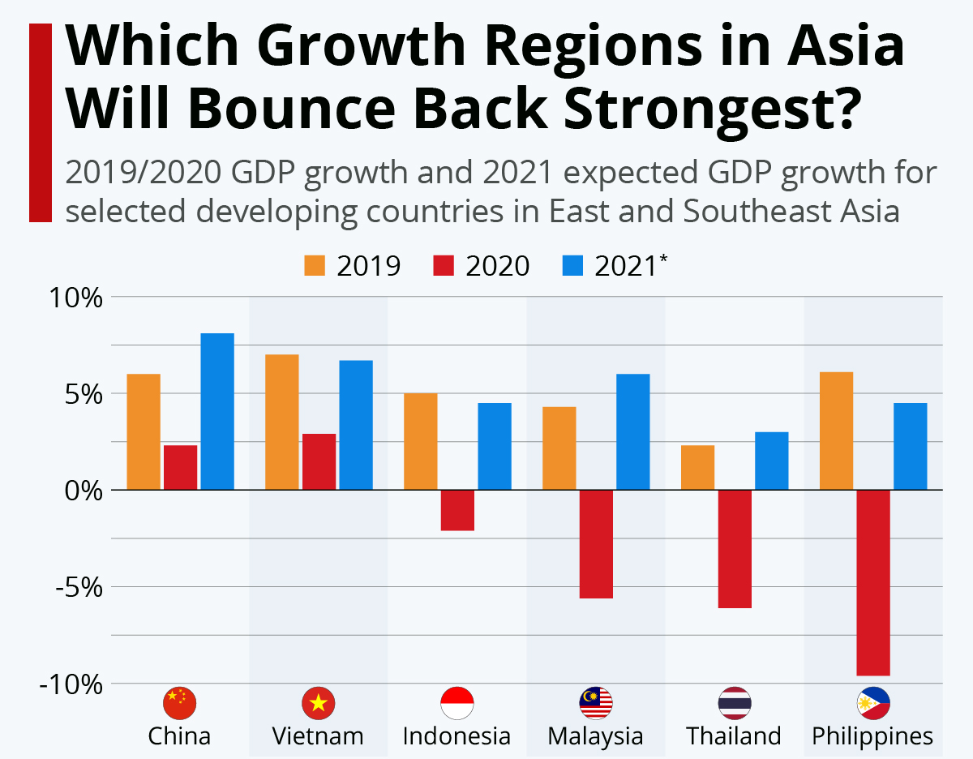  Penetrating the western province of China is almost impossible as the wage growth and consumption is indirectly proportional (Normuminovich et al. 2021).
Social | The Demographic of the fashion industry is largely open to International brands, population growth of the entire East Asian territory is estimated to be at 0.655%, where the average life expectancy is about 73.18 years. The contribution of youth in the fashion industry is more than 19%, whereas the maximum contribution is seen from the age group of 15 to 54 which marks at 72% (Lang et al. 2019). However there are regions within East Asian countries which follow a child policy that critically limits the group of fashion brands.  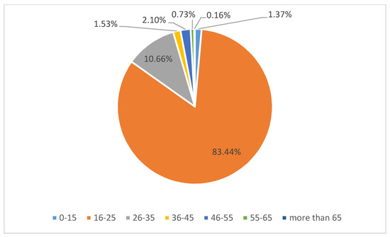  Literacy rates in the East Asian countries are at 90% which makes the significance for Digital Marketing more crucial for international brands. Support for communist parties in East Asian countries regulates the wave of urbanisation through their social behaviour and acceptance for international brands (Li et al. 2019).
Technological | Technology is a driving force for the fashion industry in East Asian countries as there are more than 650 million internet users present in the territory. However, there are no stable online payment methods present within the territory as there are bad credit card payments occurring in the fashion industry (Mainolfi, 2020). Use of automation is appreciated in this territory and recyclable product manufacturing is entirely driven by sustainability demands of the customers.
Table 1: PEST analysis of East Asian Territory
(Source: Self-Created)

Porter’s 5 forces analysis
Threat of new entrance  (High) | New entrance in the textile industry of the East Asian market is lately driven by innovation. China and other territories of East Asia are not well coming for new brands. Tales and the Unexpected will require building economic scale to lower the entire fixed price per unit of their product (Majumdar et al.2020). Research and development will require a huge amount of investment in order to enter the dynamic fashionindustry ofEast Asian countries.
Bargaining power of suppliers (Medium) | The bargaining power of suppliers in East Asian territory is mostly Limited due to the presence of Huge number of suppliers and a huge number of production units related to raw materials. Powerful suppliers Such as Atelier, Sreepriya Exports, TAL Apparel major players for the international brands (Zhao and Lin, 2019). The Chinese region within East Asia is the largest supplier of fashion products. Building effective relationships by developing different strategies to bring in Raw materials will be a major challenge for tales and the unexpected.
Bargaining power of customers (High) | The buyers within East Asian territory are largely demanding, the attention is mostly provided to cheap products that offer Great Value to the customers are keen to seek increasing discounts along with offers that results in bringing down more than 30% of market price (McMaster et al. 2020). Rapid innovation in the fashion industry has given such power to the customers. Fashion companies within the region are extremely dynamic in offering products that lead to industry profitability. The presence of a large customer base of around 650 million people in the station territory gains Power over the apparel companies.
Threat of substitute products (High) | Threat of substitute products in the East Asian territory is extremely high as the number of customers are huge along with the number of apparel companies. There are more than 60000 companies that manufacture textile among these, more than 21000 companies focus on men's apparel (Sen et al. 2020). There are an infinite number of services offered by the apparel companies in Eastern Asia which makes it extremely difficult for new players to gain or table position in the market. Switching costs of customers are at all time high and the competition does take a huge toll on the profitability of an organisation.
Rivalry among existing customers (Medium) | Rivalry among existing customers is at a neutral level since there are a huge number of apparel clothing companies which offer different ranges of products. One of the major aspects of rivalry is the adaptation of sustainability in the East Asian territory. Scaling the new products will result in competing better with the existing player. Companies such as Dior, Gucci, Oscar De La Renta, Comme Des Garcons, Hermes and others Are major names in vintage clothing in EA station territory. However, the range of products offered by these companies vary and customers get a huge amount of options related to purchase (Haseeb et al. 2020).
Table 2: Porter’s 5 Forces Analysis of East Asian Territory
(Source: Self-Created)

Brand positioning and intellectual property
Brand positioning for Deals And the unexpected is the most significant aspect in respect to expansion in the East Asian territory since introducing the brand and its relevant products will decide the feet of success. 7Cs Compass modelis among the most successful brand positioning models for a new entrant in an international territory.

7Cs of Brand Positioning
Commodity |  | Cost
The company sells authentic vintage British clothing which is unique in its own way. Authentic British clothing is not popular and common in the East Asian territory. The company can directly market its product to the potential customers by revealing the type of services it offers (Hardy and Hauge, 2019). |  | Cost of the product must be revealed to the customers on a priority basis in order to attract the customers. The company mostly markets luxury and products that are made to order. Initially, the company can change this strategy and move to already Manufactured products that can enable the customers to look into their products as well as try them on before placing an order (Melović et al. 2020). Cost of product should be Limited to the average pricing of luxury apparel brands, cost of product can vary from £150-£250 In the initial stages.
Consumer |  | Communication
The consumers can gain a significant amount of knowledge related to authentic British clothing once they approach the company. Tales and the unexpected can provide information related to their products and the type of warranty it includes in their product. Communication related to sustainability and manufacturing of the products will help in building a better brand position (Khare, 2023). customers might consider buying product of this brand if it offers additional features and discounts according to the customer needs |  | Communication medium for the company is one of the most significant aspects to make itself popular among the customers of eastern territory. Tales and the unexpected must take the digital route In order to market its products. The company must be actively posting in social media handles such as Instagram, Facebook and other community forums such as Reddit. The company can critically answer questions or queries asked by potential customers in order to build a name for itself. This will particularly result in creating the brand's image within the potential customers of the territory for the making the brand itself a popular name among the new buyers.
Channel |  | Circumstances
Channel of selling the products will directly start from physical stores present in different areas of the Eastern territory. These stores will mostly be available within the Metropolitan sector. Malls and large shopping complexes can be the host for tales and the unexpected shop (Heinberg et al. 2020). The company should even let the customers know that they can appoint themselves in order to discuss the product as well as the types of design they particularly want the company to make. |  | External factors must also be taken into consideration, for instance, the type of products they sell in a particular weather condition (Akbari et al. 2021). Social and cultural norms of East Asian territory should also be taken into consideration as consumers do not accept every kind of product. International environment related to politics and trade policies must be taken into consideration as well. Joining hands with popular suppliers in the particular territory will help it penetrate the already existing apparel market of East Asia.
Table 3: 7Cs of Brand Positioning
(Source: Self-Created)

Intellectual property (IP) protection
Intellectual property or IP protection is significant for tales and the unexpected in order to cover all the trademarks, copyrights and trade secrets. East Asian countries are notorious with their laws and rights of international players. The company must protect its IP using the “Patent law of China '' and the “Copyright law of China, 2019”. The company must also abide by the regulations of “Unfair competition Prevention Act, 2015” of Japan as well. Deals And the unexpected must protect its vintage apparel style and unique marketing techniques in order to become unique and recognised in the populated April market of East Asia (Hao et al. 2021).

Buying

Product and product range
The product range of this company is generally segmented into four distinctive categories namely clothing, hats, shoes and accessories for men. Primary competitive advantage will be gained by the company in the EastAsian markets due to the sophistication of clothes along with a touch of aristocracy which are much in demand by the large population of customers. An exceptional blend of unusual and unique fashion factors provided by the company will help them to capture the East Asian markets with ease (Su et al. 2019).
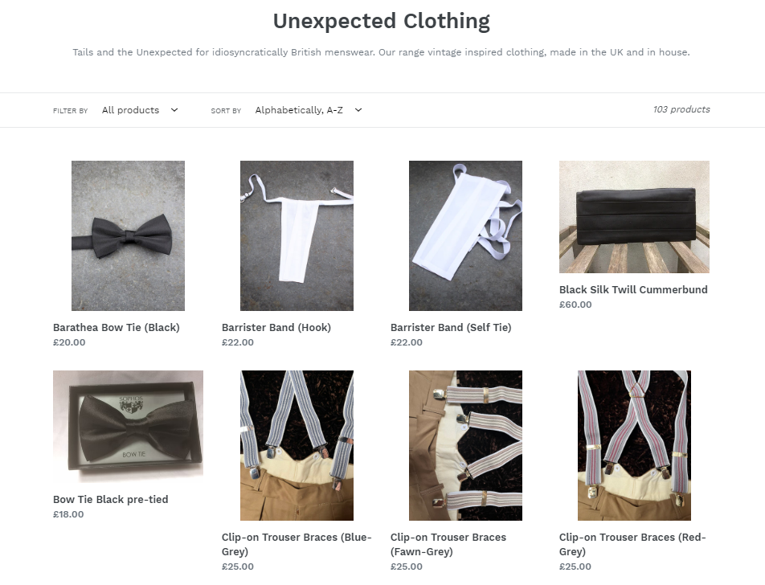
Figure2: Clothing segments of Tails and the Unexpected
(Source: Tailsandtheunexpected, 2023)

Manufacturers
The company takes up the help of local clothing manufactures as in most of the cases it has been seen that they tend to manufacture their products in house. The company holds a strong belief that manufacturing their own things will help them to maintain the quality issues and also they can keep their standards high, without the interference of a third party.

Figure 2: Factors effecting Buying Criteria of Tales and the Unexpected
(Source: Self-Created)

Consideration of key buying metrics
The KPI for tracking consumer feedback after purchasing items and the standardised viewpoint for the growth of a key market. One of the important factors to be taken into account throughout the organisational standards may have been how it assists to keep the loyal client base. The organisation has proved themselves as a quirky menswear business where the main buying persona of the company is to sell their traditional British as well as European clothing primarily through online platforms and in some cases also by appointment too (Robert, 2023). The company believes that men should take care of their appearance in a first-hand manner rather than just being fashion conscious in general terms.

Sustainability of post-consumer use of the product
The company has been looking for developing sustainable initiatives that will help them to gain the attention of the new territory, as it has been seen that environmental consciousness is rising among the East Asian countries in an alarming manner. Various sustainable approaches like usage of fine fabrics and fibres, waste management, production of long lasting products and many more are to be undertaken by the company in order to fit in the new territory (Li et al. 2020).
Opportunities and Challenges confronted
When considering the expansion of “Tails and the Unexpected” to East Asia, several opportunities, challenges, and key management aspects emerge. These are:
Opportunities:
- Expanding Market: East Asia, with countries like China, Japan, and South Korea, has a massive population. This presents a vast market for “Tails and the Unexpected” products.
- Economic Growth: Many East Asian countries are experiencing robust economic growth, increasing the purchasing power of their citizens.
- Fashion-forward Communities:Places like Tokyo, Seoul, and Shanghai are known for their fashion-forward communities, potentially making them receptive to new and innovative products.
Challenges:
- Cultural Sensitivity: East Asian countries have rich and diverse cultures. What works in one country might not necessarily be accepted in another. For example, color symbolism varies; white is associated with mourning in China, while in Western cultures, it’s often seen as pure and innocent.
- Language Barriers: Doing business in East Asia will necessitate understanding and communicating in various languages.
- Local Competition: Local brands in East Asia might offer similar products at a lower price or with a better understanding of the local market.
Management Aspects need to consider for Tales and the Unexpected
- Corporate Governance:
Adhering to Local Laws: Each East Asian country has its regulations, especially concerning foreign businesses. It’s crucial to be compliant to avoid legal complications. For instance, China’s regulations on foreign investments and joint ventures are notoriously intricate.

Ethical Considerations: Ensuring that the company operates ethically, especially concerning labour practices. Remember the backlash against brands accused of sweatshop labour in Asia.
- Business Strategy:
Localization: Instead of adopting a one-size-fits-all approach, adapt products and marketing strategies to cater to local tastes and preferences. McDonald’s, for instance, offers rice-based meals and localized flavours in some East Asian markets.
- Partnering with Local Brands:
This can help navigate local business landscapes and tap into established distribution channels.
- Cultural Sensitivity:
- Hire Local Talent: They can provide insights into the local market, culture, and consumer behavior. For example, Samsung, a Korean company, when expanding globally, employs locals in its branches worldwide to better understand and cater to diverse markets.
- Cultural Training: Educate your staff about the cultures of the countries you’re expanding into to avoid cultural faux pas.
For example,Starbucks has successfully expanded into China by adapting its offerings, introducing products like Green Tea Lattes and Mooncakes. Moreover, Shanghai Disneyland includes elements and attractions that are culturally specific to China, ensuring its appeal to local visitors. In conclusion, while East Asia presents significant opportunities for “Tails and the Unexpected”, the company must carefully navigate challenges through informed corporate governance, effective business strategy, and a keen sense of cultural sensitivity.

Barriers that might confronted by company
“Tails and the Unexpected,” considering an expansion into East Asia, must navigate a myriad of barriers. Cultural nuances, such as the significance of gift-giving in China and the emphasis on respect and honour in Japan, can greatly influence marketing strategies. Regulatory landscapes present challenges too; South Korea has stringent advertising regulations, while China’s ever-changing import rules require businesses to stay constantly updated. Differences in consumer preferences, like Japan’s inclination towards high-quality local products and China’s rapidly changing tastes amidst stiff local competition, are pivotal. Economic fluctuations in emerging economies, like variable exchange rates and inflation, can impact pricing strategies. The digital environment in countries like China, where Western platforms like Google are restricted, demands an adaptation to platforms like WeChat and Baidu. Distribution channels, especially in Japan, are layered and complex, making market entry for newcomers a challenge. Language barriers loom large across East Asia, making localized marketing and communication indispensable. Intellectual property concerns, particularly in China, necessitate proactive protection measures for designs and trademarks. Lastly, building consumer trust is crucial in East Asia; a brand’s reputation is fragile and can be easily tarnished by negative publicity. For a successful venture, “Tails and the Unexpected” must not only conduct comprehensive market research but also understand local dynamics, adapt to cultural norms, and remain flexible in regulatory changes. Collaborating with local experts could be invaluable in this expansion journey.
Recommendations to enable the company to succeed.

Business Model
A large number of the East Asian consumers now prefer to have goods and services delivered right to their homes, the buying habits of consumers have changed dramatically over time. A D2C model will assist the business in distributing its goods through direct digital channels. The direct-to-consumer (D2C) business strategy is renowned for giving marketers the ideal platform for communicating with clients directly. As this business strategy will help the firm avoid any business intermediaries, it is more probable that it will decrease its business overheads and maximise its earnings inside the chosen region.

Logistics and Sales
Logistics and seals being the key contributor for the company’s Expansion in the East Asian sector. Partnering with key distributors along with optimising channels of custom clearance and excise duties will be the primary initiation for market penetration. A market of more than £244bn has major distributors all over the place, the Shori cloth From Rajasthan is a major distributor of wholesale apparel products all over Eastasia (Nash, 2019). The company can join hands with Shori Cloth in order to distribute their products all throughout the Station Market. Xiamen Wingtas Group Co. and Fuzhou Lemao Apparel Co. The largest distributor of April in the Western province, the Company can partner with these 2 distributors in order to understand and take advantage of the custom clearance aspect in China and its Western province. The import duty of apparel in China is 20%, in other East Asian countries it is at a stable 10% with prices ranging from £0.9 to £0.5 per metre (Nash, 2019).

Marketing strategy and marketing channels
Omni channel marketing strategy will serve to be beneficial for the company while entering into the new territory as the customer centric approach of this will help Tails and the Unexpected to integrate their marketing channels in a common platform and thereby will lead to the development of a uniform and consistent customer experience. The company already has a developed and promising website for selling its products to the customers and in order to reduce its costing while entering into the new territory they can use their existing website for marketing effectively (Zhao and Lin, 2020). It has been seen that in East Asia the customer population is very tech savvy and they prefer buying commodities directly from the websites of the shopping companies, thus using their own business website as the marketing channels. Huge growth in infrastructure and presence of vast land masses had resulted in creating necessary IT capabilities for handling the domestic fashion market.

Marketing Partners/ Build Strategic Local Partnerships
To get them to promote its line of products, this fashion brand can form alliances with marketing partners like social media influencers. If Tails and the unexpected products are supported by well-known social media influencers, customers in this new market are more likely to interact with them. In many developing countries, local businesses have a strong grasp of the cultural and regulatory landscape. By forming strategic alliances or partnerships with local businesses, “Tails and the Unexpected” can gain quicker access to the market, benefit from local insights, and build trust with local consumers. In order to implement this one need to identify and collaborate with reputable local businesses, either as distributors or as co-branding partners. For example, partnering with a popular Vietnamese fashion brand could introduce “Tails and the Unexpected” to an established customer base, while sharing insights about Vietnamese consumer preferences and buying behavior.

Campaign
The business will use recycling programmes to demonstrate a strong sense of environmental sustainability while focusing on sustainability as the core theme. The population of East Asia is becoming more conscious of sustainability, and as a result, local customers are placing more value on buying from companies who uphold sustainability in their goods and services (Nash, 2019). The people of the new region have been emphasising utilising paper bags, wearing recyclable clothing, and other practises to lessen their influence on the environment. Therefore, in order to expand its customer base in the new zone, they must run sustainability programmes.

Conclusion
This study has brought attention to a report that suggests an expansion of the British apparel SME, Tails and the Unexpected in East Asia with the use of effective brand positioning and marketing strategies. Different business models like Pestle, Porter's Five Forces, and the Seven C's have been used for market and consumer analysis of the East Asia market and from the findings evaluation has been done whether this new territory will serve to be beneficial for the organisation on or in creating long term business success. It has been found out that, consumer purchasing power within East Asian countries is inferential since the current inflation situation within the countries are not being taken into account, as a result, growth of SME is hunted by trade politics in the territories. Providing value to the customers and building effective barriers to safeguard the new product within the industry will be significant. Overall, it can be said that the expansion of Tales and the Unexpected will be a successful endeavour in East Asian countries. Tails and the Unexpected" faces multifaceted challenges in its East Asian expansion, particularly in developing nations like Vietnam. Strategic local partnerships and a focused digital marketing approach tailored to regional preferences are pivotal. Embracing local insights and platforms can significantly enhance the brand's market entry and acceptance. Collaborative efforts will be crucial for the brand's sustained success in this diverse and dynamic region.

References
Apparel market in the UK (2022). Available at:https://www.statista.com/topics/3348/apparel-market-in-the-uk/?kw=&crmtag=adwords&gclid=CjwKCAjwvdajBhBEEiwAeMh1U-5tBSRvIdnYi49CfJWay4MK51pNg1Y_IHx6aGB5Rzqdc7XHguOl0RoCA9IQAvD_BwE#topicOverview.
Robert, J. (2023) “Revealed: Six trends shaping the UK fashion industry,” Voyado [Preprint]. Available at:https://voyado.com/blog/revealed-six-trends-shaping-the-uk-fashion-industry/?utm_term=&utm_campaign=UK+%7C+Search+%7C+Generic+%7C+Marketing&utm_source=adwords&utm_medium=ppc&hsa_acc=7618086137&hsa_cam=19637473357&hsa_grp=148208165903&hsa_ad=659962625729&hsa_src=g&hsa_tgt=dsa-19959388920&hsa_kw=&hsa_mt=&hsa_net=adwords&hsa_ver=3&gad=1&gclid=CjwKCAjwvdajBhBEEiwAeMh1U2eLAxj7lScbhkmHYMhnh1xuoeALICbR74eZAwuniaoSwsB84cKEZxoCIS8QAvD_BwE.
Tailsandtheunexpected (2023) Tails and the Unexpected | Idiosyncratic British Clothing. Available at:https://www.tailsandtheunexpected.co.uk/.
Zhang, B., Zhang, Y. and Zhou, P., 2021. Consumer attitude towards sustainability of fast fashion products in the UK. Sustainability, 13(4), p.1646.
Slater, S. and Demangeot, C., 2021. Marketer acculturation to diversity needs: The case of modest fashion across two multicultural contexts. Journal of Business Research, 134, pp.702-715.
Goworek, H., Oxborrow, L., Claxton, S., McLaren, A., Cooper, T. and Hill, H., 2020. Managing sustainability in the fashion business: Challenges in product development for clothing longevity in the UK. Journal of Business Research, 117, pp.629-641.
Nash, J., 2019. Exploring how social media platforms influence fashion consumer decisions in the UK retail sector. Journal of Fashion Marketing and Management: An International Journal, 23(1), pp.82-103.
Li, Y., Diabat, A. and Lu, C.C., 2020. Leagile supplier selection in Chinese textile industries: a DEMATEL approach. Annals of Operations Research, 287, pp.303-322.
Su, J., Watchravesringkan, K., Zhou, J. and Gil, M., 2019. Sustainable clothing: Perspectives from US and Chinese young Millennials. International Journal of Retail & Distribution Management, 47(11), pp.1141-1162.
Xu, J. and Wang, B., 2019. Intellectual capital performance of the textile industry in emerging markets: A comparison with China and South Korea. Sustainability, 11(8), p.2354.
Nikhashemi, S.R., Jebarajakirthy, C. and Nusair, K., 2019. Uncovering the roles of retail brand experience and brand love in the apparel industry: Non-linear structural equation modelling approach. Journal of Retailing and Consumer Services, 48, pp.122-135.
Li, Y., Pinto, M.C.B. and Diabat, A., 2020. Analyzing the critical success factor of CSR for the Chinese textile industry. Journal of Cleaner Production, 260, p.120878.
Jung, H.J., Choi, Y.J. and Oh, K.W., 2020. Influencing factors of Chinese consumers’ purchase intention to sustainable apparel products: Exploring consumer “attitude–behavioral intention” gap. Sustainability, 12(5), p.1770.
Zhao, H. and Lin, B., 2020. Impact of foreign trade on energy efficiency in China’s textile industry. Journal of Cleaner Production, 245, p.118878.
Normuminovich, Y.S., Payziyevna, A.F. and Azimdjanovna, A.N., 2021. Analysis of the effectiveness of the textile industry. 湖南大学学报 (自然科学版), 48(12), pp.1587-1597.
Lang, C., Seo, S. and Liu, C., 2019. Motivations and obstacles for fashion renting: A cross-cultural comparison. Journal of Fashion Marketing and Management: An International Journal.
Li, F., Frederick, S. and Gereffi, G., 2019. E-commerce and industrial upgrading in the Chinese apparel value chain. Journal of Contemporary Asia, 49(1), pp.24-53.
Mainolfi, G., 2020. Exploring materialistic bandwagon behaviour in online fashion consumption: A survey of Chinese luxury consumers. Journal of Business Research, 120, pp.286-293.
Majumdar, A., Shaw, M. and Sinha, S.K., 2020. COVID-19 debunks the myth of socially sustainable supply chain: A case of the clothing industry in South Asian countries. Sustainable Production and Consumption, 24, pp.150-155.
Zhao, H. and Lin, B., 2019. Will agglomeration improve the energy efficiency in China’s textile industry: Evidence and policy implications. Applied Energy, 237, pp.326-337.
McMaster, M., Nettleton, C., Tom, C., Xu, B., Cao, C. and Qiao, P., 2020. Risk management: Rethinking fashion supply chain management for multinational corporations in light of the COVID-19 outbreak. Journal of Risk and Financial Management, 13(8), p.173.
Sen, S., Antara, N., Sen, S. and Chowdhury, S., 2020. The Unprecedented pandemic'COVID-19'effect on the Bangladesh apparel workers by shivering the apparel supply chain. Sen, S., Antara, N., Sen, S., & Chowdhury, S.(2020). The Unprecedented Pandemic'COVID-19'Effect on the Apparel Workers by shivering the Apparel Supply Chain. Journal of Textile and Apparel, Technology and Management, 11(3), pp.1-20.
Haseeb, M., Haouas, I., Nasih, M., Mihardjo, L.W. and Jermsittiparsert, K., 2020. Asymmetric impact of textile and clothing manufacturing on carbon-dioxide emissions: Evidence from top Asian economies. Energy, 196, p.117094.
Hardy, V. and Hauge, J., 2019. Labour challenges in Ethiopia’s textile and leather industries: no voice, no loyalty, no exit?. African Affairs, 118(473), pp.712-736.
Khare, A., 2023. Green apparel buying: Role of past behavior, knowledge and peer influence in the assessment of green apparel perceived benefits. Journal of International Consumer Marketing, 35(1), pp.109-125.
Heinberg, M., Katsikeas, C.S., Ozkaya, H.E. and Taube, M., 2020. How nostalgic brand positioning shapes brand equity: Differences between emerging and developed markets. Journal of the Academy of marketing Science, 48, pp.869-890.
Akbari, M., Nazarian, A., Foroudi, P., Seyyed Amiri, N. and Ezatabadipoor, E., 2021. How corporate social responsibility contributes to strengthening brand loyalty, hotel positioning and intention to revisit?. Current Issues in Tourism, 24(13), pp.1897-1917.
Melović, B., Jocović, M., Dabić, M., Vulić, T.B. and Dudic, B., 2020. The impact of digital transformation and digital marketing on the brand promotion, positioning and electronic business in Montenegro. Technology in Society, 63, p.101425.
Hao, Y., Ba, N., Ren, S. and Wu, H., 2021. How does international technology spillover affect China's carbon emissions? A new perspective through intellectual property protection. Sustainable Production and Consumption, 25, pp.577-590.
Su, J., Watchravesringkan, K., Zhou, J. and Gil, M., 2019. Sustainable clothing: Perspectives from US and Chinese young Millennials. International Journal of Retail & Distribution Management, 47(11), pp.1141-1162.

