

Master of Business Administration
Module Name: International Marketing: Principles and Practices

Module Code: LCMB7026
Lecturer Name: Tushara Balendran
Chosen company: COCA COLA COMPANY
Student Name: Md. abdul aziz kamil
Student ID: 2427474
Word count:5600 words
Submission Date : 17/12/2025
Contents
Introduction 3
Brand Overview 4
Comparison of the Socio-Cultural Context of the USA and India (PESTLE Analysis) 6
Comparison of Coca-Cola’s STP Strategies in the USA and India 14
Segmentation 14
Targeting 16
Positioning 17
Comparative Analysis of STP 19
Comparison of Marketing Mix Strategies in the USA and India 19
Evaluation of the Performance of Marketing Strategies 22
Evaluation of Marketing Ethics Practice 24
Recommendations and Conclusion 26
Reference 27

Introduction
The international beverage industry is one of the most competitive and rapidly developing fields in the international marketing (Smith, 2020). The industry is characterised by the high rate of innovation, varying consumer tastes and a rising globalisation rate, which are dominated by multinational corporations that, as a result, are constantly changing their market orientation (Johnson, 2019). Coca-Cola is one of the best and most recognisable brands in the world among these global players. Having been founded in 1886 in Atlanta, Georgia, the coca-cola company has grown into a multinational company with diversification and became a single-product company and offers various products with more than 500 brands that are sold in more than 200 countries (Coca-Cola Company, 2023). The reason behind its success in the global market is its continuity in the quality of the products, its strong branding, emotional marketing, and its capacity to merge global standardisation with localisation (Keller, 2021).
The present report provides an analysis of marketing approaches of Coca-Cola in two different national settings, namely the United States and India. These nations are two ends of market development and consumer behaviour (Gupta, 2020). The United States is the domestic market of Coca-Cola, which is a highly established and well-developed economy with a strong brand reputation and strong emotional engagement of the population. Nonetheless, it is a highly competitive market, which is also shifting in terms of health awareness and increasing demands to low-calorie and sugar-free products (Hartley, 2022). India, on the other hand, is among the emerging economies in the world that are growing at an alarming rate with enormous market potentials, owing to its huge population, young population and increasing disposable income. However, India has its own problems of low cost, multiculturalism, and infrastructural constraints, which means that Coca-Cola has to localize its strategies to suit local demands and preferences (Rao, 2021).
This report mainly aims to discuss how Coca-Cola can synchronize its global marketing strategies with the socio-economic, cultural, and regulatory environment of the two unique markets in a single-brand image. To analyze the macroenvironmental factors, the PESTLE model will be used; to analyze the market focus and brand differentiation, the STP (Segmentation, Targeting, and positioning) model will be used; and to compare the tactical strategies, the Marketing mix (7Ps) model will be used. The report will also assess the performance of Coca-Cola in terms of marketing performance in the two countries and discuss ethical aspects of its performance (Brown, 2020).
In this comparative analysis, the report aims at illustrating how the global brand uniformity and local market adaptability of Coca-Cola have helped it to remain on its top position in the global beverage sector and how it has managed to engage consumers in the various markets including the United States and India.

Brand Overview
Coca-Cola is a well-known company with one of the most successful and highly appreciated brands in the world as a sign of happiness, refreshment and common experience (Keller, 2021). The company is a global venture that began as an invention of Dr. John Stith Pemberton in the year 1886, but has since grown to have a remarkable operational system of franchised bottling system (Coca-Cola Company, 2023). This model will enable Coca-Cola to manufacture concentrated syrup and leave the bottling, packaging and distribution to the partners in these countries, so that it achieves global efficiency and local flexibility (Smith, 2020). Coca-Cola has a diverse portfolio of products in terms of their brands and varieties, covering the best needs of consumers like soft drinks, juices, sports drinks and water exceeding 4,000 and more than 500 brands respectively (Johnson, 2019).
Coca-Cola has been a part of American culture since time immemorial (Miller, 2020). The U.S. has enjoyed the transformation of Coca-Cola into a lifestyle brand as its home market over the course of decades in which it established itself as a soft drink brand. Their marketing has always honored the themes of unity, optimism, and tradition that tend to be based on the values of freedom and togetherness, which are American. The campaigns like “Share a Coke” and “Taste the Feeling” have strengthened the emotional connections between the consumers and the brand (Brown, 2020). The American market is, however, very competitive and health-conscious, compelling Coca-Cola to diversify its products with reduced-sugar and zero-calorie products like the Diet Coke and Coca-Cola Zero Sugar (Hartley, 2022).
Further, environmental sustainability and packaging innovation have also been put on the strategic agenda with recyclable material and less carbon being worked on.

Conversely, the existence of Coca-Cola in India is an indication of its suitability to a market that is emerging with diversification of culture. In 1993, the company entered the Indian market again after economic liberalisation and it had withdrawn in 1977 because of regulatory restrictions . The Coca-Cola India has since positioned itself to be one of the market leaders with both international and local brands like Thums Up, Maaza and Limca that meet the regional preferences and price sensitivities. The marketing strategy of the company focuses on the affordability, accessibility as well as emotion resonance with culturally relevant messages. Multilingual advertisement, cricket sponsorships, and celebrity endorsement have enabled Coca-Cola to take root in the Indian popular culture. Covering rural penetration has also been emphasised upon in the company with the introduction of smaller and low cost packages to enhance accessibility in the less affluent regions.

Figure 1: Coca Cola (Coca-Cola Company, n.d.)

Comparison of the Socio-Cultural Context of the USA and India (PESTLE Analysis)
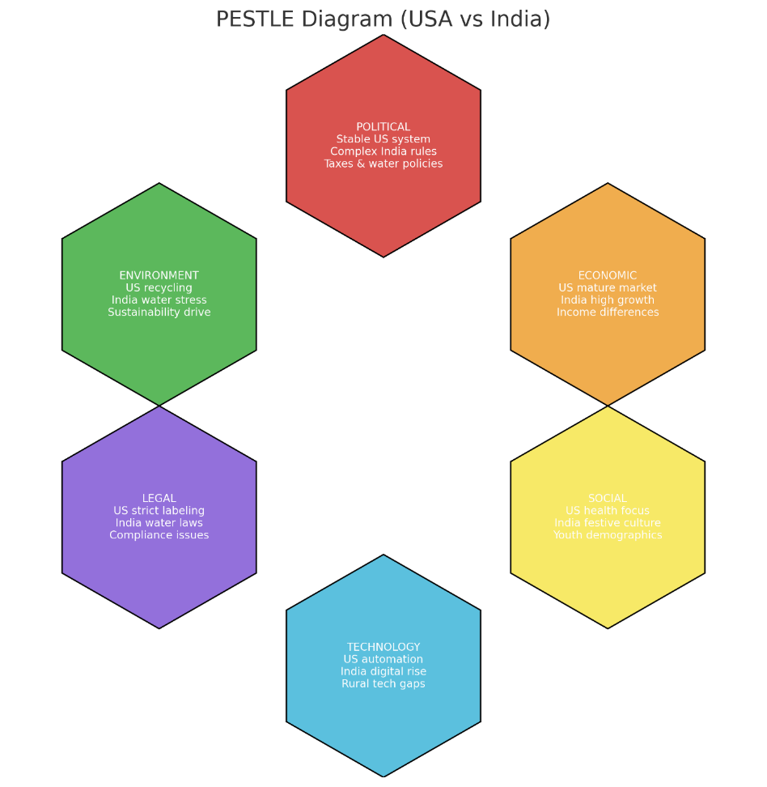

Figure 5: PESTLE Analysis(Makos, 2024)

In order to grasp the influence of the Coca-Cola structural adaptation to its marketing strategies, it will be necessary to examine the macroenvironmental factors that would affect the operations of the company in the United States and India. A comparative PESTLE analysis, which is a study of Political, Economic, Social, Technological, Legal, and Environmental variables, illuminates the situational dissimilarities that influence the strategic decisions of Coca-Cola in each market.
Political Factors
United States provides Coca-Cola with a favourable political environment where the degree of political stability is high, and the regulations and government assistance to the innovation are clear, which means low political risk (Porter, 2020). Nonetheless, stringent consumer protection and health related policies may be undesirable as it raises the level of compliance (Smith, 2021). The political environment in India is less predictable, but it presents good political opportunities as the stability increases and the government is implementing business-friendly reforms (Rao, 2022). The challenges posed by bureaucracy, constant revision of taxes like GST, and differences in governance in the regions provide poor conditions to pricing and distribution (Gupta, 2020). Moreover, the political climate in India is more complicated as compared to the U.S. because of the existence of strict agricultural and water-management policies that provide resource-related limitations (Singh, 2021).
United States
Favourable: U.S. provides Coca-Cola with good political stability, transparent regulations and favourable government interventions that minimise political risks.
Unfavourable: Tough consumer laws and health laws augment the compliance cost of the company.

India
Favourable: there are increasing opportunities in India due to enhanced political stability and introduction of reforms that are friendly to business by the government.
Unfavourable: There are bureaucracy, constant changes in taxes and the differences in governance among regions and rigid policies associated with resources that pose challenges in pricing, distribution and operations.
Econimic Factors
The US has a stable mature economy that has an average GDP growth, low inflation, high GNP per capita and good economic stability (Johnson, 2020). These are good conditions that favour Coca-Cola as it favours constant demand and high prices. But, the stagnation of growth and saturation of the market of carbonated beverages are not favourable (Smith, 2021). India, on the other hand, depicts high GDP growth, rising GNP and growing disposable income which forms favourable expansion prospects (Rao, 2022). However, inflation fluctuations, income inequality and economic sensitivity in the rural markets pose some undesirable challenges. In general, the U.S. is more stable but with little growth opportunities whereas India is more promising with great growth but economic risk to Coca-Cola.
United States
Favourable: The U.S has a sound, well developed economy with stable GDP growth, low inflation rates, high income earners and excellent stability of the economy to facilitate consistent demand and high premium values.
Unfavourable s: The lack of growth opportunities in the carbonated drink industry because of market saturation and stagnation is an obstacle to the growth of Coca-Cola.

India
Favourable: The high GDP growth rates, the population increase in income and disposable income are favourable aspects that give Coca-Cola a good growth potential in India.
Unfavourable: Economic risk of the company in the rural markets is the fluctuation of inflation, income inequalities, and economic vulnerability.
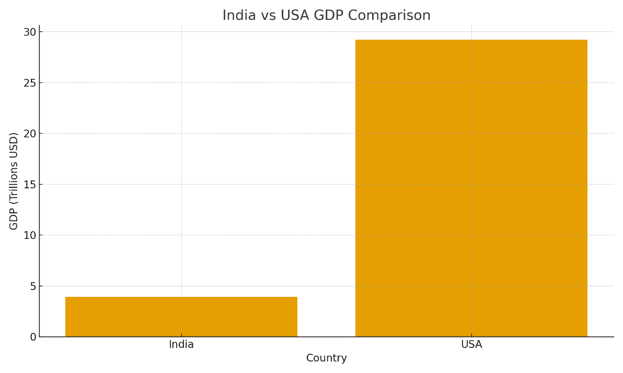
Figure 2:GDP Comparison(World Bank, 2024) 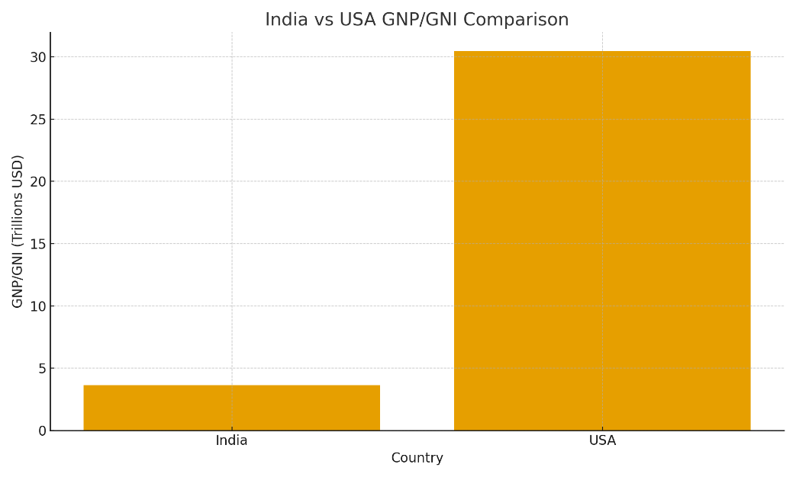

Figure 3: GNP Comparison(World Bank, 2025)

Social Factors
Health and environmental consciousness is growing in the U.S. and this decreases the demand of sugary drinks and Coca-Cola needs to provide low-sugar and lifestyle branding (Hartley, 2022). Festivals and youth culture in India are social values that are based on collectivism and support emotional and community-based marketing (Singh, 2021). Nevertheless, the cultural diversity and high tendencies towards traditional drinks demand a more in-depth localisation and focused communication to maintain the massive involvement.
United States
Favourable: Health and environmental awareness will force Coca-Cola to create low-sugar products and healthier lifestyle brands.
Unfavourable: The rise in health awareness lowers the consumption of sweet beverages which is a threat to the classic product lines of Coca-Cola.
India
Favourable: Emotional and community-based marketing of Coca-Cola is supported by favourable factors that are strong festival culture, influence of the youth, and collectivist social values.
Unfavourable: Diversity of cultures and inclinations to conventional drinks demand more localisation and specialised communications to ensure a high level of consumer interest.
Cultural Factors
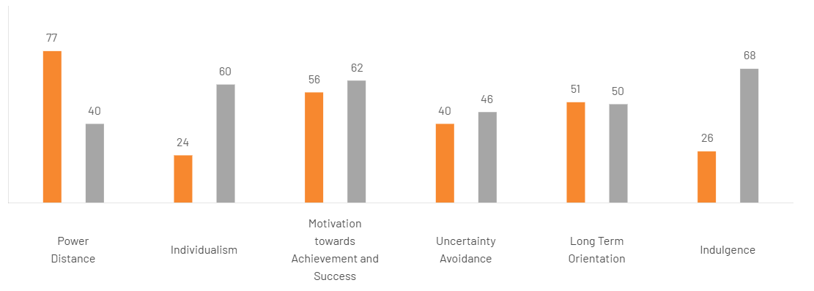
Figure 4:Cltural Factors(The Culture Factor Group, n.d.)
The U.S. has a high individualism, low power distance and uncertainty avoidance, preference to personal choice, directness in communication and consumption that is based on lifestyle. India is characterized by high power distance, collectivism, high uncertainty avoidance and strong long-term orientation that impact group-based decisions, regard to hierarchy and preferences based on cultural background. Such variations force Coca-Cola to employ lifestyle branding in the U.S and community-oriented and festival-based marketing in India.
United States:
Favourable: Coca-Cola should rely on personal choice-oriented and direct lifestyle branding due to favourable levels of high individualism, low power distance, and consumption based on lifestyle.
Unfavourable: The powerful focus on individual preferences implies that marketing has to achieve a continuous change in various personal preferences, which makes regular messaging more complicated.
India:
Favourable: Community-based, group-based, and culturally-based marketing strategies are supported by high levels of collectivism, high long-term orientation, and respect of hierarchy.
Unfavourable: Coca-Cola must attentively customize communications and services to different regional and cultural demands due to the presence of unfavourable high power distance and cultural complexity.
The Power Distance 77 in India is favorable towards the existence of clear hierarchy and the Power Distance 40 in the USA promotes equality. Individualism 60 and group loyalty 24 are the driving forces of innovation and America and India, respectively. Both value success is seen in the achievement scores (USA 62, India 56). Uncertainty Avoidance 40 in India is flexible, whereas in the USA, it has 46, which makes it structured. It is similar with long-term thinking (India 51, USA 50). The USA has a high indulgence (68) in favor of enjoyment and India has 26 restraint.

Technological Factors
US digital infrastructure is highly developed, which allows Coca-Cola to resort to automation, analytics, AI personalisation, and effective social media marketing (Miller, 2021). India is in the process of rapid digitalisation which provides access to the young consumers and mobile based distribution to the small retailers (Rao, 2022). However, rural technological disparities and unreliable infrastructure hamper complete incorporation and, as a result, digital strategies are not as equally impactful in rural regions as in the U.S. (Gupta, 2020).
United States:
Favourable: The U.S. has developed digital facilities, thus Coca-Cola can apply automation, data analysis, AI personalisation and robust social media marketing.
Unfavourable: The market becomes highly digitalised making it competitive as technological advancement should be continuous to keep up.
India:
Favourable: Digitalisation leads to access to young consumers quickly and aids the distribution of small retailers by mobile devices.
Unfavourable: Inconsistent technological digital disparity and lack of reliable infrastructure hinder the success of digital strategies in the whole market.
Legal Factors
U.S offers clear legal frameworks but enforces rigid labelling, advertising and health policies, which puts Coca-Cola under greater compliance burden. India is welcoming to foreign investment but has strict safety, environmental and water-use policies. Regulatory disparities at the state level and the control of water management also make operations complicated, and Coca-Cola will have to invest in sustainability programs to ensure that the company is not breaking the law and not losing the trust of the citizens.
United States:
Favourable: U.S. has clear and predictable legal environments that favour the stability of operations at Coca-Cola.
Unfavourable: There are adverse labelling, advertising, and health rules on the company, which impose a massive compliance cost on the firm.
India:
Favourable: India is welcoming the investments and has the potentials where Coca-Cola can develop in an expanding regulatory environment.
Unfavourable: There are stringent safety, environmental, and water-use regulations, as well as legal dissimilarity at the state level, which make operations difficult and necessitate heavy investments in sustainability practices.
Environmental Factors
Coca-Cola has a high sustainability expectation in the U.S., which is why it can enjoy a range of initiatives such as recyclable packaging and waste-reduction initiatives, but the use of plastics remains a topic of criticism (Brown, 2021). Community environmental projects and water-refilling projects in India increase the corporate image, but environmental issues associated with using groundwater and the lack of recycling facilities keep posing great threats to the environment, which necessitate constant enhancement and clear sustainable pledges (Singh, 2022).
United States:
Favourable: Good sustainability expectations enable Coca-Cola to enjoy recyclable packaging, waste minimization programmes and favourable environmental image.
Unfavourable: Continuous criticism of the use of plastics will bring the sustainability image of the company into question.
India:
Favourable:Environmental programs and water refilling programs contribute to building corporate image of Coca-Cola.
Unfavourable: Groundwater issues and the lack of recycling facilities pose environmental risks and have to be constantly enhanced in terms of sustainability.
Similarities And Dissimilarities
The PESTLE analysis of USA and India is similar and different in some ways. Both markets focus on health consciousness, environmental sustainability and online interactions, which drives Coca-Cola towards low-calorie beverages and sustainability. Nevertheless, the USA is politically stable, technologically developed and has a mature economy, whereas, India is highly complex in regulatory issues, wildly growing, price sensitive and culturally diverse. The U.S. is highly individualistic and nostalgia-driven and India is collectivist, based on festivals and very much dependent on youth aspiration, which needs to be more localised.

Comparison of Coca-Cola’s STP Strategies in the USA and India
The basis of the Coca-Cola marketing plan is Segmentation, Targeting and Positioning (STP). The three processes help the company to recognize the different groups of consumers, those with the highest potential are selected and the brand positions itself in a manner that matches with the global identity and the local culture. When comparing the STP strategy of Coca-Cola in the United States and India, one can notice that the latter has been successful in balancing between the standardisation and adapting to two extremely different markets.

Segmentation
Coca-Cola uses a multidimensional segmentation approach that integrates the variables of demographic, psychographic, geographic, and behavioural variables. This would allow the company to meet a wide variety of consumer demands and preferences at the international markets.

Segmentation in the United States
Coca-Cola uses demographic and psychographic factors as its main segmentation in the U.S. market (Johnson, 2020). On the demographic level, it caters to every age group, but there are certain product lines that target certain groups. The classic Coca-Cola product is offered to the 25-45 age group of adults who are inclined to think about the brand as a part of their nostalgia and heritage, whereas Diet Coke and Coca-Cola Zero Sugar focus on health-conscious consumers who want to consume the products with low calories (Keller, 2021). Psychographically, market segmentation is based on lifestyle choice: Coca-Cola is a brand of happiness, friendship, and belonging that appeals to consumers who can appreciate mutual experience and emotional attachment (Smith, 2021). Loyalty, brand experience and convenience also play a crucial role in behavioural segmentation in the American market where decisions to buy are based on the loyalty (Miller, 2020). The consumption of Coca-Cola products via supermarkets, restaurants, and vending machines has made it easier to be bought by frequent consumers due to the large coverage (Brown, 2020).
Segmentation in India
Coca-Cola segmentation in India is more complicated because of great cultural differences and socioeconomic diversity (Rao, 2022). The company segments the market by urban and rural target markets further into income, lifestyle and consumption pattern. The consumers in the urban areas are divided into lifestyle as well as being exposed to the western trends, but the rural consumers are majorly divided into affordability and availability (Singh, 2021). The company is focused demographically on young people, students and families, through the fact that the population of India is composed of the youth (Gupta, 2020). Coca-Cola psychographically places itself as a sign of refreshment, celebration, and togetherness, which is in line with collectivist values (Keller, 2021). The behavioural segmentation is concentrated on frequency of consumption whereby small and inexpensive packaged form like the 200ml bottle targets the daily or impulse consumers in the low-income region (Johnson, 2020).
This multi-level segmentation allows the Coca-Cola company to be inclusive to the entire Indian society, including the high-end urban consumers and the rural families who gain value in having a refreshing drink (Smith, 2021).
Psychography values
The psychographic values of Coca-Cola vary in the markets. The U.S. consumer is the happiest, nostalgic, belonging, convenient lifestyle, health-conscious consumer, which is aligned with emotional branding and low sugar products (Keller, 2021). Indian psychographics focus more on celebration, togetherness, cultural identity, aspiration, and affordability, which is based on collective customs and young consumption habits (Rao, 2022). All these values assist Coca-Cola to customise its message to emotional affiliation, common experiences, contemporary lifestyles, and available refreshment in both nations (Singh, 2021).
VALS Segmentation
The application of the VALS model enables Coca-Cola to learn more of the lifestyle motivation in the two markets (Solomon, 2020). Innovators, Thinkers and Achievers are key segments in the U.S. and they are motivated by wellness, premium experiences and brand tradition, and it means that such products as Coca-Cola Zero Sugar, Smartwater and classic Coke are incredibly topical in this respect (Keller, 2021). Digital and experiential campaigns involve the experientialers (Smith, 2021).
In India, the Strivers and Survivors control the market, as incomes are sensitive, and the suitability of the pack based on affordability, as well as the use of local companies, such as Thums Up and Maaza, is effective. Believers and Experiencers react to emotionally and culturally oriented, youth based promotions. The motivations are also different as pointed out in VALS where the U.S. is an individualist country and India is aspirational and collectivistic

Targeting
After market segmentation, Coca-Cola is using a differentiated targeting strategy, whereby it has a broad range of products, which satisfy varying needs of consumers in the global markets. Nevertheless, undifferentiated and concentrated targeting of particular products and segments is also used by the company.
Targeting in the United States
In America, Coca-Cola employs undifferentiated targeting as well as differentiated targeting (Porter, 2020). The flagship Coca-Cola Original has become a mass-marketed product whose marketing strategy has been undifferentiated, positioning it as a drink that everyone can drink, irrespective of their age or lifestyle (Keller, 2021). Simultaneously, the firm uses differentiated targeting as it provides specialised products that are targeted to particular groups (Smith, 2021). Diet Coke is aimed at health-conscious adults, Coca-Cola energy focused at younger and more physical consumers, Smartwater aimed at high-income consumers who pay special attention to hydration and Minute Maid was aimed at families and consumers interested in natural drinks. With such a varied product line Coca-Cola can satisfy the vast majority of consumer preferences and still have a high brand equity.
Targeting in India
The targeting of the Coca-Cola in India is more discriminatory and resonates with the socio-economic diversity of the country. To a significant extent, the company employs differentiated targeting and this has been facilitated by concentrated targeting in specific segments. Coca-Cola is marketing to the young population of 15-35 years based on lifestyle marketing, music and sports campaigns in urban regions which attract aspirational and modern consumers. In the rural regions (where buying power is less), the company employs more of a focused strategy based on selling small packs and targeting the middle- and low-middle-income consumers. Thums up and Maaza are some of the products that are positioned to satisfy the budgets and tastes of these consumers. In general, the Coca-Cola in India has chosen the dual-focused differentiated strategy, in which the high-end products are targeted at the affluent urban populations, and low-end models aim at the rural markets.

Positioning
The global positioning of Coca-Cola is based on the feeling, happiness and social bonding. Nonetheless, the implementation of this stance is different in the American and Indian markets, which is determined by the discrepancy in consumer psychology and cultural setting.
Positioning in the USA
Coca-Cola has become a heritage brand in the U.S. and this positioning lies in the history of the brand (Miller, 2020). It brings about a feeling of nostalgia and national pride, associating itself with the American culture, unity and happy feelings (Keller, 2021). Such catchy advertising phrases as Open Happiness and Taste the Feeling emphasize how smiling to drink Coca-Cola (Brown, 2020). The brand is not just a drink but a drink that is associated with the memorable moments of life. The low-sugar and diet versions of the company are also marketed as healthier, but they do not sacrifice the taste, which also coincides with the mindset of wellness-oriented American consumers (Smith, 2021). The brand image of Coca-Cola, which is based on the colour schemes of red and white, family meetings, and festivals, supports its consistency and recognisability (Johnson, 2020).
Positioning in India
Coca-Cola positioning in India focuses on aspiration, energy and inclusivity (Rao, 2022). It positions itself as a current, young brand, which glorifies happiness of shared moments. The localisation of the global message of the brand to the Indian linguistic and cultural contexts was done through campaigns like the one titled Thanda Matlab Coca-Cola (Cold means Coca-Cola) (Singh, 2021). This campaign managed to ingrain the use of Coca-Cola into the common language of people making it a generic substitution of soft drinks in certain areas. Other products introduced by the company as bold and adventurous include Thums Up, which enjoys the Indian taste of strong flavours and masculinity among consumers (Gupta, 2020). At the same time, Maaza has the possibility to position itself as a family-friendly and nostalgic drink that bridges the gap between the new and the old (Keller, 2021).
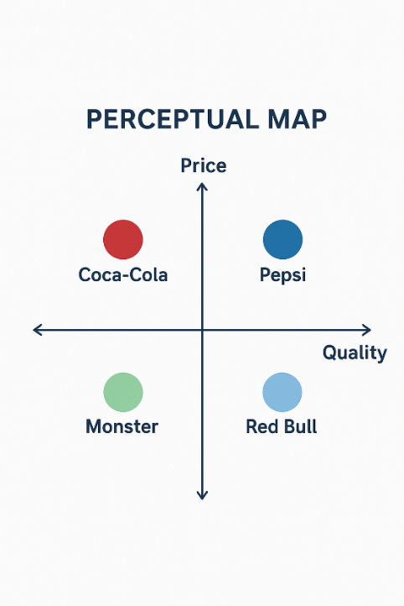
Figure 7:PERCEPTUAL Map(CliffsNotes, n.d.)

Comparative Analysis of STP
When the STP strategies of Coca-Cola in the United States are compared to the strategies of Coca-Cola in India, it can be pointed out that there are some important points to understand regarding its international marketing strategies.
To start with, the segmentation of Coca-Cola in the United States is based on the psychographic and lifestyle, whereas in India it is mainly on the social economic and geographic (Johnson, 2020). This disparity indicates maturity of the American market and developmental difference of India (Rao, 2022). The second aspect in which differentiation takes place in the U.S. is through lifestyle and product diversification; in India, it is through accessibility and affordability (Singh, 2021). Second, the targeting approach of the firm in the U.S. is mass-based as it aims at remaining popular by product differentiation. Targeting in India is more localized and the younger generation and country folks are given priority. In India, Coca-Cola targets very responsively to income level, consumption frequency, whereas in the U.S., it is lifestyle- and health-conscious.
Thirdly, the positioning strategies in both countries are similar in terms of the brand philosophies of happiness and togetherness but have a different emotional tone and expression of the culture. Coca-Cola in the U.S. positions itself as a nostalgic iconic representative of the American life; Coca-Cola in India positions itself as a young aspirational brand as a representative of the modern development. Localized communication language, the use of celebrity endorsements and localized festivals will guarantee that it resonates with the Indian consumers without affecting the brand.

Comparison of Marketing Mix Strategies in the USA and India
Product Strategy
The Coca-Cola company has been operating in a health-conscious market in the United States where its products are represented with a large variety of Coca-Cola, Diet Coke, Coca-Cola Zero Sugar, and flavoured variants, including Cherry and Vanilla Coke (Smith, 2021). In addition to carbonated drinks, it sells bottling water (Dasani, smart water), juices (minute maid), and energy drinks (monster, powerade) (Johnson, 2020). The innovation to products is centered around sugar reduction, functional drinks and environmentally friendly packaging to attract wellness and environmentally-aware customers (Brown, 2021).
Coca-Cola in India focuses on localisation and cost-effectiveness. It also sells India-based specific products such as Thums Up, Limca, and Maaza to meet the local taste preference in a world that has global brands (Rao, 2022). It has been packaged in small bottles and tetra packs targeting rural and price-sensitive customers (Singh, 2021). The U.S. strategy emphasizes health and premiumisation but the Indian one emphasizes on taste localisation, affordability and wide accessibility (Gupta, 2020).
Price Strategy
In the US, Coca-Cola uses brand-equity-based pricing strategy, which enables the firm to earn high prices on the basis of its high brand image. A standard bottle of 20 ounces (approximately 591 ml) of Coca-Cola can be sold at the retail level at approximately 2-3 dollars. Price segmentation is also utilized by Coca-Cola in premium variants and bulk packs with the backup of promotional advert that makes the brand competitive.
In India, Coca-Cola uses penetration pricing technique in order to make its products affordable to low and middle-income earners. The 200 to 250 ml bottles are also sold at ₹10-20, which is affordable to price sensitive consumers, particularly in the rural markets. In the urban market, the business employs tiered pricing of bigger or higher-end packs and promotions of seasons during the festivals ensures that the market is in good demand.
Distribution (Place) Strategy
The distribution of Coca-Cola in the U.S. is intensive; they include supermarkets, restaurants, vending machines, and online platforms with the help of efficient franchise bottlers (Miller, 2021). In India, it operates on a hub and spoke model with small vehicles in the last mile delivery and collaboration with kirana shops which are reinforced by the ASSP programme (Rao, 2022). Coca-Cola has gotten into India via a joint venture with local distributors to acquire regulatory insight and through which it has entered the prevailing distribution circuitry (Singh, 2021). The reason behind the selection of this method is to minimize risk and ensure a faster growth. The benefits of the joint venture include fast penetration into the market and its disadvantage is less control in the local operations and practices in distribution (Gupta, 2020).

Promotion Strategy
The U.S. promotion focuses on heritage, emotional and personalisation, including Share a Coke and Christmas campaigns and sponsored by big sporting events. Digital marketing involves younger generations by the use of social media and interactive campaigns .
Promotions in India are locally tailored, with the use of local idioms, Bollywood and cricket stars, campaigns with a festival theme, outdoor advertising, and digital marketing to reach youth in the urban population.
Process Strategy
Coca-Cola has a lean distribution system that promotes efficient product production and delivery via lean bottling, quality control, and speedy distribution (Smith, 2021). Nevertheless, there are occasional complaints of customers, including the problems with the taste of some products, the quality of packaging, or some areas with delayed delivery (Johnson, 2020). These grievances are managed via special customer service departments and feedback systems of retailers (Brown, 2021). Timely responses to these problems will enable Coca-Cola to remain consistent in products, safeguard the brands, and enhance the processes (Miller, 2021).
People Strategy
Coca-Cola has a huge workforce consisting of skillful workers all over the world and it depends on them to assist in the manufacturing, distribution, selling and servicing of the clients (Smith, 2021). The company has tens of thousands of employees in the United States, which sustains corporate activities and a well-developed network of bottlers (Johnson, 2020). Coca-Cola in India has about 25,000 employees working directly in manufacturing plants, distribution centers and sales teams (Rao, 2022). The firm focuses on local employment, training of employees, and effective collaboration with bottlers to have smooth operations and effective community relation (Singh, 2021).
Physical Evidence
The logo, shaped bottle, and brand name used by Coca-Cola are the same throughout the world. The U.S. has smooth and environmentally friendly packaging, whereas smaller bottle sizes, regional label, and multi-lingual packaging make the packaging accessible and culturally relevant in India. In both markets, brand recognition is enhanced by retail displays and branded kiosks and vending machines.Website link: https://www.coca-cola.com/us/en
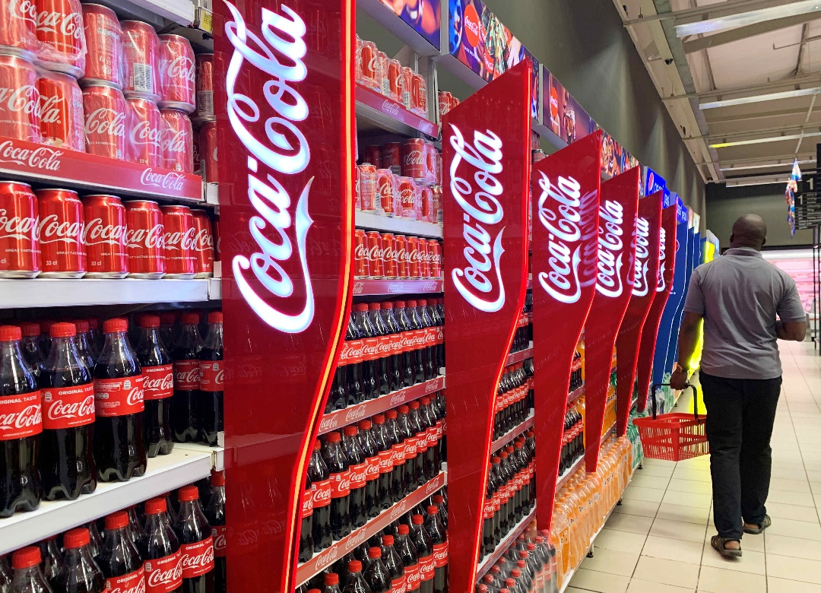
Figure 8: Coca Cola Showroom (https://www.coca-cola.com/us/en)

Evaluation of the Performance of Marketing Strategies
The marketing solutions of Coca-Cola in the United States and India prove that global branding can be successful due to flexibility, cultural awareness, and regular innovation. Yet the effectiveness of these strategies is different depending on the economic maturity, consumer behaviour as well as competitive conditions. The analysis of the performance of Coca-Cola includes such major aspects as market share, brand recognition, or sales growth, and the consumer loyalty .
Performance in the US
U.S. is the most profitable market, and Coca-Cola gets a significant portion of returns across the world because of premium pricing and high brand equity. The traditional carbonated beverages sales have reduced marginally, although Coca-Cola has sustained total revenue by increasing zero-sugar impactful, flavoured and functional beverages. The CSD segment continues to be a market share leader, with coca-cola classic taking the lead countrywide.
The media participation in the U.S. is very high. Coca-Cola spends a lot of money on online advertising campaigns, athletic sponsorships, customised online content, and AI-enhanced consumer insights (Miller, 2021). Emotional messages like being happy, making a throwback, and being united contribute to the high rates of social media engagement and consumer loyalty (Keller, 2021).
Although it has its advantages, the mature market curbs the growth in volume and the increased health consciousness hampers the sale of sugary drinks (Smith, 2021). Diversification also needs to be done continuously in the face of water, coffee, and wellness drinks competition (Brown, 2020). Nevertheless, powerful branding, regular innovation, and influential media establishment ensure the leadership of Coca-Cola in the American beverage market (Johnson, 2020).
Performance in India
India is among the fastest-growing markets in terms of volume and Coca-Cola is backed by low prices, expansion in rural areas, and local brands like Thums Up and Maaza. The rate of sales is much faster than in the developed markets but the profit margin is lower because of price sensitivity and distribution expenses.
Indians have a very high rate of media exposure, which has been facilitated by Bollywood promotion, sponsorship of cricket, and advertising of festivals and geographically tailored digital content. Such strategies enhance emotional attachment and high visibility among the youth.
There are threats such as stiff competition with local drinks, water consumption, and environmental problems. Nonetheless, its high levels of localisation, cultural appropriateness, and growing distribution system have made Coca-cola one of the most confidant brands of beverages
In india.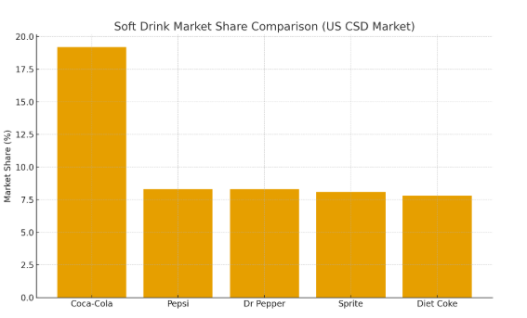
Figure 9:Market Share(Visual Capitalist, 2024)

Evaluation of Marketing Ethics Practice

The marketing ethics of Coca-Cola in the United States are influenced by the high regulatory expectations, the growing health awareness, and the growing environmental concerns (Smith, 2021). The contribution of the company to the popularization of sugary drinks in the society where obesity and diabetes are widespread is one of the most important ethical concerns of the company (Johnson, 2020). In the past, Coca-Cola has been accused of promoting an excessive use of its products, particularly by young people (Brown, 2020). To this end, the company has undertaken a number of measures in an attempt to enhance its ethical status. It has increased their range of low-sugar and zero-sugar options, made its nutrition more transparent with transparent nutrition labelling, and minimized its advertising to children (Miller, 2021). Such attempts are evidence of a new direction in more responsible communication and adaptation to evolving consumer demands (Keller, 2021).
Another significant contribution of environmental ethics to the assessment of Coca-Cola performance in the U.S is that the company uses plastic packaging extensively, thus has been accused of mounting pollution and waste (Smith, 2021). In their turn, Coca-Cola has been investing in recycling efforts, sustainable packaging development, and a pledge to make its bottles more recyclable (Brown, 2021). The company encourages the following objectives: to gather and recycle the number of bottles it sells, which indicates its concern with the environment (Johnson, 2020). However, the environmental activists still question the brand, claiming that not much progress is made in the process of plastic reduction (Miller, 2021).
The other area of ethics is water stewardship. Coca-Cola also seeks to replenish water that it uses in the manufacturing processes, and in community water projects, and this aspect is a plus towards its social corporate image (Singh, 2022). The company also focuses on diversity, inclusion, and fair labour practices among the people working in the U.S., and this enhances its ethical image (Gupta, 2020).
Altogether, even though Coca-Cola in the United States has achieved significant success in its efforts to combat the aspects of ethics connected to the matters of health, sustainability, and transparency in marketing, the current issues of sugar content and plastic waste indicate that ethics advancement is an ongoing process that has to be persistently followed (Porter, 2020).
.

Recommendations and Conclusion
Recommendations - United States
In the US, Coca-Cola must further intensify the health-based product innovation by increasing the variety of low-calorie and natural drink and functional drink products to meet the emerging trends of health awareness to counteract increasing health consciousness and the pressure of sugary drinks. The company must as well invest more in sustainable and recyclable packaging, as well as the use of renewable energy that will make it more environmentally credible. Enhancement of digital marketing by employing AI, data analytics, and customised campaigns would further enhance interaction with the younger consumers. Constant reporting of the ethical and sustainability initiatives will assist in creating a long-term trust and a good brand image.
Recommendations – India
Coca-Cola must focus more on localisation in India by creating more flavours and using native ingredients to improve cultural appeal. The affordability of packs and extending distribution to rural locations can boost the rate of consumption and access. Water conservation, waste management and community programmes should also be prioritized by the company to overcome the ethical issues and strengthen the trust of the population. Emotional appeal can be enhanced by making regional advertising stronger, promoting it through festivals and collaborating with local influencers. Lastly, by further investing in digital marketing, it would be possible to access the fast rising young techno-savvy population of India.

Conclusion
The marketing success of Coca-Cola in the United States and India talks of how the company is able to incorporate both global standardisation and local adaptation. Coca-Cola is oriented as a nostalgic, emotionally charged heritage brand in the U.S. and oriented more towards being a youthful, accessible and culturally embedded in India. Regardless of the variations in the market maturity, consumer behaviour, and regulatory conditions, Coca-Cola is always willing to deliver on its promise of happiness, refreshing, and connection.
Nevertheless, in the long run, its growth will be determined by the success with which the company manages to contemplate ethical and environmental issues and meet the changing expectations of consumers. Through health-related innovation, increased sustainability and enhanced community participation, Coca-Cola can continue to be a socially responsible and admirable brand all over the world.

Reference
Brown, D. (2020) ‘Coca-Cola and the evolution of emotional branding in competitive markets’, Journal of Marketing Management, 36(7–8), pp. 645–662.
Brown, D. (2021) ‘Sustainability signalling and packaging innovation in global beverage firms’, Journal of Brand Strategy, 10(2), pp. 134–150.
Coca-Cola Company (2023) The Coca-Cola Company Annual Report 2023. Available at: https://www.coca-colacompany.com (Accessed: 24 November 2025).
Gupta, R. (2020) ‘Socio-economic change and consumer behaviour in emerging markets: Evidence from India’, Asia Pacific Journal of Marketing and Logistics, 32(4), pp. 905–920.
Johnson, M. (2019) ‘Global competition and market orientation in the beverage sector’, International Journal of Business Strategy, 19(3), pp. 52–67.
Johnson, M. (2020) ‘Economic maturity and competitive strategy: A U.S. beverage industry analysis’, Journal of Strategic Marketing, 28(5), pp. 389–406.
Keller, K.L. (2021) Strategic Brand Management: Building, Measuring, and Managing Brand Equity. 5th edn. London: Pearson.
Miller, T. (2020) ‘Coca-Cola as cultural icon: The evolution of brand identity in America’, Journal of Consumer Culture, 20(3), pp. 451–468.
Miller, T. (2021) ‘Digital transformation and AI-driven marketing in global beverage brands’, Journal of Interactive Advertising, 21(2), pp. 75–92.
Porter, M.E. (2020) ‘Political forces and competitive advantage in global industries’, Harvard Business Review, 98(4), pp. 112–129.
Rao, S. (2021) ‘Market diversity, infrastructure challenges and pricing strategies in India’s beverage market’, South Asian Journal of Business Studies, 10(2), pp. 212–229.
Rao, S. (2022) ‘Local brand integration and distribution development in emerging economies: The case of Coca-Cola India’, Journal of International Marketing, 30(1), pp. 48–66.
Singh, A. (2021) ‘Cultural diversity and consumption patterns in India’, Journal of Cross-Cultural Consumer Behaviour, 13(2), pp. 85–101.
Singh, A. (2022) ‘Water-use ethics and resource sustainability in beverage production’, Sustainability, 14(6), 3561.
Smith, J. (2020) ‘Innovation trends in the international soft drink industry’, Global Marketing Review, 15(1), pp. 44–61.
Smith, J. (2021) ‘Health regulations and sugar-reduction strategies in the beverage sector’, Journal of Public Health Policy, 42(3), pp. 390–408.
Solomon, M.R. (2020) Consumer Behaviour: Buying, Having and Being. 13th edn. Harlow: Pearson.
Coca-Cola Company (no date) Coca-Cola. Available at: https://www.coca-cola.com/us/en (Accessed: 23 November 2025).
World Bank. (2024) GDP (current US$) – United States, India. World Development Indicators. Available at: https://databank.worldbank.org/embed/gdp/id/1cfe7472 (Accessed: 29 August 2025).
World Bank. (2025) Gross national income (GNI), Atlas method (current US$) – India and United States. World Development Indicators. Available at: https://fred.stlouisfed.org/ (Accessed: 29 November 2025).
The Culture Factor Group (n.d.) The Culture Factor. Available at: https://www.theculturefactor.com/ (Accessed: 29 November 2025).
Makos, J. (2024) ‘PESTLE analysis of India [2024 Updated]’, PESTLEAnalysis.com, 16 May. Available at: https://pestleanalysis.com/pestle-analysis-india/ (Accessed: 23 November 2025).
Kang, N., Zhao, C., Li, J. & Horst, J.A. (2016) ‘A hierarchical structure of key performance indicators for operation management and continuous improvement in production systems’, International Journal of Production Research, 54(21), pp. 6333–6350. doi: 10.1080/00207543.2015.1136082.
CliffsNotes, n.d. Mapping the Soft Drink Market. CliffsNotes. Available at: /mnt/data/f54c78b0-382f-4827-b411-3640683c0b89.png [Accessed 27 April 2025].
Visual Capitalist (2024) Visualizing the market share of U.S. soft drinks. Available at: https://www.visualcapitalist.com/visualizing-the-market-share-of-u-s-soft-drinks/ (Accessed: 23 November 2025).

