Module Name: Hotel Placement Research Project
BMIH6008

Name of Student
Mohammed Zahed Minhaz Siddiquei
2017481

Lecturer Name: Laurence Blake

PROPOSAL ON OPERATION OF FOOD RESOURCES IN HOTEL INDUSTRY: FOOD WASTAGE MANAGEMENT
TABLE OF CONTENTS
1.0 Introduction 3
2.0 Background 3
3.0 Research aim 3
4.0 Research objectives 3
5.0 Research questions 4
6.0 Research Rationale 4
7.0 Literature Review 4
6.1 Literature gap 6
8.0 Methodology 7
8.1 Research philosophy 7
8.2 Research Approach 7
8.3 Data collection 7
9.0 Possible outcome 7
10.0 Research ethics 8
11.0 Time Horizon 9
12.0 Conclusion 9
Reference List 10
Appendices 12

1.0 Introduction
The wastage of food is an important part of the business running. It is also a deep ethical issue. Although now-a days there are different modern technologies and processes available to minimize food wastage, still the phenomenon continues. It is estimated that a total of about 920,000 tonnes of food got wasted each year globally by the hospitality and food industry (Wrap, 2013). This is a research proposal which will evaluate the operation and management of food resources to minimize food wastage.

2.0 Background
The wastage of food is a major concern for the hospitality industries and the issues related to that. A large amount of food wastage could increase hunger across the world. Also, it will increase the food inequalities between the rich and poor (Filimonau, 2021). In relation to the hotel industry, it will lead to an increase in the violation of business ethics, which could dent the brand’s image. There are various modern techniques and processes available in today's world (Amundson, 2020). These include the collection of wastes in specific separate plastic bags, maximum use of parts of the vegetables and animal products for food making, so that least wastage of foods can be achieved, as well as preparation of different foods to attract more customers. [Refer to appendix 1]

3.0 Research aim
The aim of the research is to investigate the food resource management by the hotels and how they achieve a minimal wastage of food.

4.0 Research objectives
The objectives of the research are given below.
- To discuss different processes and techniques for the effective management of food waste by hotels.
- To analyse the effectiveness of the used procedures regarding the management of food waste.
- To explore the possibilities of newly emerging techniques for effective management of food resources.
- To investigate the internal dynamics of the hotel for an effective management of food resources.

5.0 Research questions
The research questions for the proposal are below.
- What are the different processes and techniques for the effective management of food waste by hotels?

2) What are the effectiveness of the used procedures regarding the management of food waste?

- How the possibilities of newly emerging techniques for effective management of food resources will be achieved?
- What are the internal dynamics of the hotel for an effective management of food resources?

6.0 Research Rationale
The research proposal is important, as it will investigate the amount of food wastage and its impact on the overall business environment of the hotels. Also, the techniques and internal management system which is followed by the hotels regarding the management of food resources will be evaluated (Bilska et al. 2020). This will help to understand the impact reduction of food waste on the overall human development index of the United Kingdom as well (Reynolds et al. 2020). For all these reasons, the research proposal about the topic of management of food resources and wastage is important.

7.0 Literature Review
According to the author, Okumus et al. 2020, the phenomenon of food wastage is a serious concern for the management of environmental and economic concerns as well. The study investigated how chefs, managers, and other employees in an all-inclusive hotel regarding tackling food waste and a comprehensive waste reduction process had carried out. Also, the perception of the employees of the hotel employees regarding the wastage of food and how the amount of wastage could be reduced in an inclusive way (Okumus et al. 2020). The study was conducted after interviewing of 33 employees working in a hotel in Turkey. The results of the study found that, preferences, guest behavior, attitudes, and others were the primary stimulant behind the food waste. The results also found that, the cultural background of the guests played a big role in their eating behavior, which influences the generation volume of food waste.
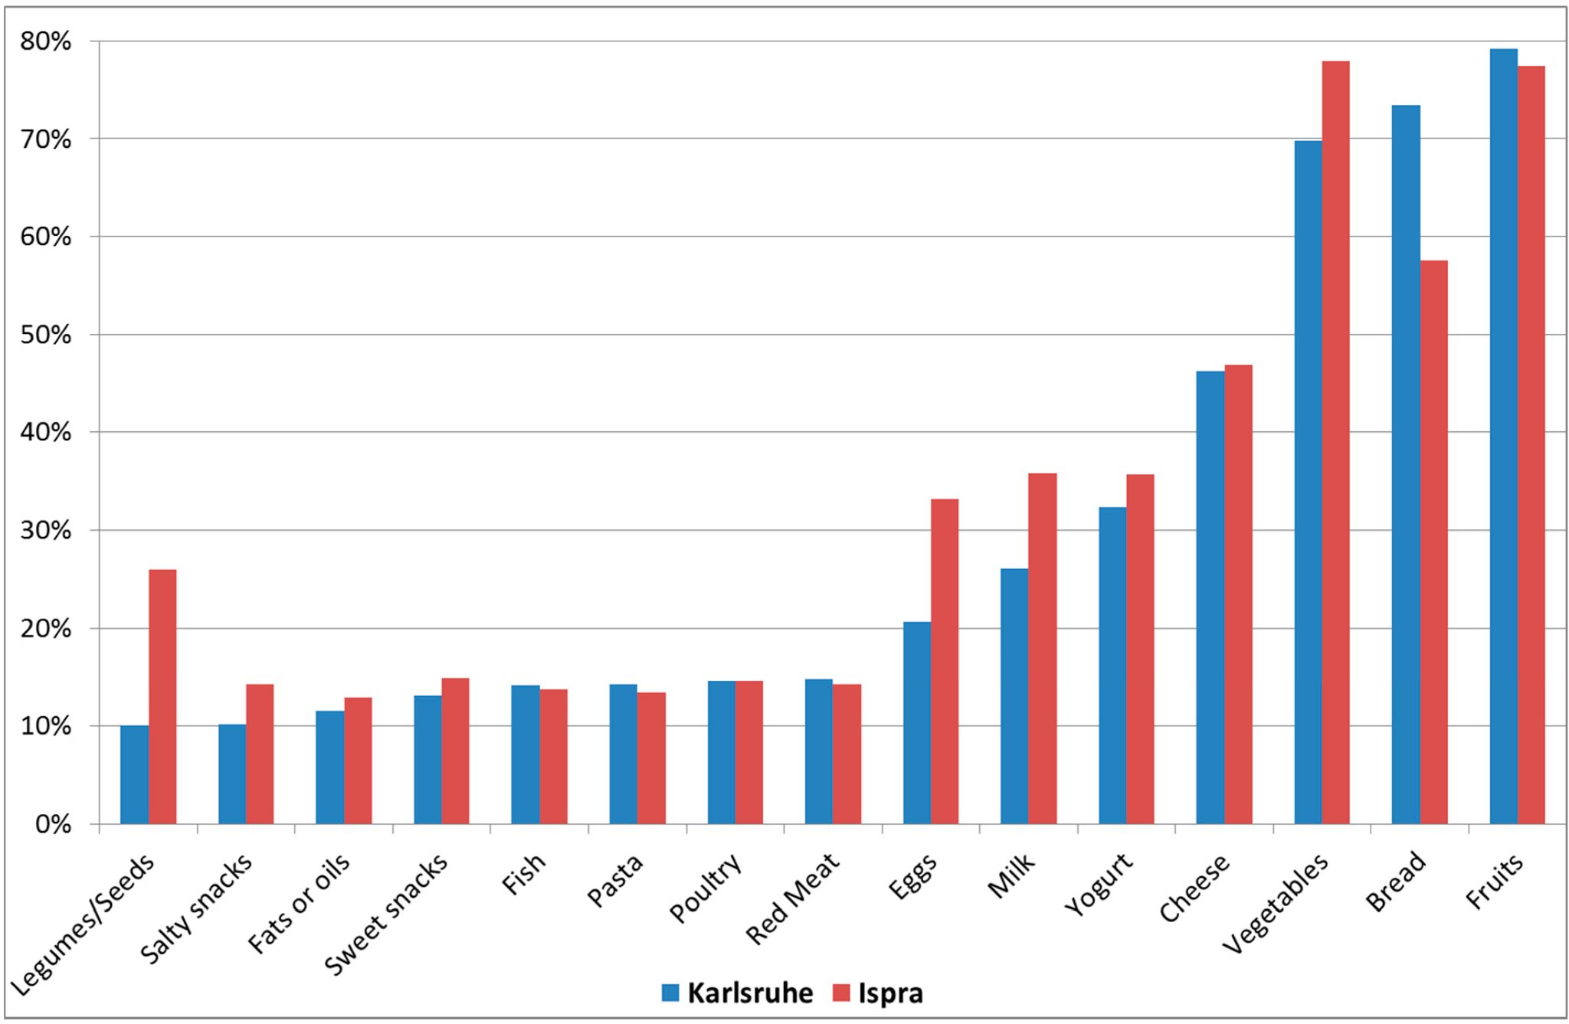
Figure 1: Graph showing the food items in relation with the food wastage in Turkey
(Source: www.mdpi.com)
According to the author, Martin-Rios et al. 2020, the generation of food waste is a major issue that needs to be handled effectively. Wasting food products would mean that, the possibility of an increasing number of hungry people across the globe. This study completed a thorough review of the amount of food wastage, techniques and processes adopted by the hotels regarding the reduction of food waste, and the response of the hotel employees to reduce the food waste (Martin-Rios et al. 2020). The study was conducted among different hotels of Switzerland, between 2017 to 2018. The collection of data had been done through the result of the study found that, over 50 hotel kitchens in the country had successfully achieved the food waste reduction of 55%, which also saved their cost by 5%. The study also concluded that by adjusting the breakfast menu served to the guests, they had successfully reduced the food wastage by 10 kg per week.
According to the author, Filimonau et al. 2020, the study was about a comprehensive, cross-sectional research procedure that analysed the management of food waste across restaurants in the UK and the Netherlands. They had analysed different food waste management strategies adopted by the restaurants in those countries (Filimonau et al. 2020). The strategies include the redistribution of surplus food products, cooking materials, repurposing of excess food products, and designing of food according to customer preferences among others. They also analysed the food mitigation targets set out by the restaurant and hotel chains. The result of the study found that about 75% of the food waste was categorised as avoidable. They had suggested the adaptation of food mitigation strategies, maximum use of food resources, and others to minimise the food wastage. The food items with the wastage percentage and their carbon footprint is given below.
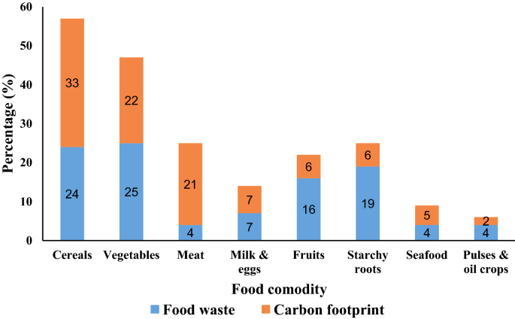
Figure 2: Food items with wastage percentage and carbon footprint in the UK
(Source: Filimonau et al. 2020)

6.1 Literature gap
The main drawback of the literature review is that all the journal and articles selected published after 2019. Besides that, the articles are also not peer reviewed.

8.0 Methodology
The method that will be adopted in this study, is a secondary research design. The data analysis of this study will be of qualitative nature.

8.1 Research philosophy
The philosophy of the research which will be followed in the study is “interpretivism”. That is, researchers will interpret the results, based on the collection of previously published literature on the same or related subjects (Filimonau et al. 2019).

8.2 Research Approach
The research approach, which will be followed is based on the “deductive” approach. The logic behind the following of this approach is that, if the proposition of the study that will be analysed by the researchers is true, then subsequent conclusions also must be true.

8.3 Data collection
For the research proposal, the researchers will analyse different previously published literature, which was focused on the specific issue of food resource management, and tackling food waste, across the hotels in the United Kingdom.

9.0 Possible outcome
The result of the proposal will find that, there are already almost all the hotels and restaurants follow a standard measurement regarding the wastage of vegetables and animal products during preparation of food items. As per analysis by the researchers, it will be clearly observed that the prospect of food wastage is a major challenge for the hospitality industries in the UK (Dalke et al. 2021). In the UK, almost 3.4 million tonnes of food waste is being generated per year. There is also the prospect of fall in the human development index of the country (Malefors et al. 2019). The researchers will find that, the perception of the hotel employees regarding the wastage of food and how the amount of wastage could be reduced in an inclusive way. The designing of food items according to the particular specification and customer demand is also an important step (Santagata et al. 2021). It is observed that, there will be a reduction of food waste by following the customer preferences. [Refer to appendix 2]
In the hotels of the UK, it is found that, the maximum wastage of food had occurred in the dishwashing department of the breakfast area of the hotel H3. In maximum, it is almost 48% (Talwar et al. 2023). The second highest food wastage is found to have happened in the breakfast buffet of the hotel H1. And, almost 36% (Tomaszewska et al. 2021). In the overall context of the four hotels, the dishwashing area, breakfast buffet area, and food production department have the maximum amount of food wastage. The result is given in the figure below.
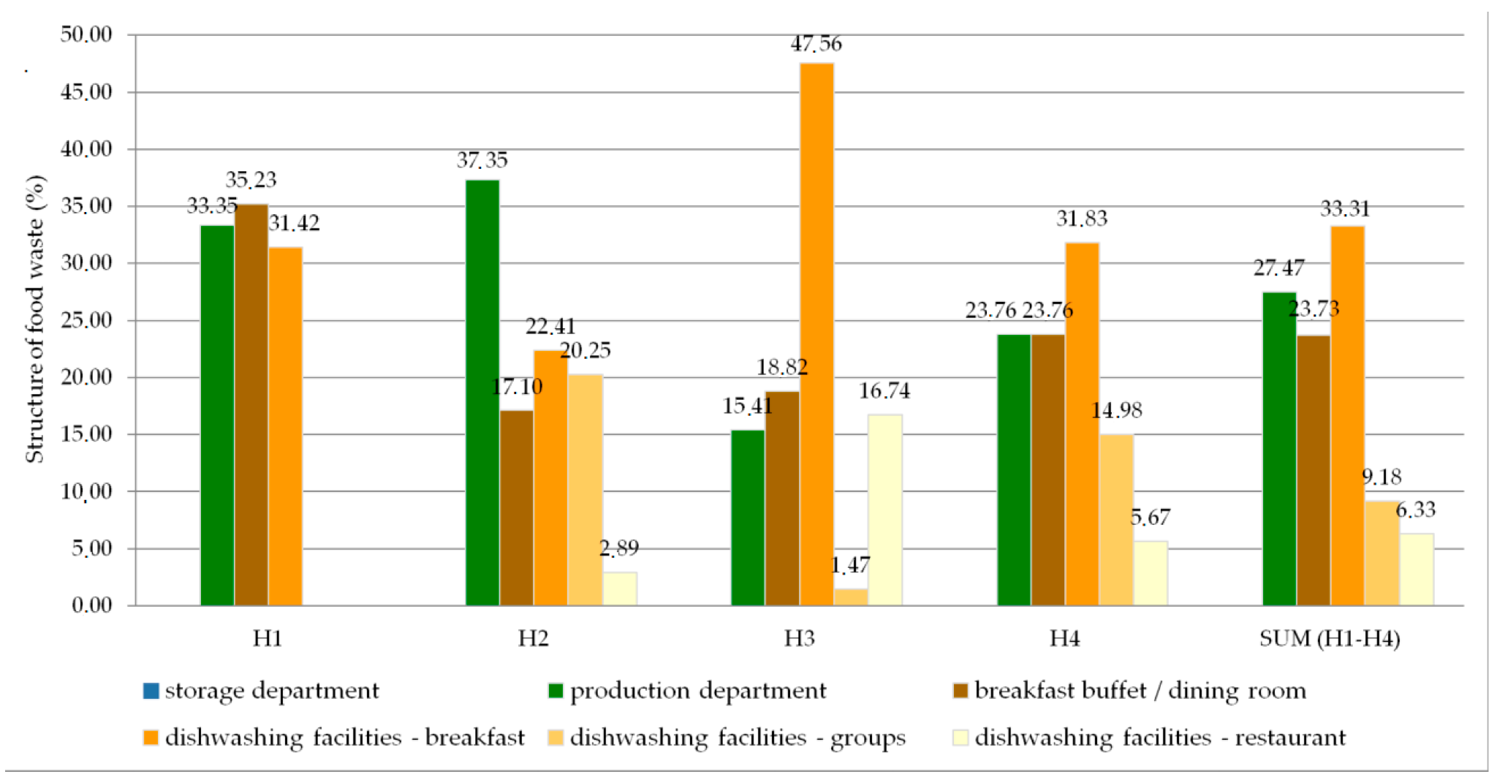
Figure 3: Graph showing the amount of food wastage in hotels
(Source: Tomaszewska et al. 2021)

Research ethics
In the many stages involved in the research have considered the ethics and values that are necessary to abide by the standards and procedures of performing research.
The sources which have been considered for secondary research will be authenticated properly and also the privacy of the data will be maintained. The data interpretation will be done in proper manner so that the narrative of author doesn’t get misinterpreted. The research will also be done in ethical way without harming any living being and without violating law and order.

11.0 Time Horizon
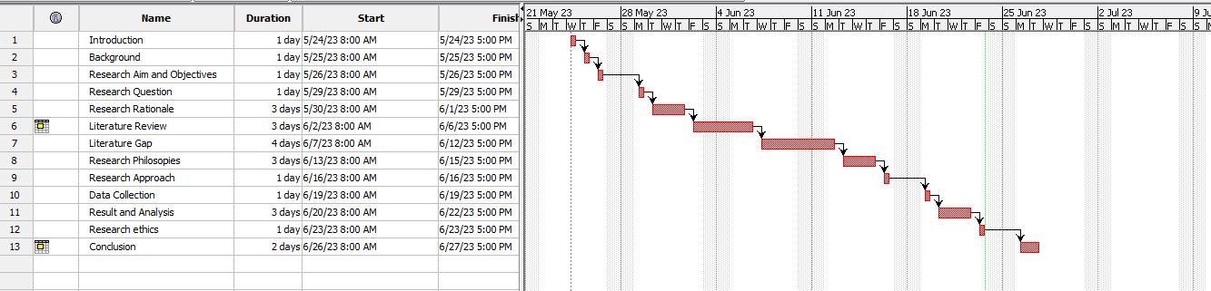
Figure 4: Time Horizon
(Source: Self-created in Project Libre)

12.0 Conclusion
In conclusion, it can be said that the research proposal will help the researchers to understand the reasons, impact, and the concept of food wastage in the hotels and restaurants of the United Kingdom. The research proposal will help in the understanding of the internal dynamics of a hotel, the technologies and modern food preparation techniques followed, so that it reduces the food wastage. There is also the prospect of behavior and management of employees regarding the food preparation. The modification of the food menu according to the choices of customers is also an important part of the minimisation of food wastage.

Reference List
Amundson. (2020) A multi-stakeholder partnership to fight food waste in the hospitality industry: a contribution to the United Nations Sustainable Development Goals 12 and 17. Available at: https://www.tandfonline.com/doi/abs/10.1080/09669582.2020.1849232 (Accessed on: 22 June 23)
Bilska, B., Tomaszewska, M. and Kołożyn-Krajewska, D. (2020) Managing the risk of food waste in foodservice establishments. Sustainability, 12(5), p.2050.
Dalke, R. et al. (2021) Current status of anaerobic digestion of food waste in the United States. Renewable and Sustainable Energy Reviews, 151, p.111554.
Filimonau, V. (2021) The prospects of waste management in the hospitality sector post COVID-19. Resources, Conservation and Recycling, 168, p.105272.
Filimonau, V. et al. (2019) Restaurant food waste and the determinants of its effective management in Bulgaria: An exploratory case study of restaurants in Plovdiv. Tourism Management Perspectives, 32, p.100577.
Filimonau, V. et al. (2020) A comparative study of food waste management in full-service restaurants of the United Kingdom and the Netherlands. Journal of Cleaner Production, 258, p.120775.
Malefors, C. et al. (2019) Towards a baseline for food-waste quantification in the hospitality sector—quantities and data processing criteria. Sustainability, 11(13), p.3541.
Martin-Rios, C., Hofmann, A. and Mackenzie, N. (2020) Sustainability-oriented innovations in food waste management technology. Sustainability, 13(1), p.210.
Okumus, B. et al. (2020) Tackling food waste in all-inclusive resort hotels. International Journal of Hospitality Management, 88, p.102543.
Patel, S. et al. (2021) Opportunities, challenges and trade-offs with decreasing avoidable food waste in the UK. Waste Management & Research, 39(3), pp.473-488.
Reynolds, et al. (2020) Routledge handbook of food waste. Available at: https://www.rouledge.com/books (Accessed on: 22 June 23)
Santagata, R. et al. (2021) Food waste recovery pathways: Challenges and opportunities for an emerging bio-based circular economy. A systematic review and an assessment. Journal of Cleaner Production, 286, p.125490.
Talwar, S. et al. (2023) Food waste and out-of-home-dining: antecedents and consequents of the decision to take away leftovers after dining at restaurants. Journal of Sustainable Tourism, 31(1), pp.47-72.
Tomaszewska, M. et al. (2021) Estimation of the scale of food waste in hotel food services—A case study. Sustainability, 13(1), p.421.
Worldwildlife.org. (2020) Fighting Food Waste in Hospitality and Food Service. Available at: https://www.worldwildlife.org/pages/fighting-food-waste-in-hospitality-and-food-service (Accessed on: 22 June 23)
Wrap. (2013) Overview of waste in the hospitality and food service sector. Available at: https://wrap.org.uk/resources/report/overview-waste-hospitality-and-food-service-sector (Accessed on: 22 June 23)

Appendices
Appendix 1: Food items wasted in the hotel and hospitality sector
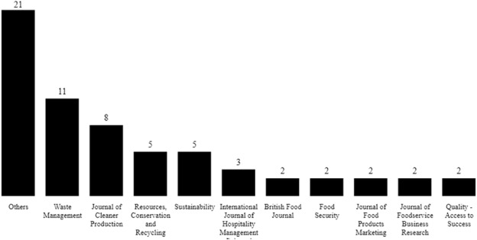
(Source: www.mdpi.com)

Appendix 2: Food waste per sector in the UK
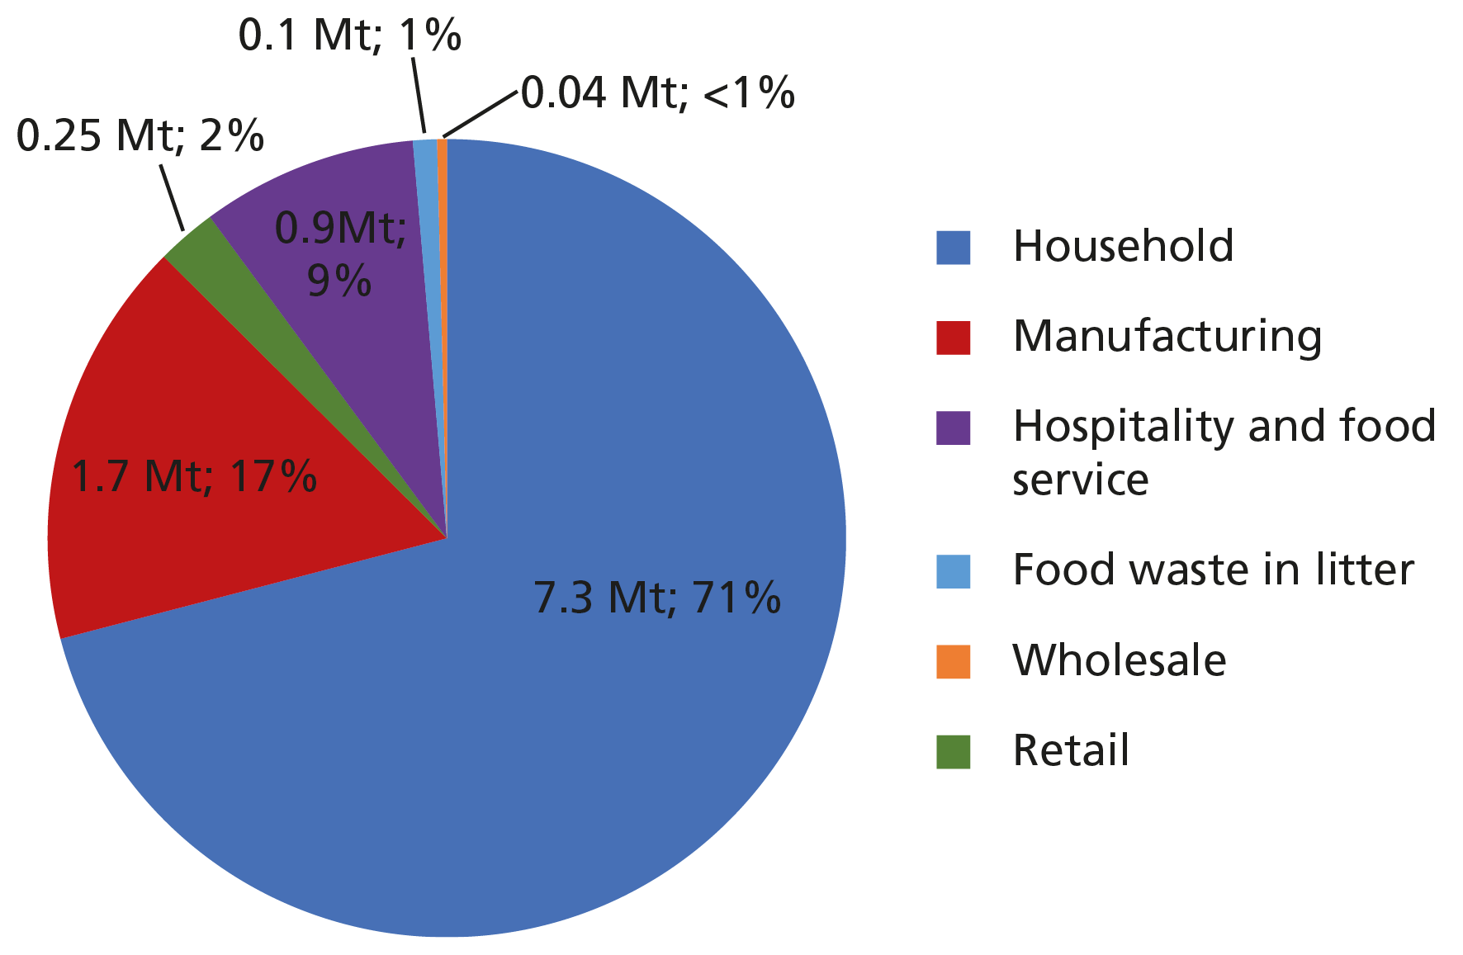
(Source: www.publications.parliament.uk)

