

University of Wales Trinity Saint David

Aryan Adibmehr 1802462

Designing a MTB fork
ACMA5010

Lecturer: Kelvin Lake

Bicycles in their modern form have existed for well over 100 years, this beginning with the introduction of the ‘’safety bicycle’’ in the late 19th century. Although dedicated mountain bikes now occupy a distinct category in the bicycle market, this wasn’t always the case. What is now known as the ‘’road’’ bike was predominantly the only type of bicycle available for most of the history of the bicycle.
Today’s mountain bikes which consist of several sub-types started around the late 1970’s as a variation of the only bikes available then, which were road bikes with rigid tubular steel frames, and rigid tubular steel forks. Road bikes up to that point had remained relatively unchanged both in design and materials, and this trend continued mostly with the exception of drivetrain components and different frame/fork materials appearing over the years.
Early mountain bikes started to vary from road bikes mostly in using larger volume tyres and different frame geometry. These changes made for increased shock absorption on rough dirt roads and also made the bicycles more stable on steep trails reducing the tendency for the bike tipping forward.
These experimental bikes were made to ride over rougher and steeper trails than what road bikes had traditionally been used for, but their frames and forks remained of rigid steel construction for some time until the idea to use suspension forks came about, and eventually suspension frames were also introduced leading to the modern ‘’full suspension’’ mountain bike, as opposed to ‘’hard tail’’ mountain bikes which have a rigid frame with suspension forks.
Suspension forks introduce several factors such as the need to maintain their telescopic motion without excess perceptible clearance and maintaining this without premature wear in the sliding components, in addition to aspects pertaining to their function as suspension elements such as spring rate and damping. Considering this, their basic structural requirements remain the same as rigid forks which have been made for well over 150 years and provide long service on all types of bikes without failure. The bicycle fork as a structural element has one of the most severe tasks as it is a cantilevered beam which sees millions of cyclic loads applied to its end as a result of road roughness and braking. In addition, a fork failure leads to an immediate crash, so there is no safe way in which a fork can structurally fail in use.
Considering the safety requirements of forks and importance of light weight in bicycles, every effort has been made to alleviate the magnitude of the stress seen by the fork material. The number of loading cycles is a function of road roughness and instances of braking, so cannot be controlled in any way by changing the fork itself. On a perfectly smooth road without any braking the load on the fork could theoretically be constant, which negates the effect of fatigue, but this is not how bicycles are used and fatigue is the predominant failure mode for bicycle parts, as opposed to overload failures.
The cyclic loads placed on the fork in use are mostly in-plane of the bike frame, tending to deflect the fork ends rearward. Some out of plane bending occurs as a result of a rider pulling on the handlebars while riding, but these are far smaller and less numerous than the constant in-plane oscillations of the fork ends while riding. The effects of the vibrations caused by these deflections are evident in the ‘’false brinelling’’ which occurs in the bearings of the headset with use. The fretting wear which causes this happens more in the front and back portions of the bearing races than the sides, which reflects the direction of the loads seen by the fork. This false brinelling is sometimes misinterpreted as plastic deformation of the races as if they were dented by the balls, but it is just as prevalent in the top bearing as the bottom one, the bottom once taking the impact loads directly.
Light weight bike forks have always been designed to resist these in-plane loads as efficiently as possible to alleviate stress and improve fatigue life. This can be seen in the cross section of the steel tubes used in bike forks. They have an oval cross section (see fig. 1), proving a deeper beam cross section in the direction that that they are loaded most, reducing the maximum bending stress seen by the material under braking and bumps. Another aspect of this is that bike forks, whether metal or carbon fibre taper towards the axle. This is as a result of the bending moments and therefore the stress being greatest away from the axle, where the fork legs are restrained by the ‘’crown’’ assembly which transfers the loads to the headset bearing assembly.
Traditional steel forks used on track bike (see fig.2), which roll on smooth track and do not have brakes differ from the usual road fork in that their fork blades are round and not as stiff in the fore/aft direction because they do not see the same loads as road forks. The round cross section also increases lateral rigidity which might benefit track riders who pull very hard on the handlebars.
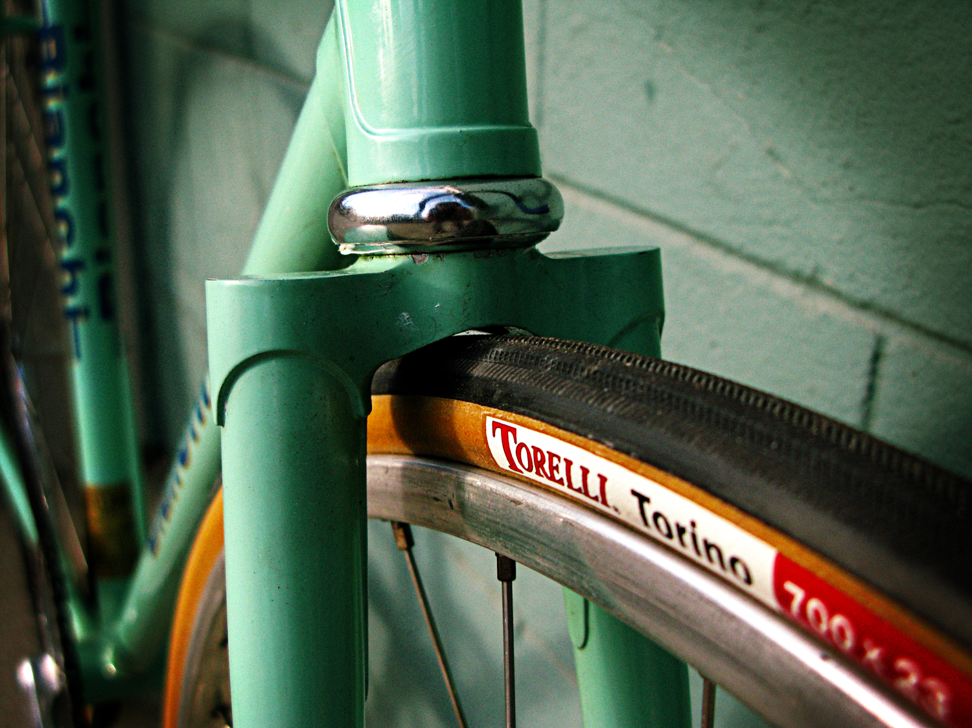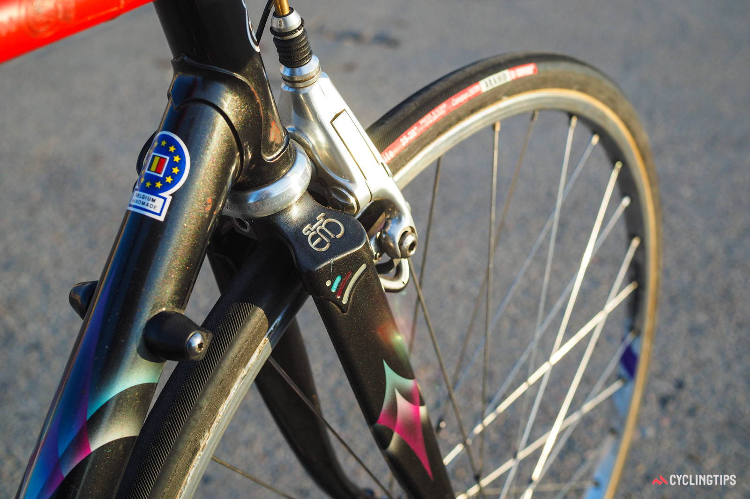
Fig. 2: Round fork blades used on traditional track bikes which don’t see the same loads as road or mountain bikes.
Fig. 1: Ovalised fork blades on a Merckx MXL road bike which increase rigidity of the fork in the direction of most severe loads.

These bending loads are due to several factors and occur in both forward and rearward directions. For example, due to the head tube angle of the bike the fork is under a bending load such that the axle tends to deflect forward under the weight of the rider alone, even without any road shock or braking loads. This bending moment puts the rear side of the fork blades in tension and can eventually lead to fatigue cracks (see fig. 3) on the rear side of the fork blades from vertical road vibrations at the fork blade-crown junction (Jobst Brandt, 1998).

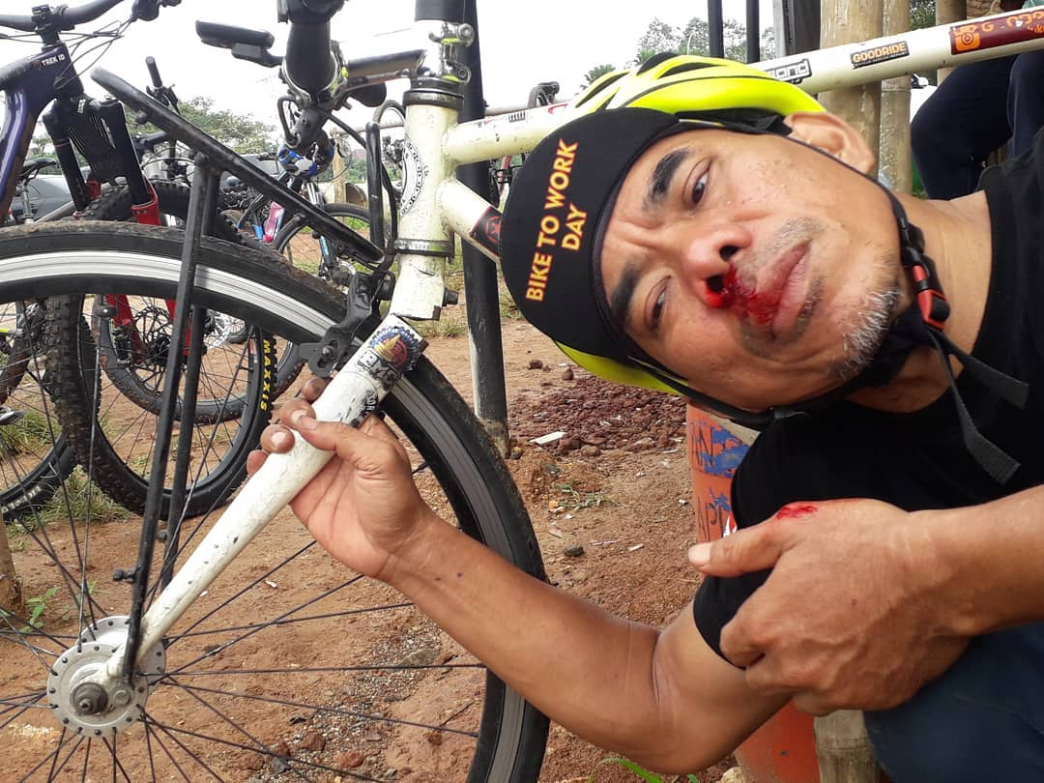

Fig. 3: A lucky escape for a rider who’s fork failed in fatigue due to vertical road vibrations. Photo: @pei_adanya Instagram.

The stress that results from this loading is exacerbated as the head tube angle of a bicycle increases, fork length and weight being equal. I.e. as the steering axis becomes less vertical, the bending moment experienced by the fork blade connection to the fork crown increases. The reverse of this is true for riding loads that tend to deflect the axle rearward, such as those resulting from bumps encountered and from braking. However, the fatigue effects from the former type of loading tend to outweigh that of the latter and long term fatigue cracks in forks tend to cause the fork to fail forward rather than backward (Jobst Brandt, 1998). As the head tube angle becomes less vertical, the size of bump which can be encountered by the wheel and be taken axially by the fork crown/steerer tube becomes larger. For e.g., a 0.6 inch bump is taken axially by a 73 degree head tube angle (17 degree from vertical) which has been common on road bikes for a long time. The larger a bump that is encountered, the closer to horizontal the steerer tube axis has to be to take the bump axially rather than in bending. The head tube angle of mountain bikes is always lower to varying degrees (i.e. closer to horizontal) than road bikes for handling reasons which make the steering more controlled and increase the wheelbase of the bike for more stability at high speed, but it also serves to reduce the bending load seen by the fork crown area and therefore the fork blades over larger bumps. Aligning the steerer tube axis so that bumps are taken more axially by the fork also serves suspension forks in that there is less of a bending moment in the guides of their telescopic motion (Jobst Brandt, 2002).
If an assumption is to be made that a maximum weight equal to the rider’s weight is placed on the front wheel at a particular point in a ride, the bending moment on the fork purely from the vertical load is as follows:
$$bending moment=m∙g ∙fork length∙\sin{θ}$$
θ: head tube angle (measured from vertical)
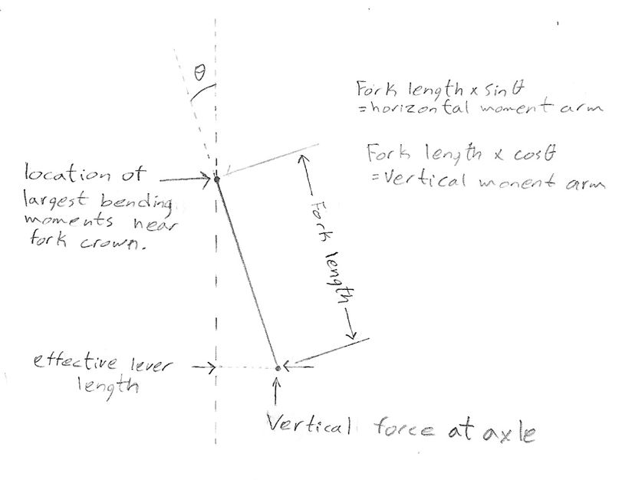Fork length: length from axle to where crown meets the fork stanchions

Fig. 4: Drawing showing effective moment arms relative to axle forces on the fork.

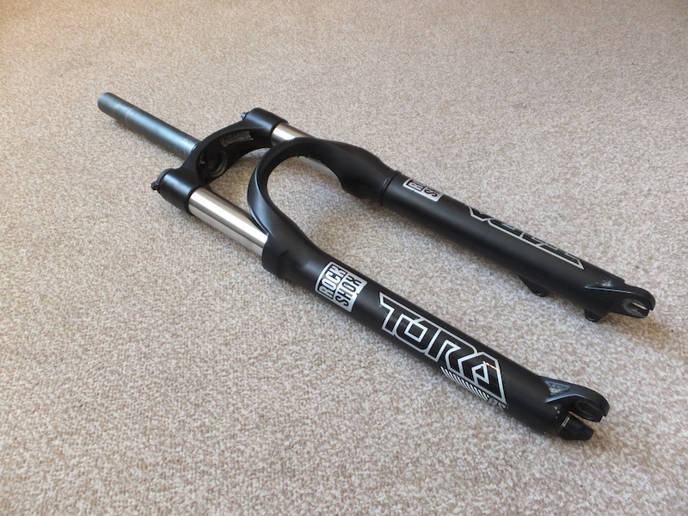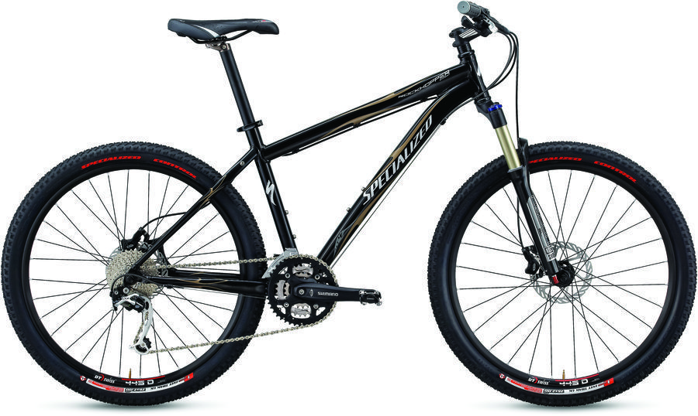
Fig. 6: RockShox Tora 302 fork.
Fig. 5: 2009 Specialized Rockhopper mountain bike.

In the case of a 70 kg rider, using a RockShox Tora 302 fork (axle to crown length 0.485 m) on a 2009 Specialized Rockhopper mountain bike with a 70 degree head tube angle (20 degree from vertical), the moment supported by the fork in this loading condition is
$$bending moment=70∙9.81 ∙0.455∙\sin\left(20\right)=106 N∙m$$
Length of 0.455 is used instead of 0.485, as some of the height is taken up by the fork crown which connects the fork legs to the steer tube. It is assumed that the fork stanchions are fully restrained at this junction, so the fork length is adjusted to only include the legs/stanchions.
Based on this bending moment, and considering it is supported by 2 stanchions, the moment seen by each stanchion in this loading condition near the fork crown is 106/2 or 53 Nm.
According to Oertel et al. (2010), the braking force which acts to decelerate the mass of a typical 80 kg rider and bike when braking rapidly is 400 N. A 120 kg rider pushing their weight back to be able to brake as hard as possible can reportedly generate a decelerating force of over 700N. Front brakes were tested in this experiment as maximum braking forces generated by individual brake calipers were under consideration, and rear brakes can only contribute marginally to deceleration as the rear tyre has very limited grip when stopping. It is possible to assume the retarding force provided by the front tyre which acts on the mass of the system must be transferred through the fork, and that the entirety of this force is seen at the axle attachment to the fork. Thus is possible to determine some further moments experienced by the fork stanchions:

$$bending moment=400 ∙0.455∙\cos\left(20\right)=171 N∙m$$
$$bending moment=700∙0.455∙\cos\left(20\right)=299 N∙m$$
The moment seen by each stanchion is these cases is approximately 85 Nm and 150 N respectively. These moments are a result of horizontal force deflecting the axle backward, and are counter to that which is caused by vertical loads on the axle. Since it is likely that some weight will be applied to the handlebars, the net moment seen near the fork crown is likely lower than those shown. The more weight the rider applies to the handlebars while a large braking moment is being generated, the more the fork will be loaded axially and the moment caused by braking diminished. But this is likely to bring rider weight forward and limit braking force in itself, so it is difficult to predict how the fork will be loaded in bending by the combination of the forces acting.

Fig. 8: Measuring the steel stanchions on the RockShox Tora 302 with Vernier calipers. 32mmm diameter.
Fig. 7: A closer look at the RockShox Tora 302 fork.
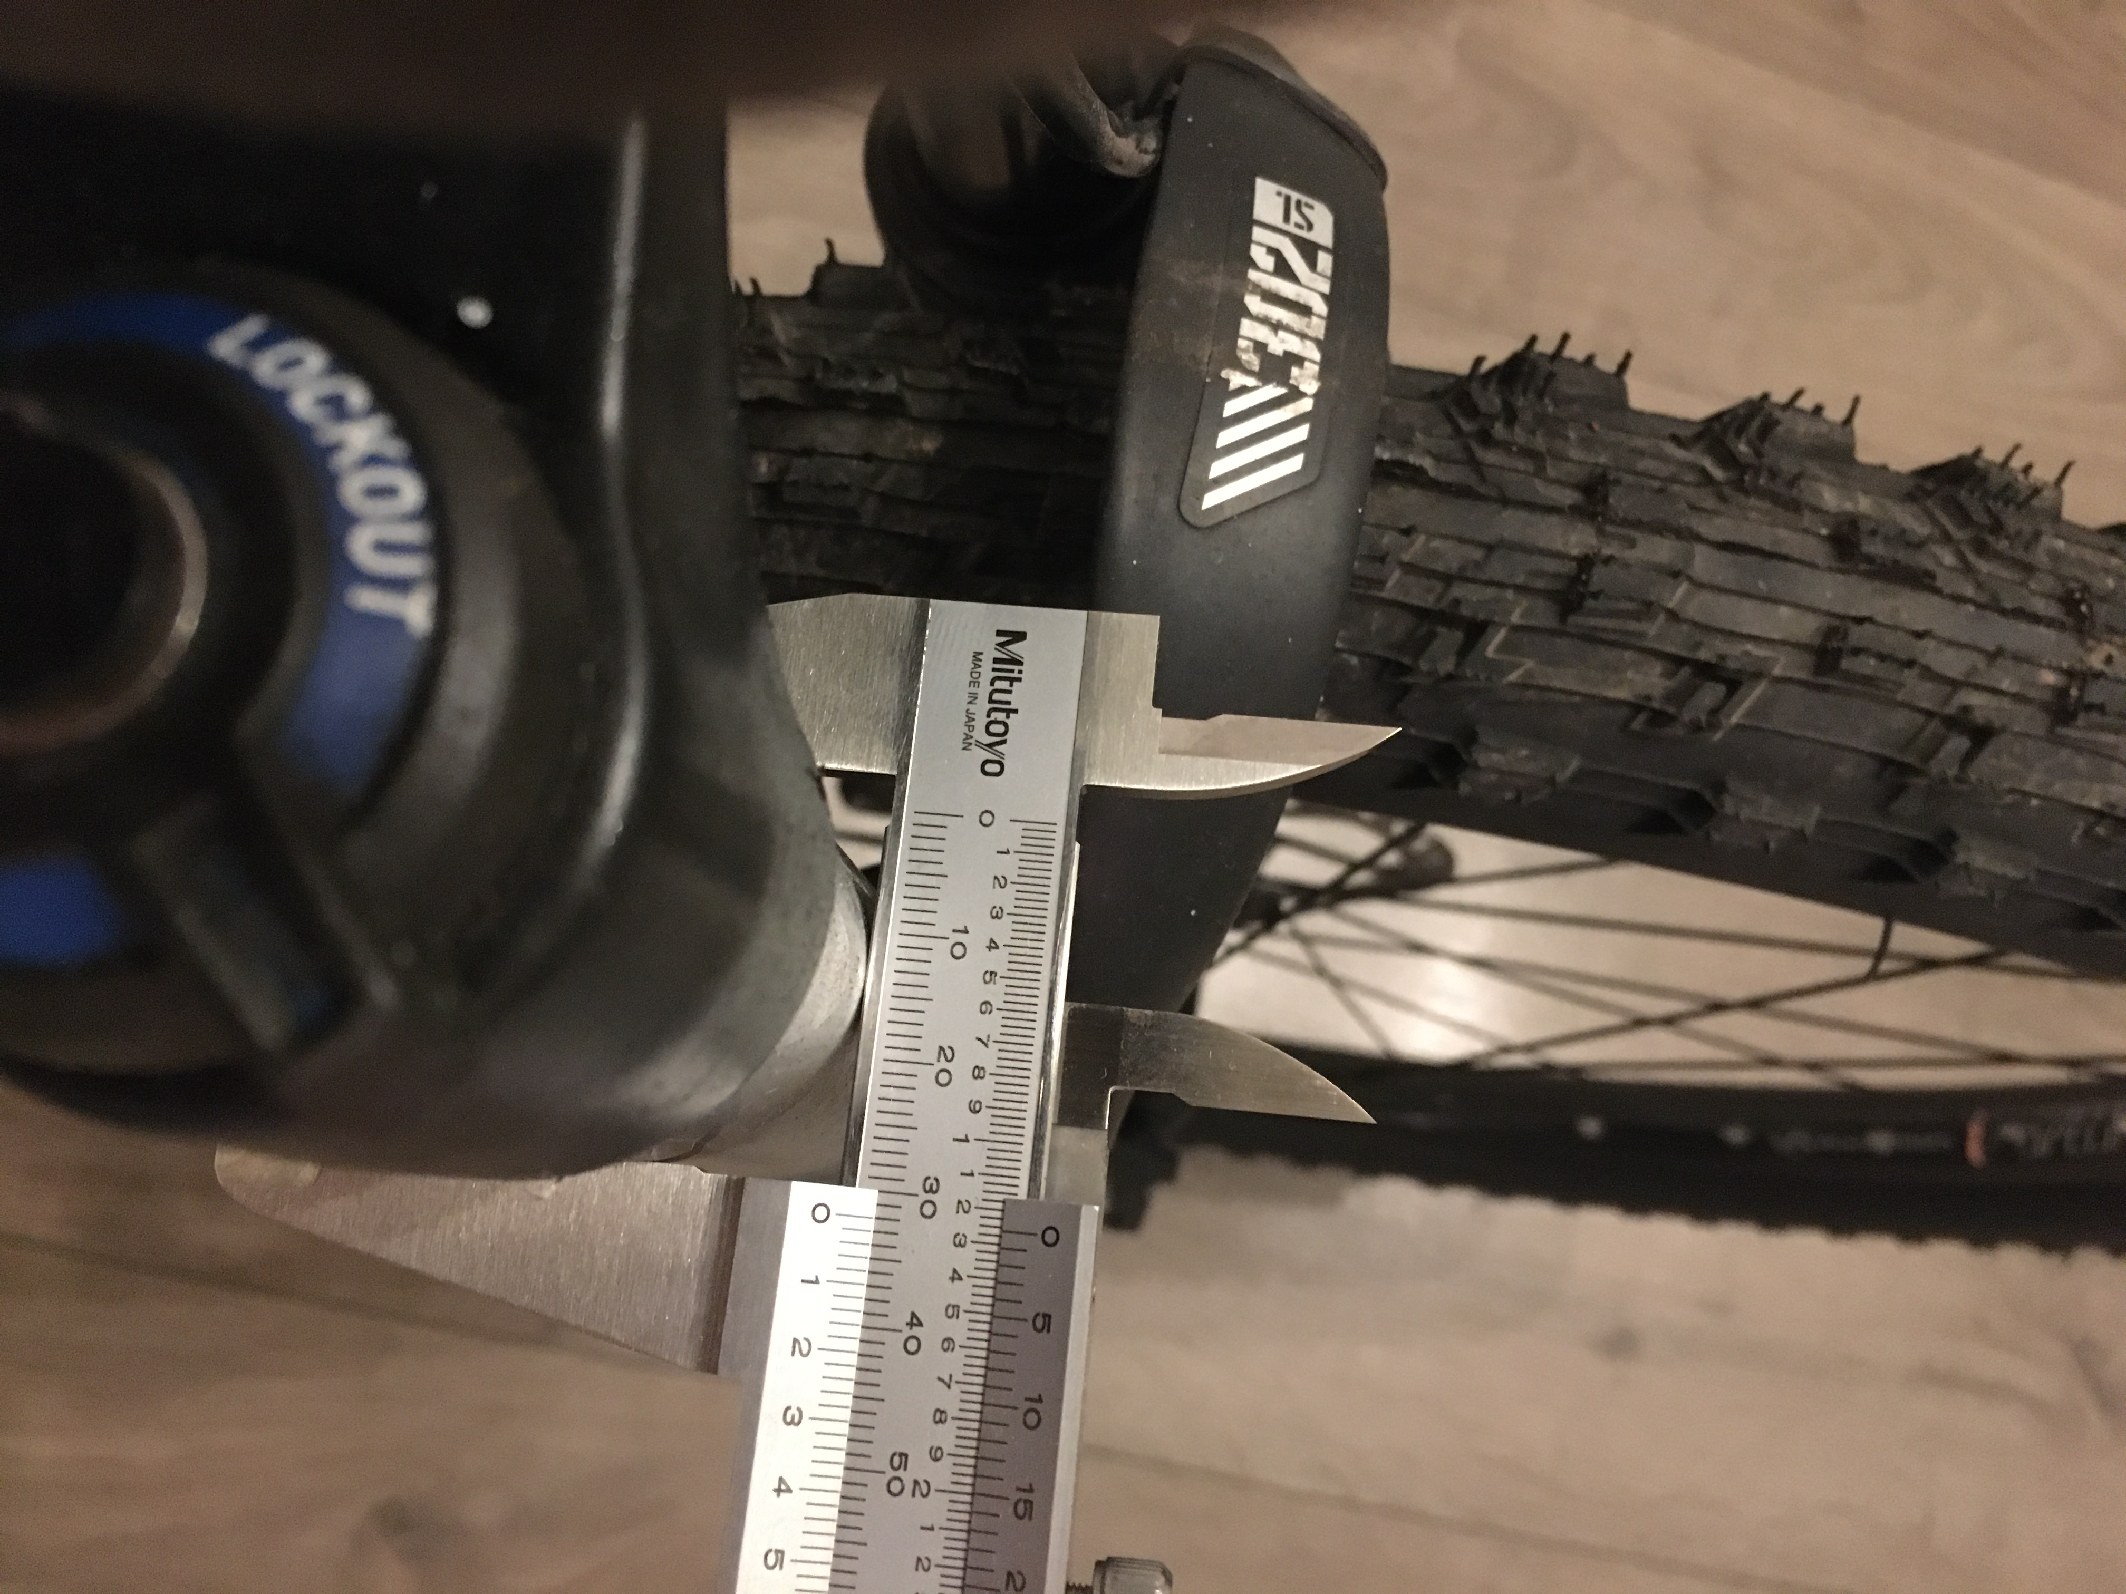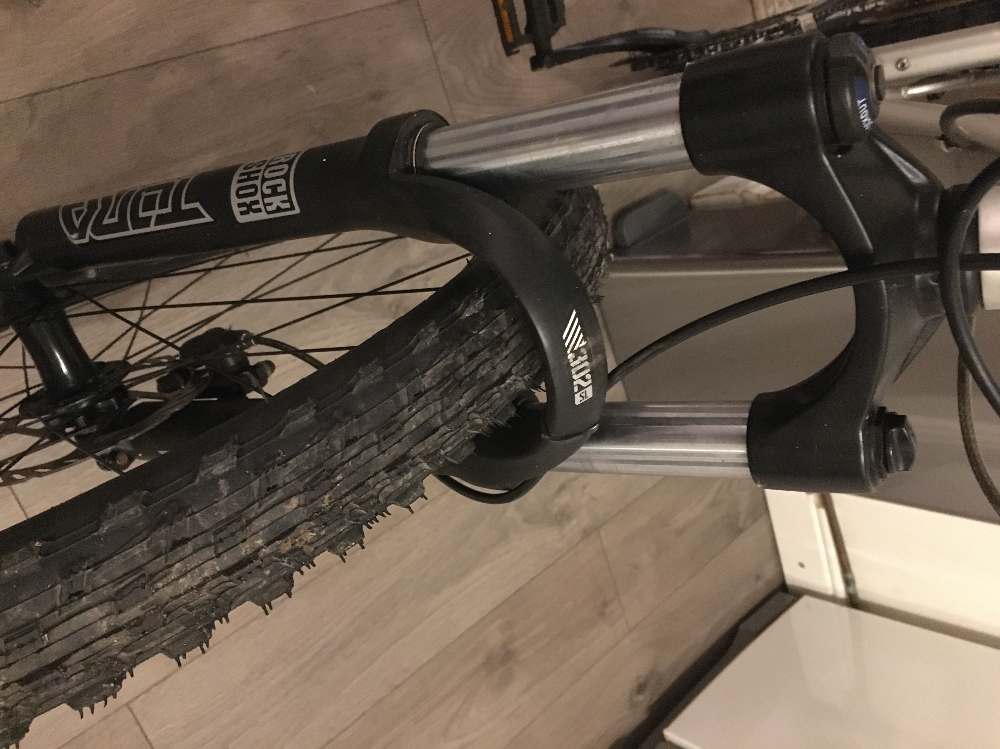
The bending stress on a beam is a function of bending moment, second moment of area, and the distance of the furthest element from the neutral axis, given by:
$$σ_{max}= \frac{M}{I} y_{max}$$
The second moment of area of the stanchion, being a circular tube is given by (32mm OD, 28mm ID)
$$I= \frac{π}{64}× \left(D^{4}-d^{4}\right) = \frac{π}{64}× \left({0.032}^{4}-{0.028}^{4}\right) =2.13×{10}^{-8} m^{4}$$
$$σ_{max}= \frac{M}{I} y_{max}= \frac{85}{2.13×{10}^{-8}} ×0.016=63.8 Mpa$$
$$\frac{150}{2.13×{10}^{-8}} ×0.016=112.7 Mpa$$
In the case of the 700N braking force, the deflection of the axle is given by:
$Y_{max}= \frac{WL^{3}}{3E∙I} = \frac{700{×0.455}^{3}}{3×210×{10}^{9}×2.13×{10}^{-8}}=$4.9 mm

The deflection of 4.9mm is within the 10mm specification. Using a 32mm diameter stanchion the maximum bending stress is 112 Mpa under that particular loading condition.
The maximum stresses for 30mm and 28 mm diameter (with 2mm wall) stanchions are `138.7 Mpa and 173.9 Mpa.
The stress increases disproportionately with diameter reduction. It is desirable that the material under cyclic load operate within as small a percentage of its yield strength as possible. This increases the fatigue life of the part, and in case of steel, a percentage of yield which allows infinite cycles of a given stress is known as the ‘’endurance limit’’. Typically the endurance limit is taken as being below 35%-60% of yield strength for steels with hardness below 40 RHC (1200 Mpa) (ASM International, 2008). Keeping the operating stresses low widens the options for the alloys which may be used while staying within their endurance limit and allows for higher durability and reliability of the part.
One requirement of steel stanchions is that they be hard chrome plated to prevent corrosion and also provide a hard surface which will not score easily and work well against the wiper seals of the fork lowers. This is similar to hydraulic cylinders which use hard chrome plate rods with wiper seals.
A common material used for hydraulic cylinder shafting is AISI 1045 steel. It has a yield strength of 310 Mpa. The most common steel used in bicycle frame and forks is AISI 4130 which has a yield strength of 435 Mpa. If a stanchion diameter of 30 mm is used (138 Mpa max bending stress), it will both save weight and stay within 50% yield of AISI 1045 steel. This is a safe option which will guarantee high fatigue life if a steel with yield similar to 310 Mpa is used, and even more of a margin if a steel with higher yield strength is used. Staying with the already existing 32mm diameter stanchion would be wise since the load calculations performed here did not take into account stress due to large bumps or hard landings which are difficult to quantify.
The RockShox Tora 302 fork which was looked at and measured here uses forged aluminium lowers and a forged aluminium crown which connects the stanchions to the steerer tube. Forging is only economical if large volumes will be produced. For a prototype, using machined parts is more sensible as tooling costs are very low and different versions of a design can be tested for stiffness and ride quality for example without investing huge amounts of money and time into obtaining forgings. Long term fatigue testing of specimens would require the final design to be forged and fully tested.

References
Oertel, C et al., (2010) Construction of a test bench for bicycle rim an disc brakes. 8th conference of the international sports engineering association. Available at: https://www.sciencedirect.com/science/article/pii/S1877705810003462

Bibliography
1998 Usenet discussion of broken forks, including Jobst Brandt, author of ‘’The Bicycle wheel’’.
Available at: https://yarchive.net/bike/fork_failures.html

2002 Usenet discussion of bicycle head angles, including Jobst Brandt.
Available at: https://yarchive.net/bike/head_angle.html

Development of a freeride mountain bike suspension fork (2008)
Available at: https://onlinelibrary.wiley.com/doi/full/10.1002/jst.16

RockShox Tora 302 fork specifications
Available at: https://www.mbr.co.uk/reviews/products/rockshox-tora-302-174-99

AISI 4130 and AISI 1045 steel properties
4130:
https://www.thomasnet.com/articles/metals-metal-products/all-about-4130-steel-properties-strength-and-uses/
1045: https://www.azom.com/article.aspx?ArticleID=6130#:~:text=AISI%201045%20steel%20is%20a,ranging%20between%20170%20and%20210

