

STUDENT NAME: RAHUL AMITKUMAR SHRIMALI (2519362)

MODULE: INTERNATIONAL MARKETING: PRINCIPLES AND PRACTICES

TITLE: ASSESSMENT COMPONENT 1: INDIVIDUAL REPORT

PROGRAMME: MASTER OF BUSINESS ADMINISTRATION

Table of Contents
A. SECTION 1: MARKETING REPORT 3
1. Introduction 3
2. Comparative Analysis Of The Market 4
2.1 PESTEL Analysis 4
Germany (home market): 5
India ( Emerging Market): 6
2.2 Hofstede Cultural Analysis 10
3. Comparative Analysis of STP 15
3.1 Segmentation 15
3.2 Targeting 17
3.3 Positioning 18
19
4. Comparative Analysis of International Marketing Mix 19
5. Market Entry Strategy 24
6. Ethical Issues 26
7. Recommendations 27
8. Conclusion 29
Section 2: Reflective Report 30
9. Introduction: 30
10. Description: 30
11. Feelings: 32
12. Evaluation: 33
Conclusion: . 35
13. Action Plan: 35
14. References 36

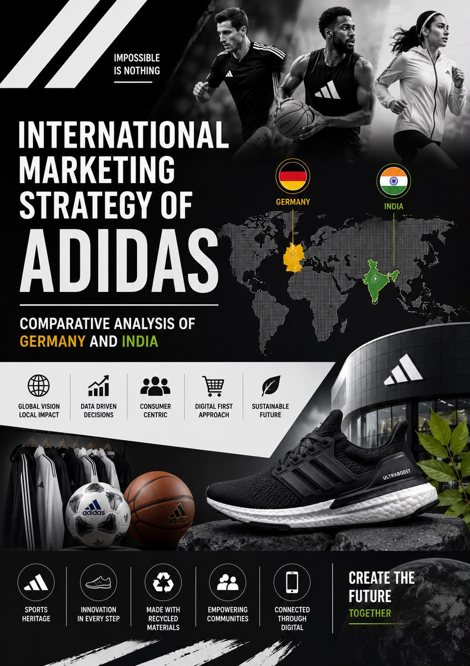

SECTION 1: MARKETING REPORT

Introduction
Adidas AG, established in 1949 and based in Herzogenaurach, Germany, is one of the most popular sports brands globally and is regarded particularly well for its “Three Stripes” identity and range of shoes, clothes, and other equipment. The report compares the international marketing strategies of Adidas in two very different markets – Germany, its established home market, and India, a high-growth emerging market. It analyzes the influence that political, economic, social, technological, environmental, and legal conditions as well as differences in culture, as identified in Hofstede’s dimensions in each country, have on consumer behaviour and marketing. The report furthermore provides an assessment of the segmentation, targeting and positioning of Adidas. It also shows strategies related to the product, price, place, promotion, people, process and physical evidence. 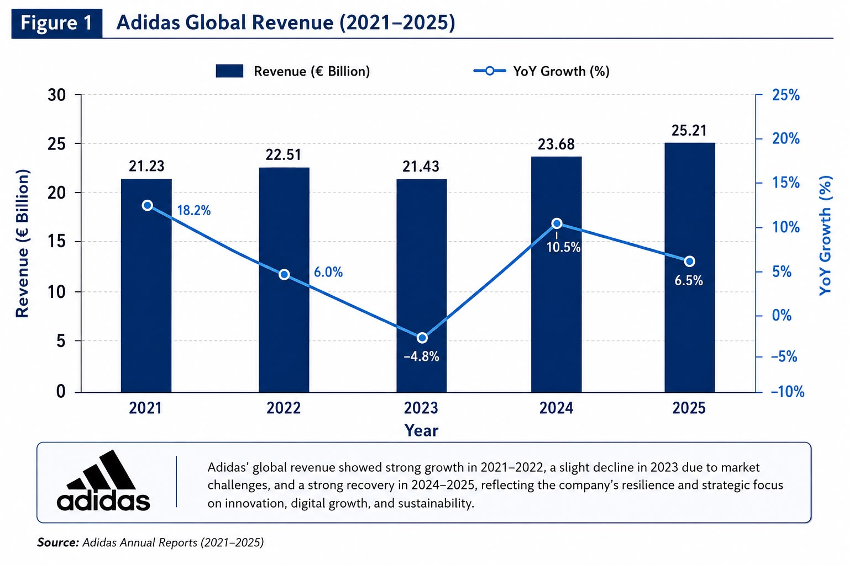

Comparative Analysis Of The Market

PESTEL Analysis

It is important that they favor environmentally friendly products and are very alert to the community. Corporate accountability. Environmental claims are closely checked by German regulators and NGOs.
Consumers’ beliefs and values, families, ties and community are useful.Personal success and effectiveness resonate well.
Germany is advanced in technology. The internet engages over 90% users, and e-commerce is well established (over 80% Germans shopped online in 2024). Usage of mobile devices is very high.

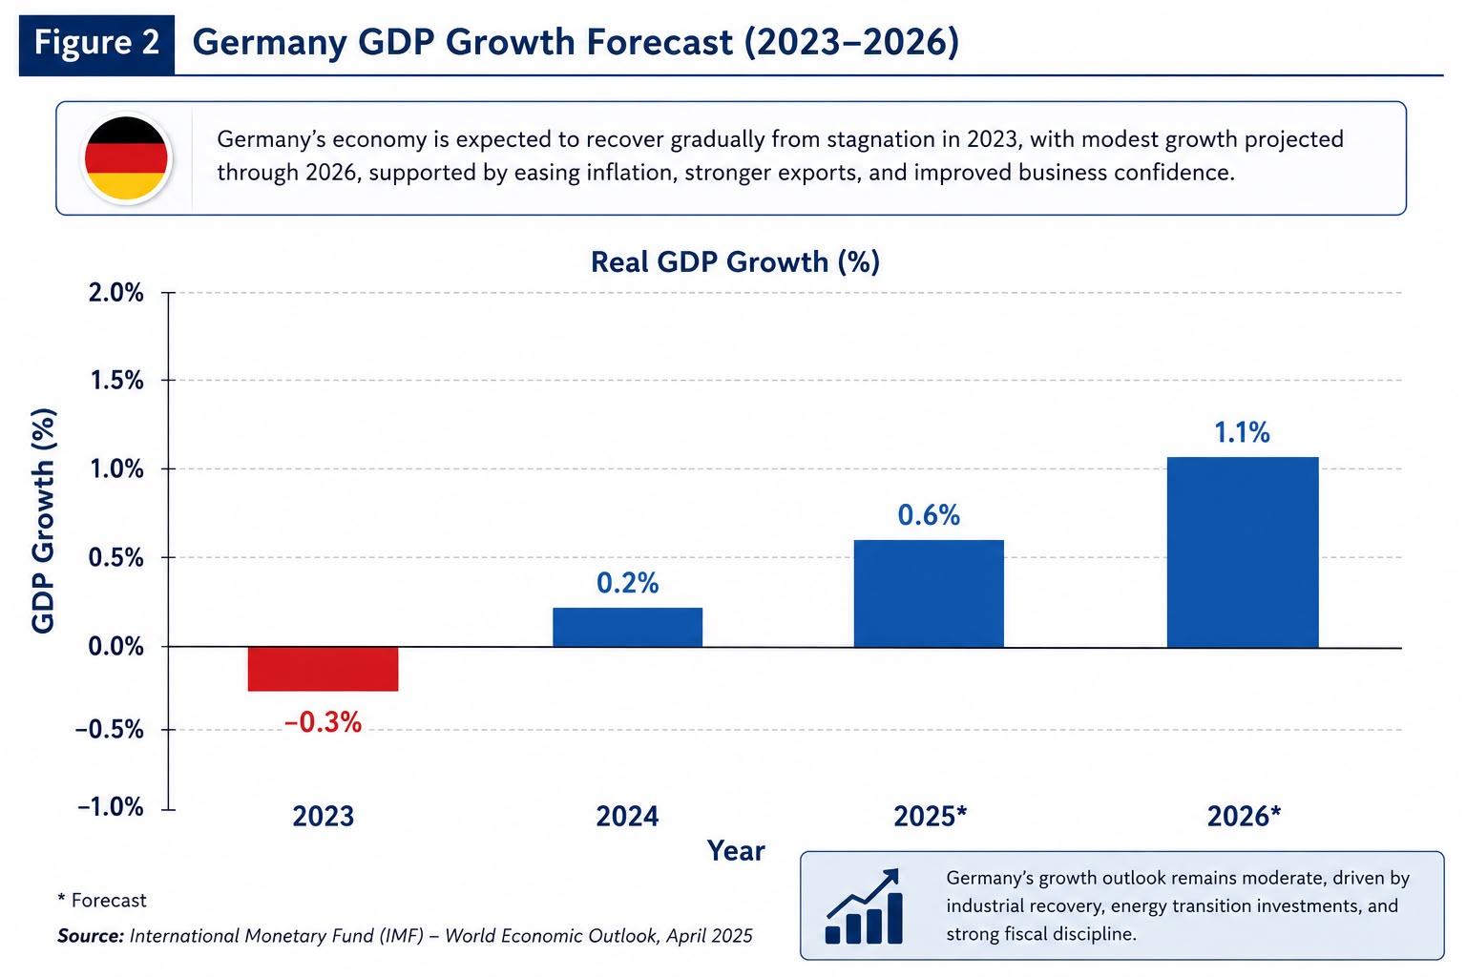
Germany (home market): take advantage of cutting-edge systems. Tech-savvy products (e.g. smart wearables) are appreciated by German consumers and look forward to seamless shopping experiences.
Ending Environmental factors are significant. Germany has put in place climate policies (carbon neutrality by 2045) and recycling laws that are strict. Sustainable practices sought by consumers. Adidas.
The advertising of “50% recycled” by the Adidas was found misleading by the regulator. So, Adidas’s. In this competition, environmental efforts must be real and true. Germany’s labour laws are strong, involving a national minimum wage and work councils in many companies.
Unions are powerful and workers have robust protections.
Additionally, within the EU, Germany is subjected to trade agreements (like free trade within the EU),.but additionally to tariffs and regulations for imports from outside the EU. Germany has a stable political environment. Prosperity, however with high compliance
India ( Emerging Market): The political situation of India is democratic but complicated. The state.
The government has launched programs that bolster business which include (Make in India for manufacturing and sports. development schemes such as Khelo India. Foreign brands can open single-brand retail stores in India. All manufacturers are allowed to own up to 100% of single-brand retail if they meet local sourcing requirements (at least 30% of the value). The agreement enables Adidas to take over its stores with conditions.
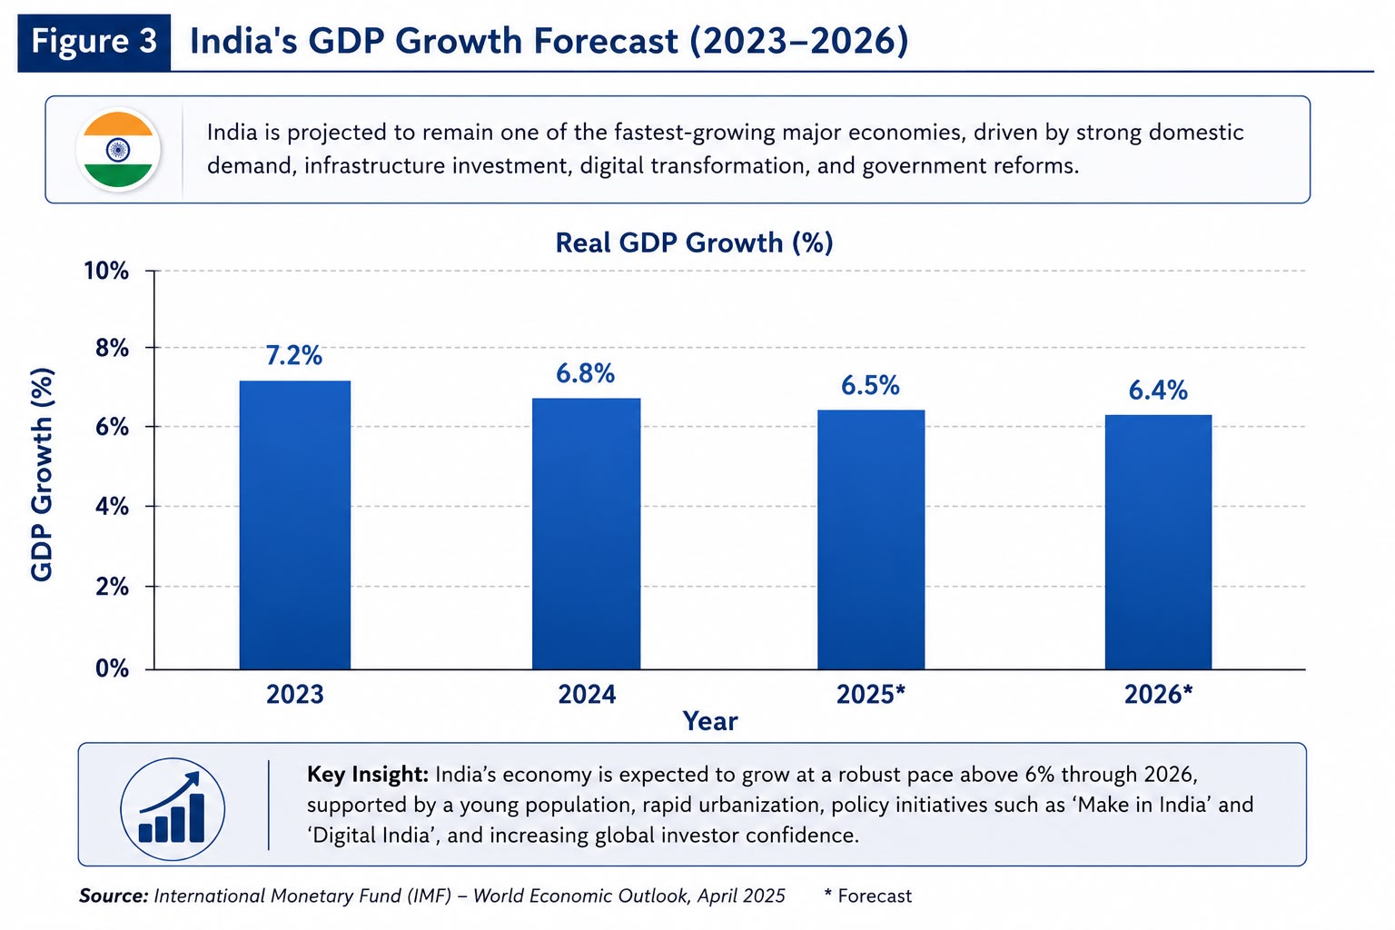
Business may still be hampered by bureaucracy and policy uncertainties. The challenges are moderate tariffs on imported goods and bureaucratic obstacles. All the same, India has become more receptive to.
Watan Expected estimates for 2026 at approx. 6.4%. The nation's GDP (Purchasing Power Parity) is worth several trillion dollars.
creating an enticing market due to its size. Most importantly, India has a large population (1.4+ billion). Regardless of
In India, a huge number of middle class households are rising, through poverty is not yet as potent.
disposable income Per capita, income levels are far below those in Germany, though.
Highly sensitive to price. Fluctuating inflation can impact purchasing power, as some prices are politically sensitive. The Adidas costs and the Indian rupee’s fluctuations against the euro.
prosperity.
India’s demographic profile is far removed from that of Germany’s. India’s populations is too high. With an average age of about 29, around 65% are below the age of 35. This is youthful. A demographic implies the market consists of more young adults and teens. There is also a sporting culture. Awareness increases. Urbanization is on the increase (roughly 35 percent urban now versus 30 percent a decade ago).
affect consumer behavior to a degree. India has a collectivist society overall (as we will see in our Hofstede analysis), which means that community and family opinions influence purchasing decisions. Inspiring. It is the second-largest online market in the world. Around 60% of people use the Internet. Indian youth are engaging the social media like never before YouTube, Instagram, Twitter, and indigenous apps like ShareChat. Online shopping is scaling up.
In 2025, according to an estimate, 280 million to 300 million shoppers in India shopped online. This was a significant increase from approximately 200 million shoppers in 2022. Few years back. According to Bain & Co’s projections, India’s e-retail market will touch $170 billion.
$190 billion by 2030. The technologically advanced landscape generates excellent opportunities that benefit Adidas.
Promotion Over the Internet.
India is facing environmental issues due to rapid growth; pollution is rising rapidly in cities (air quality in Delhi, Kolkata, and Mumbai-Curie is poor) and resource issues are getting worse (water scarcity in states like Rajasthan, and Karnataka). Nonetheless, authorities and.
Sustainability is becoming popular among consumers. There are regulations on plastics and waste.
Restrictions have become stricter(ban on single use plastic in many region). Consumer behavior and supply chains are impacted by severe weather such as monsoon rains and high heat. For Adidas, the adaptation to climate is relevant.
India. Recent reforms of labor laws into new coding the rules, don’t, therefore, simple.
Work In Progress. Advertising is less regulated than in Europe, but there are rules.
Rules (no claiming anything about health benefits). Drafts of recent data protection acts are similar to GDPR For Adidas, compliance refers to tax-related conformity such as the GST system.
charges of import and changing rules.
To sum up, India's PESTEL profile is a combination of opportunities (huge population, economic growth,. digitalization) and challenges (low per-capita income, regulatory complexity, infrastructure gaps).
Adidas needs to deal with these by customizing their marketing mix (especially price and place) the state’s digital take-up.

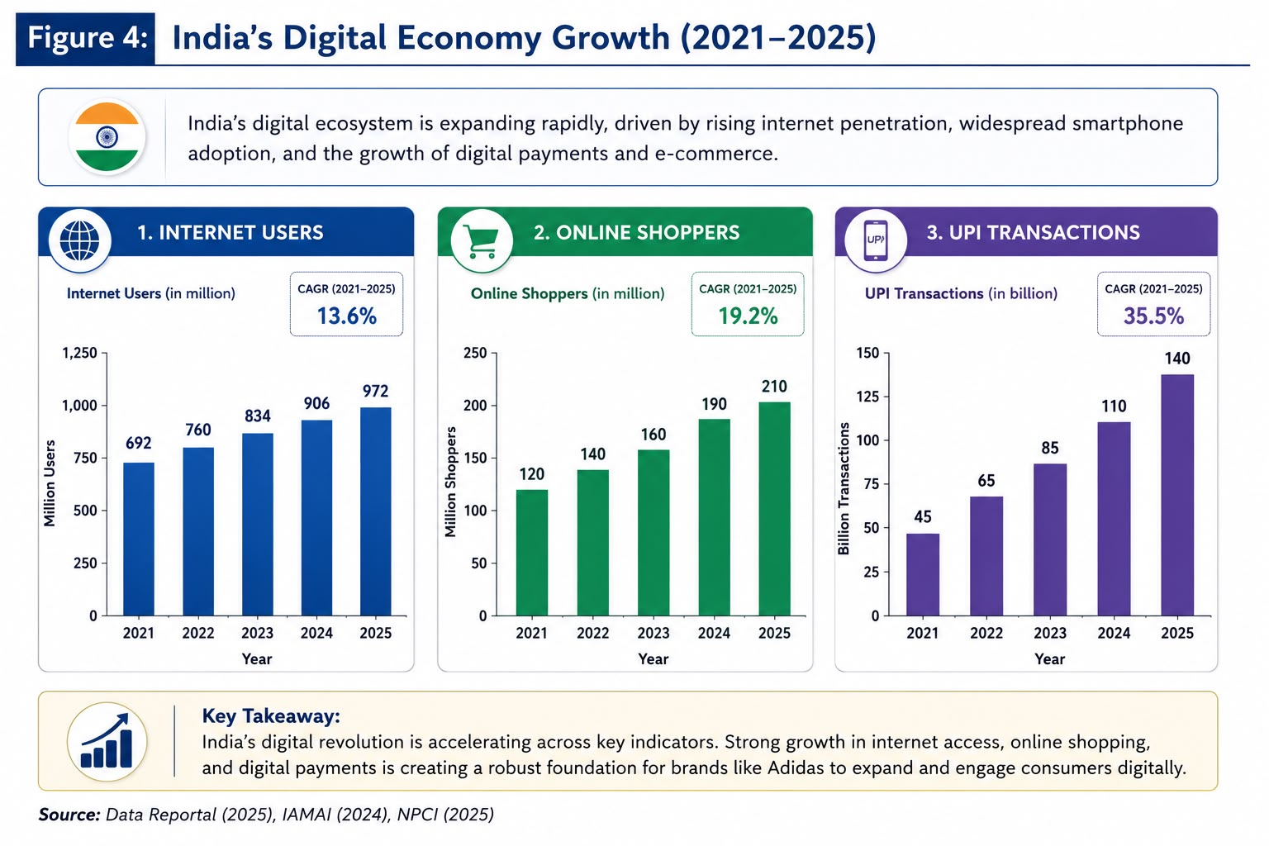

2.2 Hofstede Cultural Analysis

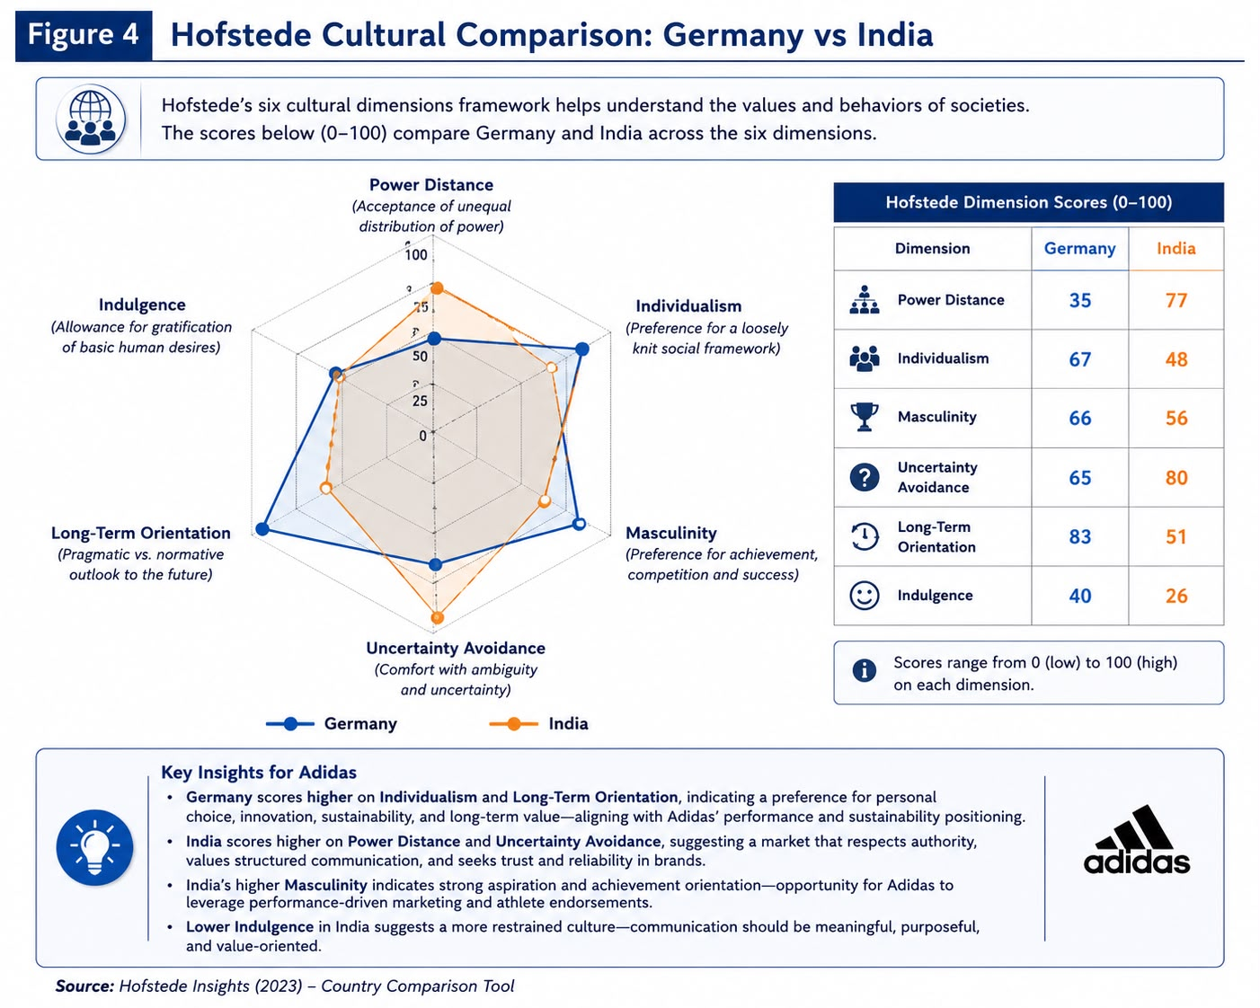
Comparing cultural dimensions can help explain differences in consumer behaviour. Based on Hofstede's research.
Germany scores 35 on Power Distance and 67 on Individualism. India goal.
Scored 77 on Power Distance and 48 on Individualism. Low power distance Germany
Germans prefer equality and informality; social hierarchies not highly accepted. 12 words Highs of India.
Power Distance refers to the respect for hierarchical relationships. Adidas marketing plan.
This means that in Germany ads could be uncomplicated and egalitarian.
Messages that communicate status (e.g. endorsements by revered stars, premium positioning) can be effective.
A high score on individualism (67) in Germany means people see themselves as.
Self-governing. Marketing can be effective by appealing to choice and personal achievement. India scored (48) indicates a
Family and community opinion matters in collectivist culture. Therefore, Indian marketing frequently.
Emphasizes group success and pride (for example, celebrating national or sports victory together).
Campaigns in Germany may highlight individual performance targets.
Germany scores 65 on Uncertainty Avoidance whereas India scores 40. Germans
Like structure, clear rules, and minimal objective risk. The consumers take time to read product information and.
assurance Germany’s Adidas must feature prominent quality assurance/technical specification copy.
Indians may be comparatively more tolerant of uncertainty, and may try new products without.
a trusted brand will most likely have minimal vetting. UAI of India tells to exercise caution.
However, overall there is more ability to innovate.
Regarding Masculinity (degree of competitiveness), both countries are quite high (Germany 66, India 56). It means both highly value ambition, accomplishment and success.

3. Comparative Analysis of STP
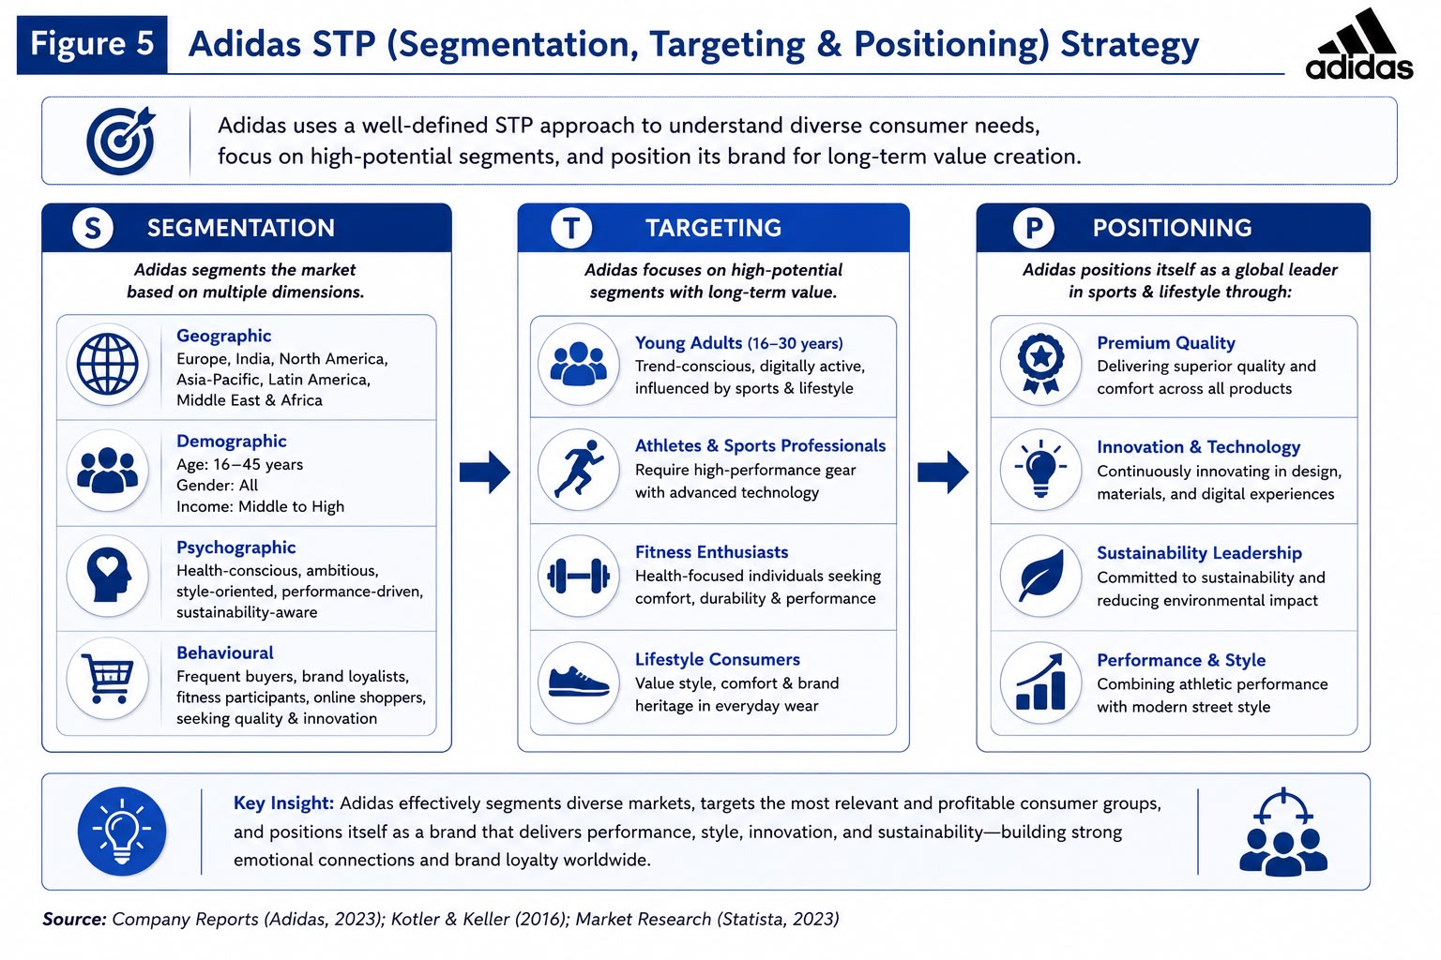

3.1 Segmentation

Adidas segments both markets by demographic, psychographic, and behavioral bases. In Germany, the company clearly distinguishes by age and lifestyle. Key segments include:
Competitive Athletes: Serious runners, cyclists, and football players who demand high-performance footwear and apparel. These consumers often belong to organized clubs and value technical features.
Lifestyle Youth: Teenagers and young adults (often 15–30) who follow trends. They gravitate to Adidas Originals and fashion collaborations (e.g. with celebrities or designers). They buy sneakers and casual gear primarily for style.
In India, segmentation must account for greater diversity:
Urban Youth (15–35): This includes college students and young professionals in metros, who are digitally connected and brand-aware. They have some disposable income and seek global trends in fashion and sports. Within this group, a subset is highly influenced by Bollywood and cricket stars, buying branded sneakers and jerseys.
Sports Fans: A segment of all ages passionate about sports (especially cricket, but also football and Olympic sports). These consumers buy official team T-shirts and shoes. Adidas’s cricket team sponsorship suggests this as a target market.
Regional/Cultural Segments: While India is a market for sports goods, regional festivals and languages can create micro-segments.
Gender: Historically male-dominated, but female sportswear is a growing segment in India as more women take up fitness activities.
Overall, segmentation in India is more granular due to socio-economic diversity. Adidas often uses sub-branding and tiered product lines to address these segments (e.g. Adidas Neo for budget youth, performance line for athletes).

3.2 Targeting

In Germany, Adidas goes after middle-to-high income consumers who value quality and performance. The main target group includes active sports people of any age: be it a footballer of the teenager or the middle-aged jogger. Adidas’s marketing in Germany is engineered magic which connects with technical-minded consumers. This market segment includes style-conscious youth and urban consumers who adopt Adidas as a fashion statement which is served by marketing Originals and designer collaborations. Targets for specific genders include women looking for comfortable and attractive sports clothes – such as women’s running and training campaigns and product ranges.
Adidas has focused more on mass market penetration in India. One prominent strategy involved the targeting of cricket fans. Adidas’ sponsorship of the national cricket team must have definitely aimed at millions of Indians who are crazy about cricket. This target primarily urban and semi-urban males of 15-45 years old, merchandising also targets younger fans, (boys and girls playing cricket). The tiered pricing with respect to jersey price makes it affordable to a wide range of income in the segment.
Adidas also targets the urban Millennials of India influenced by global sports culture. Delhi, Mumbai, Bangalore are the cities, where they are being tried out. Since Generation Z is tech-savvy and active on social media.

3.3 Positioning

Adidas is a premium sports and lifestyle brand but with local flavourations. The brand's positioning in Germany emphasizes its innovative performance heritage. It frequently highlights its origin story of Adolf Dassler’s goal – to create the best for athletes and its German engineering credibility. Ads proudly showcase particulars of the technical cushioning system (like BOOST technology) or moisture-wicking material used.
Germany Adidas has invested in sponsoring Bundesliga and the national teams. For example. In 2026 it became the Bundesliga's “Official Future Partner” with a €100 million funding deal, showing how much the brand is tied to Germany’s No. 1 sport. German advertising often has ads with professional athletes pushing their limits in the Autobahn and Black Forest running trails. The positioning is aligned with German cultural values, such as efficiency and quality.
In India, Adidas is being presented as aspirational and young. The brand promises global excellence in sport, but offers it locally. For instance, marketing campaigns may combine international heroes with local superstars (for instance, ads that showcase Lionel Messi playing cricket with young Indians). Often referring to India, the tagline conveys glamour and modernity, as in ‘Adidas is for the heroes of sport’ .
According to it, the Indian “underdog athlete” can accomplish great things with its help. Campaigns highlight the thrill of sports as well as nationalism. The brand also utilizes bollywood connect: it runs commercials in which film stars are seen exercising or endorsing the sport or sport-products.
To sum up, in Germany Adidas is positioned on performance and engineering (“the best for serious athletes”), whereas in India it is positioned as an aspirational lifestyle brand linked to cultural passions (especially cricket) and youthful vitality.

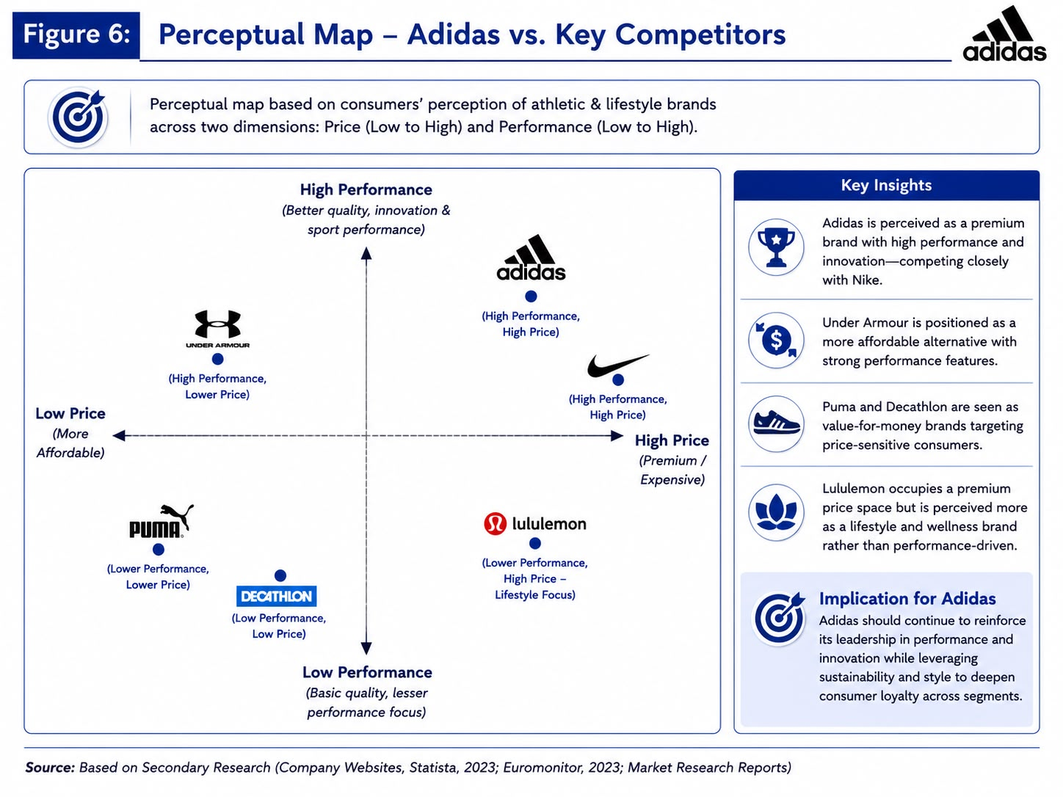

4. Comparative Analysis of International Marketing Mix

Product: In Germany, Adidas covers all areas of its product range. This entails high performance equipment. Consumers in Germany expect the latest technology: for example, Adidas often launches its latest shoe innovations BOOST and FUTURECRAFT there first. The brand’s commitment to sustainability goes beyond manufacturing but also extends to its products. The presence of premium and limited edition items, such as fashion sneakers, in stores is quite common these days.
The range of products is partly adapted in India. Almost all international products are manufactured by Adidas India for domestic use; such as running shoes, training kits, and football boots. It notably sells cricket apparel (jerseys, shirts) including team india kit and even some local co-branded equipment. Footwear made for football and running are available in the market but have colour/style modifications according to Indian youth preference. Wearable designs can feature Indian tricolor or festival themes. Adidas’ sizing is an international standard; moreover, style popular with German consumers is made available to Indians as well.
Price: Pricing Strategy varies across markets. In Germany, Adidas is a pricey brand. Products are sold at a higher rate than actual cost due to branding. For example, a high-end running shoe may retail for €150–200 while a soccer jersey will cost over €90. Promotions in Germany follow a typical retail calendar (winter/summer sales) although the Adidas brand deliberately refrains from deep discounting outside of clear-out periods so as to the prestigious nature of the brand. Germans expect quality; Adidas stands behind its prices and product quality through technology and durability.
In India, Adidas employs a relatively flexible pricing strategy. The latest tech shoes, flagship products still priced at a premium (e.g. ₹9,000–12,000 for high-end shoes). Also, roughly comparable to €120–160. Adidas does have mid-tier and budget offers too. For example, according to reports, Adidas has introduced a three-tier pricing for cricket jerseys, with a top premium version for ₹4,999, fan version for ₹999 and an intermediary for ₹2,499. The tiered system enables the brand to reach a wider income level. You should look for sales or discounts around Diwali or other festivals. As Indian consumers are price-sensitive, Adidas closely compares its prices with competition like Puma, Nike and domestic brands. Consequently, Adidas India includes a greater range of price segmentation and local promotions than Germany to accommodate different income levels within the nation.

Place: Distribution channels of Adidas show market maturity In Germany, the brand has a broad range of retail outlets: major cities have Adidas flagship and concept stores; other cities have multi-brand sports retailers (e.g. SportScheck, Karstadt Sport) and shop-in-shops. Adidas items can be found at department and shoe outlets. Also, the German e-commerce site of Adidas serves the whole country, and it is sold via major online retailers (Amazon, Zalando). Distribution is growing rapidly in India. Adidas India maintains more than 300 exclusive brand outlets situated in Tier-1 and Tier-2 cities like Delhi, Mumbai, and Bangalore among others. It has many more shop-in-shops in multi-brand retailers and malls. Franchises were historically important but today many outlets are company-owned. Adidas sells through its Indian website and is among the top sellers on Indian e-commerce platforms Amazon India, Myntra, Flipkart.
Promotion: Promotion tactics are adapted to suit local consumer media and culture. Adidas's advertising emphasizes sport performance and innovation. Sponsorships are key Adidas is the official sponsor of the national teams of Germany; Adidas also provides the match ball of the Bundesliga. Sports events like the World Cup and Olympics coincide with advertising.
Promotion in India is highly mass-market and star-driven. Attention is paid to cricket: Adidas’s sponsorship of the Indian cricket jersey gets much coverage on TV, internet and print. Commercials on TV often display Bollywood or sports stars (like a famous film star running with youngsters). To connect with more people, Adidas runs celebrity endorsement deals with cricketers and athletes and sometimes Bollywood celebrities known for fitness. The Bollywood-style creativity used in digital and social campaigns ensures that they grab attention. During IPL matches, contests with prizes (signed jerseys) is organized inside the mall. Promotional timing is in accordance with Indian festivals (eg Diwali discounts). Marketing campaigns on YouTube and Instagram influencer are strong among youth. The messaging in India often appeal to emotion and aspiration (e.g. “Winning spirit”), vis a vis technical messaging in Germany.

People:
This element examines the human side of the enterprise: staff, customer service, brand representatives, and labor ethics.
Germany:
Adidas must navigate strong labor laws, national minimum wages, and influential works councils, meaning operations and owned stores adhere to strict employee rights and standards.
India:
Ensuring ethical labor practices for retail staff, service providers, and local factory workers is a critical focus, given historic labor rights issues in the region's garment industry.
Process:
Process refers to the systems, logistics, and technological pathways that deliver the Adidas experience to the consumer.
Germany:
Supported by Germany’s position at the forefront of Industry 4.0, Adidas leverages advanced manufacturing technology and inventory management logistics.
Data processing is strictly governed by European GDPR laws, requiring highly secure, compliant marketing and customer data handling.
India:
A massive shift in transaction processes has occurred through India's Unified Payments Interface (UPI), which Adidas integrates to facilitate the billions of mobile transactions happening monthly.
Supply chain processes are heavily influenced by government regulations; to own 100% of single-brand retail, Adidas must process 30% of its procurement locally.

Physical Evidence:
This involves the tangible cues that help consumers evaluate the brand, including store aesthetics, packaging, and digital interfaces.
Germany:
The physical retail environment includes high-end concept and flagship stores that visually represent precision, heritage, and modern German engineering.
Packaging and product materials serve as physical evidence of sustainability claims, utilizing clear environmental labeling, recycled materials, and reduced plastics to satisfy demanding NGOs and regulators.
India:
Visual merchandising relies heavily on vibrant, interactive cues, such as large mall displays during major sporting events (like IPL matches) and festival-themed visual elements (e.g., Diwali).
The digital physical evidence (app and website UI) is tailored for a youthful, smartphone-reliant demographic, often integrating localized vernacular languages (like Hindi) and Bollywood-style creativity to build brand aspiration.
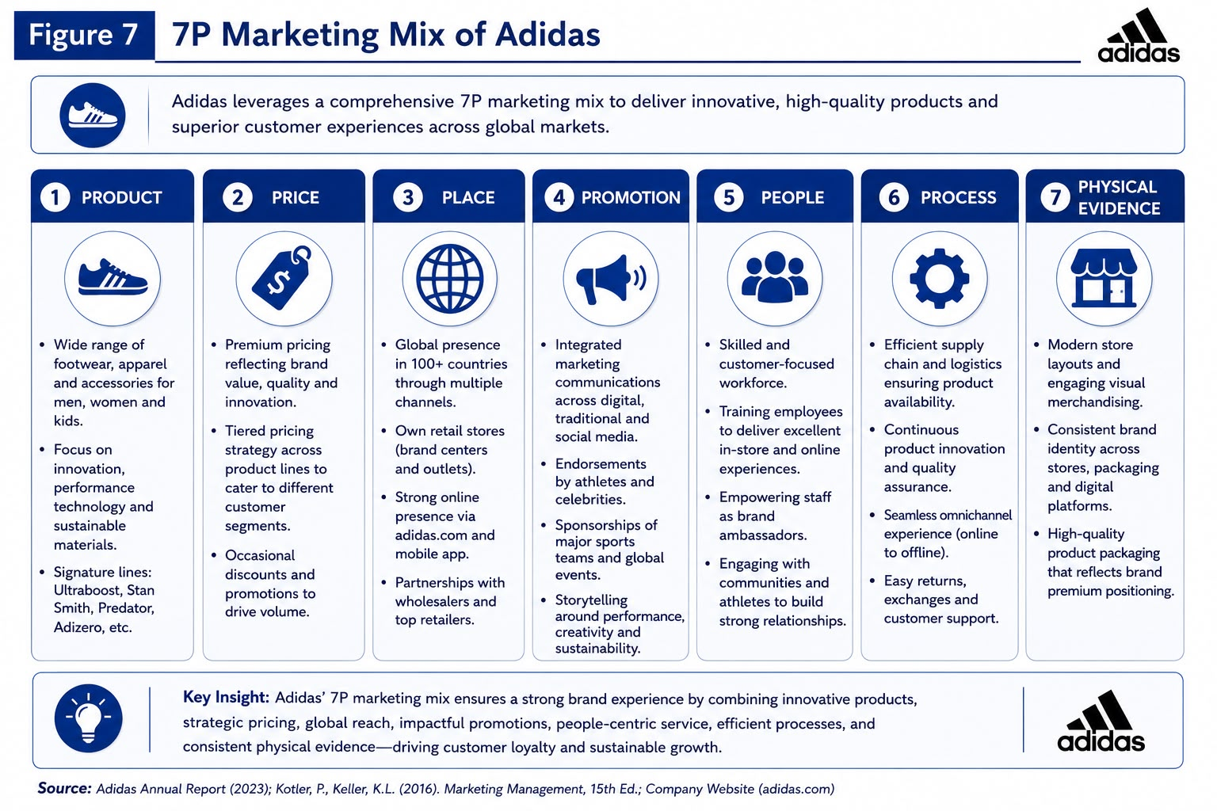

5. Market Entry Strategy

Adidas entered India in a phased manner, keeping regulation in mind. Adidas start was franchising and joint ventures: Adidas partnered with local companies to open Adidas stores under license. (1980s-1990s) This was in line with India’s then-stringent foreign ownership rules. During the early 2000s, when India liberalized FDI in retail, Adidas formed a wholly-owned subsidiary (Adidas India Pvt Ltd) to take direct control of its business. In the 2010s By allowing 100 per cent FDI in single-brand retail (provided local sourcing is ensured), Adidas could wholly own and grow its own retail network.
A significant factor was complying with the local sourcing rule: to enable 30% local procurement, Adidas invested in local manufacturing and sourcing, working with Indian and nearby factories to make shoes and clothing. For example, Adidas amplified manufacturing operations in India and surrounding countries. On distribution, Adidas partnered with mall developers and franchisees in Tier-2 cities for their existing retail infrastructure. To penetrate the Indian market, a chief partnership like sponsoring the cricket jersey in 2020 was signed, which benefitted the brand and gave an instant fillip.
The franchise, full direct investment, and local partnerships were combined as the market entry strategy. Adidas was able to evade restrictions at first and then gain full ownership rights. The strategy was to create flagship stores in urban areas to build brand presence, while also using multi-brand and online channels. Adidas used to enjoy global brand equity. Also, this meant that its recognition during its entry in India was instant. Most importantly, sustained success involved required adapting to the complexities of India’s retail environment through joint ventures and alliances.

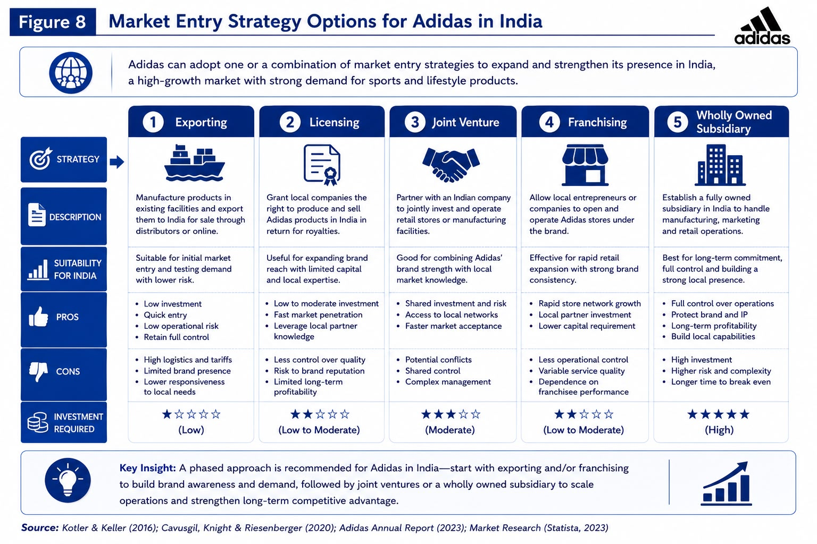

6. Ethical Issues

Supply Chain Labor: The bulk of adidas products are made in Asia – for instance, 92% of its total production volume was in Asia in 2024. It is important to have ethical factories around the globe. Watchdog organizations such as the Clean Clothes Campaign have called out many brands, including Adidas, for failing to ensure living wages and freedom of association in supplier factories. Adidas has a Supplier Code of Conduct and audits factories, but such criticism points to the need for better transparency and enforcement. Adidas must ensure that in India, its retail staff and local service providers are paid a fair wage and given good working conditions, as India has had issues of labour rights in garment factories.

Environmental Sustainability: Most sustainable brands artificially inflate the level of credibility of their claims to garner customer trust. According to a ruling in 2018 by a French advertisement authority, Adidas 50% recycled material was advertising falsely. Take care not to exaggerate eco-credentials. Consumers in Germany and the authorities are quite sensitive. Accordingly, the brand must back its sustainability claims with numbers (for example, clearly stating the percentages of the materials being recycled and under what conditions). In India, consumer knowledge has grown but they still give more priority to cost. India's environment regulations are emerging (i.e. restrictions on single use plastic) as well, so it would complement the ethical stance of Adidas to show compliance (i.e. reduce plastic in packaging).

Marketing Ethics: Adidas must be aware marketing. When it signs high-profile deals (like its Rs 350-crore sponsorship of the Indian cricket team), it faces scrutiny. Such transactions should be above-board and executed with transparency and fairness by Adidas. We should not exaggerate benefits in advertising. In Germany and India, no misleading practices allowed (e.g. apparel health claims). Ethical marketing also means to avoid the unethical targeting of consumers. For example, an Adidas ad directed at children in a sporting context must remain within the law. It is ethical behavior to be culturally sensitive – ads should respect local norms (for example, not misusing religious symbols).

Corporate Ethics: Adidas also needs to maintain corporate governance ethics. This includes executive conduct, anti-corruption, and data privacy. In Europe, strict GDPR rules apply to customer data; Adidas must protect German customers’ information. In India, new data protection laws are emerging, so ethical handling of consumer data is important.

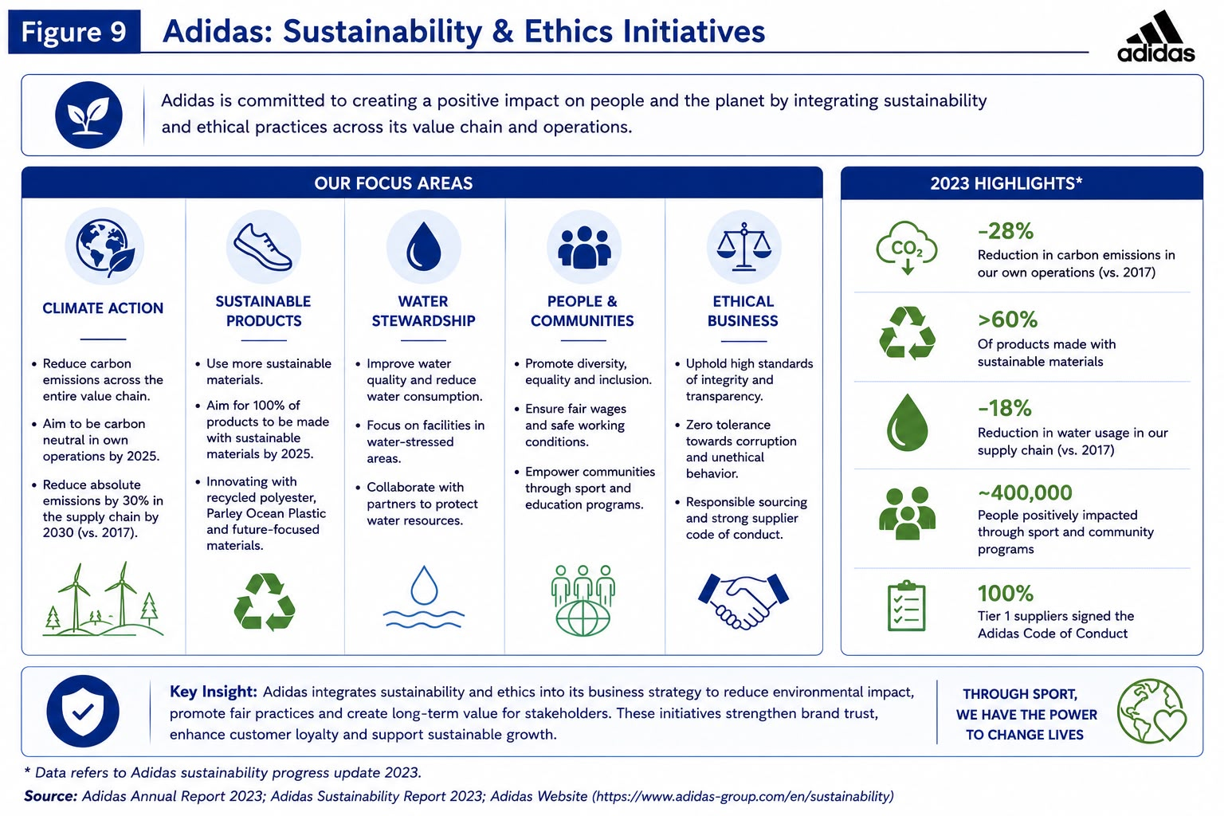

8. Conclusion

Adidas operates in two different environments, Germany and India, and its marketing strategies must reflect that. The German Market Are Mature And Demanding. Consumers Have High Standards Of Premium Quality, Technological Advisory And Genuine Corporate Responsibility. Brand growing and differentiation are more important than extension in slow economic growth. Adidas’s heritage and technical product lines are a good fit in Germany, but the brand has to continually innovate and maintain very high environmental and labour standards to satisfy German consumers.
Unlike India's market characterized by high growth potential, youthfulness, and diversity. Although average earnings are lower, the population and rising middle class present huge volume opportunities. Sports are an integral part of Indian culture (especially cricket) and fashion trends are aspirational. Therefore, Adidas’s strategy in India must focus on mass appeal and local relevance, as seen in its localized offerings like cricket gear and Bollywood-esque advertising. India's current technological boom and urbanization means that e-commerce goes hand-in-hand with Adidas' strategy for the country.
Our assessments show that Adidas has a fine global image and big resources which provide a strong base but actual success will depend on execution in each place. The German consumer thinks precision of product, personal success and environmental protection, while Indian consumers prefer aspirational, community messaging and price point. Adidas tackles this by tweaking its segmentation, product, pricing and promotion strategy in a stark way. For instance, the German consumer is a wealthy athlete while the Indian one is a flashy youth.

Section 2: Reflective Report

9. Introduction:

This section will reflect on what I have learned and experienced while conducting research and writing the international marketing of Adidas. The Gibbs’ Reflective Cycle organises my reflection into six different sections namely Description (what happened), Feelings (my response to it), Evaluation (what was good or bad), Analysis (what else is going on), Conclusion (what could I have done). Action Plan (if it happened again what would I do). Through critical reflection, I can improve my performance in the future.

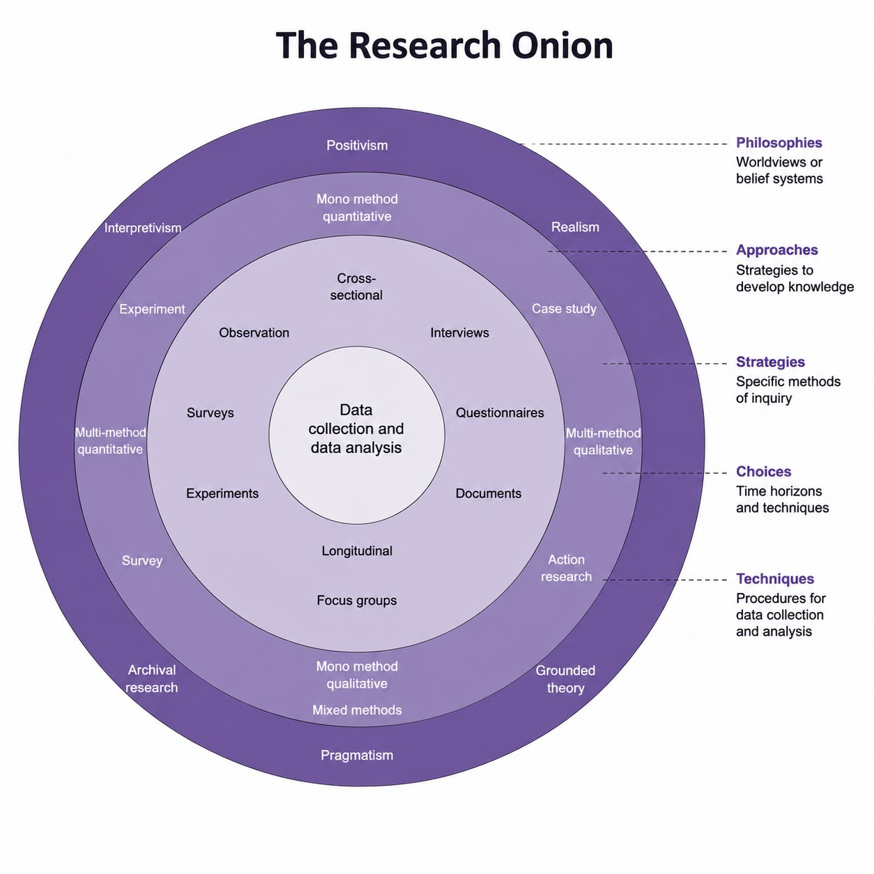
10. Description: To produce Section 1, I first gathered data on Adidas and both markets. I started with Adidas's own materials. I downloaded its annual and quarterly reports and press releases from the official Adidas Group website (Adidas AG, 2025a). These provided up-to-date figures for sales, profits and regional breakdowns. Next, I researched macro-environmental data. I used credible sources such as the European Commission report on Germany's economy (European Commission, 2025) and the International Monetary Fund (IMF) database for India's economic growth projections (IMF, 2025). I also used Hofstede Insights to compare Germany and India across cultural dimensions (Hofstede Insights, 2025). For India's market trends, I used reports from IBEF (IBEF, 2025) and IMARC Group (IMARC Group, 2025). . With the data collected, I organised it by framework. For PESTEL, I listed the political, economic, social, technological, environmental and legal factors for Germany and India. I compared them side by side. For Hofstede, I summarised each cultural dimension and considered its marketing implications. For STP, I identified segments and target markets in each country using demographic and psychographic variables. The marketing mix elements were then tabulated by country, for example by comparing distribution channels in Germany and India.

11. Feelings: To begin with, I was both excited and a bit nervous. I was very excited to analyse a real company that I am interested in but 5000 words seemed like quite a lot. I was worried whether I would be able to find enough credible information and actually manage the word count. When I started the research, I felt satisfaction when I found high-quality data (e.g. confirming the revenue figures of Adidas in the official report). It was the data which made me trust the analysis.
Frustration caused difficulties at times. I had to comb through thick financial reports, government forecasts and others. I was alarmed of missing anything and constantly making sure to align. I often felt pressured to ensure that I had an accurate source for every claim, which slowed down drafting.
In the course of writing there were times where I felt “in the zone” – for example, in the synthesis of Hofstede’s cultural categories and marketing examples I felt focused and engaged. On the flip side, I became tense each time I formatted the same citations, getting page numbers and wording right.

12. Evaluation: Outcomes of the performance were primarily positive. To obtain accurate data, I checked official reports, reputable news sites, for context, and academic frameworks (Hofstede scores). The variety ensures credibility of the content. The report was organized using the given headings to cover the required topics. The analysis was extensive – we looked at macroenvironment, culture, STP, marketing mix and entry, ethics with concrete recommendations. The chart for sales from 2023 and 2026 gave a sense of clarity.
My writing was generally clear and formal. I was able to connect theories to examples. The Hofstede dimension of Power Distance makes an excellent point regarding Adidas’ celebrity endorsements in India. Citing net sales and growth figures gave weight to trends. I integrated data effectively.
On the downside, I struggled with time management. I may have focused too much on minor PESTEL details and not enough on polish. Several paragraphs were lengthy; while I provided detailed evaluations, the addition of concise sentences could add clarity. Depending on the analysis, my tone can be dry. I could make it more humanized by infusing it with narrative flow or varied sentence structures instead of bulleting. Although I included so much citations, I should make sure that they are incorporated well also.
With more time, I would refine sentences for better rhythm, avoiding repetition and improving transitions. For instance, making links between sections clearer (e.g. “Adidas’s positioning shifts because of these PESTEL factors…”). I would also check for any further gaps (perhaps consumer data containing market share?). However, I would not overcomplicate the gap analysis. All in all, I think I met the required specifications of the report but they could be more tightly phrased.

Analysis: I learned to incorporate various frameworks with factual information through this experience. Collecting and interpreting cross-country data (global economic forecasts, cultural dimensions, market reports) through various marketing lenses enhanced my understanding. For instance, when it was written down, the conceptual link between Germany’s strong Uncertainty Avoidance and the requirement for product guarantees made sense. The presence of hard figures, such as Germany’s aging population or India’s young median age,adds to our analysis, beyond theory.
I realized that my research method was to go topic by topic (e.g. get all PESTEL info, then get all STP info). This was helpful for organization, but I occasionally repeated myself (for instance, mentioning environmental factors in PESTEL and ethics). In the future, a better approach (drafting then researching) could improve channels between sections. Nonetheless, utilizing outlines proved helpful to ensure none of the required parts was missed.

13. Action Plan:
To improve my future works, I will 1. Prepare a Detailed Outline: Before we start writing, I will prepare an expanded outline that lists every point and sub-point I need to write in each section. It will allow for better coverage and help organizing from the start. 2. I will break the project into phases (e.g. research done by day 3, draft by day 5, revisions by day 7). My planner or digital reminders will keep me on schedule and give me enough time to edit. 3. I will focus on making sentences more engaging and avoid monotony in writing them. On the one hand, I might read well-written business reports or articles for style, while at the same time editing my drafts to remove jargon or simplifying complex sentences. 4. Peer Review: I will swap drafts with classmates or mentors to get feedback on the logic, flow and clarity. Sometimes I overlook errors, but other close one catches them for me. 5. I’ll use Gibbs’ reflective model or journaling after each significant assignment and not wait until the end. Frequent reconsideration will assist me in adjusting tactics.

14. References
• adidas AG (2026) adidas reports record revenues for 2025. [Press release] Available at: https://www.adidas-group.com/en/media/news-archive/pressreleases (Accessed July 2026)
• adidas Group (2025) Annual Report 2024: Group Management Report. Available at: https://report.adidas-group.com/2024 (Accessed July 2026).
• Sher, D. (2026) Adidas: Pushing Sports Performance Further with Ground-Breaking Technology. Investing.com, 28 April 2026. Available at: https://www.investing.com (Accessed July 2026).
• Choudhury, A.R. (2024) How Adidas earned its stripes in India. Economic Times – Brand Equity, 4 June 2024. Available at: https://economictimes.indiatimes.com/brand-equity (Accessed July 2026).
• ClearlyCultural (no date) Hofstede’s Cultural Dimensions: Germany & India. Available at: http://clearlycultural.com/geert-hofstede-cultural-dimensions (Accessed July 2026).
• European Commission (2026) Economic forecast: Germany (Spring 2026). Available at: https://ec.europa.eu/info/business-economy-euro (Accessed July 2026).
• International Monetary Fund (2026) World Economic Outlook Database – April 2026 (Country: India). Available at: https://www.imf.org/external/datamapper (Accessed July 2026).
• India Brand Equity Foundation (2025) India’s E-Commerce Boom: Trends & Future Prospects. (Updated 2025) Available at: https://www.ibef.org/research (Accessed July 2026).
• Market Growth Reports (2024) Sportswear Market Size & Trends (to 2035). Available at: https://www.marketresearch.com (Accessed July 2026).
• Good On You (2024) How ethical is Adidas?. Good On You Magazine. Available at: https://goodonyou.eco/adidas-ethical (Accessed July 2026).
• Bundesliga (2026) Bundesliga and adidas to enter strategic cooperation as “Official Future Partner”. 18 March 2026. Available at: https://www.bundesliga.com (Accessed July 2026).
• adidas Group (2024) Annual Report 2024: Sourcing & Supply Chain. Available at: https://report.adidas-group.com/2024/annual/sourcing (Accessed July 2026).
• IMARC Group (2023) India Sportswear Market – Size & Forecast (2025-2034). Published July 2023. Available at: https://www.imarcgroup.com/india-sportswear-market (Accessed July 2026).
• Bain & Company (2024) How India Shops Online: 2025. Available at: https://www.bain.com/insights (Accessed July 2026).
• Ken Research (2024) India Sports Apparel Market Outlook to 2030. Published Dec 2024. Available at: https://www.kenresearch.com/industry-reports (Accessed July 2026).

