Student Number – 2200310

Title: A written assignment critically evaluating how Assessment for Learning can be utilised in a series of learning opportunities to aid progression across chosen areas of learning and experience.

One of the twelve Pedagogical Principles laid out by the Welsh Curriculum is Assessment For Learning (AFL). AFL generates feedback that is subsequently utilised to raise student performance within the classroom (Cambridge Assessment International Education, 2023). Assessment For Learning can be split into four elements, these are as follows; Sharing Criteria with Learners, Quality of questions/quality of talk, Use and quality of feedback, and Peer and Self assessment. Assessment For Learning is important to education as it allows for not only teachers to modify their own methods for a more effective practice but also encourages students to become actively involved in their own education (Johnson, 2023). This aligns with the twelve Pedagogical Principles of the Welsh Curriculum, particularly learner involvement, since Assessment For Learning gives students the chance to guide their own learning as they progress (2022). Although Assessment For Learning is important within education it can also be hard to achieve. Due to the teacher to pupil ratio, it can be challenging to know and gauge every pupils level of learning at all times (Gershon, 2013, p.205). Therefore, throughout this assignment I will be combining research, professional opinion, real life learning contexts and personal knowledge to evaluate how Assessment for Learning (AFL) can be used to influence progression effectively or non-effectively across different Areas of learning and experience (ALOES).
Firstly, who will I be evaluating? Whom are my lessons intended to? The lesson plans are intended for Key stage two year five and six mixed classed, the pupils within this class age between nine and ten years old. There are 26 pupils in total, 15 year fives and 11 year sixes, consisting of a mixed ability grouping (High progression step 2 and progression step 3), which means different abilities i.e. students with additional learning needs (ALN) and More, able and talented (MAT) pupils are taught as one in the same classroom setting (Collins, 2024). The additional learning needs that need key focus on within this classroom are; attention-deficit/hyperactivity disorder (ADHD), language barriers, dyspraxia, dysgraphia and dyslexia. In order for all ALN students to progress further in each ALOE, I must plan for extra support and guidance to facilitate every need. While it is crucial to facilitate for each need within the classroom, MAT pupils as they equally require assistance and direction in order to progress. The class is based in a Catholic School meaning Humanities (Religion RVE) takes up a high percentage of the school’s Curriculum. Pupils entered year five and six in September 2023, with these lessons being presented in December, 2023. Through Pupil Voice it was decided that the term topic for the end of the year would be Traditions i.e. the different Country traditions, Religious traditions and celebrated Festival Traditions, with the end goal being Christmas Traditions.
The first Area of Learning and Experience I will be evaluating is Humanities encompassing the History and Religion aspect to this element (Appendix 1). Humanities allows curious minds to develop a greater comprehension behind concepts (Welsh Government, 2022). Therefore, combining previous learning with this ALOE allowed for pupils to understand the greater meaning behind Christmas Traditions. The second Area of Learning and Experience I have chosen is Maths and Numeracy (Appendix 2). Long division is the focus of this lesson, pupils have previously been learning about short division and long division and now long division through worded problems. Within this ALOE I want pupils to take their focus from maths and into the numeracy side i.e. worded problems. Finally, the last Area of Learning I want to evaluate is Language, Literacy and Communication (LCC) (Appendix 3). Previous learning has taken place to understand the key aspects to literature i.e. Adjectives. In particular, poem writing and the ability to expand sentences. Literature has the capability to encourage and influence pupils alongside build on communication and linguistics (Welsh Government, 2022). Therefore, I believe this area of Learning and Experience with a AFL strategy can progress the pupils further in creativity and achieve a sophisticated level of communication in day to day life. Ultimately, the foundations that the Welsh curriculum is built on is Child Progression, it is so important to ensure when planning for these ALOES that each pupil is treated as an individual and at the speed needed to achieve personal progress (2023). Within this assignment, I want to evaluate if Assessment for Learning can be used in a number of learning opportunities to aid progress for each student in the chosen Areas of Learning and Experiences.

Assessment for Learning (AFL) really came to light through two UK professors, Dylan William and Paul Black. William and Black developed their argument for AFL through research, which was then supported by a number of projects. For example, they took twenty five maths teachers, and 246 students. The project was over the course of twenty weeks and involved an experimental group and a controlled group, both teaching the same subjects and we’re both given a test before the test and a test after. The experimental group was participating in AFL, particularly the self assessment element, with pupils doubling the mean average of the controlled group (Black et al., 2003, p.12). The research and results by William and Black kickstarted the push for AFL in modern day classrooms, however, literature states that Black and William saw room for improvement (Black, P., William, D., 2010, p.83) this is something I want to build on throughout this assignment. Background behind AFL would introduce the two types of assessment, Summative and Formative. Literature describes summative assessment as a procedure where a result is achieved using a criteria/standards (Bacquet, 2020, p.29) i.e. a midpoint exam. Whereas formative assessment is far more of a casual approach in comparison to summative assessment (Bacquet, 2020, p.30) i.e. a class discussion. As previously discussed , AFL can be split up into the four elements; Sharing criteria with learners, Quality of questions/quality of talk, Use and quality of feedback and Peer and Self assessment. These are all strategies to assess where pupils are in learning and how teaching can assist further progress.
To delve in deeper, by providing learners with the resources they need to succeed, teachers who share the criteria with their pupils are giving them the best opportunity to progress in their learning. Royce Sadler an Australian educationalist supports this view as he stated “we need to let students into the secret” in order for pupils to become insiders to their own learning and to understand the context behind this learning (Sadler, 1998). However, Ralph Waldo Emerson argues against this aspect of AFL due to a success criteria acting as a tick list for pupils disabling them from progressing to their full potential (Emerson, 2015). Allowing pupils into their own assessment can see for a greater level of progression in and amongst all Areas of learning and experience (ALOES) this is outlined within Donaldsons Curriculum point of view on Assessment.
Proceeding forward, a component of assessment for learning is the quality of talk and questions. This can be achieved by having students or teachers ask questions to demonstrate understanding and participate in a discussion in order to aid progression. In line with the Welsh Curriculum, assessment has to be about what matters, it is language that helps us communicate, which is essential for building relationships with others i.e. pupil and teacher. Communication also help us to make sense of the information we have read, heard or seen and deepen our grasp of a subject (2022). Asking questions can assist in bridging the mental divide within a topic agrees Mike Gershon (Gershon, 2013, p.36). On the other hand, while producing a critical review on questioning in education Mikyeong argued that questioning is developed on ‘memorization’ as apposed to the progression of a pupils intelligence (Yang, 2006). Suggesting the information stays in their short term memory and will be displaced in contrast to their long term memory where it is processed and understood by the learner. Asking questions is a simple and effective aid for assessing pupils progress but in order to guarantee that students have the chance to advance, the questions must be relevant and timed accordingly. Similarly, Quality of feedback shares similar attributes to quality of questioning and quality of talk. Student feedback can be extremely effective from a teachers point of view and a pupils, it is a way pupils can feedback their concerns or what is working well for them, both equally important for a teacher to make necessary adjustments in order to aid pupil progression. Christopher Pagan, a Physics teacher, trialed this concept as his pupils were not progressing the way he hoped, he decided to ask the students to feedback their thoughts and ideas and with doing so he was able to alter his teaching approach which aided his students to progress further with the subject (Minero, 2016). Who better to asses learning than the pupils themselves? With this being said, it is important how such feedback is acquired. Speaking out can be scary, especially for young people. Many pupils will not engage with feedback out of fear of being embarrassed to give the wrong response. Students need to understand that this approach is not meant to trick them (Gershon, 2013, p.26).
Finally, Peer and Self assessment, in order for pupils to have the ability to learn throughout their lives, they must be able to evaluate their own development and identify areas that still require learning (Donaldson, 2015). Self and peer assessment allows students to take an active role in their own learning, linking to one of the twelve pedagogical principles laid out by the Welsh Curriculum. Constructivist theorist such as Lev Vygotsky would support this view on assessment as he believes children learn best through social interactions i.e. peer assessment. However, it can be argued that pupils may not be at a high enough intellectual standard to peer or self assess work, it may be an unreliable source of assessment (Biblioteca, n.d.). Combining this assessment method with the success criteria element of AFL can ensure that pupils can mark and assess work correctly inline with the task.
In context with Donaldsons curriculum, aiding students to advance is a core principle in Wales. Progression is the main goal of assessment for learning and is expressed within the statements of what matters and the four main purposes (Welsh Government, 2021). Although, AFL is implemented to reach progress for pupils it can also be used a useful tool for teachers to improve their own learning and create more productive and effective lessons in the future. To support this, Gershon states that as a result of AFL, educators can make lessons based off a response from the pupils focusing on their existing knowledge and producing new content for them to learn and progress. Instead of teaching pupils a random rigid take on the curriculum (Gershon, M, 2013, p.11/12). What I think Gershon means by saying this is that a lot of teachers just teach what they think is right rather than paying attention to the needs of the pupils in order to progress. To move forward with this assignment I have contemplated the literature above and used it as a guide to plan my own lessons involving AFL strategies to develop the best way to progress pupils in my chosen ALOES.

My first chosen Area of Learning and Experience (ALOE) is Humanities (Appendix 1). I made this decision as a series of lessons lead up to this one, lesson one consisted of looking at different Countries traditions, i.e. The Day of the Dead, does Tunisia celebrate Christmas? Then compare these traditions with our own Countries traditions. Lesson two consisted of what traditions as a school do we celebrate? I.e. Saint Davids Day. To end with this lesson plan (Appendix 1) the opportunity to explore the meaning behind Christmas Traditions. I wanted to see learners progress their ‘Enquiry and Exploration’ this statement of what matters allows for students to comprehend the ideas underlying the humanities more deeply (Welsh Government, 2022). In the introduction, all pupils could tell me what traditions they have at Christmas but could not express the greater meaning behind those traditions, for example: Why do we decorate a Christmas tree? This is what I wanted the pupils to progress their learning on, find out the deeper meaning behind the things they do. An article supports this by revealing that finding the greater meaning behind topics, can help us to master the subjects, alongside giving us the ability to value the world and the elements it has to offer (Rupp, 2022). Moreover, I chose to implement the AFL strategy the ‘Exit Ticket’ (Appendix 1A). This strategy can arguably fit under a few elements of AFL, Quality of feedback and Quality of questions/quality of talk, however, I chose to make quality of questioning and quality of talk the focus for this ALOE. An exit ticket is designed in order for students to identify what they have learnt and ask any questions they have. Some pupils (50%) within the group of learners struggle with verbal communication and ultimately shyness to speak out when they need help, because of this, the exit ticket was an effective AFL method for this class as I, as the teacher, can assess a whole class understanding and identify areas that I might need to provide extra support on in the future. This AFL technique is consistent with Lev Vygotsky’s Constructivist theory of the Zone of Proximal Development, which holds that students perform best in the ‘need help with’ zone. In order to facilitate advancement in the ALOE, the more knowledgeable other (MKO) can provide teaching and learning based in the exit ticket questions provided by students. However, David Ginsburg, a maths teacher, disagrees with this AFL as it comes ‘too late’ the information gathered becomes irrelevant as it is out of your control to correct any errors made in the lesson, along with any great concepts the class may have benefited from (Ginsburg, 2015). While this is something I had to be cautious with, from a teaching point of view it was important that I made sure to plan for a revisit of these questions otherwise I agree, the pupils would not have been able to progress. To counter act, a benefit of this AFL strategy is the opportunity to recall on learning, something J.B. Watson theorised ensures remembering learning is based on ‘frequency and recency’. Therefore, because students must recall on learning in order for it to remain in their long term memory, this AFL strategy enables students to progress in the ALOE. This AFL method worked for both ALN and MAT students because there was no right or wrong questions or answers, it was personal. Pupils with ALN asked more basic questions i.e. ‘Is Santa real?’ Whereas the MAT pupils asked to expand on what they already know i.e. They knew Christmas trees originated in Germany leading to ask ‘how did they get to the UK?’ (Appendix 1A). All in all, for the group of learners I was evaluating this method of AFL was successful in ensuring pupil progression in Humanities.
The next ALOE I chose to aid pupil progression in was Mathematics and Numeracy (Appendix 2). From previous learning, I observed that the class as a whole were struggling to progress in long division. I introduced new and different learning contexts and the aim for this lesson was to progress pupils in the principle of ‘Strategic Competence’ (Welsh Government, 2022). In order to progress, pupils, independently for the MAT and supported for the ALN, were required to identify and apply the long division approach learnt in previous sessions and apply it to numeracy based questioning. In order to measure if the new learning techniques were effective to pupil progression I implemented the AFL strategy of a traffic light system linking to the self assessment element of AFL. Based off Williams and Blacks project I chose this ALOE (Maths) and AFL strategy (Self assessment) to see if progression does really improve. I used Bob Eberle’s SCAMPER method to A- adapt and E- eliminate (Elmansy, 2015) the ‘stereotypical’ traffic light system to work better for my group of learners. To adapt the method I did two things: Firstly, I eliminated the amber light, from previous experience with this method used in schools I found pupils saw this as a ‘safe’ choice because many teachers would overlook these individuals as they were ‘neutral’. Secondly, I displayed the lights in form of smiley faces, because red typically has a down face with the connotation of something bad. Cherry psychology colour development supports this decision by stating the colour red is associated with danger and warning (2023). I adapted this because I did not want any pupil fearing that they were bad for not understanding a task. Red meant pupils need more support moving forward – Request Red – a request for help. Moreover, I also introduce names to the lights (Graham and Rupert). By anthropomorphising (adding human features) I found pupils especially with ALN, took greater interest and care of the strategy, ultimately expanding their understanding of it. Proceeding forward, Twinkl, a educational resource provider, states that self assessment approaches such as the traffic light system are excellent strategies to promote pupil accountability for their own learning (linking to one of the twelve Pedagogical Principles) alongside raising involvement and to track gaps in pupils learning to progress further teaching (Twinkl, 2019). It is important to note the possibility of biases aspect here, as they ultimately are selling products to us as teachers.To expand on this, taking into consideration the age and progression step of my learners, I found that implementing self assessment and establishing that responsibility within their learning was a vital step. This is because they are going to be making that transition into secondary school in a few months time where they will be expected to take responsibility for their own learning. Graham Donaldson agrees with this inline with the Welsh Curriculum (successful futures) stating it is important that we encourage children to take ownership of their education through self assessment (Donaldson, 2015). On the other hand, while the Welsh Assembly do agree that self assessment should be implemented in the classroom there are things to be cautious about. With a key focus on ALN and low ability pupils, self assessment is not something pupils will just know how to do, self assessment will only happen if teachers support them in learning this skill (2010, p.27). In conclusion, I observed significant progression in my selected ALOE after implementing this AFL method. Within this school math topics usually last for one week, after which students move onto the next section. However, by using the traffic light system, whereby pupils self-assessed their learning, I was able to determine that approximately 80/90% of children still required extra support (Appendix 2A). As a result, switching topics was not a wise decision as how can pupils progress with this AFL if they just moved on with the ALOE. Appendix 2B shows the progress students made by self-assessing their learning for two weeks, a significant impact.
Finally, the last ALOE I chose to evaluate was Language, Literacy and Communication (LLC) (Appendix 3). For this subject, I implemented two AFL strategies: First one being, not only giving but producing a success criteria with the children and second of all, a live marking method. This ALOE has a cross-curricular link to digital competence framework (DCF) through enabling creativity in the form of applying AFL through the medium of technology. Through previous lessons on poetry I wanted to progress their skills on being creative and descriptive in their literature writing. I panned for this aspect of the ALOE because it will encourage children’s creativity and imagination while fostering a lifetime love to the subject (Welsh Government, 2022). The first AFL element in this plan I want to discuss is success criteria. John Hattie theorised that pupils need to be on the same page as their teacher with their learning. How can students know how to be successful if it is not accessible? (STEM learning, 2019). Previous learning suggested to me that pupils were not understanding what a poem entailed, therefore, creating a success criteria with them, allowed for the class to process the criteria and answer any enquiries they had ahead of the main task. However, it can be argued that success criteria’s are based on elements and often over look the main purpose to the writing (Durran, J, 2019). To expand on this, when implementing a success criteria, especially within this ALOE, it is important to be cautious of pupils knowing the elements to being successful but also the purpose behind them. By creating the success criteria alongside the pupils, we were able to discuss as a class the meaning behind each ingredient, and I found by developing a success criteria together, made sure we were able to avoid this concern. The next AFL coincides with the first strategy, as through the use of the success criteria, I was able to go around and provide live feedback to the groups. I could identify if pupils were using the success criteria i.e. did they have alliteration? This would then be fed-back to pupils on the main board, children could then seek help to expand on their work or highlight what they were doing well. Charles Dickens Primary School saw that live marking is instant feedback, it allowed for all students to understand and act on their learning instantly, with teachers seeing the pupil progression and applying adjustments immediately if the lesson was not effective (Elliott, et al., 2020, p.143). The report would suggest that incorporating this strategy allows for teachers at the end of the day to plan accordingly with pupils needs as apposed to marking book after book (Elliott, et al., 2020, p.143). This AFL benefitted all pupils progression in LLC but in-particular those with ALN, this was because myself and other members of staff could provide instant support to these pupils and meet their needs where it counted the most (during the lesson). However, Anna Wells a former assistant head teacher informed that while live marking does hold its array of positives, it can also be time consuming which leads to many pupils missing out on being marked at all (Wells, 2018). The group of learners I evaluated consisted of 26 individuals, to mark 26 pupils work to an adequate standard in the hour would be a challenging task. Therefore, I planned with caution and live marked pupils in groups, ensuring I had enough time to provide feedback for everyone to progress in the lesson. This is supported by Ross Morrison McGill as during an interview claimed that live marking should be focused on particular students (around 1-3) each lesson to create effective progression using this AFL method (McGill, 2017). To summarise, Implementing both AFL strategies within LLC was beneficial to aid progression in this ALOE. Success criteria’s are imperative to poem writing as they provide the elements to students to meet the desired out come (creative writing – linking with Blooms Taxonomy theory, with create being at the top of complexity (Deller, 2022). Alongside live marking providing feedback instantly for full effectiveness. From trialing this AFL method the one thing I found to be cautious of, was the element of differentiation to meet the ALN in the class but also providing enough challenge for MAT pupils. Next time, I could provide an extension to allow those students, who are able to, go deeper with their learning (The English Classroom, 2020).

In conclusion, within this assignment through literature, practical experience and professional opinion, I have found that Assessment For Learning (AFL) is imperative to aid pupils progression amongst Areas of learning and Experience (ALOE). To elaborate, the process behind planning lessons with AFL as a key element involved applying different techniques i.e. success criteria’s and using them to inform teaching and aid pupil progression. I would argue that one benefit I observed in all of my selected AFLs was their ability to support students in taking ownership of their own learning through assessment for learning, facilitating two areas of the 12 pedagogical principles set out by the Welsh Government (Impact Wales, 2022). Other benefits include AFL providing the opportunity to increase student engagement, particularly for pupils who don’t usually feel confident sharing ideas i.e. the use of the exit ticket. AFL also benefited the effectiveness of following up sessions, and the element of recall helped learning progress deeper in memory. As well as providing benefits for pupil progression it also provided benefits from a teachers point of view, mainly through the decrease in workload. For example, employing live marking or self assessment meant less marking and evaluation for the teacher at the end of the school day. High percentages of teachers are leaving the occupation with 68% stating this was down to the workload pressure (Education support, 2022). Teaching is a rewarding but demanding profession, and I think that one approach to lessen this stress is through AFL. Moreover, there are still limitations and things that could be worked on in order to perfect this method of assessment. William and Black kickstarted AFL in the mainstream education, however, literature from their book ‘inside the black box’ implied that even themselves saw ways of improvement. For example, highlighting the issue of effective learning, AFL can be in-consistent with each lesson, and is not being shared with other teachers amongst the school meaning there is no link to a critical review/theme to how they are assessing (William, D., Black, P., 2010, p. 83/84). To build on this point, I do agree that AFL is not something being shared coherently throughout schools and in order for AFL to reach its full potential in pupil progression this needs to be worked on. For example, during staff meetings this should become a focus/speaking point for teachers mainly between the key stages (KS1/2) to establish what is working well and to give all students the same opportunity to progress ALOES. To close, I will continue implementing AFL strategies in my own teaching profession as I see it as a crucial step in progressing learning forward.

Word count: 4,364.

References

Biblioteca. (N.d.) Available at: http://mibibliotecatec.weebly.com/uploads/5/4/5/7/54577939/selfpeerassessment.pdf (Accessed: 20 December 2023)

Bacquet, J.N. (2020) Implications of Summative and Formative Assessment in Japan – A Review of the Current Literature. United Kingdom: University of Leicester.

Black, P. Harrison, C. Lee, C. Marshall, B. William, D. (2003) Assessment for Learning: Putting it into practice. England: Open University Press.

Black, P., William, D. (2010) Inside the black box: Raising standards through classroom assessment. Available at: http://greatschoolspartnership.org/wp-content/uploads/2016/11/Inside-the-Black-Box-of-Assessment-PDK-2010.pdf (Accessed: 6 January 2024).

Cambridge Assessment International Education. (2023) Getting started with Assessment for Learning. Available at: https://cambridge-community.org.uk/professional-development/gswafl/index.html#:~:text=Assessment%20for%20learning%20(AFL)%20is,learn%20and%20to%20what%20standard. (Accessed: 28 January 2023).

Cherry, K. (2023) Red color psychology – The color red is associated with both positive and negative emotions. Available at: https://www.verywellmind.com/the-color-psychology-of-red-2795821#:~:text=People%20tend%20to%20associate%20red,sometimes%20poisonous%20or%20dangerous%20animals. (Accessed: 4 January 2024).

Collins Dictionary. (2024) Definition of mixed ability. Available at: https://www.collinsdictionary.com/dictionary/english/mixed-ability#:~:text=adjective%20%5Busually%20ADJECTIVE%20noun%5D,%5BBritish%5D (Accessed: 28 January 2023).

Deller, J. (2022) The ultimate guide to understanding Bloom’s taxonomy. Available at: https://kodosurvey.com/blog/ultimate-guide-understanding-blooms-taxonomy#:~:text=Bloom%27s%20taxonomy%20is%20based%20on,such%20as%20analysis%20and%20evaluation. (Accessed: 2 January 2024).

Donaldson, G. (2015) Successful Futures. Available at: https://www.gov.wales/sites/default/files/publications/2018-03/successful-futures.pdf (Accessed: 29 December 2023).

Durran, J. (2019) Re-thinking ‘success criteria’: a simple device to support pupils’ writing. Available at: https://jamesdurran.blog (Accessed: 2 January 2024).

Education Support (2022) Teacher Wellbeing Index 2022: record numbers plan to leave profession as mental health suffers. Available at: https://www.educationsupport.org.uk/news-and-events/news/teacher-wellbeing-index-2022-record-numbers-plan-to-leave-profession-as-mental-health-suffers/#:~:text=68%25%20of%20staff%20cited%20volume,leaders%2C%2066%25%20school%20teachers (Accessed: 6 January 2024).

Elmansy, R. (2015) A guide to the SCAMPER Technique for Creative Thinking. Available at: https://www.designorate.com/a-guide-to-the-scamper-technique-for-creative-thinking/ (Accessed: 3 January 2024).

Elliott, V., Randhawa, A., Ingram, J., Nelson-Addy, L,. Griffin, C. And Baird, J.A. (2020). Feedback: Practice Review. London: Education Endowment Foundation. The report is available from: https://ora.ox.ac.uk/objects/uuid:6c8ad1dd-e6ce-4f0a-9f7e-dd17140247e4/download_file?file_format=application%2Fpdf&safe_filename=Elliott_et_al_2020_Feedback_in_action_.pdf&type_of_work=Report (Accessed: 5 January 2024).

Emerson, W, R. (2015) Why I struggle with learning objectives and success criteria’s. Available at: https://learningspy.co.uk/learning/8696/ (Accessed: 29 December 2023)

Gershon, M. (2013) How To Use Assessment For Learning In The Classroom, The Complete Guide. Great Britain: Amazon.

Gershon, M. (2013) How To Use Questioning In The Classroom, The Complete Guide. Great Britain: Amazon.

Ginsburg, D. (2015) Exit tickets: Too Little, Too Late. Available at: https://www.edweek.org/teaching-learning/opinion-exit-tickets-too-little-too-late/2015/06
(Accessed: 3 January 2024).

Impact Wales. (2022) What are the 12 pedagogical principles and how should you use them? Available at: https://www.impact.wales/news/12-pedagogical-principles/ (Accessed: 6 January 2024).

Johnson, E. (2023) What Is Assessment For Learning And Why Is It Still Important For Your Teaching? Available at: https://thirdspacelearning.com/blog/what-is-assessment-for-learning/#:~:text=a%20different%20context.-,Why%20is%20assessment%20for%20learning%20important,active%20role%20in%20their%20learning. (Accessed: 1 January 2024).

McGill, M. R.(2017) Thoughts on the marking crisis by @TeacherToolKit. Available at: https://www.youtube.com/watch?v=5sgmfJU-raA&t=326s (Accessed: 6 January 2024).

Minero, E. (2016) Improving teaching with expert feedback – from students. Available at: https://www.edutopia.org/practice/student-surveys-using-student-voice-improve-teaching-and-learning (Accessed: 29 December 2023).

Rupp, E, E. (2022) Deep understanding: 5 tips to achieve mastery of your subject matter. Available at: https://able.ac/blog/deep-understanding/#:~:text=Increased%20creativity%3A%20When%20you%20develop,unique%20ideas%20and%20valuable%20insights. (Accessed: 3 January 2024).

Sadler, R. (1998) Letting students into the secret: Further steps in making criteria and standards work to improve learning. Paper presented at the Annual Conference for State Review Panels and District Review Panel Chairs, July 1998.

STEM learning. (2019) John Hattie: Learning intentions and success criteria. Available at: https://www.stem.org.uk/resources/elibrary/resource/273227/john-hattie-learning-intentions-and-success-criteria#:~:text=John%20Hattie%20explains%20the%20importance,as%20a%20result%20of%20doing. (Accessed 4 January 2024).

The English Classroom. (2020) Success Criteria. Available at: https://theenglishclassroom.blog/2020/05/12/success-criteria/ (Accessed: 6 January 2024).

Twinkl. (2019) Self Assessment Traffic Light Cards. Available at: https://www.twinkl.co.uk/resource/t-c-2548947-self-assessment-traffic-light-cards (Accessed: 4 January 2024).

Welsh Assembly Government. (2010) How to develop thinking and assessment for learning in the classroom. Wales: Crown copyright.

Welsh Government. (2023) Designing your curriculum – Implementation and practical considerations. Available at: https://hwb.gov.wales/curriculum-for-wales/designing-your-curriculum/implementation-and-practical-considerations/#pedagogy (Accessed: 1 January 2024).

Welsh Government. (2022) Humanities – Statements of What Matters. Available at: https://hwb.gov.wales/curriculum-for-wales/humanities/statements-of-what-matters/ (Accessed: 1 January 2024).

Welsh Government. (2022) Language, Literacy and Communication – Statements of What Matters. Available at: https://hwb.gov.wales/curriculum-for-wales/languages-literacy-and-communication/statements-of-what-matters/ (Accessed: 1 January 2024).

Welsh Government. (2023) Enabling learning. Available at: https://hwb.gov.wales/curriculum-for-wales/designing-your-curriculum/enabling-learning#:~:text=Child%20development%20and%20curriculum%20design,important%20and%20meaningful%20to%20them. (Accessed: 1 January 2024).

Welsh Government. (2021) The curriculum for Wales – Progression code. Available at: https://www.gov.wales/sites/default/files/publications/2021-11/curriculum-for-wales-progression-code.pdf (Accessed: 2 January 2024).

Welsh Government. (2022) Supporting Learning progression: assessment guidance. Available at: https://hwb.gov.wales/curriculum-for-wales/assessment-arrangements/supporting-learner-progression-assessment-guidance (Accessed: 2 January 2024).

Welsh Government. (2022) Mathematics and Numeracy – Principles of Progression. Available at: https://hwb.gov.wales/curriculum-for-wales/mathematics-and-numeracy/principles-of-progression/ (Accessed: 4 January 2024).

Wells, A. (2018) The Pros and Cons of live marking. Available at: https://www.teachertoolkit.co.uk/2018/03/04/live-marking-2/ (Accessed: 6 January 2024).

Yang, M. (2006) A critical review of research on questioning in education: limitations of its positivistic basis. Available at: https://files.eric.ed.gov/fulltext/EJ752340.pdf (Accessed: 2 January 2024).

Appendix

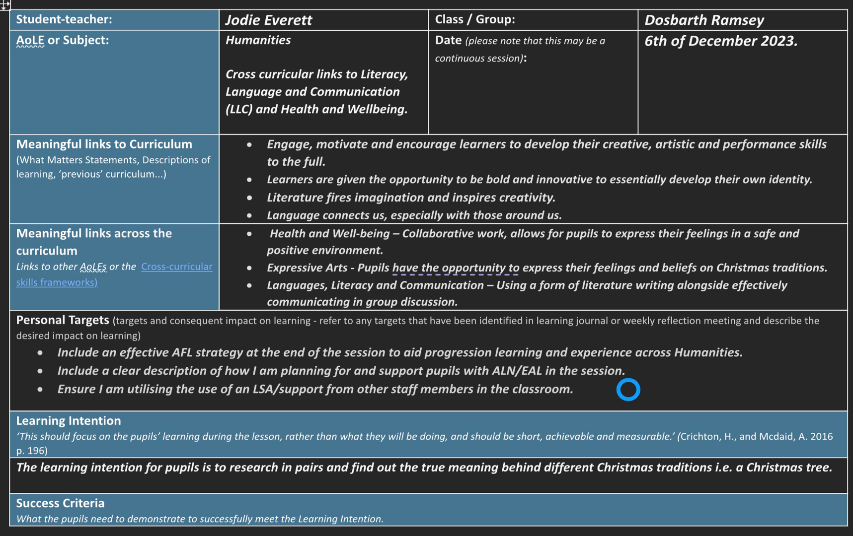
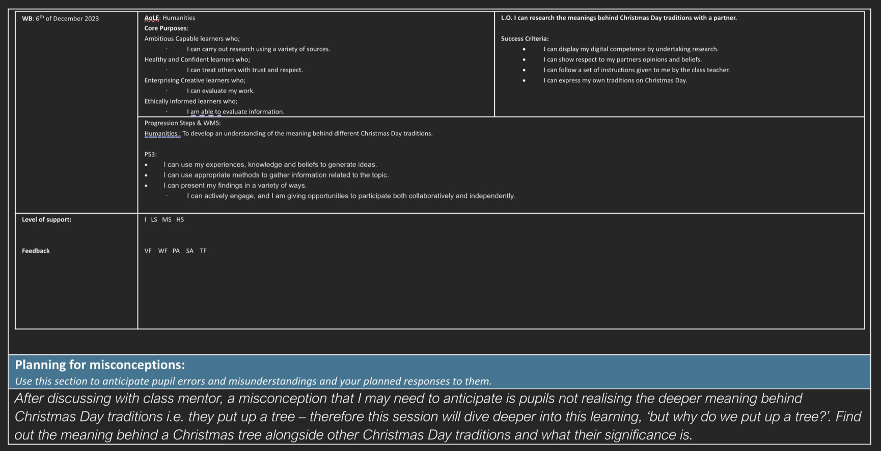
Appendix 1 – Exit ticket (AFL) Humanities (ALOE)

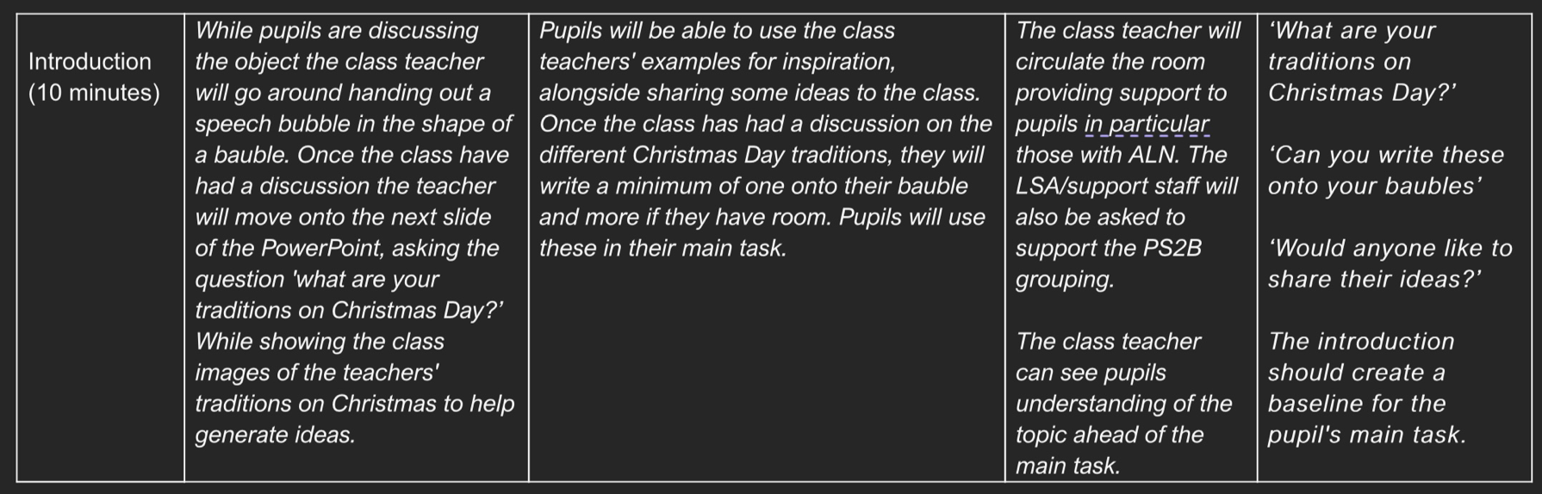
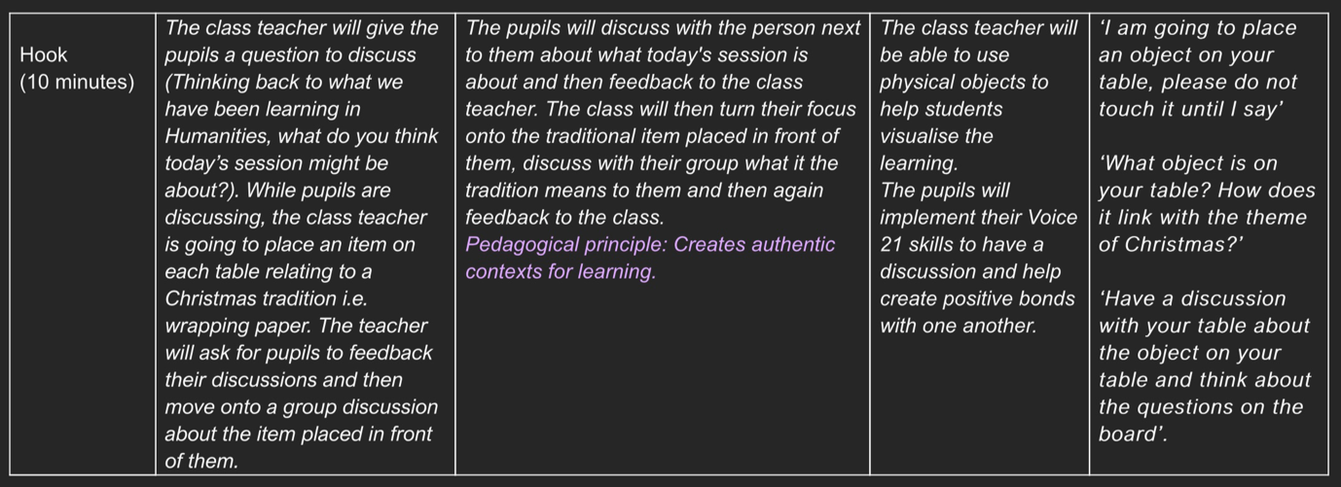
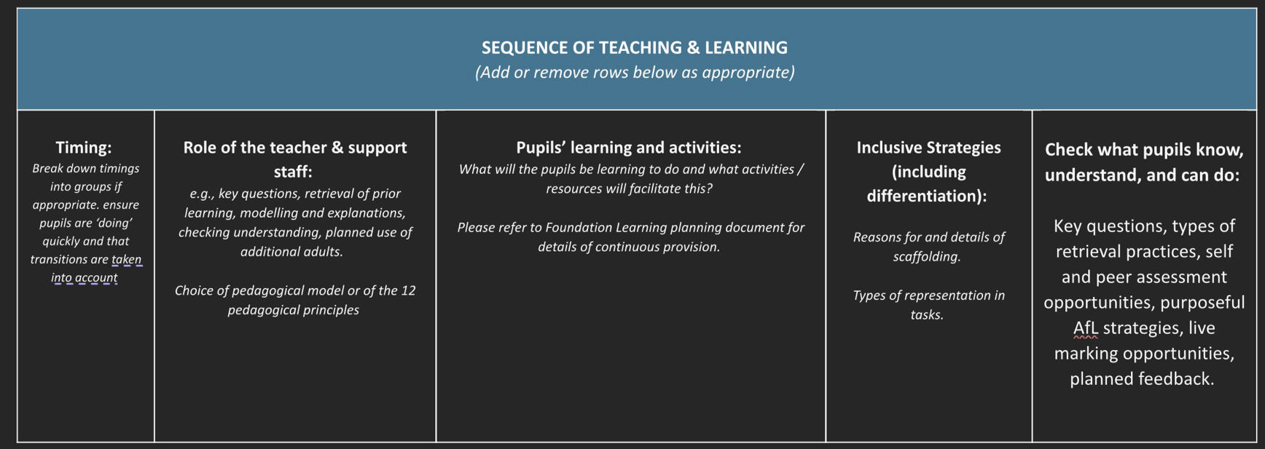

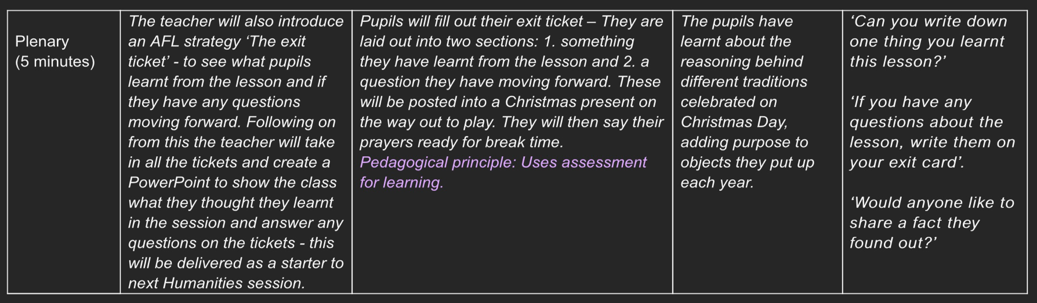
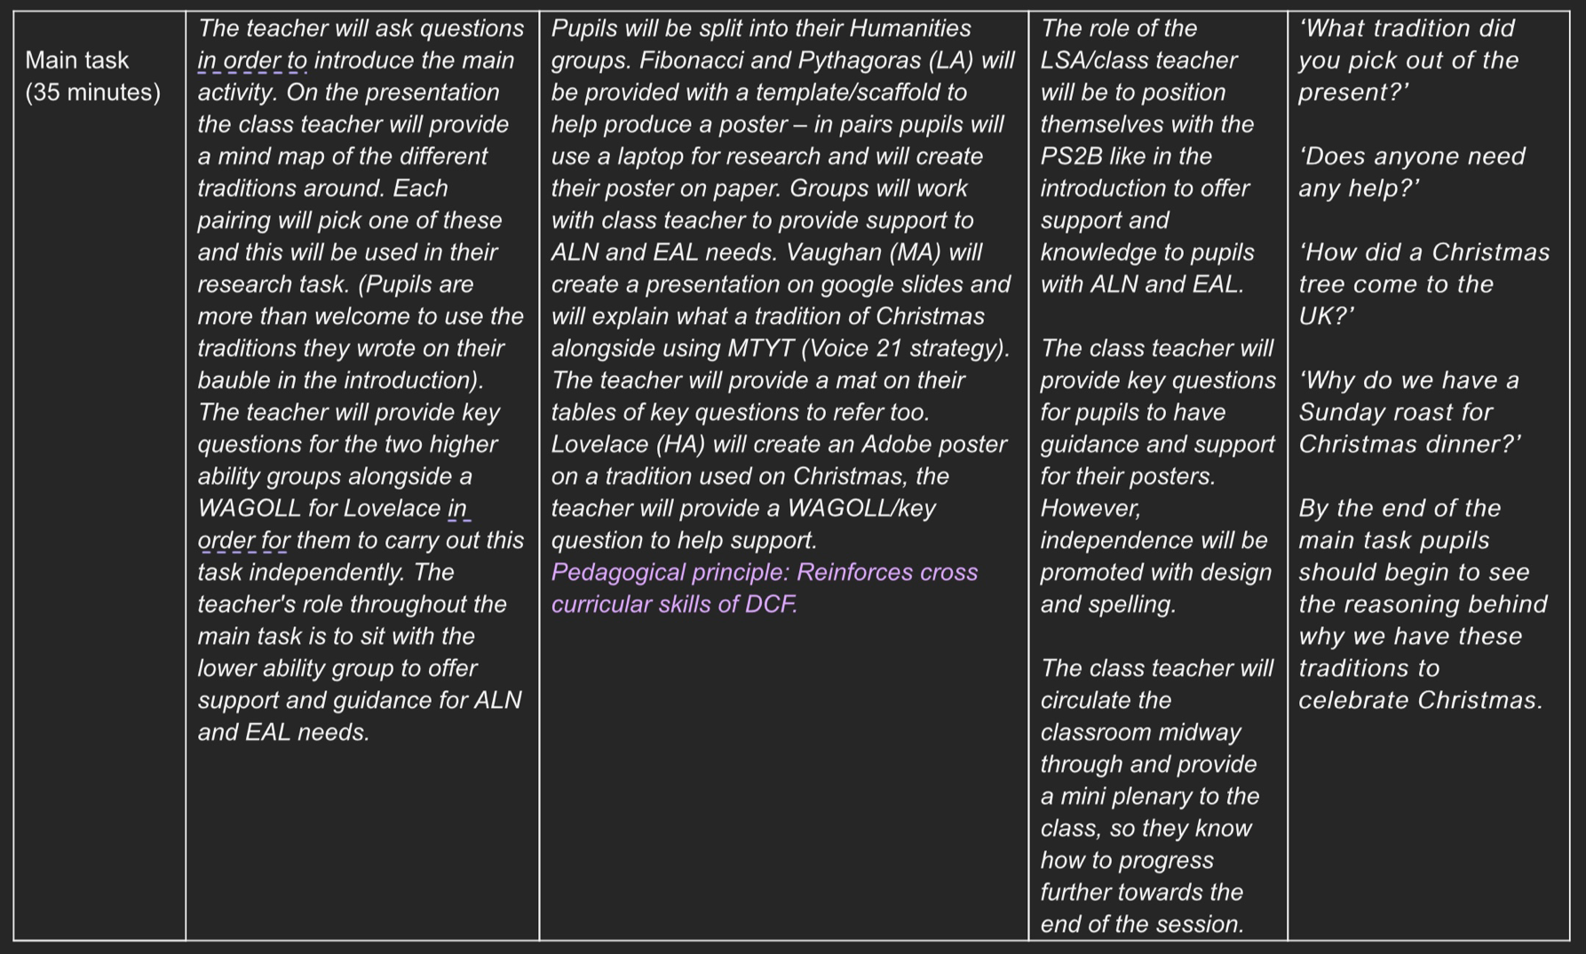

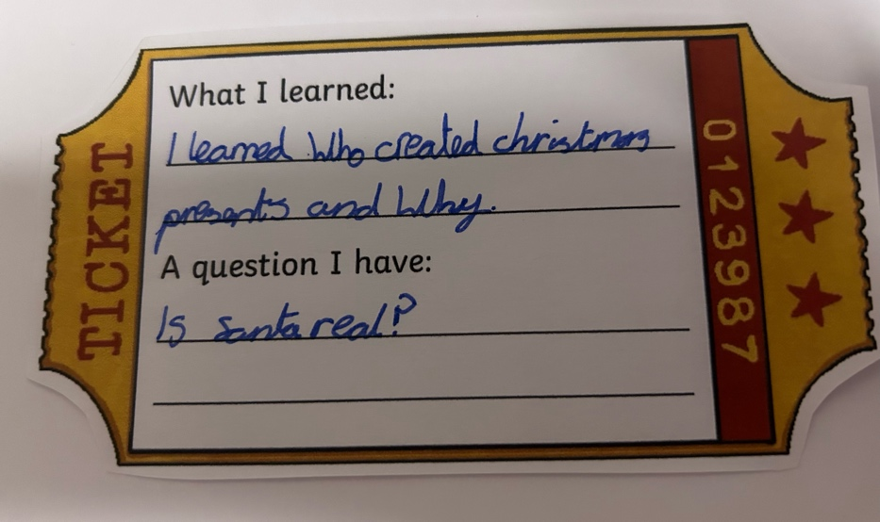
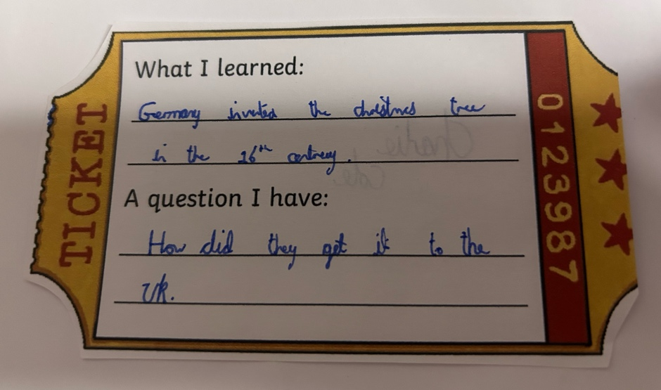
Appendix 1A – Examples of filled out Exit Tickets

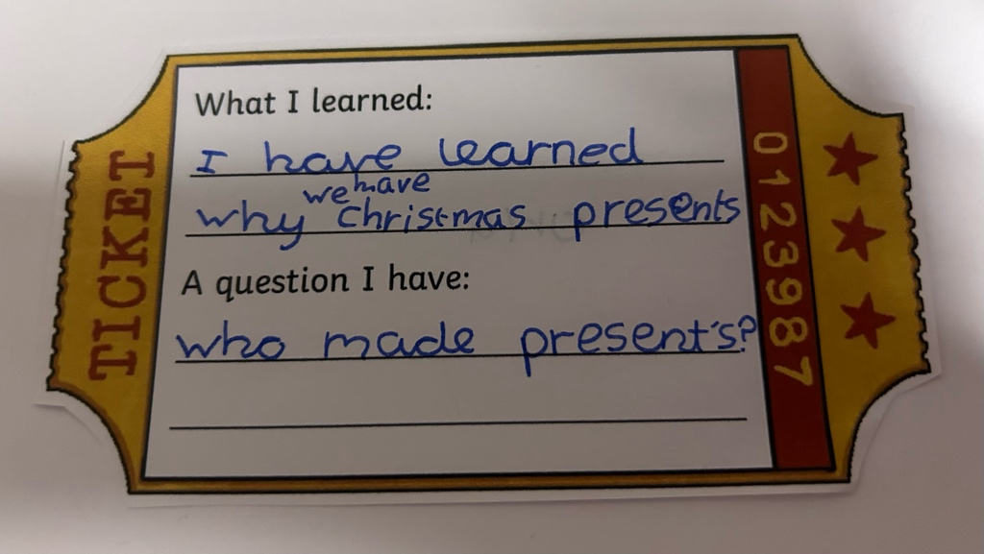

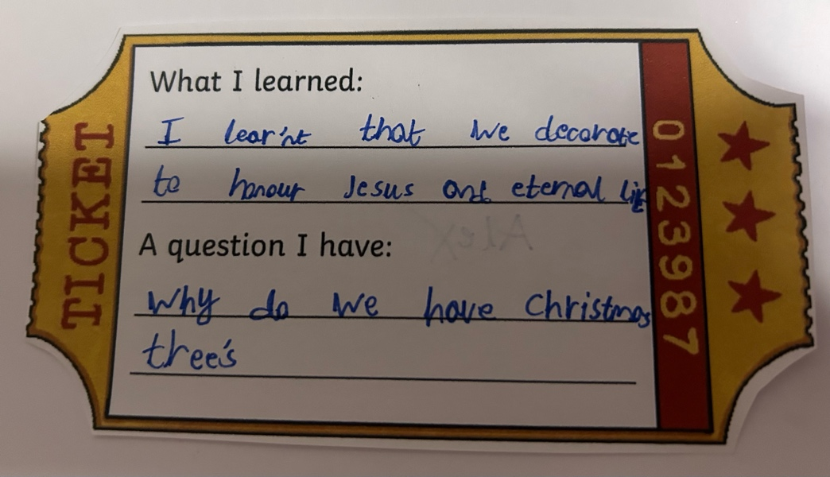
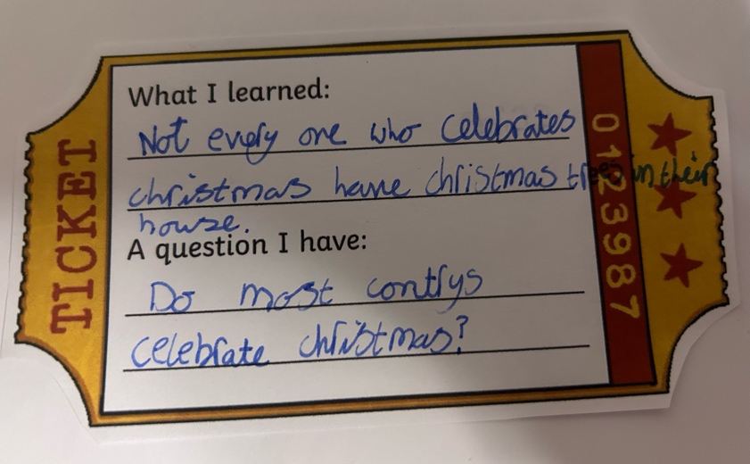
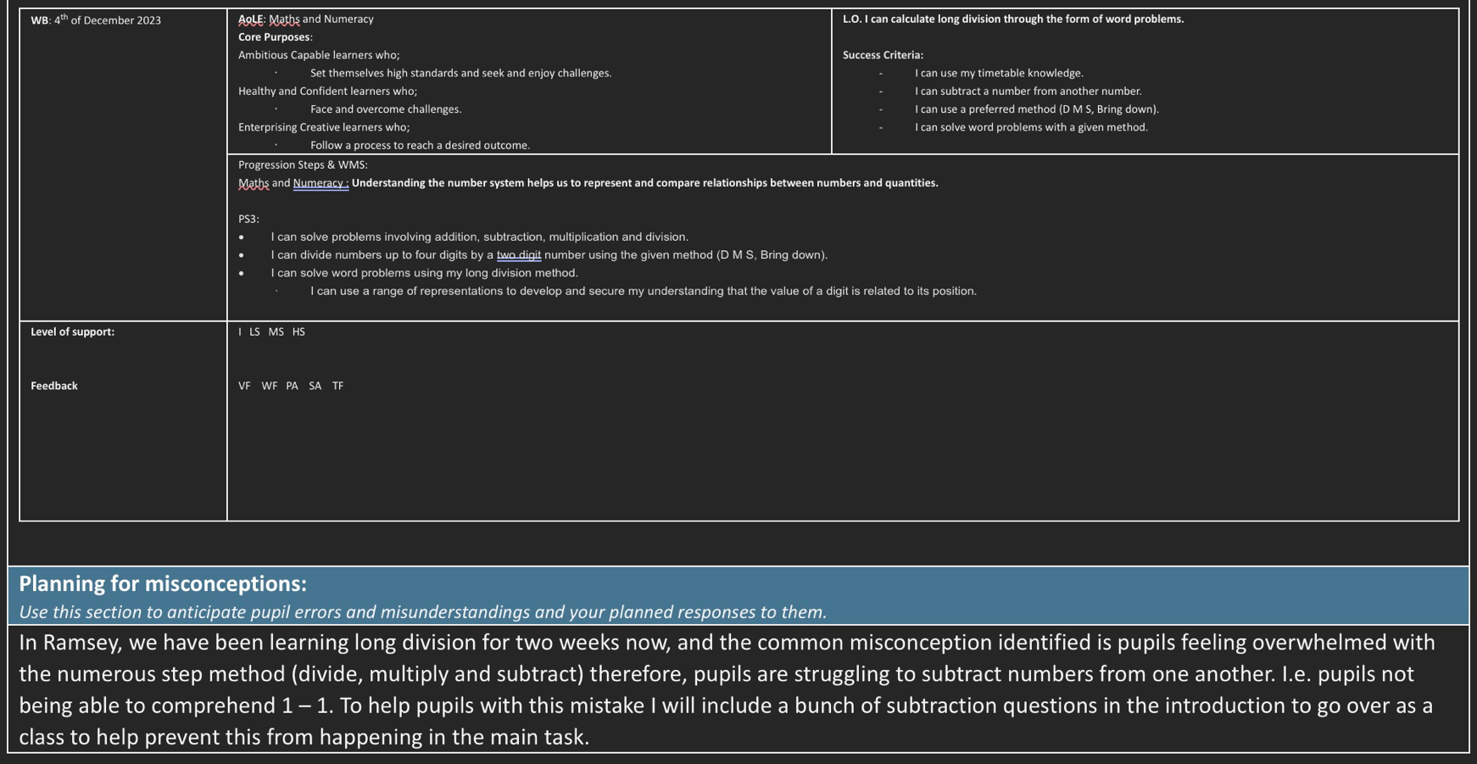
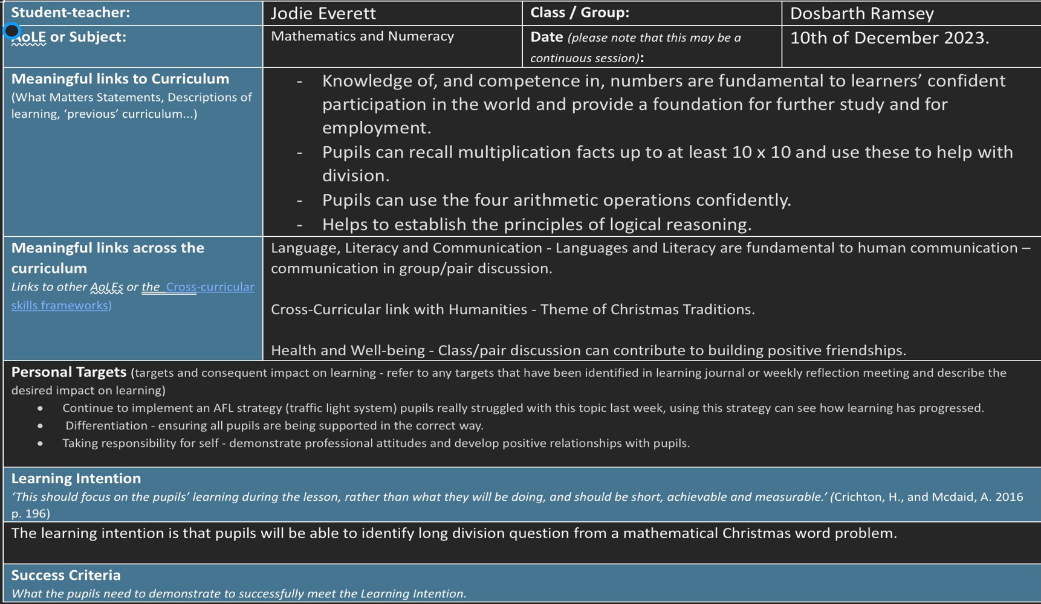
Appendix 2 – Traffic Light system (AFL) Mathematics (ALOE)

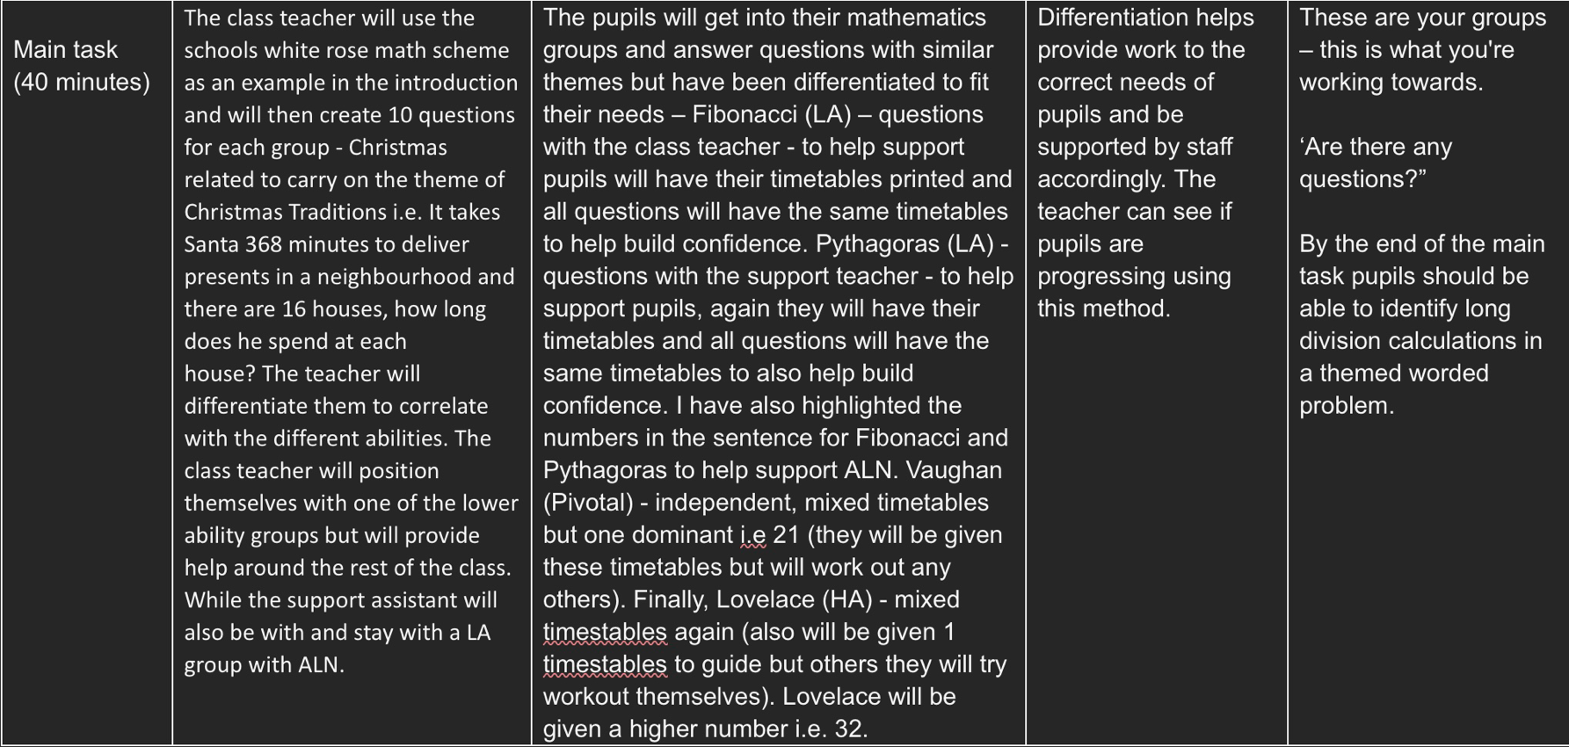
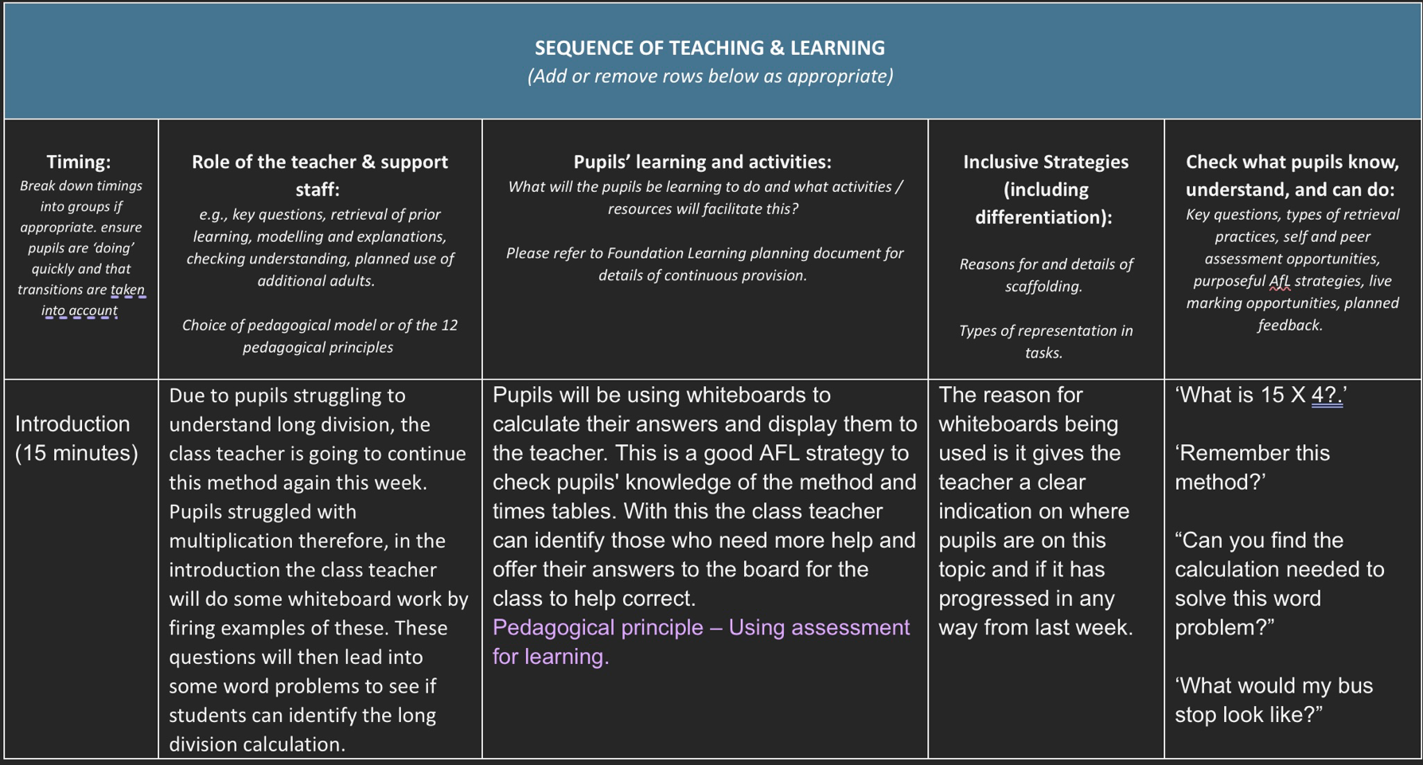

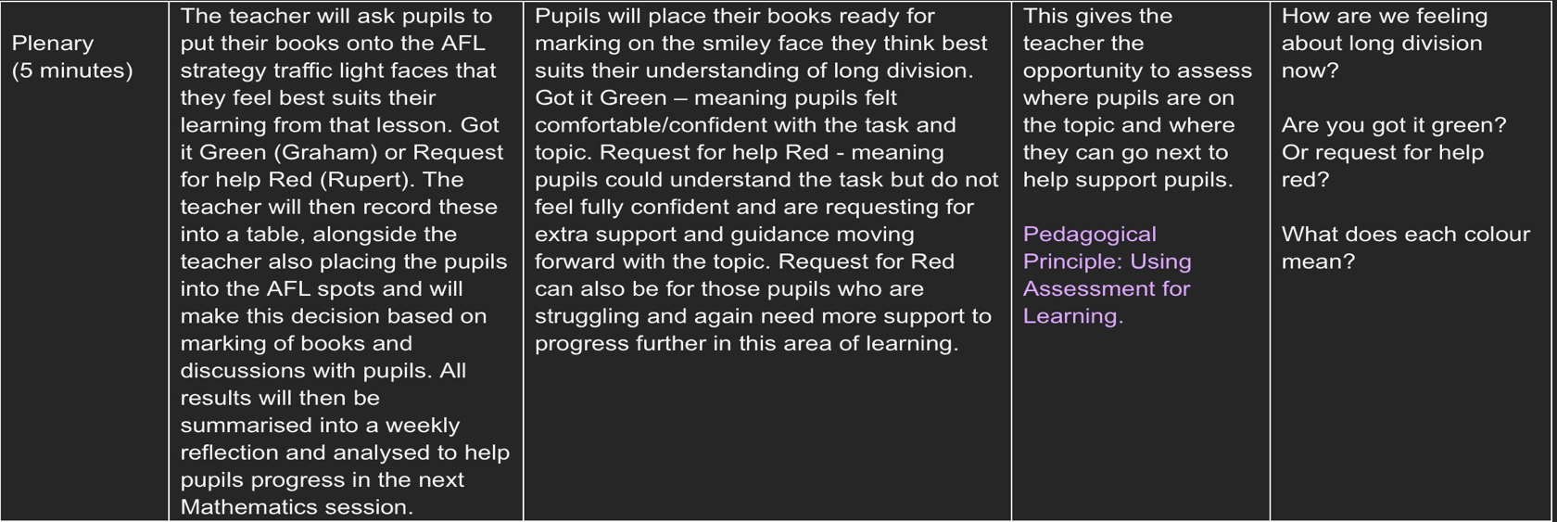
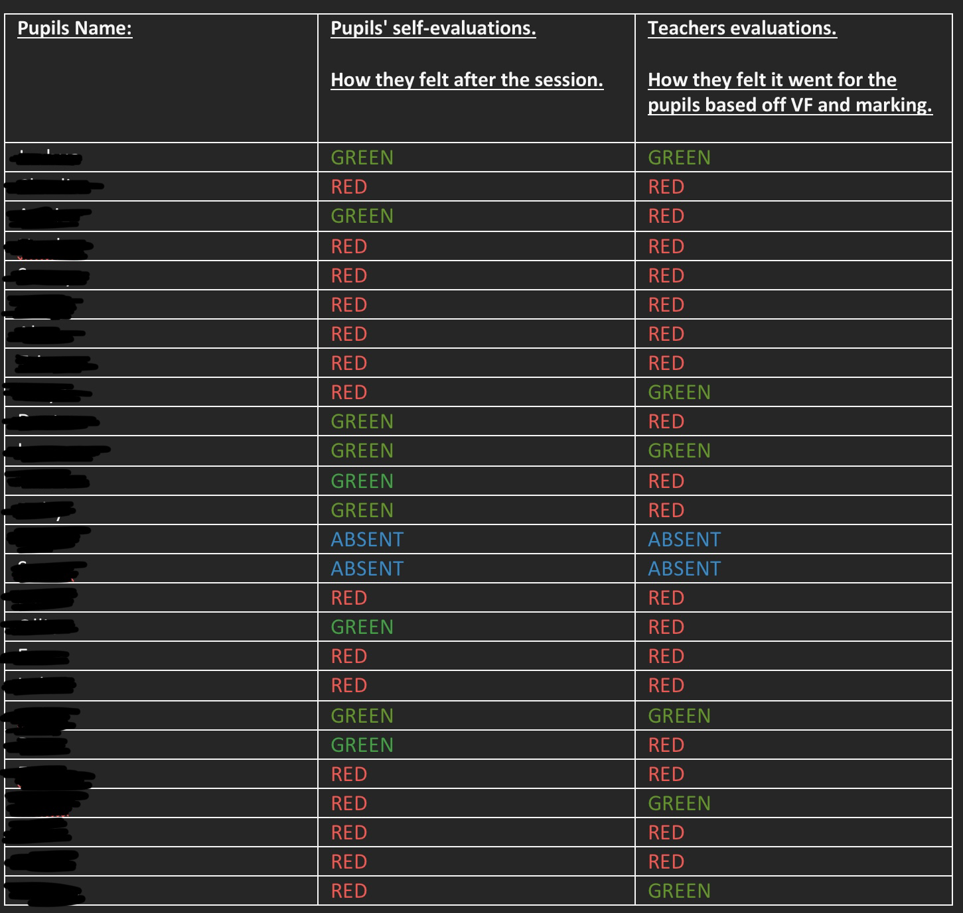
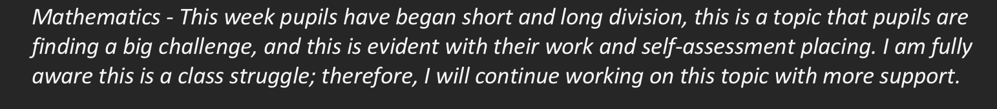
Appendix 2A – Example of the following up after the use of this AFL strategy

Appendix 2B – Example of the following up session after using more of the AFL in class

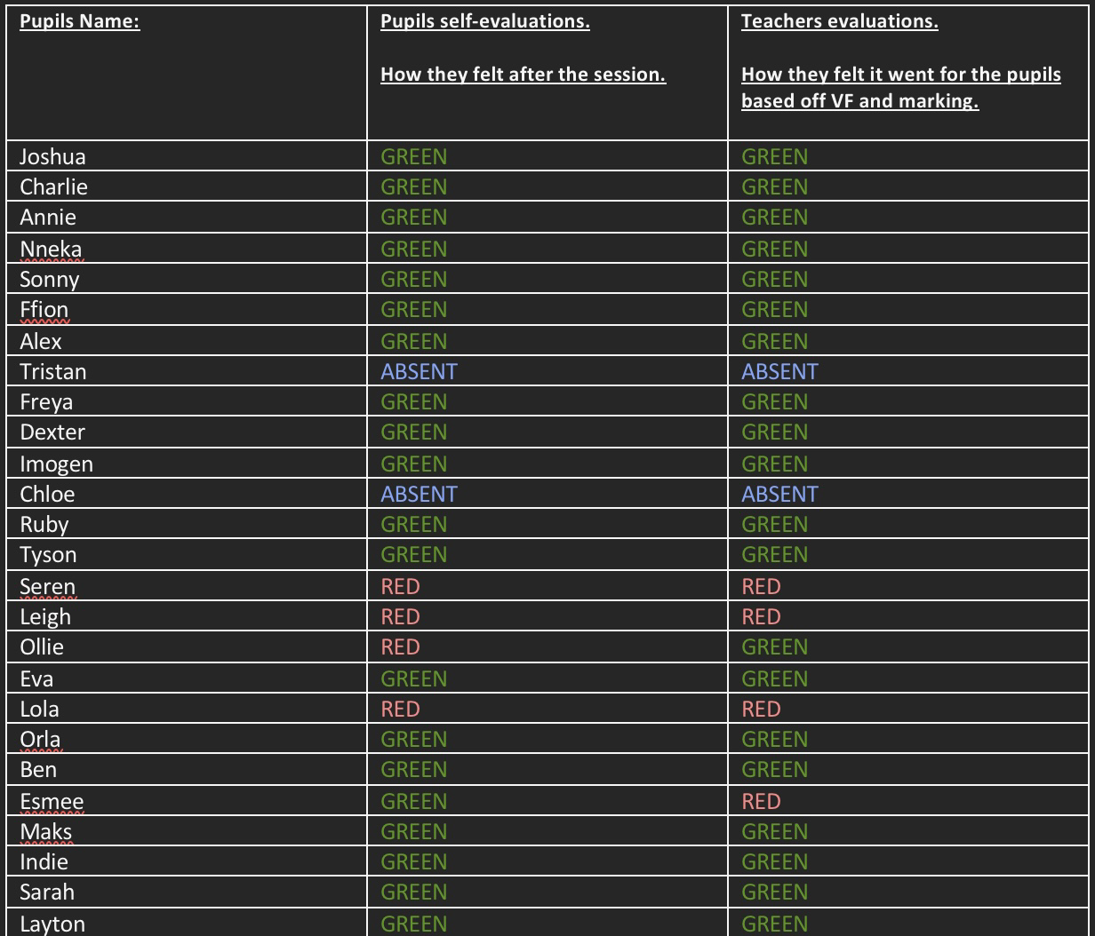

Appendix 3 – Live Marking/Success Criteria (AFL) language, Literacy and Communication (ALOE)


