Tourism Strategic Planning and

Management for Spain

M6X01932

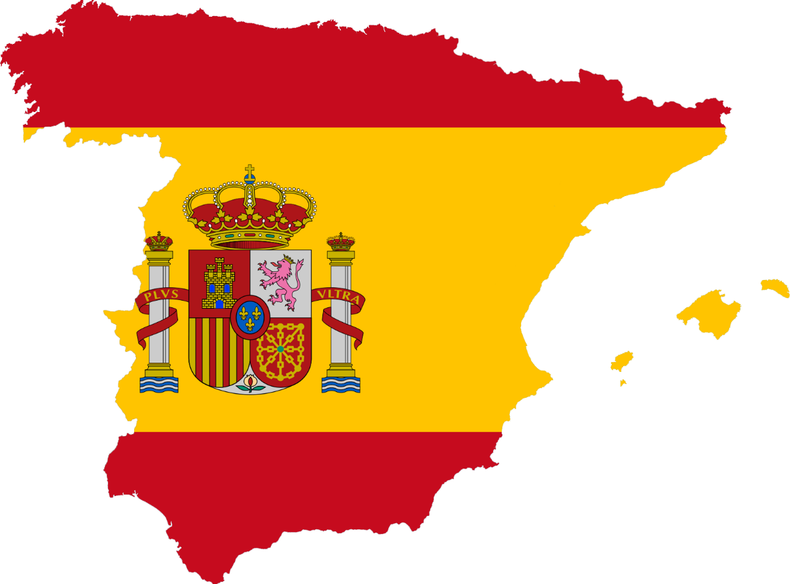

Student: Dayna Mehandzhiyska
1815045
Lecturer: Dale Clarke

Contents

Introduction 3
Tourism strategic planning of Spain 4
Tourism missions of Spain 5
Product development 6
Marketing strategies 7
Conclusion 7
References 8

Introduction

The aim of this report is to analyse the approach taken by the country toward Strategic Tourism Planning and Management.
At the present stage, the processes of globalization require the expansion of the scope of strategies in tourism, which are increasingly gaining an international dimension.
International tourism plays a major role in Spain's economic development strategy. One of the goals of the government in Spain is to diversify and specialize the products in order to sell outstanding products in the respective tourist markets. This is done through the Spanish Tourist Institute, which is a government organization that promotes Spanish tourism abroad. Spain currently offers its visitors a complex and diverse tourism product that has undergone constant development over the years. Its tourist-geographical position contributes greatly to the successful development of the tourism industry, as the country is easily accessible by sea, land, and air. The good and maintained infrastructure also benefits both the access of the tourists and the movement inside the country itself. Due to the high number of mountains on Spanish territory, there are numerous opportunities for practicing various types of winter sports, which through the southern location of Spain can be combined with sea recreation, sports or cultural visits. The hospitality and the Spanish temperament in combination with the typical Spanish music, cuisine, customs and traditions make the country desirable destination to visit all year round. (Costa, Panyik and Buhalis, 2014)
Strategic management ensures the achievement of the goals of the tourism system in the long run. It contributes to the sustainable development of the system as a whole and its individual components. It integrates the various processes taking place at the local level into unified technologies in the creation and implementation of the tourism product at the macro level. Sustainability is achieved with properly set goals and limiting parameters, established methodology and techniques of tourism management. (Cooper and Hall, 2007)
The evolution of Spain as a tourist destination over the years goes through a number of difficult moments that the country manages to cope with and thus becomes one of the leaders in the world tourist market. One of the main obstacles for the country over the years is the solution of the problem with the coast, which arises due to the high tourist demand and the lack of a ready concept for territorial development of tourism and the construction of an international tourist base and infrastructure. The solution of the numerous problems begins with the democratic stage in Spanish history and with the introduction of a number of changes aimed at regulating the tourism process and the correct solution of the territorial problems that have arisen. With the introduction of regulated measures, Spanish tourism begins a new stage of development, which is characterized by an increase in all indicators.

Tourism strategic planning of Spain

Planning is a decision-making process for managing future actions. The modern role of tourism in people's lives determines the need for planning and coordination of tourism activities. It connects with the system of tourism policy and integrates with it. The main goal of tourism planning can be the development of strategies and guidelines for sustainable development of the tourism industry in accordance with the economic, social, cultural and environmental conditions and requirements of the territory or settlement. (Evi C. Soteriou and Coccossis, 2009)
The best strategy is that which emerges from a strong agreement on Destinations; each region needs to build up and choose a strategy for the development of tourism itself. Containing and renewing supplies for long-term destinations and targeted tourism growth strategy in developing destinations are essential to the future approach.
The numerous initiatives and courses of action come from the strategies and ideas addressed during the preparation of the country’s 2020’ tourism Strategy.

- Optimization on the value for the client

- Maintaining the tourism model 's sustainability

- Improvement of competitiveness

- introducing a new shared tourism system leadership

Spain is the world's leading destination in holiday tourism and the second in terms of number of arrivals and income -58.1 million international tourists in 2006 gave a tourism surplus of 27,444 million euros-; It is a key sector for the Spanish economy and society. Tourism generated 11% of Spanish GDP in 2005 and currently employs 2.7 million people: 12.4% of the employed population. Beyond its weight as a specific sector, it has an important multiplier effect and strong implications on other strategic sectors of the country: construction, environment and health, among others.
Spanish Tourism Plan Horizon 2020 is a project promoted by the Ministry of Industry, Tourism and Trade and carried out by the tourism sector itself. The Spanish tourism plan "Horizon 2020" includes a strategy for long-term successful response to the challenges of the Spanish tourism system in a process that allowed to build a solution:
-The priority of the plan is the participation of the largest possible number of agents dealing with tourism, regardless of whether they are public or private. In addition, their goals and strategies are agreed with all of them in order to achieve the greatest possible participation in their implementation.
- To ensure the success of the Plan, it is based on maximum technical rigor, facilitating the credibility of its objectives.
- The best communication of the goals and strategies of the Plan should be communicated with enthusiasm, achieving maximum motivation of the sector and the society for its achievement.
- The plan defines new goals and actions that will achieve different and qualified competitive advantages; that is, unique, which allow differentiation with respect to their main competitors.
Therefore, the Spanish Tourism Plan Horizon 2020 is a new work process in defining tourism policies on a national scale, which for the first time establishes long-term strategic reflection efforts, creating a methodology based on comprehensive participation systems.

In addition, the Spanish Constitution stipulates that the development of the tourism sector falls within the competence of the regional authorities in Spain. In this regard, the development of measures to stimulate tourism, including domestic tourism, is being carried out at the regional level. In 2012, the Spanish Government develops a National Comprehensive Plan for Tourism Development in Spain for 2012–2015. (Plan Nacional e Integral de Turismo 2012–2015). The development of domestic tourism in Spain is not positioned as a priority, for this reason less attention is paid to this area than attracting foreign tourists to Spain. In the mentioned Plan, there has been a downward trend in recent years in the number of Spanish citizens who spend holidays in their country. In this regard, the Plan contains a set of measures aimed at stimulating national tourism, among which the implementation of a broad nationwide awareness-raising campaign to promote local tourism destinations among Spanish citizens is at the fore. The solution to this problem is achieved by placing advertising materials in the press (thematic newspaper tabs and brochures), on radio, and television. The information campaign in support of domestic tourism is ongoing, however, it intensifies as the holiday period approaches (summer holidays and Christmas holidays). This way among the advertising campaigns launched by the Ministry of Industry, Energy and Tourism within the framework of the Plan, one can note the project "España, el destino que llevas dentro", the purpose of which is to demonstrate to the national consumer all the beauty and diversity of their country. During the campaign, advertising information is distributed between June and September through digital media, information posters and other media.
(Tourism Forecasting and Strategic Planning 2020, 2008)

Tourism missions of Spain

Spain’s main tourism goal is to make the tourist system more sustainable and competitive by the end of 2020, as well as to contribute to the maximum level of social well-being. The country ranks first in the world in the number of ecologically clean beaches and places for sports and recreation, where special efforts are made to protect the environment and the safety of holidaymakers.
The country has special program, devoted to the development of tourism for the elderly and the maintenance of employment in tourist areas, which is implemented by the Institute for the Elderly and Social Services of Spain. The purpose of ​​this program is that seniors to be provided with significant discounts on travel packages (accommodation, moving, meals, excursions) within the country from October to June (the period of traditionally low tourist flow from abroad). Thus, the program helps as stimulating the development of tourism for persons of retirement age and maintain the level of employment in the resort cities of Spain throughout the year. (Buhalis, Darcy and Ambrose, 2012)
For the preparation of the Spanish Tourism Plan Horizon 2020, has been carried out a thorough diagnosis that covers the different realities of the tourism sector. Given the future trends the rigorous diagnosis carried out constitutes an exercise of responsibility that helps to guarantee that the tourism sector is bequeathed to subsequent generations with the expected potential for social welfare.
The diagnosis has been grouped into four priority areas:
- Competitiveness
- Destinations
- Offer and products
- Management models and human resources

In order to make its next steps toward future expansion of its sustainable tourist system, Spain could use as an example some other countries with already established good sustainable practices.
- Wastewater treatment plants across Europe are beginning to use energy and other waste resources to reduce their consumption and even produce energy. An excellent example of this is the Aarhus treatment plant in Marseille, Denmark, which produces more than 150% of the energy it needs to operate by investing in more efficient technologies.
- in Cyprus, recycled water is increasingly used as a reliable resource, for example for irrigation and protection against drought. With the help of European funds, two projects are already under way: a water reuse scheme in Antupolis and a similar scheme in Larnaca.

Product development

The development of new products is important in the tourism planning process. New trends are increasingly focusing on products related to nature, health and well-being. The main reasons for this emerging demand are the changing working conditions, stress, and increased aging of the population.
The offers of Spanish tourist products are very diverse and are characterized by the provision of different types of tourist services, which are partially adapted to the new market behaviour. The sun and beach products continue to be the undisputed engine of Spanish tourism. Cultural and urban tourism is consolidating as a reality within tourism products in Spain and offers high potential for competitive growth, which must be based on greater segmentation and specialization of destinations. Other products - such as business and congresses, health and wellness, sports or rural and nature - are in full development. The country has a differentiated advantage due to the width of the accommodation it offers, which in recent years has been strengthened in the superior categories (4 and 5 stars. In addition, the improvement in the quality offered is evidenced by the increasing implementation of security systems in companies and services in the sector. The Spain brand has levels of recognition comparable to those of large multinational companies and evokes the key features and qualities that have allowed the destination to take its current international leadership, despite being overly associated with its sun and beaches products. Spain is the country that is best appreciated by tourists in terms of value for money, and other exceptional qualities such as the feeling of freedom and security, perceived as differentiated competitive values ​​compared to new destinations. Among the most important weaknesses of the Spanish tourism system is the high dependence on German, British, and French markets and the weak positioning in the demand segments with high purchasing power. The Spanish tourism model, accustomed to the supply market, makes it difficult to develop tourism products in line with the new customer requirements.

Marketing strategies

the marketing organizations of the destinations are important, because through the application of an adequate management model the sustainability of the tourist area will be achieved, the tourist product will be positioned and promoted, based on both its main and extended specialization, through the participation of all stakeholders. (Costa, Panyik and Buhalis, 2014)
From the point of view of the trends that will affect the development of Spain’s tourism in the near future, four factors stand out that will decisively influence the provision of tourism services and their marketing:
- The increase in international competition, the result of economic globalization and deregulation of markets, which can create a situation of overcapacity for certain segments.
- New types of clients in traditional markets and opportunities to attract new clients in new markets.
- Environmental trends, with an agenda of political and economic measures around the commitments to adapt and mitigate climate change.
The tourism sector must adapt to this new environment to obtain maximum profitability, attending to new market needs, anticipating them to detect and take advantage of opportunities and listening to the client to create new products and services.

Conclusion

- The Spanish Tourism Plan Horizon 2020 creates a long-term strategic framework for successfully addressing the challenges of the Spanish tourism system. Within this framework, the Spanish Tourism Plan 08-12 has been developed, which is designed as a lever for progress towards the goals of Tourism 2020 and includes in the form of programs and guidelines for action the commitments of the State Tourism Administration to promote the Spanish tourism sector. to achieve the goals set by him.
The research done highlights the need to address some raised challenges and their possible solutions
- Sustainability action priorities must provide an understanding of the environmental impacts that the sector creates, in addition to those generated by the environment on the sector.
- Improving the competitive environment, especially in terms of employment and training and productivity.
- The adaptation of the management, products and services and marketing carried out by Spanish companies and tourist destinations

The Spanish and European dedication to knowledge-based growth, Innovation, productivity, improvements, and the sustainability of economy reference structure will be established for this sector. The culture of value creation needs to be fully incorporated into its own transformation, thereby giving it the opportunity to make a definitive contribution to economic modernisation and social well-being. Tourism is indeed a key part of economic and social development in Spain. It requires to renew its rates of development to ensure and maximise its Contribution to social well-being, the new era of tourism defined by the Technological change, responsibility for the environment and the demands of a new society.

References

- Buhalis, D., Darcy, S. and Ambrose, I., 2012. Best Practice In Accessible Tourism: Inclusion, Disability, Ageing Population And Tourism. 1st ed. Bristol: Channel View Publications.
- Cooper, C. and Hall, C., 2007. Contemporary Tourism: An International Approach. 1st ed. Butterworth-Heinemann, pp.49;109;249.
- Conrady, R. and Buck, M., 2012. Trends And Issues In Global Tourism 2007. 1st ed. Berlin: Springer Science & Business Media.
- Costa, C., Panyik, E. and Buhalis, D., 2014. European Tourism Planning And Organisation Systems. 1st ed. Bristol: Channel View Publications, p.384.
- Lemelin, R., Dawson, J. and Stewart, E., 2012. Last Chance Tourism: Adapting Tourism Opportunities In A Changing World. 1st ed. Routledge.
- Theobald, W., 1998. Global Tourism. 1st ed. Butterworth-Heinemann.
- Evi C. Soteriou, E. and Coccossis, H., 2009. Integrating Sustainability into the Strategic Planning of National Tourism Organisations. Journal of Travel Research, 49(2), pp.191-205.
- Modul.ac.at. 2008. Tourism Forecasting And Strategic Planning 2020. [online] Available at: <https://www.modul.ac.at/uploads/files/research/tourmis/2008/International_Seminar_Spanish_Tourism_Plan__de_Paz_.pdf> [Accessed 8 August 2020].

