

Assessment 1 – Reading Task Template
PART 1: Upload your photo of your A3 in-class notes here:
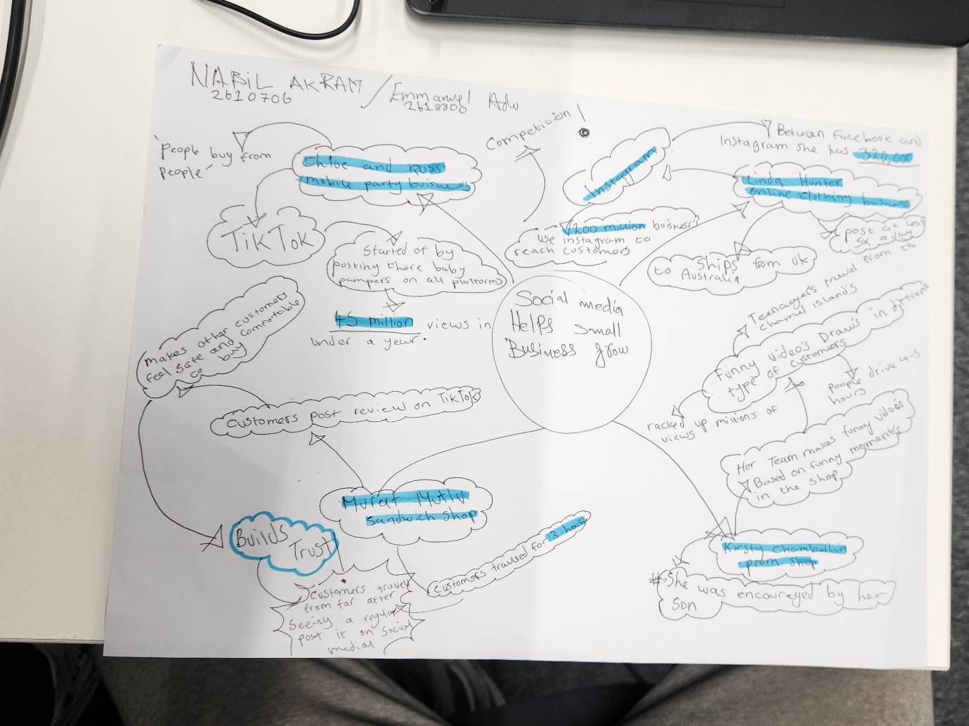

PART 2:
- Answer every question below in 1-3 full sentences.
- Use your own words. Do not use generative AI to answer these questions.
- Include a specific detail from the text when asked.
REMINDER
- The main idea is the overall message of the whole text.
- A key point helps to explain the main idea.
- A specific detail or example from the text shows that the key point is true.

- What is the main idea of the whole text?
Main idea of whole text social media.tik tok,Instagram,we can improve small business on social media.

- What is one key point that supports the main idea, and which specific example from the text shows this?
One key points is more important.that customer generated contenton social media,we can boost a business sales and custumer reach.example malik kebab shop.where customer travaled up to 3 hourse for a chicken burger ofter a video posted by a regular customer went a viral.

- What is a different key point that supports the main idea, and which specific example from the text shows this?
Another key point is that social media.social media can help a business grow.we can share post.many thousand people can see that post and can buy things.can eat.

- Which part of the text do you think is most important, and why?
Most important part of the text is the quote explaining that consumers respond better to authentic relatable content rather than obvious.this is key because,social nmedia marketing people succeeds.

Reflection:
- What did you find difficult in this task (including in-class components), and why was it difficult?
I found it hard to explain about business examples .in short clear words.using my own simple language.

- What helped you with this difficulty, and how did it help you?

My friend gave me good advice,I feel less stressed and more confident.i ask my other teacher. He also helped me.i always take help from my wife

