Production Diary:

Connor Hale 1701744

Introduction
This production diary will cover my process of my retopology model and my ending reflection of how well I kept to my 10 week plan. Each week will have an entry as to what I have completed and what I covered in the week.

Risk Assessment
Before I start working on my retopology I need to go over the potential risks that can happen during the process and what I can do to stop them/prevent them from happening.
In the event that I lose/corrupt my work I can:
- Set extra time throughout my plan or give myself extra hours towards the end of my schedule.
- I can back up work every week, this way I won’t have to start all over again in the event I lose my files.
- Also use cloud storage to have a virtual back up if I need it.

Creative Practice Week 1:
We started off the year with creative practice, which consisted of using Maya (a 3D modelling software). For game design Maya can be used to make a base model of your character, prop, asset or any object in your game. It’s advised that you don’t use textures or anything other than creating a base since your project when exported will need to have the entire project for it to work.
In my first lesson we learnt the very basics of Maya, like switching to the different windows, going from object mode to construction mode and placing a simple object into Maya. Since I haven’t used Maya before, I’m going to have to practice with it in and out of class.

Creative Practice Week 2:
We started the week by looking into 3D modelling and the basics of creating your character and the rules you need to follow. We learned about different tools that commonly used in Maya and how the software works. We also learned the different terms of use like faces, edges and vertexes. We then went into how polygons work in Maya and all the different software tools. We learnt that the best way to create models in most software is to make them using squares and triangles.

Creative Practice Week 3:
Started retopology, edge flows, making objects live, tools like quad draw.
This week we started retopology. The process of adding individual polygons to a character that we have been given. It’s a role in the game design process and includes every dynamic and moving character in the game. The reason we have to do it is so that every character doesn’t have as many polygons that the raw character comes with. The character by itself comes with over a million polygons and is too much to be inputted into a game by itself and requires the game designer to bring that number down by retopoligizing each character.
When retopoliogizing, each character needs to have good edge flow, which is how the mesh on the character flows around the character. When the character has bad edge flow, lots of problems can arise and is needed in the animation process so that the character can be controlled properly.

Creative Practice Week 4:
This was our second lesson in retopology. Using large quads to start off with, then add in subdivisions later so that you have structure. This process is mostly used for the body and not so much on the face. We also needed to keep into consideration the edge flow and how certain muscles and appendages react to movement.
We were also taught about the particular shapes used around knees, elbows and muscles so that the character can move when it comes to animation.

Creative Practice Week 5:

This week we covered scheduling and making a production plan in class. This week I also made the hands for my retopology. It was difficult to get the hands and edge flow correct and took up most of my practice time where I should have been covering all the aspects. This week in my research sessions I need to cover hands and edge flow some more. Next week I’ll need to make progress on the legs and feet which I haven’t started.
Using images from the internet I started making my hands. It took a few hours to make the hand work, but most of the time was taken up by trying to get edge flow correct and prevent spiralling on each of the fingers.
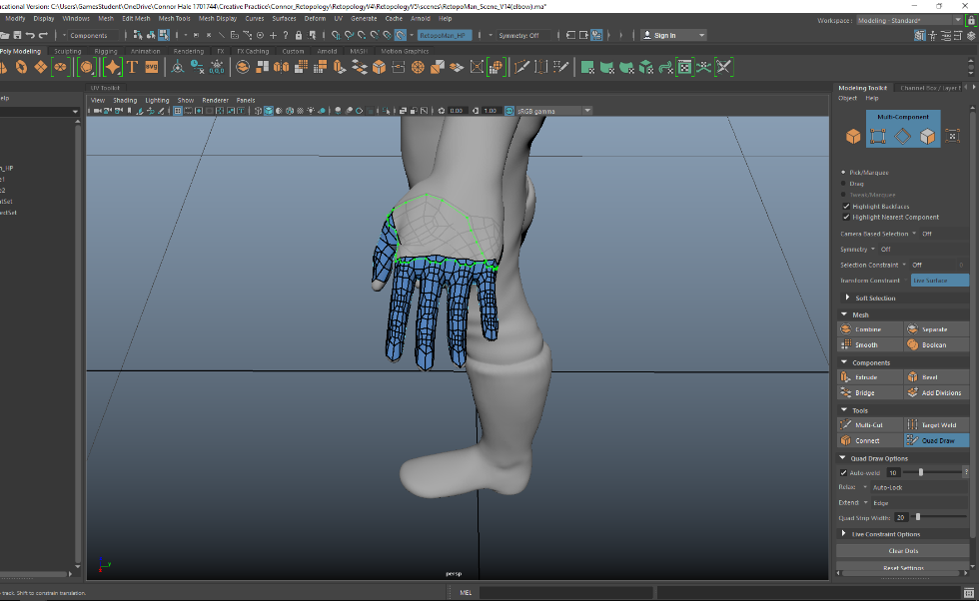

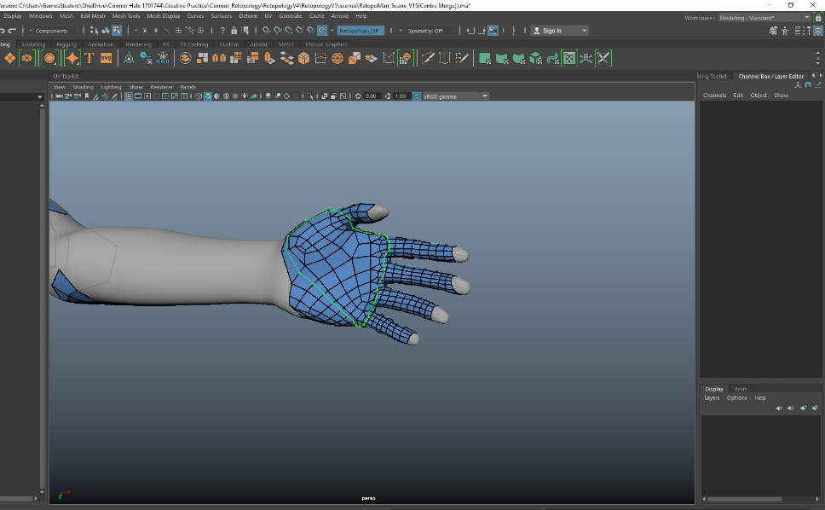
Creative Practice Week 6:
This class session we were taught about merging and symmetry. For now as a class we were taught that symmetry doesn’t equate to realism, since realistically no one is perfectly symmetrical. However since we are only starting out we should stick to using the symmetry mode for now.
It’s a skill that needs to be practiced. Since creating perfect symmetry and merging it down the centre is a long meticulous process that needs to work otherwise it will break the character down the line.
In the class I practiced using symmetry. It took a few tries before I eventually got my first characters head to work.
The first few tries ended up with triangles that I couldn’t get rid of, so I needed to start again and re try. This time I managed to get the triangles sorted out by deleting a few quads to make it symmetrical.

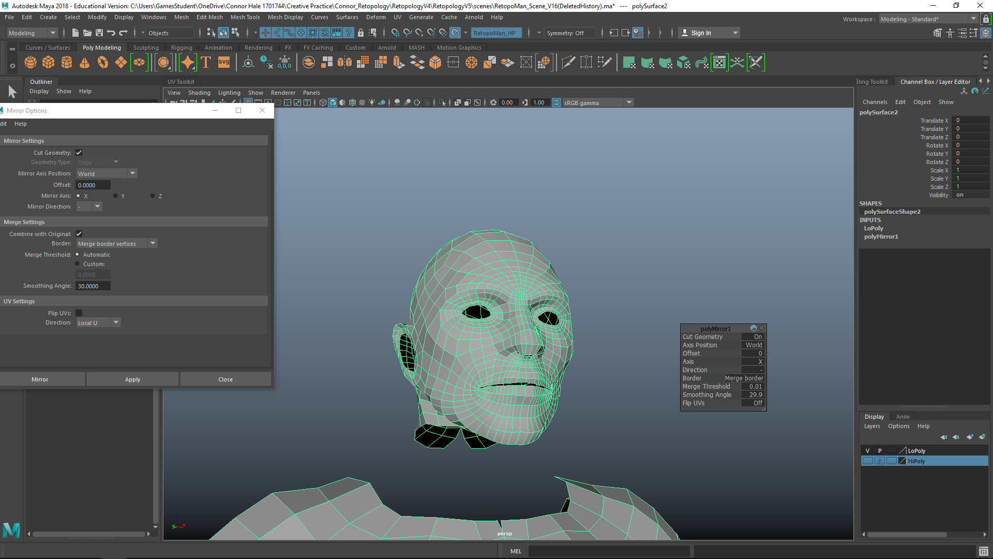
(Finished Product)
At this point I reviewed my production plan to see how well I was keeping up with my schedule.
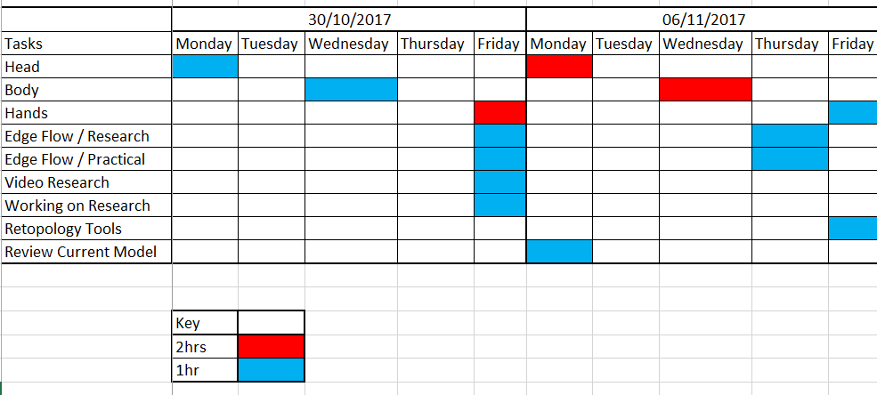

I have not been keeping to it exactly the way I planned, instead I have been working on one single part for most of the work hours. My plan was to work on everything simultaneously but I found it was easier to work on a single part of the body per week. I’m now going to need to change my plan to better suit my schedule. However I have generally kept to the amount of hours I want to work on my retopology per week.

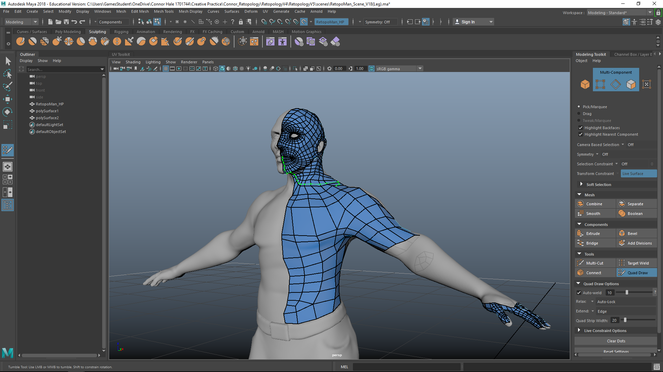
Creative Practice Week 7

In my first session in class I started to connect the head on the body that I made. I didn’t run into any problems and the edge flow remained intact.

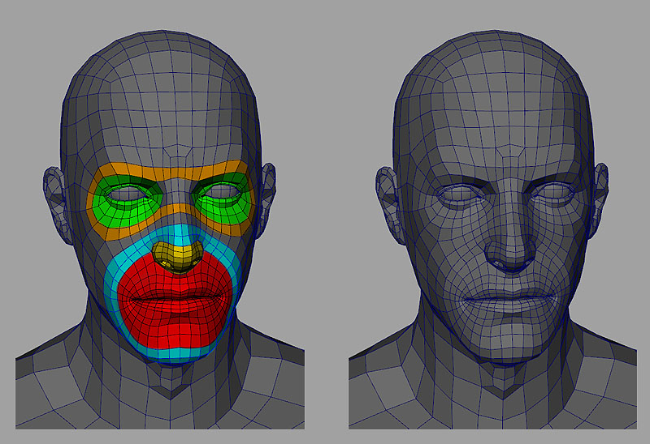
In my research session I went over face edge flow and corrected the face. This was the image I’ve been using to make my retopology face, and I plan use the symmetry tool towards the end to connect it together.

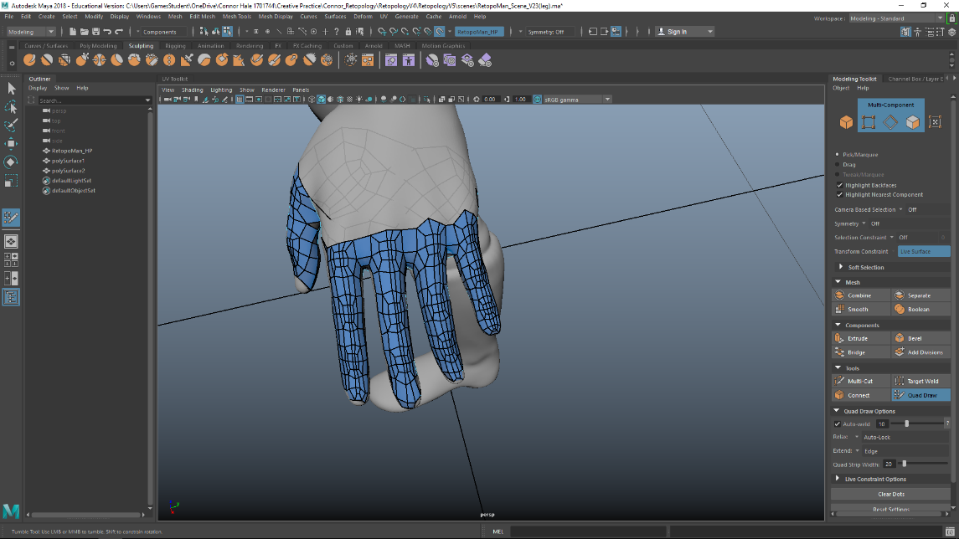
This week I also finished the hands. After around 5 attempts to get the correct edge flow.

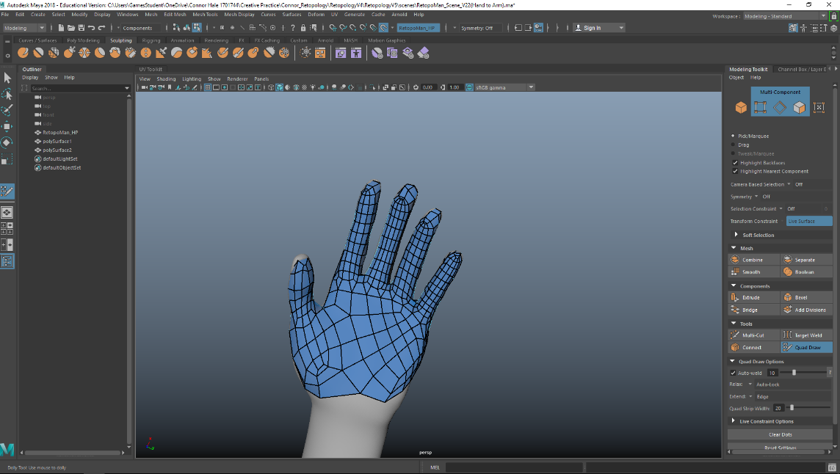
After the multiple attempts I’m happy with what my hands look like. The biggest problem I had was attempting to use many different methods on completing hands.

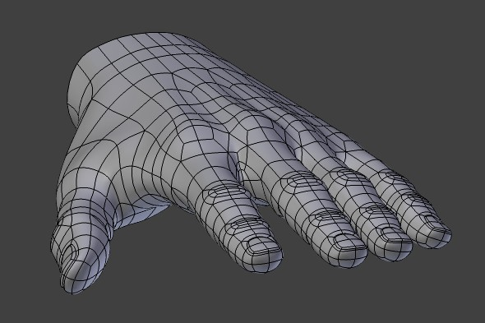
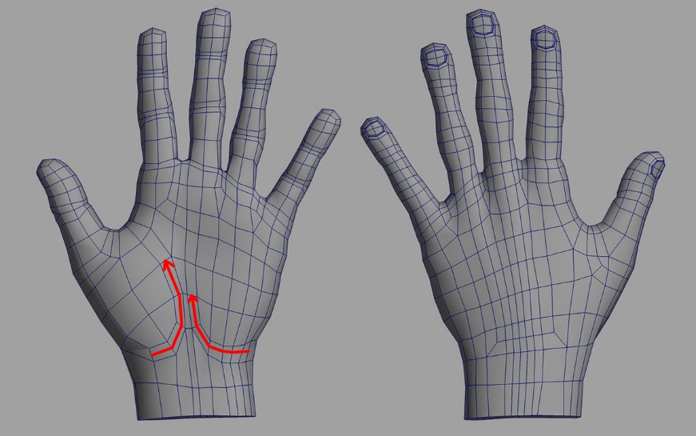
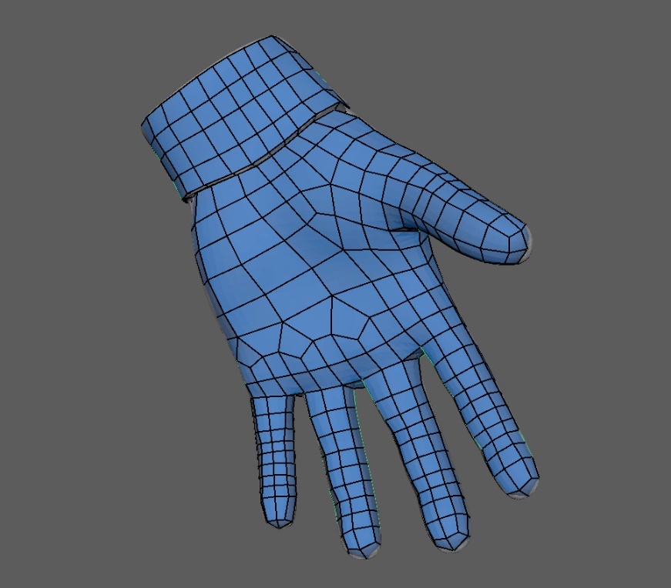
As for research, since I used multiple sources to construct my hand, it took too long to incorporate all the techniques. It ended up being too detailed and probably unusable for a simple game character.

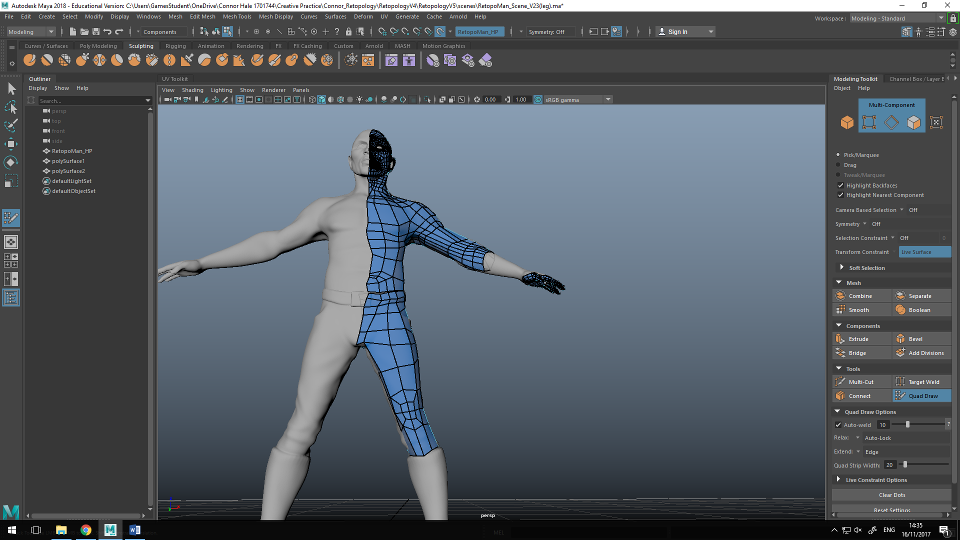

I also started on the legs of my retopology. I’m going slowly work my way down the arm and leg simultaneously and after I have finished it should all fit together and be ready to mirror and have my full retopology. For future reference I think I’m going to use this format, since I found it was easiest to work on the different parts of the body after I had completed the more complicated stuff like hands and the face.

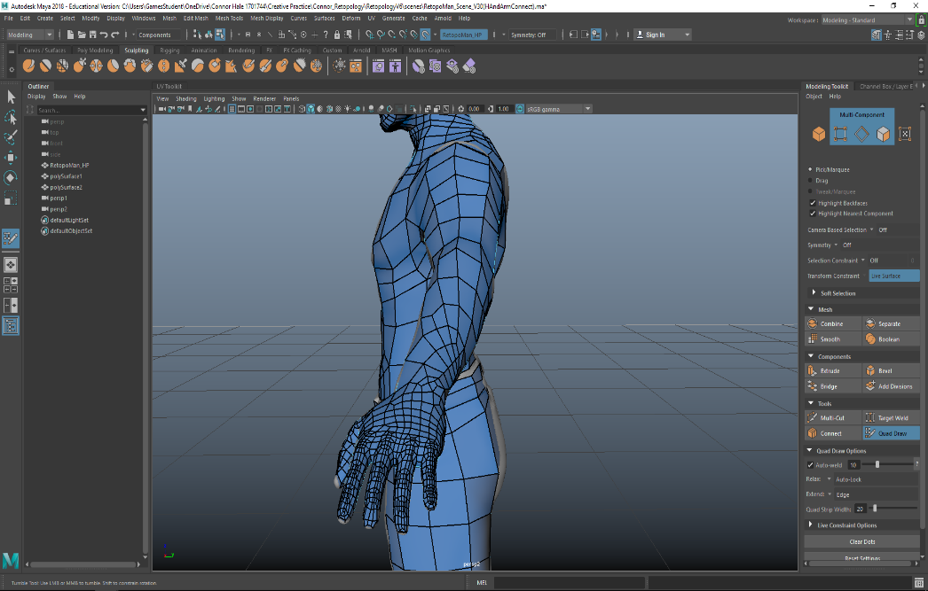
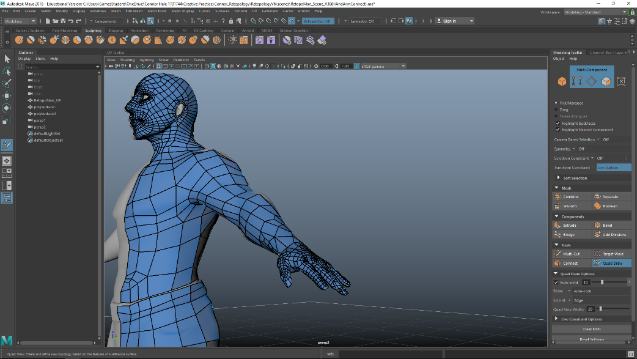
I finished the arm and hand. It didn’t turn out as I hoped since the edge loops from the hand didn’t connect to the simplicity of the arm. This in the end cause problems in getting easy edge flow from the arm to the hand. This was my 8th attempt and took most of the day. From here on in I’m going to attempt to keep the rest of the body simple so that it doesn’t interfere with rest of the body.
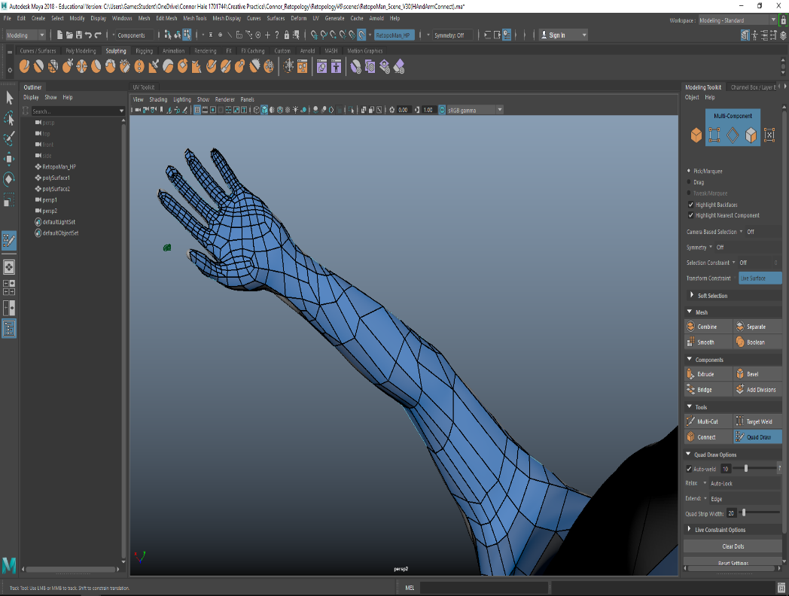
Next session I’m going to need to practice making an easier hand that doesn’t take almost 4 hours to complete. So in the future I can find a method that fits better with the character and not take as many polygons to complete.
For future reference I’m going to need a new way of making the hand work with the arm and body.

Creative Practice Week 8
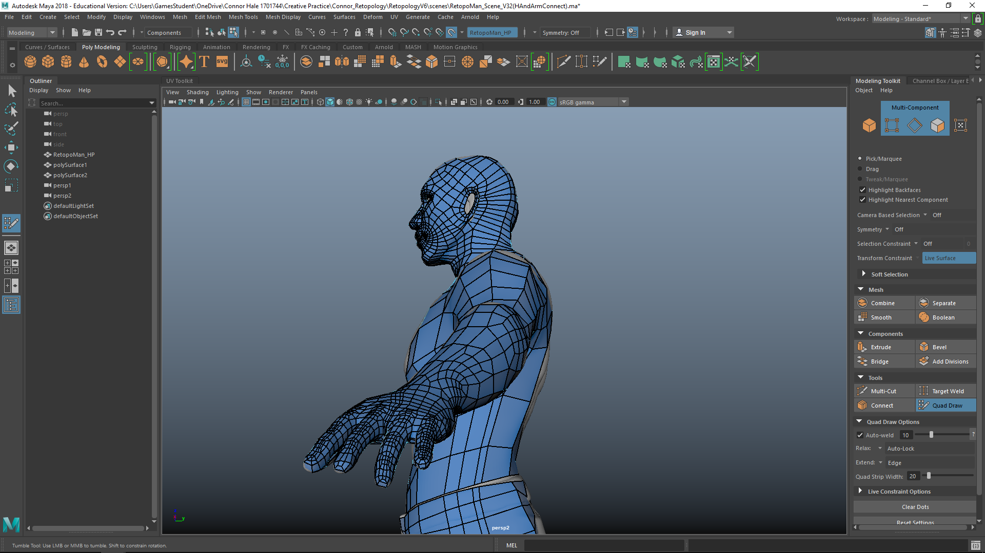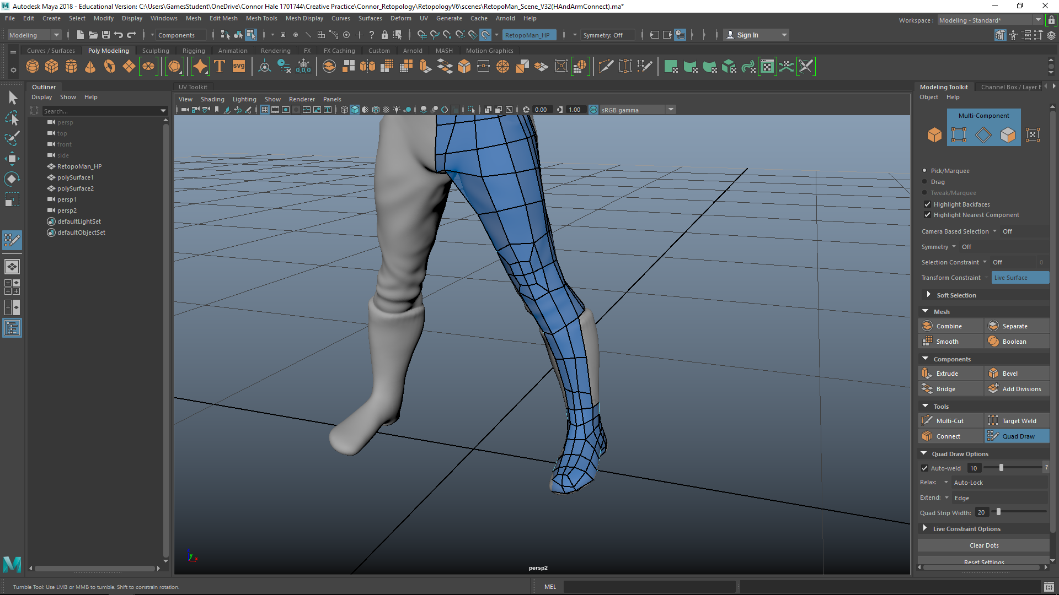
In my session in class I finished connecting the arms and legs. The first half of the session was re-doing the hand again to try and make the edge flow not spiral around the character. This version was my best way of stopping spirals, but I had to make the edge flow around the entire body for it to work. It is not perfect but it works for what I’m doing now since it actually connects to the arms.
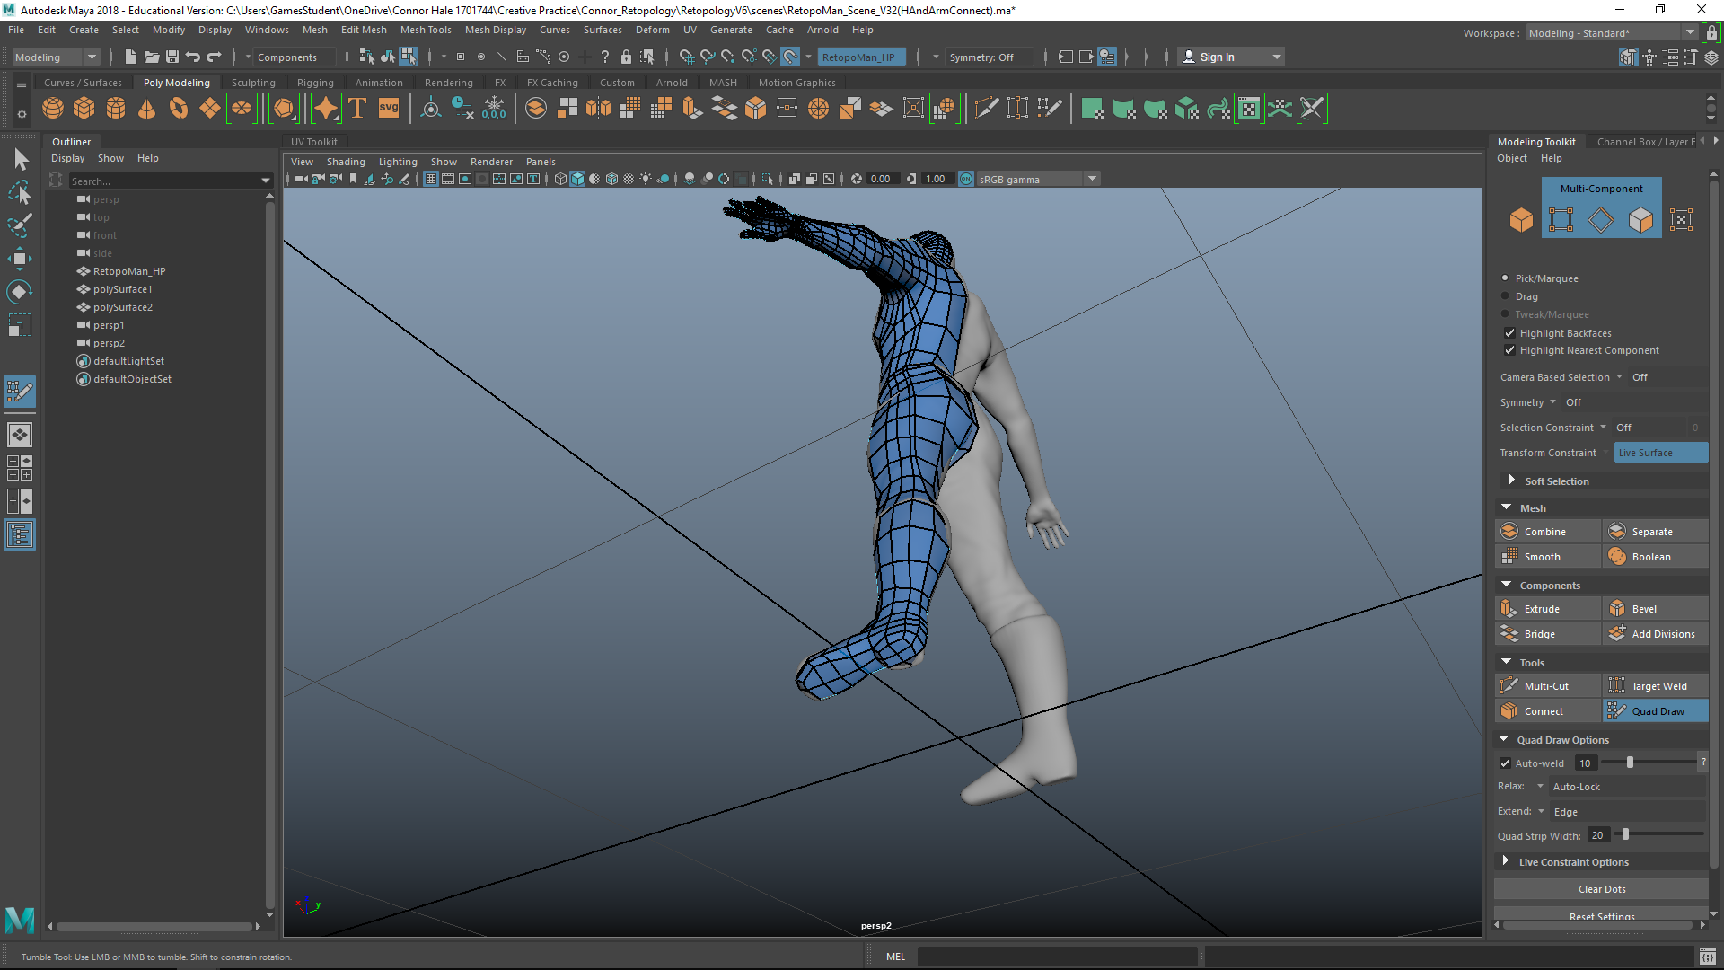
The second half of the session was me completing the foot and leg. This stage was easier than connecting the arm to the hand and took only 30 minutes to complete. Since this stage went easier than I had planned on my diary I should be slightly ahead of schedule and finish mirroring by next session. This gives me more time to practice on making a better body or to work on other class projects. In the future I can take this information and make a better plan when completing characters in the future.
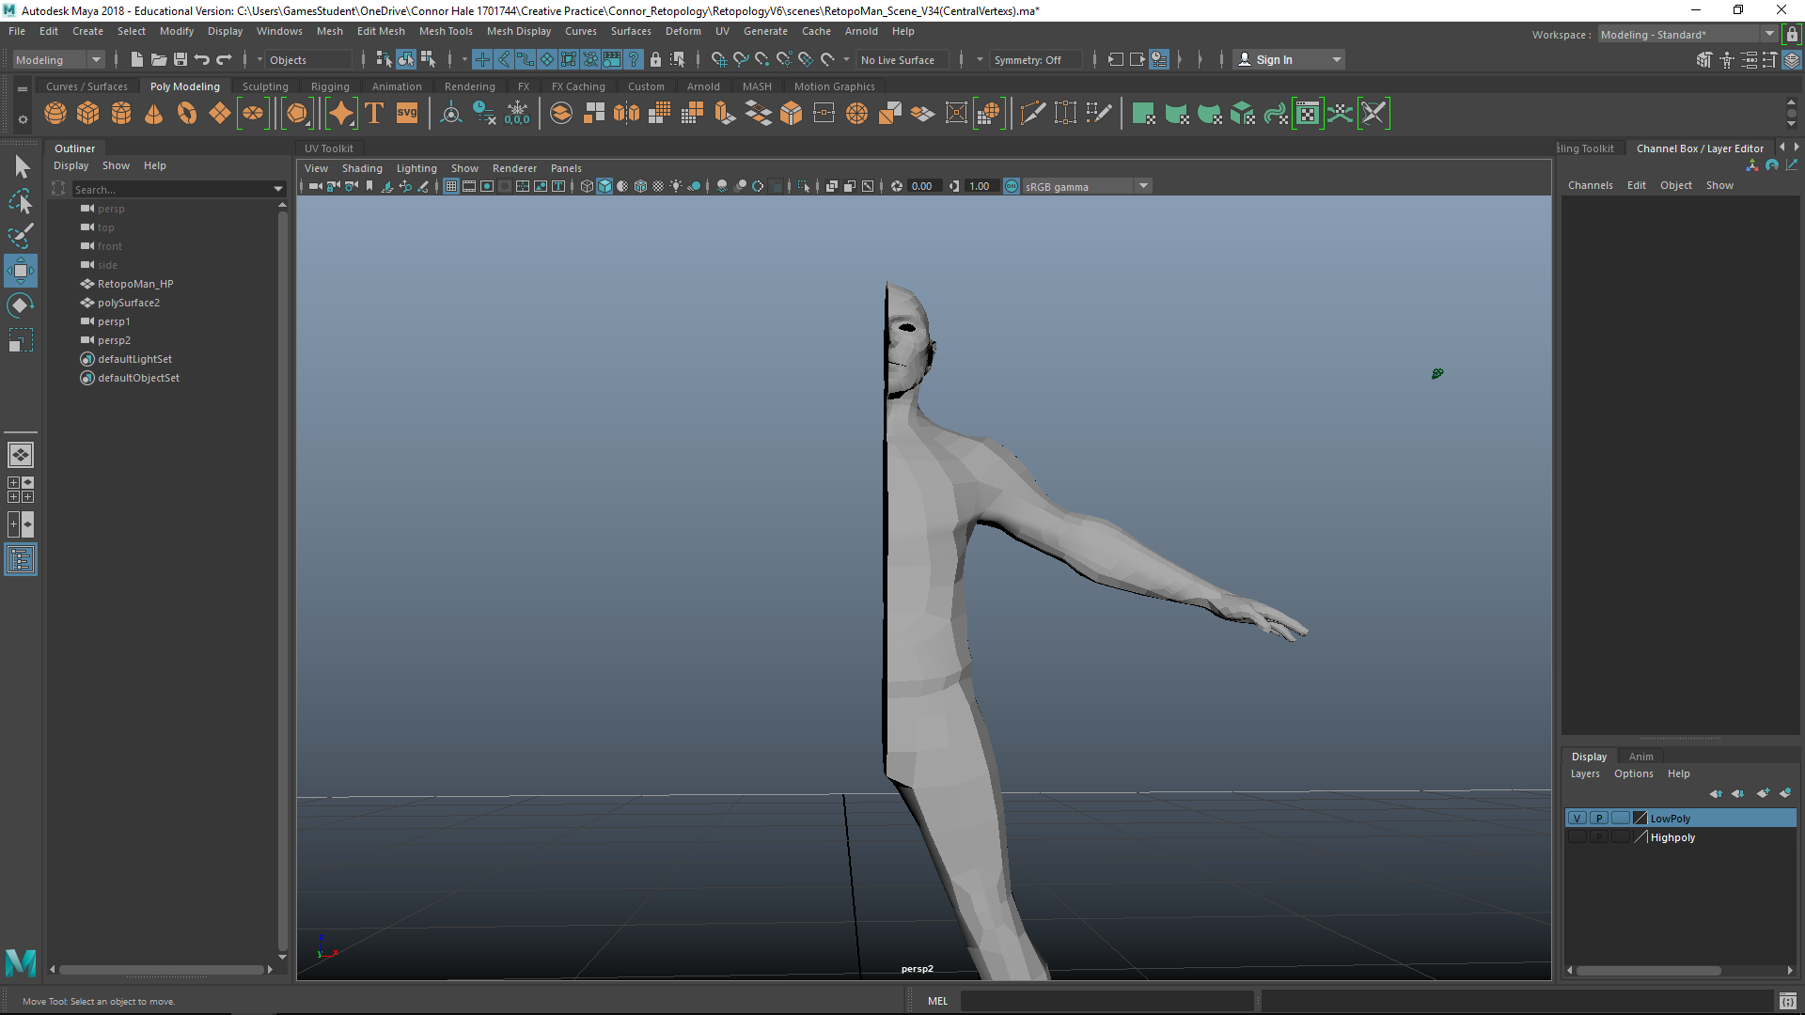
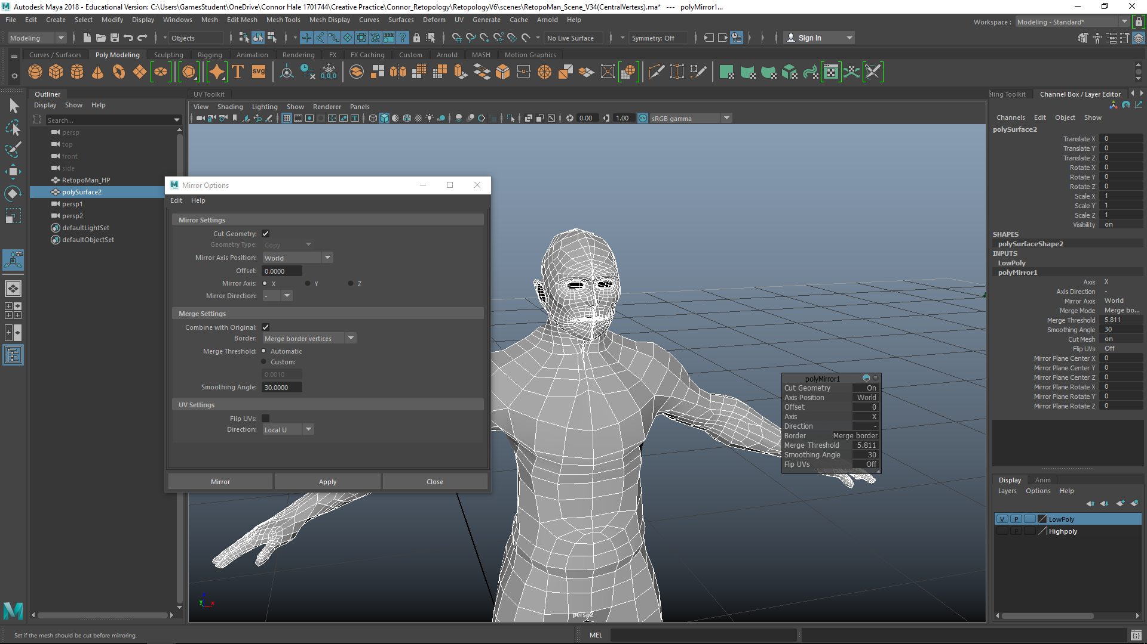
My next session involved me centring the model to prep for the mirroring process.

(My failed asset)
The model was too flat and I realised the mouse was set to a different setting and made the object flat. After two attempts I realised it was the mouse so I fixed it with “Ctrl + b” to reset the mouse. I then tried again to get it to work.
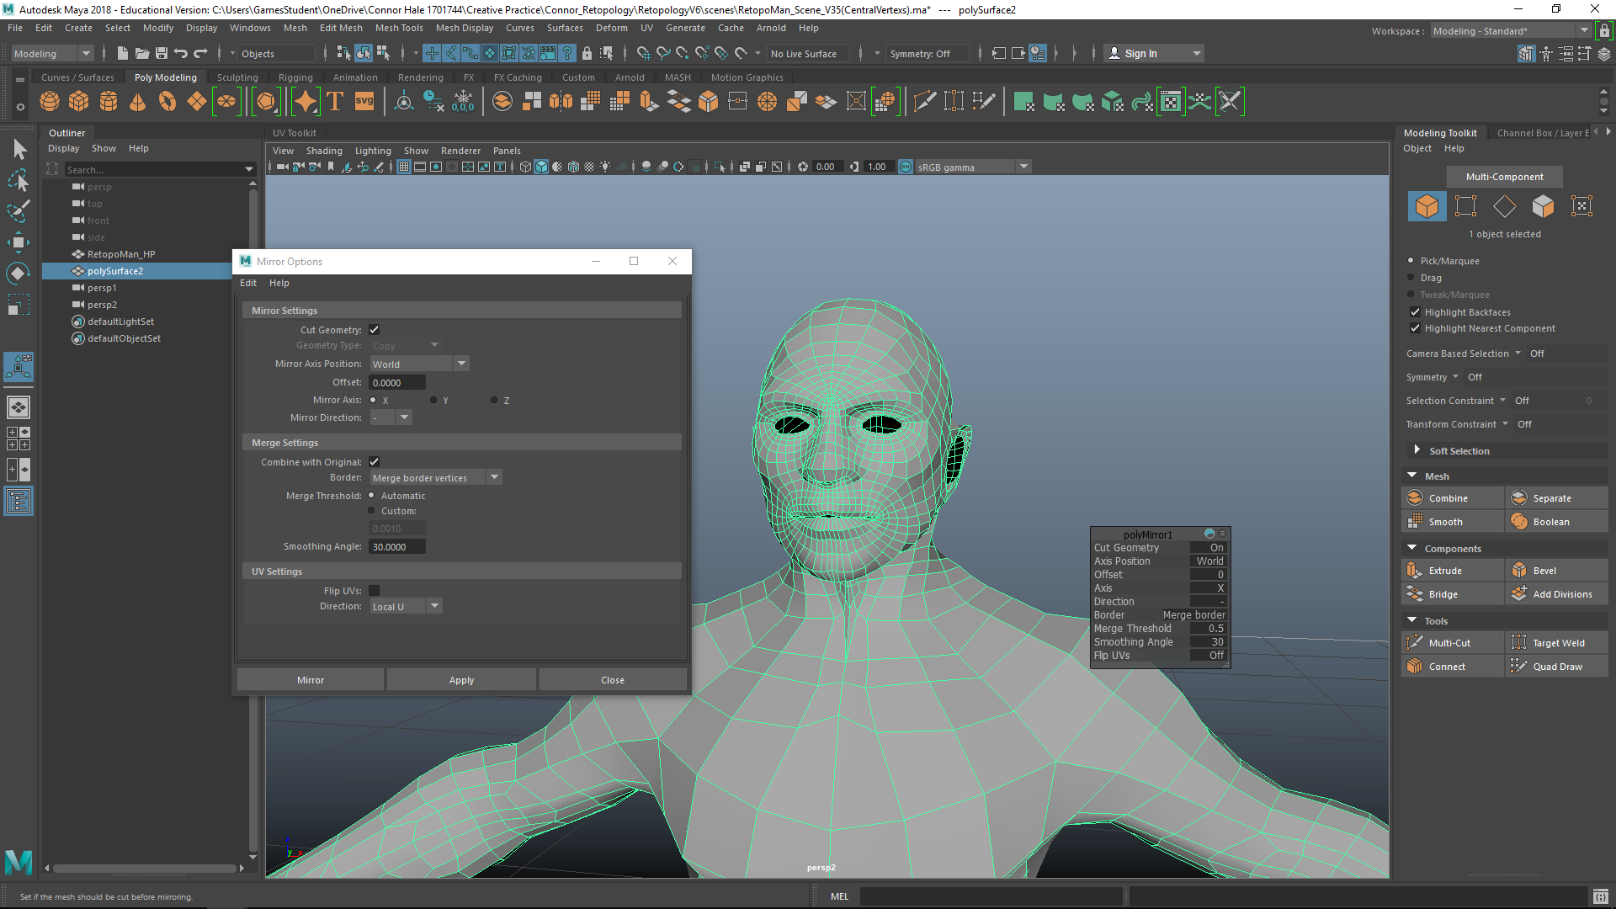
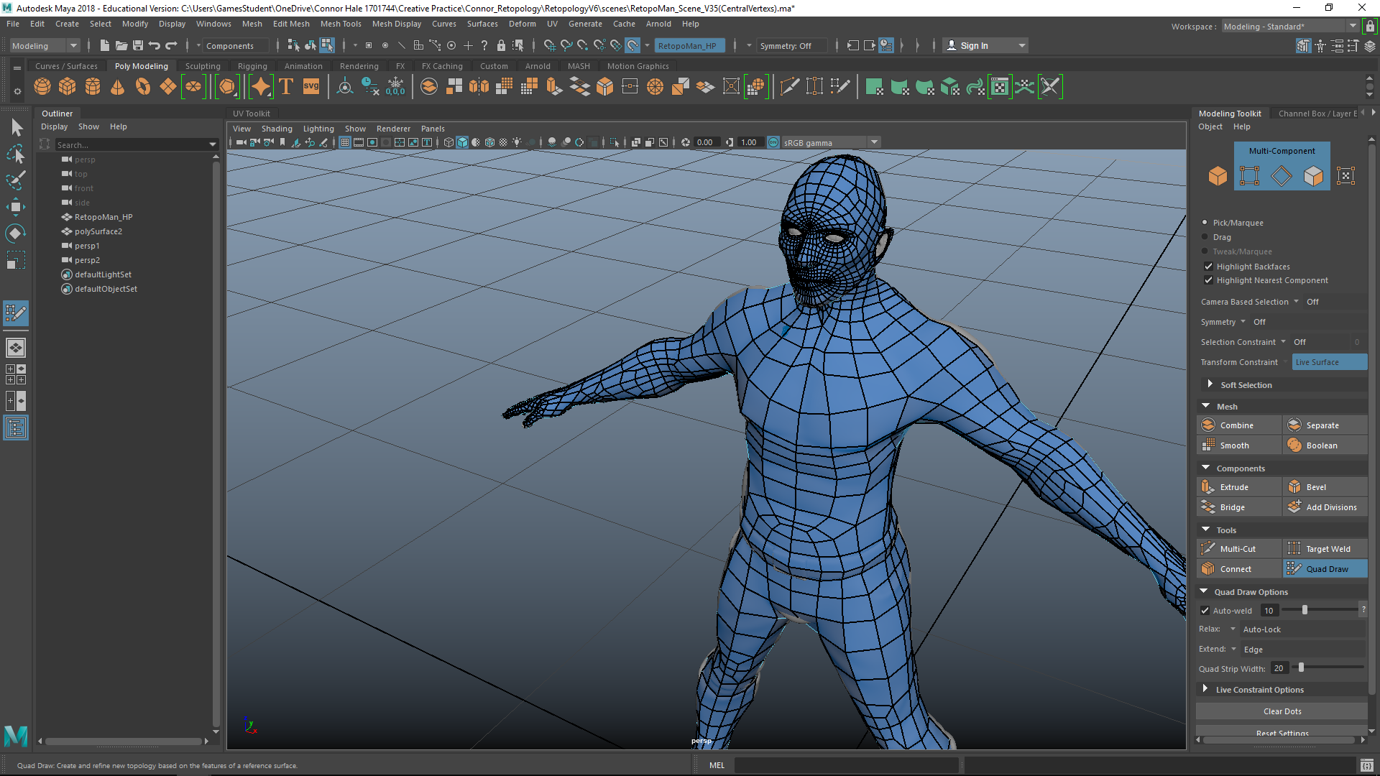
It turned out that it was the problem and my model turned out alright. After adjusting the “merge threshold“ the model turned out ok.

I then went into quad draw and tidied up the model using the smooth tool. I’m quite happy with how my end model turned out and I had only noticed one flaw in the entire edge flow of the object (in-between the middle and ring finger tendon) which spirals around the object and doesn’t flow around the character. Aside from that I’m happy with the edge flow of my character.
Creative Practice Week 9:
This week I didn’t have much to do in terms of retopoligising my character, so this week I covered my theory and reviewed my plan again.
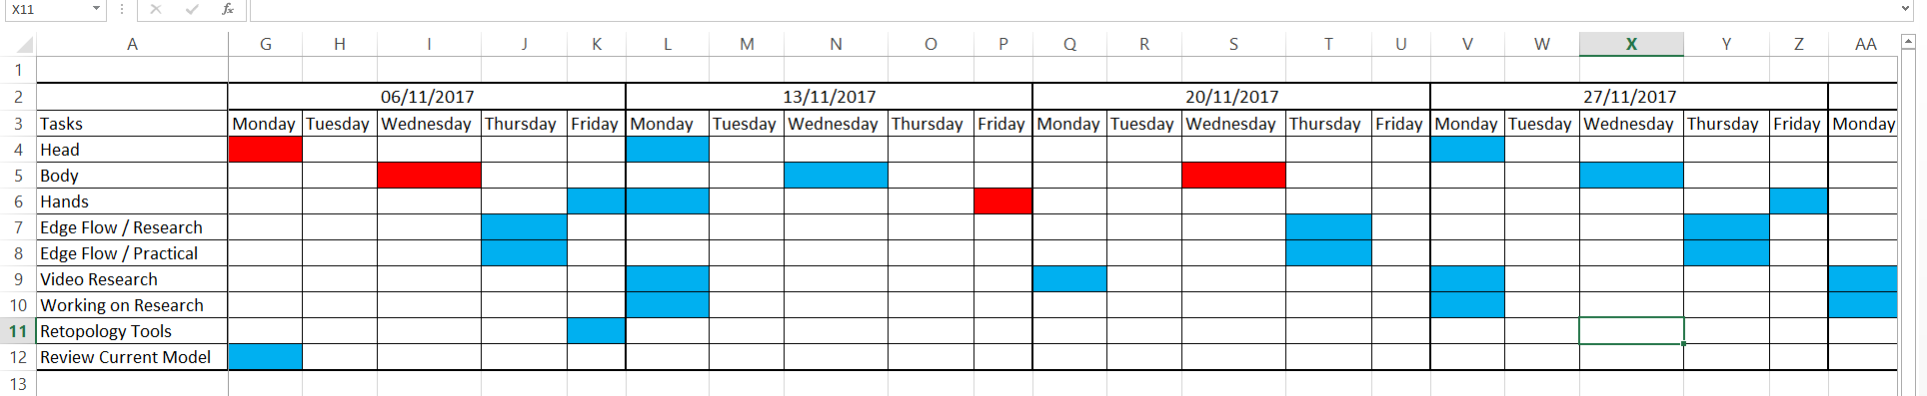
My plan had me doing work on my retopology for the 9th and last week. But since I had completed it before this I don’t need to work on my retopology in this time. I could have used this time as my risk assessment time, in the case that I corrupt my work. But since I hadn’t completed a retopologised character before I think the time allocated worked better than I had first expected.

Conclusion
Since I haven’t completed a retopology before I wasn’t sure how much time I should have set myself beforehand and I had to guess how much time I needed and stick to a plan. I think I had done well with sticking to my plan and also allocating time for my retopology character. In the future I can now plan a characters development more accurately and as I progress with making more characters, it won’t take as much time to complete.

Bibliography

  - Face Retopology References
http://wiki.polycount.com/wiki/FaceTopology -
https://hejiraproject.files.wordpress.com/2011/04/headtopologyflow.jpg -
https://www.youtube.com/watch?v=CIe0SEvK-sI -

  - Hand Retopology References
https://www.pinterest.com/pin/304978205998439246/ -
http://austins3dworld.blogspot.co.uk/2017/04/hand-retopology.html -
https://www.pinterest.com/pin/366339750910721457/ -
https://www.youtube.com/watch?v=bdafGU__lSc -
http://wiki.polycount.com/wiki/Limb_Topology -

  - Body Retopology References
https://www.youtube.com/watch?v=5UiyWP1QGTQ -
http://wiki.polycount.com/wiki/BodyTopology -
https://community.secondlife.com/image_extract/111233i54B61F2287D2427F.png -

