

Name: Nene Toure
Student ID: 2411571
Module Code: BMHP5023
Module: BMHP5023 Introduction to Physiology
Lecturer: Shaila Hussain
25th November 2025

BMHP5023: Case Study Report: Understanding Type 1 and Type 2 Diabetes in Health and Social Care

Introduction
Diabetes mellitus is a chronic metabolic and endocrine disorder that affects how the body uses glucose, its main source of energy. The condition occurs when the pancreas fails to produce enough insulin, or when the body’s cells cannot use it effectively. Insulin is a hormone made by beta cells in the pancreas, part of the islets of Langerhans, that allows glucose from food to enter cells to be used for energy.
When insulin is absent or ineffective, glucose builds up in the bloodstream, resulting in hyperglycaemia (high blood sugar). Chronic hyperglycaemia can damage nerves, blood vessels, and organs, leading to complications such as kidney failure (nephropathy), retinopathy (eye damage), neuropathy (nerve pain), and cardiovascular disease (NHS, 2024).
There are two main forms of diabetes. Type 1 diabetes (T1DM) is an autoimmune disease where the immune system destroys the beta cells, causing complete insulin deficiency. It often develops in children or young adults and requires daily insulin injections (WHO, 2023). Type 2 diabetes (T2DM) occurs when the body becomes resistant to insulin or the pancreas cannot produce enough to overcome this resistance. Type 2 is more common in adults, especially those who are overweight, physically inactive, or have a family history of diabetes (NICE, 2023).
According to Diabetes UK (2024), 4.3 million people in the UK live with diabetes around 90% with Type 2and a further 850,000 are undiagnosed. People of African, Caribbean, and South Asian heritage are at higher risk due to genetic predisposition and traditional dietary habits rich in carbohydrates and oils.
In health and social-care settings, professionals encounter many individuals living with diabetes who require ongoing monitoring, support with medication, meal planning, and emotional reassurance. Understanding the biological processes behind diabetes helps staff to deliver safe, person-centred care.

Blood Sugar Regulation
The regulation of blood glucose levels, known as homeostasis, involves the endocrine system and the pancreas. Two hormones insulin and glucagon work in balance to maintain glucose between 4 and 7 mmol/L.
After eating, carbohydrates are digested into glucose and absorbed into the bloodstream. The rise in blood glucose triggers beta cells to release insulin. Insulin acts as a “key” that unlocks cell membranes, allowing glucose to enter cells, where it is used for energy or stored as glycogen in the liver and muscles (Marieb & Hoehn, 2019).
When blood-glucose levels fall, alpha cells of the pancreas release glucagon, which signals the liver to convert glycogen into glucose (glycogenolysis) and release it into the blood. This ensures a steady energy supply between meals (Tortora & Derrickson, 2021).
In Type 1 diabetes, the body produces no insulin at all, leading to a dangerous rise in glucose and the breakdown of fat for fuel. This produces ketones, which can cause diabetic ketoacidosis (DKA) a potentially life-threatening emergency.
In Type 2 diabetes, insulin is still produced, but the cells become resistant to it. The pancreas initially compensates by releasing more insulin, but over time, beta cells become exhausted and insulin levels drop.
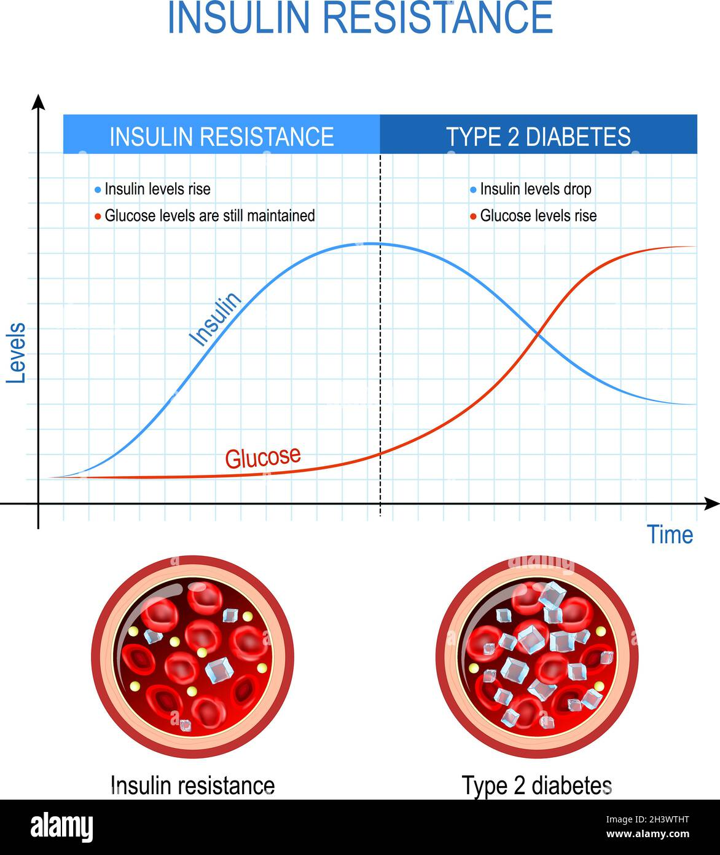 Alamy (2021)
Insulin Resistance and Type 2 Diabetes – Comparison of Insulin and Glucose Levels Over Time
Type 2 Diabetes Insulin Resistance and Glucose Regulation.
After eating, the pancreas releases insulin, but resistant cells fail to respond adequately, leaving glucose trapped in the blood.
In early stages, insulin resistance may not show symptoms. Over years, glucose levels remain high, leading to complications like foot ulcers and poor wound healing. The progression from insulin resistance to full Type 2 diabetes .

Case Example from Practice
Mr K, a 58-year-old man in supported accommodation, presented with fatigue, thirst, and frequent urination. His glucose was 14 mmol/L and HbA1c 76 mmol/mol. After GP review, he began metformin and joined a walking group organised by the support team. Staff helped him plan balanced meals, reducing sugary drinks and fried foods. Three months later, his HbA1c improved to 49 mmol/mol.
This example highlights how early detection, lifestyle change, and multidisciplinary teamwork prevent complications and improve quality of life.
For care workers, recognising early warning signs such as tiredness, increased urination, and blurred vision is essential for safeguarding service users.

3. Cellular Metabolism
All body cells require energy to perform functions such as muscle contraction, cell repair, and nerve signalling. This energy is generated by cellular respiration, the process by which glucose and oxygen are converted into adenosine triphosphate (ATP).

The Three Stages of Respiration
- Glycolysis Occurs in the cytoplasm; glucose splits into two molecules of pyruvate, releasing 2 ATP.
- Krebs Cycle (Citric Acid Cycle) Occurs in mitochondria; pyruvate is oxidised, releasing carbon dioxide and transferring energy to NADH and FADH₂.
- Electron Transport Chain (ETC) Occurs in the mitochondrial membrane; electrons pass through enzymes to produce up to 34 ATP.
Equation: C₆H₁₂O₆ + 6O₂ → 6CO₂ + 6H₂O + Energy (ATP)

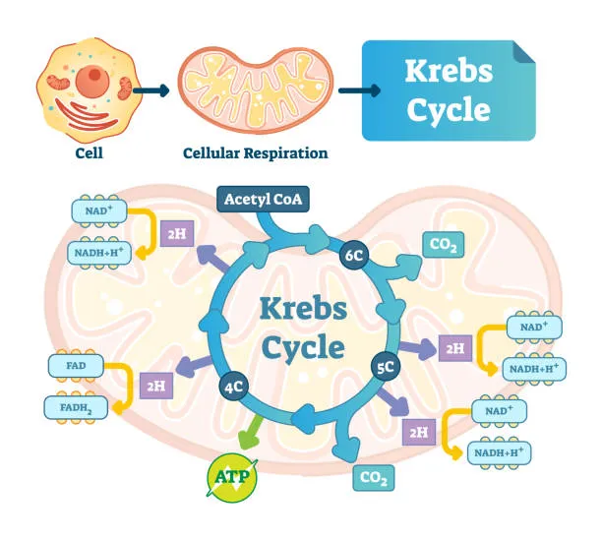
(PraxiLabs, 2023)
Cellular Respiration Conversion of Glucose to ATP.
Glycolysis, the Krebs cycle, and the electron-transport chain illustrate how glucose and oxygen produce ATP energy.

When insulin is absent or ineffective, glucose cannot enter cells, forcing the body to use fat for fuel. This produces ketone bodies, leading to acid buildup and fatigue. Energy deficiency explains why people with uncontrolled diabetes often feel weak and tired.
Example: Mrs A, a 72-year-old woman with T2DM, was found lethargic and confused. Her glucose reading was 22 mmol/L, and urine showed high ketones. Staff followed the emergency protocol: they offered fluids, recorded vital signs, and called for medical support. After treatment, her condition stabilised.
Understanding how glucose produces energy helps staff link physical symptoms (like tiredness or thirst) to internal physiological processes, improving observation and reporting.

Recording and Tracking Blood-Glucose Levels
Routine glucose monitoring is critical for managing diabetes. It helps identify abnormal trends, supports medication adjustment, and prevents complications such as hypoglycaemia (low glucose) or hyperglycaemia (high glucose).

Common Monitoring Methods
- Finger-prick testing using a glucometer for immediate results.
- Continuous Glucose Monitoring (CGM) sensors that send data to a smartphone.
- HbA1c blood tests, showing average glucose over 2–3 months (target ≤ 48 mmol/mol).

Example from Practice
Mr D, a man with mild learning disabilities, often forgot to check his glucose. One morning, he appeared disoriented and thirsty. A support worker tested his blood sugar 18 mmol/L and followed the care plan: offered water, notified the nurse, and documented the result. Early detection prevented deterioration.
Professional Link: As a support worker, Nene understands that accurate record-keeping, communication, and following protocols are key skills. Recording readings ensures information is shared with GPs, nurses, and families, promoting safety and continuity of care.
Digital tools such as Freestyle Libre make self-monitoring easier, promoting independence for people with physical or cognitive impairments (NHS, 2024). Staff must still verify accuracy and ensure clients understand how to use devices safely.

5. Recommendations for Effective Management

Healthy Diet
A balanced diet is the cornerstone of diabetes management. The Eatwell Guide (Public Health England, 2023) encourages fruit, vegetables, lean protein, and whole grains, limiting salt, sugar, and saturated fat.
Practical Example: For a West African client, staff could recommend brown rice instead of white rice, adding leafy vegetables such as okra or spinach, and reducing oil in stews. Such culturally sensitive adjustments make healthy eating realistic and sustainable.

Physical Activity
Exercise improves insulin sensitivity and circulation. The NHS (2024) recommends 150 minutes of moderate activity per week. In supported housing, staff can arrange morning walks or dance classes.
Example: Ms S, a 65-year-old woman with limited mobility, began chair-based exercise sessions. After six weeks, her blood pressure dropped, and her glucose stabilised. This example shows how adaptation encourages participation

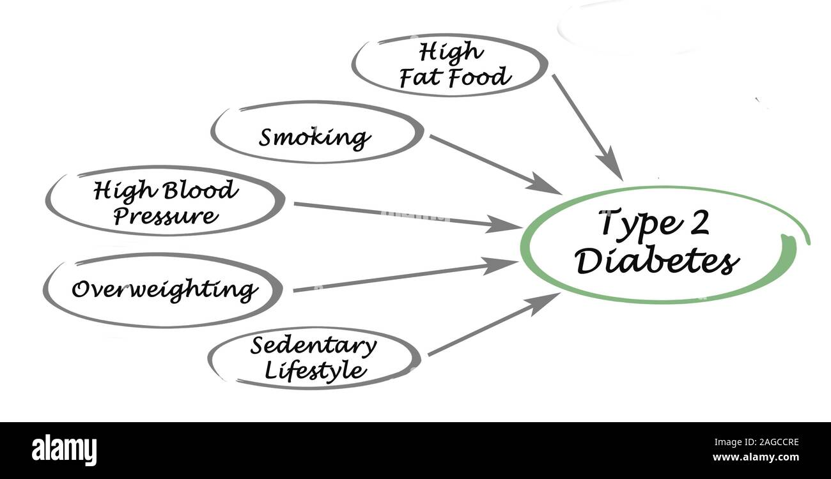Alamy (2012)
Type 2 Diabetes – Diagram showing risk factors such as high-fat food, smoking, high blood
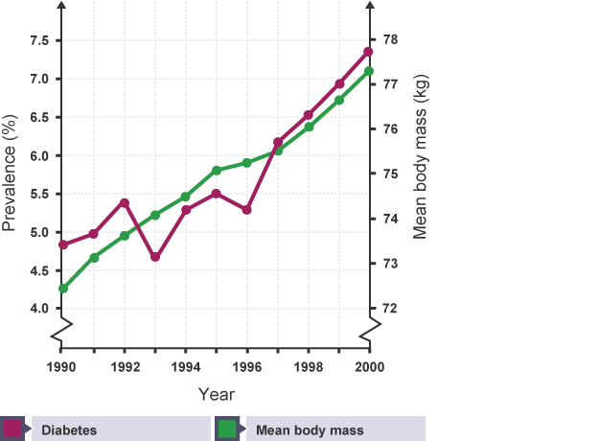
Alamy (2021) This graph visually shows the relationship between mean body mass (average weight) and the prevalence of diabetes over time

Smoking and Alcohol
Smoking and alcohol both worsen insulin resistance and increase heart-disease risk. Diabetes UK (2023) reports that smokers with diabetes are twice as likely to develop cardiovascular problems. The GP Lifestyle Questionnaire recommends a maximum of 14 alcohol units weekly. Support workers can offer motivational support, direct clients to stop smoking services, and discuss healthy alternatives like herbal teas or water.

Stress Management
Stress raises cortisol and adrenaline, leading to higher glucose (Harvard Health, 2023). Techniques like mindfulness, prayer, or breathing exercises help. Staff can include relaxation goals in care plans or encourage participation in social clubs to reduce isolation and stress.

Education and Self-Management
Education empowers people with diabetes to make informed decisions. The DESMOND programme (NHS England, 2023) provides structured sessions on diet, physical activity, and medication. Support workers can reinforce learning through repetition and simple explanations.
Example: Mr J, a man with learning difficulties, attended DESMOND training with staff support. He learned to test his glucose independently, improving his confidence and engagement.

Medication and Monitoring
Metformin remains the first-line treatment, reducing glucose production in the liver (NICE, 2023). Other medications such as GLP-1 receptor agonists or insulin may be prescribed. Support workers should observe for side effects like nausea, encourage adherence, and record readings consistently.

Person-Centred Care Planning
According to Writing a Good Care Plan (NHS, 2023), plans should set realistic, measurable goals for example, “walk 20 minutes daily” or “limit sugary drinks.” Regular reviews ensure accountability and adaptation when needed. Collaborative planning empowers clients to take ownership of their health. Healthline (2023) explains that excess body fat, particularly around the abdomen, releases inflammatory chemicals that reduce the body’s sensitivity to insulin. This process leads to insulin resistance, a key factor in developing Type 2 diabetes. Maintaining a healthy weight and regular exercise can significantly lower this risk.

Addressing Health Inequalities
People from low-income or ethnic-minority backgrounds may face barriers such as language or cost of healthy food. Health professionals must provide translated materials, culturally adapted advice, and community support. Equality in care is essential to ethical practice (PHE, 2023).

Collaborative and Holistic Care
Diabetes care is most effective when delivered by a multidisciplinary team that includes general practitioners (GPs), nurses, dietitians, psychologists, podiatrists, pharmacists, and social workers. Each professional plays a vital role: GPs oversee diagnosis and medication; nurses monitor glucose levels and foot health; dietitians provide nutritional advice; and social workers or support workers ensure that care plans are followed in the community. Collaboration between these professionals promotes consistency, safety, and continuity of care.
Support workers often act as a bridge between the medical team and the individual, translating medical recommendations into practical, daily routines. For example, they may remind service users to take medication on time, help plan balanced meals, record glucose readings, and offer emotional reassurance when individuals feel anxious or frustrated about their condition. This close daily support ensures that small problems such as skipped meals, low mood, or missed medication are noticed early and managed before they lead to hospital admission.
Holistic care views each person as a whole being, not simply a collection of symptoms or medical needs. It recognises that living with diabetes can affect physical health, mental wellbeing, self-esteem, and social relationships. For instance, individuals may feel isolated due to dietary restrictions or cultural misunderstandings. A holistic approach addresses these emotional and psychological dimensions, ensuring that interventions promote dignity, empowerment, and independence rather than dependence.
In practice, holistic support might involve arranging culturally appropriate meals, helping service users access community exercise groups, or coordinating care with family members to build a supportive network. Professionals should also consider social factors such as housing, financial stress, or access to transportation, which can all affect self-care and health outcomes.
This collaborative, person-centred approach reflects the core values of health and social care, including respect, equality, and compassion. By working together across disciplines, professionals provide integrated support that empowers individuals to take control of their diabetes, maintain independence, and enjoy a better quality of life.

Conclusion
Diabetes mellitus is a complex but manageable condition that affects millions worldwide. It results from either autoimmune destruction of insulin producing cells (Type 1) or insulin resistance (Type 2). Both lead to high blood glucose and long-term complications.
Understanding the physiological processes such as insulin secretion, glucose regulation, and cellular respiration enables health and social-care professionals to provide safe, evidence-based care. Regular monitoring, education, and lifestyle support are essential.
Professionals like support workers play a vital role in observation, motivation, and daily assistance. By practising compassion, clear communication, and teamwork, they empower individuals to manage diabetes effectively and live healthier, more independent lives.

References
Alamy (2025) Type 2 diabetes: illustration showing insulin resistance and high blood-glucose levels (Image ID: 337104978). [Online image]. Available at: https://www.alamy.com/type-2-diabetes-image337104978.html (Accessed: 28 November 2025).
Alamy Stock Photo (2025) Type 2 Diabetes – Insulin Resistance and Glucose Regulation (Image ID: 2H7WX37). [Online image]. Available at: https://www.alamy.com (Accessed: 28 November 2025).
Alamy Stock Photo (2025) Insulin Resistance and Type 2 Diabetes Comparison (Image ID: 2H3WTHT). [Online image]. Available at: https://www.alamy.com (Accessed: 28 November 2025).
BBC Bitesize (2024) Homeostasis: blood glucose regulation and diabetes. BBC. Available at: https://www.bbc.co.uk/bitesize/guides/z8t47p3/revision/5 (Accessed: 28 November 2025).
Diabetes UK (2023) Smoking and Diabetes. Available at: https://www.diabetes.org.uk (Accessed: 28 November 2025).
Diabetes UK (2024) Diabetes Prevalence Statistics. Available at: https://www.diabetes.org.uk (Accessed: 28 November 2025).
Guyton, A. and Hall, J. (2020) Textbook of Medical Physiology. 14th ed. Philadelphia: Elsevier.
Harvard Health (2023) Stress and Blood Sugar. Available at: https://www.health.harvard.edu (Accessed: 28 November 2025).
Healthline (2023) What Impact Does Obesity Have on Insulin Resistance? Available at: https://www.healthline.com (Accessed: 28 November 2025).
Marieb, E. and Hoehn, K. (2019) Human Anatomy and Physiology. 11th ed. Harlow: Pearson Education.
NHS (2024) Living with Diabetes. Available at: https://www.nhs.uk (Accessed: 28 November 2025).
NHS England (2023) DESMOND Programme. Available at: https://www.england.nhs.uk (Accessed: 28 November 2025).
NICE (2023) Type 2 Diabetes in Adults: Management (NG28). Available at: https://www.nice.org.uk (Accessed: 28 November 2025).
PraxiLabs (2023) The Krebs Cycle: A Step-by-Step Explanation. PraxiLabs. Available at: https://praxilabs.com/en/blog/2023/01/02/krebs-cycle/ (Accessed: 28 November 2025).
Public Health England (2023) The Eatwell Guide. London: Public Health England (PHE).
Tortora, G. and Derrickson, B. (2021) Principles of Anatomy and Physiology. 16th ed. Hoboken, NJ: Wiley.
World Health Organization (2023) Global Report on Diabetes. Geneva: World Health Organization (WHO).

