
<Applying Computational and Logical Thinking to Propose a Solution to Online Grocery Deliveries>
Laurel Black
Analysing and Solving Problems – Computing
University of Wales Trinity Saint David

Date of submission 09th January 2026
Abstract
Online grocery delivery companies face challenges regarding delivery efficiencies, fuel consumption concerns, with studies supporting the necessity of timely and efficient delivery orders for the companies and customers involved.
Solutions will be logically proposed to ensure successful optimisation of routes and orders, focusing on the online delivery service GrocerQuick in particular.
Contents
 | Page Number
Introduction | 3
Deconstruction | 3
2.1 MoSCoW Requirements | 3-5
Solution | 5-7
Conclusion | 7-8

1. Introduction
To optimise online grocery services, requirements and constraints will be calculated with methods including abstraction, deconstruction, algorithmic thinking, deconstruction; a series of simplified, broken-down procedures to make the process well defined to solve the problem proposed. The MoSCoW method and charting will be included to define the proposed procedure and solution.
Computational thinking will also be generalised and considered to propose a solution to the problem.
2. Deconstruction
To consider the most efficient solution regarding optimisation of online grocery deliveries, computational thinking and logical problem solving will be considered.
Computational thinking has been used prior to the age of computing and can be considered for many fields.
Modularization will be considered. P. Denning and M. Tedre state that modularization is the necessity to divide things into smaller, manageable pieces. Additionally, a practice that became known as “data abstraction” is considered; a design with the organisation is proposed, and finding the most appropriate data structure for the task was key for finding an algorithm [1].
When modularisation and data abstraction is considered for the task proposed, the MoSCoW method is the most efficient choice to solve the delivery problem.
2.1 MoSCoW Requirements
The MoSCoW method is the prioritisation technique we will be using to focus on our resources for resolving difficulties regarding the management of delivery routes and fuel consumption.
Peet recommends that the MoSCoW method succeeds in a cost effective manner on a universal scope of projects, that will be able to deliver valuable change early, additionally, collaboration and improved teamworking regarding a project [2]

Table 1. The MoSCoW Method
Must Haves | Should Haves | Could Haves | Won’t Haves
Website with timetable booking system  Correct stock accuracy on website in accordance with grocery store stock  Fully and correctly allocated staffing  Staff and Delivery timetable system  Geography/postcode set limit variables  A click and collect option to ease bandwidth of deliveries | Mobile/App access  Limited time slot reservation. Hold a customer’s basket for a set amount of hours/days, with the option of payment to confirm booking  cut off time for some shorter notice delivery orders  Procedure in place in an event of customer not answering door or being in, such as a card for the letterbox to reschedule delivery efficiently  Customer communications via email, text, app website etc | Staff allocation to routes, using a system to isolate certain customer delivery areas (for example, by postcode per delivery driver)  easy FAQ/contact us navigation if items are missing, late or any other delivery issues experienced by customer  Predictive analytics to predict peak order times for efficient allocation  Last-Mile logistics solutions; third party delivery providers and route optimisation software  Tracking features | Peak/Off Peak Allotments with varied pricing  Same day deliveries at a premium rate for eligible locations  Feedback and review service  social media  Customer loyalty scheme compatible  Carbon considerations:  Bagless deliveries  Scheme for order minimums  Delivery passes
Table 1 shows that must haves are non-negotiables. ‘Could Haves’, as they are used in the MoSCoW method, are worth considering. For example, the CMA shows that 97% of shoppers are a member of supermarket loyalty schemes, and on average shoppers are members of 3 supermarket loyalty schemes [3]. However, as this does not show any evidence in prioritising delivery efficiencies, this priority can be excluded for GrocerQuick, allocating this factor into the ‘Won’t Haves’.
Additionally, in the ‘Could Haves’ have included methods offering delivery opportunities for customers within drivers set locations, such as Sainsbury’s greener grocery delivery [4]. Although offering a scheme which may improve efficiency and carbon footprint for driving routes, it is more important to prioritise our ‘Must Haves’ and ‘Should Haves’ first to solve delivery efficiency.
3. Solution
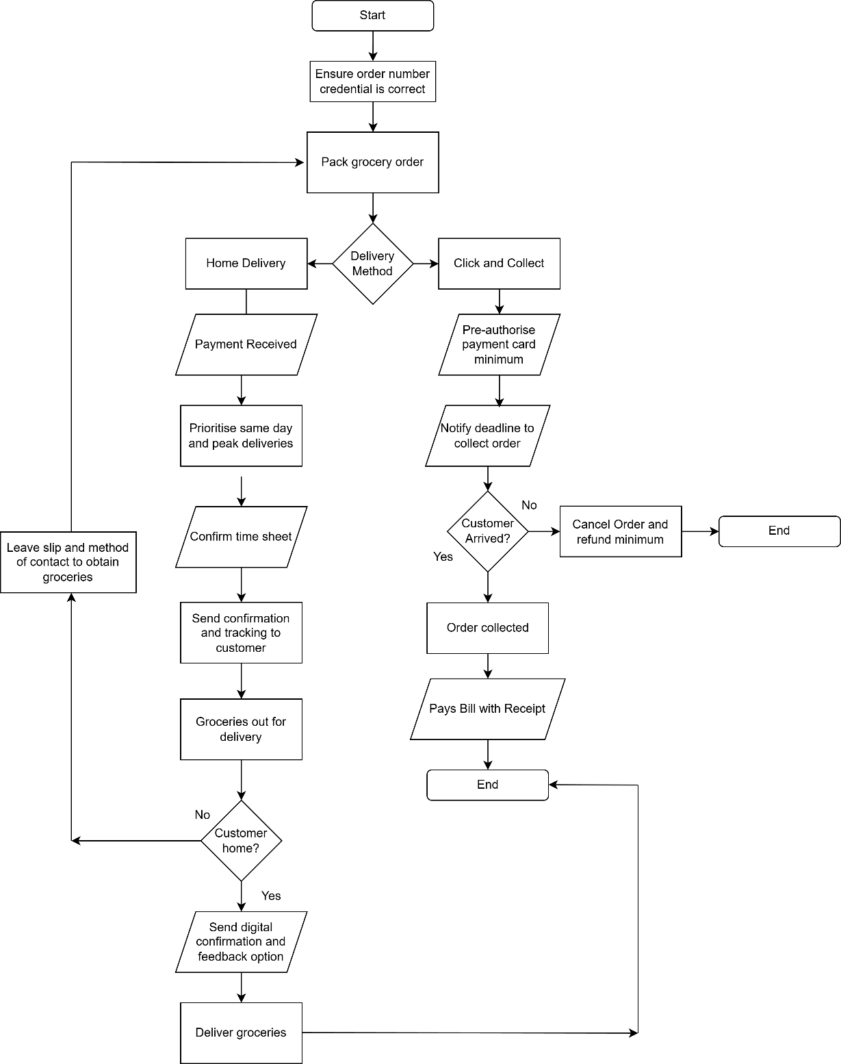

Figure 1. Flowchart representing an algorithmic solution to the proposed problem.
Considering deconstruction and the use of prioritisation methods, deciding on the MoSCoW requirement method as the most appropriate choice, as shown in Figure 1, a solution can now be proposed. Prioritisation methods can be elaborated upon, including factors that could not be justified using the MoSCoW method.
Dall’Acque stresses the importance of strategic research to avoid failure and minimise risk [5].
Ensuring the customer’s order number is correct before packing the delivery reduces the risk of incorrect order details or credentials. Reducing the risk of errors and will permit a smoother flow of workload prior to preparing the order; It was shown according to Deliverect that retailers that improved their picking and packing processes saw a 25% reduction in the time it took to prepare orders for delivery [6].
Both online grocery deliveries and click and collect methods are offered on a widespread basis by major grocery retailers and smaller retailers alike.
Click and collect is not only beneficial to distribute an efficient workload for timely grocery deliveries. Tesco, the largest online grocer in the UK, doubled its online ordering slots to 1.2 million per week between March and May 2020 and other retailers increased theirs by 50% over a similar period, taking on additional staff to meet this demand [7]. Our method confirms offering click and collect is a top priority to consider.
according to M. Piecyk at al at Westminster University, grocery deliveries are more successful with the use of time slots and booking systems. Use of this method makes the chance of failed delivery rates, including the risk of no-one at home to receive the delivery, low [7].
A last-mile delivery van making multiple drops that the total shopping vehicle kilometres (i.e. personal travel plus last-mile trip) can be reduced by 60-80%, depending on drop-density and van load factor. Additionally, introducing methods such as Click and Collect proposes efficiency in allocating grocery orders, which is offered by a majority of online grocery retailers [7].
Retailers that implemented last-mile solutions saw a 20% improvement in delivery reliability, with on-time deliveries increasing to nearly 95% [6].
Regarding Home Deliveries, prioritisation of workloads and staff are critical to ensure efficient deliveries, fuel consumption and schedule sorting; geographical conditions should already be considered and set prior to offering home delivery, in line with staffing availability.
In consideration of ensuring the highest efficiency and success rate of deliveries, automated communication systems should be considered throughout the procedure of all grocery delivery methods; 67% of customers are more accepting of delays when adequately informed throughout the process [6].
Include an order confirmation, a consideration to update on packing updates, successfully out for delivery, followed by providing the customer with a receipt.
Applying a computational thinking approach to solve the problem, we simplify the processes. However, L. Dall’Acque also stresses necessity towards intellectual discipline, creative flexibility, and open mindedness for a successful outcome.
It is also necessary to implement consideration of the customers for strategic intelligence, known as SI. Management should consider participating in the strategy process regarding a knowledge and understanding of the customers and all members involved to the strategic analysis [5].
Feedback, or a pathway for Frequently Asked Questions should be considered. Although execution of all structures and priorities proposed should minimise the chance of unsuccessful deliveries, professional development of communications such as social media could both mutually benefit customer satisfaction as well as professional strengths.
Social Media has the potential to be a consideration to improve customer communications and connections [5]. MoSCoW however represents this as a less significant priority as this could be less relevant regarding delivery and fuel efficiency.
There are competitive records regarding offering low delivery or free deliveries despite costs involved in picking and delivering goods to customers. It is not a priority for problem solving driving efficiency or fuel consumption, and may in fact increase the fuel consumption and delivery efficiency due to a potential increase in smaller, more frequent Last-Mile deliveries [7].
Prioritisation methods failed to show any improvement on delivery solutions regarding energy use and CO2 emissions. However, UK policy commitments to reduce greenhouse gases (GHG) in the UK and many other countries require the road freight industry to achieve major change in relation to this aspect of vehicle activity. The UK’s government’s commitment to bring all GHG emissions to net zero by 2050 [7].
4. Conclusion
Delivery time reliability is crucial for retaining customers and building loyalty. With online grocery shopping on the rise, customers expect fast, accurate, and dependable deliveries. A recent study showed that 64% of customers would switch to another retailer if their groceries were delivered late more than once [6].
This report has set out to propose logical strategies and solutions to provide to the problems addressed from GrocerQuick.
In this investigation, the aim was to assess solutions for GrocerQuick. Exercising logical thinking methods such as computational thinking (CT) and the MoSCoW method. Proposing solutions such as click and collect may distribute grocery orders and staff more effectively; while reducing fuel consumption
Applying a five-dimensional model to Computational Thinking skills successfully includes defining the problem with elements such as abstraction and decomposition, to understand the problem [8]. Decomposition is used to divide the problem into smaller solvable problems. The method we found most appropriate for this was the MoSCoW method.
Fig 1 demonstrates an algorithmic solution to the problem. What can be clearly seen in this figure is the general pattern that the workload can be more effectively allocated between methods such as home delivery, as well as click and collect, in an efficient and complimentary manner for the proposed problem.
The most important limitation lies in the fact that QrocerQuick may be hesitant to consider offering Click and Collect. The findings support the recommendation for the proposed problem. Relevant allocations should be considered to evaluate this solution.
Additionally, concerns such as carbon emissions and CO2 were discovered in the findings. Although little correlation was shown to improve delivery efficiencies, it may need to be a consideration for alternative concerns.
The result of this investigation shows that generalisation has been used in accordance to complete the five-dimensional model of Computational Thinking [8], to successfully propose a solution to optimise the deliveries of GrocerQuick.
This report adds to the growing body of research that indicates success in the considerations proposed to solve the problems proposed by GrocerQuick, with the effectiveness of logical thinking. Methods such as click and collect and last mile deliveries.
Methods decided upon such as the MoSCoW method shows that other considerations were lower on the prioritisation table and thus less logically relevant to solve the issue.
Further studies might explore considerations that could not be prioritised at this time, such as greenhouse gas (GHG) emissions.

References

[1] | P. J. Denning, M. Tedre, “Computational Thinking: A Disciplinary Perspective,” EBSCOhost Education Source, vol. III, no. 20, pp. 374-375, May 2021.
[2] | C. Peet, “What is MoSCoW Prioritization?,” LinkedIn Learning, 2 November 2023. [Online]. Available: https://www.linkedin.com/learning/what-is-moscow-prioritization/applying-moscow-prioritization?. [Accessed 27 December 2025].
[3] | Competition & Markets Authority, “Research and analysis Executive summary,” Competition & Markets Authority, 27 November 2024. [Online]. Available: https://www.gov.uk/government/publications/review-of-loyalty-pricing-in-the-groceries-sector/executive-summary. [Accessed 27 December 2025].
[4] | Sainsbury's, “Enjoy greener grocery delivery,” Sainsbury's Supermarkets Ltd, 2025. [Online]. Available: https://www.sainsburys.co.uk/webapp/wcs/stores/servlet/gb/groceries/get-ideas/features/enjoy-greener-grocery-delivery. [Accessed 28 December 2025].
[5] | L. Dall'Acqua, Computational Thinking for Problem Solving and Managerial Mindset Training, Italy: Hershey: IGI Global, 2021, pp. 95-203.
[6] | Deliverect, “7 Proven Strategies for Grocery Retailers to Improve Delivery Time Reliability,” Deliverect, 26 September 2024. [Online]. Available: https://www.deliverect.com/en-gb/blog/fmcg-and-grocery/7-proven-strategies-grocery-retailers-to-improve-delivery-time-reliability. [Accessed 27 December 2025].
[7] | M. Piecyk, J. Allen, A. Woodburn, M. Cao, “Online Grocery Shopping and Last-Mile Deliveries,” Westminster University, City of Westminster, 2021.
[8] | T. Palts, M. Pedaste, “A Model for Developing Computational Thinking Skills,” Informatics in Education, vol. I, no. 19, pp. 114-125, 2020.

