

Module Name: Introduction to Public Health
Assignment Title: Supporting paper Task2
Module Code: LCHS4004_LON
Student Name: Victoria Oltean
Student ID: 2212115
Lecturer Name: Laila Surani

Table of Contents
Introduction....................................................................................................................................3
Strategies Used in the UK to Measure the Incidence of Tuberculosis..........................................4
Strategies Used in the UK to Monitor the Incidence of Tuberculosis............................................5
Strategies Used in the UK to Control the Incidence of Tuberculosis.............................................6
Conclusion.....................................................................................................................................7
References....................................................................................................................................8

Introduction
Tuberculosis (TB) is a bacterial infection that spreads through inhaling small droplets from the coughs or sneezes of infected people. While it mainly affects one’s lungs, it can also affect other parts of the body, including the abdomen, glands, bones and the nervous system. TB is a potentially serious condition, but it can be cured if he right antibiotics are being administered (NHS, 2019).
Worldwide, 1.6 million people died from tuberculosis in 2021 only, while 10.6 million have been infected, and the disease is the 13th leading cause of death. One important factor to be considered is that over 80 percent of the deaths happened in low and middle-income countries, where the healthcare system is not developed well and funding is much tighter (WHO, 2022).
People born outside the UK are at much higher risk than people born in the UK, and in 2021, there were 4,425 people with TB in England corresponding to a rate of 7.8 per 100,000 population (GOV, 2022).
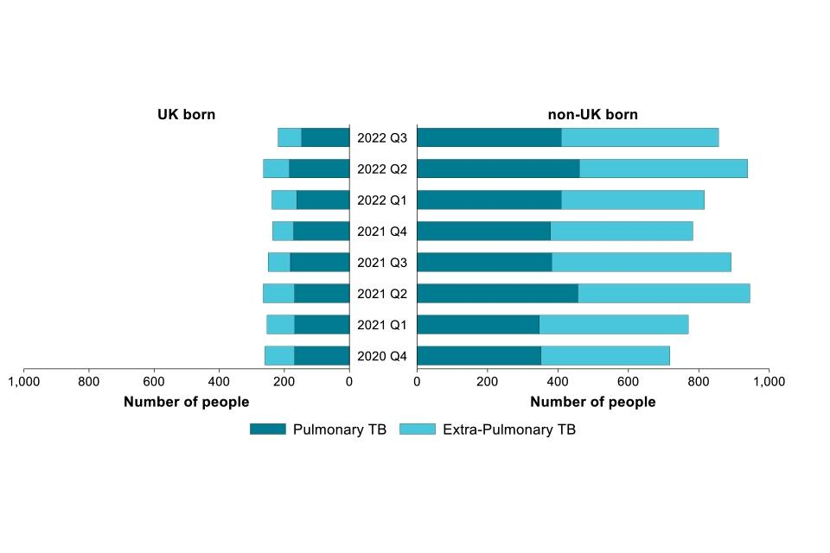
Figure 1. People infected with tuberculosis born in the UK and non-UK born (Official Statistics, 2023).

Strategies Used in the UK to Measure the Incidence of Tuberculosis
The main symptoms of tuberculosis include night sweats, weight loss, high temperature, loss of appetite, fatigue, and a persistent cough that lasts for longer than three weeks. People infected with tuberculosis have most probably been exposed for a longer period to someone that suffers from the disease, or have a weak immune system. The TB can also be latent in the body, and is not infectious, and people can leave with it without any complications. Tuberculosis can be treated or prevented. Prevention will involve a vaccine, that is usually administered to children, but adults under 35 can also benefit from it if they are believed to be at risk. The groups at risk of infection will include children living in areas with high rates of TB, people with family members from countries with high TB rates, and people going outside of the country in areas with high TB rates for longer than 3 months. Treatment for TB will consist of antibiotics taken for at least 6 months, which might be changed if the body is immune to certain antibiotics (NHS, 2019).
People infected with TB should always take precautions even during their treatment, as they might be contagious for weeks still. The World Health Organisation (2022) has introduced a new target that focuses on ending the TB pandemic by 2030, which comes with a series of measures including early detection, vaccinations, and access to treatment in the early stages.
For instance, we have discussed the case of Mr. Patel, who has suffered from a productive cough for over two months, has night sweats, lost 5-kg, has a loss of appetite, and fever, and who has admitted to A&E as his symptoms worsened. As his GP referred him to A&E a week prior due to the symptoms he has, the healthcare system failed to take the necessary measures in treating him, as prescribing antibiotics. As Mr. Patel is sharing a flat with five other people, and a room with two others, he must be isolated and his flat mates should test for TB as well, as they have been exposed to the infection for over two months. As we know, people born outside the UK are more prone to the infection, and also Mr. Patel might consider the BCG vaccination as he is under the age of 35 and qualifies for it.

Strategies Used in the UK to Monitor the Incidence of Tuberculosis
According to the European Centre of Disease and Control (2022), EU countries were very close to reaching the target for reduction in number of TB deaths by 35% against the 2015 baseline, but the existing downward trend in TB mortality halted in 2020 due to the COVID-19 pandemic, which ultimately compromised achievement of the target. Similarly, the UK has reported that theer was a decline in TB cases until 2019, and between 2020 and 2021, the rate increased again by 7.3 percent. Even if England is a low-incidence country, the majority of people infected have been born outside the UK, and TB is more common in urban areas, with London having about 35 percent of the cases, which is 1569 people (GOV, 2022).
The Department of Health in the UK has introduced several strategies of monitoring tuberculosis, such as creating maps for regions that support local areas in assessing local TB service needs, developing local TB action plans and monitoring the progress in achieving the ambitions of these. Additionally, information is easily accessible for everyone, and healthcare facilities are promoting awareness when it comes to identifying the symptoms and get treatment in time.

Strategies Used in the UK to Control the Incidence of Tuberculosis
Controlling the spread of the disease can be a very challenging task, especially in low or middle-income countries. However, in the UK, the incidence of TB is quite low, with more cases of people infected being born outside of the country. Mr. Patel has been born in Bangladesh, which is a high-risk country according to international statistics, this being a big factor in the case study analysed, and also the fact that he has arrived in the UK recently.
The UK Government (2022) has highlighted the importance of multi-stakeholder collaboration as essential to the implementation of the action plan, including support for staff and action on inequalities, and also the intervention of primary care, integrated care boards, and local authorities in the control of TB. The main priorities of the Action Plan implemented in the UK focus on the recovery from Covid-19, the prevention of tuberculosis, its detection, the control of the disease, and developing and maintaining a healthcare workforce that will have the capacity to manage TB in all its aspects.

Conclusion
The prevalence of tuberculosis has seen an increase in the last few years, and one of the main causes is the spread of Covid-19 and the relevant connection between the two. With UK being a multicultural country, the incidence of TB is not easy to monitor and control. A central tool to support the action plan is the national tuberculosis surveillance system that is meant to support the monitoring of the prevention and control efforts in England and informs service improvement.
One of the main areas of improvement is developing the healthcare system and lowering the incidence of the disease all around the country, by reducing the wait time for diagnosis and treatment, and by promoting awareness of TB in communities.

References
European Centre for Disease Prevention and Control (2022). Tuberculosis surveillance and monitoring in Europe 2022 –2020 data. [online]
European Centre for Disease Prevention and Control. Available at: https://www.ecdc.europa.eu/en/publications-data/tuberculosis-surveillance-and-monitoring-europe-2022-2020-data [Accessed 29 Mar. 2023].
GOV (2023). Tuberculosis (TB): action plan for England, 2021 to 2026. [online] GOV.UK. Available at: https://www.gov.uk/government/publications/tuberculosis-tb-action-plan-for-england/tuberculosis-tb-action-plan-for-england-2021-to-2026 [Accessed 29 Mar. 2023].
GOV.UK (2022). What is TB and what are we doing to combat it? - UK Health Security Agency. [online] ukhsa.blog.gov.uk. Available at: https://ukhsa.blog.gov.uk/2022/03/23/what-is-tb-and-what-are-we-doing-to-combat-it/ [Accessed 29 Mar. 2023].
NHS (2019). Symptoms - Tuberculosis (TB). [online] NHS. Available at: https://www.nhs.uk/conditions/tuberculosis-tb/symptoms/ [Accessed 29 Mar. 2023].
UK Health Security Agency (2023). National quarterly report of tuberculosis in England: Quarter 3, 2022 provisional data. [online] GOV.UK. Available at: https://www.gov.uk/government/statistics/tuberculosis-in-england-national-quarterly-reports/national-quarterly-report-of-tuberculosis-in-england-quarter-3-2022-provisional-data [Accessed 29 Mar. 2023].
World Health Organization (2022). Tuberculosis. [online] World Health Organization. Available at: https://www.who.int/news-room/fact-sheets/detail/tuberculosis [Accessed 29 Mar. 2023].

