

Student’s Name: Rabina Bi
Student Number: 2235612
Module Code and Title: Changemakers: Creativity and Value Creation - BMHP5014
Lecturer’s Name: Tomy Adattu Chacko
Assignment Title: Component 1: Online portfolio of set exercises

Task 1 – Concept Map
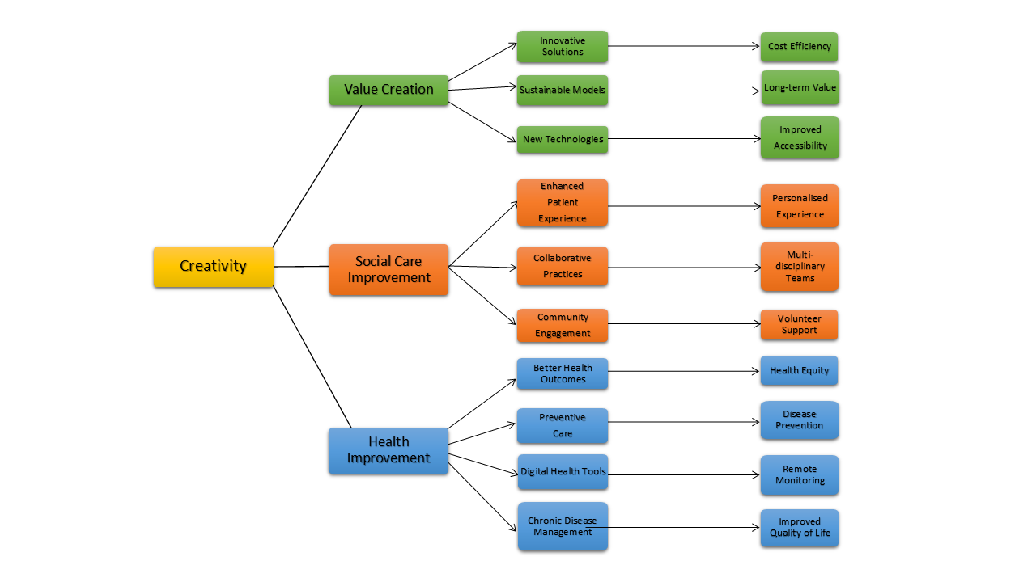
Figure 1: Concept Map created on canva

The concept map clearly demonstrates that health and social care improvement and value creation result from a critical interplay between creativity, elements. Creativity in health and social care fuels the development of innovative solutions. It leads to the achievement of cost efficiency and sustainable models, thereby bringing about long-term value for both providers and patients. Introducing new technologies, creative initiatives enhance accessibility to improve experience for patients by allowing the personalization of care. This helps develop a more patient-centered style in that it allows individualized treatment plans that will further enhance the reflection of diverse health needs.
Improved social care is another significant creative outcome, especially through the encouragement of collaborative practice. They offer mul-disciplinary teams that work in a coherent manner towards a holistic approach at service delivery. Creativity plays a massive role in facilitating community engagement so that better health outcomes and higher health equity are achieved. For instance, volunteer support usually plays a crucial role in underserved communities. The support would ensure that care reaches the people in need.
In health improvement, the digital health tools which include remote monitoring add more support to preventive care and disease prevention; hence treatments are administered earlier while control measures on chronic conditions are improved for better quality of life for the patients by taking some burdens caused by diseases out of them. In a nutshell, the above concept map shows creativity is the driving force in value creation in health and social care because of the improvements of outcomes and efficiencies in care while making it more patient centered.

Task 2 - Self-Reflection of Group Activity
Divergent thinking involves generating multiple, diverse ideas or solutions to a problem, whereas convergent thinking focuses on narrowing down these options to find the best solution (Zhang, Sjoerds and Hommel, 2020).
Description:
In our BMPH5014 class, we explored the versatility of a paper clip. The activity asked us to list practical and unconventional uses for it. I initially viewed it as a tool to hold papers but soon realized it could be used to open a SIM card slot or even clean nails.
Feelings:
At first, I felt excited about the creativity required. However, as the activity progressed, I became more concerned about safety, especially after realizing that some of the uses I suggested could be dangerous, especially for children.
Evaluation:
The activity was engaging, and it encouraged us to think outside the box. While it promoted resourcefulness, I found some suggestions, like using it to clean nails, questionable in terms of hygiene and safety.
Analysis:
This task highlighted how we can quickly shift from convergent thinking (single-use focus) to divergent thinking (multiple creative uses). However, it also made me realize the importance of evaluating ideas for safety and practicality, especially when presenting creative solutions.
Conclusion:
I learned that divergent thinking can be productive but should be approached with caution. In future activities, I will focus on the balance between creativity and practicality.
Action Plan:
Next time, I will critically assess ideas for feasibility and safety before sharing them, ensuring my creative thinking doesn't compromise others.

Task 3 - Case Study of a UK innovation
Write a concise case study analysis of an innovative project or initiative within the NHS or UK social care. Focus on how creativity was used to drive change and the value it created for patients or service users (400 words, 2 sources).
NHS Remote Monitoring for Chronic Illness Management
Introduction
The NHS launched a remote monitoring initiative to improve chronic illness management, addressing the growing burden on healthcare services and the need for more proactive care. This project aimed to empower patients with conditions like heart disease and diabetes to manage their health from home, reducing hospital visits and enabling earlier interventions. Key stakeholders included patients, healthcare providers, and system administrators, all seeking better care outcomes and service efficiency (NHS, 2024).
Creativity and Innovation
The creativity behind this initiative lay in leveraging digital health technologies and rethinking traditional care delivery models. Through wearable devices, mobile apps, and telemedicine, the NHS included patients into live monitoring of key clinical parameters such as blood pressure, glucose levels, and heart rate. All information was then shared with healthcare teams so that patient health could be monitored remotely and possible areas for intervention could be identified.
With the collaborative partnerships between technology developers, clinicians, and patients, the tools ensured they were user-friendly as well as reflective of clinical needs. This transformed model replaced routine in-person check-ups with continuous monitoring and enabled a patient with control of health. AI was then used to sort through the vast amounts of data generated with alerts issued to clinicians where trends were felt perturbing and the immediate care should be provided. Creative problem-solving proved helpful in surmounting such challenging issues as ensuring patient engagement and data security by using gamification techniques and providing user support.
Impact
This creative solution delivered substantial value. For patients, it improved self-management of chronic conditions and significantly reduced hospital admissions by 30% within the first year. Early interventions based on real-time data also led to better health outcomes, reducing complications from unmanaged conditions. Additionally, patient satisfaction scores rose by 20% as patients felt more in control of their health. For the NHS, the initiative led to cost savings due to fewer hospital stays and more efficient resource allocation. Increased accessibility, especially for rural or elderly patients, further enhanced the project’s success, demonstrating how creativity can drive both healthcare improvement and system sustainability (NHS England, 2020).

Task 4 - Research Task
Identify a current issue in health and social care (e.g., patient wait times, staff burnout). Find two pieces of research that explain the reason for this problem. Paraphrase the findings of each article (300 words, 2 sources).

Article 1: Organizational Reasons for Job Burnout (Moczydłowska, 2016)
Joanna Moczydłowska's research identifies several organizational factors contributing to job burnout, as perceived by managers and their subordinates. Key risk factors include excessive pressure from workload, time constraints, and responsibility, alongside rigid expectations of compliance with management decisions. Lack of career development opportunities, such as limited promotion potential due to flattened organizational structures and insufficient training funds, also contributes to frustration and dissatisfaction. The inability of employees to fully utilize their skills and knowledge exacerbates feelings of stagnation. Other burnout risks include poor interpersonal relations, unresolved conflicts, low salaries, and job insecurity. These factors create a stressful work environment that diminishes employee motivation and mental well-being. Despite awareness of these issues, managers often feel powerless to implement changes, leading to a sense of inertia within the organization. This lack of real influence and action worsens the organizational climate, further contributing to burnout among staff members.
Article 2: Causes of Nursing Staff Burnout (Te‐Feng et al., 2020)
The study explores work-family conflict and emotional exhaustion as predictors of burnout among nursing staff: a mediated role of emotional exhaustion. Emotional exhaustion mediates the relationship between work-family conflict and burnout, leading to depersonalization and reduced professional efficacy. Supervisor support is of crucial importance in the mitigation of effects. Whenever supervisors provide support, they reduce work family conflict and emotional exhaustion and have a positive effect on the nurses' work behaviors and job satisfaction. Emotional exhaustion, associated with an imbalance between workload and available resources, results in mental fatigue and stress, thus proving to be a challenge to the nurses. Supervisor support for nurses helps to reduce workload, improves work autonomy, and allows for a supportive work environment. The findings also suggest that organizations should reduce WFC and increase supervisor support as it is only when these are the case that the emotional demands of their work would be managed, and thus, nurses would recover from burnout.
Task 5 - Contemporary Technology Quiz
- Name one benefit of using wearable devices (e.g., smartwatches) in managing chronic health conditions.
Wearable devices allow real-time monitoring of vital signs such as heart rate and blood pressure. This continuous data collection helps detect early signs of deterioration, allowing for timely medical intervention. As a result, patients can better manage chronic conditions, improving health outcomes.
- How can AI chatbots assist in mental health care? Provide one example.
AI chatbots can provide 24/7 support to individuals seeking mental health assistance. For example, they can offer cognitive-behavioral therapy (CBT) techniques, helping users manage anxiety and depression. This instant access to support reduces the strain on mental health services and provides immediate relief to users.
- How does electronic health record (EHR) integration improve communication between healthcare providers?
EHR integration allows seamless sharing of patient information across healthcare teams. This ensures that all providers have access to the most up-to-date medical history, lab results, and treatment plans. As a result, it improves coordination and reduces the risk of errors or duplicate testing.
- Give one example of how virtual reality (VR) is used in rehabilitation therapy.
VR is used in stroke rehabilitation to help patients regain motor skills through immersive, controlled environments. For example, patients can perform simulated physical tasks that promote neural plasticity, aiding recovery. This engaging method improves motivation and accelerates therapy progress.
- Describe how electronic booking systems improve access to healthcare services.
Electronic booking systems allow patients to schedule appointments online, reducing wait times and streamlining administrative processes. Patients can easily check availability and select convenient times, improving access to care. Additionally, these systems help reduce scheduling errors and overbooking.
- How can technology be used to promote preventative care and support health promotion initiatives?
Technology such as health apps and wearable devices can track physical activity, diet, and sleep patterns, promoting healthier lifestyles. Public health campaigns can leverage social media and mobile apps to spread awareness of preventative measures. Additionally, personalized reminders for check-ups and vaccinations enhance engagement in preventative care.
- What is one advantage of using telemedicine for routine consultations compared to in-person visits?
Telemedicine allows patients to consult healthcare providers from the comfort of their homes, saving time and reducing travel expenses. This convenience is especially beneficial for patients with mobility issues or those living in remote areas. Additionally, it reduces exposure to contagious illnesses in clinical settings.
- How can robotics improve precision and outcomes in surgical procedures?
Robotic surgery allows for highly precise movements that are difficult for human hands to replicate. Surgeons can operate through smaller incisions, reducing recovery times and minimizing complications. This precision also reduces the likelihood of human error, leading to better outcomes for patients.
- Explain how smart home technology can assist individuals with dementia in their daily activities.
Smart home technology can remind individuals with dementia to complete daily tasks, such as taking medication or locking doors. Automated lighting and temperature controls can improve safety and comfort. These tools reduce reliance on caregivers and promote independence while ensuring a secure living environment.
- How can AI improve efficiency in care workers' jobs and reduce their workload?
AI can automate routine administrative tasks, such as scheduling and record-keeping, freeing up care workers to focus on patient care. It can also assist in monitoring patient health through predictive analytics, identifying at-risk individuals before complications arise. This enhances efficiency and reduces the workload on healthcare staff.

Task 6 - Podcast

https://uowtsd-my.sharepoint.com/:u:/g/personal/2235612_student_uwtsd_ac_uk/EUpGVt7FVB9JsAsQftWcmTUBqCjkviFlE-f6zdqUcErm3A?email=union%40uwtsd.ac.uk&e=1XarRH

Task 7 - NHS Leadership Framework Analysis
Write a short summary (150 words) explaining the key components of the NHS Leadership Framework. Then, choose one component and describe (100 words) how a leader might use it to encourage creativity and improve care in the NHS (2 sources).
Summary of NHS Leadership Framework
The NHS Leadership Framework outlines essential leadership qualities for all staff, regardless of their role, focusing on collaboration, innovation, and service improvement. It emphasizes seven core domains: demonstrating personal qualities, working with others, managing services, improving services, setting direction, creating the vision, and delivering the strategy. Each domain encourages self-awareness, effective communication, and accountability while promoting patient safety, resource management, and strategic planning. Leaders are encouraged to embody values that align with the NHS’s mission, fostering environments where innovation, continuous improvement, and patient-centered care thrive. A key focus is the collaboration between individuals and teams to deliver high-quality care. The framework aims to build leadership capacity across all levels, ensuring that leadership isn’t confined to senior roles, but shared by all staff to drive service delivery and innovation effectively (NHS, 2011).
Application of "Encouraging Improvement and Innovation"
A leader can use the "Encouraging Improvement and Innovation" component to foster creativity by creating a culture that questions the status quo and welcomes new ideas. In the NHS, this can involve encouraging open dialogue among staff and patients to explore innovative ways of improving patient care, such as adopting new technologies like AI for diagnostics. By modeling innovative behaviors, leaders inspire their teams to take calculated risks, try new approaches, and collaborate across disciplines, resulting in improved care delivery and patient outcomes. This approach fosters continuous service improvement and transforms healthcare practices to meet evolving needs (McCutcheon, 2014; NHS, 2011).

Task 8 - Self-Reflection Journal Entry
Write a short journal entry about what you learned in this module. Focus on how your understanding of creativity and value creation withing H&SC has changed and how it has informed your professional practice (150 words).
This module has broadened my understanding of creativity and value creation within health and social care (H&SC) in ways I hadn’t previously considered. Initially, I associated creativity primarily with the use of cutting-edge technologies, but now I see it as central to rethinking care delivery, improving patient engagement, and fostering innovation across all levels of the healthcare system. I have learned that creativity is not confined to isolated innovations but involves a continuous process of enhancing care pathways, promoting interdisciplinary collaboration, and introducing new ways to improve patient outcomes. Value creation, I now realize, encompasses both tangible and intangible benefits such as better patient experiences, more efficient resource use, and the creation of sustainable care models. This knowledge has informed my professional practice by encouraging me to think more creatively when addressing challenges, focusing on innovative solutions that improve the quality of care and patient satisfaction, and contributing to long-term system-wide improvements.

Reference List
McCutcheon, K. (2014). A leadership framework to support the use of e-learning resources. Nursing Management, 21(3).
Moczydłowska, J. (2016). Organisational reasons of job burnout. Ekonomia i Zarzadzanie, 8(2), pp.7–12. doi:https://doi.org/10.1515/emj-2016-0011.
NHS (2011). Leadership Academy Leadership Framework. [online] Available at: https://www.leadershipacademy.nhs.uk/wp-content/uploads/2014/11/Leadership-Framework.pdf [Accessed 14 Oct. 2024].
NHS (2024). Supporting care with remote monitoring. [online] NHS Transformation Directorate. Available at: https://transform.england.nhs.uk/covid-19-response/technology-nhs/supporting-the-innovation-collaboratives-to-expand-their-remote-monitoring-plans/.
NHS England (2020). The role of remote monitoring in the future of the NHS. [online] NHS Transformation Directorate. Available at: https://transform.england.nhs.uk/blogs/role-remote-monitoring-future-nhs/ [Accessed 14 Oct. 2024].
Te‐Feng, Chang, Y., Hsu, Y., Huang, L. and Yang, C. (2020). Causes of nursing staff burnout: Exploring the effects of emotional exhaustion, work–family conflict, and supervisor support. Japan Journal of Nursing Science, 18(2). doi:https://doi.org/10.1111/jjns.12392.
Zhang, W., Sjoerds, Z. and Hommel, B. (2020). Metacontrol of human creativity: The neurocognitive mechanisms of convergent and divergent thinking. NeuroImage, 210(116572), p.116572. doi:https://doi.org/10.1016/j.neuroimage.2020.116572.

