Lesson Plan Phase 1

Lesson Plan – Step 1 Cynllun Gwers – Cam 1

Student-teacher | Rhiana Smith | Class:
AoLE or Subject | Religious Education | Date: | 21/01/20
Lesson Focus: | Martin Luther King
Meaningful links to Curriculum
Meaningful links to:  Cross Curricular Responsibilities | Literacy, Numeracy, Developing pupils’ use of the Welsh language.
Personal Targets (Linked to QTS and identifed in weekly review)

- Ensure that I am planning creative lessons for Key Stage 4.
- Improve my timing of tasks.

Learning Objectives (focus on Learning- use accessible vocabulary):
The pupils will learn to:

To learn about the life and work of Martin Luther King Jr
To identify how Martin Luther King is considered to be a pacifist

Success Criteria (clearly linked to each Learning Objective and related to the process and/or product of learning) | Assessment of Pupils’ Learning  Evidence  (What have the learners to say/write/do/produce – to demonstrate learning)
- Pupils will be able to describe the life and work of Martin Luther King Jr including key events in his life | - Pupils will demonstrate an understanding of the life and work of Martin Luther King by being able to use problem solving skills to arrange the key points in his life into a comic strip in the correct order

Time | Activities/Methodology/Key Concepts  (Teacher’s Role – including key teaching points and key questions) | Pupil Tasks  (Pupils’ role -including differentiation strategies, engagement in formative assessment and homework) | Resources  (Including Health and Safety requirement)
Opening phase (with links to prior learning) | Welcome class into the classroom after they’ve been lined up outside, welcoming them with incidental Welsh such as “Bore da pawb” “Eisteddwch yn ddawel” to encourage the Curriculum Cymreig.  Teacher to ask the class to tell her what the date is in Welsh to encourage them to develop their Welsh language skills. To develop their oracy skills, teacher to conduct ‘drilling’ where class repeat the date in Welsh after her. Teacher to then introduce the Lesson Objectives (Nod y Wers) to the class and ask them to write them, the date and title in Welsh. | Pupils to use their problem solving skills and prior knowledge to arrange the life of MLK into the correct order.  Pupils to respond to teacher in Welsh where their knowledge extends to this. | Comic book strip, mixed up  Books, pens.
Teaching & Core Learning | Teacher to provide class with a mixed up comic book strip reflecting the life of MLK. Teacher to direct class to rearrange them into the correct order to reflect the events of his life.  Teacher to give praise and ask questions in Welsh, such as ‘oes problem?’ and ‘bendigedig!’  Once pupils are finished, teacher to display the correct order that the comic strip should be in. By withholding this, this encourages pupils to be independent learners. | Pupils to use their problem solving skills and prior knowledge to arrange the life of MLK into the correct order.
Plenary | Teacher to instruct the class to close the lesson and tidy up in Welsh, wishing them goodbye in Welsh (Hwyl Fawr)

Reflection

I believe that the lesson I delivered where I used a considerable amount of Welsh was successful and effective. The reason I believe this is that the audience I delivered the lesson to were able to understand my commands and conversation as I used accessible, incidental Welsh. If there were any new words or phrases that I wanted to introduce to them that I assumed they would not be familiar with, then I would use a drilling technique to ensure that they understood the language I was using and how to use it themselves.
To improve my lesson, I could have adapted the resource I used (a mixed up comic book strip) and written the resource in Welsh to add more of a challenge to the audience who would need to rely on problem solving skills and their prior knowledge of the Welsh language.
In my future practice as an NQT I will strive to include as much incidental Welsh in my lessons as appropriate to ensure that I am promoting the curriculum Cymreig and contributing to the national effort to promote the Welsh language and reach 1 million Welsh speakers in Wales by 2050.

Examples of incorporating Welsh into my lessons whilst on placement

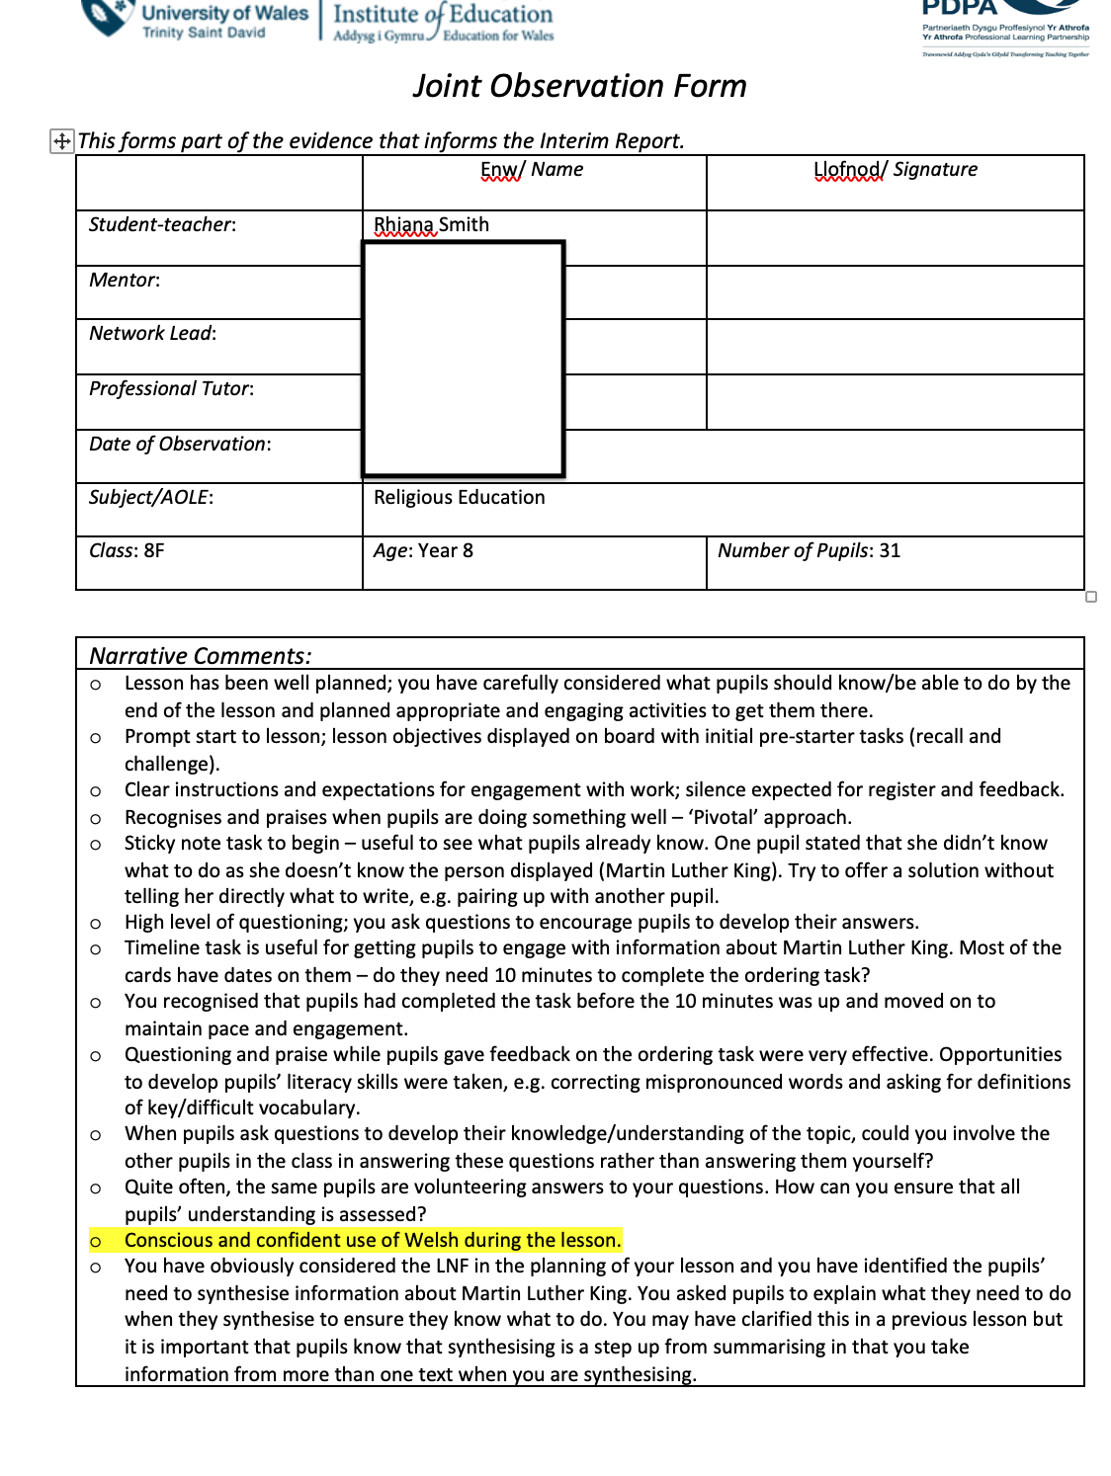

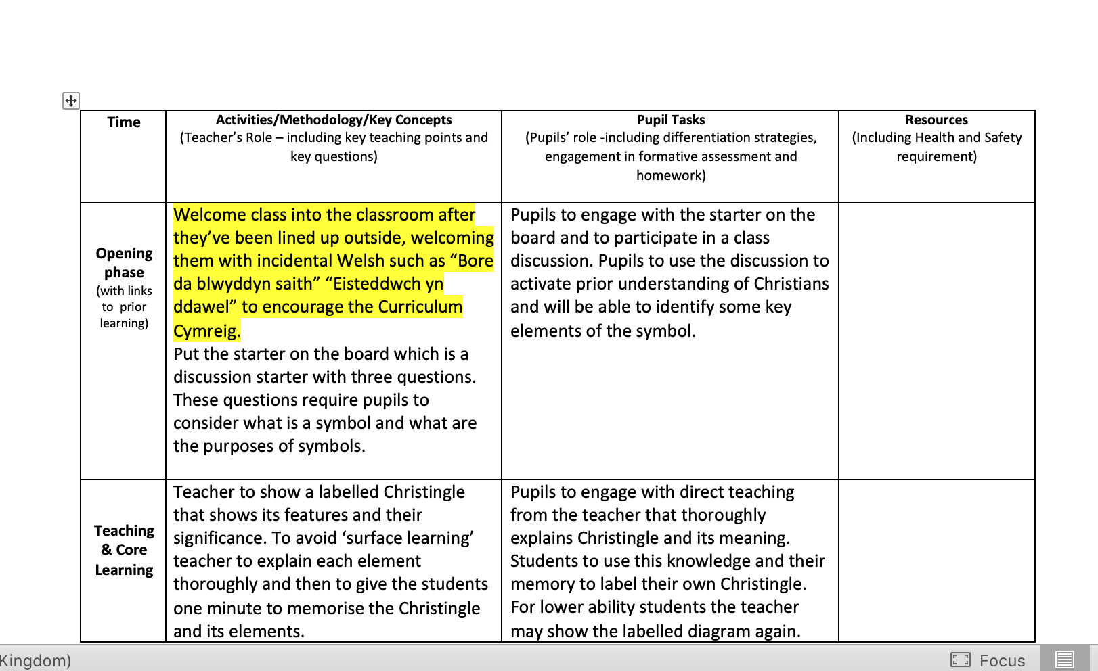

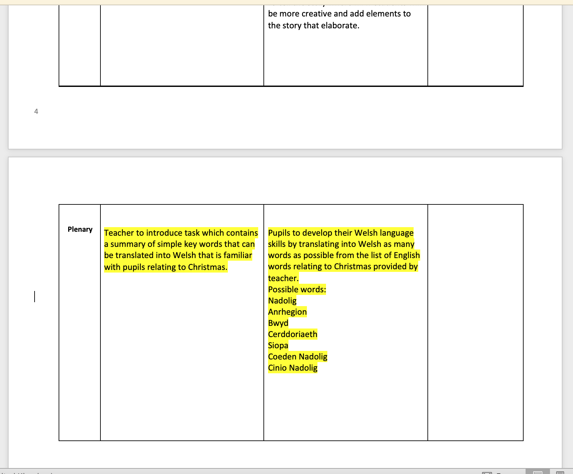
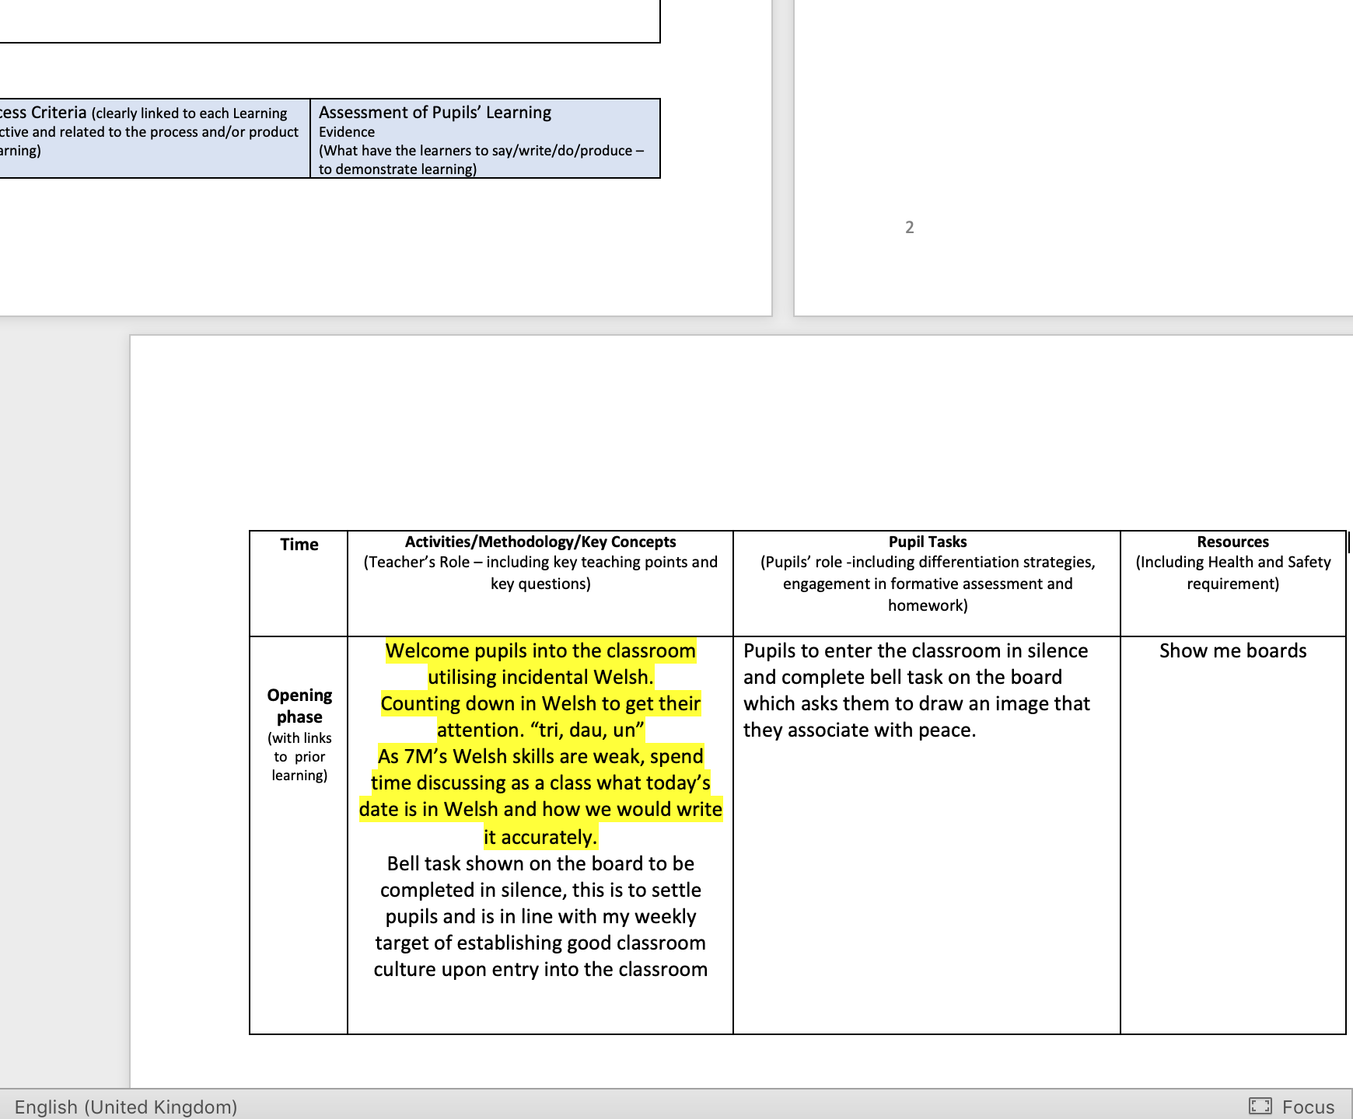

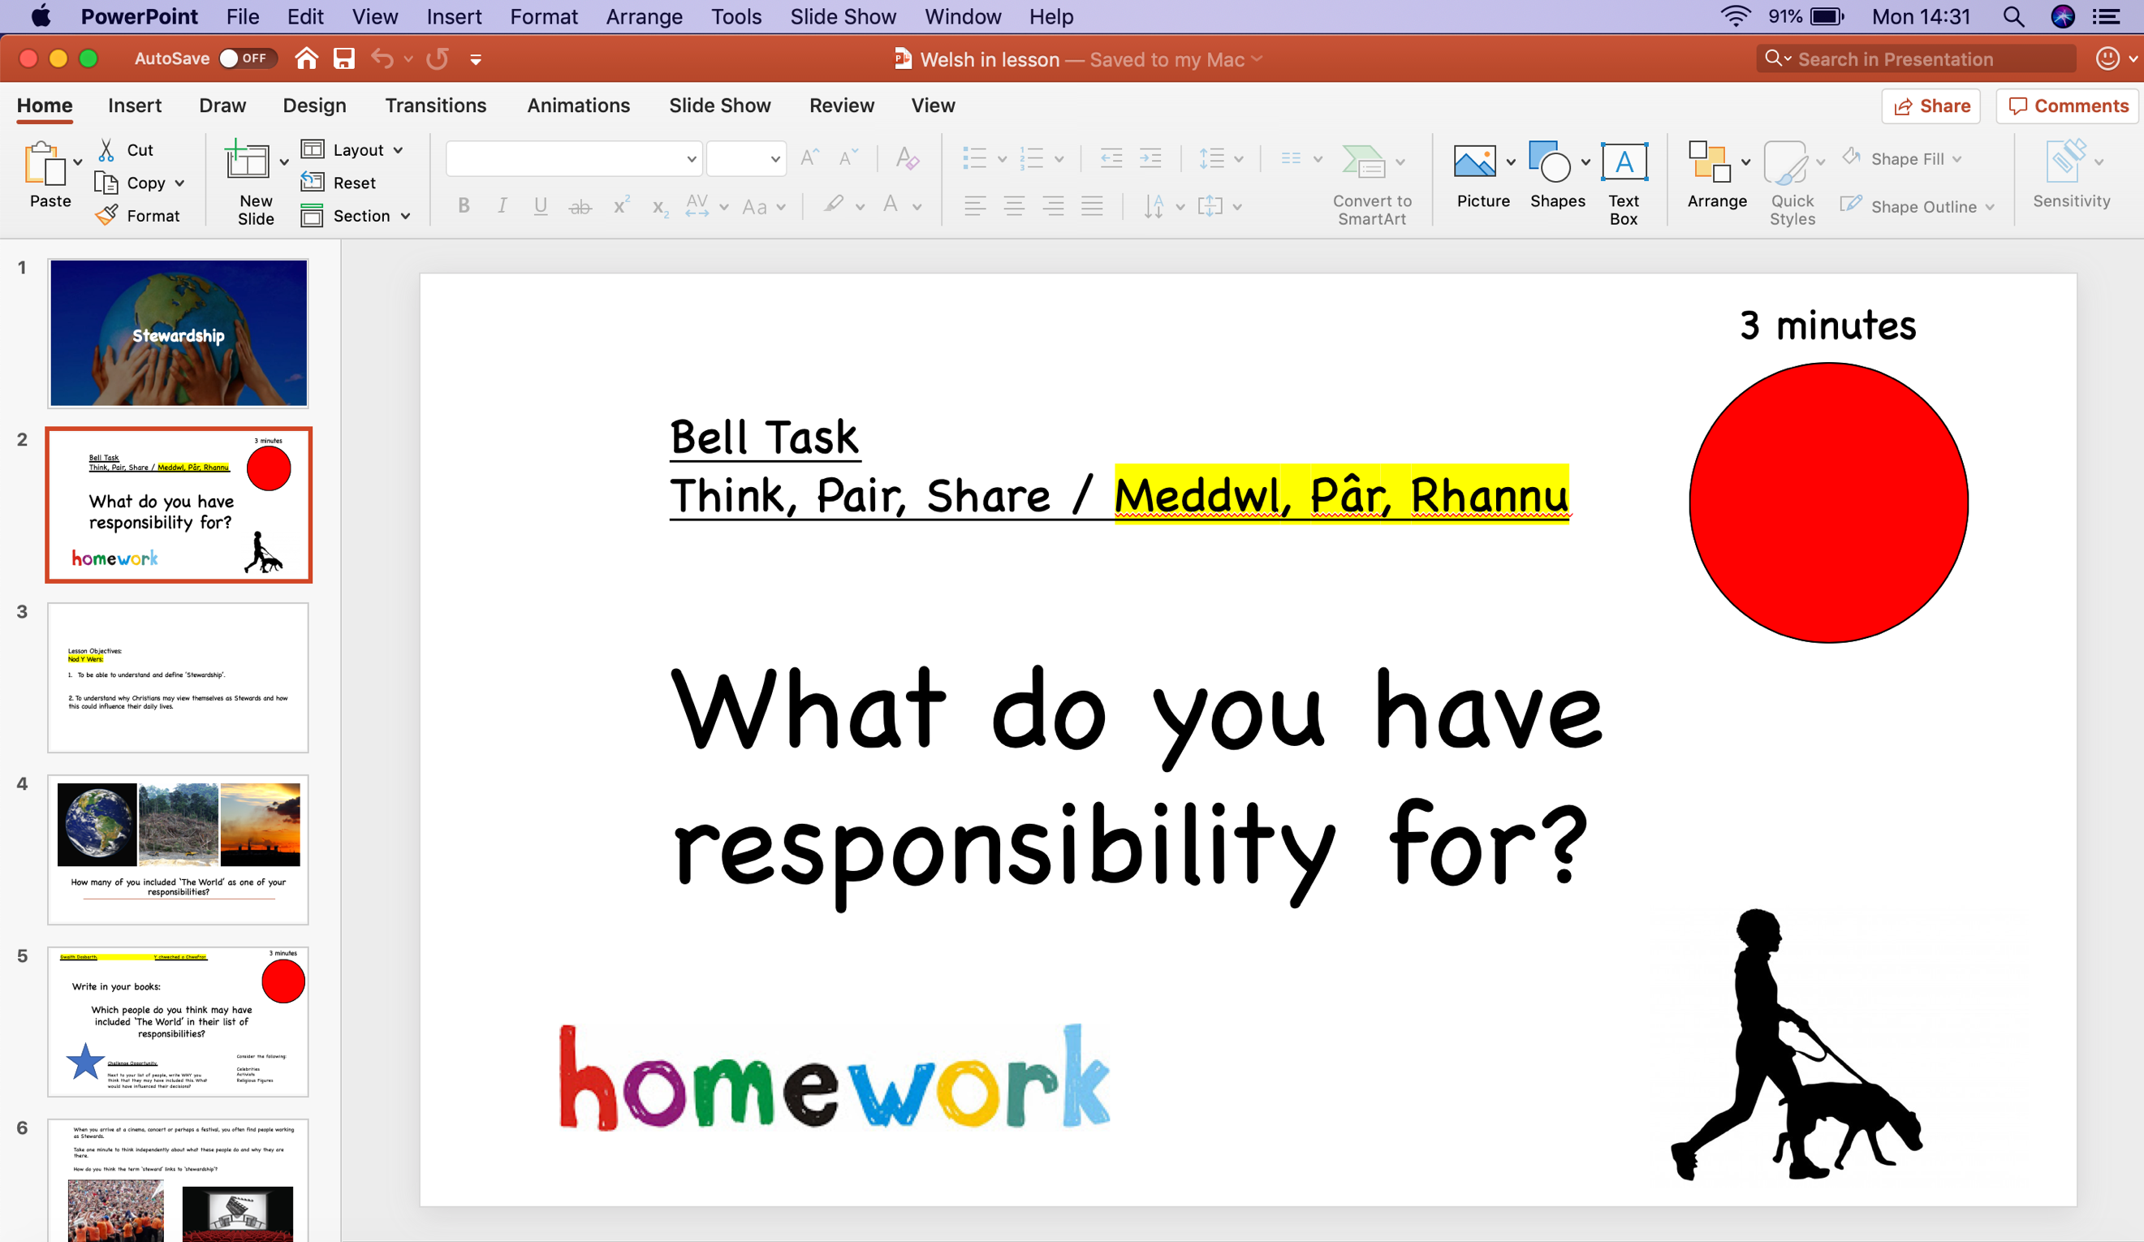

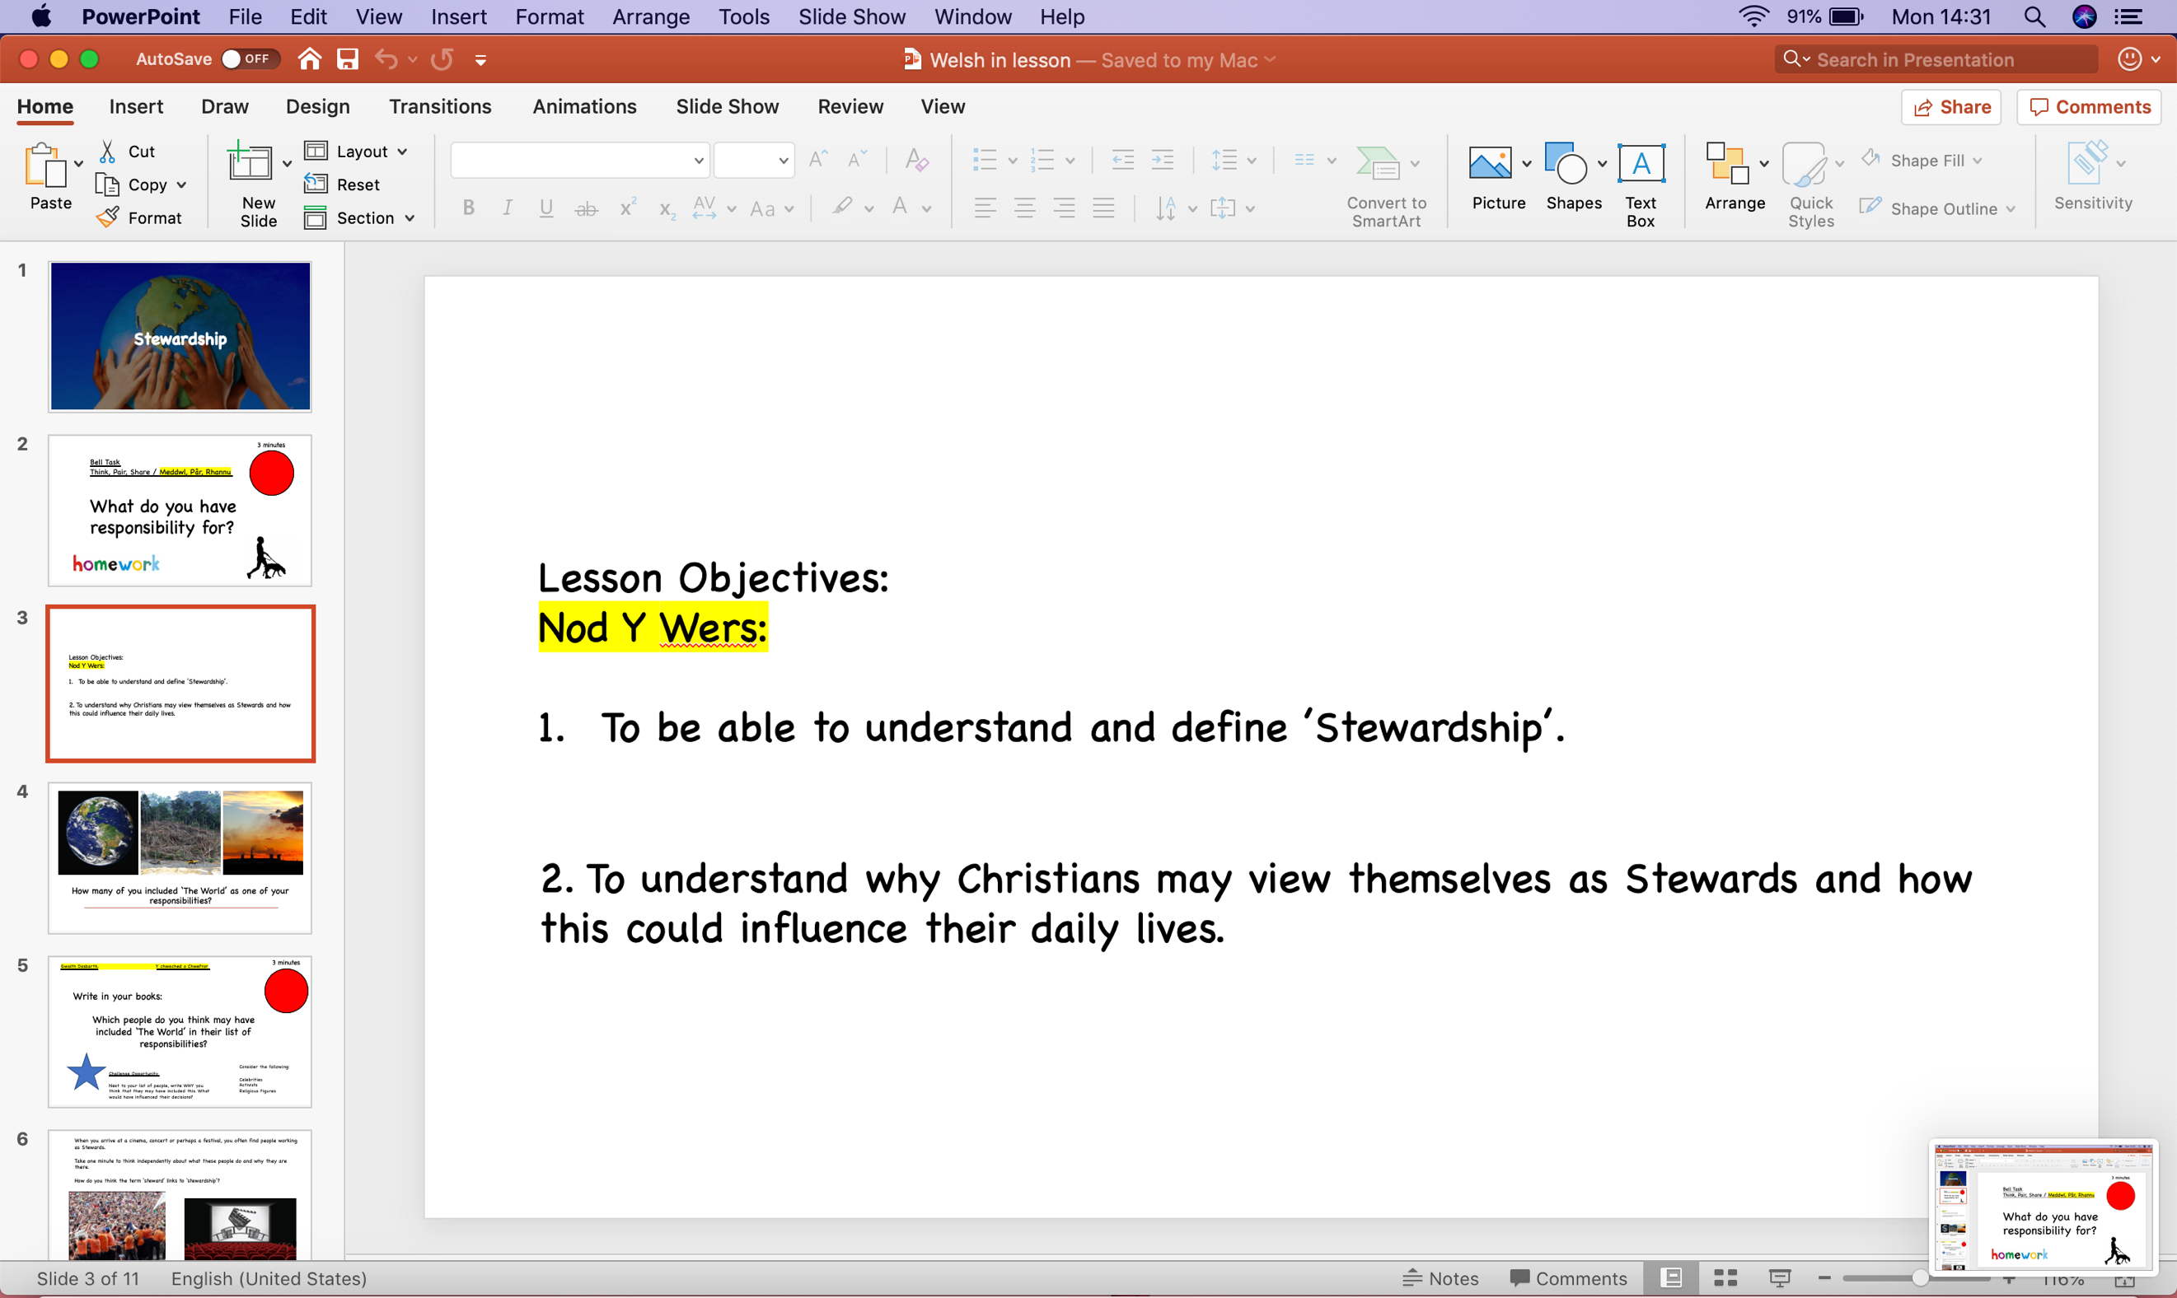

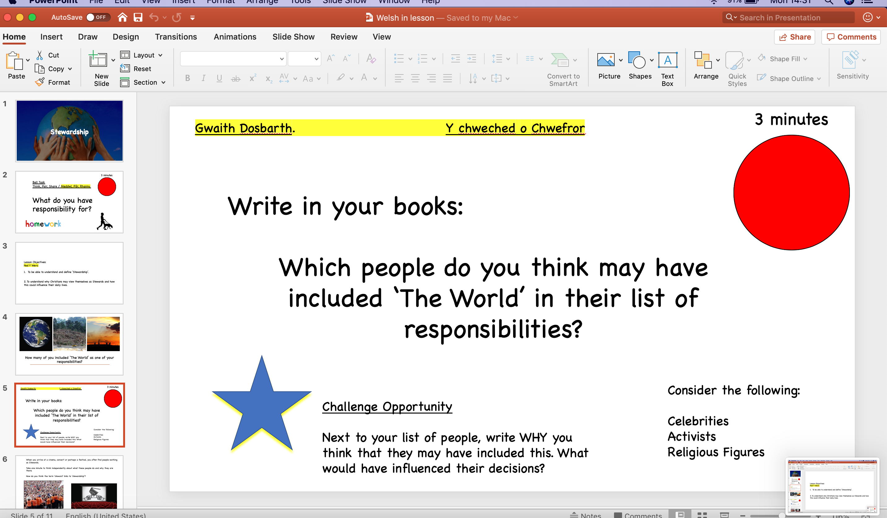

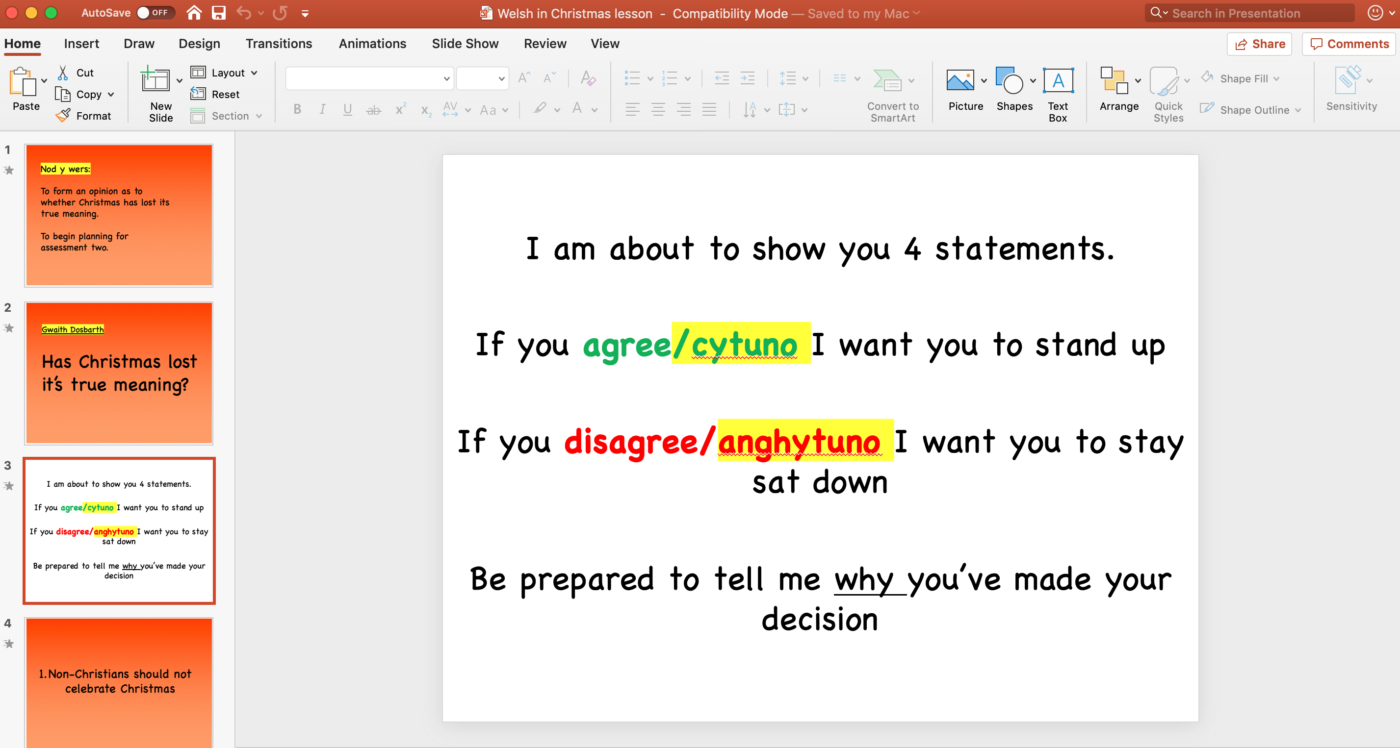

Professional Development in my Welsh language skills



