
Name: Jonathan Huw Jones
Student number: 1909131

Course: B.Eng. (Hons) Mechanical and Manufacturing Engineering
Module: Advanced Materials and Processes
Module code: M6X00414
Lecturer: Graham Howe & Greg Owen

Assignment Title: Advanced Processes Report
Submission Deadline: 22nd June 2020
Word count: 2125
Additive Manufacturing within the Medical Device Industry

Declaration of Authenticity

This report is the result of the Authors original research. It has been composed by the Author and has not been previously submitted for examination which has led to the award of a degree.

Signed: Jonathan Jones Date: 17th June 2020

Contents
Main Body 3
Additive Manufacturing within the Medical Device sector 3
Fundamentals of Additive Manufacturing 4
Advantages/Disadvantages of Additive Manufacturing vs Machining and porous coat of Hips Acetabular shells 6
Advantages 6
Disadvantages 6
The future for Additive Manufacturing 7
Conclusion 8
Bibliography 9
References 9
Table of figures 10
Relevant Standards 10

Abstract
Additive Manufacturing is widely utilised in an array of sectors (e.g. Automotive, Aviation) within the manufacturing industry, however his report focuses on the fundamental principles of Additive Manufacturing (3D printing) and its impact on my current industry sector (Medical Device).
With a combination of knowledge and understanding gained from the review of the latest research and objective data published by subject matter experts, I will aim to demonstrate a solid understanding and awareness of explore the fundamental scientific principles of Additive Manufacturing, analyse the manufacturing process, its environmental & safety implications and evaluate its future impact on the medical device industry.
I’ll focus on the origins of its use within the industry, and as the technology has advanced, its uses today and the impact it will have on future industry (Industry 4.0) and environmental requirements.
Zimmer Biomet use Additive Manufacturing in the production of varied families of orthopaedic implants including knee, spine, dental, shoulder and ankle extremity, however the focus of this report will be for orthopedic hip implant, specifically G7 OsseoTi® Acetabular shell as this is the product family that is produced at the Bridgend site.

Main Body

Additive Manufacturing within the Medical Device sector

Originally, from the perspective of my employer Zimmer Biomet, the use of Additive Manufacuring within the business was limited to the production of prototype samples during the Product Development and Design stage of new product introduction where the utilisation of the 3D printing process (Culmone, Henselmans, van Starkenburg, & Breedveld, 2020), partnered with a 3D CAD package, was a cheaper and quicker option to produce prototypes with a Thermoplastic polymer before running full production development parts.
However, with an ever increasing focus on Quality, cost saving and waste reduction, manufacturers have increased their use of Additive Manufacturing in recent years, as the technology has advanced, to meet efficiency and contiuous improvement targets in regular production runs. During the last decade the usage of the process has been introduced to the manufacture of orthopedic implants for the market, as the technology has driven advancements in process capability, operation runtimes, tighter dimensional tolerances and development of complex trabecula structures (see figure 1) that mimic the cancellous meshlike feature found in the porous framework of human bone (see figure 2) has progressed. (Zimmer Biomet Orthopedic Inc, 2017)
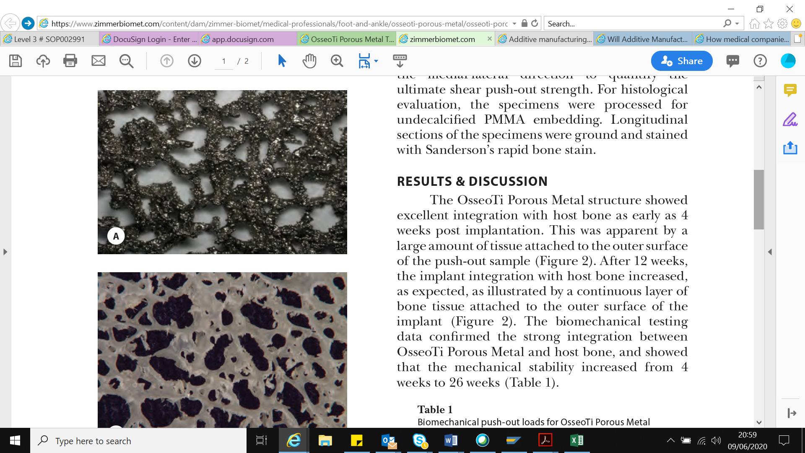
Figure 1. Trabecular structure of G7 OsseoTi Acetabular shell
Figure 2. Porous structure of human cancellous bone
This structure accelerates the adhesion of human tissue to the orthopedic implant by promoting cell migration, vascularisation and subsequent tissue integration or “ingrowth” between metal and bone (Gautam Gupta, August 2012). These benefits are critical to the patient who can experience increased recovery times and reduced implant rejection rates due to these characteristics (Mahmoud & Elbestawi, 2019).
As a measure to mitigate business continuity and maximise supply capacity, we outsource production of G7 OsseoTi® Acetabular shell to a third party manufacturer (Lincotek Trento SPA, 2019) in addition to our in-house manufacture.

Fundamentals of Additive Manufacturing

Over the last three decades, Additive Manufacturing has made significant technological leaps which has taken it from a niche technology used by hobbyists for small scale projects often using open sourced designs, to R&D teams utilising 3D printers paired with CAD software to create produce low cost/accurate prototypes. This became a viable option as processing costs (initial outlay of equipment/media and operating), process speeds and capability/accuracy reduced & increased respectively.
Since 2009, the medical device industry (Royal Academy of Engineering, 2013), and Zimmer Biomet in particular, has started to embrace the benefits of producing medical implants with the UK site, specifically sourcing its G7 OsseoTi® Acetabular shell primarily via a third party manufacturer (Lincotek Trento SPA, 2019) and, at a reduced capacity, from our in-house at our Warsaw (US) site. In comparision, the G7 range of acetabular hip shells also include a PPS (pourous coated) range of shells produced by conventional standardised machining methods from both casting or raw material barstock (see figure 3). These both require significant processing, to produced required dimensions, however in the case of the PPS shell the surface finish on outside diameter is applied post machining operation by the addition of the time comsuming and expensive operation, where complexity of control and the high rate of scrap being a significant issue (Sher, 2020).

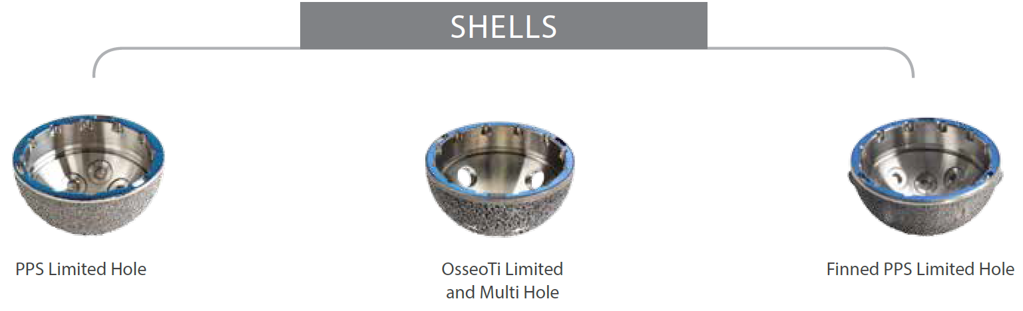
Figure 3. G7 range of Acetabular shells
In comparision, with the capability of the Additive Manufacturing process being able to produce the accurate and complex lattice structure that is required for the G7 OsseoTi surface finish provides an aopportunity to save on additional processing and production leadtimes from receipt of raw material to finished product.
In addition to the 3D laser printing systems, the OsseoTi process (at both Lincotek Trento SPA and Zimmer Biomet Warsaw sites) also involves the use of other equipment in a sequence of operation for producing the G7 Acetabular shell blanks with the porous surfaces from titanium alloy (Ti6Al4V) powders. The G7 OsseoTi process is based on Selective Laser Melting (SLM) technology of Additive Manufacturing methods (Farinia Group) (Goodridge & Babu, 2015)which utilizes a high-power laser beam to selectively melt and locally fuse loose the titanium alloy metal powder as the laser scans across a bed of powder which is deposited onto a build platform, or basplate, to obtain the desired thre dimensional part. After every cycle of the high power laser, the powder bed is lowered a short distance and a new layer of fine powder is deposited onto the build.
In the case of the G7 Acetabular shell constructs are printed layer by layer to create a fully-integrated component comprised of a solid hemispherical region for the substrate along with a porous lattice structure on the substrate surface which are printed simultaneously to create a single integrated part.
The output of the OsseoTi process is a medical device with a porous outer structure with predetermined requirements of pore size, porosity, thickness and strength that supports bone attachment and a solid substrate with the desired mechanical properties which provides the structural strength for the device.
However, this only represents part of the manufacturing process to produce finished G7 OsseoTi Acetabular shells for joint replacement application. The OsseoTi process at Lincotek results in semi-finished OsseoTi Acetabular shells or shell blanks which are produced in a sequence of operation starting with the Ti6Al4V alloy powders (Shirazi, et al., 2015) as raw materials and employing several manufacturing techniques to create the shell blanks as shown in the process flow (figure 4).
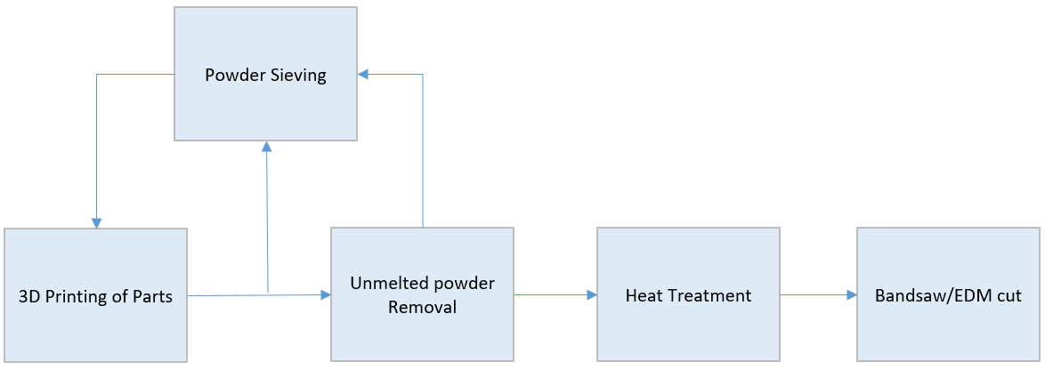
Figure 4.Manufacturing Process Flow

Following the SLM fabrication cycle, the build plate along with the parts attached to the plate are removed from the system and placed inside a sealed cabinet where they are subjected to a blast of inert gas from a nozzle. The purpose of the inert gas jet is to remove any un-melted loose metal powders from the build that are not used in the SLM process. In the blast cabinet, the jet of high-pressure inert gas is aimed manually at the parts on the build plate to dislodge and remove the loose metal powders from the parts. The powders in each layer that do not interact with the laser beam in the SLM process remain un-melted and are recycled for another build. To ensure consistency in the distribution of powder particles from one build to the next, the powders are sieved in a separate sieving module or station before being charged back into the SLM machine to be used in the next build.
The build plates and parts from multiple cycles are then transferred to a vacuum furnace where they are subjected to a high temperature heat treatment cycle to relieve any internal stresses generated in the build from the rapid heating and cooling effects from the laser sintering cycle.
After the heat treatment cycle in the vacuum furnace, the parts are separated from the build plate with the help of a band saw or electrical discharge machining (EDM). The band saw is used to cut through the supports that were used to anchor the parts to the base plate during the build cycle. Following inspection, the separated parts are deemed as the 3D printed OsseoTi G7 blanks. The OsseoTi G7 blanks are further processed (including turning, drilling, thread cutting, anodise, etch, final clean/inspection, sterile pack and gamma sterilisation) to before they can be released finished parts.

Advantages/Disadvantages of Additive Manufacturing vs Machining and porous coat of Hips Acetabular shells

The increased use of Additive Manufacturing for Acetabular Hip shells against the conventional manufacturing processes used to produce standard porous coated shells is driven by the Lean targets that reduce many of the 8 Wastes, however the current status of the technology brings disadvantages which ensures that historic production processes will be the preferred or only viable option for the near future. The folowing must be considered

Advantages
- Waste reductions
  - Processing leadtimes from the receipt of raw material to dispatch to customer are reduced due to reduced processing operations.
  - Material scrap reduction due to elimination of material removal required to produce the three dimensional part. (Horizon Technology, 2020)
  - Environmental impact. The reduction of the above wastes will have significant positive impacts to carbon footprint associated with the total process from transport of raw material, (Carlström, 2018) (3DEO, 2018)
- Lower headcount to run the automated process after initial setup. Lincotek are able to setup and moitor 15 EOS printers and supervise remotely during the 20 hour runtime using one operator.
- Bespoke implants/Instrumentation using 3D moodelling techniques. Reducing the need to bring large instrument kits, which hold the full size range of instruments into the Operation Room. Both Implant and the required instruments can be printed to suit the specific requirements of the Patient/Customer.
- Flexibility and resourcing of equipment. During the COVID-19 crisis, Zimmer Biomet were able to redirect resource to support front line staff by producing personal protection equipment using open sourced designs.
- Development acceleration. Design changes to the CAD drawing can be quickly re-engineered (Fried, 2019) and development prototypes produced withou the need for increased leadtimes for raw material or standard machining processes.
- Maximum manufacturing flexibility. Once the design has been settled on, manufacturing the implantable parts can begin. From custom-made to small-size batches or even mass production, a competitive miscellaneous range of items can be ready in just a few working days by using additive manufacturing technology.

Disadvantages
- Costly technology. These printers are still costly and not readily available. (Vaishya & Vaish, 2019). With the addition of high cost of specialised raw materials and processing for many manufacturers there is no reason to make the investment if the parts can be produced using traditional machining methods. (Horizon Technology, 2020)
- Not effective to produce large volume production parts. Additive Manufacturing is still considered to be a niche process and as such the progress of developing the process has some way to go until production run times improve enough to make this a viable option for a greater scope of inductries withing manufacturing. (Horizon Technology, 2020)

The future for Additive Manufacturing

- Bio-printing. With the 3D printing of orthopedic implants using metal metal now well established in the industry, bio printing is the next stage in development. This technology is expected to be the ultimate game changer in the Healthcare inductry. Benefits would include lower implant rejection rates due to the the implants being produced using the patients own genetic material and bespoke fitment. (Vaishya & Vaish, 2019)
- Real time printing of surgical instruments (Ali Madani, 2018)
- Industry 4.0. With the expected major paradigm shift in the manufacturing practises of the future, Additive Manufacturing is seen as a key technology which will provide great economic, quality and environmental benefits.

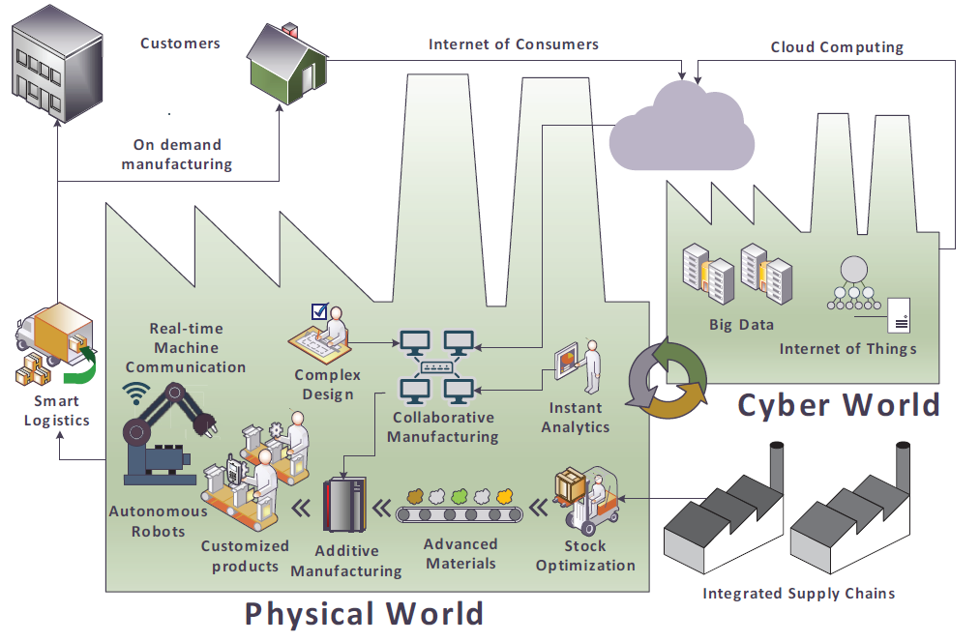
Figure 5. Schematic of smart factories with general properties required in Industry 4,0

Conclusion

Although the process being over 3 decades old, Additive Manufacturing is still considered to be in its infancy and has a long way to go until it develops into a viable alternative to current traditional manufacturing process, particularly for large scale part production. Nevertheless, the process has been embraced within the Medical Device industry for the many advantages it offers and its ability to produce customised high quality products.

In the future, with an increased importance placed on Industry 4.0 and environmental impacts, Manufacturing (smart factories) will depend heavily on developing the process as it will be key to reducing wastes and increasing efficiencies.

The current version of the Acetabular shell (hip joint) is in transition between production by traditional, heavily laboured, manufacturing processes and sole manufacturing by additive manufacturing methods, however until the required developments to increase production speeds and reduce associated costs have been addressed the reliance on this process along cannot be relied upon.

The future for this process is extremely positive and its contribution to medical device manufacture is assured.

Bibliography

References

3DEO. (2018, July 25). Environmental Impact of Additive Manufacturing. Retrieved from 3deo: https://news.3deo.co/environmental-impact-of-additive-manufacturing
Ali Madani, C. A. (2018, May 05). Will Additive Manufacturing Revolutionize Orthopedic Product Manufacture? (O. D. Technology, Interviewer) Retrieved from Ali Madani, CEO, Avicenne Medical 05.29.18
Carlström, R. (2018, November 14). Additive manufacturing can reduce industry’s environmental impact. Retrieved from https://www.theengineer.co.uk: https://www.theengineer.co.uk/additive-manufacturing-can-reduce/
Culmone, C., Henselmans, P., van Starkenburg, R., & Breedveld, P. (2020). Exploring non-assembly 3D printing for novel compliant surgical devices. PLoS ONE. Vol. 15 Issue 5, 1-21.
Dilberoglua, U. M., Gharehpapagha, B., Yamana, U., & Dolena, M. (2017, June 30). The role of additive manufacturing in the era of Industry 4.0. Retrieved from www.sciencedirect.com: https://pdf.sciencedirectassets.com/306234/1-s2.0-S2351978917X0005X/1-s2.0-S2351978917303529/main.pdf?X-Amz-Security-Token=IQoJb3JpZ2luX2VjEMb%2F%2F%2F%2F%2F%2F%2F%2F%2F%2FwEaCXVzLWVhc3QtMSJGMEQCIG8Lt85eg6qshRYiPAxd7FLYd9Jw5YTpkcI%2BvT9i3laxAiBj82Zt%2B4yC
Farinia Group. (n.d.). What is Additive Layer Manufacturing (ALM)? . Retrieved from www.farinia.com: https://www.farinia.com/additive-manufacturing/3d-technique/additive-layer-manufacturing
Fried, S. (2019, April 18). Additive Manufacturing: Advantages and Disadvantages for PCB Prototyping. Retrieved from Nano Dimension: https://www.nano-di.com/blog/2019-additive-manufacturing-advantages-and-disadvantages-for-pcb-prototyping
Gautam Gupta, P. D. (August 2012). OsseoTi Porous Metal For Enhanced Bone Integrationan Animal Study. Advanced Process Technologies.
Goodridge, R., & Babu, S. (2015). Additive Manufacturing. Materials Science & Technology, Vol. 31 Issue 8, 881-883.
Haleem, A., & Javaid, M. (2019). Additive Manufacturing Applications in Industry - 4.0: A Review. Journal of Industrial Integration and Management, Vol. 4, No. 4, 1-23.
Horizon Technology. (2020, April 24). 3 Advantages & Disadvantages of Additive Manufacturing Process Vs. PM. Retrieved from https://www.horizontechnology.biz: https://www.horizontechnology.biz/blog/advantages-and-disadvantages-of-additive-manufacturing-process-vs-powder-metallurgy
Lincotek Trento SPA. (2019). Advantages of additive manufacturing. Retrieved from https://www.lincotekmedical.com: https://www.lincotekmedical.com/products-services/additive-manufacturing/advantages-of-additive-manufacturing/
Mahmoud, D., & Elbestawi, M. A. (2019). Selective laser melting of porosity graded lattice structures for bone implants. International Journal of Advanced Manufacturing Technology, Vol. 100 Issue 9-12, 2915 - 2927.
Royal Academy of Engineering. (2013, November). Additive Manufacturing. Retrieved from Royal Academy of Engineering: www.raeng.org.uk/AM
Sher, D. (2020, February 15). How medical companies use AM for production today, part 6: Zimmer Biomet and OPM. Retrieved from 3D Printing Media Network: https://www.3dprintingmedia.network/zimmer-biomet-additive-manufacturing/
Shirazi, S., Gharehkhani, S., Mehrali, M., Yarmand, H., Metselaar, H., Adib Kadri, N., & Osman, N. (2015). A review on powder-based additive manufacturing for tissue engineering: selective laser sintering and inkjet 3D printing. Science & Technology of Advanced Materials, Vol. 16 Issue 3, 1.
Zimmer Biomet Orthopedic Inc. (2017). OsseoTi® Porous Metal Technology. Retrieved from https://www.zimmerbiomet.com: https://www.zimmerbiomet.com/medical-professionals/hip/product/g7-acetabular-system.html
Zimmer Biomet Orthopedics Inc. (2015). G7 Acetabular Surgical Technique. Retrieved from Biomet.com: http://www.biomet.com/wps/wcm/connect/internet/d661463c-eb2d-4011-8057-aaa752bc6d8f/BMET0120.5_G7.pdf?MOD=AJPERES&CONVERT_TO=url&CACHEID=d661463c-eb2d-4011-8057-aaa752bc6d8f
Zimmer Biomet Othropedics Inc. (2015). G7 Surgical Techniques. Retrieved from http://www.biomet.com/wps/wcm/connect/internet/d661463c-eb2d-4011-8057-aaa752bc6d8f/BMET0120.5_G7.pdf?MOD=AJPERES&CONVERT_TO=url&CACHEID=d661463c-eb2d-4011-8057-aaa752bc6d8f

Table of figures

Figure 1. Trabecular structure of G7 OsseoTi Acetabular shell 3
Figure 2. Porous structure of human cancellous bone 3
Figure 3. G7 range of Acetabular shells 4
Figure 4.Manufacturing Process Flow 5
Figure 5. Schematic of smart factories with general properties required in Industry 4,0 7

Relevant Standards
- ISO/ASTM 52900(en) - Additive manufacturing
- ISO 841, Industrial automation systems and integration — Numerical control of machines — Coordinate system and motion nomenclature
- ISO 10241-1, Terminological entries in standards — Part 1: General requirements and examples of presentation
- ISO 10303, Industrial automation systems and integration — Product data representation and exchange
- ISO 17296-2, Additive manufacturing — General principles — Part 2: Overview of process categories and feedstock
- ISO/ASTM 52915, Standard specification for additive manufacturing file format (AMF)
- ISO/ASTM 52921, Standard terminology for additive manufacturing — Coordinate systems and test methodologies
- ASTM D4821 – 16, Standard Guide for Carbon Black—Validation of Test Method Precision and Bias
- ISO/IEC 12207:2008, (en) Systems and software engineering — Software life cycle

