Word count 3228 minus references
Research Question :
Exploring housing decarbonisation carried out by Swansea Council. Is there still a difference between the policy objectives of retrofit housing in Wales and the renovations carried out?
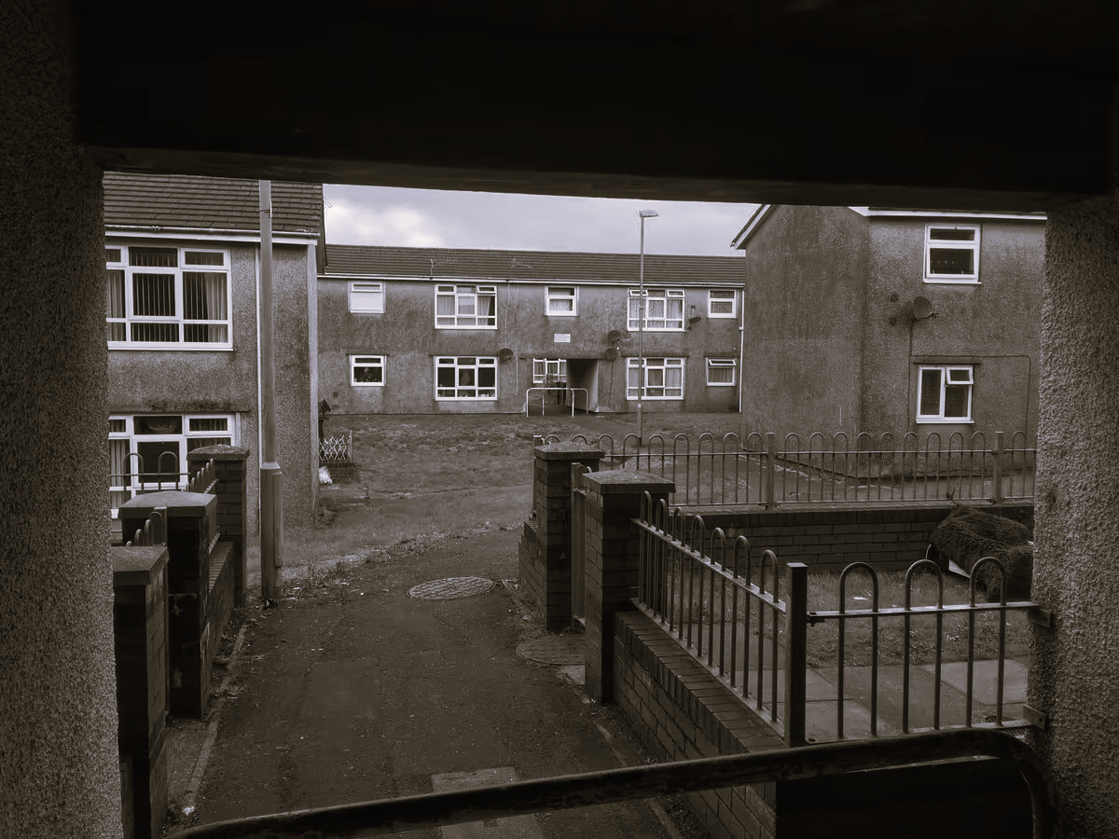
Figure: 01 Swansea Counci target for decarbonisation, Heol Emrys, Penlan (Credit : Richard Youle 2022)

The study aims to ask what is the best method of retrofitting buildings that addresses the problems experienced in decarbonization since 2021. Including, buildings with existing with existing damp and mould problems, looking at the mistakes made in retrofitting in the past, finding the best and most affordable solutions.
Aim of the research
In the Griffiths-Williams (2021) Welsh Government WPPN’s Decarbonisation and Building Materials webinar, ‘Constructing Excellence in Wales ,’ Rico Wojtulewicz, Head of Planning and Policy pinpoints lack of skills, ’ there is too much voter pleasing, to get it right we need Passivhaus,’ (Wojtulewicz in Griffiths-Williams 2021, 19:38). He concludes shockingly, ‘ we see solar panels are fitted and not connected to anything’. (Wojtulewicz in Griffiths-Williams 2021 20:47).
Exploring the realities of retrofit, considered by Ed Green and Simon Lannon, Welsh School of Architecture’s paper, ‘Homes of today for tomorrow Decarbonising Welsh Housing between 2020 and 2050 Stage 4: retrofit in practice. They found since the 1961 Ministry of Housing and Local Government report the same issues are present,

‘where there is, still a clear need for better quality housing, but a lack of understanding of how meaningful improvement could or should be made.’ (Green and Lannon (2024,p.4).

The study aims to understand past and present failures, despite legislation and what is being achieved now in 2026. Colin King’s principles, the 4C’s method of considering retrofitting will be applied different case studies identifying potential solutions, including Swansea Council decarbonization site in Clydach. PAS regulations used to analise the findings.

King’s four Cs illuminate barriers and opportunities. Context includes understanding location, construction and occupancy, with an understanding of geography. Coherence covers understanding connections into the building, moisture and mould management. Very importantly is Capacity, to allow for mistakes and the unexpected to occur. Caution is the understanding that after care and use of a building should be monitored for the unexpected and challenges in the future. (King, 2024).
Three case studies will examine two Swansea Council houses and non-corporate plan for the insulation retrofit of a grade II listed church conversion in Holt will be compared to understand limitations in private sector decarbonisation projects. These are explored in the Strategy section of the dissertation. The research aims to explore the failings of retrofits and gaps in legislation, using a variety of data gathering devices to identify best practice and past mistakes. Analysis will include current projects, see Figures 01/02 part of Swansea Council’s latest decarbonisation programme. Powell and Dobson’s projections and plans will be examined including news articles. A Wales Online article illustrates decarbonisation in 2019 making mistakes, ‘Council tenants paid £443,000 compensation for 'hugely intrusive' bathroom and kitchen upgrades.’(Youle 2019, p.1). Conclusions will be drawn from data analyzed, questionnaires, policies and construction data including use of technology including thermal imaging, plus examination of energy efficiency certificates.

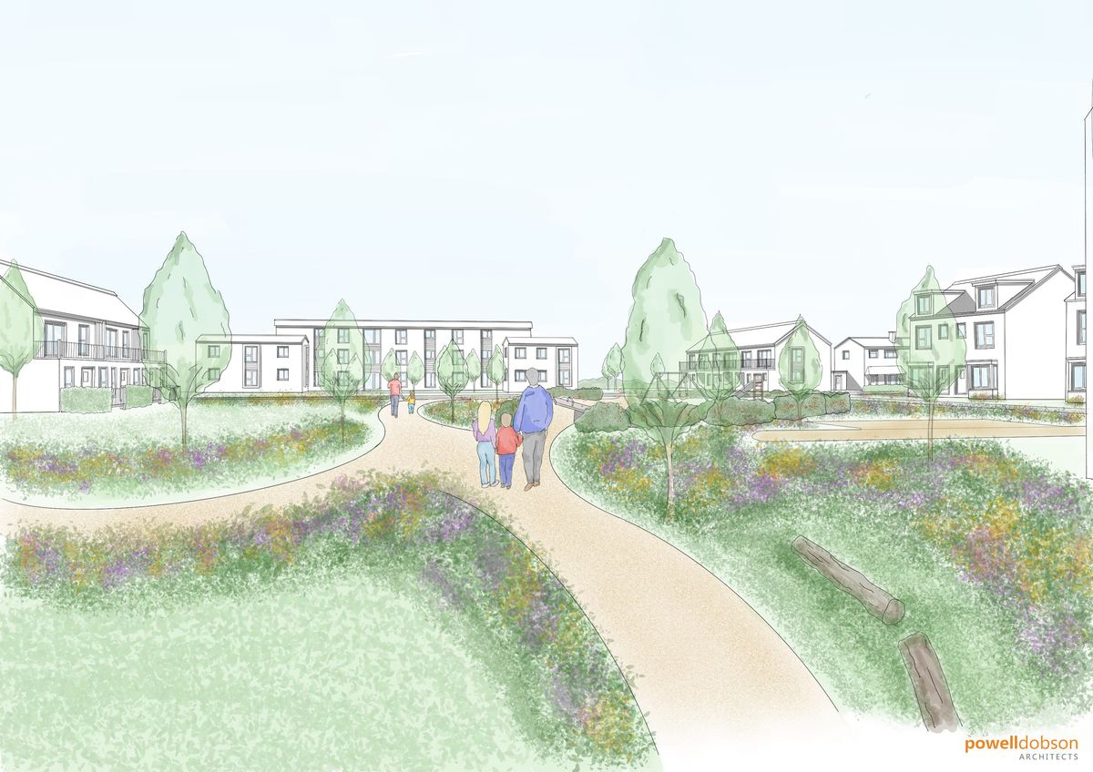
Figure :02 Plans: partially decarbonised Heol Emrys, note new builds to the right and green areas, decarbonised retrofit to the rear, centre of the picture(Credit Powell Dobson Architects 2022)
Strategy for conducting the research
The study will follow Linda Groat and David Wang, referring to the 2nd Edition of Architectural Research Methods 2013, to focus the research question. The diagram shows the interrelationship between the aims, methodology, data gathering and structure of the study. The diagram is inspired by Lara’s use of organic diagrams in his combined strategy research to reflect the organic growth of researching architecture in harmony with nature, like a tree with branches(Lara, 2019).

Strategy for conducting the research

Literature Review
. Source: various reliable
. Source Accuracy
Primary policy document: Welsh Government (2025)‘Welsh Government Consultation Document 2025, Building Regulations Part L Review Changes to Part L(conservation of fuel and power) Part O (overheating) Part F (ventilation) of the Building Regulations for Dwellings and non-domestic buildings.’
Methodology Groat and Wang(2019) Chapter 12, ‘Case Studies and Combined Strategies, referring to Architect Fernando Lara’s use of these strategies.

Contextual Purpose
. Motivation : to seek faults and improvements in decarbonisation
Primary source: Griffiths-Williams 2021 Welsh Government WPPN’s Decarbonisation and Building Materials webinar
. Audience : professionals, stake holders, the public
. Impact : to highlight current decarbonisation
Primary source : Swansea Council Decarbonisation schemes, questionnaires, policy documents
Research Purpose
. Theory : examine documents
. Application: active site analysis

Research Question: Decarbonisation faults and improvements
Decarbonisation faults and improvements

Case studies : Swansea Council decarbonisation projects ongoing and new retrofits 2027, private sector comparison retrofit church conversion
Strategies and Tactics:
Use of Case Studies and Combined strategies

Strategies

Tactics

Figure : 03 Diagram showing interconnections in dissertation (credit Groat and Wang 2013).

Theoretical Structure Conceptualization Specific to the Setting , following Kin’s 4 C’s : Context, Coherence, Capacity and Caution
Quantitative Stage Literature Review : a wide variety of secondary sources have been examined including numerous Welsh Government policy documents and initial interviews with professionals in the field e.g. Swansea Council staff

Structure within the research methods Needs Assessment Qualitative Stages
. Interviews with professionals and the community
. Observations of sites to be studied
. Documents, primary sources and secondary pinpointed in detail
Use of qualitative and quantitative research from others, referring to Swansea Council and Cardiff University

Program Follow-up and Refinement
Qualitative Stage
. Interviews with residents
. Observations : clarifying connections, looking for gaps
. Documents/interpretation of data: professional audit from Building Services mentoring and peer review questionnaires

Program Implementation and Test
Based on Dr John Creswell American health and wellbeing researcher mixed methods that supports King and Lara’s holistic organic connections in research data gathering
Check data gathering at mid-point to recalibrate if data is not covering key areas of the research question
Qualitative stage
Experimental Intervention
Test Program Based on qualitative measures
Access technology and field of measurement
Instrument and Measure Development
. Quantitative Research,: questionnaire’s producing graphs
. Specify Measure : use King’s boundaries and structures
. Develop Instrument : technology, thermal imaging, site measurement

Figure : 04 Conceptualisation flow chart (credit Creswell 2015).

The decarbonisation projects will be judged using PAS and Welsh Government recommendations , practical observations from project managers, photographs and reported evidence from Cardiff University webinar series 2025/2026 Design Research Approaches for Transforming Homes for Future Generations.

Initial Investigations informing Case Studies
The researcher carried out policy research and interviews with Swansea Council and Welsh Government Staff. Gained advice from Architects, examined webinars, papers, media reports and oral accounts from residents whilst on placement with Swansea Council. Site visits were carried out, site induction and basic health and safety training were attended. Equipment reviews were carried out for technological studies and structure of sites, routines and time tables were studied including mentoring included in documented records for final dissertation draft in 2027. Consultations with clients took place in similar terms for the private sector data case study gathering (Steward, 2026b).
Case Studies
Case studies: The three case studies will examine the two Swansea Council solutions to retrofitting in Townhill and Clydach where cavity insulation has caused damp issues, the two experimental biobased techniques will be examined to determine the advantages and disadvantages. The third case study will be a private sector decarbonisation project.
Swansea Council Project manager, Andrew Jackett stressed the importance of community involvement,
‘We didn’t think we would have trouble securing shared areas where residents accessed utility meters but they were broken into, obscured and blocked by packs of dogs, discarded fake human skeletons and Christmas decorations.’ (Steward, 2026a)
King; s Four C’s checklist will be valuable in anaylising holistic site data.

Methodology
The study intends to use the methodology reviewed by Groat and Wang, ‘Case Studies and Combined Strategies,’(Groat and Wang, 2013, p.415). Suiting the fluid outcomes of the project. Lived experience element where questionnaire’s, live case studies and qualitative oral evidence will be considered.
The study will use criteria of analysis used by Swansea Council: PAS 2035:2023 Retrofitting dwellings for improved energy efficiency 2024. See below key PAS table:

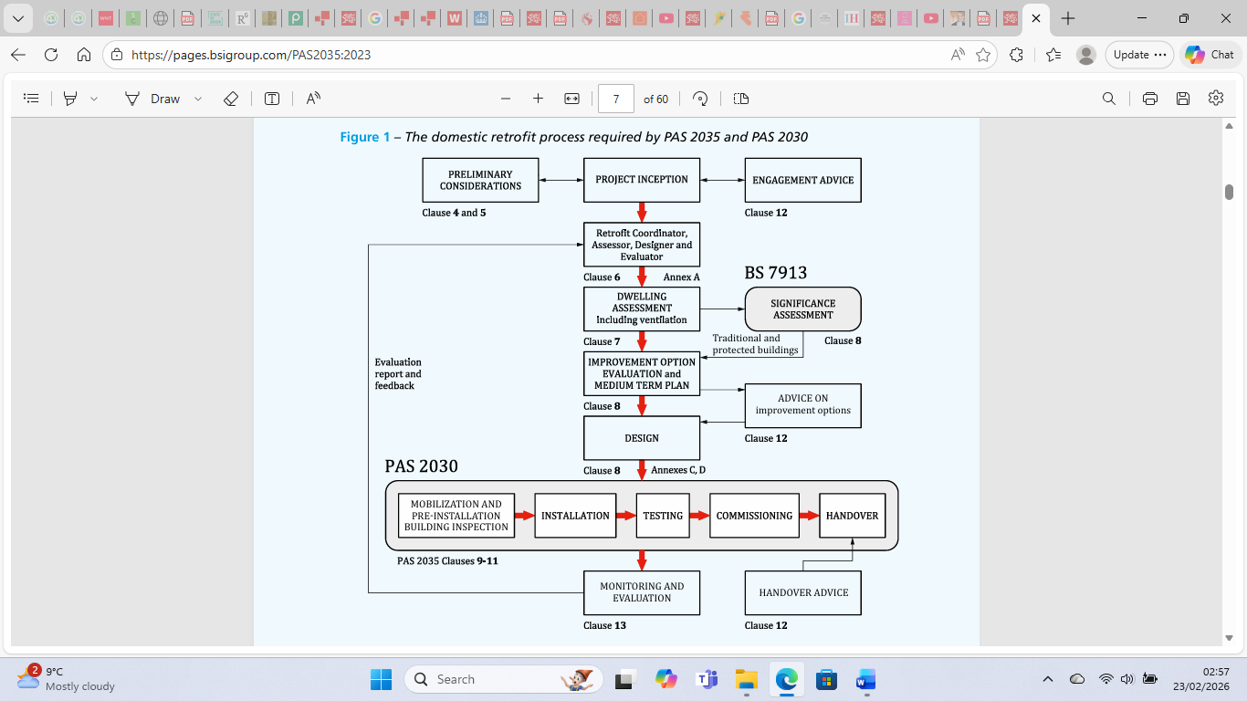
Figure :05 Flow diagram of the retrofit process required by PAS 2035 and 2030 (credit British Standards Institution, 2024).

Qualitative and quantitative data will include residents and professionals. London University College’s analysis paper designed to understand hard to decarbonise homes will assist the analysis of the decarbonisation issues.
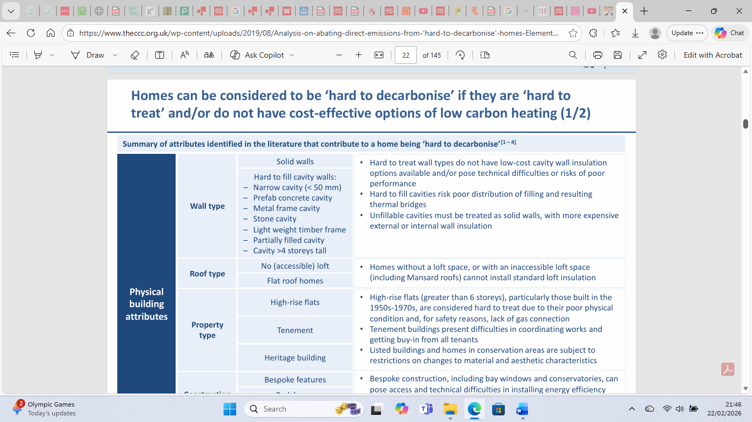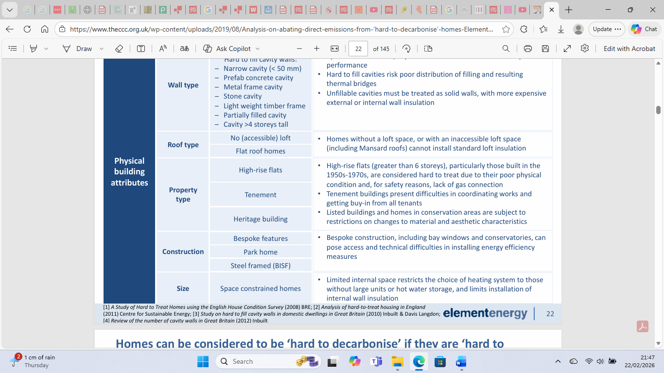
Figure 06: definitions of hard to decarbonise homes, showing why there lower performance outcomes (credit London University College, 2019)

Literature Search
Linda Groat and David Wang’s chapter on combined strategies in 2nd Edition of Architectural Research Methods 2013, refers to Modernist researcher and South American Architect Fernando Lara, in his comparison of Modernism in two cities. The study will use some of Lara’s strategies by using multiple data collection sources in order to understand the residents and practitioners opinions of the decarbonisation(Groat and Wang, 2013).
Groat and Wang’s essential recommendations for empirical combined methodology research will be used to give the theoretical structure. Showing rationalization of issues such as causal understanding of links between the case studies in real life contexts as in a building site environment, to ensure theoretical studies correlate with the new data collected in the field.
Groat and Wang’s methodology referring to Lara is used due to the profound understanding Lara has of intrinsic issues effecting outcomes in retrofit and decarbonisation. Reference will be made to his survey book, Carranza, L.E and Fernando, L.L (2015) Modern Architecture in Latin America: Art, Technology, and Utopia and webinar, ‘Fernando Lara : The other of the other, Modern Architecture in Latin America, Center for Latin America and Caribbean Studies,’ 2017.
Lara identifies the same ‘needs’ issues Project Manager Jackett observed in the Swansea Council project, the same issues identified in the 2021 webinar by the Constructing Excellence in Wales Body. Illustrated by Wojtulewicz, ‘That’s the problem in the decarbonisation process that there are few people in the business focussed on required needs.’ (Wojtulewicz in Griffiths-Williams, 2021 15:13) referring to, the lack of knowledge in construction and short fallings in connections with policies and planners to the built environment causing failings.
American wellbeing researcher Creswell has been used to give fluid but well defined parameters to the initial and ongoing research in using one of his flow chart diagrams, see Figure 04.

The study aims to explore the issue identified in decarbonisation programmes in Wales of concern, identified in 2021 that since the pandemic there is a short fall in successful performance outcomes between Welsh policy and the actual sustainability results in the decarbonised homes. Using the primary sources in the form of reports made in 2021 by the Constructing Excellence in Wales Body and relevant Welsh Government policies.
To support this research to gain a strong view of how decarbonisation has been developing in the last 4 years since the pandemic, the research will examine the accountability and reports that were discussed in the 2021 Welsh Government WPPN’s (Welsh Procurement Policy Note) The Decarbonisation and Building Materials webinar.
The webinar, ‘Constructing Excellence in Wales ,’ was led by chief executive, Catherine Griffiths-Williams. The Constructing Excellence in Wales body was set up in 2002 by Welsh Government reflecting the recommendations of the Egan Report, ‘Rethinking Construction.’ It’s now an independent body, ‘campaigning to highlight the industry role in underpinning key Welsh Government strategies and creating a built environment fit for the future.’(Griffiths-Williams, 2021, 1:35)

This webinar has been chosen to set the scene as a view of decarbonisation its faults and innovations developing. The faults and recommendations raised in the webinar will then be compared to a second document that is current Welsh Government report showing recommendations currently being floated as answers to the faults in decarbonisation and retrofit.
The second document used is the, ‘Welsh Government Consultation Document, Building Regulations Part L Review Changes to Part L(conservation of fuel and power) Part O (overheating) Part F (ventilation) of the Building Regulations for Dwellings and non-domestic buildings.’ The document will be an interesting body of information to compare the faults and strategies in the building construction and materials used and reviewed in 2021 in Wales by an independent body that lives in the spirit of supporting Welsh Government policies. The 2025 document will illustrate the Welsh Government view now of which areas in retrofit and decarbonisation matter today.

The study will focus on the part of the 2025 document that refers to ‘Chapter 3 Part L,F and O Standards for Existing Dwellings in 2024,’ which gives recommendations for the implementation of remedial decarbonisation work. It is a consultation document referencing areas covered by the 2021Welsh Government webinar.
One of the interesting comments in the consultation document refers to in Question 34, suggests the importance of using,
‘insulation of exact ducting drainage measures to combat build-up of possible condensation water in existing dwellings,’ (Welsh Government, p.40,2025)
The webinar, documents and written accounts will be explored to detect failures in the decarbonisation of existing housing stock and explore the recommendations in 2025 there to address the long term failures.
The study takes the idea from Construction Manager Alex Read who is quoted in the webinar as expressing the need for celebrating the good things in the construction industry that can make decarbonisation work as mistakes are learnt from.
To get a grip on the actual construction materials and their procurement and application the researcher will examine the testimony from 2021 webinar(Excellence in Wales,2021), that includes an explanation of how business get advice in Wales from the introduction from Rob Newman, explaining the Commercial Policies advisor role. The most interesting comments to be examined come from ‘The National Federation of Builders representative Rico Wojtulewicz, Head of Planning and Policy, who gives an insight into the building materials used and the effects of the increase of building material prices and lack of training in retrofit best practice in Wales.
This theme has grown since 2021 and been observed by Colin King. The study will refer to King and his articles criticising the outcomes of retrofit decarbonisation projects. Including his article, ‘When Planning Retrofit Works, Stick to the ‘Four Cs.’ Also taken into consideration is the article about King written by Matthew Forbes Milloy (2025)‘Knowledge, Ignorance and Power: What About the Mould?’
To underpin understanding of the current situation regarding decarbonisation policies the study will explore the work of Engineer and consultant on large scale housing projects, Christopher Jofeh as being a primary starting point in understanding how different policies in Wales link together to inform the legislation regarding decarbonisation legally an d in wider terms including wellbeing. Significantly Jofeh was the former chair of the Implementation Group on Decarbonisation of Existing Housing in Welsh Government 2020-2024.
Jofeh, in his online account of the progress of policies of decarbonisation in Wales is clear that, The Well Being of Future Generations (Wales) Act 2015 is a clear signal of an important document to support decarbonisation activities as decarbonisation clearly support many wellbeing issues in Wales. Jofeh calls it, ‘A very profound piece of legislation,’ (Jofeh, 2020 0:29) That legally has to be taken into account by every public body in Wales including Welsh Government which should make it easier to promote retrofit and decarbonisation projects in Wales. Jofeh points out in his presentation on behalf of the London South Bank University.
The study will explore the benefits of decarbonisation working. That the benefits for Wales generally and in wellbeing of the nation are widespread across the spectrum. Including in economic terms, less imported energy and general energy expenditure. Less impact on vulnerable households. Pluses for Welsh employment, skills and business. These benefits in Jofeh’s terms include improved learning and productivity for people in warm better housing and community regeneration. See below chart outlining Jofeh’s ideas which the study will use as one of the criteria to discuss the benefits of decarbonisation working in alignment with Welsh Government policies.

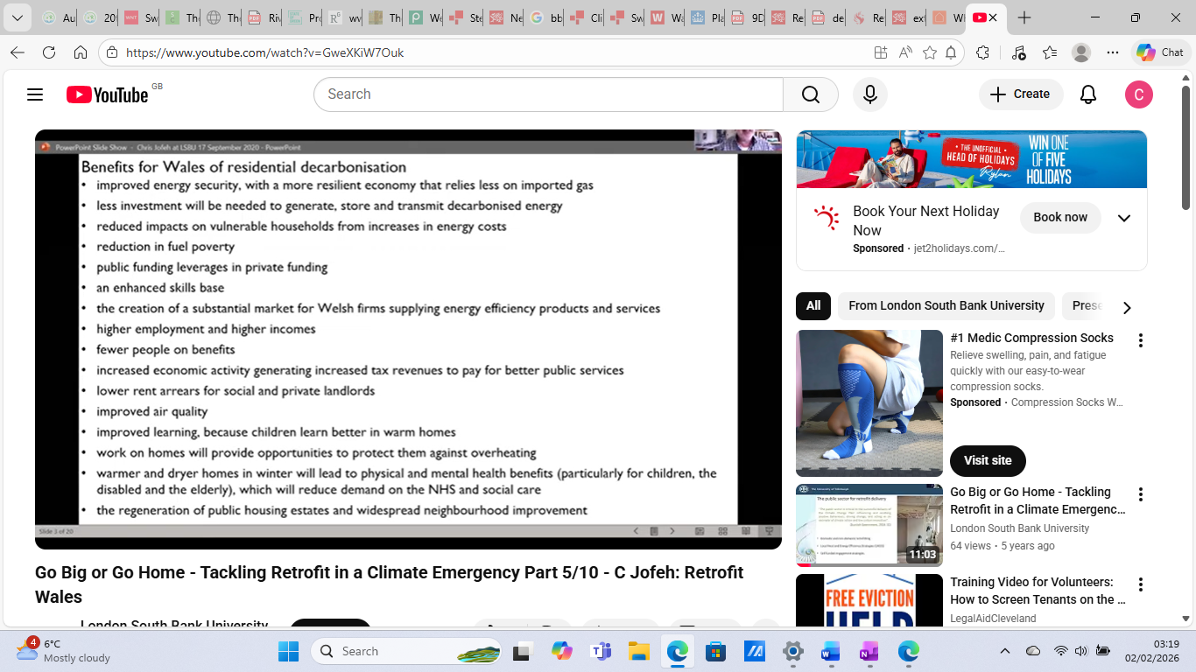
Figure :07 London South Bank University Go Big or Go Home - Tackling Retrofit in a Climate Emergency Part( credit Jofeh, 2020)

A plan is also set out by Jofeh in his document accepted by Welsh Government, ‘The Decarbonisation of Existing Homes in Wales,’2020.
Also, the document, ‘Better Homes, Better Wales, Better World, Decarbonising Existing Homes in Wales Report to Welsh Ministers from the Decarbonisation of Existing Homes in Wales Advisory Group, July 2018,’ will be referred to, giving further background to the expectations of decarbonisation results.
Reference will be made to the City and County of Swansea (2014)The One Swansea Plan and Delivery Frame work Chapter 5 Improving and Making the Best Use of Existing Housing Stock 5.1 Managing and Improving Council Housing document refers to the earlier Welsh Government strategy “Better Homes for People in Wales” and in April 2002, that introduced the Welsh Housing Quality Standard (WHQS) . To give wider scope to understanding the issue of decarbonisation failures in Wales the study will also examine the University College of London report, ‘Analysis on abating direct emissions from ‘hard-to-decarbonise’ homes, with a view to informing the UK’s long term targets A study for the Committee on Climate Change Final Report (Version 3.4) (July 2019). This report further explored in the methodology of the study will help pin point areas in the insulation decarbonisation process that need to be inspected closely.
The research will include oral accounts from current construction decarbonisation projects being carried out by the City and County of Swansea in the Clydach area, concerning current social housing stock. The researcher has been invited to examine current decarbonisation projects and to have the opportunity to explore comparisons fo two different houses being retrofitted. Swansea Council adheres closely to the PAS (Publically Available Specification)2035:2023 Incorporating Corrigendum No. 1 Retrofitting dwellings for improved energy efficiency – Specification and guidance Department of Energy Security and Net Zero 2024 BSI Standards Limited 2024. This document will be examined in the strategies of conducting the research as one of the yardsticks to assess the decarbonisation success rates when comparing the pilot and the main case study.
Cardiff University are supporting Swansea Council in their decarbonisation project and the study will refer to their ongoing research findings examining the success of the retrofit including insulation. The researcher will be following their webinar series, ‘design Research Approaches for Transforming Homes for Future Generations, Cardiff University (Coombes, 2026) as it rolls out and consulting with their team to acquire up to date data to examine in the study.
The researcher will also be using various mixed methodologies that enable thorough exploration of the comparisons of the decarbonised houses and pinpointing improvements in construction methods.
The methodologies explored by Groat and Wang will be used in the dissertation. Terminology used by Groat and Wang refer to a particular form of mixed methodologies they write of as ,Case Studies and Combined Strategies,’(Groat and Wang, 2013, p415).

The researcher has chosen this method because of its sensitivity and passion to seek out the facts in the ‘ordinary,’ by examining the built environment thoughtfully and by use of a number of qualitative and practical methods, ‘in their real life contexts,’(Groat and Wang, 2013, p419).
Once the work is completed the sustainability of the retrofits in terms of the past failures in Wales e.g. damp reoccurring with cross examination of policies, evidence, questionnaires and holistic evidence.

References
Carranza, L.E and Fernando, L.L (2015) Modern Architecture in Latin America: Art, Technology, and Utopia (Joe R. and Teresa Lozano Long Series in Latin American and Latino Art and Culture) University of Texas Press, Texas

CHICLTD (2026) How to use a CHIC Framework and DPS
Available at : https://www.chicltd.co.uk/wp-content/uploads/sites/94/2025/06/How-to-use-a-CHIC-Framework-and-DPS-5.pdf (Accessed: 12 February 2026).

Climate Change Committee (2019) Analysis on abating direct emissions from ‘hard-to-decarbonise’ homes, with a view to informing the UK’s long term targets A study for the Committee on Climate Change Final Report (Version 3.4) July 2019 Element Energy Lt
Available at:Analysis-on-abating-direct-emissions-from-‘hard-to-decarbonise’-homes-Element-Energy-UCL.pdf (accessed January 2026).

Climate Change Committee Wales (2025)Fourth Carbon Budget
Available at: https://www.theccc.org.uk/publication/wales-fourth-carbon-budget/
(Accessed: 5 March 2026).
Creswell, C.W (2015) A Concise Introduction to Mixed Methods Research. London: Sage.

Decarbonisation of Homes in Wales Advisory Group(2018) Decarbonisation of Existing Homes in Wales Advisory Group (2018), Better Homes, Better Wales, Better World, Decarbonising Existing Homes in Wales Report to Welsh Ministers
Available at:https://www.gov.wales/sites/default/files/publications/2019-07/independent-review-on-decarbonising-welsh-homes-report.pdf(accessed January 2026).

Department for Energy Security and Net Zero(2024) PAS 2035:2023 Incorporating Corrigendum No. 1 Retrofitting dwellings for improved energy efficiency – Specification and guidance
Available at :https://pages.bsigroup.com/PAS2035:2023 (Accessed: 5 March 2026).

Forbes Milloy, M (2025)‘Knowledge, Ignorance and Power: What About the Mould?’ Refurb and Retrofit Magazine. Available at : https://www.refurbandretrofit.com/knowledge-ignorance-and-power-what-about-the-mould/
(Accessed: 12 February 2026).

Future Generations Commissioner for Wales Department Welsh Government (2015) The Well Being of Future Generations (Wales) Act 2015 Available at: https://futuregenerations.wales/do/get-in-touch/ (Accessed: 5 March 2026).

Green, E and Lannon, S (2024) Homes of today for tomorrow Decarbonising Welsh Housing between 2020 and 2050 Stage 4: retrofit in practice, Welsh School of Architecture. Available at :
https://www.gov.wales/sites/default/files/publications/2024-03/homes-of-today-for-tomorrow-decarbonising-welsh-housing-between-2020-2050.pdf
(Accessed: 5 March 2026).

Griffiths-Williams (2021) Welsh Government WPPN’s Decarbonisation and Building Materials webinar, ‘Constructing Excellence in Wales The Constructing Excellence in Wales
Available at:https://www.gov.wales/building-stronger-future-welsh-construction
(accessed January 2026).

Groat, L and Wang, D ( 2013) Architectural Research Methods 2nd Edition of Architectural Research Methods Wiley &Sons Hoboken, New Jersey

Jofeh, C (2020) Go Big or Go Home - Tackling Retrofit in a Climate Emergency Part 5/10 Retrofit Wales: London South Bank University
Go Big or Go Home - Tackling Retrofit in a Climate Emergency Part 5/10 - C Jofeh: Retrofit Wales
(accessed January 2026).

King, C (2024)When planning retrofit works, stick to the ‘four Cs’ Inside Housing
Available at : https://www.insidehousing.co.uk/comment/when-planning-retrofit-works-stick-to-the-four-cs-86017 (Accessed: 5 March 2026).

Palate, S (2024) Urban Planning 2024 Heating Standards and Obsolescence in Post‐War Britain’s Homes for Today and Tomorrow Department of Architecture, University of Cyprus, 18 April 2024 Volume 9 Article 7754 Open Access Journal. Available at:
file:///C:/Users/cstew/Downloads/UP%209%20-%20Heating%20Standards%20and%20Obsolescence%20in%20Post-War%20Britain's%20Homes%20for%20Today%20and%20Tomorrow%20(1).pdf
(Accessed: 5 March 2026).

Passivhaus Trust (2026) Passivhaus Benefits
Available at: https://www.passivhaustrust.org.uk/ (Accessed: 5 March 2026).

Steward, B., (2026a) Conversation with Project Manager Andrew Jackett Clydach Depo, Building Services Department Swansea Council, Swansea Council, 18 February
Steward, B., (2026a) Consultations with clients took place in similar terms for the private sector data case study gathering 20 February.

Swansea Council (2014) Chapter 5 Improving and Making the Best Use of Existing Housing Stock 5.1 Managing and Improving Council Housing The One Swansea Plan People have good places to live and work.
Available at: https://democracy.swansea.gov.uk/documents/s22398/5%20-%20LHS%20stock.pdf (Accessed: 5 March 2026).

Swansea Council (2023a) Climate Change and Nature Strategy 2022-2030. Available from: https://www.swansea.gov.uk/article/20500/Climate-Change-and-Nature-Strategy-2022-2030 (Accessed: 27 February 2024).

Swansea Council (2023b) Corporate plan 2023 / 2028. Available from: https://www.swansea.gov.uk/article/22119/Corporate-plan-2023--2028
(Accessed: 27 February 2024).

Swansea Council (2023) Retro-fit council bungalows cutting the cost of tenants' electricity bills : Improvement works completed on a row of award-winning energy-saving retrofit council homes in Craig Cefn Park have significantly reduced electricity bills of tenants.
Available at: https://www.swansea.gov.uk/article/23485/Retro-fit-council-bungalows-cutting-the-cost-of-tenants-electricity-bills (Accessed: 5 March 2026).

Swansea Council (2024) Net Zero 2030 policies. Available from: https://www.swansea.gov.uk/netzero2030policies
(Accessed: 27 February 2024).

Vingerling, H.J.J and Hendriks, N.A (2002) Solutions And Strategies To Upgrade The Existing Housing Stock Foundation for Building Research (SBR) Rotterdam The Netherlands 2Eindhoven University of Technology Building and Architecture The Netherlands
Available at: https://www.irbnet.de/daten/iconda/CIB9257.pdf (Accessed: 5 March 2026).

Welsh Government(2001) Strategy “Better Homes for People in Wales” Welsh Housing Quality Standard (WHQS)
Available at: https://democracy.swansea.gov.uk/documents/s22398/5%20-%20LHS%20stock.pdf (Accessed: 5 March 2026).

Welsh Government (2026) Optimised Retrofit Programme: How we are helping registered social landlords reduce the carbon footprint of existing social housing
Available at: https://www.gov.wales/sites/default/files/pdf-versions/2026/2/3/1772031311/optimised-retrofit-programme-3-year-5-guidance-2026-2027.pdf (Accessed: 5 March 2026).

Welsh Government (2025) Welsh Government Consultation Document 2025, Building Regulations Part L Review Changes to Part L(conservation of fuel and power ) Part O (overheating) Part F (ventilation) of the Building Regulations for Dwellings and non-domestic buildings.
Available at: Welsh-Building-Regulations-Part-L-2025-Review-NIA-Response.pdf (Accessed: 5 March 2026).

Welsh Government (2025) Welsh Housing Quality Standard: as at 31 March 2025 (official statistics in development) Information on the progress made by social landlords in achieving the Welsh Housing Quality Standard (WHQS) for all their stock as at 31 March 2025.
Available at: https://www.gov.wales/welsh-housing-quality-standard-31-march-2025-official-statistics-development-html (Accessed: 5 March 2026).

Welsh Government (2018) External Wall Insulation (EWI) Project guide Procurement guide for EWI, tailored for Local Authorities and RSLs
Available at: https://www.gov.wales/sites/default/files/publications/2019-04/external-wall-insulation-project-guide.pdf (Accessed: 5 March 2026).

Welsh Government (2014)Practice Guidance Planning for Sustainable Buildings Wales Planning Policy Development Programme
Available at: https://www.gov.wales/sites/default/files/publications/2018-09/planning-sustainable-buildings.pdf (Accessed: 5 March 2026).

Welsh Government (2019) Better Homes, Better Wales, Better World Decarbonising existing homes in Wales : Report to Welsh Ministers from the Decarbonisation of Homes in Wales Advisory Group
Available at: https://www.gov.wales/sites/default/files/publications/2019-07/independent-review-on-decarbonising-welsh-homes-report.pdf (Accessed: 5 March 2026).

Youle, R (2025) Council faces £900m bill to upgrade social housing BBC News
Available at: https://www.bbc.co.uk/news/articles/cnvmm6gml1ro (Accessed: 5 March 2026).

Youle , R (2022) Major investment to modernise one of Swansea's most tired-looking housing estates is coming : It would be a huge improvement, according to feedback from residents Wales Online
Available at: https://www.walesonline.co.uk/news/wales-news/penlan-swansea-police-housing-estate-25467461 (Accessed: 5 March 2026).

Youle, R (2019) Council tenants paid £443,000 compensation for 'hugely intrusive' bathroom and kitchen upgrades: “We give the occupier money as a recognition of the difficulty they go through." Wales Online
Available at: https://www.walesonline.co.uk/council-tenants-paid-443000-compensation-16005910 (Accessed: 5 March 2026).

List of Illustrations

FIGURE TITLES
Figure 01: Heol Emrys 2022 1

Figure :02 Plans for a decarbonised Heol Emrys 3

Figure : 03 Diagram showing interconnections in dissertation 2013 4

Figure : 04 Conceptualisation flow chart 2013 5

Figure :05 Flow diagram of the retrofit process
required by PAS 2035 and 2030, 2024 6

Figure 06: chart shows definitions of,
hard to decarbonise homes 2019 9

Figure :07 London South Bank University 15
Go Big or Go Home 2020

