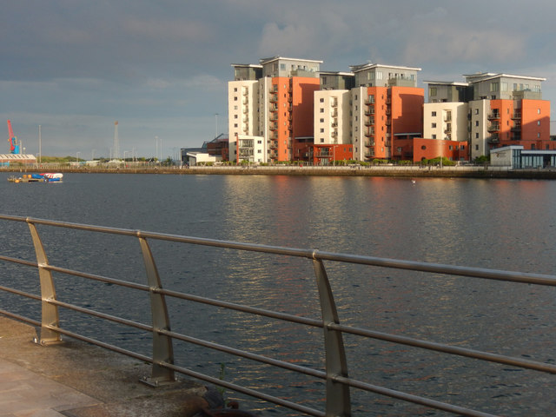

Energy Report
Prince of Wales Dock Footbridge
May 2022
Produced by: Rhydian Preece

SCS Sustainable Civil Solutions Ltd
Contents
List of Figures……………………………………………………………………………………………………………………3

- Introduction……………………………………………………………………………………………………….…4

- Findings …………………………………………………………………………………………………………………4
  - Wind energy………………………………………………………………………………………………….4
  - Solar energy………………………………………………………………………………………………….5
  - Kinetic energy……………………………………………………………………………………………….6
  - LEDs………………………………………………………………………………………………………………7
  - Lampposts…………………………………………………………………………………………………….7
  - Conclusion…………………………………………………………………………………………………….8

- References…………………………………………………………………………………………………………….9

List of Figures
Figure 1 – Image showing the Rachel Carson Bridge. [Online]. [Accessed 10 February 2022]. Williams (2021)
Figure 2 – Wind turbines for the Rachel Carson Bridge. [Online]. [Accessed 10 February 2022]. Williams (2021)
Figure 3 – Image of the Blackfriars Bridge. [Online]. [Accessed 20 February 2022]. Guardian (2014).
Figure 4 – Kinetic walkway. [Online]. [Accessed 20 February 2022]. Go To Energy (2019).
Figure 5 – LED strips along a footbridge. [Online]. [Accessed 20 February 2022]. acdc (2022).

- Introduction
When constructing this bridge, important considerations for the project are sustainability and innovation. Innovation will be implemented through the design of the bridge itself, but through this innovation, we must be sustainable in our construction methods. Though these considerations are the client's request, we believe it’s important that sustainability is used on any construction project, especially nowadays with climate change being a big problem.
So, this report will be outlining the different ways in which we plan to illuminate the bridge with different energy supplies, and how we could do this sustainably. After outlining the different power sources, we will recommend the best one that we believe should be used for this bridge type. The final decision is however given by the client.
- Findings
2.1 Wind energy
One of the first solutions that one came across was from a bridge in Pittsburgh. This bridge utilises wind power and LED lights for illumination. 16 specially designed wind turbines are mounted on steel platforms and secured to the bridge which generates power for 27,000 multi-coloured LED lights.
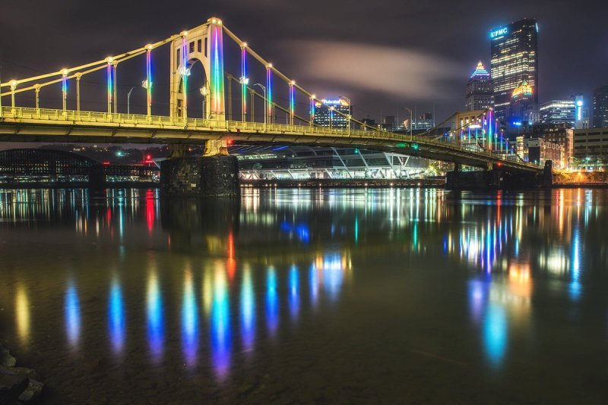
Figure 1 – Image showing the Rachel Carson Bridge. Williams (2021)
The wind turbines that were specially designed by WindStax, can store energy directly from the wind off the river. They are equipped with smart grid software, so they can store power in their battery storage systems. If there isn’t enough wind to power the LED lights, the power system can easily tap into the utility power lines. Information on this bridge was provided by Williams (2021).

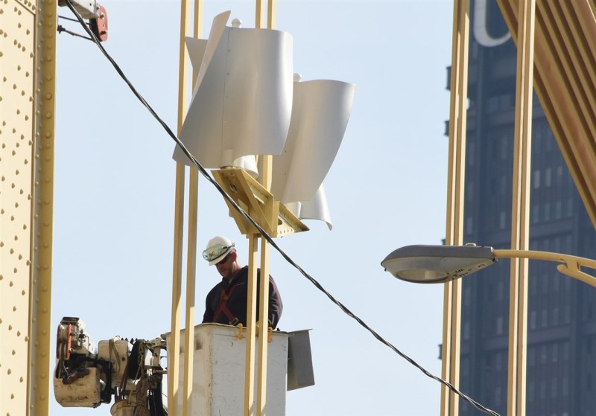
Figure 2 – Wind turbine for the Rachel Carson Bridge. Williams (2021)
This would be a viable option for our project as plenty of wind power would be generated on the Prince of Wales Dock. The wind coming from the seafront would generate enough power to illuminate the lights on this bridge. Below are the top pros and cons for Wind energy.
Wind Energy
Pros | Cons
- Renewable & clean source of energy. | - Intermittent.
- Low operating costs. | - Noise and visual pollution.
- Efficient use of land space. | - Some adverse environmental impact.
Table 1 – shows the pros and cons of wind energy
2.2 Solar Energy
The next type of energy that we could use is solar. For the wind energy, we would be mounting the wind turbines onto the bridge itself, but for solar, we would place panels all along the top of the bridge. This ensures the maximum amount of sunlight can hit these panels. The image shown below is Blackfriars bridge in London which goes across the river Thames. The bridge derives all its power from 4,400 roof-mounted photovoltaic panels. Information on this bridge is provided by Green Diary (2022).
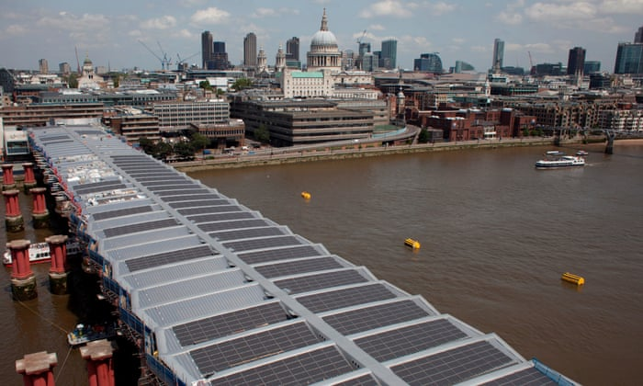
Figure 3 – Image of the Blackfriars Bridge. Guardian (2014)
If we were to use the solar panels for our bridge, they would not take up much space as they could be used at the top of the bridge. However, having all these solar panels cover the top of the bridge would limit the amount of natural sunlight coming into the bridge. This is however up to the client and their requirements. Below are the top pros and cons of solar energy.
Solar Energy
Pros | Cons
- Renewable clean energy source. | - High up-front cost
- Almost zero maintenance. | - Can be impacted by British weather.
- Proven and reliable. | - Uses a lot of roof face.
Table 2 – shows the pros and cons of solar energy
Many footbridges around the world have utilised solar energy such as Blackfriars, Brisbane footbridge, Kennedy Bridge Germany, Paleisbrug pedestrian bridge, and many more. This proves the point of solar panels being proven and reliable as they have been used on a lot of different bridges around the world.
2.3 Kinetic Energy – walkways/pavements
To make the pedestrian bridge a lot more innovative, we have decided to use a new type of renewable called kinetic energy. This will be implemented via a walkway along the bridge.
Kinetic means “resulting to or resulting from motion”, so in our case, people walking along the walkway will create kinetic energy through their footsteps. This kinetic walkway harnesses the power of footsteps to generate off-grid electricity, which in this project will power the lighting that will light up the bridge during the nighttime. This technology works using electromagnetic induction generators, which vertically displace the weight of human footsteps. The displacement motion will then create energy which is then fed to generators as usable electricity. According to CNN (2011), a single footstep can power an LED streetlamp for 30 seconds.
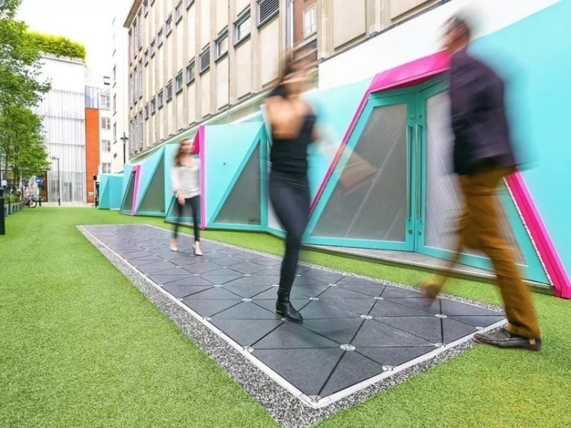
Figure 4 – kinetic walkway. Go To Energy (2019)
A UK start-up called Pavegen has been installing these kinetic pavements in various locations across the world. So SCS solutions would love to implement this brand-new technology into our bridge project.
2.4 LEDs
One of the types of lighting that we want to implement into our bridge design is LED strips. These LED strips will run along the deck of the bridge and illuminate it at night. The renewable energy sources that are chosen will store energy during the day and be used during the night to power the LEDs. An example of what the LEDs would like on the bridge can be found below.
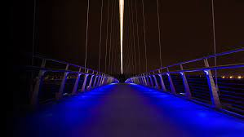
Figure 5 – LED strips along a footbridge. acdc (2022)
2.5 Lampposts
To provide extra illumination when needed, lampposts will be placed along the bridge and will automatically turn on during the night. The main utility lines will power these. The reason for implementing these lampposts is to provide pedestrians with extra safety when walking around in the nighttime.
2.6 Conclusion
To conclude, the renewable energy sources that we will be using on this project are solar panels and the kinetic walkway. These supplies will generate electricity during the day and be used to power the LEDs that run along the bridge. The lampposts will be powered by the main utilities and these are in place to provide extra illumination when needed.

- References

- Williams, S (2021) - Image showing the Rachel Carson Bridge. [Online]. [Accessed 10 February 2022]. Available from: https://www.homelectrical.com/wind-powered-led-lighting-display-rachel-carson-bridge-comes-end.6.html

- Williams, S (2021) - Wind turbines for the Rachel Carson Bridge. [Online]. [Accessed 10 February 2022]. Available from: https://www.homelectrical.com/wind-powered-led-lighting-display-rachel-carson-bridge-comes-end.6.html

- Guardian (2014) – Image of the Blackfriars Bridge. [Online]. [Accessed 20 February 2022]. Available from: https://www.theguardian.com/environment/2014/jan/22/worlds-largest-solar-powered-bridge-opens-in-london

- Go To Energy (2019) - Kinetic walkway. [Online]. [Accessed 20 February 2022]. Available from: https://www.goto.energy/kinetic-pavements-are-hitting-their-stride-in-the-energy-generation-game-236.php

- acdc (2022) - LED strips along a footbridge. [Online]. [Accessed 20 February 2022]. Available from: https://www.acdclighting.com/wp/wp-content/uploads/2019/09/Bridge-segment-guide.pdf

- Williams (2021) - Wind-Powered LED Lighting Display on the Rachel Carson Bridge Comes to an End. HomElectrical.

- Table 1 – shows the pros and cons of wind energy. Wind energy pros and cons. EnergySage.

- Green Diary (2022) - Giant solar-powered bridges that inspire big infrastructure developers to think green. Greendiary.

- Table 2 – shows the pros and cons of solar energy. Solar Energy Pros and Cons. SunStore.

- CNN (2011) - Green sidewalk makes electricity -- one footstep at a time. CNN Business.

