Expansion of the clothing brand “Brada” and relocation
of the store in Kennington

Module name: Project Management
Module tutor name: John-Paul Okeke
Student names and numbers:
Simona Yaneva 1605683
Wilson Makabala 1606029
Syed Rahman 1605376
Loide Braghin 1605698

Content:
- Background of the project by Simona Yaneva 1605683...............................................3
  - SMART Objectives by Simona Yaneva 1605683..........................................3
  - Project scope by Simona Yaneva 1605683..................................................4
  - Constraints by Simona Yaneva 1605683.....................................................5
- Business case by Wilson Makabala 1606029…………..…………………………………………….….5
  - Cost and benefit analysis by Wilson Makabala 1606029…..………………….….6
  - Risk analysis by Wilson Makabala 1606029…..…………………………………………6
  - Risk prevention by Wilson Makabala 1606029…….……………………………….…7
- Project organisation chart by Syed Rahman 1605376………………………………..……………..9

  - Project Organisation chart by Syed Rahman 1605376……………………………..9
  - Project communication management plan by Syed Rahman 1605376….10
- Gantt chart by Loide Braghin 1605698………….…………………………….………………………….13

  - PERT method for project evaluation by Loide Braghin 1605698…………….15

  - Task network diagram by Loide Braghin 1605698………………………………….16

- References……………………………………..………………………………………………………………………20

- Appendix……………………………………………..…………………………………………………………………21

1 . Background of the project Simona Yaneva 160568
At the present there is a stall of the clothing brand “Brada” on Camden market. Because of the increasing interest the client needs to expand and relocate in a boutique on Kennington area. The clothing brand of the client has a reputation of being well socially oriented and eco-friendly. The client produces the clothing using only eco-friendly textiles imported from Bangladesh. They are famous with the fact that only nontoxic chemicals have being involved in the process of their fabrics. The client also runs campaigns in South Africa against the murder of the wild animals and are popular with having strong position against using leathers in the clothing industry.
1.1. SMART Objectives by Simona Yaneva 1605683
Our objectives for the project are SMART. The word SMART (Management, 2017) stands for:
Specific - this means that our objectives are concrete as much as possible.
Measurable - which means that the progress can be measured at any point of time.
Achievable – means that achieving the objective is absolutely possible.
Realistic – which means that the possibility of achieving the objective is real.
Time bounded – our objectives have a deadline.
The iron triangle of the project scope is the project time, quality and budget. When creating our SMART objectives we need to identify what is the most important for our project – the quality, budget or time? We need to open the new boutique not later than 02.04.2018 and therefore our objectives are the following:
- Wilson to research for a suitable and available store in Kennington between the 02.02.2018 and 27.03.2018. His milestone is to offer a report on the weekly meetings.
- Simona responsible to be created an interior design project and to get approval by 28.03.2018. Her milestone is to offer a report for the progress every Friday on the weekly meetings of the team.
- Simona responsible to renovate the store, between 29.03.2018 and 12.04.2018.
- Rahman responsible to transport the inventory by 13.04.2018. To be discussed on the weekly meetings.
- Loide responsible to be created an ecommerce website of the brand until 16.03.2018. Loide to offer a report for the progress of the website on the weekly meetings.
- Every Friday after the weekly meetings of the team, Sayd have to email a summarized report to Mr McKensey showing information about the progress of the project.
1.2. Project scope by Simona Yaneva 1605683
The scope of the project is everything that needs to be done during the project (UK, 2017). Our project scope includes:
- Researching for and renting a store in high street Kennington with the size 800 sq.ft. – 1200 sq.ft. and rent up to £1500.
- Creating an interior design project
- Decorating the store
- Transport the inventory to the new boutique
- Creating an ecommerce website for the brand
The project must also include all the exclusions from the scope (BUSINESS, 2017).
Exclusions from the scope:
- The scope does not include designing the inventory inside the store.
- The scope does not include marketing and advertising of the website.
1.3. Constraints by Simona Yaneva 1605683
The constraints of our project is the time, we have only 3 months to research for a store, decorate it and transport the inventory to the new boutique in Kennington.

2. Business case by Wilson Makabala 1606029
The brand “Brada” has a huge popularity and clientele from Italy and the Italian community. Kennington is an area with high concentration of Italians and the relocation in Kennington will increase the business of the client. Building an ecommerce website is also required to be received orders from Italy and abroad.
The brand is popular with its campaigns “Save the wild animals” in South Africa, and 10% from its profits give to “Save the wild animals” charity in South Africa. The brand is famous to be using only eco-friendly materials produced with nontoxic materials and has a strong environmentally friendly model of growth.
2.1 Cost and benefit analysis by Wilson Makabala 1606029
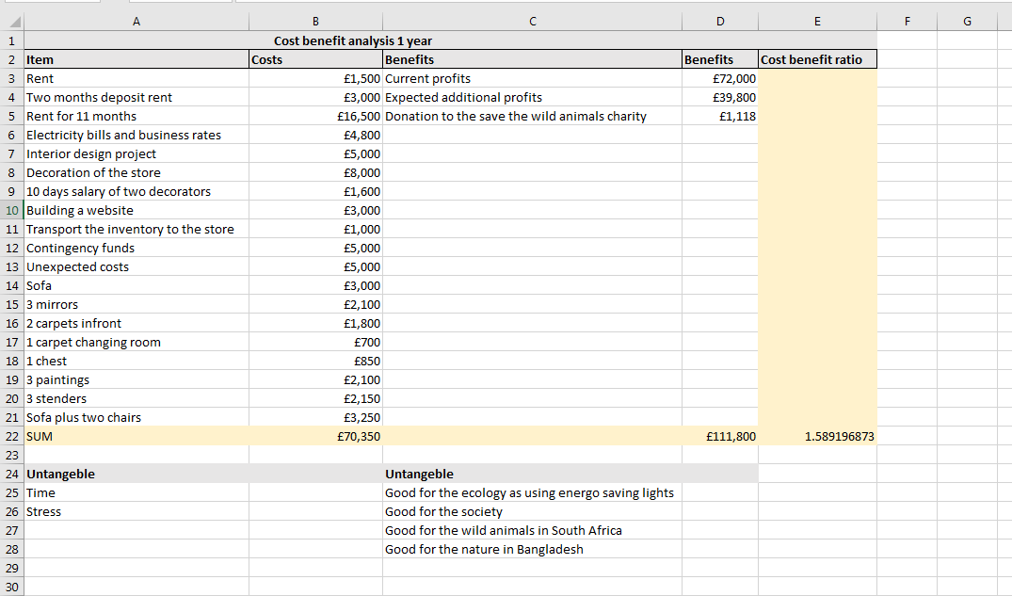
Our Cost benefit analysis shows a ratio over 1.5891, which means that in less than half of year the client will earn back his investment.
2.2. Risk Analysis: Risk Identification by Wilson Makabala 1606029
Risk by definition is uncertainty that matters, either known or unknown (RiskDoctorVideo, 2017). The risks can have negative or positive impact on the project. When the possible effect is negative we can call them threats and when it is positive we can call them opportunities. In project management we need to identify both of them. When the risks have positive impact on the project our actions are to increase the probability of happening. And when the impact can be negative our actions in risk management are to eliminate their probability of occurring.
Risk opportunity in our project is that we can find and rent a store in the first 21 days from the begging of the project. An opportunity is also that the new store will be in very good condition and will take us less time to repair.
2.3. Risk prevention by Wilson Makabala 1606029
When evaluating the project risks that might occur we must examine how high the probability of the risk to occur is and how high impact would it has on the project (Videos, 2017). We can evaluate them as low, medium and high (PMP, 2017). We must also examine what actions must be taken. The typical responses strategies for threats in risk management are (RiskDoctorVideo, 2017):
- Avoid – eliminate the uncertainty
- Transfer – Transfer the ownership
- Reduce – Reduce to “acceptable”
- Accept – Control and manage residual
Risk register
Risk Item | Probability/Impact | Risk management strategy | Critical date | Current status
Wilson Makabala will not find a store by 02.04.2018 | High/High | Let Rahman and Loide help Wilson. They may need to work overtime during the weekends, depending on the project`s progress. | 02.04.2018
The store will have bad past reputation | Low/Medium | To be investigated | N/A
The store will have big damages needing repair | Low/High | To be investigated | N/A
We will not get the interior design approved on time | Medium/High | To be arranged a contingency plan with a second designer | 03.04.2018
The decorators will delay the project | Medium/High | To be provided £5000 contingency funds | 11.04.2018

3. Roles and responsibilities by Syed Rahman 1605376
1) Wilson Makabala – project risk manager. He is responsible to research for and rent a store.
2) Simona Yaneva – project manager. She is responsible to employ an interior designer and for decorating the new store.
3) Syed Rahman – project communication manager. He is responsible for the communication through the project, email the weekly reports to Mr McKensey and transport the inventory of the client into the new boutique.
4) Loide Braghin – project time manager. She is responsible to employ a website developer for the building of the ecommerce website.

3.1. Project organisation chart by Syed Rahman 1605376

Project Sponsor Mr McKensey

Project manager Simona Yaneva
Interior Designer

Decorators

Project communication manager Syed Rahman
Project risk manager Wilson Makabala
Project time manager Loide Braghin

Man with a mini van
Website developer
Estate Agents

3.2. Project communication management plan by Syed Rahman 1605376
When making a communication management plan we have to identify the level of interest and the level of authority each stakeholder has over the project and in what form are we going to distribute the information (Solutions, 2017).
When making the communication plan we have to consider (Professional, 2017):
- Who are going to be our stakeholders?
- How are we going to distribute the information?
- What are we going to communicate through the project?
The four commonly used communication methods are (Professional, 2017):
- Formal written
- Formal verbal
- Informal written
- Informal verbal
In our project the communication is going to have to be delivered between our management team, our project sponsor Mr McKensey, our website developed and our interior designer.
To reduce the communication channels between each stakeholder we are going to use three separate WhatsApp conference chat rooms.
To be the communication clear and concrete as much as possible we are going to avoid slang language, sense of humour and sending misleading, not related to the project messages (Tools, 2017). The communication through WhatsApp can be informal and can provide detailed information through the project with immediate response and option to send an instant image. Using WhatsApp conference chat rooms is good approach to keep all the stake holders updated about any changes on the project or occurring risks. An instant and full update can be provided if the project is going on budget or on target.
We are going to call weekly meetings every Friday to discuss any changes and the progress of the project. To avoid noise in the conversation Rahman is going to be sending a summarized report by email to our project sponsor every Friday after the weekly meetings.
On the weekly meetings to be discussed the progress of the project, change requests and project management plan updates.

Communication Plan
Type of Information | Prepared by | Distribution List | Purpose of Communication | Frequency | Channel
Informal messaging | Rahman | Loide, The project sponsor and the Website developer | Communicating The Progress Of the Website | Daily | Website Development WhatsApp Group
Informal messaging | Rahman | Simona, the project sponsor and the interior designer | Communication The Progress of the Interior Design Project | Daily | Interior Design WhatsApp Group
Informal messaging | Rahman | Management Team | Communicating the Progress of rent a Store and Progress of the entire Project | Daily | Management Team WhatsApp Group
Informal verbal | Rahman | Management team | Discussing the interior design project, the website development and the eventual options for a store | Weekly  Every Friday | Meeting
Summarized Report | Rahman | Rahman and the project sponsor | Summarized report for the progress of the project | Every Friday after the meetings | Email

4.Gantt chart by Loide Braghin 1605698
When creating a Gantt chart for our project we will be using Project evaluation and review technique (PERT) (Pati, 2017).
Every activity on the project has a logical sequence which is known as precedence relationship. When creating a network diagram we can determine the critical path, which is the longest path in the network. Also the slack of time for the non-critical activities can be estimated (Wise, 2017).

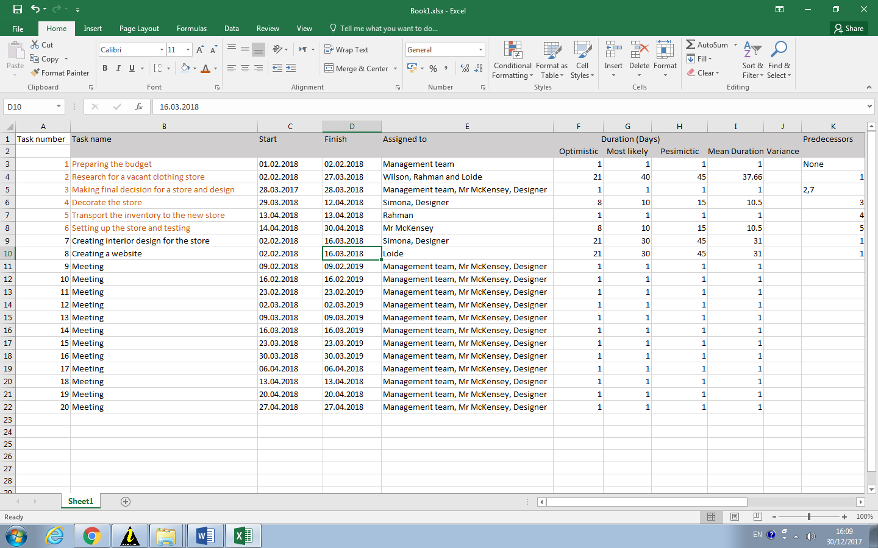
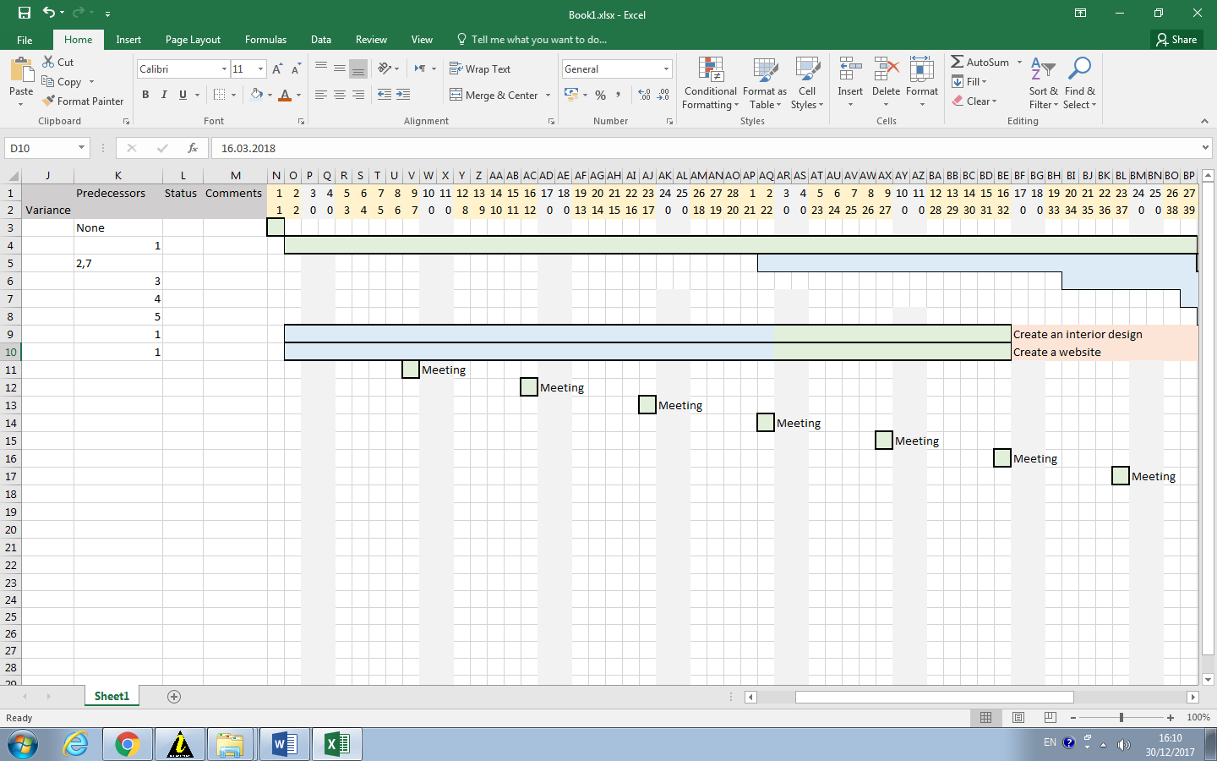
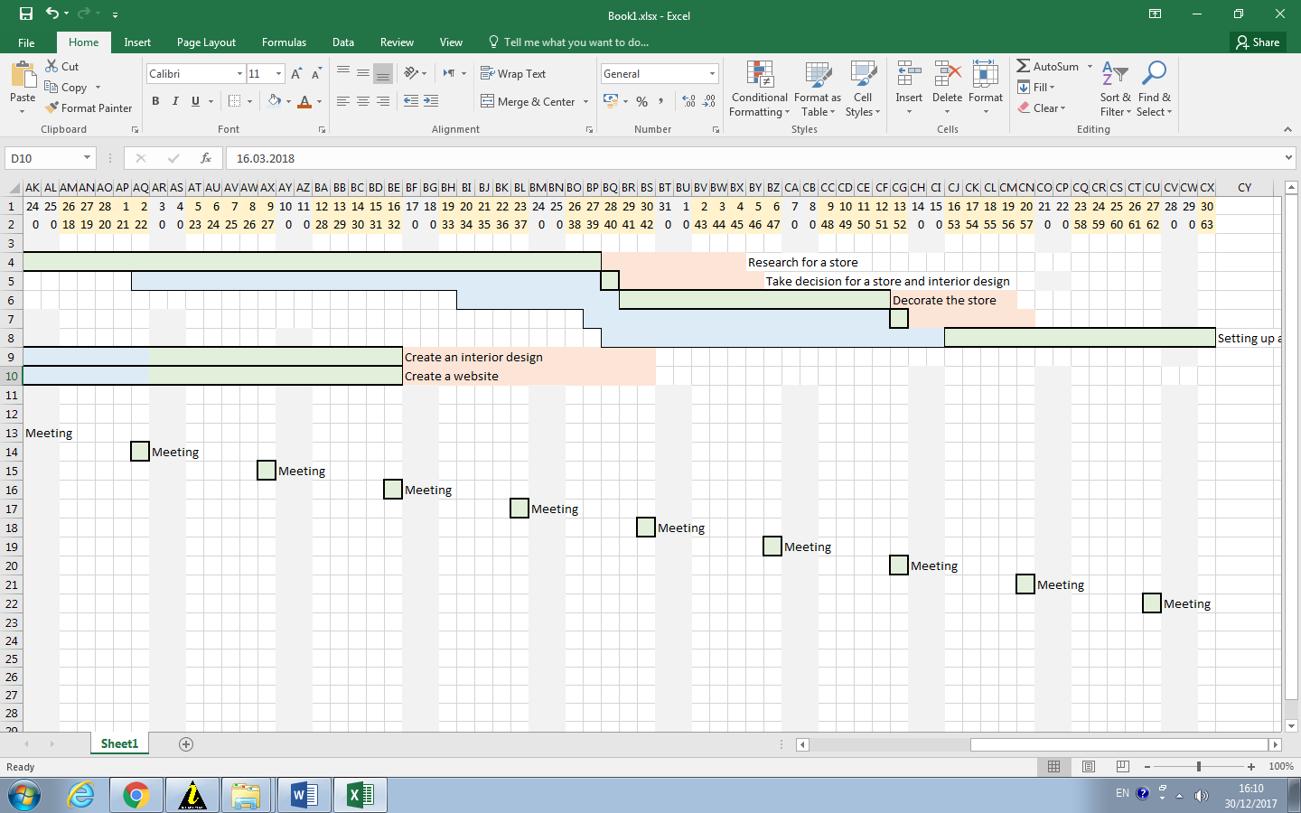
  - PERT method for project evaluation by Loide Braghin 1605698
To use the PERT method for project time estimation three different time estimates for each activity from the project are needed. They are:
- The most optimistic time
- The most likely time
- The most pessimistic time
The first task of our project is to estimate the budget for each activity. When this task finishes the research for a store can start, creating a website and an interior design project.
We are not going to work during the weekends therefore the duration of our project is maximum 63 days. We have a lot of slack time provided, and flexibility through the project.
The research for the store is the most risky task because it is on the critical path and its delay can delay the whole project. Depending on the progress which can be tracked on the weekly meetings, we have created a contingency plan to work overtime if needed during the weekends. We have also provided £5000 contingency funds just in case that we need to shorten the decoration time to 3 or 4 days. We might need to shorten the setting up of the store and testing to 5 days if needed. Our network diagram below (See 4.2.) shows the order of our activities.

  - Task network diagram

Early Start | N: Task | Early Finish
Late  Start | Duration  (Days) | Late Finish
Legend:

41 | 3 | 42
41 | 1 | 42
42 | 4 | 52
42 | 10 | 52
1 | 2 | 41
1 | 40 | 41

52 | 5 | 53
52 | 1 | 53

0 | 1 | 1
0 | 1 | 1

1 | 7 | 31
11 | 30 | 41

1 | 8 | 31
23 | 30 | 53
53 | 6 | 63
53 | 10 | 63

For our project we want to find out how likely is it to finish the project on time and what deviations we can expect on the project and every task. We can calculate these using the following formulas:
To calculate the actual time each task will take (mean time), we have to use the following formula:
t_{e}= ($\frac{to+4.tm+tp}{6}$)
To calculate Variance: σ² = $(\frac{tp-to}{6})$²
To calculate if we are going to finish the project on or before 63 days we are going to use the following formula: p $\left[\frac{æ-µ}{σ} ≤63\right]$
Legend:
- Setting up the budget
- Research for a store
- Take final decision for a store and an interior design
- Decorate the store
- Transport the inventory of the client
- Setting up the store and testing
- Creating interior design
- Create an ecommerce website

Activity | Predecessors | t_{o} | t_{m} | t_{p} | Mean(µ) | Variance (σ²) | Standard Deviation (σ)
1 | - | 1 | 1 | 1 | 1 | 0 | 0
2 | 1 | 21 | 40 | 45 | 37.66 | 4 | 2
3 | 2,7 | 1 | 1 | 1 | 1 | 0 | 0
4 | 3 | 8 | 10 | 15 | 10.5 | 1.66 | 1.288
5 | 4 | 1 | 1 | 1 | 1 | 0 | 0
6 | 5 | 8 | 10 | 15 | 10.5 | 1.66 | 1.288
7 | 1 | 21 | 30 | 45 | 31 | 4 | 2
8 | 1 | 21 | 30 | 45 | 31 | 4 | 2
∑ | - | - | - | - | 61.66 | - | 4.576

We need to calculate the mean duration and variance on each activity on the critical path. ∑ µ = 61.66, ∑ σ = 4.576.
P (æ ≤ 63) = $\left[\frac{æ-µ}{σ} ≤63\right]$ = (63 – 61.66) / 4.576
P (z ≤ 0.2928)
Our Z value is Z ≤ 0.2928. Using standard normal distribution table we can find the probability of finishing the project on or before 63 days.
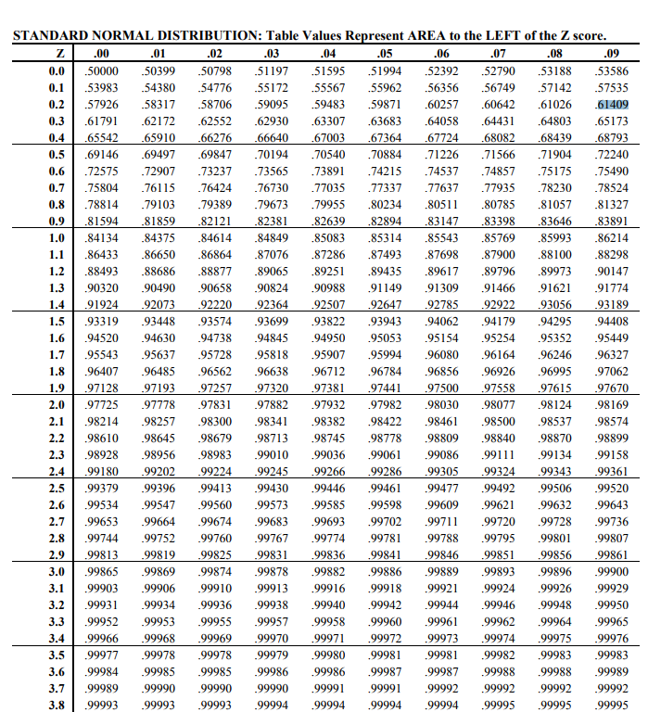
The standard distribution table shows that the value of probability to finishing the project on or before 63 days is 0.61409, i.e. 61% is the chance of completing the project on or before 63 days.

References:
BUSINESS, C. (2017, 12 21). The Basics of Good Project Management. Retrieved from www.youtube.com: https://www.youtube.com/watch?v=5d16JwWwjKo
COTTRELL, S. (2013). THE STUDY SKILLS HANDBOOK. UK: Palgrave Macmillan.
Management, A. B.-P. (2017, 12 21). Project Objectives, TQC, SMART Objectives. Retrieved from www.youtube.com: https://www.youtube.com/watch?v=BoZBu3tHU4c
Pati, A. (2017, 12 21). www.youtube.com. Retrieved from PERT in Project Management: https://www.youtube.com/watch?v=NXFdwr1Vf0k
PMP. (2017, 12 21). www.youtube.com. Retrieved from Project Risk Management: https://www.youtube.com/watch?v=iPUwhVG-jSI
Professional, P. -P. (2017, 12 21). Project Communications Planning. Retrieved from www.youtube.com: https://www.youtube.com/watch?v=In7GX5qlpvU
RiskDoctorVideo. (2017, 12 21). Managing risk in projects - PMI UK Chapter Oxford Branch meeting. Retrieved from www.youtube.com: https://www.youtube.com/watch?v=GO2rpxjbi_A
Simplilearn. (2017, 12 21). PMP Training Videos | Lesson 10: Project Communications Management | Simplilearn. Retrieved from www.youtube.com: https://www.youtube.com/watch?v=k8KjFuhzBaQ
Solutions, D. C. (2017, 12 21). www.youtube.com. Retrieved from How to Create a Communications Plan: https://www.youtube.com/watch?v=WWEdiOzLYOg&feature=youtu.be
Tools, M. (2017, 12 21). Cost-Benefit Analysis. Retrieved from https://www.mindtools.com: https://www.mindtools.com/pages/article/newTED_08.htm
Tools, M. (2017, 12 07). www.mindtools.com. Retrieved from Getting the Right Messages Across in the Right Way: https://www.mindtools.com/CommSkll/CommunicationsPlanning.htm
UK, A. E. (2017, 12 21). What is Project Scope Management? and Major Elements in Project Scope Management | AIMS Lecture. Retrieved from www.youtube.com: https://www.youtube.com/watch?v=sCCyf-skt5g
Videos, P. M. (2017, 12 21). What Is Project Risk? Retrieved from www.youtube.com: https://www.youtube.com/watch?v=nbhLDJkNnzY
Videos, P. M. (2017, 12 20). What Is Risk Management In Projects? Retrieved from www.youtube.com: https://www.youtube.com/watch?v=x7A9idByPA4&feature=youtu.be
Wise, K. (2017, 12 21). PERT - Project Management Techniques||with solved problem||Operations Research Tutorial. Retrieved from www.youtube.com: https://www.youtube.com/watch?v=WrAf6zdteXI

Appendix:

1.3 Project Initiation Document (PID)  (Blank PID to copy and paste into your assignment to fill in) | Tick when complete
Section 1 – What is the project all about?
Expansion of the clothing brand “Brada” and relocation of the store in Kennington

Project Title: Expansion and relocation of the clothing brand “Brada” in Kennington high street

Background: The clothing brand “Brada” has a stall in Camden market. The brand is famous with its social campaigns in South Africa and proactive initiatives to save the wild animals from being used in the clothing industry.
Purpose: The brand has a huge popularity and clientele from Italy and the Italian community. Kennington is an area with high concentration of Italians and the relocation on a high street Kennington will benefit the business. Building an ecommerce website is also required to be received orders from Italy and abroad.
Objectives (and how they will be measured)
- Wilson to research for a suitable and available store in Kennington between the 02.02.2018 and 27.03.2018. His milestone is to offer a report on the weekly meetings.
- Simona responsible to be created an interior design project and to get approval by 28.03.2018. Her milestone is to offer a report for the progress every Friday on the weekly meetings of the team.
- To renovate the store, between 29.03.2018 and 12.04.2018.
- Rahman responsible to transport the inventory by 13.04.2018.To be discussed on the weekly meetings.
- Loide responsible to be created an ecommerce website of the brand until 16.03.2018. Loide to offer a report for the progress of the website on the weekly meetings.
- Every Friday after the weekly meetings of the team, Sayd have to email a summarized report to Mr McKensey showing information about the progress of the project.
Project scope: To be made a research for and rent a store. Decorate the store, create an ecommerce website and transport all the inventory from Camden Market to Kennington.
Exclusions from scope:
- The scope does not include designing the inventory inside the store.
- The scope does not include marketing and advertising of the website.
Deliverables (including dates of completion)
To be emailed a report to Mr McKensey every Friday about the progress of the project. Also including an update of the interior and website design projects.
Date of completion of the project 30 April 2018.
Constraints: Constrained by the time. The new boutique has to open on the 2nd of May. Strong risk management and risk prevention actions are required especially during the first task of the project – finding a store, as its delay can delay the whole project.

Assumptions: We assume that the interior design project will be accepted on time.

Section 2: Why should this project go ahead?

Business case: Project Benefits
The brand has an eco-friendly model of growth. It benefits the eco system in Bangladesh. It also profits the “Save the wild animals” charity in South Africa. And has a huge popularity among the Italian community.

Options

Cost and Timescale: The budget for the project is £50,000 and the timescale 3 months.

Cost/Benefit Analysis
Risk Analysis: Risk Identification
1) There is a risk that Wilson Makabala will not find a store by 02.04.2018.
2) There is a risk the new store will have a bad past reputation.
3) There is a risk that the new store will have big damages to repair.
4) There is a risk that the designer will not deliver the interior design project on time.
5) There is a risk that the decorators will delay the project.

Risk prevention:
1) To be able to find a store on time Rahman and Loide will help Wilson in the research for the store. They may need to work overtime during the weekends, depending on the progress of the project.
2) To be examined only stores with the appropriate store licences, and to be researched about the store`s history and if its needed serious refurbishment.
3) Simona to arrange a second designer as a contingency plan. And to offer a report every Friday on the weekly meetings.
4) To be provided £5000 contingency funds if the decoration time needs to be shortened.
Risk Management: For a contingency plan to be provided £5000 contingency funds in case that we need to shorten the decoration time to 3 or 4 days. The team must be able to work during the weekends especially during researching for a store.
Risk Monitoring: Every Friday of the week to be called a meeting and to be offered a report from Wilson, Loide and Simona, to be monitored the progress of the research for the new store, website and interior design.

Section 3: Who will work on the project?

Roles and Responsibilities
Wilson Makabala is responsible to research for and rent a store.
Simona Yaneva is responsible to create an interior design and decorate the store.
Syed Rahman responsible to lead the communication and transport the inventory.
Loide Braghin responsible for building a website.

Project Organisation Chart/Structure diagram
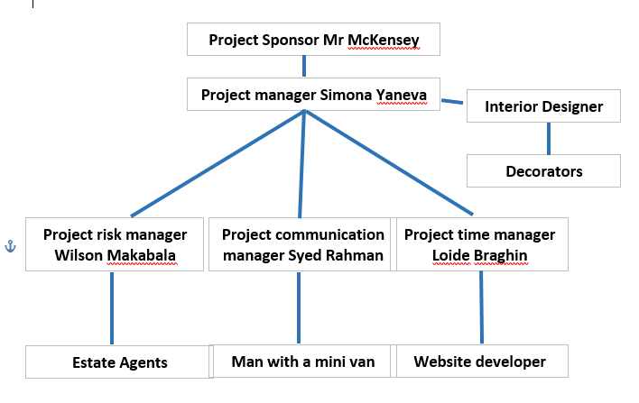

Names of: Project Sponsor
John McKensey

Project Manager (PM) Simona Yaneva

Section 4: How and when will the project be delivered?

Initial Project Plan: The projects starts on the 1st of February and finishes on the 30th April.
Assignments/Milestones
Every Friday of the week to be called a meeting of the team and to be discussed the progress of the project.

List milestones here | List times when they should be achieved by here
To be emailed a report to Mr McKensey | 09.02.2018
To be emailed a report to Mr McKensey | 16.02.2018
To be emailed a report to Mr McKensey | 23.02.2018
To be emailed a report to Mr McKensey | 02.03.2017
To be emailed a report to Mr McKensey | 09.03.2018
To be emailed a report to Mr McKensey | 16.03.2018
To be emailed a report to Mr McKensey | 23.03.2018
To be emailed a report to Mr McKensey | 30.03.2018
To be emailed a report to Mr McKensey | 06.04.2018
To be emailed a report to Mr McKensey | 13.04.2018
To be emailed a report to Mr McKensey | 20.04.2018
To be emailed a report to Mr McKensey | 27.04.2018

Schedule (Gantt Chart)
Human Resource Requirements:
Project Team
Simona Yaneva – Project Manager
Wilson Makabala – Project Risk Manager
Syed Rahman – Project Communication manager
Loide Braghin – Project time manager

Support Staff
Designer
Decorators
Man with a minivan
Website developer

Additional Staff

Project Control: Monitoring mechanisms
Weekly meetings

Communication channels and schedules
Communication through email and WhatsApp
Every Friday of the week to be called a meeting of the team and to be emailed a summarized report to the project sponsor.

Quality Control:
To be provided a report from each team member about the progress of the project

